Lab5

Q1.

Code(.aspx)

<%@ Page Language="C#" AutoEventWireup="true" CodeBehind="WebForm1.aspx.cs" Inherits="Validator1.WebForm1" %>

<!DOCTYPE html>

<html xmlns="http://www.w3.org/1999/xhtml">

<head runat="server">

<title></title>

</head>

<body>

<form id="form1" runat="server">

<div>

Choose candidate<br />

<asp:DropDownList ID="DropDownList1" runat="server">

<asp:ListItem>Butcher</asp:ListItem>

<asp:ListItem>Frenchie</asp:ListItem>

<asp:ListItem>MM</asp:ListItem>

<asp:ListItem>Hughie</asp:ListItem>

</asp:DropDownList>

<asp:RequiredFieldValidator ID="RequiredFieldValidator1" runat="server" ControlToValidate="DropDownList1" ErrorMessage="Candidate Empty"></asp:RequiredFieldValidator>

<br />

House<asp:RequiredFieldValidator ID="RequiredFieldValidator3" runat="server" ControlToValidate="RadioButtonList1" ErrorMessage="House Not Chosen"></asp:RequiredFieldValidator>

<br />

<asp:RadioButtonList ID="RadioButtonList1" runat="server">

<asp:ListItem>Red</asp:ListItem>

<asp:ListItem>Blue</asp:ListItem>

<asp:ListItem>Green</asp:ListItem>

</asp:RadioButtonList>

Class<br />

<asp:TextBox ID="TextBox1" runat="server"></asp:TextBox>

<asp:RequiredFieldValidator ID="RequiredFieldValidator2" runat="server" ControlToValidate="TextBox1" ErrorMessage=" Class field empty"></asp:RequiredFieldValidator>

<asp:RangeValidator ID="RangeValidator1" runat="server" ControlToValidate="TextBox2" ErrorMessage="Class Not in Range" MaximumValue="12" MinimumValue="6" Type="Integer"></asp:RangeValidator>

<br />

Email Id<asp:RequiredFieldValidator ID="RequiredFieldValidator4" runat="server" ControlToValidate="TextBox2" ErrorMessage="Email Id Field Empty"></asp:RequiredFieldValidator>

<asp:RegularExpressionValidator ID="RegularExpressionValidator1" runat="server" ControlToValidate="TextBox2" ErrorMessage="Incorrect email" ValidationExpression=".+@.+"></asp:RegularExpressionValidator>

<br />

<asp:TextBox ID="TextBox2" runat="server"></asp:TextBox>

<br />

<br />

Contact Number<asp:CustomValidator ID="CustomValidator1" runat="server" ControlToValidate="TextBox3" ErrorMessage="Invalid phone number" OnServerValidate="CustomValidator1_ServerValidate1" ValidateEmptyText="True"></asp:CustomValidator>

<br />

<asp:TextBox ID="TextBox3" runat="server"></asp:TextBox>

<br />

<br />

<asp:Button ID="Button1" runat="server" OnClick="Button1_Click" Text="Vote" />

<br />

<asp:ValidationSummary ID="ValidationSummary1" runat="server" ShowMessageBox="True" />

<br />

</div>

</form>

</body>

</html>

Code(aspx.cs)

using System;

using System.Collections.Generic;

using System.Linq;

using System.Web;

using System.Web.UI;

using System.Web.UI.WebControls;

namespace Validator1

{

public partial class WebForm1 : System.Web.UI.Page

{

protected void Page_Load(object sender, EventArgs e)

{

}

protected void CustomValidator1_ServerValidate(object source, ServerValidateEventArgs args)

{

int val = Int32.Parse(args.Value.Substring(0, 2));

if (val > 50)

{

args.IsValid = true;

}

else

args.IsValid = false;

}

protected void Button1_Click(object sender, EventArgs e)

{

}

protected void CustomValidator1_ServerValidate1(object source, ServerValidateEventArgs args)

{

try

{

int val = Int32.Parse(args.Value.Substring(0, 1));

if (val > 50 && args.Value.Length == 10)

{

args.IsValid = true;

}

else

args.IsValid = false;

}

catch

{

args.IsValid = false;

}

}

}

}

Output

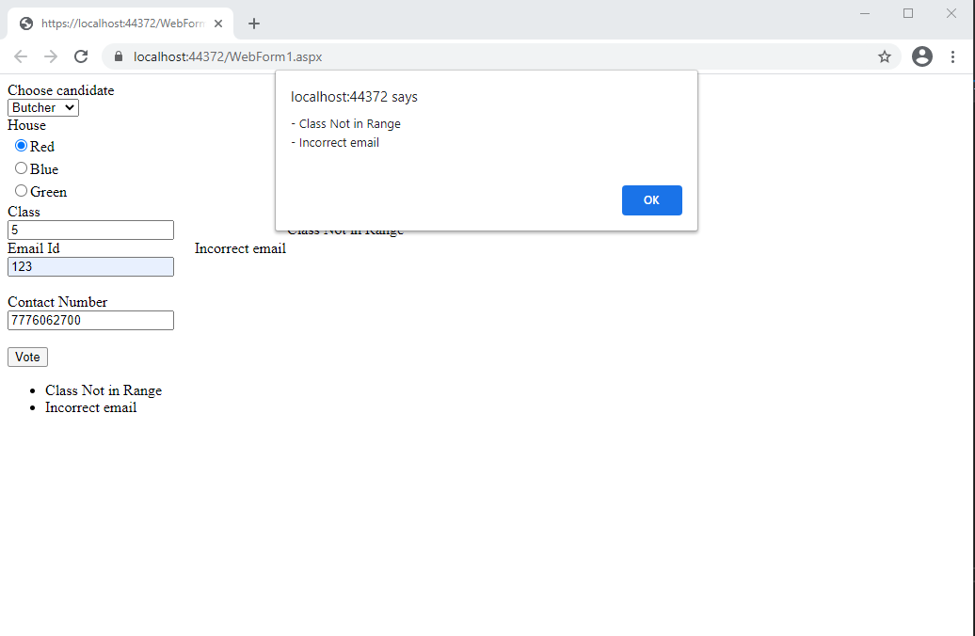

Q2.

Code(.aspx)

Master Page

<%@ Master Language="C#" AutoEventWireup="true" CodeBehind="Site1.master.cs" Inherits="EcomFirm.Site1" %>

<!DOCTYPE html>

<html>

<head runat="server">

<title></title>

<asp:ContentPlaceHolder ID="head" runat="server">

</asp:ContentPlaceHolder>

<style type="text/css">

.auto-style1 {

height: 985px;

}

.auto-style2 {

font-size: xx-large;

}

</style>

</head>

<body>

<form id="form1" runat="server">

<div class="auto-style1" style="background-color: #9900FF; background-repeat: repeat">

<h1 class="auto-style2">

<asp:Image ID="Image1" runat="server" Height="174px" ImageUrl="~/logo.png" Width="250px" />

Welcome To My Shopping Cart</h1>

<p>

Reach out to us at <a href="mailto:info@myshoppingcart.in">info@myshoppingcart.in</a></p>

<p>

Contact(Toll-Free) +91 8787878787

</p>

<p>

<asp:HyperLink ID="HyperLink1" runat="server" NavigateUrl="~/WebForm1.aspx">Electronics</asp:HyperLink>

</p>

<p>

<asp:HyperLink ID="HyperLink2" runat="server" NavigateUrl="~/WebForm3.aspx">Baggage</asp:HyperLink>

</p>

<p>

<asp:HyperLink ID="HyperLink3" runat="server" NavigateUrl="~/WebForm4.aspx">Offers</asp:HyperLink>

<asp:ContentPlaceHolder ID="ContentPlaceHolder1" runat="server">

</asp:ContentPlaceHolder>

</div>

</form>

</body>

</html>

Page1

<%@ Page Title="" Language="C#" MasterPageFile="~/Site1.Master" AutoEventWireup="true" CodeBehind="WebForm1.aspx.cs" Inherits="EcomFirm.WebForm1" %>

<asp:Content ID="Content1" ContentPlaceHolderID="head" runat="server">

</asp:Content>

<asp:Content ID="Content2" ContentPlaceHolderID="ContentPlaceHolder1" runat="server">

<p>

Mobiles</p>

<p>

Choose Mobile model:

<asp:DropDownList ID="DropDownList1" runat="server">

<asp:ListItem>Samsung</asp:ListItem>

<asp:ListItem>OnePlus</asp:ListItem>

<asp:ListItem>Apple</asp:ListItem>

<asp:ListItem>MI</asp:ListItem>

<asp:ListItem></asp:ListItem>

</asp:DropDownList>

</p>

<p>

Choose Vendor:

<asp:DropDownList ID="DropDownList2" runat="server">

<asp:ListItem>Vendor 1</asp:ListItem>

<asp:ListItem>Vendor 2</asp:ListItem>

<asp:ListItem>Vendor 3</asp:ListItem>

<asp:ListItem></asp:ListItem>

</asp:DropDownList>

</p>

<p>

&nbsp;</p>

<p>

Laptops</p>

<p>

Choose Mobile model:

<asp:DropDownList ID="DropDownList3" runat="server">

<asp:ListItem>Sony</asp:ListItem>

<asp:ListItem>Lenovo</asp:ListItem>

<asp:ListItem>Apple</asp:ListItem>

<asp:ListItem>HP</asp:ListItem>

<asp:ListItem></asp:ListItem>

</asp:DropDownList>

</p>

<p>

Choose Vendor:

<asp:DropDownList ID="DropDownList4" runat="server">

<asp:ListItem>Vendor 1</asp:ListItem>

<asp:ListItem>Vendor 2</asp:ListItem>

<asp:ListItem>Vendor 3</asp:ListItem>

<asp:ListItem></asp:ListItem>

</asp:DropDownList>

</p>

<p>

&nbsp;</p>

<p>

Printers</p>

<p>

Choose Mobile model:

<asp:DropDownList ID="DropDownList5" runat="server">

<asp:ListItem>Xerox</asp:ListItem>

<asp:ListItem>HP</asp:ListItem>

<asp:ListItem>Canon</asp:ListItem>

<asp:ListItem>MI</asp:ListItem>

<asp:ListItem></asp:ListItem>

</asp:DropDownList>

</p>

<p>

Choose Vendor:

<asp:DropDownList ID="DropDownList6" runat="server">

<asp:ListItem>Vendor 1</asp:ListItem>

<asp:ListItem>Vendor 2</asp:ListItem>

<asp:ListItem>Vendor 3</asp:ListItem>

<asp:ListItem></asp:ListItem>

</asp:DropDownList>

</p>

<p>

&nbsp;</p>

</asp:Content>

Page2

<%@ Page Title="" Language="C#" MasterPageFile="~/Site1.Master" AutoEventWireup="true" CodeBehind="WebForm3.aspx.cs" Inherits="EcomFirm.WebForm3" %>

<asp:Content ID="Content1" ContentPlaceHolderID="head" runat="server">

</asp:Content>

<asp:Content ID="Content2" ContentPlaceHolderID="ContentPlaceHolder1" runat="server">

<h2>Choose Baggage</h2>

Bag1:<br />

<asp:ImageButton ID="ImageButton1" runat="server" Height="116px" ImageUrl="~/hp-001-blue-line-laptop-backpack-hp-original-imaevy9bnnrx6mjz.jpeg" Width="113px" />

<br />

<br />

Bag2:<br />

<asp:ImageButton ID="ImageButton2" runat="server" ImageUrl="~/rucksack.jpg" Width="122px" />

<br />

<br />

Bag3:<br />

<asp:ImageButton ID="ImageButton3" runat="server" ImageUrl="~/trolley-bags-500x500.jpg" OnClick="ImageButton3_Click" Width="168px" />

</asp:Content>

Page4

<%@ Page Title="" Language="C#" MasterPageFile="~/Site1.Master" AutoEventWireup="true" CodeBehind="WebForm4.aspx.cs" Inherits="EcomFirm.WebForm4" %>

<asp:Content ID="Content1" ContentPlaceHolderID="head" runat="server">

</asp:Content>

<asp:Content ID="Content2" ContentPlaceHolderID="ContentPlaceHolder1" runat="server">

<h2>Offer page</h2>

<p>

<asp:ImageButton ID="ImageButton1" runat="server" Height="170px" ImageUrl="~/offer.jpg" Width="161px" />

</p>

<p>

Second Offer</p>

<p>

<asp:ImageButton ID="ImageButton2" runat="server" Height="170px" ImageUrl="~/offers.png" Width="166px" />

</p>

</asp:Content>

Output

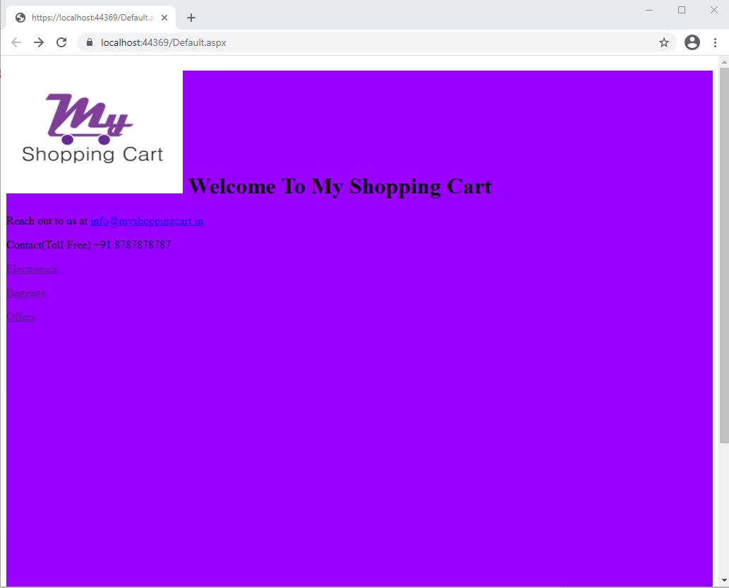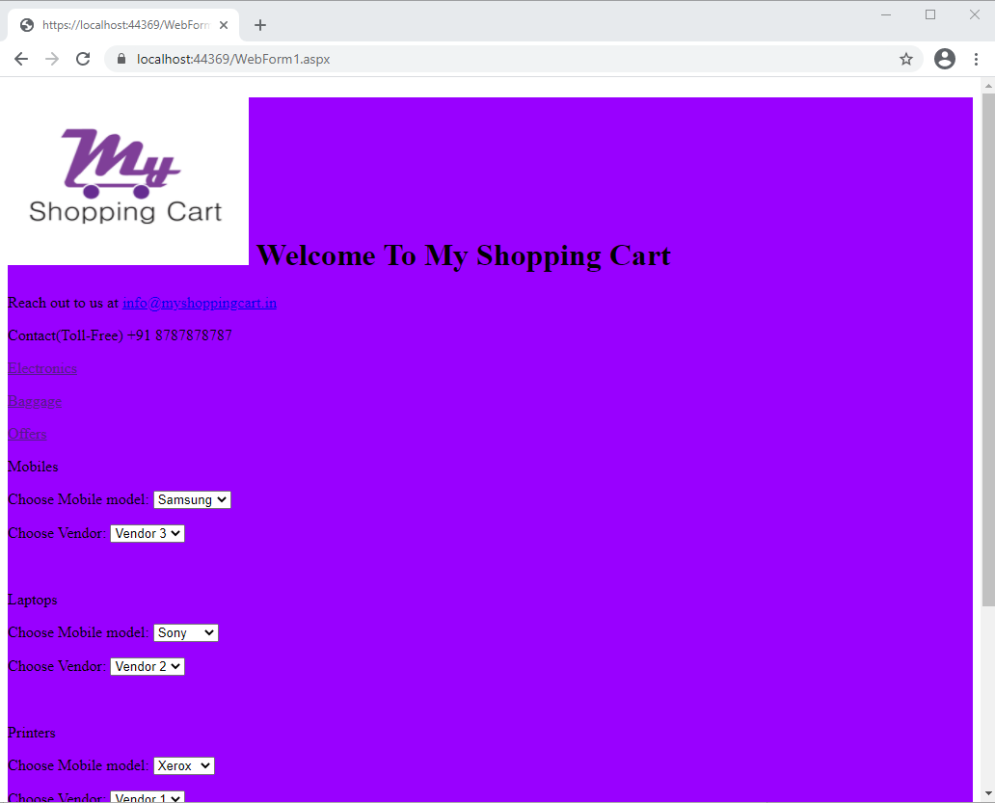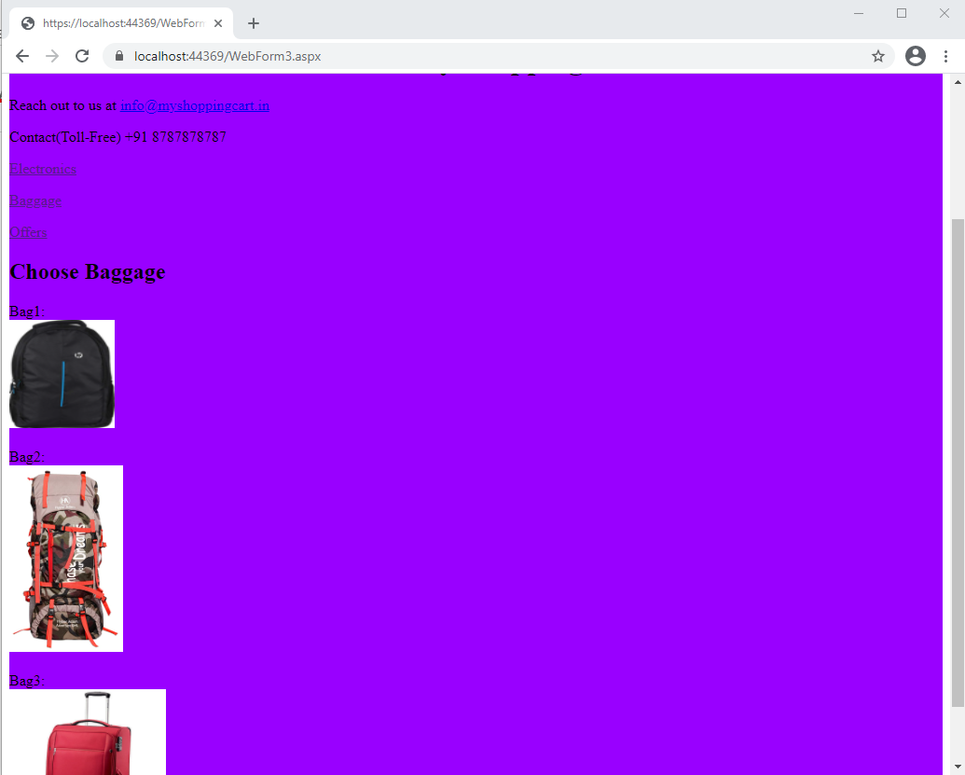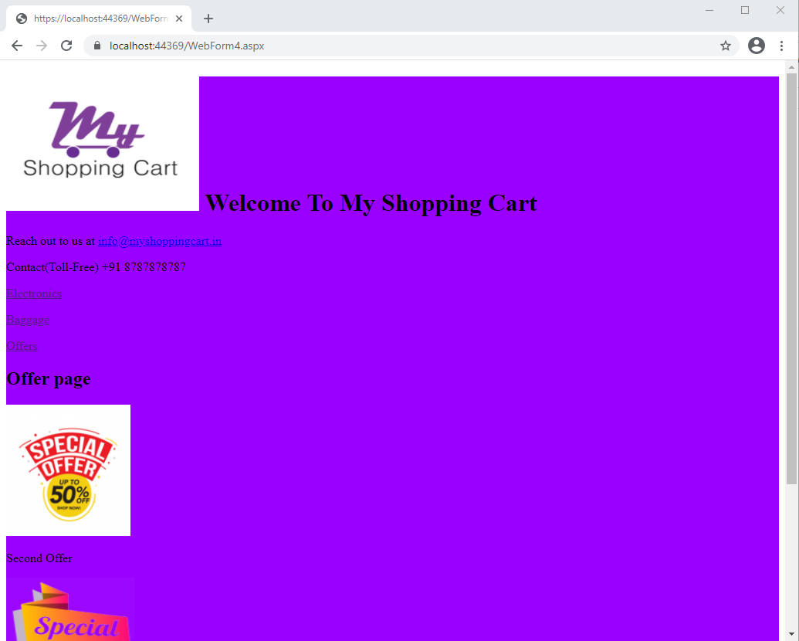

Q3.

Code(.ASPX)

<%@ Page Language="C#" AutoEventWireup="true" CodeBehind="WebForm1.aspx.cs" Inherits="Theme.WebForm1" Theme ="Summer" %>

<!DOCTYPE html>

<html xmlns="http://www.w3.org/1999/xhtml">

<head runat="server">

<title></title>

</head>

<body>

<form id="form1" runat="server">

<div>

<asp:Image ID="Image1" runat="server" />

<asp:DropDownList ID="DropDownList1" runat="server"></asp:DropDownList>

</div>

</form>

</body>

</html>

Code(aspx.cs)

using System;

using System.Collections.Generic;

using System.Linq;

using System.Web;

using System.Web.UI;

using System.Web.UI.WebControls;

namespace Theme

{

public partial class WebForm1 : System.Web.UI.Page

{

protected void Page_Load(object sender, EventArgs e)

{

if (!IsPostBack)

{

DropDownList1.Items.Add("Summer");

DropDownList1.Items.Add("Monsoon");

if (Session["Theme"] != null)

{

Page.Theme = Session["Theme"].ToString();

}

}

}

protected void DropDownList1_SelectedIndexChanged(object sender, EventArgs e)

{

//Page.Theme = Session["Theme"].ToString();

}

}

}

Output:

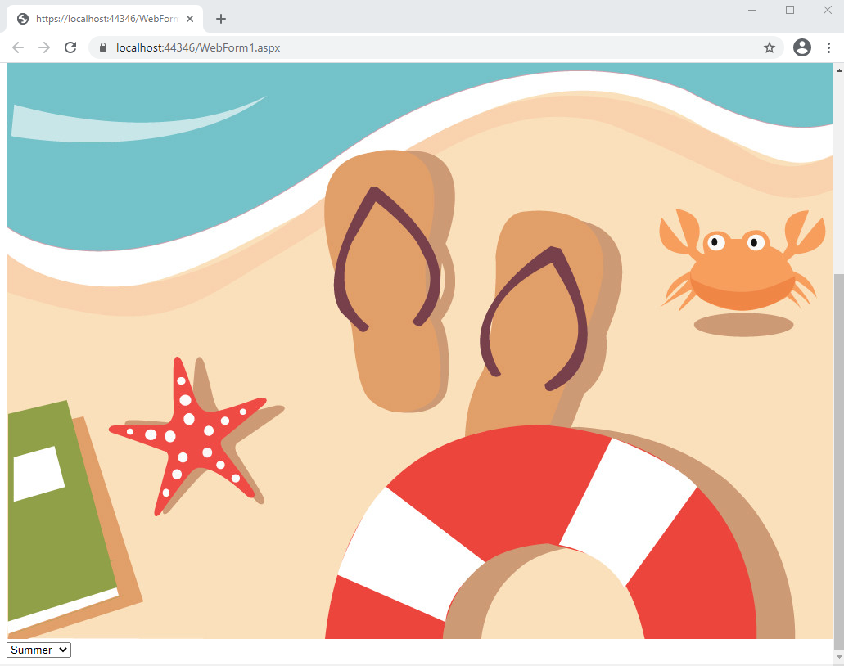

Q4.

Code(.aspx)

|  |
| --- |
| ﻿<%@ Master Language="C#" AutoEventWireup="true" CodeFile="MasterPage.master.cs" Inherits="MasterPage" %> |
|  |  |
|  | <!DOCTYPE html> |
|  |  |
|  | <html> |
|  | <head runat="server"> |
|  | <title></title> |
|  | <asp:ContentPlaceHolder id="head" runat="server"> |
|  | </asp:ContentPlaceHolder> |
|  | </head> |
|  | <body> |
|  | <form id="form1" runat="server"> |
|  | <div> |
|  | <asp:ContentPlaceHolder id="ContentPlaceHolder1" runat="server"> |
|  |  |
|  | </asp:ContentPlaceHolder> |
|  | </div> |
|  | </form> |
|  | </body> |
|  | </html> |

Page2

<%@ Page Title="" Language="C#" MasterPageFile="~/MasterPage.master" AutoEventWireup="true" CodeFile="Default2.aspx.cs" Inherits="Default2" %>

<asp:Content ID="Content1" ContentPlaceHolderID="head" Runat="Server">

</asp:Content>

<asp:Content ID="Content2" ContentPlaceHolderID="ContentPlaceHolder1" Runat="Server">

</asp:Content>

Page 3

<%@ Page Title="" Language="C#" MasterPageFile="~/MasterPage.master" AutoEventWireup="true" CodeFile="Default.aspx.cs" Inherits="_Default" %>

<asp:Content ID="Content1" ContentPlaceHolderID="head" Runat="Server">

</asp:Content>

<asp:Content ID="Content2" ContentPlaceHolderID="ContentPlaceHolder1" Runat="Server">

</asp:Content>