**Lab7**

**Q1.**

**Code(.aspx)**

<%@ Page Language="C#" AutoEventWireup="true" CodeBehind="WebForm1.aspx.cs" Inherits="JuiceBar.WebForm1" %>

<!DOCTYPE html>

<html xmlns="http://www.w3.org/1999/xhtml">

<head runat="server">

<title></title>

</head>

<body>

<form id="form1" runat="server">

<div style="font-weight: 700">

<h1>

<strong>Welcome to Juice Bar!</h1>

<br />

Choose a Fruit:</strong><asp:CheckBoxList ID="CheckBoxList1" runat="server" style="margin-top: 0px" >

</asp:CheckBoxList>

<br />

Choose an Ice-Cream:<asp:RadioButtonList ID="RadioButtonList1" runat="server">

</asp:RadioButtonList>

<br />

<asp:Button ID="Button1" runat="server" OnClick="Button1_Click" Text="Make Milkshake" />

<br />

<br />

<asp:Label ID="Label1" runat="server"></asp:Label>

</div>

</form>

</body>

</html>

**Code(aspx.cs)**

using System;

using System.Collections.Generic;

using System.Linq;

using System.Web;

using System.Web.UI;

using System.Web.UI.WebControls;

namespace JuiceBar

{

public partial class WebForm1 : System.Web.UI.Page

{

protected void Page_Load(object sender, EventArgs e)

{

if (!IsPostBack)

{

List<string> Fruit = new List<string>();

Fruit.Add("Apple");

Fruit.Add("Mango");

Fruit.Add("Orange");

Fruit.Add("Watermelon");

CheckBoxList1.DataSource = Fruit;

List<string> IceCream = new List<string>();

IceCream.Add("Chocolate");

IceCream.Add("Vanilla");

IceCream.Add("Strawberry");

IceCream.Add("Butterscotch");

RadioButtonList1.DataSource = IceCream;

this.DataBind();

}

}

protected void Button1_Click(object sender, EventArgs e)

{

int[] arr = { 50, 70, 60 };

Random r = new Random();

int num = r.Next(0, 3);

Label1.Text = "The Milkshake you picked has <br/> " + CheckBoxList1.SelectedItem.Text + "<br/>&<br/> " + RadioButtonList1.SelectedItem.Text + "<br/><br/>Total Price : Rs." + arr[num].ToString();

}

}

}

**Output**

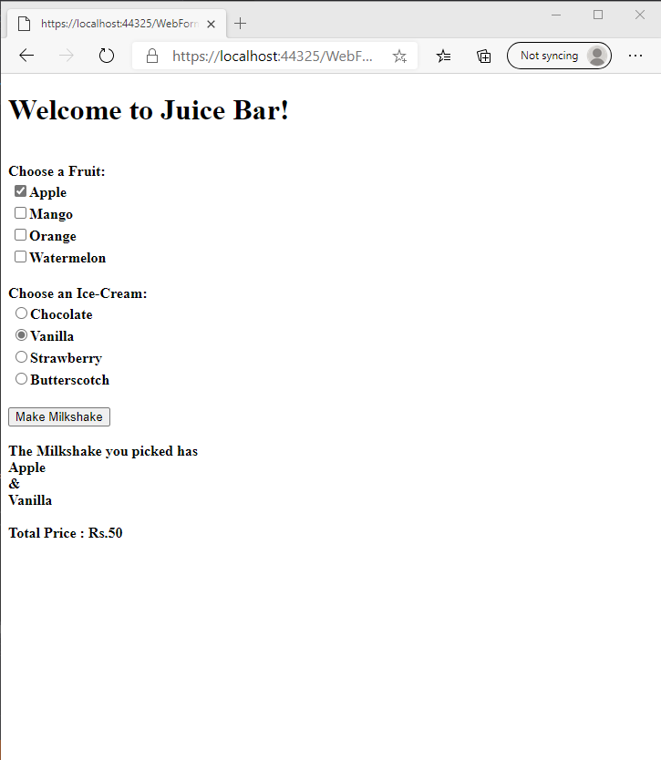

**Q2.**

**Code(.aspx)**

**Page1**

<%@ Page Language="C#" AutoEventWireup="true" CodeBehind="WebForm2.aspx.cs" Inherits="Tour.WebForm2" %>

<!DOCTYPE html>

<html xmlns="http://www.w3.org/1999/xhtml">

<head runat="server">

<title></title>

</head>

<body>

<form id="form1" runat="server">

<div>

Select Location:<br />

<asp:ListBox ID="ListBox1" runat="server" AutoPostBack="True" DataSourceID="SqlDataSource1" DataTextField="place" DataValueField="place" OnSelectedIndexChanged="ListBox1_SelectedIndexChanged1"></asp:ListBox>

<asp:SqlDataSource ID="SqlDataSource1" runat="server" ConnectionString="<%$ ConnectionStrings:whatConnectionString2 %>" SelectCommand="SELECT [place] FROM [Tour]"></asp:SqlDataSource>

<br />

<asp:Label ID="Label1" runat="server" Text="Label"></asp:Label>

<br />

<asp:Button ID="Button1" runat="server" Text="Button" />

<br />

</div>

</form>

</body>

</html>

**Page2**

<%@ Page Language="C#" AutoEventWireup="true" CodeBehind="WebForm1.aspx.cs" Inherits="Tour.WebForm1" %>

<!DOCTYPE html>

<html xmlns="http://www.w3.org/1999/xhtml">

<head runat="server">

<title></title>

</head>

<body>

<form id="form1" runat="server">

<div>

<asp:GridView ID="GV1" DataSourceID="SqlDataSource1" runat="server" AllowSorting="True" AutoGenerateColumns="False" >

<Columns>

<asp:BoundField DataField="place" HeaderText="place" SortExpression="place" />

<asp:BoundField DataField="days" HeaderText="days" SortExpression="days" />

<asp:BoundField DataField="cost" HeaderText="cost" SortExpression="cost" />

<asp:BoundField DataField="Travel_Agency" HeaderText="Travel_Agency" SortExpression="Travel_Agency" />

</Columns>

</asp:GridView>

<asp:SqlDataSource ID="SqlDataSource1" runat="server" ConnectionString="<%$ ConnectionStrings:whatConnectionString2 %>" SelectCommand="SELECT * FROM [Tour] WHERE ([place] = @place)">

<SelectParameters>

<asp:QueryStringParameter Name="place" QueryStringField="place" Type="String" />

</SelectParameters>

</asp:SqlDataSource>

</div>

</form>

</body>

</html>

**Code(aspx.cs)**

**Page1.**

using System;

using System.Collections.Generic;

using System.Linq;

using System.Web;

using System.Web.UI;

using System.Web.UI.WebControls;

namespace Tour

{

public partial class WebForm2 : System.Web.UI.Page

{

protected void Page_Load(object sender, EventArgs e)

{

}

protected void ListBox1_SelectedIndexChanged(object sender, EventArgs e)

{

Label1.Text = ListBox1.SelectedItem.Text;

Console.WriteLine(ListBox1.SelectedItem.Text);

Response.Redirect("~/WebForm1.aspx?place=" + ListBox1.SelectedItem.Text);

}

protected void ListBox1_SelectedIndexChanged1(object sender, EventArgs e)

{

Label1.Text = ListBox1.SelectedItem.Text;

Console.WriteLine(ListBox1.SelectedItem.Text);

Response.Redirect("~/WebForm1.aspx?place=" + ListBox1.SelectedItem.Text);

}

}

}

**Output**:

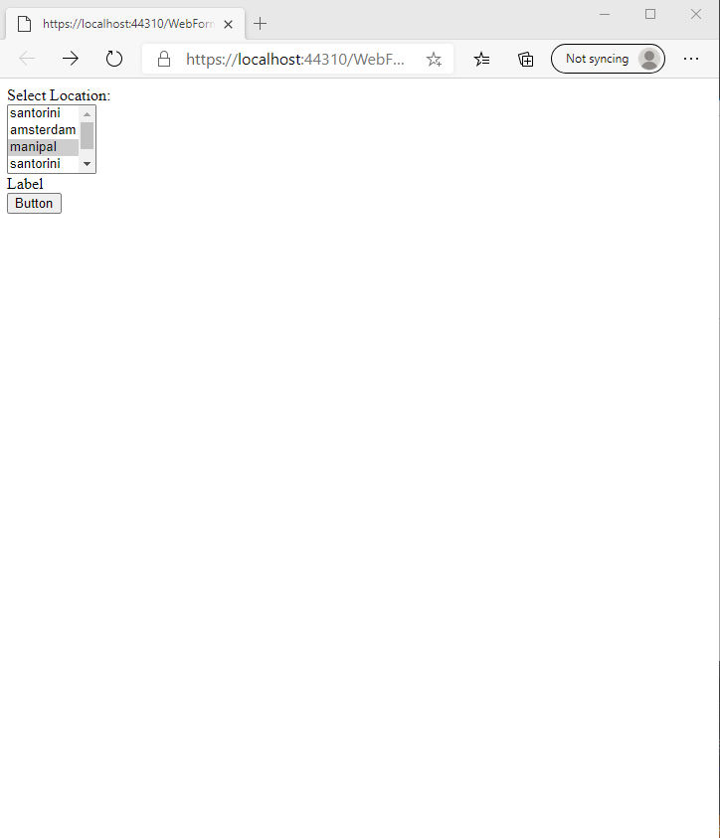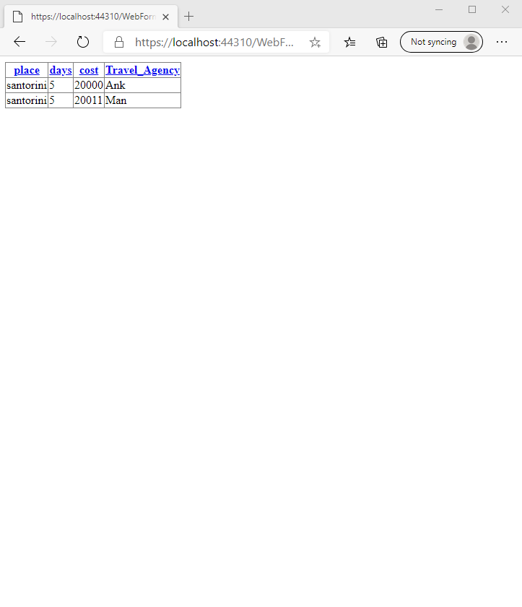

**Q3.**

**Code(aspx)**

<%@ Page Language="C#" AutoEventWireup="true" CodeBehind="WebForm1.aspx.cs" Inherits="StateCity.WebForm1" %>

<!DOCTYPE html>

<html xmlns="http://www.w3.org/1999/xhtml">

<head runat="server">

<title></title>

</head>

<body>

<form id="form1" runat="server">

Select State:

<asp:DropDownList ID="DropDownList1" runat="server" AutoPostBack="True">

</asp:DropDownList>

<div>

Select City:

<asp:DropDownList ID="DropDownList2" runat="server" DataSourceID="SqlDataSource1" DataTextField="City" DataValueField="City">

</asp:DropDownList>

<asp:SqlDataSource ID="SqlDataSource1" runat="server" ConnectionString="<%$ ConnectionStrings:statecityConnectionString %>" SelectCommand="SELECT [City] FROM [Table] WHERE ([StateId] = @StateId)">

<SelectParameters>

<asp:ControlParameter ControlID="DropDownList1" Name="StateId" PropertyName="SelectedValue" Type="Int32" />

</SelectParameters>

</asp:SqlDataSource>

</div>

</form>

</body>

</html>

**Code(aspx.cs)**

using System;

using System.Collections.Generic;

using System.Linq;

using System.Web;

using System.Web.UI;

using System.Web.UI.WebControls;

namespace StateCity

{

public partial class WebForm1 : System.Web.UI.Page

{

protected void Page_Load(object sender, EventArgs e)

{

if (!IsPostBack)

{

Dictionary<int, string> State = new Dictionary<int, string>();

State.Add(0, "Maharashtra");

State.Add(1, "Karnataka");

State.Add(2, "Rajasthan");

State.Add(3, "Tamil Nadu");

State.Add(4, "Sikkim");

DropDownList1.DataSource = State;

DropDownList1.DataTextField = "Value";

DropDownList1.DataValueField = "Key";

this.DataBind();

}

}

}

}

**Output**

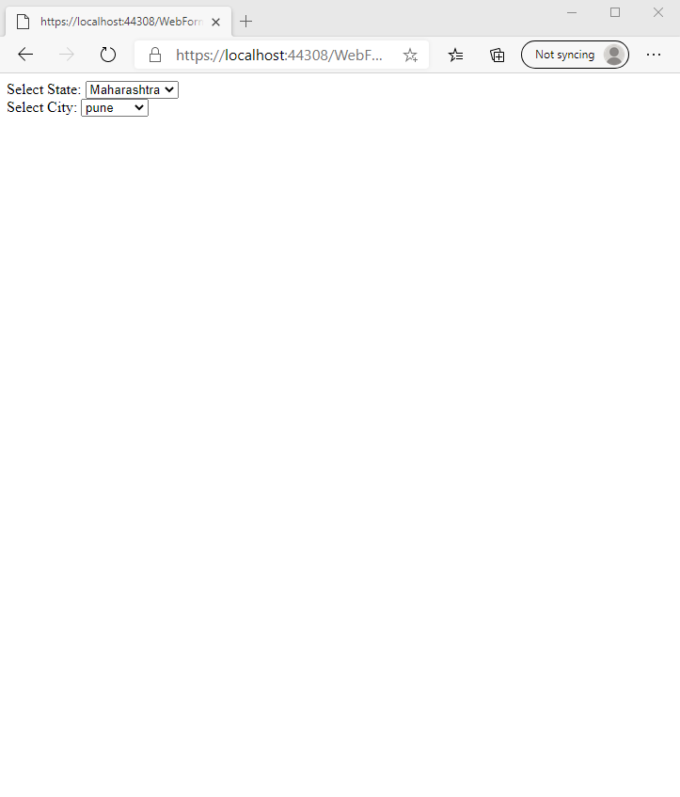

**Q4.**

**Code(.aspx)**

<%@ Page Language="C#" AutoEventWireup="true" CodeBehind="WebForm1.aspx.cs" Inherits="Legend.WebForm1" %>

<!DOCTYPE html>

<html xmlns="http://www.w3.org/1999/xhtml">

<head runat="server">

<title></title>

</head>

<body>

<form id="form1" runat="server">

Choose the genre: <asp:DropDownList ID="DropDownList1" runat="server" OnSelectedIndexChanged="Change" AutoPostBack="true"></asp:DropDownList><br />

<asp:ListBox ID="ListBox1" runat="server" OnSelectedIndexChanged="Change2" AutoPostBack="true"></asp:ListBox><br />

<asp:Label ID="Label1" runat="server"></asp:Label>

</form>

</body>

</html>

**Code(aspx.cs)**

using System;

using System.Collections.Generic;

using System.Data.SqlClient;

using System.Linq;

using System.Web;

using System.Web.UI;

using System.Web.UI.WebControls;

namespace Legend

{

public partial class WebForm1 : System.Web.UI.Page

{

protected void Page_Load(object sender, EventArgs e)

{

if (!IsPostBack)

{

Dictionary<int, string> dict = new Dictionary<int, string>();

dict.Add(0, null);

dict.Add(1, "comedy");

dict.Add(2, "romance");

dict.Add(3, "animated");

DropDownList1.DataTextField = "Value";

DropDownList1.DataValueField = "Key";

DropDownList1.DataSource = dict;

DropDownList1.DataBind();

}

}

protected void Change(object sender, EventArgs e)

{

ListBox1.Items.Clear();

SqlConnection con = new SqlConnection();

con.ConnectionString = @"Data Source=(localdb)\MSSQLlocalDB;Initial Catalog=houseKeeping1;Integrated Security=True;Connect Timeout=30;Encrypt=False;TrustServerCertificate=False;ApplicationIntent=ReadWrite;MultiSubnetFailover=False";

try

{

con.Open();

SqlCommand com = new SqlCommand("Select name from Table2 where category=@param1", con);

com.Parameters.AddWithValue("@param1",DropDownList1.SelectedItem.Text);

SqlDataReader reader = com.ExecuteReader();

while (reader.Read())

{

ListBox1.Items.Add(reader["name"].ToString());

}

}

catch (Exception ex)

{

Label1.Text = ex.ToString();

}

finally

{

con.Close();

}

}

protected void Change2(object sender, EventArgs e)

{

Label1.Text = "";

SqlConnection con = new SqlConnection();

con.ConnectionString = @"Data Source=(localdb)\MSSQLlocalDB;Initial Catalog=houseKeeping1;Integrated Security=True;Connect Timeout=30;Encrypt=False;TrustServerCertificate=False;ApplicationIntent=ReadWrite;MultiSubnetFailover=False";

try

{

con.Open();

SqlCommand com = new SqlCommand("Select name, age from Table2 where category=@cat and name=@n", con);

com.Parameters.AddWithValue("@n", ListBox1.SelectedValue);

com.Parameters.AddWithValue("@cat", DropDownList1.SelectedItem.Text);

SqlDataReader reader = com.ExecuteReader();

while (reader.Read())

{

Label1.Text += "Name: " + reader["name"].ToString() + "<br>Age: " + reader["age"];

}

}

catch (Exception ex)

{

Label1.Text = ex.ToString();

}

finally

{

con.Close();

}

}

}

}

**Output**

