**Lab8**

**Q1.**

**Code(.aspx)**

<%@ Page Language="C#" AutoEventWireup="true" CodeBehind="WebForm1.aspx.cs" Inherits="StaffGridView.WebForm1" %>

<!DOCTYPE html>

<html xmlns="http://www.w3.org/1999/xhtml">

<head runat="server">

<title></title>

</head>

<body>

<form id="form1" runat="server">

<div>

<asp:GridView ID="GridView1" runat="server" AutoGenerateColumns="False" DataKeyNames="Name" DataSourceID="SqlDataSource1" AllowSorting="True" OnRowDataBound="GridView1_RowDataBound" OnSelectedIndexChanged="GridView1_SelectedIndexChanged">

<Columns>

<asp:TemplateField HeaderText="Details" SortExpression="name">

<ItemTemplate>

<b>Name:</b>

<%# Eval("name") %>

<br />

<b>Age:</b>

<%# Eval("age") %>

</ItemTemplate>

</asp:TemplateField>

<asp:BoundField DataField="designation" HeaderText="Designation"/>

<asp:BoundField DataField="salary" HeaderText="Salary"/>

</Columns>

</asp:GridView>

<asp:SqlDataSource ID="SqlDataSource1" runat="server" ConnectionString="<%$ ConnectionStrings:TestDBConnectionString %>" SelectCommand="SELECT * FROM [Staff]"></asp:SqlDataSource>

</div>

</form>

</body>

</html>

**Code(aspx.cs)**

using System;

using System.Collections.Generic;

using System.Linq;

using System.Web;

using System.Web.UI;

using System.Web.UI.WebControls;

namespace StaffGridView

{

public partial class WebForm1 : System.Web.UI.Page

{

protected void Page_Load(object sender, EventArgs e)

{

}

protected void GridView1_SelectedIndexChanged(object sender, EventArgs e)

{

}

protected void GridView1_RowDataBound(object sender, GridViewRowEventArgs e)

{

if (e.Row.RowType == DataControlRowType.DataRow)

{

int age = (int)DataBinder.Eval(e.Row.DataItem, "Age");

if (age > 35)

{

e.Row.BackColor = System.Drawing.Color.Red;

e.Row.ForeColor = System.Drawing.Color.White;

}

}

}

}

}

**Output**

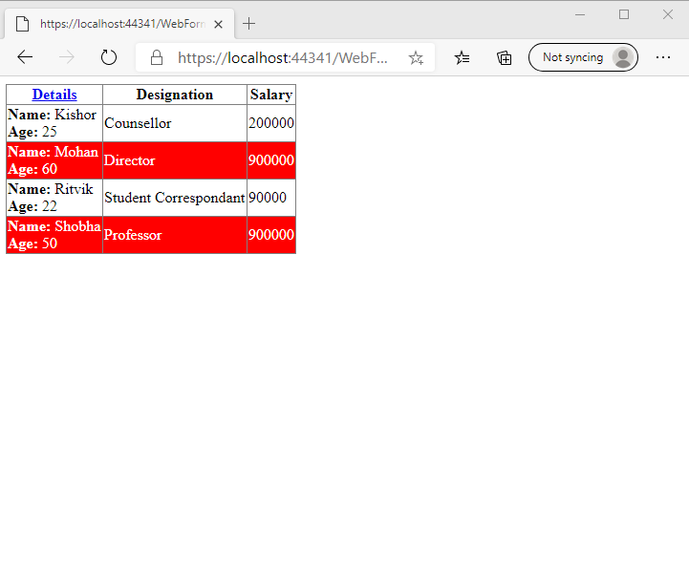

**Q2.**

**Code(.aspx)**

<%@ Page Language="C#" AutoEventWireup="true" CodeBehind="WebForm1.aspx.cs" Inherits="Author.WebForm1" %>

<!DOCTYPE html>

<html xmlns="http://www.w3.org/1999/xhtml">

<head runat="server">

<title></title>

</head>

<body>

<form id="form1" runat="server">

<div>

<asp:GridView ID="GridView1" runat="server" DataSourceID="SqlDataSource1" AllowPaging="True" AutoGenerateColumns="False" BackColor="#33CC33" DataKeyNames="Id" ForeColor="Red" OnSelectedIndexChanged="GridView1_SelectedIndexChanged" PageSize="3">

<Columns>

<asp:CommandField ShowEditButton="True" />

<asp:TemplateField HeaderText="Id" SortExpression="Id">

<EditItemTemplate>

<asp:Label ID="Label1" runat="server" Text='<%# Eval("Id") %>'></asp:Label>

</EditItemTemplate>

<ItemTemplate>

<asp:Label ID="Label3" runat="server" Text='<%# Bind("Id") %>'></asp:Label>

</ItemTemplate>

</asp:TemplateField>

<asp:TemplateField HeaderText="Name" SortExpression="first_name">

<EditItemTemplate>

First Name :

<asp:TextBox ID="TextBox2" runat="server" Text='<%# Bind("first_name") %>'></asp:TextBox>

<br />

Last Name :

<asp:TextBox ID="TextBox3" runat="server" Text='<%# Bind("last_name") %>'></asp:TextBox>

</EditItemTemplate>

<ItemTemplate>

First Name :

<asp:Label ID="Label1" runat="server" Text='<%# Eval("first_name") %>'></asp:Label>

<br />

Last Name :

<asp:Label ID="Label2" runat="server" Text='<%# Eval("last_name") %>'></asp:Label>

</ItemTemplate>

</asp:TemplateField>

<asp:TemplateField HeaderText="Title" SortExpression="book_title">

<EditItemTemplate>

<asp:Label ID="Label4" runat="server" Text='<%# Bind("book_title") %>'></asp:Label>

</EditItemTemplate>

<ItemTemplate>

<asp:Label ID="Label4" runat="server" Text='<%# Bind("book_title") %>'></asp:Label>

</ItemTemplate>

</asp:TemplateField>

<asp:TemplateField HeaderText="genre" SortExpression="genre">

<EditItemTemplate>

<asp:Label ID="Label5" runat="server" Text='<%# Bind("genre") %>'></asp:Label>

</EditItemTemplate>

<ItemTemplate>

<asp:Label ID="Label5" runat="server" Text='<%# Bind("genre") %>'></asp:Label>

</ItemTemplate>

</asp:TemplateField>

<asp:TemplateField HeaderText="copies_sold" SortExpression="copies_sold">

<EditItemTemplate>

<asp:TextBox ID="TextBox5" runat="server" Text='<%# Bind("copies_sold") %>'></asp:TextBox>

</EditItemTemplate>

<ItemTemplate>

<asp:Label ID="Label6" runat="server" Text='<%# Bind("copies_sold") %>'></asp:Label>

</ItemTemplate>

</asp:TemplateField>

</Columns>

</asp:GridView>

<asp:SqlDataSource ID="SqlDataSource1" runat="server" ConnectionString="<%$ ConnectionStrings:TestDBConnectionString %>" SelectCommand="SELECT * FROM [Authors]"></asp:SqlDataSource>

</div>

</form>

</body>

</html>

**Output**:

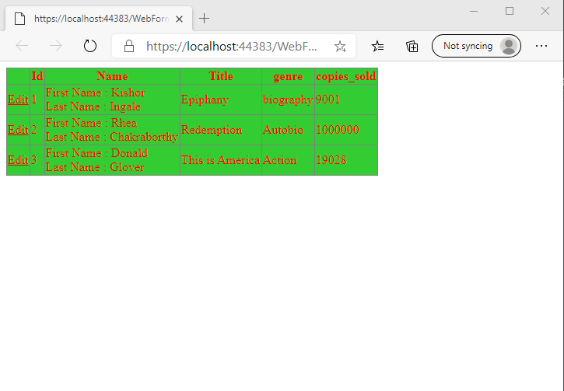

**Q3.**

**Code(aspx.cs)**

using System;

using System.Collections.Generic;

using System.IO;

using System.Linq;

using System.Web;

using System.Web.UI;

using System.Web.UI.WebControls;

using System.Xml.Linq;

namespace CarXml

{

public partial class WebForm1 : System.Web.UI.Page

{

protected void Page_Load(object sender, EventArgs e)

{

if (!this.IsPostBack)

{

string file = Path.Combine(Request.PhysicalApplicationPath, @"C:\Users\IT_Lab\Downloads\Cars.xml");

XDocument doc = new XDocument(

new XDeclaration("1.0", null, "yes"),

new XElement("Cars",

new XElement("Detail", new XElement("Name", "I20"), new XElement("Make", "Hyundai"), new XElement("Price", "700000")),

new XElement("Detail", new XElement("Name", "I10"), new XElement("Make", "Hyundai"), new XElement("Price", "600000"))));

doc.Save(file);

}

}

}

}

**Output**:

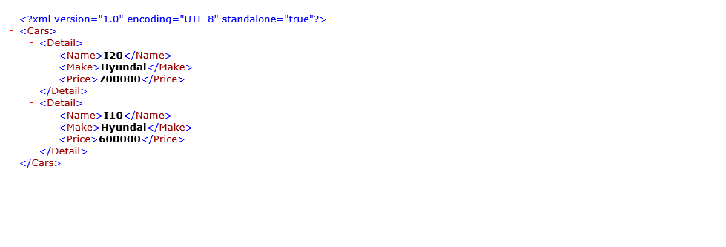

**Q4.**

**Code(.aspx)**

<%@ Page Language="C#" AutoEventWireup="true" CodeBehind="WebForm1.aspx.cs" Inherits="ProductAdd.WebForm1" %>

<!DOCTYPE html>

<html xmlns="http://www.w3.org/1999/xhtml">

<head runat="server">

<title></title>

</head>

<body>

<form id="form1" runat="server">

<div style="height: 319px">

<asp:GridView ID="GridView1" runat="server" DataSourceID="SqlDataSource1" AutoGenerateColumns="false" AllowSorting="true" DataKeyNames="id">

<Columns>

<asp:BoundField DataField="id" HeaderText="Id" ReadOnly="true" SortExpression="id"/>

<asp:TemplateField HeaderText="Name" SortExpression="name">

<ItemTemplate>

<b>Name:</b>

<%# Eval("name") %>

</ItemTemplate>

<EditItemTemplate>

<b>Name:</b>

<asp:TextBox ID="TextBox2" runat="server" Text='<%# Bind("name") %>'></asp:TextBox>

<asp:RequiredFieldValidator ID="RequiredFieldValidator1" runat="server" ErrorMessage="Name is required" EnableClientScript="false" ControlToValidate="TextBox2"></asp:RequiredFieldValidator>

</EditItemTemplate>

</asp:TemplateField>

<asp:TemplateField HeaderText="Details">

<ItemTemplate>

<b>Price:</b>

<%# Eval("price") %>

<br />

<br />

<b>Quantity:</b>

<%# Eval("quantity") %>

</ItemTemplate>

<EditItemTemplate>

<b>Price:</b>

<%# Eval("price") %>

<br />

<br />

<b>Quantity</b>

<asp:TextBox ID="TextBox1" runat="server" Text='<%# Bind("quantity") %>'></asp:TextBox>

<asp:RangeValidator ID="RangeValidator1" runat="server" ErrorMessage="Quantity should be between 1 and 20" ControlToValidate="TextBox1" EnableClientScript="false" Type="Integer" MinimumValue="1" MaximumValue="20"></asp:RangeValidator>

</EditItemTemplate>

</asp:TemplateField>

<asp:CommandField ShowEditButton="true"/>

</Columns>

</asp:GridView>

<asp:SqlDataSource ID="SqlDataSource1" runat="server" ConnectionString="Data Source=(localdb)\MSSQLLocalDB;Initial Catalog=TestDB;Integrated Security=True;Pooling=False" SelectCommand="SELECT * FROM Product" UpdateCommand="UPDATE Product SET quantity=@quantity,name=@name WHERE id=@id"></asp:SqlDataSource>

</div>

</form>

</body>

</html>

**Output**

