ConRR R Markdown Template

Your Name Here

2025-10-18

Table of Contents

# Main Heading

This template should help you with the basics of R Markdown: text, code “chunks”, in-line code, plots and tables. It is easy to make lists, for example

* Make a list
* Check it twice
* Find out who’s naughty and nice
* Come to town

Here is some text: just type the same way as you would type in Word. Directly below this text, there is a code “chunk”, where you can type R code:

# This is a chunk: your R code goes in here just like a regular R script:  
scores <- c(5, 3, 6, 8, 10)  
m <- mean(scores)  
m

## [1] 6.4

pacman::p_load(rio, here, ggplot)

## Installing package into 'C:/Users/tekle/AppData/Local/R/win-library/4.5'  
## (as 'lib' is unspecified)

## Warning: package 'ggplot' is not available for this version of R  
##   
## A version of this package for your version of R might be available elsewhere,  
## see the ideas at  
## https://cran.r-project.org/doc/manuals/r-patched/R-admin.html#Installing-packages

## Warning: unable to access index for repository http://www.stats.ox.ac.uk/pub/RWin/bin/windows/contrib/4.5:  
## cannot open URL 'http://www.stats.ox.ac.uk/pub/RWin/bin/windows/contrib/4.5/PACKAGES'

## Warning in p_install(package, character.only = TRUE, ...):

## Warning in library(package, lib.loc = lib.loc, character.only = TRUE,  
## logical.return = TRUE, : there is no package called 'ggplot'

## Warning in pacman::p_load(rio, here, ggplot): Failed to install/load:  
## ggplot

films <- import(here('1_data/films.csv'))   
  
head(films)

## V1 tconst averageRating numVotes titleType primaryTitle  
## 1 1 tt0252994 8.0 16 short Climbing Jacob's Ladder  
## 2 2 tt2369678 6.0 9 tvMovie In Sickness and in Health  
## 3 3 tt0069282 6.2 1023 movie Slither  
## 4 4 tt1861338 8.2 8 short God Bless the Child  
## 5 5 tt0821815 6.6 16 tvMovie Westward Ho!  
## 6 6 tt0047180 7.7 424 movie Liliomfi  
## originalTitle startYear endYear runtimeMinutes  
## 1 Climbing Jacob's Ladder 1899 \\N \\N  
## 2 In Sickness and in Health 2012 \\N 88  
## 3 Slither 1973 \\N 97  
## 4 God Bless the Child 2011 \\N 3  
## 5 Westward Ho! 1988 \\N 55  
## 6 Liliomfi 1955 \\N 109  
## genres  
## 1 Documentary,Short  
## 2 Family  
## 3 Comedy,Crime,Thriller  
## 4 Comedy,Short  
## 5 Adventure,Animation,Comedy  
## 6 Comedy

ave.vot<- ggplot(data = films, mapping = aes(x = averageRating, y = numVotes))+  
 geom_point()+  
 labs(title = 'Relationship between the number of votes and average rate of the films',  
 x = 'Average Rating',  
 y = 'Number of votes',  
 caption = 'Source: Films data set')

## Sub-heading: chunk options

By default, knitr will show both your code and the output in the resulting document. You can use chunk options to change this behaviour. They work like R command arguments. First, tell knitr to not show the code, by using echo=FALSE:

## [1] 6.4

Second, tell knitr to not show the output, using results='hide:

scores <- c(5, 3, 6, 8, 10)  
the.mean <- mean(scores)  
the.mean

You can also tell knitr to not run the code at all, using eval=FALSE:

scores10 <- c(5, 3, 6, 8, 10, 3, 6, 12, 4, 9)  
mean(scores10)

Instead of setting these options in every chunk, you can set options at the beginning that will then be in place for every chunk. We call this a “global” chunk option, and we do this in the very first chunk in this document where we set echo=TRUE using the line knitr::opts_chunk$set(echo = TRUE).

A useful aspect of R Markdown is that, in the text, you can use objects that you’ve created inside the chunks. For example, the mean of scores is 6.4. You can even run little bits of code inside the text: the sum of the five scores is 32, for example.

## Sub-heading: plots

You can run code that creates plots, and knitr will show them by default:

myplot <- ggplot(data=diamonds, aes(x=cut, y=price, fill=color)) +  
 geom_bar(stat="identity")+  
 scale_fill_brewer(palette="Set3")  
myplot

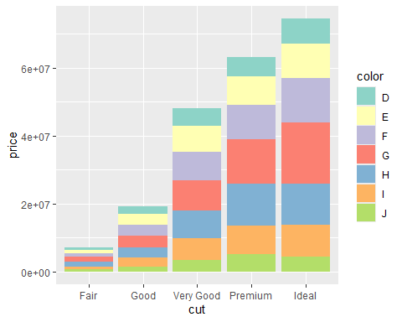

### Sub-sub-heading: chunk options for plots

There are also chunk options that let you alter your plot, such as specifying the dimensions:

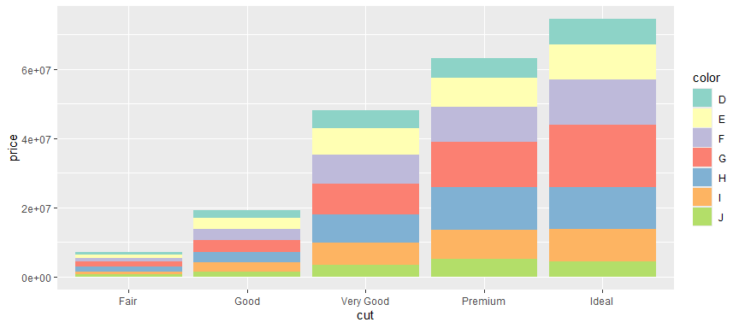

## Tables

### kable: for basic tables

The kable command is a fast way to create tables. Here is the simple output of R without using any commands:

tab <- head(diamonds[, 1:7])  
tab

## # A tibble: 6 × 7  
## carat cut color clarity depth table price  
## <dbl> <ord> <ord> <ord> <dbl> <dbl> <int>  
## 1 0.23 Ideal E SI2 61.5 55 326  
## 2 0.21 Premium E SI1 59.8 61 326  
## 3 0.23 Good E VS1 56.9 65 327  
## 4 0.29 Premium I VS2 62.4 58 334  
## 5 0.31 Good J SI2 63.3 58 335  
## 6 0.24 Very Good J VVS2 62.8 57 336

Now using kable:

kable(tab)

| carat | cut | color | clarity | depth | table | price |
| --- | --- | --- | --- | --- | --- | --- |
| 0.23 | Ideal | E | SI2 | 61.5 | 55 | 326 |
| 0.21 | Premium | E | SI1 | 59.8 | 61 | 326 |
| 0.23 | Good | E | VS1 | 56.9 | 65 | 327 |
| 0.29 | Premium | I | VS2 | 62.4 | 58 | 334 |
| 0.31 | Good | J | SI2 | 63.3 | 58 | 335 |
| 0.24 | Very Good | J | VVS2 | 62.8 | 57 | 336 |

The kable command has arguments for altering how the table looks, including changing the column names, alignment, captions, rounding, and more.

better.colnames <- c("Carat", "Cut", "Colour", "Clarity", "Depth(%)", "Relative width", "Price($)")  
better.tab <- kable(tab,  
 col.names = better.colnames,  
 align = c("rcccrrr"),  
 caption = "My sensible caption")  
better.tab

My sensible caption

| Carat | Cut | Colour | Clarity | Depth(%) | Relative width | Price($) |
| --- | --- | --- | --- | --- | --- | --- |
| 0.23 | Ideal | E | SI2 | 61.5 | 55 | 326 |
| 0.21 | Premium | E | SI1 | 59.8 | 61 | 326 |
| 0.23 | Good | E | VS1 | 56.9 | 65 | 327 |
| 0.29 | Premium | I | VS2 | 62.4 | 58 | 334 |
| 0.31 | Good | J | SI2 | 63.3 | 58 | 335 |
| 0.24 | Very Good | J | VVS2 | 62.8 | 57 | 336 |

More details on kable here: <https://bookdown.org/yihui/rmarkdown-cookbook/kable.html>