Tushare 股票数据可视化分析实验
基于 Tushare 的数据获取、分析、可视化与实验报告
生成时间：2026-04-01 16:54:39

一、实验说明
本实验依据用户提供的作业细则完成。由于原始语雀页面外部访问返回 403，本报告以用户消息中给出的题目要求为准。数据来源为 Tushare Pro 日线行情接口。
实验对象概览
项目 | 内容
题目一 | 贵州茅台（600519.SH）2025 年日线行情
题目二 | 中国平安、比亚迪、贵州茅台 2025 年收益率对比
题目三 | 比亚迪 最近 1 年均线趋势与交易信号分析

二、题目一：单只股票日线行情分析与可视化
对研究股票按交易日期升序排序后进行缺失值和重复值检查，并统计收盘价与成交量特征。
清洗与统计结果
项目 | 内容
股票 | 贵州茅台（600519.SH）
记录数 | 243
重复值数量 | 0
缺失值单元格数量 | 0
收盘价均值 | 1476.08
收盘价标准差 | 58.98
成交量均值 | 32,873.50
最高收盘价 | 1637.86
最低收盘价 | 1377.18
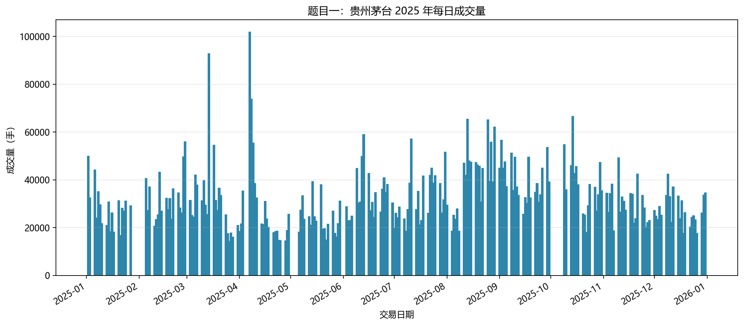
图 1 题目一每日成交量柱状图
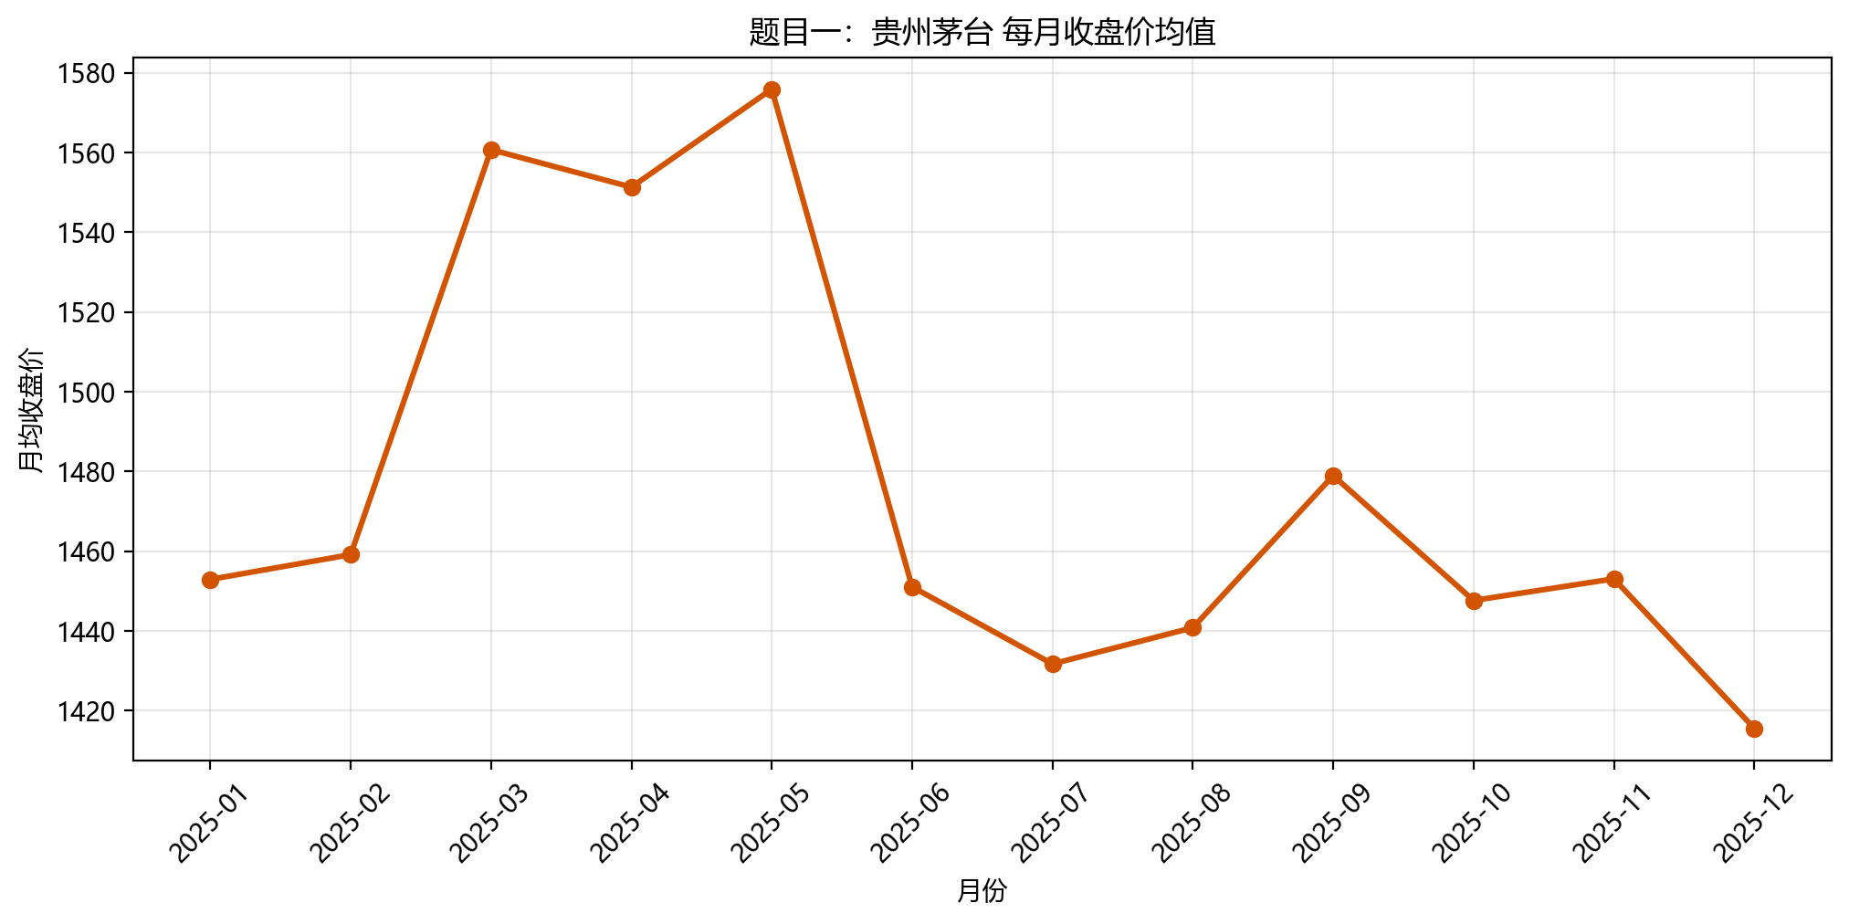
图 2 题目一每月收盘价均值折线图

三、题目二：多只股票收益率对比分析
选择金融、汽车新能源、食品饮料三类风格不同的股票，对 2025 年累计收益率进行比较，并展示其中一只股票的短中期均线变化。
最终累计收益率
项目 | 内容
中国平安 (601318.SH) | 34.88%
比亚迪 (002594.SZ) | -63.95%
贵州茅台 (600519.SH) | -7.45%
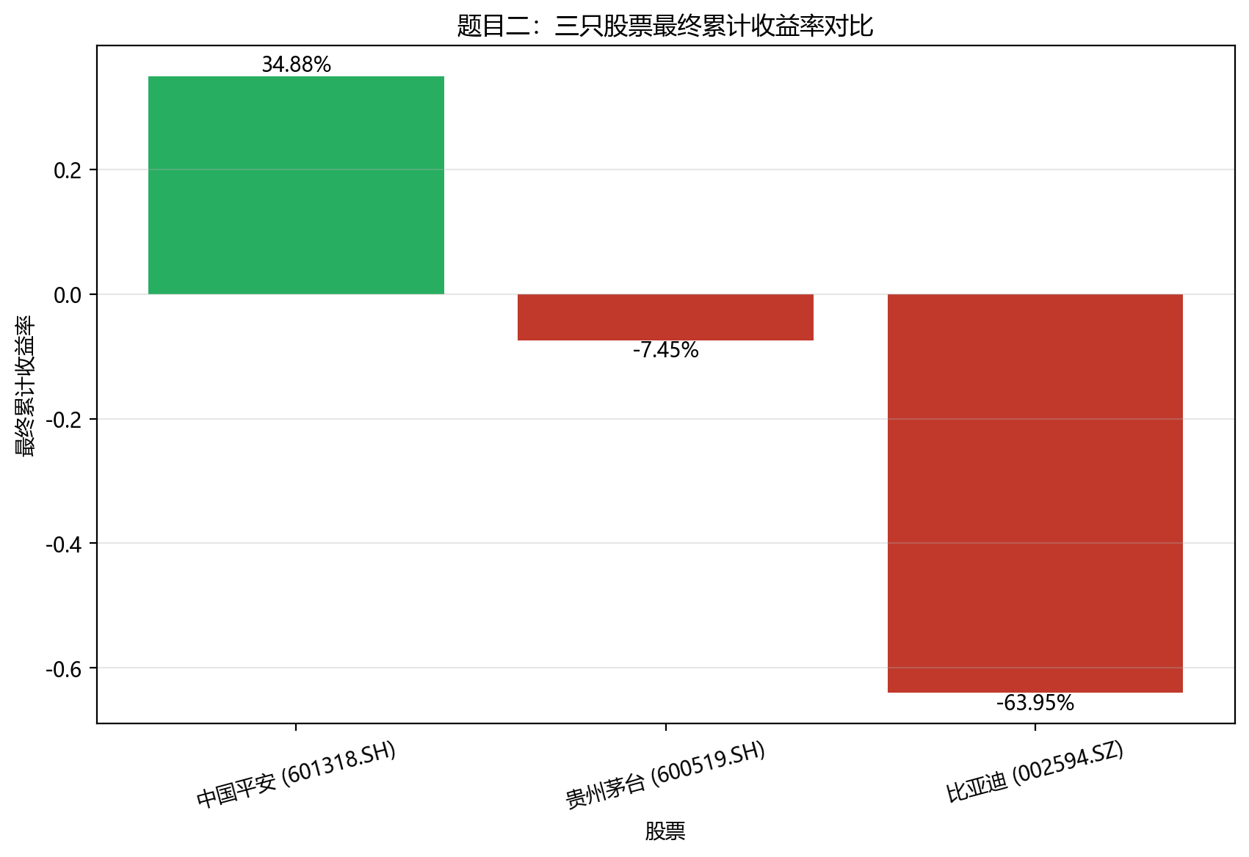
图 3 三只股票最终累计收益率柱状图
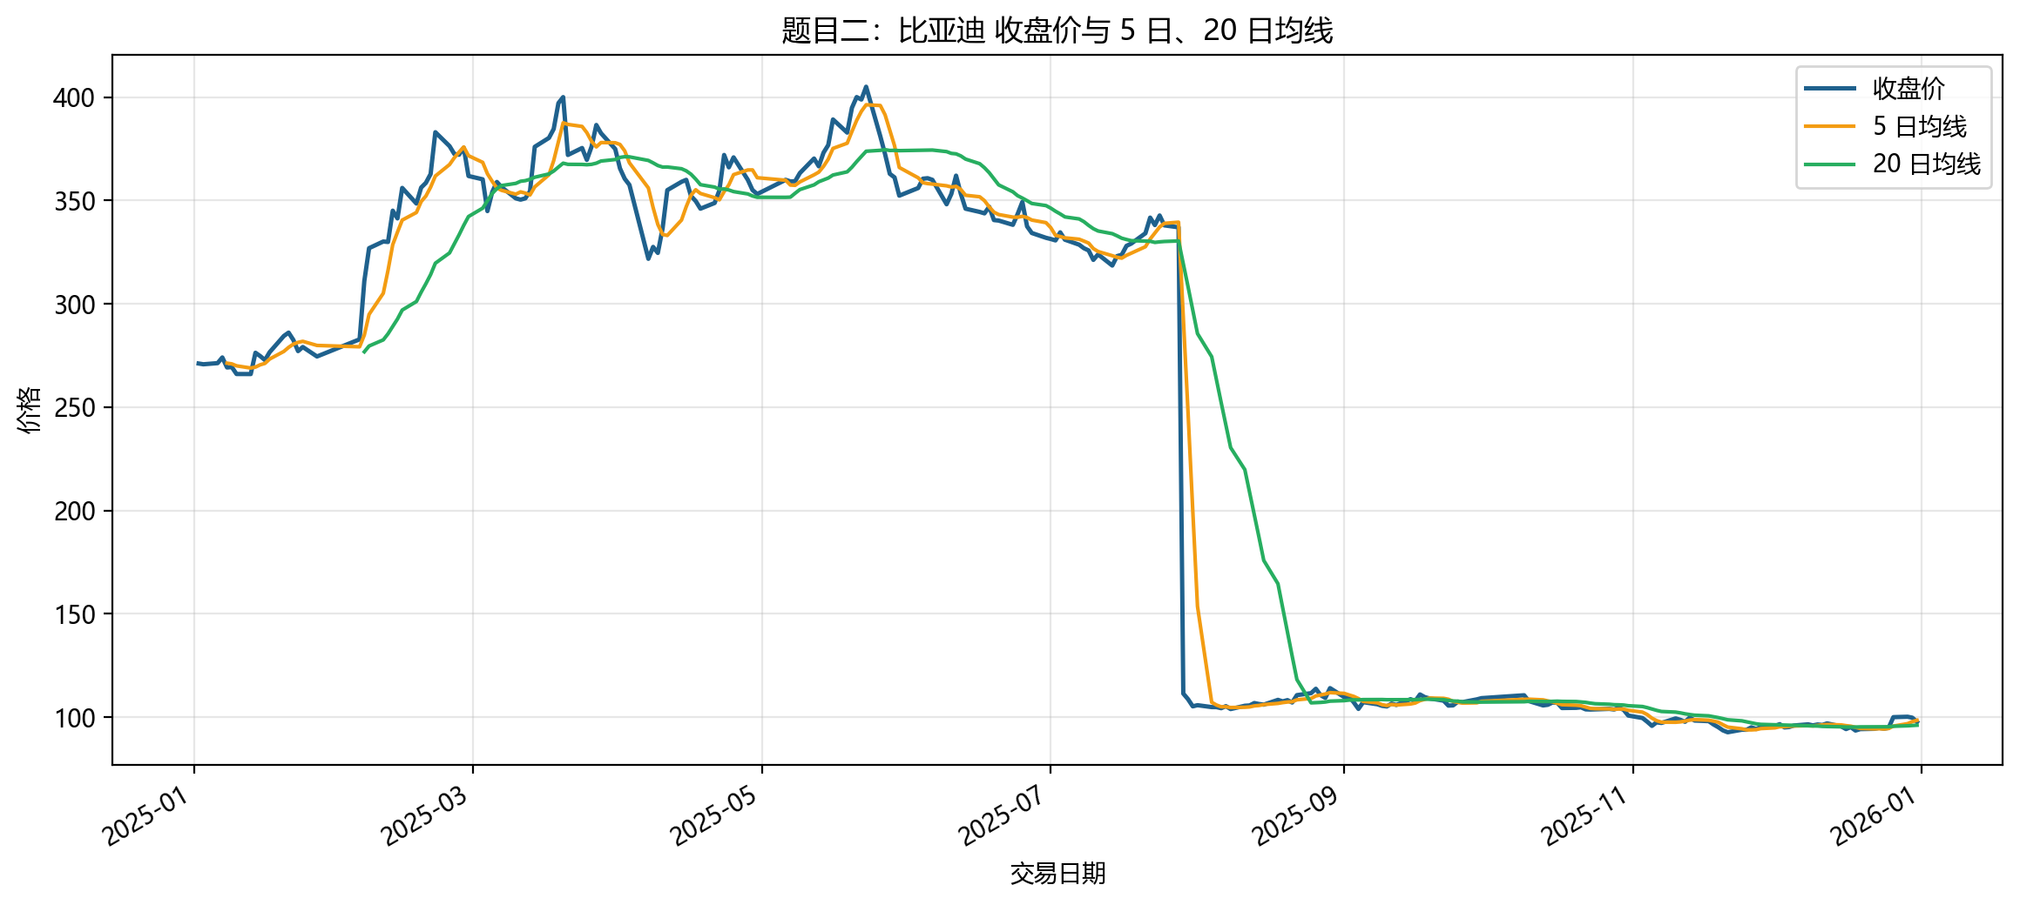
图 4 任选股票收盘价与 5 日、20 日均线图

四、题目三：趋势识别与简单交易信号分析
采用 5 日均线上穿 20 日均线作为买入信号，下穿 20 日均线作为卖出信号，并使用滞后一日持仓计算策略收益。
策略指标
项目 | 内容
股票 | 比亚迪（002594.SZ）
买入信号数 | 8
卖出信号数 | 8
股票累计收益率 | -71.92%
策略累计收益率 | -71.22%
最大回撤 | -73.83%
完整交易次数 | 7
盈利交易次数 | 0
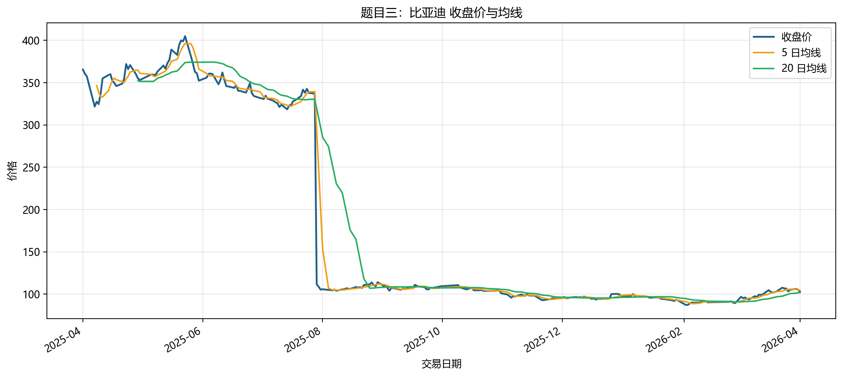
图 5 收盘价与 5 日、20 日均线图
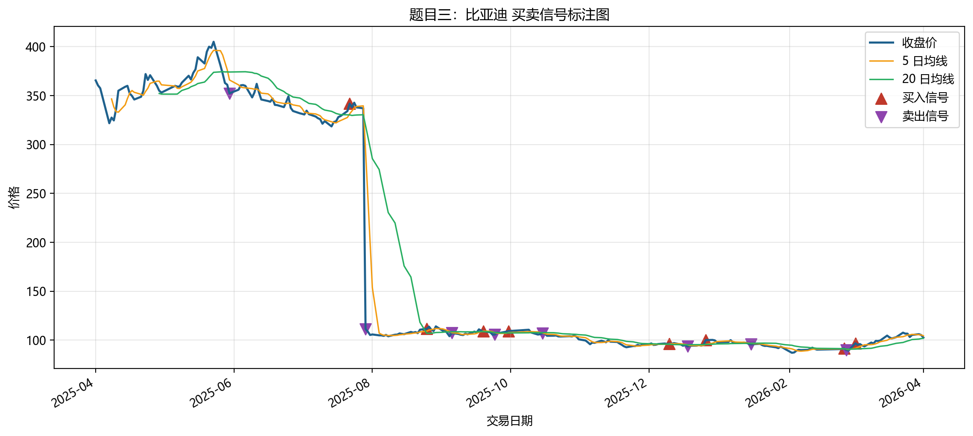
图 6 买卖信号标注图
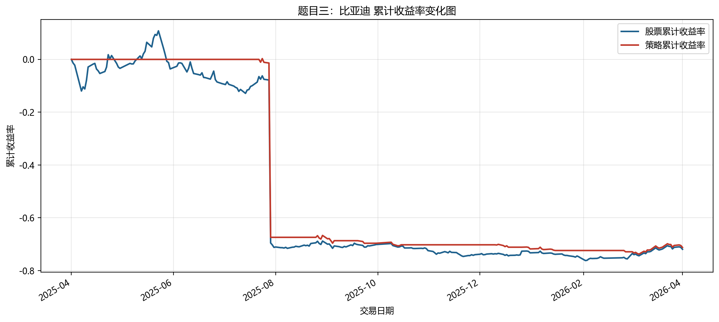
图 7 累计收益率变化图
结果分析：
- 研究区间内共出现 8 次买入信号、8 次卖出信号，完成 7 笔完整交易，盈利交易占比约为 0.00%。
- 股票自身累计收益率为 -71.92%，均线策略累计收益率为 -71.22%，两者差值为 0.69%。
- 策略累计收益序列的最大回撤约为 -73.83%，说明在震荡行情中仍可能出现较明显回撤。
- 该规则优点是逻辑简单、易于实现，能够在趋势形成后跟随价格方向，适合用作技术分析入门示例。
- 局限在于均线信号具有滞后性，横盘震荡时容易频繁触发买卖，且未考虑交易成本、滑点和仓位管理。

五、代码附录
按照提交要求，以下附上本实验核心代码文件。

代码附录：src\config.py
from __future__ import annotations
import os
from dataclasses import dataclass, field
from datetime import date, timedelta
from pathlib import Path
from dotenv import load_dotenv
BASE_DIR = Path(__file__).resolve().parent.parent
DOCS_DIR = BASE_DIR / "docs"
OUTPUTS_DIR = BASE_DIR / "outputs"
CHARTS_DIR = OUTPUTS_DIR / "charts"
DATA_DIR = OUTPUTS_DIR / "data"
REPORT_DIR = OUTPUTS_DIR / "report"
@dataclass(frozen=True)
class StockInfo:
ts_code: str
name: str
industry: str
@dataclass(frozen=True)
class Settings:
project_title: str = "Tushare 股票数据可视化分析实验"
token: str = ""
task1_stock: StockInfo = StockInfo("600519.SH", "贵州茅台", "食品饮料")
task2_stocks: tuple[StockInfo, ...] = (
StockInfo("601318.SH", "中国平安", "金融保险"),
StockInfo("002594.SZ", "比亚迪", "汽车新能源"),
StockInfo("600519.SH", "贵州茅台", "食品饮料"),
)
task3_stock: StockInfo = StockInfo("002594.SZ", "比亚迪", "汽车新能源")
task1_start: str = "20250101"
task1_end: str = "20251231"
task2_start: str = "20250101"
task2_end: str = "20251231"
task3_start: str = field(
default_factory=lambda: (date.today() - timedelta(days=365)).strftime("%Y%m%d")
)
task3_end: str = field(default_factory=lambda: date.today().strftime("%Y%m%d"))
def ensure_directories() -> None:
for path in (DOCS_DIR, OUTPUTS_DIR, CHARTS_DIR, DATA_DIR, REPORT_DIR):
path.mkdir(parents=True, exist_ok=True)
def load_settings() -> Settings:
load_dotenv()
token = os.getenv("TUSHARE_TOKEN", "").strip()
settings = Settings(token=token)
ensure_directories()
return settings

代码附录：src\analysis.py
from __future__ import annotations
import json
import time
from dataclasses import dataclass
from pathlib import Path
import matplotlib
matplotlib.use("Agg")
import matplotlib.dates as mdates
import matplotlib.pyplot as plt
import numpy as np
import pandas as pd
import tushare as ts
from src.config import CHARTS_DIR, DATA_DIR, Settings, StockInfo
plt.rcParams["font.sans-serif"] = ["Microsoft YaHei", "SimHei", "DejaVu Sans"]
plt.rcParams["axes.unicode_minus"] = False
@dataclass(frozen=True)
class Task1Result:
stock: StockInfo
cleaned_data_file: Path
monthly_mean_file: Path
volume_chart: Path
monthly_chart: Path
summary_file: Path
total_rows: int
duplicate_rows: int
missing_cells: int
closing_price_mean: float
closing_price_std: float
volume_mean: float
highest_close: float
lowest_close: float
@dataclass(frozen=True)
class Task2Result:
stocks: tuple[StockInfo, ...]
combined_data_file: Path
final_return_file: Path
cumulative_return_bar_chart: Path
ma_chart: Path
final_returns: dict[str, float]
@dataclass(frozen=True)
class Task3Result:
stock: StockInfo
signal_data_file: Path
metrics_file: Path
ma_chart: Path
signal_chart: Path
cumulative_return_chart: Path
buy_signals: int
sell_signals: int
stock_cumulative_return: float
strategy_cumulative_return: float
max_drawdown: float
completed_trades: int
profitable_trades: int
analysis_text: list[str]
@dataclass(frozen=True)
class AnalysisBundle:
task1: Task1Result
task2: Task2Result
task3: Task3Result
master_summary_file: Path
def _slugify_stock(stock: StockInfo) -> str:
return f"{stock.ts_code}_{stock.name}".replace(".", "_")
def _save_figure(fig: plt.Figure, path: Path) -> Path:
path.parent.mkdir(parents=True, exist_ok=True)
fig.savefig(path, dpi=200, bbox_inches="tight")
plt.close(fig)
return path
def _calculate_max_drawdown(cumulative_series: pd.Series) -> float:
wealth = (1 + cumulative_series.fillna(0)).cummax()
drawdown = (1 + cumulative_series.fillna(0)) / wealth - 1
return float(drawdown.min())
def _count_completed_trades(df: pd.DataFrame) -> tuple[int, int]:
buy_dates = df.index[df["signal"] == 1].tolist()
sell_dates = df.index[df["signal"] == -1].tolist()
completed = 0
profitable = 0
sell_pointer = 0
for buy_date in buy_dates:
while sell_pointer < len(sell_dates) and sell_dates[sell_pointer] <= buy_date:
sell_pointer += 1
if sell_pointer >= len(sell_dates):
break
sell_date = sell_dates[sell_pointer]
buy_price = float(df.loc[buy_date, "close"])
sell_price = float(df.loc[sell_date, "close"])
completed += 1
if sell_price > buy_price:
profitable += 1
sell_pointer += 1
return completed, profitable
class TushareAnalyzer:
def __init__(self, settings: Settings) -> None:
self.settings = settings
self.pro = ts.pro_api(settings.token)
def run_all(self) -> AnalysisBundle:
task1 = self.run_task1()
task2 = self.run_task2()
task3 = self.run_task3()
master_summary = self._write_master_summary(task1, task2, task3)
return AnalysisBundle(
task1=task1,
task2=task2,
task3=task3,
master_summary_file=master_summary,
)
def fetch_daily_data(self, stock: StockInfo, start_date: str, end_date: str) -> pd.DataFrame:
frame = self.pro.daily(ts_code=stock.ts_code, start_date=start_date, end_date=end_date)
if frame.empty:
raise ValueError(
f"Tushare 未返回数据：{stock.name} ({stock.ts_code}) {start_date} - {end_date}"
)
time.sleep(0.2)
return frame
@staticmethod
def clean_daily_data(frame: pd.DataFrame) -> tuple[pd.DataFrame, int, int]:
cleaned = frame.copy()
duplicate_rows = int(cleaned.duplicated(subset=["trade_date"]).sum())
cleaned = cleaned.drop_duplicates(subset=["trade_date"]).copy()
cleaned["trade_date"] = pd.to_datetime(cleaned["trade_date"], format="%Y%m%d")
cleaned = cleaned.sort_values("trade_date").reset_index(drop=True)
missing_cells = int(cleaned.isna().sum().sum())
return cleaned, duplicate_rows, missing_cells
@staticmethod
def add_indicators(frame: pd.DataFrame) -> pd.DataFrame:
enriched = frame.copy()
enriched["daily_return"] = enriched["close"].pct_change().fillna(0)
enriched["cumulative_return"] = (1 + enriched["daily_return"]).cumprod() - 1
enriched["ma5"] = enriched["close"].rolling(window=5).mean()
enriched["ma20"] = enriched["close"].rolling(window=20).mean()
enriched["month"] = enriched["trade_date"].dt.to_period("M").astype(str)
return enriched
def run_task1(self) -> Task1Result:
stock = self.settings.task1_stock
raw = self.fetch_daily_data(stock, self.settings.task1_start, self.settings.task1_end)
cleaned, duplicate_rows, missing_cells = self.clean_daily_data(raw)
enriched = self.add_indicators(cleaned)
data_file = DATA_DIR / f"task1_{_slugify_stock(stock)}_cleaned.csv"
monthly_file = DATA_DIR / f"task1_{_slugify_stock(stock)}_monthly_mean.csv"
summary_file = DATA_DIR / f"task1_{_slugify_stock(stock)}_summary.json"
enriched.to_csv(data_file, index=False, encoding="utf-8-sig")
monthly_mean = (
enriched.groupby("month", as_index=False)["close"].mean().rename(
columns={"close": "monthly_close_mean"}
)
)
monthly_mean.to_csv(monthly_file, index=False, encoding="utf-8-sig")
volume_chart = self._plot_task1_volume(stock, enriched)
monthly_chart = self._plot_task1_monthly_mean(stock, monthly_mean)
summary = {
"stock_name": stock.name,
"stock_code": stock.ts_code,
"total_rows": int(len(enriched)),
"duplicate_rows": duplicate_rows,
"missing_cells": missing_cells,
"closing_price_mean": float(enriched["close"].mean()),
"closing_price_std": float(enriched["close"].std(ddof=1)),
"volume_mean": float(enriched["vol"].mean()),
"highest_close": float(enriched["close"].max()),
"lowest_close": float(enriched["close"].min()),
}
summary_file.write_text(json.dumps(summary, ensure_ascii=False, indent=2), encoding="utf-8")
return Task1Result(
stock=stock,
cleaned_data_file=data_file,
monthly_mean_file=monthly_file,
volume_chart=volume_chart,
monthly_chart=monthly_chart,
summary_file=summary_file,
total_rows=summary["total_rows"],
duplicate_rows=duplicate_rows,
missing_cells=missing_cells,
closing_price_mean=summary["closing_price_mean"],
closing_price_std=summary["closing_price_std"],
volume_mean=summary["volume_mean"],
highest_close=summary["highest_close"],
lowest_close=summary["lowest_close"],
)
def run_task2(self) -> Task2Result:
combined_frames: list[pd.DataFrame] = []
final_returns: dict[str, float] = {}
for stock in self.settings.task2_stocks:
raw = self.fetch_daily_data(stock, self.settings.task2_start, self.settings.task2_end)
cleaned, _, _ = self.clean_daily_data(raw)
enriched = self.add_indicators(cleaned)
enriched["stock_name"] = stock.name
enriched["industry"] = stock.industry
final_returns[f"{stock.name} ({stock.ts_code})"] = float(enriched["cumulative_return"].iloc[-1])
combined_frames.append(enriched)
stock_file = DATA_DIR / f"task2_{_slugify_stock(stock)}_cleaned.csv"
enriched.to_csv(stock_file, index=False, encoding="utf-8-sig")
combined = pd.concat(combined_frames, ignore_index=True)
combined_data_file = DATA_DIR / "task2_combined_stock_data.csv"
combined.to_csv(combined_data_file, index=False, encoding="utf-8-sig")
final_return_frame = pd.DataFrame(
{
"stock": list(final_returns.keys()),
"final_cumulative_return": list(final_returns.values()),
}
).sort_values("final_cumulative_return", ascending=False)
final_return_file = DATA_DIR / "task2_final_cumulative_returns.csv"
final_return_frame.to_csv(final_return_file, index=False, encoding="utf-8-sig")
cumulative_return_bar_chart = self._plot_task2_cumulative_return_bar(final_return_frame)
ma_target = self.settings.task3_stock
ma_frame = combined.loc[combined["ts_code"] == ma_target.ts_code].copy()
ma_chart = self._plot_ma_chart(
stock=ma_target,
frame=ma_frame,
path=CHARTS_DIR / f"task2_{_slugify_stock(ma_target)}_ma_chart.png",
title=f"题目二：{ma_target.name} 收盘价与 5 日、20 日均线",
)
return Task2Result(
stocks=self.settings.task2_stocks,
combined_data_file=combined_data_file,
final_return_file=final_return_file,
cumulative_return_bar_chart=cumulative_return_bar_chart,
ma_chart=ma_chart,
final_returns=final_returns,
)
def run_task3(self) -> Task3Result:
stock = self.settings.task3_stock
raw = self.fetch_daily_data(stock, self.settings.task3_start, self.settings.task3_end)
cleaned, _, _ = self.clean_daily_data(raw)
enriched = self.add_indicators(cleaned)
enriched = self._build_signals(enriched)
signal_data_file = DATA_DIR / f"task3_{_slugify_stock(stock)}_signals.csv"
metrics_file = DATA_DIR / f"task3_{_slugify_stock(stock)}_metrics.json"
enriched.to_csv(signal_data_file, index=False, encoding="utf-8-sig")
ma_chart = self._plot_ma_chart(
stock=stock,
frame=enriched,
path=CHARTS_DIR / f"task3_{_slugify_stock(stock)}_ma_chart.png",
title=f"题目三：{stock.name} 收盘价与均线",
)
signal_chart = self._plot_signal_chart(stock, enriched)
cumulative_return_chart = self._plot_task3_cumulative_return_chart(stock, enriched)
buy_signals = int((enriched["signal"] == 1).sum())
sell_signals = int((enriched["signal"] == -1).sum())
stock_return = float(enriched["cumulative_return"].iloc[-1])
strategy_return = float(enriched["strategy_cumulative_return"].iloc[-1])
max_drawdown = _calculate_max_drawdown(enriched["strategy_cumulative_return"])
completed_trades, profitable_trades = _count_completed_trades(enriched.set_index("trade_date"))
analysis_text = self._build_strategy_analysis(
stock_return=stock_return,
strategy_return=strategy_return,
buy_signals=buy_signals,
sell_signals=sell_signals,
max_drawdown=max_drawdown,
completed_trades=completed_trades,
profitable_trades=profitable_trades,
)
metrics = {
"stock_name": stock.name,
"stock_code": stock.ts_code,
"start_date": self.settings.task3_start,
"end_date": self.settings.task3_end,
"buy_signals": buy_signals,
"sell_signals": sell_signals,
"stock_cumulative_return": stock_return,
"strategy_cumulative_return": strategy_return,
"max_drawdown": max_drawdown,
"completed_trades": completed_trades,
"profitable_trades": profitable_trades,
"analysis_text": analysis_text,
}
metrics_file.write_text(json.dumps(metrics, ensure_ascii=False, indent=2), encoding="utf-8")
return Task3Result(
stock=stock,
signal_data_file=signal_data_file,
metrics_file=metrics_file,
ma_chart=ma_chart,
signal_chart=signal_chart,
cumulative_return_chart=cumulative_return_chart,
buy_signals=buy_signals,
sell_signals=sell_signals,
stock_cumulative_return=stock_return,
strategy_cumulative_return=strategy_return,
max_drawdown=max_drawdown,
completed_trades=completed_trades,
profitable_trades=profitable_trades,
analysis_text=analysis_text,
)
@staticmethod
def _build_signals(frame: pd.DataFrame) -> pd.DataFrame:
signal_frame = frame.copy()
buy_cross = (signal_frame["ma5"] > signal_frame["ma20"]) & (
signal_frame["ma5"].shift(1) <= signal_frame["ma20"].shift(1)
)
sell_cross = (signal_frame["ma5"] < signal_frame["ma20"]) & (
signal_frame["ma5"].shift(1) >= signal_frame["ma20"].shift(1)
)
signal_frame["signal"] = 0
signal_frame.loc[buy_cross, "signal"] = 1
signal_frame.loc[sell_cross, "signal"] = -1
signal_frame["position"] = np.nan
signal_frame.loc[buy_cross, "position"] = 1
signal_frame.loc[sell_cross, "position"] = 0
signal_frame["position"] = signal_frame["position"].ffill().fillna(0)
signal_frame["strategy_return"] = (
signal_frame["position"].shift(1).fillna(0) * signal_frame["daily_return"]
)
signal_frame["strategy_cumulative_return"] = (
1 + signal_frame["strategy_return"].fillna(0)
).cumprod() - 1
return signal_frame
@staticmethod
def _build_strategy_analysis(
stock_return: float,
strategy_return: float,
buy_signals: int,
sell_signals: int,
max_drawdown: float,
completed_trades: int,
profitable_trades: int,
) -> list[str]:
outperform = strategy_return - stock_return
if completed_trades > 0:
win_rate = profitable_trades / completed_trades
else:
win_rate = 0.0
performance_text = (
f"研究区间内共出现 {buy_signals} 次买入信号、{sell_signals} 次卖出信号，"
f"完成 {completed_trades} 笔完整交易，盈利交易占比约为 {win_rate:.2%}。"
)
comparison_text = (
f"股票自身累计收益率为 {stock_return:.2%}，均线策略累计收益率为 {strategy_return:.2%}，"
f"两者差值为 {outperform:.2%}。"
)
risk_text = (
f"策略累计收益序列的最大回撤约为 {max_drawdown:.2%}，"
"说明在震荡行情中仍可能出现较明显回撤。"
)
strengths_text = (
"该规则优点是逻辑简单、易于实现，能够在趋势形成后跟随价格方向，"
"适合用作技术分析入门示例。"
)
limitation_text = (
"局限在于均线信号具有滞后性，横盘震荡时容易频繁触发买卖，"
"且未考虑交易成本、滑点和仓位管理。"
)
return [performance_text, comparison_text, risk_text, strengths_text, limitation_text]
def _plot_task1_volume(self, stock: StockInfo, frame: pd.DataFrame) -> Path:
fig, ax = plt.subplots(figsize=(14, 6))
ax.bar(frame["trade_date"], frame["vol"], color="#2E86AB", width=1.5)
ax.set_title(f"题目一：{stock.name} 2025 年每日成交量")
ax.set_xlabel("交易日期")
ax.set_ylabel("成交量（手）")
ax.grid(axis="y", alpha=0.3)
ax.xaxis.set_major_locator(mdates.MonthLocator(interval=1))
ax.xaxis.set_major_formatter(mdates.DateFormatter("%Y-%m"))
fig.autofmt_xdate()
return _save_figure(fig, CHARTS_DIR / f"task1_{_slugify_stock(stock)}_volume.png")
def _plot_task1_monthly_mean(self, stock: StockInfo, monthly_mean: pd.DataFrame) -> Path:
fig, ax = plt.subplots(figsize=(12, 5))
ax.plot(
monthly_mean["month"],
monthly_mean["monthly_close_mean"],
marker="o",
linewidth=2.2,
color="#D35400",
)
ax.set_title(f"题目一：{stock.name} 每月收盘价均值")
ax.set_xlabel("月份")
ax.set_ylabel("月均收盘价")
ax.grid(alpha=0.3)
plt.xticks(rotation=45)
return _save_figure(fig, CHARTS_DIR / f"task1_{_slugify_stock(stock)}_monthly_mean.png")
@staticmethod
def _plot_ma_chart(stock: StockInfo, frame: pd.DataFrame, path: Path, title: str) -> Path:
fig, ax = plt.subplots(figsize=(14, 6))
ax.plot(frame["trade_date"], frame["close"], label="收盘价", color="#1F618D", linewidth=1.8)
ax.plot(frame["trade_date"], frame["ma5"], label="5 日均线", color="#F39C12", linewidth=1.5)
ax.plot(frame["trade_date"], frame["ma20"], label="20 日均线", color="#27AE60", linewidth=1.5)
ax.set_title(title)
ax.set_xlabel("交易日期")
ax.set_ylabel("价格")
ax.grid(alpha=0.3)
ax.legend()
ax.xaxis.set_major_locator(mdates.MonthLocator(interval=2))
ax.xaxis.set_major_formatter(mdates.DateFormatter("%Y-%m"))
fig.autofmt_xdate()
return _save_figure(fig, path)
@staticmethod
def _plot_task2_cumulative_return_bar(final_return_frame: pd.DataFrame) -> Path:
fig, ax = plt.subplots(figsize=(10, 6))
colors = ["#27AE60" if value >= 0 else "#C0392B" for value in final_return_frame["final_cumulative_return"]]
ax.bar(final_return_frame["stock"], final_return_frame["final_cumulative_return"], color=colors)
ax.set_title("题目二：三只股票最终累计收益率对比")
ax.set_xlabel("股票")
ax.set_ylabel("最终累计收益率")
ax.grid(axis="y", alpha=0.3)
plt.xticks(rotation=15)
for idx, value in enumerate(final_return_frame["final_cumulative_return"]):
ax.text(idx, value, f"{value:.2%}", ha="center", va="bottom" if value >= 0 else "top")
return _save_figure(fig, CHARTS_DIR / "task2_cumulative_return_comparison.png")
def _plot_signal_chart(self, stock: StockInfo, frame: pd.DataFrame) -> Path:
fig, ax = plt.subplots(figsize=(14, 6))
ax.plot(frame["trade_date"], frame["close"], label="收盘价", color="#1F618D", linewidth=1.8)
ax.plot(frame["trade_date"], frame["ma5"], label="5 日均线", color="#F39C12", linewidth=1.2)
ax.plot(frame["trade_date"], frame["ma20"], label="20 日均线", color="#27AE60", linewidth=1.2)
buy_points = frame.loc[frame["signal"] == 1]
sell_points = frame.loc[frame["signal"] == -1]
ax.scatter(
buy_points["trade_date"],
buy_points["close"],
label="买入信号",
marker="^",
s=90,
color="#C0392B",
)
ax.scatter(
sell_points["trade_date"],
sell_points["close"],
label="卖出信号",
marker="v",
s=90,
color="#8E44AD",
)
ax.set_title(f"题目三：{stock.name} 买卖信号标注图")
ax.set_xlabel("交易日期")
ax.set_ylabel("价格")
ax.grid(alpha=0.3)
ax.legend()
ax.xaxis.set_major_locator(mdates.MonthLocator(interval=2))
ax.xaxis.set_major_formatter(mdates.DateFormatter("%Y-%m"))
fig.autofmt_xdate()
return _save_figure(fig, CHARTS_DIR / f"task3_{_slugify_stock(stock)}_signal_chart.png")
def _plot_task3_cumulative_return_chart(self, stock: StockInfo, frame: pd.DataFrame) -> Path:
fig, ax = plt.subplots(figsize=(14, 6))
ax.plot(
frame["trade_date"],
frame["cumulative_return"],
label="股票累计收益率",
color="#1F618D",
linewidth=1.8,
)
ax.plot(
frame["trade_date"],
frame["strategy_cumulative_return"],
label="策略累计收益率",
color="#C0392B",
linewidth=1.8,
)
ax.set_title(f"题目三：{stock.name} 累计收益率变化图")
ax.set_xlabel("交易日期")
ax.set_ylabel("累计收益率")
ax.grid(alpha=0.3)
ax.legend()
ax.xaxis.set_major_locator(mdates.MonthLocator(interval=2))
ax.xaxis.set_major_formatter(mdates.DateFormatter("%Y-%m"))
fig.autofmt_xdate()
return _save_figure(fig, CHARTS_DIR / f"task3_{_slugify_stock(stock)}_cumulative_return.png")
def _write_master_summary(
self, task1: Task1Result, task2: Task2Result, task3: Task3Result
) -> Path:
summary = {
"project_title": self.settings.project_title,
"task1": {
"stock": task1.stock.name,
"stock_code": task1.stock.ts_code,
"total_rows": task1.total_rows,
"duplicate_rows": task1.duplicate_rows,
"missing_cells": task1.missing_cells,
"closing_price_mean": task1.closing_price_mean,
"closing_price_std": task1.closing_price_std,
"volume_mean": task1.volume_mean,
"highest_close": task1.highest_close,
"lowest_close": task1.lowest_close,
},
"task2": {
"final_returns": task2.final_returns,
},
"task3": {
"stock": task3.stock.name,
"stock_code": task3.stock.ts_code,
"buy_signals": task3.buy_signals,
"sell_signals": task3.sell_signals,
"stock_cumulative_return": task3.stock_cumulative_return,
"strategy_cumulative_return": task3.strategy_cumulative_return,
"max_drawdown": task3.max_drawdown,
"completed_trades": task3.completed_trades,
"profitable_trades": task3.profitable_trades,
"analysis_text": task3.analysis_text,
},
}
path = DATA_DIR / "analysis_master_summary.json"
path.write_text(json.dumps(summary, ensure_ascii=False, indent=2), encoding="utf-8")
return path

代码附录：src\report_builder.py
from __future__ import annotations
from datetime import datetime
from pathlib import Path
from docx import Document
from docx.enum.section import WD_SECTION
from docx.enum.text import WD_ALIGN_PARAGRAPH
from docx.oxml.ns import qn
from docx.shared import Inches, Pt
from src.analysis import AnalysisBundle
from src.config import BASE_DIR, REPORT_DIR, Settings
def _set_document_style(document: Document) -> None:
document.styles["Normal"].font.name = "Microsoft YaHei"
document.styles["Normal"]._element.rPr.rFonts.set(qn("w:eastAsia"), "Microsoft YaHei")
document.styles["Normal"].font.size = Pt(11)
def _add_heading(document: Document, text: str, level: int = 1) -> None:
heading = document.add_heading(text, level=level)
heading.alignment = WD_ALIGN_PARAGRAPH.LEFT
def _add_kv_table(document: Document, title: str, items: list[tuple[str, str]]) -> None:
document.add_paragraph(title)
table = document.add_table(rows=1, cols=2)
table.style = "Table Grid"
header = table.rows[0].cells
header[0].text = "项目"
header[1].text = "内容"
for key, value in items:
row = table.add_row().cells
row[0].text = str(key)
row[1].text = str(value)
def _add_image(document: Document, image_path: Path, caption: str) -> None:
document.add_picture(str(image_path), width=Inches(6.4))
paragraph = document.add_paragraph(caption)
paragraph.alignment = WD_ALIGN_PARAGRAPH.CENTER
def _add_code_block(document: Document, file_path: Path) -> None:
_add_heading(document, f"代码附录：{file_path.relative_to(BASE_DIR)}", level=2)
paragraph = document.add_paragraph()
run = paragraph.add_run(file_path.read_text(encoding="utf-8"))
run.font.name = "Consolas"
run._element.rPr.rFonts.set(qn("w:eastAsia"), "Consolas")
run.font.size = Pt(8)
class ReportBuilder:
def __init__(self, settings: Settings, bundle: AnalysisBundle) -> None:
self.settings = settings
self.bundle = bundle
def build(self) -> Path:
document = Document()
_set_document_style(document)
self._build_cover(document)
self._build_overview(document)
self._build_task1(document)
self._build_task2(document)
self._build_task3(document)
self._build_code_appendix(document)
path = REPORT_DIR / "Tushare股票数据可视化分析实验报告.docx"
document.save(path)
return path
def _build_cover(self, document: Document) -> None:
title = document.add_paragraph()
title.alignment = WD_ALIGN_PARAGRAPH.CENTER
title_run = title.add_run(self.settings.project_title)
title_run.bold = True
title_run.font.size = Pt(20)
subtitle = document.add_paragraph()
subtitle.alignment = WD_ALIGN_PARAGRAPH.CENTER
subtitle.add_run("基于 Tushare 的数据获取、分析、可视化与实验报告")
meta = document.add_paragraph()
meta.alignment = WD_ALIGN_PARAGRAPH.CENTER
meta.add_run(f"生成时间：{datetime.now():%Y-%m-%d %H:%M:%S}")
document.add_page_break()
def _build_overview(self, document: Document) -> None:
_add_heading(document, "一、实验说明", level=1)
document.add_paragraph(
"本实验依据用户提供的作业细则完成。由于原始语雀页面外部访问返回 403，"
"本报告以用户消息中给出的题目要求为准。数据来源为 Tushare Pro 日线行情接口。"
)
_add_kv_table(
document,
"实验对象概览",
[
("题目一", f"{self.bundle.task1.stock.name}（{self.bundle.task1.stock.ts_code}）2025 年日线行情"),
("题目二", "中国平安、比亚迪、贵州茅台 2025 年收益率对比"),
("题目三", f"{self.bundle.task3.stock.name} 最近 1 年均线趋势与交易信号分析"),
],
)
def _build_task1(self, document: Document) -> None:
task1 = self.bundle.task1
_add_heading(document, "二、题目一：单只股票日线行情分析与可视化", level=1)
document.add_paragraph(
"对研究股票按交易日期升序排序后进行缺失值和重复值检查，并统计收盘价与成交量特征。"
)
_add_kv_table(
document,
"清洗与统计结果",
[
("股票", f"{task1.stock.name}（{task1.stock.ts_code}）"),
("记录数", str(task1.total_rows)),
("重复值数量", str(task1.duplicate_rows)),
("缺失值单元格数量", str(task1.missing_cells)),
("收盘价均值", f"{task1.closing_price_mean:.2f}"),
("收盘价标准差", f"{task1.closing_price_std:.2f}"),
("成交量均值", f"{task1.volume_mean:,.2f}"),
("最高收盘价", f"{task1.highest_close:.2f}"),
("最低收盘价", f"{task1.lowest_close:.2f}"),
],
)
_add_image(document, task1.volume_chart, "图 1 题目一每日成交量柱状图")
_add_image(document, task1.monthly_chart, "图 2 题目一每月收盘价均值折线图")
def _build_task2(self, document: Document) -> None:
task2 = self.bundle.task2
_add_heading(document, "三、题目二：多只股票收益率对比分析", level=1)
document.add_paragraph(
"选择金融、汽车新能源、食品饮料三类风格不同的股票，对 2025 年累计收益率进行比较，并展示其中一只股票的短中期均线变化。"
)
_add_kv_table(
document,
"最终累计收益率",
[(name, f"{value:.2%}") for name, value in task2.final_returns.items()],
)
_add_image(document, task2.cumulative_return_bar_chart, "图 3 三只股票最终累计收益率柱状图")
_add_image(document, task2.ma_chart, "图 4 任选股票收盘价与 5 日、20 日均线图")
def _build_task3(self, document: Document) -> None:
task3 = self.bundle.task3
_add_heading(document, "四、题目三：趋势识别与简单交易信号分析", level=1)
document.add_paragraph(
"采用 5 日均线上穿 20 日均线作为买入信号，下穿 20 日均线作为卖出信号，"
"并使用滞后一日持仓计算策略收益。"
)
_add_kv_table(
document,
"策略指标",
[
("股票", f"{task3.stock.name}（{task3.stock.ts_code}）"),
("买入信号数", str(task3.buy_signals)),
("卖出信号数", str(task3.sell_signals)),
("股票累计收益率", f"{task3.stock_cumulative_return:.2%}"),
("策略累计收益率", f"{task3.strategy_cumulative_return:.2%}"),
("最大回撤", f"{task3.max_drawdown:.2%}"),
("完整交易次数", str(task3.completed_trades)),
("盈利交易次数", str(task3.profitable_trades)),
],
)
_add_image(document, task3.ma_chart, "图 5 收盘价与 5 日、20 日均线图")
_add_image(document, task3.signal_chart, "图 6 买卖信号标注图")
_add_image(document, task3.cumulative_return_chart, "图 7 累计收益率变化图")
document.add_paragraph("结果分析：")
for paragraph_text in task3.analysis_text:
document.add_paragraph(paragraph_text, style="List Bullet")
document.add_section(WD_SECTION.NEW_PAGE)
def _build_code_appendix(self, document: Document) -> None:
_add_heading(document, "五、代码附录", level=1)
document.add_paragraph("按照提交要求，以下附上本实验核心代码文件。")
for relative_path in [
"src/config.py",
"src/analysis.py",
"src/report_builder.py",
"src/main.py",
]:
_add_code_block(document, BASE_DIR / relative_path)

代码附录：src\main.py
from __future__ import annotations
from src.analysis import TushareAnalyzer
from src.config import load_settings
from src.report_builder import ReportBuilder
def main() -> None:
settings = load_settings()
if not settings.token:
raise SystemExit("Missing TUSHARE_TOKEN. Please configure it in .env first.")
analyzer = TushareAnalyzer(settings)
bundle = analyzer.run_all()
report_builder = ReportBuilder(settings, bundle)
report_path = report_builder.build()
print(f"{settings.project_title} 已完成。")
print(f"Word 报告：{report_path}")
print(f"汇总结果：{bundle.master_summary_file}")
if __name__ == "__main__":
main()

