**Appendix**

As discussed in Section 3, we performed robustness checks of the decision tree reported in Figure 2. To do so, we compared the decision tree reported in Figure 2 with two new decision trees obtained by modifying the dataset used. Specifically, these two new decision trees were developed from two datasets obtained by changing the admissible values of the initial parametric analysis (cf. Table 5), as reported in Table A1. More in detail, we expanded (cf. Robustness check #1) and decreased (cf. Robustness check #2) the initial dataset. In Robustness check #1, we decreased the minimum admissible values by circa 10% and increased the maximum ones by the same percentage, except parameter $d,$ for which we did not increase the maximum admissible value, as this is related to the maximum traveling distance, which cannot be higher than what is already considered. In Robustness check #2, we increased the minimum admissible values by circa 10% and decreased the maximum ones by the same percentage. Notably, we modified only the admissible values of the input parameters that were found to have a relevant effect on the decision-making process (cf. Figure 1), while the negligible input parameters were kept fixed as before. The two new decision trees are reported in Figure A1 (Robustness check #1) and Figure A2 (Robustness check #2).

|  |  |  |  |
| --- | --- | --- | --- |
| **Parameter** | **Admissible values** | | **Unit measure** |
| **Robustness check #1** | **Robustness check #2** |
| $$T$$ | 5 | 5 | *(weeks)* |
| $$cb$$ | 50,500 | 50,500 | *(€* / *unit)* |
| $$MTTF$$ | 85 | 85 | *(weeks)* |
| $$Ps$$ | 4 | 4 | *(kg)* |
| $$cp$$ | 700 | 700 | *(€* / *unit)* |
| $$Lt$$ | 2 | 2 | *(weeks)* |
| $$Ec$$ | 18; 20; 30; 40; 50; 60; 70; 80; 90; 100; 110; 120; 130; 140; 150; 160; 170; 180; 190; 200 | 22; 30; 40; 50; 60; 70; 80; 90; 100; 110; 120; 130; 140; 150; 160 | *(kWh* / *kg)* |
| $${Ci}_{i}$$ | 45; 100; 150; 200; 250; 300; 350; 400; 450; 500; 550; 600; 650 | 55; 100; 150; 200; 250; 300; 350; 400; 450; 500; 550 | *(gCO2* / *kWh)* |
|  | 175; 200; 500; 1,000; 1,500; 2,000; 3,000; 4,000; 5,000; 6,000; 7,000; 8,000; 9,000; 10,000; 11,000; 12,000; 13,000; 14,000; 15,000 | 220; 500; 1,000; 1,500; 2,000; 3,000; 4,000; 5,000; 6,000; 7,000; 8,000; 9,000; 10000; 11,000; 12,000; 13,500; | *(km)* |
| $$t$$ | 11; 44; 125; 1,000 | 9; 36; 100; 810 | *(gCO2* / *ton* * *km)* |
|  | 0.2 | 0.2 | *(weeks)* |
| $$L_{1}$$ | 2.2 | 2.2 | *(weeks)* |
| $$h$$ | 0.0058 | 0.0058 | *(euro / euro * weeks * unit)* |

**Table A1.** Values adopted for the development of the dataset for the robustness check of the decision tree.

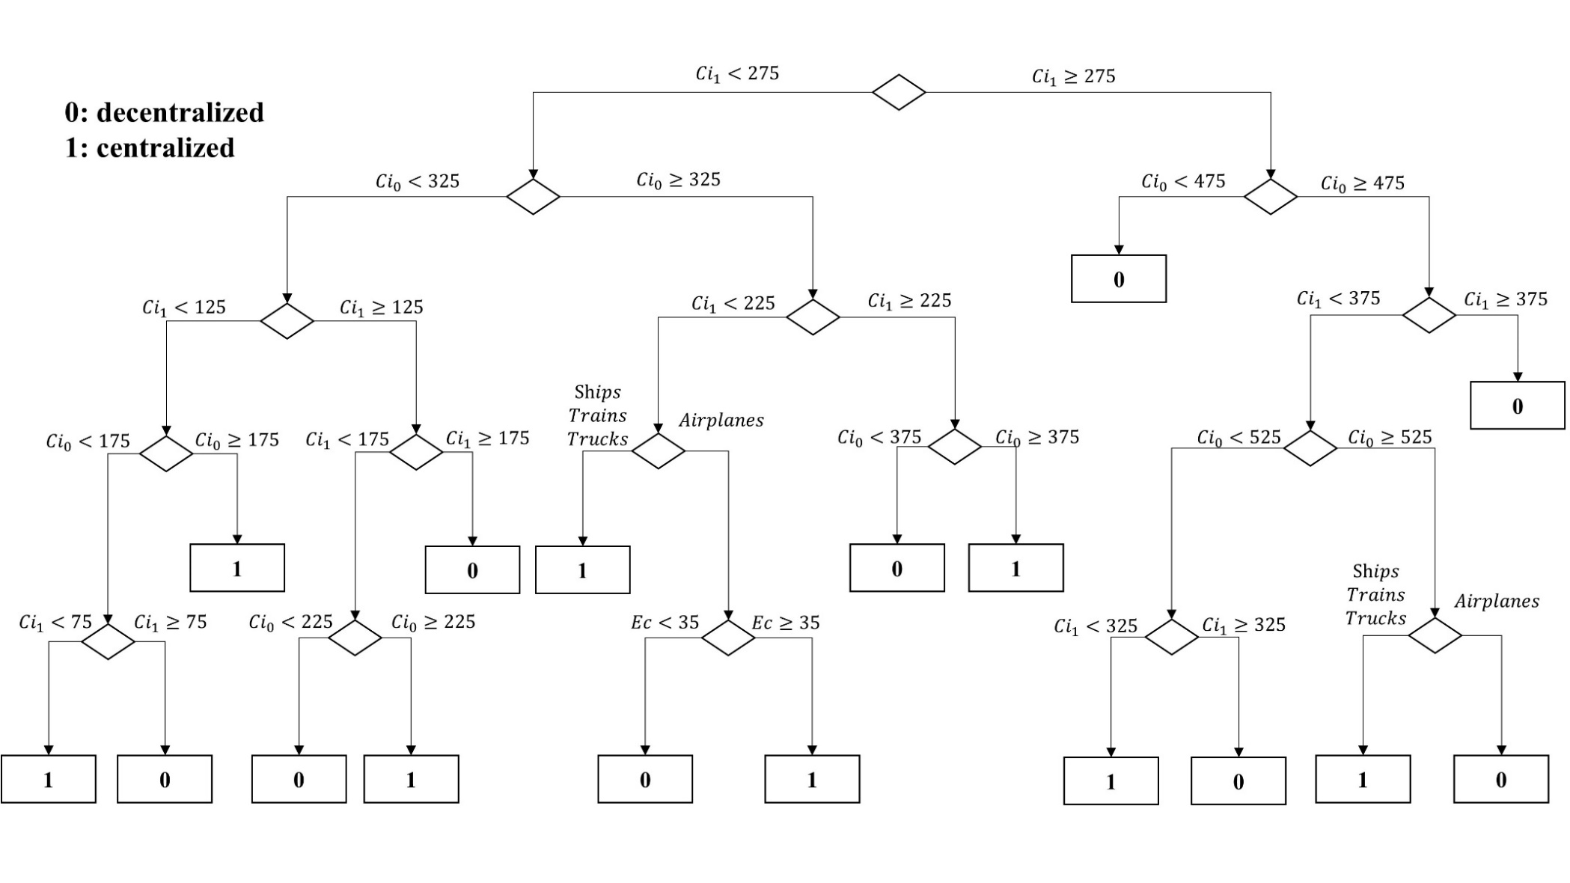

**Figure A1**. Decision tree obtained for Robustness check #1.

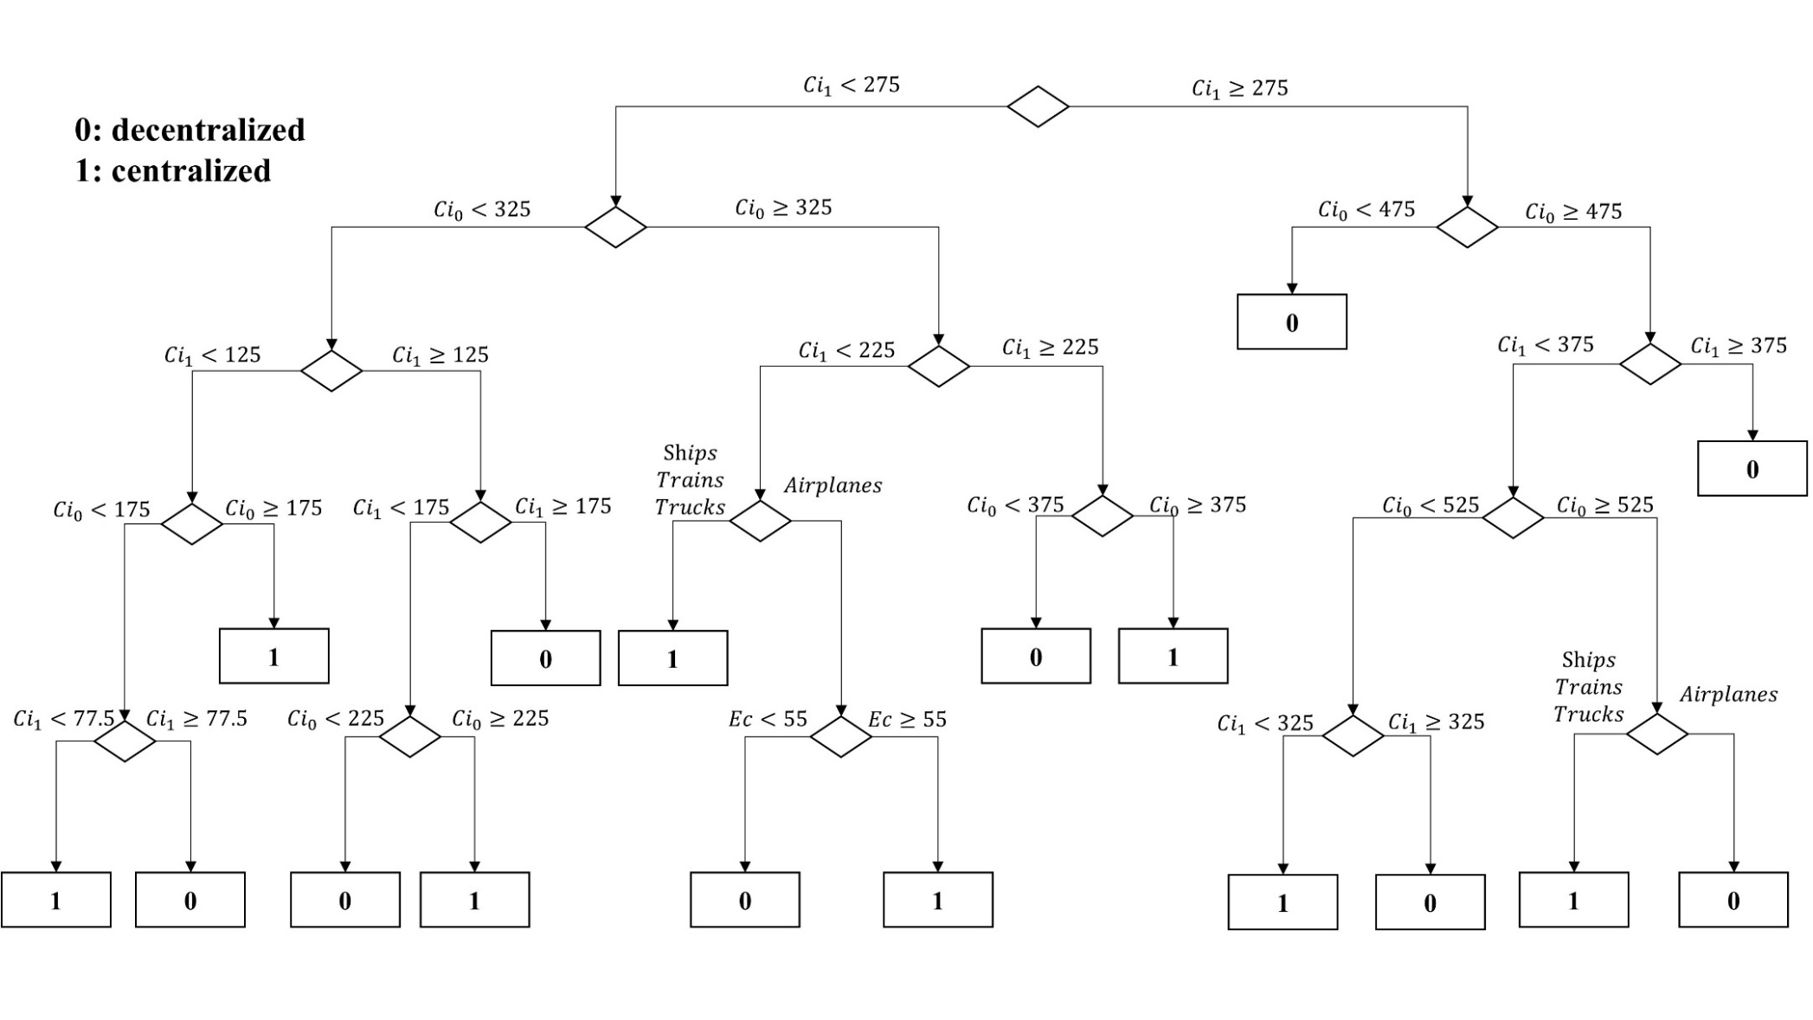

**Figure A2**. Decision tree obtained for Robustness check #2.

Comparing the decision tree obtained for the initial dataset (Figure 2) with the two decision trees developed to carry out robustness checks, it can be easily observed how the changes in the decision trees are negligible. This allows us to ascertain that the decision tree reported in the manuscript is robust, and the suggestions provided are also robust and reliable. This finding was further confirmed in the case study, where the decision suggested by the decision tree matched the results obtained from the mathematical model.