**Appendices**

**Appendix A**

As discussed in the manuscript, an online workshop with practitioners working on AM and spare parts have been carried out to validate and ensure the correctness of the values adopted for developing the decision tree. Here (Table A1) we report the details of the practitioners who have participated in the online workshop (which lasted 1 hour).

|  |  |  |  |
| --- | --- | --- | --- |
| Expert ID | Position | Experience (Years) | Country |
| 1 | Head of Industrial Digital Division | 8 | Italy |
| 2 | Production Planner | 7 | Germany |
| 3 | Head of Logistics and Supply Chain Department | 11 | Finland |
| 4 | Head of Procurement Department | 8 | Denmark |
| 5 | Production Planner | 10 | Norway |
| 6 | Head of Supply Chain | 11 | Norway |
| 7 | Head of Digitalization | 4 | Norway |

**Table A1.** Experts’ description

**Appendix B**

Here we report the 26 different countries that currently adopts carbon taxes and that we have focused on in this work (Table B1). Per each of this country, we report their current values of carbon tax, the unitary energy cost, and the carbon intensity of electricity generation. Moreover, in Table B2 we report also the distance between each country (capital country A – capital country B).

|  |  |  |  |  |
| --- | --- | --- | --- | --- |
| **Country** | **Abbreviation** | **Carbon tax (€/tonCO2,eq)** | **Unitary energy cost (€/kWh)** | **Carbon intensity of electricity generation (kgCO2,eq/kWh)** |
| Argentina | ARG | 3 | 0.026 | 354 |
| Canada | CAN | 45 | 0.13 | 170 |
| Chile | CHIL | 5 | 0.17 | 291 |
| Colombia | COL | 5 | 0.2 | 260 |
| Denmark | DEN | 25 | 0.35 | 152 |
| Finland | FIN | 78 | 0.18 | 79 |
| France | FRAN | 45 | 0.28 | 56 |
| Iceland | ICLD | 36 | 0.15 | 28 |
| Ireland | IRE | 42 | 0.53 | 291 |
| Japan | JPN | 2 | 0.22 | 485 |
| Latvia | LATV | 15 | 0.36 | 123 |
| Liechtenstein | LCHT | 122 | 0.45 | 117 |
| Luxembourg | LXM | 45 | 0.24 | 105 |
| Mexico | MEX | 4 | 0.12 | 507 |
| Netherlands | NETH | 52 | 0.35 | 268 |
| Norway | NORW | 85 | 0.11 | 30 |
| Poland | POL | 0 | 0.24 | 662 |
| Portugal | PORT | 24 | 0.22 | 166 |
| Singapore | SING | 4 | 0.22 | 471 |
| South Africa | SAFR | 8 | 0.18 | 708 |
| Spain | SPN | 15 | 0.24 | 174 |
| Sweden | SWDN | 117 | 0.2 | 41 |
| Switzerland | SWTZ | 88 | 0.34 | 35 |
| Ukraine | UKR | 1 | 0.07 | 260 |
| United Kingdom | GRBR | 21 | 0.44 | 238 |
| Uruguay | URU | 146 | 0.26 | 129 |

**Table B1.** Details of countries considered



**Table B2.** Distance matrix

**Appendix C**

Here, for the sake of comparison with the decision tree developed considering both the economic and environmental terms, we report the decision tree developed considering only the economic term (Figure C1).

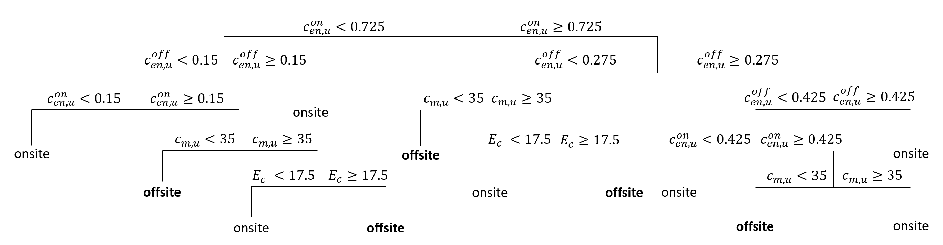

**Figure C1.** Decision tree for onsite/offsite AM production developed considering only economic terms

By comparing it with the decision tree reported in Figure 2, it can be seen that the two decision trees are identical.

**Appendix D**

Here we report the frequency distribution of the importance that the environmental costs (i.e. the environmental factor monetized through the carbon tax, $c_{t}∙\left({CE}_{p}^{x}+{CE}_{t}^{x}\right)$) over the total costs $C_{tot}^{x}$ for the onsite AM production (i.e. $x=on$).

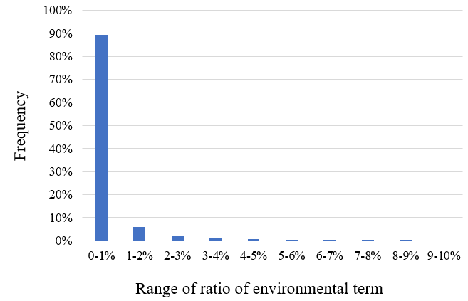

**Figure D1.** Frequency distribution of the ratio of environmental costs over total costs for onsite AM production (i.e. $x=on$).

As it can be seen by comparing Figure D1 with Figure 3, the results for the onsite and offsite configuration are basically the same: in both, the environmental costs represent at least 5% of the final total cost in less than 1% of the scenarios analyzed (specifically, 0.54% for the offsite and 0.50% for the onsite), and both have almost 90% of the scenarios analyzed where the environmental costs represent less than 1% of the final total cost (i.e., 89.4% for the offsite and 88.9% for the onsite).

**Appendix E**

As described above, the choice to use $E_{c}$ and ${ci}^{off}$ as x- and y-axis derives from the results of the main effects plot analysis carried out to identify the input parameters that play a bigger contribution on the environmental term. The analysis has been carried out only for the offsite scenario as it is the one characterized also by the transportation phase. As it can be seen from Section 3.1, the variable input parameters that contribute to the environmental term are the energy consumption of AM machines, $E_{c}$, the distance between the printing hub and the site of use, $d^{off}$, and the carbon intensity of electricity generation, ${ci}^{off}$. Notably, in carrying out the main effects plot analysis we have assumed that the transportation occurs through airplanes as these lead to the highest CO2,eq emissions.

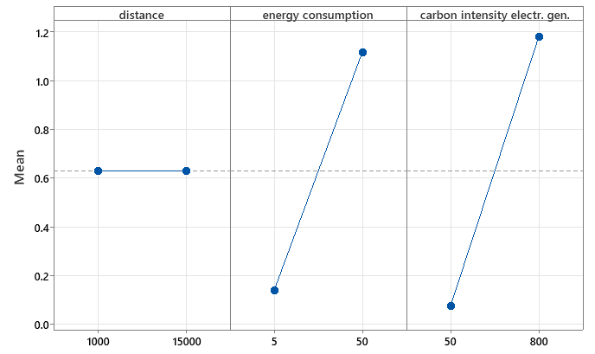

**Figure E1.** Main effects plot to identify the input parameters that play a bigger contribution on the environmental term.

**Appendix F**

The extension of Table 3 is reported in Table F3. Here, we report the carbon tax values that Norway should adopt to make so that Equinor would prefer producing in Norway than in the host countries. Here we consider as host countries only those not included in Table 3, i.e. those not adopting the carbon tax (Algeria, Angola, Australia, Azerbaijan, Belgium, China, Germany, India, Libya, Nigeria, South Korea, Suriname, Tanzania, and Vietnam). Before that, we report in Table F1 the unitary energy cost and the carbon intensity of electricity generation for each of these countries, and in Table F3 their distance from Norway (capital to capital).

|  |  |  |  |
| --- | --- | --- | --- |
| **Country** | **Abbreviation** | **Unitary energy cost (€/kWh)** | **Carbon intensity of electricity generation (kgCO2,eq/kWh)** |
| Algeria | ALGR | 0.02 | 635 |
| Angola | ANGL | 0.04 | 175 |
| Australia | ASTL | 0.28 | 549 |
| Azerbaijan | AZR | 0.04 | 671 |
| Belgium | BELG | 0.43 | 138 |
| China | CHIN | 0.08 | 586 |
| Germany | GER | 0.40 | 381 |
| India | IMD | 0.08 | 713 |
| South Korea | KOR | 0.11 | 431 |
| Libya | LBYA | 0.13 | 825 |
| Nigeria | NRA | 0.02 | 523 |
| Norway | NORW | 0.11 | 30 |
| Suriname | SURM | 0.07 | 349 |
| Tanzania | TAZN | 0.13 | 339 |
| Vietnam | VTNM | 0.13 | 475 |

**Table F1.** Details of host countries considered

|  |  |  |  |  |  |  |  |  |  |  |  |  |  |  |
| --- | --- | --- | --- | --- | --- | --- | --- | --- | --- | --- | --- | --- | --- | --- |
| **Homeland** | **Host country** | | | | | | | | | | | | | |
| **ALGR** | **ANGL** | **ASTL** | **AZR** | **BELG** | **CHIN** | **GER** | **IMD** | **KOR** | **LBYA** | **NRA** | **SURM** | **TAZN** | **VTNM** |
| **NORW** | 2619 | 7626 | 15939 | 3445 | 1085 | 7008 | 835 | 5968 | 7705 | 3002 | 5634 | 8105 | 7652 | 8256 |

**Table F2.** Distance Norway – host country

|  |  |  |  |  |  |  |  |  |  |  |  |  |  |  |  |
| --- | --- | --- | --- | --- | --- | --- | --- | --- | --- | --- | --- | --- | --- | --- | --- |
| **Homeland** |  | **Host country** | | | | | | | | | | | | | |
| **Current ct** | **ALGR** | **ANGL** | **ASTL** | **AZR** | **BELG** | **CHIN** | **GER** | **IMD** | **KOR** | **LBYA** | **NRA** | **SURM** | **TAZN** | **VTNM** |
| **NORW** | 85 | >266 | >1950 | always | >277 | always | >232 | always | >175 | >262 | >61 | >379 | >517 | >277 | >188 |

**Table F3.** Carbon tax values necessary to render production in Norway preferable to the production in the host country where spare parts are needed. Always means that despite the values of carbon tax adopted, it is always preferable. > XXX means that it is preferable if the carbon tax is greater than the value XXX: if this is written in red, this means that the current carbon tax is currently lower, whereas if it is green, it means that it is already greater.

**Appendix G**



**Table G1.** Modified Table 5 considering a higher carbon tax