**Appendices**

**Appendix A**

As discussed in the manuscript, an online workshop with practitioners working on AM and spare parts was conducted to validate and ensure the correctness of the values adopted for developing the decision tree. Here (Table A1) we report the details of the practitioners who participated in the online workshop (which lasted 1 hour).

|  |  |  |  |
| --- | --- | --- | --- |
| Expert ID | Position | Experience (Years) | Country |
| 1 | Head of Industrial Digital Division | 8 | Italy |
| 2 | Production Planner | 7 | Germany |
| 3 | Head of Logistics and Supply Chain Department | 11 | Finland |
| 4 | Head of Procurement Department | 8 | Denmark |
| 5 | Production Planner | 10 | Norway |
| 6 | Head of Supply Chain | 11 | The Netherlands |
| 7 | Head of Digitalization | 4 | Norway |

**Table A1.** Experts’ description

**Appendix B**

As outlined in Section 4, we conducted a robustness analysis of the decision tree shown in Figure 1. This involved comparing the original decision tree with two alternative trees generated from modified datasets. These new datasets were created by adjusting the allowable parameter ranges used in the initial analysis (see Table 1), as detailed in Table B1. Specifically, robustness check #1 involved expanding the parameter ranges by lowering the minimum values by 10% and raising the maximum values by the same margin The only exception was parameter $d$ (maximum travel distance), which remained unchanged because it cannot logically exceed the original maximum. Likewise, the carbon tax values $c_{t}$ were kept constant to reflect current real-world values. In robustness check #2, the ranges were narrowed by increasing the minimum values and decreasing the maximum values by roughly 10%. Importantly, the parameters that were kept fixed during the development of the original decision tree were also kept fixed in the robustness checks.

|  |  |  |  |  |  |  |  |  |  |
| --- | --- | --- | --- | --- | --- | --- | --- | --- | --- |
| **Parameter** | **Values** | | | | | | | | **Unit of measure** |
| **Robustness check #1** | | | | **Robustness check #2** | | | |
| $$λ$$ | 0.0043; 0.0048; 0.0096; 0.019; 0.038; 0.084 | | | | 0.0053; 0.0096; 0.019; 0.038; 0.068 | | | | 1/week |
| $$c_{rm,u}$$ | 45 | | | | 45 | | | | €/kg |
| $$V$$ | 90; 100; 500; 1,000; 1,100 | | | | 110; 500; 900 | | | | cm3 |
|  | 0.00785 | | | | 0.00785 | | | | kg/cm3 |
|  | 4.5; 5; 10; 20; 30; 40; 50; 55 | | | | 5.5; 10; 20; 30; 40; 45 | | | | kW |
| $$c_{en,u}^{x}$$ | 0.045; 0.5; 0.1; 0.2; 0.3; 0.4; 0.5; 0.55 | | | | 0.055; 0.1; 0.2; 0.3; 0.4; 0.45 | | | | €/kWh |
| $$c_{gas,u}$$ | 5 | | | | 5 | | | | €/h |
| $$c_{m,u}$$ | 18; 20; 35; 50; 55 | | | | 22; 35; 45 | | | | €/h |
| $$t_{s}$$ | 2 | | | | 2 | | | | h |
| $$v$$ | 0.03 | | | | 0.03 | | | | h/cm3 |
|  | 0.0058 | | | | 0.0058 | | | | €/€*week |
| $$c_{b}$$ | 900; 1,000; 5,000; 10,000; 25,000; 50,000; 100,000; 110,000 | | | | 1,100; 5,000; 10,000; 25,000; 50,000; 90,000 | | | | €/week |
| $$T$$ | 1.8; 2; 4; 8; 8.8 | | | | 2.2; 4; 7.2 | | | | week |
| $$d^{c}$$ | 450; 500; 1,000; 2,500; 5,000; 7,500; 10,000; 12,500; 15,000 | | | | 550; 1,000; 2,500; 5,000; 7,500; 10,000; 12,500; 13,500 | | | | km |
| $$c_{t,u}$$ | truck | train | ship | plane | truck | train | ship | plane | €/ton*km |
| 0.036 | 0.0162 | 0.0198 | 0.18 | 0.044 | 0.0198 | 0.0242 | 0.22 |
| $${ci}^{x}$$ | 45; 50; 100; 200; 300; 400; 500; 600; 700; 800; 880 | | | | 55; 100; 200; 300; 400; 500; 600; 700; 720 | | | | kgCO2,eq/kWh |
| $${ce}_{t}$$ | truck | train | ship | plane | truck | train | ship | plane | gCO2,eq/ton*km |
| 103 | 36 | 9 | 890 | 127 | 44 | 11 | 990 |
| $$c_{t}^{x}$$ | 1; 10; 20; 40; 60; 80; 100; 120; 140 | | | | 1; 10; 20; 40; 60; 80; 100; 120; 140 | | | | €/tonCO2,eq |

**Table B1.** Values used to create the dataset for the decision tree’s robustness checks.

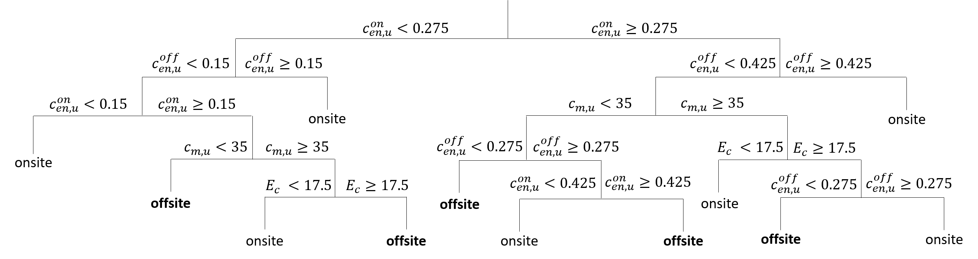

**Figure B1**. Decision tree obtained for robustness check #1.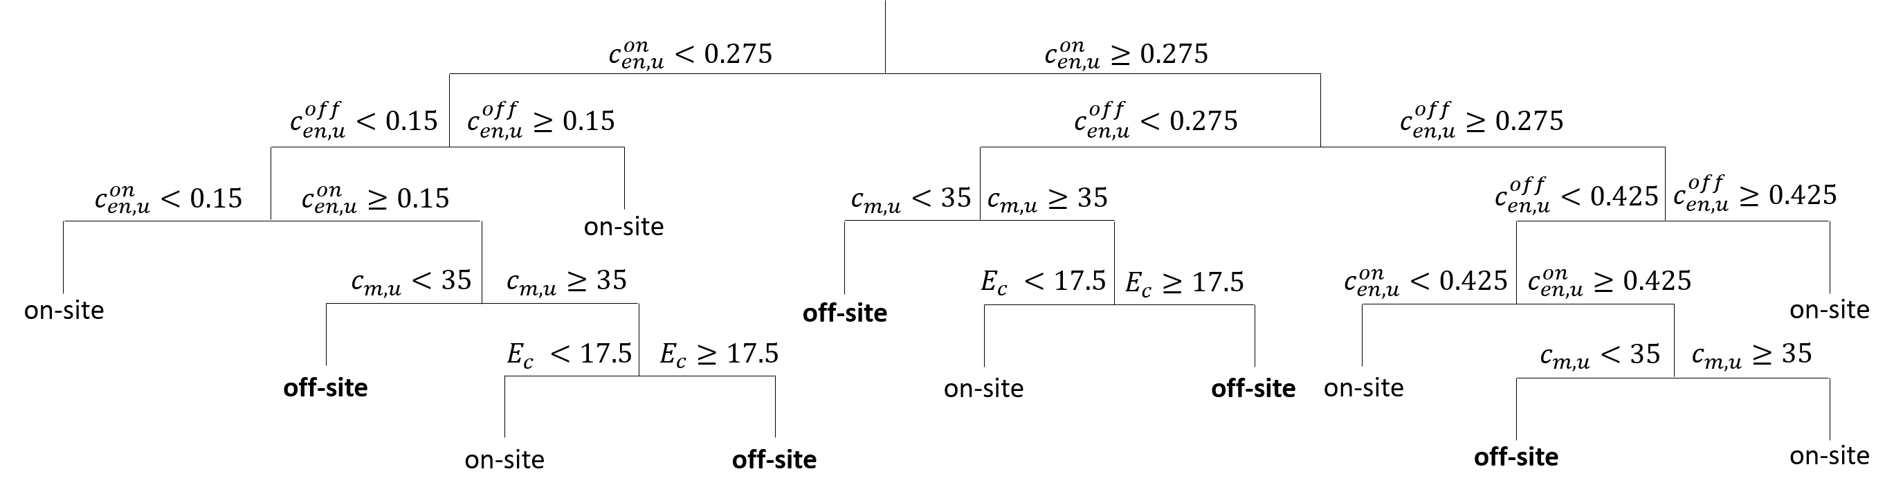**Figure B2**. Decision tree obtained for robustness check #2.

A comparison between the decision tree derived from the initial dataset (Figure 1) and the two additional trees developed for the robustness checks (Figures B1 and B2) reveals no significant differences (the branches in Figure B1 are different from those in the initial decision tree, but the areas of AM on-site and off-site convenience remain mostly unchanged). This finding confirms the robustness of the decision tree presented in the manuscript, as well as the reliability of the recommendations it offers. This conclusion is further supported by Table 2, where the decision tree results are aligned with the optimal solutions identified by the mathematical model.

**Appendix C**

Here, for the sake of comparison with the decision tree developed considering both the economic and environmental terms, we report the decision tree developed considering only the economic term (Figure C1).



**Figure C1.** Decision tree for onsite/offsite AM production developed considering only economic terms.

By comparing it with the decision tree reported in Figure 1, one can see that the two decision trees are identical.

**Appendix D**

Here we report the frequency distribution of the importance that the environmental costs (i.e. the environmental factor monetized through the carbon tax, $c_{t}∙\left({CE}_{p}^{x}+{CE}_{t}^{x}\right)$) over the total costs $C_{tot}^{x}$ for the onsite AM production (i.e. $x=on$).

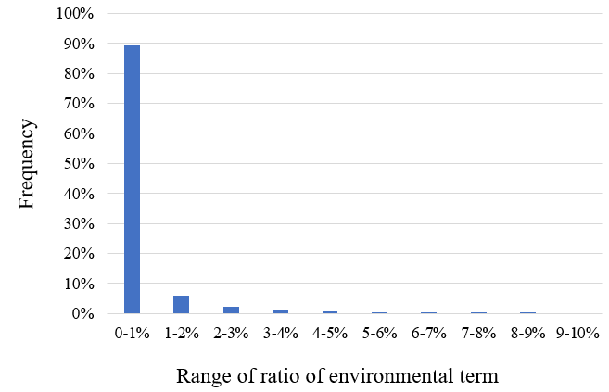

**Figure D1.** Frequency distribution of the ratio of environmental costs over total costs for onsite AM production (i.e., $x=on$).

As it can be seen by comparing Figure D1 with Figure 3, the results for the onsite and offsite configuration are basically the same: in both, the environmental costs represent at least 5% of the final total cost in less than 1% of the scenarios analyzed (specifically, 0.54% for the offsite and 0.50% for the onsite), and both have almost 90% of the scenarios analyzed where the environmental costs represent less than 1% of the final total cost (i.e., 89.4% for the offsite and 88.9% for the onsite).

**Appendix E**

As described above, the choice to use $E_{c}$ and ${ci}^{off}$ as x- and y-axis derives from the results of the main effects plot analysis carried out to identify the input parameters that play a bigger contribution on the environmental term. The analysis was conducted only for the offsite scenario, as it is the one characterized also by the transportation phase. As it can be seen from Section 3.1, the variable input parameters that contribute to the environmental term are the energy consumption of AM machines, $E_{c}$, the distance between the printing hub and the site of use, $d^{off}$, and the carbon intensity of electricity generation, ${ci}^{off}$. Notably, in carrying out the main effects plot analysis we have assumed that the transportation occurs through airplanes as these lead to the highest CO2,eq emissions.

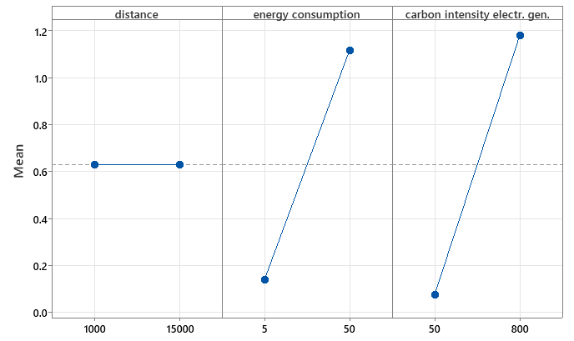

**Figure E1.** Main effects plot to identify the input parameters that play a bigger contribution on the environmental term.

**Appendix F**

In Table F1 we report the unitary energy cost, the carbon intensity of electricity generation, and the carbon tax of the homeland country (country A) of the Nordic energy company and of the countries where it operates (country B, …, country U). Moreover, in Table F2 we report the distance matrix between country A and the different host countries.

|  |  |  |  |
| --- | --- | --- | --- |
| **Country** | **Carbon tax (€/tonCO2,eq)** | **Unitary energy cost (€/kWh)** | **Carbon intensity of electricity generation (kgCO2,eq/kWh)** |
| A | 81 | 0.11 | 30 |
| B | - | 0.02 | 635 |
| C | - | 0.04 | 175 |
| D | 3 | 0.026 | 354 |
| E | - | 0.28 | 549 |
| F | - | 0.04 | 671 |
| G | - | 0.43 | 138 |
| H | - | 0.08 | 646 |
| I | 25 | 0.35 | 152 |
| J | 45 | 0.28 | 56 |
| K | - | 0.40 | 381 |
| L | - | 0.08 | 713 |
| M | 2 | 0.22 | 485 |
| N | - | 0.11 | 431 |
| O | 52 | 0.35 | 268 |
| P | - | 0.02 | 523 |
| Q | 4 | 0.22 | 471 |
| R | 15 | 0.24 | 174 |
| S | - | 0.07 | 349 |
| T | - | 0.13 | 639 |
| U | - | 0.13 | 475 |

**Table F1.** Details of the countries considered.

|  |  |  |  |  |  |  |  |  |  |  |  |  |  |  |  |  |  |  |  |  |
| --- | --- | --- | --- | --- | --- | --- | --- | --- | --- | --- | --- | --- | --- | --- | --- | --- | --- | --- | --- | --- |
| **Homeland** | **Host country** | | | | | | | | | | | | | | | | | | | |
| **B** | **C** | **D** | **E** | **F** | **G** | **H** | **I** | **J** | **K** | **L** | **M** | **N** | **O** | **P** | **Q** | **R** | **S** | **T** | **U** |
| **A** | 2619 | 7626 | 12222 | 15939 | 3445 | 1085 | 7008 | 484 | 1338 | 835 | 5968 | 8389 | 7705 | 913 | 5634 | 10031 | 2384 | 8105 | 7652 | 8256 |

**Table F2.** Distance homeland (country A) – host countries (country B, …, country U).