Transmission and Mile Per Gallon (MPG)

Cynthia Tang

June 9, 2019

## Summary

The report explored the relationship between transmission types and miles per gallon (MPG). Figure 1 in appendix showed that an manual transmission trend to be better for MPG, considering other factors. Then, we performed t-test to verify the hypothesis. To quantify the MPG difference between automatic and manual transmissins, we fitted the MPG (outcome) and a set of variables (regressors) in to multiple linar models. We selected tansmission (am), number of cylinders (cyl), gross horsepower (hp), and weight (wt) as repressors.

## Results

The mean of automatic transmission: 17.1473684 miles per gallon.  
The mean of manual transmission: 24.3923077 miles per gallon.

**Model Selection**  
We used nested model search. The detailed process of model selection is shown in **Appendix**.  
We set mpg as the outcome and transmission (am), number of cylinders (cyl), gross horsepower (hp), and weight (wt) as repressors and fitted the linear model: . Assume ~ .  
The coefficients of the linear model are showed below:

## (Intercept) factor(am)manual factor(cyl)6 factor(cyl)8   
## 33.70832390 1.80921138 -3.03134449 -2.16367532   
## hp wt   
## -0.03210943 -2.49682942

**Interpretion**  
The intercept : the expected mpg of automatic transmission when there is 4 cylinders, 0 gross horsepower, and none weight.  
The : the expected change in mpg comparing those in manual to those in automatic transmission.  
The : the expected change in mpg comparing those with 6 cylinders to those with 4 cylinders.  
The : the expected change in mpg comparing those with 8 cylinders to those with 4 cylinders.  
The : the expected change in mpg for every 1 gross horsepower increase.  
The : the expected change in mpg fot every 1000 lbs increase in the weight of cars.

**T-test**  
Assumption: Unequal variance. Detailed test results is shown in **Appendix**.  
: .  
: .  
The p-value: 6.868191710^{-4}. The type I error = 0.05, then we rejected and concluded that a manual transmission is better for MPG.

**Quantify the MPG Difference**  
 = 7.2449393.  
Adjustment: = abs() = 1.8092114.

**Diagnostics**  
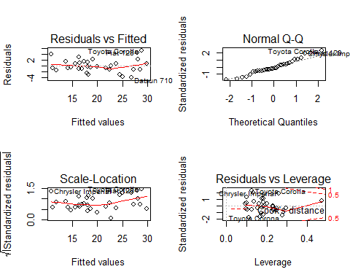

The mean of residuals is 2.688821410^{-17}, approximating to zero.  
“Residual vs Fitted”: residuals are independent. “scale-location”: the homoscedasticity of residuals. “Normal Q-Q”“: all residuals were approximately stardard normal distributed.”Residual vs Leverge“: within 0.5, no outliers.

**The uncertainty**  
We assumed other variables not included in the linear model were completely randomized. The error in the linear model followed normal distribution. However, we are uncertain whether there is a better linear model with other combination of diferent regressors.

## Appendix

### Figure

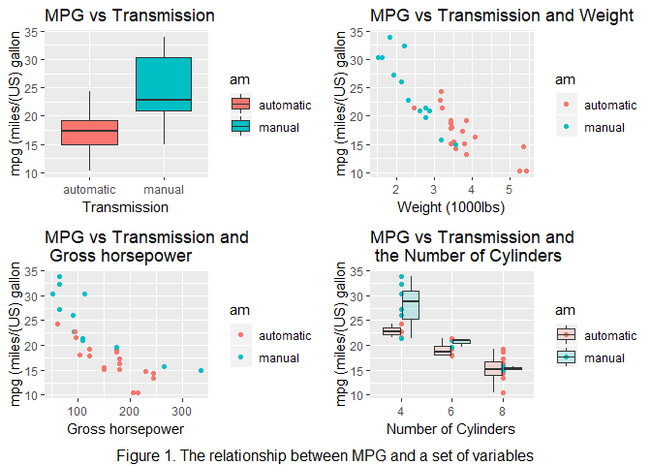

### Model Selection

## Analysis of Variance Table  
##   
## Model 1: mpg ~ factor(am)  
## Model 2: mpg ~ factor(am) + factor(cyl)  
## Res.Df RSS Df Sum of Sq F Pr(>F)   
## 1 30 720.9   
## 2 28 264.5 2 456.4 24.158 8.01e-07 ***  
## ---  
## Signif. codes: 0 '***' 0.001 '**' 0.01 '*' 0.05 '.' 0.1 ' ' 1

## Analysis of Variance Table  
##   
## Model 1: mpg ~ factor(am)  
## Model 2: mpg ~ factor(am) + factor(cyl)  
## Model 3: mpg ~ factor(am) + factor(cyl) + disp  
## Res.Df RSS Df Sum of Sq F Pr(>F)   
## 1 30 720.90   
## 2 28 264.50 2 456.40 26.7353 3.956e-07 ***  
## 3 27 230.46 1 34.04 3.9875 0.05601 .   
## ---  
## Signif. codes: 0 '***' 0.001 '**' 0.01 '*' 0.05 '.' 0.1 ' ' 1

## Analysis of Variance Table  
##   
## Model 1: mpg ~ factor(am)  
## Model 2: mpg ~ factor(am) + factor(cyl)  
## Model 3: mpg ~ factor(am) + factor(cyl) + hp  
## Res.Df RSS Df Sum of Sq F Pr(>F)   
## 1 30 720.9   
## 2 28 264.5 2 456.4 31.2446 9.43e-08 ***  
## 3 27 197.2 1 67.3 9.2141 0.005266 **   
## ---  
## Signif. codes: 0 '***' 0.001 '**' 0.01 '*' 0.05 '.' 0.1 ' ' 1

## Analysis of Variance Table  
##   
## Model 1: mpg ~ factor(am)  
## Model 2: mpg ~ factor(am) + factor(cyl)  
## Model 3: mpg ~ factor(am) + factor(cyl) + hp  
## Model 4: mpg ~ factor(am) + factor(cyl) + hp + drat  
## Res.Df RSS Df Sum of Sq F Pr(>F)   
## 1 30 720.90   
## 2 28 264.50 2 456.40 30.4123 1.557e-07 ***  
## 3 27 197.20 1 67.30 8.9686 0.005961 **   
## 4 26 195.09 1 2.11 0.2807 0.600747   
## ---  
## Signif. codes: 0 '***' 0.001 '**' 0.01 '*' 0.05 '.' 0.1 ' ' 1

## Analysis of Variance Table  
##   
## Model 1: mpg ~ factor(am)  
## Model 2: mpg ~ factor(am) + factor(cyl)  
## Model 3: mpg ~ factor(am) + factor(cyl) + hp  
## Model 4: mpg ~ factor(am) + factor(cyl) + hp + wt  
## Res.Df RSS Df Sum of Sq F Pr(>F)   
## 1 30 720.90   
## 2 28 264.50 2 456.40 39.286 1.388e-08 ***  
## 3 27 197.20 1 67.30 11.585 0.002164 **   
## 4 26 151.03 1 46.17 7.949 0.009081 **   
## ---  
## Signif. codes: 0 '***' 0.001 '**' 0.01 '*' 0.05 '.' 0.1 ' ' 1

## Analysis of Variance Table  
##   
## Model 1: mpg ~ factor(am)  
## Model 2: mpg ~ factor(am) + factor(cyl)  
## Model 3: mpg ~ factor(am) + factor(cyl) + hp  
## Model 4: mpg ~ factor(am) + factor(cyl) + hp + wt  
## Model 5: mpg ~ factor(am) + factor(cyl) + hp + wt + qsec  
## Res.Df RSS Df Sum of Sq F Pr(>F)   
## 1 30 720.90   
## 2 28 264.50 2 456.40 39.6232 1.772e-08 ***  
## 3 27 197.20 1 67.30 11.6849 0.002166 **   
## 4 26 151.03 1 46.17 8.0172 0.009017 **   
## 5 25 143.98 1 7.04 1.2230 0.279293   
## ---  
## Signif. codes: 0 '***' 0.001 '**' 0.01 '*' 0.05 '.' 0.1 ' ' 1

## Analysis of Variance Table  
##   
## Model 1: mpg ~ factor(am)  
## Model 2: mpg ~ factor(am) + factor(cyl)  
## Model 3: mpg ~ factor(am) + factor(cyl) + hp  
## Model 4: mpg ~ factor(am) + factor(cyl) + hp + wt  
## Model 5: mpg ~ factor(am) + factor(cyl) + hp + wt + factor(vs)  
## Res.Df RSS Df Sum of Sq F Pr(>F)   
## 1 30 720.90   
## 2 28 264.50 2 456.40 39.7065 1.737e-08 ***  
## 3 27 197.20 1 67.30 11.7095 0.002146 **   
## 4 26 151.03 1 46.17 8.0341 0.008954 **   
## 5 25 143.68 1 7.35 1.2782 0.268968   
## ---  
## Signif. codes: 0 '***' 0.001 '**' 0.01 '*' 0.05 '.' 0.1 ' ' 1

## Analysis of Variance Table  
##   
## Model 1: mpg ~ factor(am)  
## Model 2: mpg ~ factor(am) + factor(cyl)  
## Model 3: mpg ~ factor(am) + factor(cyl) + hp  
## Model 4: mpg ~ factor(am) + factor(cyl) + hp + wt  
## Model 5: mpg ~ factor(am) + factor(cyl) + hp + wt + factor(gear)  
## Res.Df RSS Df Sum of Sq F Pr(>F)   
## 1 30 720.90   
## 2 28 264.50 2 456.40 36.5938 5.143e-08 ***  
## 3 27 197.20 1 67.30 10.7916 0.003124 **   
## 4 26 151.03 1 46.17 7.4043 0.011916 *   
## 5 24 149.67 2 1.36 0.1091 0.897096   
## ---  
## Signif. codes: 0 '***' 0.001 '**' 0.01 '*' 0.05 '.' 0.1 ' ' 1

## Analysis of Variance Table  
##   
## Model 1: mpg ~ factor(am)  
## Model 2: mpg ~ factor(am) + factor(cyl)  
## Model 3: mpg ~ factor(am) + factor(cyl) + hp  
## Model 4: mpg ~ factor(am) + factor(cyl) + hp + wt  
## Model 5: mpg ~ factor(am) + factor(cyl) + hp + wt + factor(carb)  
## Res.Df RSS Df Sum of Sq F Pr(>F)   
## 1 30 720.90   
## 2 28 264.50 2 456.40 32.9605 3.33e-07 ***  
## 3 27 197.20 1 67.30 9.7201 0.005206 **   
## 4 26 151.03 1 46.17 6.6691 0.017370 *   
## 5 21 145.39 5 5.63 0.1627 0.973489   
## ---  
## Signif. codes: 0 '***' 0.001 '**' 0.01 '*' 0.05 '.' 0.1 ' ' 1

### T-test Results

##   
## Welch Two Sample t-test  
##   
## data: mpg by factor(am)  
## t = -3.7671, df = 18.332, p-value = 0.0006868  
## alternative hypothesis: true difference in means is less than 0  
## 95 percent confidence interval:  
## -Inf -3.913256  
## sample estimates:  
## mean in group automatic mean in group manual   
## 17.14737 24.39231