Simulation and Inferential Data Analysis_Part1

Cynthia Tang

May 30, 2019

## Overview

The rerport investigated the exponential distribution and the Central Limit Theorem (CLT). We conducted 1000 simulations to build the distribution of the averages of 40 exponentials, the distribution of the variances of 40 exponentials and compared the distribution of averages to the normal distribution.

## Simulation

We set the lambda of the exponential distribution to be 0.2. The theoretical mean of the exponential distribution is 1/lambda = 5, the theoretical standard deviation is also 1/lambda = 5.

Then, we did 1000 simulations of the averages of 40 exponentials, and plotted the distribution of the 1000 averages.

library(ggplot2)  
lambda <- 0.2  
n <- 40  
  
# The simulation of the avg of 40 exponentials  
nosim <- 1000  
set.seed(1000)  
simMeans <- apply(matrix(rexp(n * nosim, lambda), nosim), 1, mean)  
dat <- data.frame(x = c(simMeans),  
 group = factor(rep(c("sample"), each = nosim))  
 )  
  
# the statistics  
sampleMean <- mean(simMeans)  
sampleSd <- sd(simMeans)  
  
# The simulationn of the var of 40 exponentials  
set.seed(1000)  
simVars <- apply(matrix(rexp(n * nosim, lambda), nosim), 1, var)  
dat2 <- data.frame(variance = simVars,   
 group = factor(rep("sample"), nosim))  
  
# The statistics  
varsMean <- mean(simVars)

## Sample Mean VS Theoretical Mean

The plot showed the distribution of the averages of 40 exponentials. The black line indicated the theoretical mean and the red dash line indicated the sample mean of the averages of 40 exponentials.

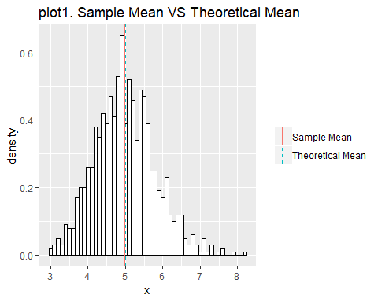

The sample mean is 4.9869634, and the theoretical mean is 5. They are pretty close according to the plot1. Additionally, The sample variance is equal to 0.6583551, which is pretty close to the theoretical variance divided by 40, which is 0.625.

## Sample Variance VS Theoretical Variance

The plot showed the distribution of the variances of 40 exponentials. The black line indicated the theoretical variance and the red dash line indicated the empirical mean of the variances of 40 exponentials.

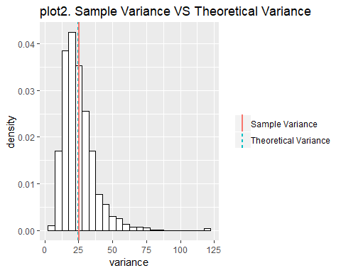

The mean of sample variances is 25.0934472, and the theoretical variance is 25. They are the almost the same according to the plot2.

## Distribution

The plot showed the density distribution of the averages of 40 exponentials. The black line indicated the normal distribution

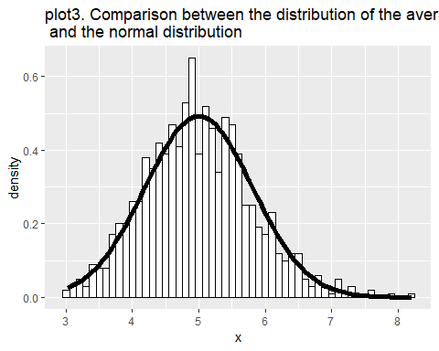

In the plot3 above, the density distribution of the averages of 40 exponentials can be approximated by the normal distribution.