## Python environment

Mac OS X comes with Python 2.7 out of the box, while you do need a python3 environment for running the software. You could make it by following the online script, see [install python3 for mac os](https://docs.python-guide.org/starting/install3/osx/) *.*

## 2. Webdriver for mac

### Download Chrome Driver

You need Google Chrome installed in your mac.

The R package has already got the chromedriver with it. Not working? Then follow the steps below to install it yourself.

1. [*http://npm.taobao.org/mirrors/chromedriver*](http://npm.taobao.org/mirrors/chromedriver)
2. [*https://sites.google.com/a/chromium.org/chromedriver/downloads*](https://sites.google.com/a/chromium.org/chromedriver/downloads)

And, the version of chromedriver which is the same as your chrome’s main version will work most stably.

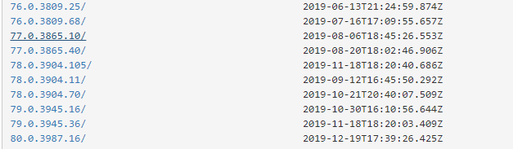

Open your Chrome browser. Type “***chrome://version***” in the address bar and hit enter to get your chrome version.



As shown in this case, both ’79.0.3945.16/’ and ’79.0.3945.36’ works well enough.

### Move chromedriver to Path

Now, we can move the driver to a path which is defined as a path in your system. You can check them with below command and you will see that /usr/local/bin folder is defined as a global path on your system.

***sudo nano /etc/paths***

Then you may get the massage like below.

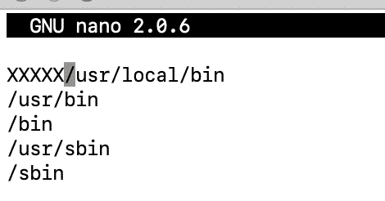

If you want you can add a specific path here and you can move the chromedriver to the folder you set.

To check python3 works and for later workflow, type

***sudo pip install selenium***

Have some problem? That may be the cause of SIP (System Integrity Protection), type

***csrutil disable*** and ***csrutil status*** to see the status. (You may need to restart to change the SIP status)

Selenium package is essential, so this step could not be jump over.

## 3. Start work

### R package needed

reticulate: a R package using to interface to python script. Version up to 1.14 or latest.

While first type “**library(reticulate)**”, it warns that it is built in R 3.62(latest), but the package works well for all R version 3.6. And then it suggest installing **miniconda** as python compiler environment, select **yes**, or you might need to acquire [conda environment](https://mac-tutorials.net/python-conda-install-mac-os-x/) in your mac.

Anyway, conda environment seems to be prerequisite.

### Input list:

1)**platform**: the system platform you use,

1 or “Windows” for “Windows”

2 or “Mac” for “Mac/Linux”

Use Windows as default

2)**genelist**: the genelist to load

3)**species**: select the species

Input one of “Human”, “Mouse” and “Rat”. Invalid input would select “Human” as default.

4)**geneset**: select the geneset to work in

Type “hallmark” or “Hallmark” represent hallmark.

Type “KEGG” or “kegg” represent KEGG

Type “BP” or “GO biological process” represent GO biological process

Type “CC” or “GO cellular component” represent GO cellular component

Type “MF” or “GO molecular function” represent GO molecular function

Invalid input would select “hallmark” as default

5)**qvalue**:represent the results would be with FDR q-value less than the input

Input more than 0.05 would use 0.05 as default

6)**outdir**: local path to save the result. (eg. F:/iu8Results), and the result show as overlap.xlsx. **Attention: each new running would cover the result file before** because of the same filename, better to change the filename after each running.

7)driverpath: the path webdriver saved to.