## 1. Python Environment

Open cmd and type 'python', if shows like :

*'Python 3.8.0 (tags/v3.8.0:fa919fd, Oct )... on win32(or 64)*

*Type "help","copyring"... for help'*

(**3.8.0 means the edition, python edition is required to be up than 3.4.0**)

then, you have aquired the python environment. If not, install python for Windows form "<https://www.python.org/downloads/>" (the latest and stable version is encouraged and install through .exe file would be easier). While installing, **Tick option “Add python to path”,** or you may do it yourself later. After finishing the installation, open a new cmd and type ‘python’ to confirm.

## 2. Webdriver

You need Google Chrome or Firefox installed in your computer.

The R package has already got the chromedriver with it. Not working? Then follow the steps below to install it yourself.

1)Open your Chrome browser.

2)Type about://version or chrome://version in the address bar and hit enter to get your chrome version.

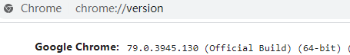

3)Download your webdriver form:

1. [*http://npm.taobao.org/mirrors/chromedriver*](http://npm.taobao.org/mirrors/chromedriver)
2. [*https://sites.google.com/a/chromium.org/chromedriver/downloads*](https://sites.google.com/a/chromium.org/chromedriver/downloads)

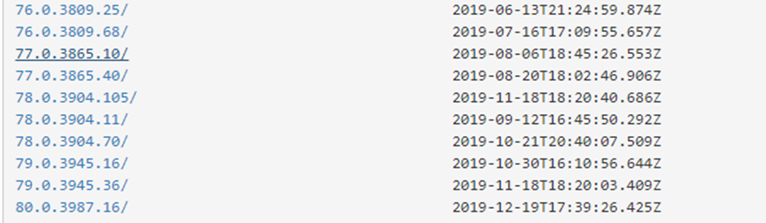

4)Choose the right version and save it to local file.

As shown in this case, both ’79.0.3945.16/’ and ’79.0.3945.36’ works well enough.

Download the web driver and save to a local file (eg. F:\WebDriver\), and add the file path to system Path. See [how to add to system Path](https://docs.microsoft.com/en-us/previous-versions/office/developer/sharepoint-2010/ee537574(v=office.14)), or you can search it for help online.

## 3. Start work

### R package needed

reticulate: a R package using to interface to python script. Version 1.14

While first do “library(reticulate)”, it warns that it is built in R 3.62(latest), but the package works well for all R version 3.6. And then it suggest installing miniconda as python compiler environment, select **yes**!

### Input list:

1. Platform: the system you use. 1 for Windows; 2 for Mac/Linux; Use Win as default.
2. StratifiedDEGenes: The output of scStratify function

3) **species**: select the species

Input one of “Human”, “Mouse” and “Rat”. Invalid input would select “Human” as default.

4) **geneset**: select the genest to work in

Type 1, “hallmark” or “Hallmark” represent hallmark.

Type 2, “KEGG” or “kegg” represent KEGG

Type 3, “BP” or “GO biological process” represent GO biological process

Type 4, “CC” or “GO cellular component” represent GO cellular component

Type 5, “MF” or “GO molecular function” represent GO molecular function

Invalid input would select “hallmark” as default

5) qvalue: represent the results would be with FDR q-value less than the input

Input more than 0.05 would use 0.05 as default

6) outdir: local path to save the result. (eg. F:\\Results), and the result show as overlap.xlsx. Attention: each new running would cover the result file before because of the same filename, better to change the filename after each running.

7) **driverpath**: the webdriver path added to the system path, see Chapter Webdriver. Take Chromedriver as an example, if the chromedriver.exe is saved to to F:\WebDriver\, then the driverpath would be F:\\WebDriver\\chromedriver. Firefox is the same.