
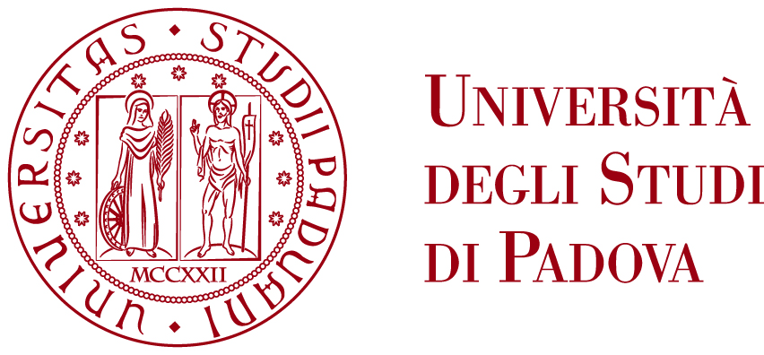
DIPARTIMENTO
DI INGEGNERIA
DELL’INFORMAZIONE

DEPARTMENT OF INFORMATION ENGINEERING

MASTER’S DEGREE IN

INFORMATION AND COMMUNICATION TECHNOLOGY - PHOTONICS

DEVELOPMENT OF A

POINTING-ACQUISITION-TRACKING SYSTEM FOR

FREE-SPACE QUANTUM COMMUNICATION

Supervisor: Prof. Giuseppe Vallone
Co-Supervisor: Dr. Francesco Vedovato

Author: Berra Federico

Academic Year 2019 – 2020
Date of graduation 07/09/2020

