|  |
| --- |
| EXCELLENT COACHING  **CPISM-E PROJECT**    ***Submitted By :***  Student 1352819: Iqra Iftikhar  Student 1353810: Mirza Misbah ul Hassan  Student 1349967: Neha Naz  Student 1352377: Muhammad Farzim Hussain    ***Submitted to :***  Sir Najam Moin |

**TABLE OF CONTENTS**

* **Introduction………………………………………………………3**
* **Acknowledgement …………………………………………… 4**
* **Preface ………………………………………………………… 5**
* **Problem Statement …………………………………………..6**
* **Hardware/Software …………………………………………… 7**
* **Flowchart …………………………………………………….….. 8**

**INTRODUCTION**

Education is the process of facilitating learning, or the acquisition of knowledge, skills, values, morals, beliefs, habits, and personal development. Education originated as transmission of cultural heritage from one generation to the next. Today, educational goals increasingly encompass new ideas such as liberation of learners, critical thinking about presented information, skills needed for the modern society, empathy and complex vocational skills.

**ACKNOWLEDGEMENTS**

We are thankful to Almighty ALLAH that by His grace we have successfully submitted our project. We are presenting our project. We have tried our best to take all relevant important topics in consideration so that this project become comprehensive.

This is our 1st Semester **E project**. We have tried our best & struggled hard for a better outlook to come.

We are hopeful that this project will fulfill the needs of the users. However suggestions and advices for improvement of this project will be thankfully received & acknowledged.

**PREFACE**

We start with the name of Allah, the most beneficent, the most merciful who gave us eligibility to complete this project.

We are very grateful to our respected Teachers, who contributed with us for the completion of this project. First of all, we would like to thanks our respected Sir **NAJAM MOIN** of Aptech for his expert advice.

Moreover, we would like to thanks all the teachers of Aptech and our classmates for their kind appreciation and moral support.

We would like to express our deepest gratitude to our parents and well-wishers whose prayers and motivation enabled us to turn our dream into reality. Special thanks to our parents who supported us day and night for our project. Finally our sincere thanks to our Sir **NAJAM MOIN** for all their assistance, help and support in making a document into reality.

**PROBLEM STATEMENT**

STANDARD PLANS:

* Every code block must have comments.
* The logic of the program needs to be explained. Proper documentation should be maintained.
* Complete Project Report along with synopsis, code and documentation should be prepared.

**Hardware/ Software Requirements**

**Hardware**

* A minimum computer system that will help you access all the tools in the courses is a Pentium 166 or better
* 64 Megabytes of RAM or better

**Software**

* Notepad/HTML editor
* Dreamweaver
* IE 5.0/ Netscape 6.0

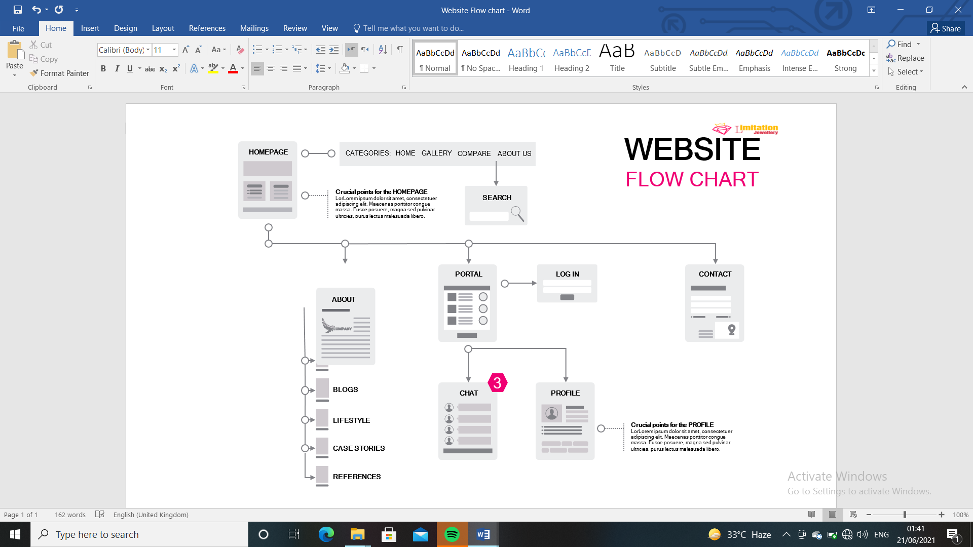

USER GUIDE

|  |  |  |
| --- | --- | --- |
| ***Serial No.*** | ***Items*** | ***Description*** |
|
| *1* | *Operating System* | *Windows 98,2000 XP etc* |
|
|
| *2* | *RAM (Memory)* | *Minimum 512 MB or better* |
|
| *3* | *Software* | *Dream viewer/ VS Code/ Notepad* |
|