UML ARCHITECTURAL & INTERACTION SPECIFICATION
Sequence Diagrams Specification
Comprehensive UML 2.5 Sequence Diagrams and Protocol Message Specifications for all 18 functional use cases of the Arts Gallery Web Application (SMT-Project), featuring 6-tier architectural lifelines, activation blocks, and payload schemas.
Specification Type | UML Sequence Diagrams & REST Interaction Protocol
Project Identifier | SMT-Project / Arts Gallery Web Application
Architectural Lifelines | 6 Tiers (Actor -> Next.js UI -> Express Router -> Controller -> MongoDB -> Cloud)
Target Infrastructure | Zero-Cost Topology (Vercel + Render + MongoDB Atlas + Cloudinary + Stripe)
Document Version & Date | Version 2.0.0 | October 2026

1. Architectural Lifelines & UML Notation Framework
The sequence diagrams in this specification model the dynamic execution flows and boundary interactions of the Arts Gallery Web Application across six formal architectural tiers:
- 1. Actor / End User Tier: Represents the human operator initiating client actions (Visitor, Registered Customer, Visual Artist, Gallery Administrator).
- 2. Next.js Web Client UI Tier: Represents the React-based Single Page Application (SPA) / SSR layer executing in the client browser, handling client state, DOM events, and HTTP requests.
- 3. Express.js API Gateway & Routing Tier: Represents the Express router handling incoming RESTful API requests, CORS policies, rate limiting, and routing dispatches.
- 4. Controller & Middleware Business Tier: Represents business logic execution, JWT Bearer authentication verification, RBAC role authorization guards, and input sanitization.
- 5. Database Tier (MongoDB Atlas & Mongoose ODM): Represents the cloud-hosted NoSQL document database, Mongoose ODM schemas, compound index execution, and aggregation pipelines.
- 6. Cloud & External Services Tier: Represents third-party zero-cost cloud integrations: Cloudinary CDN for image hosting, Stripe API for payment processing, and external carrier APIs for shipment tracking.
[UML NOTATION INVARIANT] Solid horizontal arrows with filled arrowheads denote synchronous calls (HTTP Requests, internal function calls). Dashed horizontal arrows denote return responses / callbacks. Vertical rectangles on lifelines indicate active processing execution periods.

2. Comprehensive Sequence Specifications (18 Diagrams)

SEQ-01: User Self-Registration Flow
Details the synchronous registration sequence for new Visitors registering as Customers or Artists. Enforces client-side schema validation, asynchronous email uniqueness check in MongoDB Atlas, 10-round Bcrypt password hashing, and JWT token issuance.

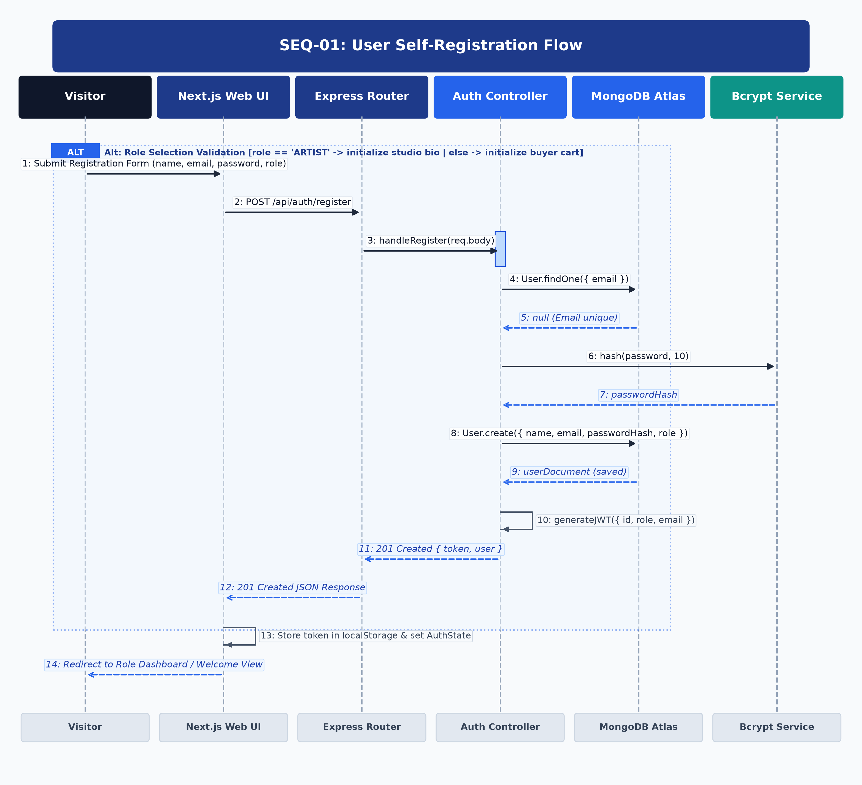
Figure: UML Sequence Diagram for SEQ-01
Architectural Lifelines & Participants: Visitor (Actor) -> Next.js Web UI -> Express Router -> Auth Controller -> MongoDB Atlas -> Bcrypt Service
Step | Source | Target | Message / Operation | Protocol / Status | Payload / Data
1 | Visitor | Next.js UI | Submit Registration Form | DOM Event | { name, email, password, role }
2 | Next.js UI | Express Router | POST /api/auth/register | HTTP/REST | JSON Body: { name, email, password, role }
3 | Express Router | Auth Controller | handleRegister(req.body) | Internal Call | Validated DTO payload
4 | Auth Controller | MongoDB Atlas | User.findOne({ email }) | Mongoose Query | Indexed email filter
5 | MongoDB Atlas | Auth Controller | null (Email is unique) | DB Cursor | No conflict found
6 | Auth Controller | Bcrypt Service | hash(password, 10) | Crypto Execution | 10 Salt Rounds
7 | Bcrypt Service | Auth Controller | passwordHash string | Return Hash | Bcrypt SHA-512 digest
8 | Auth Controller | MongoDB Atlas | User.create({ ...data, passwordHash }) | Mongoose Write | New User document
9 | MongoDB Atlas | Auth Controller | Saved User Document | DB Result | Generated _id: ObjectId
10 | Auth Controller | Auth Controller | generateJWT({ id, role, email }) | HMAC-SHA256 | Signed with JWT_SECRET
11 | Auth Controller | Next.js UI | 201 Created Response | HTTP 201 | { token: 'eyJ...', user: { id, name, role } }
12 | Next.js UI | Visitor | Redirect to Dashboard | Client Nav | Session established in localStorage

[ALTERNATIVE & EXCEPTION FLOWS] If email already exists, MongoDB returns matching user record; Auth Controller returns HTTP 409 Conflict; client renders error toast.

SEQ-02: User Authentication & JWT Session Issuance
Illustrates credential validation for existing users. The Auth Controller retrieves the user document by email, executes Bcrypt password hash comparison, and generates a signed JWT bearer token.

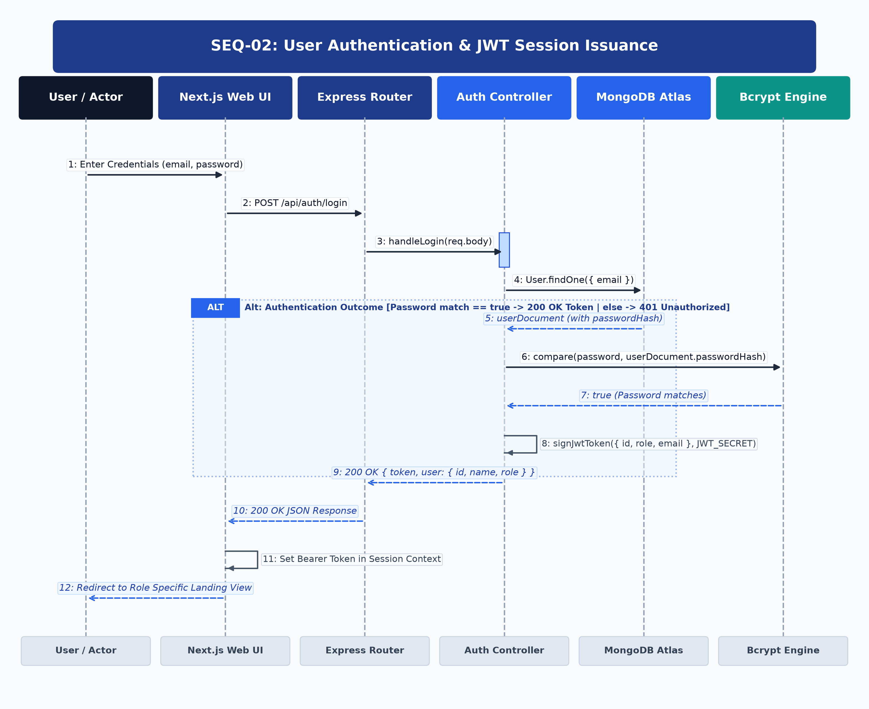
Figure: UML Sequence Diagram for SEQ-02
Architectural Lifelines & Participants: User / Actor -> Next.js Web UI -> Express Router -> Auth Controller -> MongoDB Atlas -> Bcrypt Engine
Step | Source | Target | Message / Operation | Protocol / Status | Payload / Data
1 | User | Next.js UI | Enter Credentials & Submit | DOM Event | { email, password }
2 | Next.js UI | Express Router | POST /api/auth/login | HTTP/REST | JSON: { email, password }
3 | Express Router | Auth Controller | handleLogin(req.body) | Internal Dispatch | Sanitized credentials
4 | Auth Controller | MongoDB Atlas | User.findOne({ email }) | Mongoose Query | Email index query
5 | MongoDB Atlas | Auth Controller | userDocument (with hash) | DB Cursor | User Record
6 | Auth Controller | Bcrypt Engine | compare(password, passwordHash) | Crypto Compare | Constant-time comparison
7 | Bcrypt Engine | Auth Controller | true (Credentials valid) | Boolean | Match confirmation
8 | Auth Controller | Auth Controller | signJwtToken(payload, JWT_SECRET) | JWT Sign | Token expiration 7d
9 | Auth Controller | Next.js UI | 200 OK Response | HTTP 200 | { token, user: { id, name, role } }
10 | Next.js UI | User | Route to Role Dashboard | Client Nav | Admin/Artist/Customer dashboard

[ALTERNATIVE & EXCEPTION FLOWS] If password fails comparison, Auth Controller returns HTTP 401 Unauthorized; client increments failed login counter and shows error.

SEQ-03: Profile & Studio Portfolio Management
Details profile and studio portfolio mutations. Express Auth Middleware verifies the JWT bearer token, extracts user ID claims, and updates user profile attributes in MongoDB.

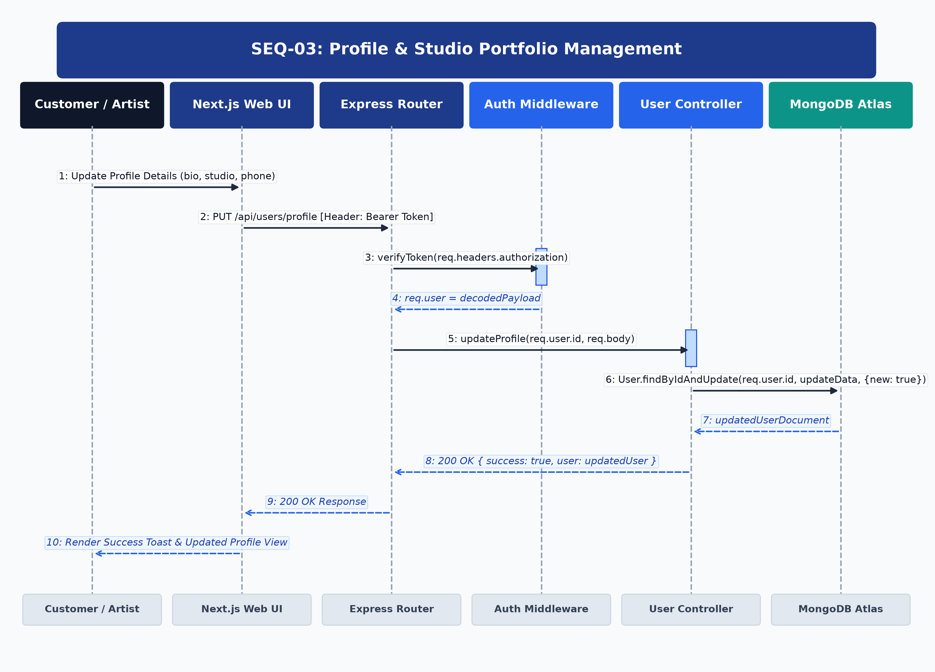
Figure: UML Sequence Diagram for SEQ-03
Architectural Lifelines & Participants: Customer / Artist -> Next.js Web UI -> Express Router -> Auth Middleware -> User Controller -> MongoDB Atlas
Step | Source | Target | Message / Operation | Protocol / Status | Payload / Data
1 | User | Next.js UI | Edit Bio, Studio & Phone | DOM Event | Form Inputs
2 | Next.js UI | Express Router | PUT /api/users/profile | HTTP/REST | Header: Bearer <token>, Body: { bio, studio, phone }
3 | Express Router | Auth Middleware | verifyToken(req.headers) | JWT Verify | Signature & Expiry Check
4 | Auth Middleware | Express Router | req.user = decodedToken | Context Pass | { id: 'usr_123', role: 'ARTIST' }
5 | Express Router | User Controller | updateProfile(req.user.id, body) | Internal Call | Sanitized update object
6 | User Controller | MongoDB Atlas | User.findByIdAndUpdate() | Mongoose Write | { bio, studioAddress, phone }
7 | MongoDB Atlas | User Controller | updatedUserDoc | DB Result | Modified document
8 | User Controller | Next.js UI | 200 OK Response | HTTP 200 | { success: true, user: updatedUserDoc }
9 | Next.js UI | User | Render Success Toast | UI Update | Profile updated in state

[ALTERNATIVE & EXCEPTION FLOWS] If token is missing or expired, Auth Middleware returns HTTP 401 Unauthorized; client prompts re-authentication.

SEQ-04: Administrative User & Role Governance
Demonstrates administrator user governance workflows. RBAC Middleware strictly enforces role=='ADMIN' claims before permitting account status toggles or role promotions.

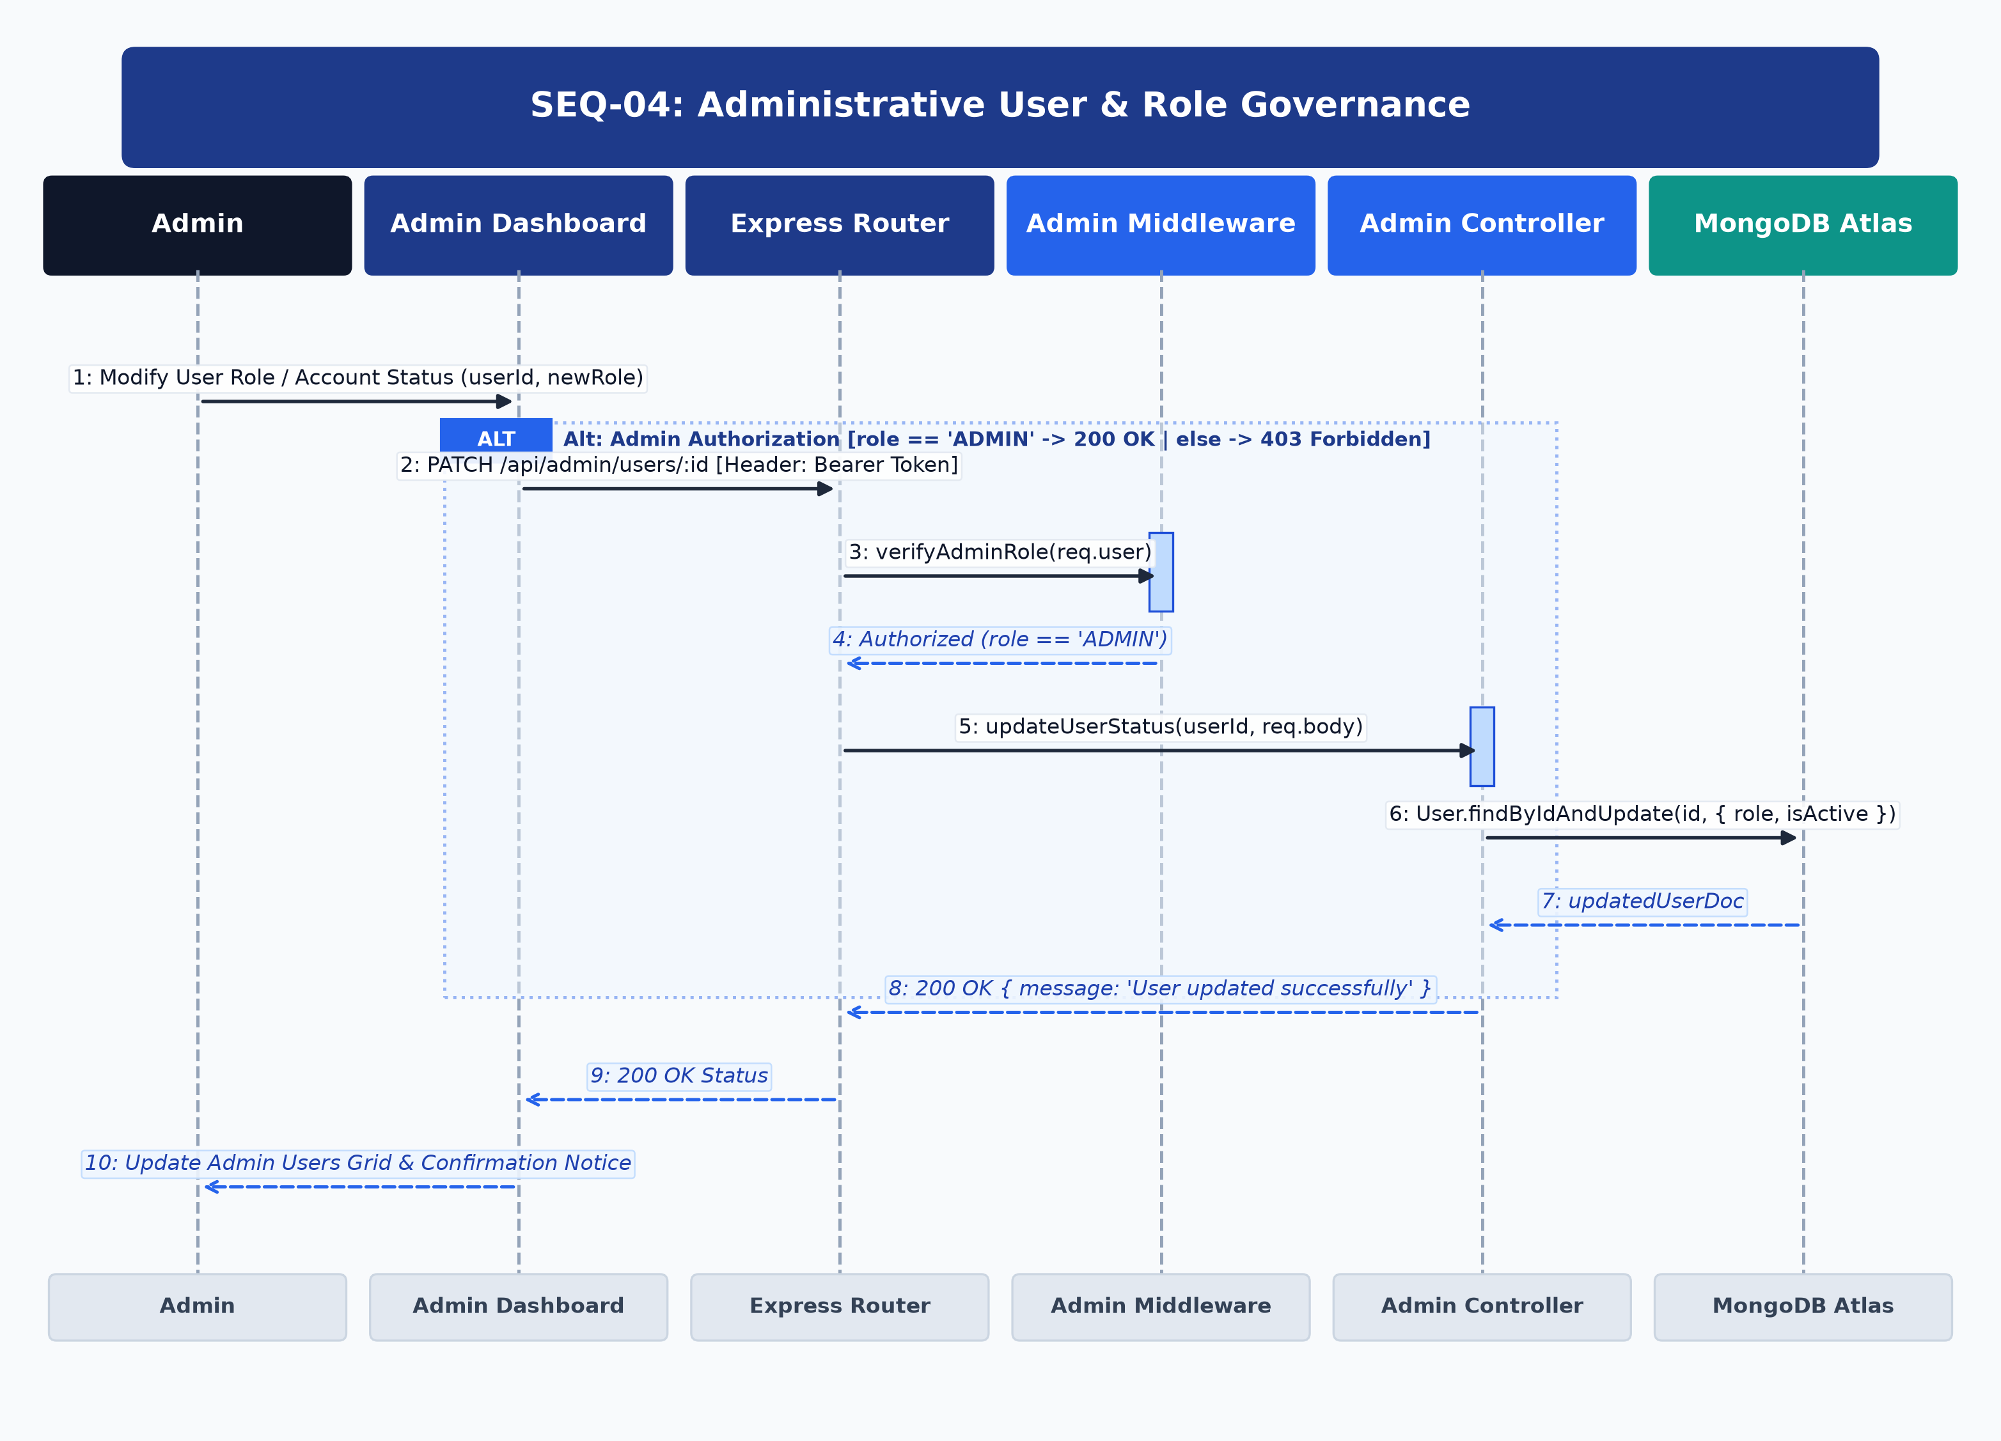
Figure: UML Sequence Diagram for SEQ-04
Architectural Lifelines & Participants: Admin -> Admin Dashboard -> Express Router -> Admin Middleware -> Admin Controller -> MongoDB Atlas
Step | Source | Target | Message / Operation | Protocol / Status | Payload / Data
1 | Admin | Admin Dashboard | Change User Role / Status | UI Action | { userId, newRole: 'ARTIST', isActive: true }
2 | Admin Dashboard | Express Router | PATCH /api/admin/users/:id | HTTP/REST | Header: Bearer <admin_token>
3 | Express Router | Admin Middleware | verifyAdminRole(req.user) | RBAC Guard | Check req.user.role == 'ADMIN'
4 | Admin Middleware | Express Router | Authorized Pass | Permission Pass | Admin permission confirmed
5 | Express Router | Admin Controller | updateUserStatus(id, body) | Internal Call | Target user update
6 | Admin Controller | MongoDB Atlas | User.findByIdAndUpdate() | Mongoose Write | { role: 'ARTIST', isActive: true }
7 | MongoDB Atlas | Admin Controller | updatedUserDoc | DB Result | Updated user record
8 | Admin Controller | Admin Dashboard | 200 OK Response | HTTP 200 | { message: 'User updated successfully' }
9 | Admin Dashboard | Admin | Update Data Grid | DOM Update | Refreshed user table

[ALTERNATIVE & EXCEPTION FLOWS] If non-admin caller attempts endpoint, Admin Middleware returns HTTP 403 Forbidden; request is logged in security auditor.

SEQ-05: Artwork Listing Creation & Cloudinary Upload
Covers high-resolution artwork asset uploading and listing creation. The client uploads the image file directly to Cloudinary CDN via signed parameters, then persists artwork metadata to MongoDB in 'PENDING' approval status.

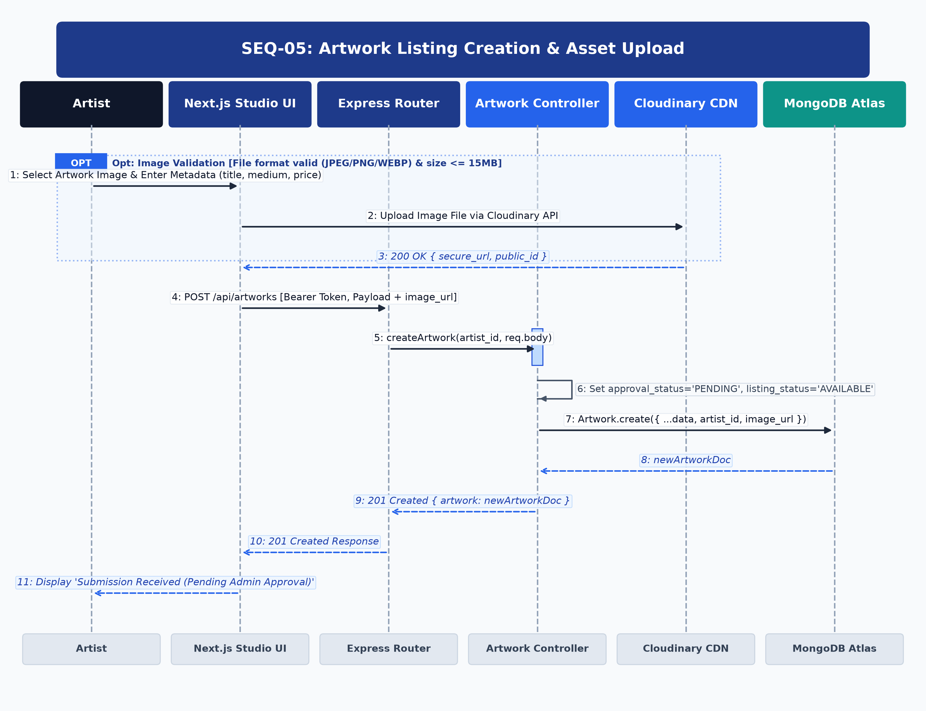
Figure: UML Sequence Diagram for SEQ-05
Architectural Lifelines & Participants: Artist -> Next.js Studio UI -> Express Router -> Artwork Controller -> Cloudinary CDN -> MongoDB Atlas
Step | Source | Target | Message / Operation | Protocol / Status | Payload / Data
1 | Artist | Next.js UI | Attach Media & Enter Info | UI Action | { title, medium, dimensions, price, file }
2 | Next.js UI | Cloudinary CDN | Upload Image File | HTTPS POST | Signed Upload Preset (max 15MB)
3 | Cloudinary CDN | Next.js UI | 200 OK Upload Result | HTTPS Response | { secure_url, public_id, width, height }
4 | Next.js UI | Express Router | POST /api/artworks | HTTP/REST | Header: Bearer <token>, Body: { ...metadata, image_url }
5 | Express Router | Artwork Controller | createArtwork(artistId, body) | Internal Call | Initializes PENDING approval
6 | Artwork Controller | MongoDB Atlas | Artwork.create() | Mongoose Write | { title, price, approval_status: 'PENDING', listing_status: 'AVAILABLE' }
7 | MongoDB Atlas | Artwork Controller | newArtworkDoc | DB Result | Generated Artwork _id
8 | Artwork Controller | Next.js UI | 201 Created Response | HTTP 201 | { artwork: newArtworkDoc }
9 | Next.js UI | Artist | Render Curation Notice | UI Update | 'Submission Received. Pending Admin Curation.'

[ALTERNATIVE & EXCEPTION FLOWS] If image upload to Cloudinary fails, client aborts artwork creation and notifies artist with error details.

SEQ-06: Artwork Listing Maintenance & Price Update
Details artwork modification workflows. The Ownership Guard ensures only the creator artist (or Admin) can update price, dimensions, or descriptions of unsold listings.

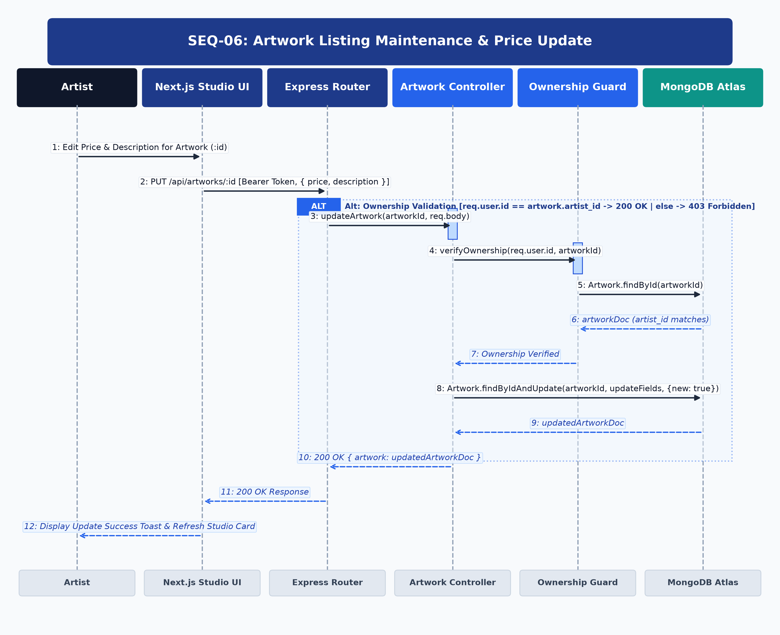
Figure: UML Sequence Diagram for SEQ-06
Architectural Lifelines & Participants: Artist -> Next.js Studio UI -> Express Router -> Artwork Controller -> Ownership Guard -> MongoDB Atlas
Step | Source | Target | Message / Operation | Protocol / Status | Payload / Data
1 | Artist | Next.js UI | Edit Price & Description | UI Action | { price: 750, description: 'Updated' }
2 | Next.js UI | Express Router | PUT /api/artworks/:id | HTTP/REST | Header: Bearer <token>, Body: { price, description }
3 | Express Router | Artwork Controller | updateArtwork(id, body) | Internal Call | Target artwork update
4 | Artwork Controller | Ownership Guard | verifyOwnership(userId, artId) | Security Check | Check artist_id matches
5 | Ownership Guard | MongoDB Atlas | Artwork.findById(artId) | Mongoose Query | Fetch artist_id
6 | MongoDB Atlas | Ownership Guard | artworkDoc | DB Result | artist_id confirmed
7 | Ownership Guard | Artwork Controller | Ownership Confirmed | Guard Pass | Authorized
8 | Artwork Controller | MongoDB Atlas | Artwork.findByIdAndUpdate() | Mongoose Write | Update fields in MongoDB
9 | MongoDB Atlas | Artwork Controller | updatedArtworkDoc | DB Result | Fresh document
10 | Artwork Controller | Next.js UI | 200 OK Response | HTTP 200 | { artwork: updatedArtworkDoc }
11 | Next.js UI | Artist | Render Success Toast | DOM Update | Studio card refreshed

[ALTERNATIVE & EXCEPTION FLOWS] If caller is not the listing creator, Ownership Guard throws HTTP 403 Forbidden; if item is already SOLD, update is rejected with HTTP 400.

SEQ-07: Artwork Status Mutation & Removal
Illustrates artwork status transitions (AVAILABLE -> RESERVED -> SOLD) and soft-deletion. All status changes are atomically written to MongoDB Atlas and logged in the AuditLog collection.

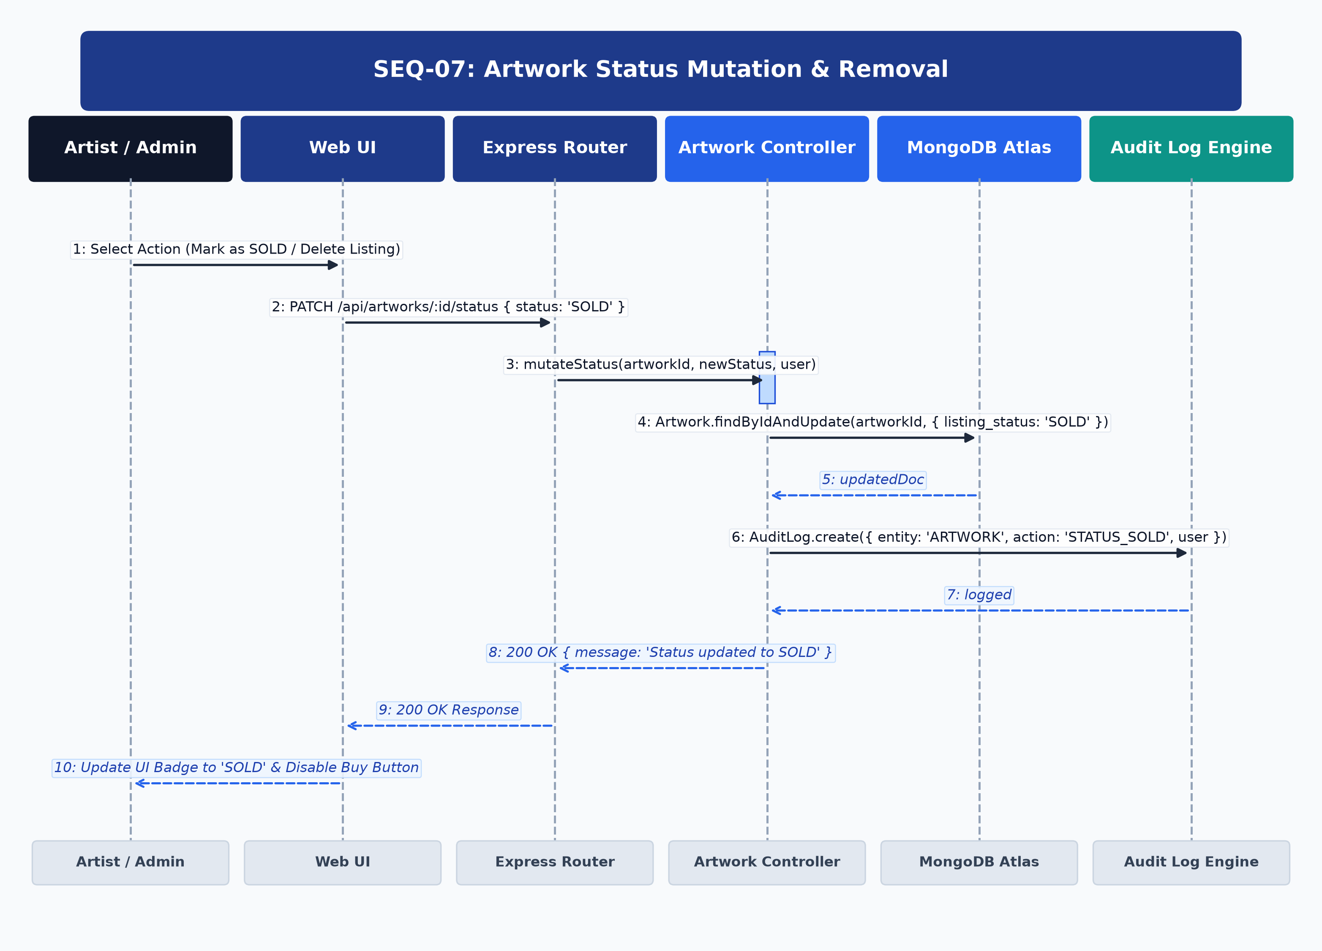
Figure: UML Sequence Diagram for SEQ-07
Architectural Lifelines & Participants: Artist / Admin -> Web UI -> Express Router -> Artwork Controller -> MongoDB Atlas -> Audit Log Engine
Step | Source | Target | Message / Operation | Protocol / Status | Payload / Data
1 | User | Web UI | Select 'Mark as SOLD' / Delete | UI Action | { action: 'MARK_SOLD' }
2 | Web UI | Express Router | PATCH /api/artworks/:id/status | HTTP/REST | Header: Bearer <token>, Body: { status: 'SOLD' }
3 | Express Router | Artwork Controller | mutateStatus(id, 'SOLD') | Internal Call | Status transition
4 | Artwork Controller | MongoDB Atlas | Artwork.findByIdAndUpdate() | Mongoose Write | { listing_status: 'SOLD' }
5 | MongoDB Atlas | Artwork Controller | updatedDoc | DB Result | Status updated
6 | Artwork Controller | Audit Log Engine | AuditLog.create() | Audit Event | { entity: 'ARTWORK', action: 'SOLD', user }
7 | Audit Log Engine | Artwork Controller | logged | Success | Log entry persisted
8 | Artwork Controller | Web UI | 200 OK Response | HTTP 200 | { message: 'Status updated to SOLD' }
9 | Web UI | User | Render 'SOLD' Badge | DOM Update | Buy button disabled on client

[ALTERNATIVE & EXCEPTION FLOWS] If deletion requested, system performs soft delete (isDeleted: true) preserving order history references.

SEQ-08: Admin Artwork Curation Pipeline
Covers gallery curation by administrators. Approving a pending submission transitions approval_status to 'APPROVED' and automatically dispatches an email notification to the artist.

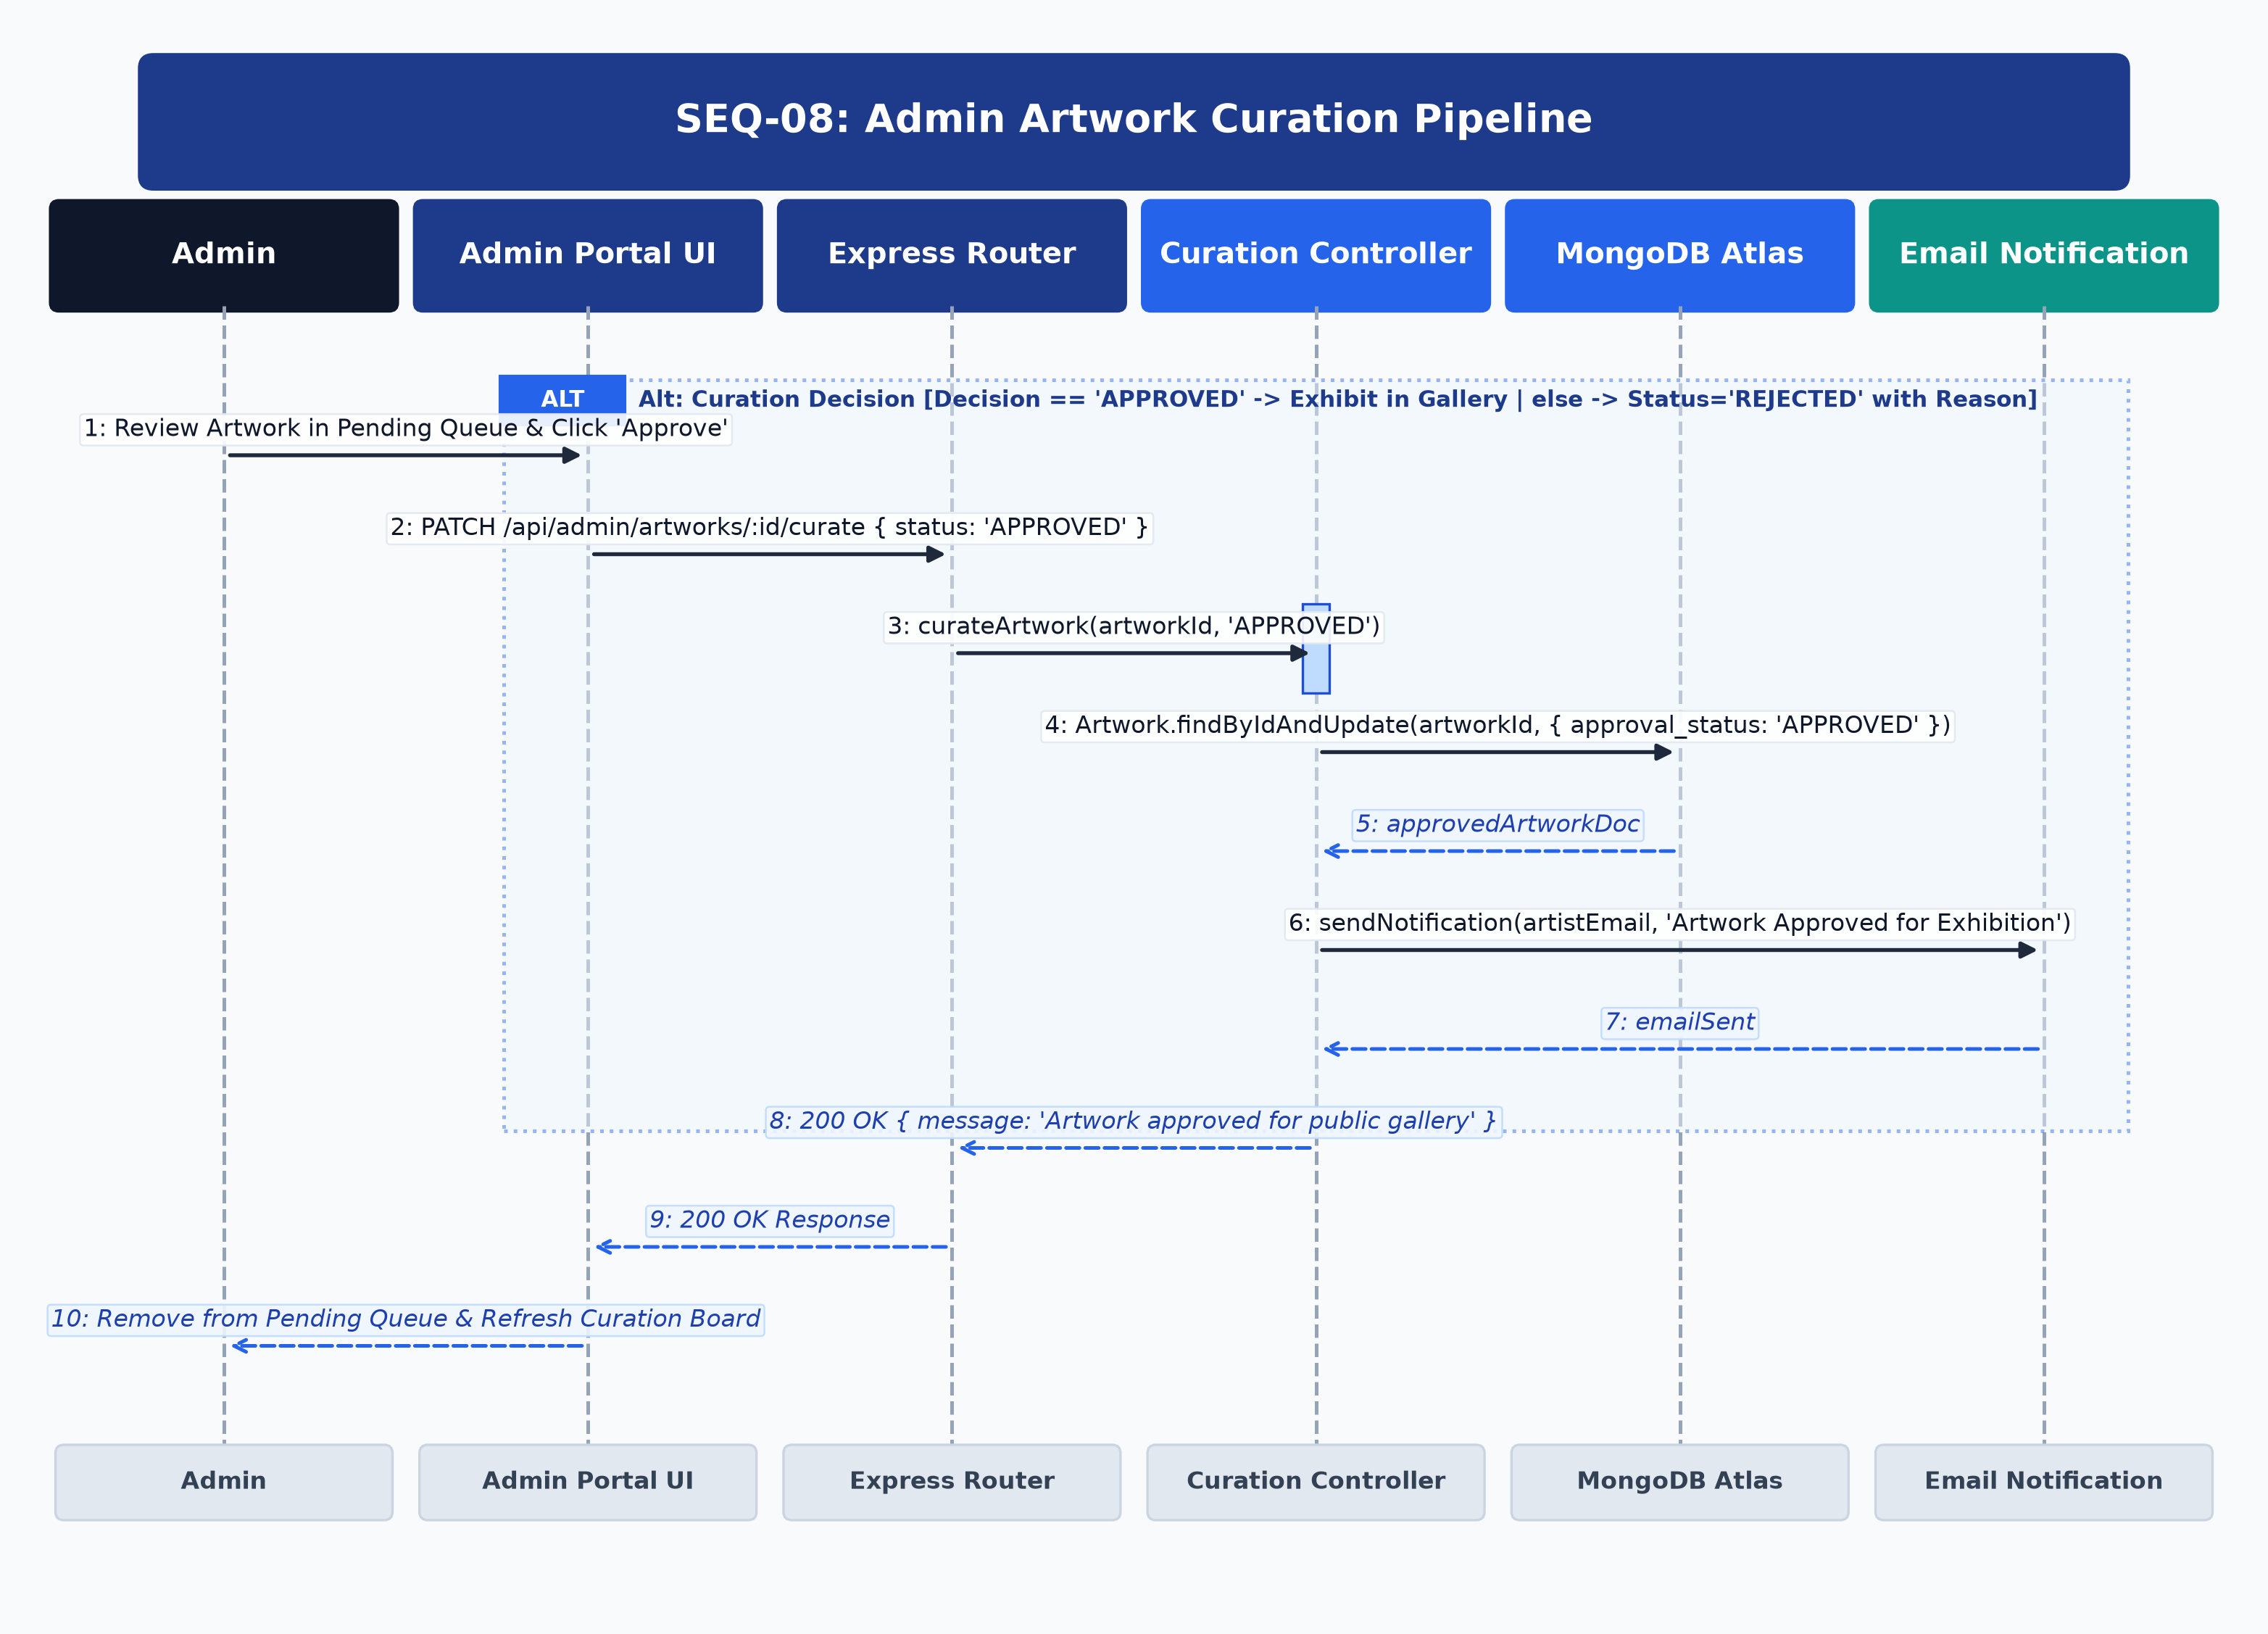
Figure: UML Sequence Diagram for SEQ-08
Architectural Lifelines & Participants: Admin -> Admin Portal UI -> Express Router -> Curation Controller -> MongoDB Atlas -> Email Notification
Step | Source | Target | Message / Operation | Protocol / Status | Payload / Data
1 | Admin | Admin Portal UI | Click 'Approve Submission' | UI Action | { decision: 'APPROVED' }
2 | Admin Portal UI | Express Router | PATCH /api/admin/artworks/:id/curate | HTTP/REST | Header: Bearer <admin_token>, Body: { status: 'APPROVED' }
3 | Express Router | Curation Controller | curateArtwork(id, 'APPROVED') | Internal Call | Curation logic
4 | Curation Controller | MongoDB Atlas | Artwork.findByIdAndUpdate() | Mongoose Write | { approval_status: 'APPROVED' }
5 | MongoDB Atlas | Curation Controller | approvedArtworkDoc | DB Result | Document updated
6 | Curation Controller | Email Notification | sendNotification(artistEmail) | Async Email | 'Artwork Approved for Gallery Exhibition'
7 | Email Notification | Curation Controller | emailDispatched | SMTP Result | Queued
8 | Curation Controller | Admin Portal UI | 200 OK Response | HTTP 200 | { message: 'Artwork approved for public gallery' }
9 | Admin Portal UI | Admin | Remove from Queue | UI Update | Queue refreshed; artwork live in gallery

[ALTERNATIVE & EXCEPTION FLOWS] If admin rejects listing, status is set to 'REJECTED' with reason text, and email is sent explaining feedback.

SEQ-09: Browse Public Gallery with Multi-Criteria Filtering
Details high-speed public gallery browsing. Express Catalog Controller queries indexed fields in MongoDB Atlas (approval_status, medium, price range) and returns paginated datasets with Cloudinary WebP thumbnail URLs.

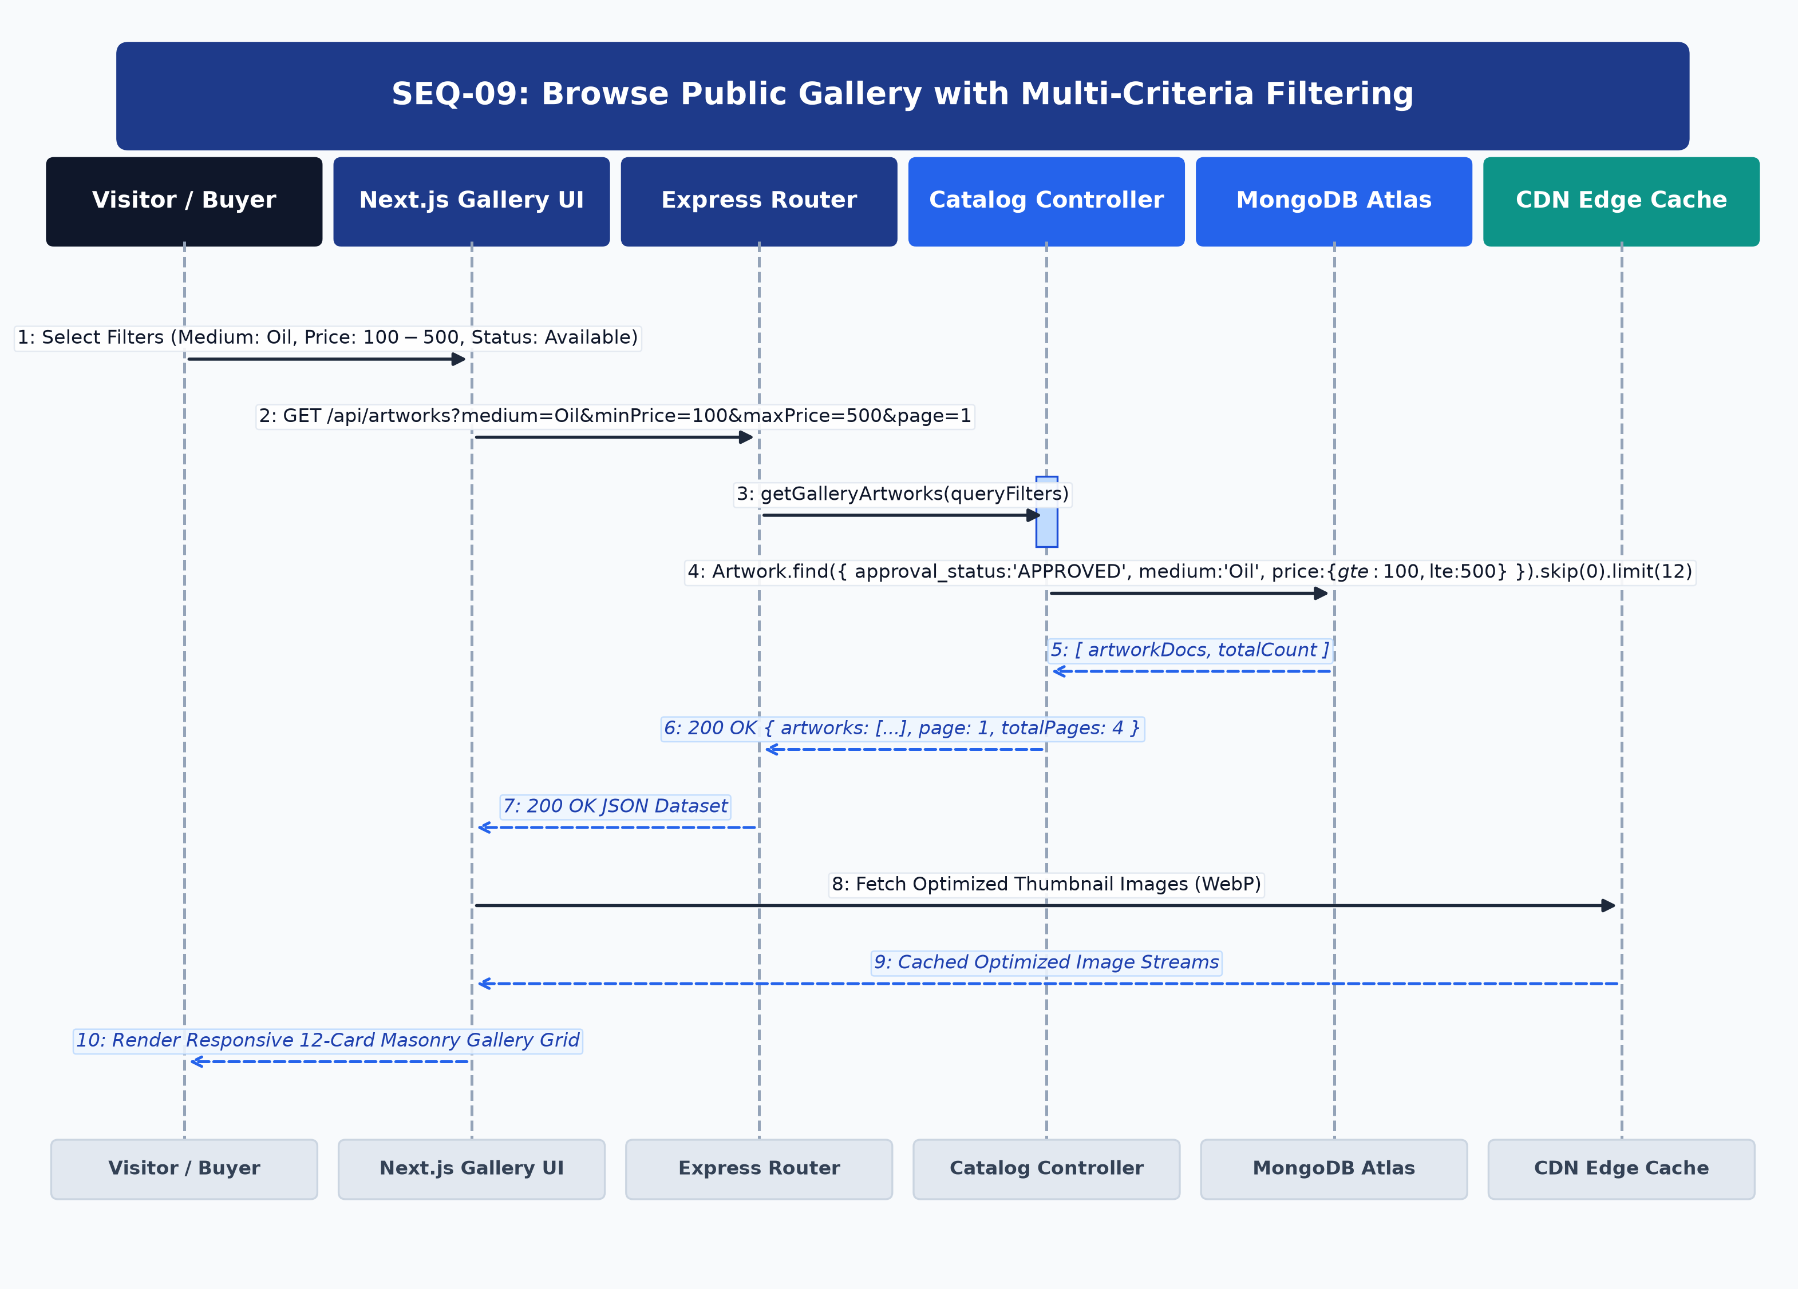
Figure: UML Sequence Diagram for SEQ-09
Architectural Lifelines & Participants: Visitor / Buyer -> Next.js Gallery UI -> Express Router -> Catalog Controller -> MongoDB Atlas -> CDN Edge Cache
Step | Source | Target | Message / Operation | Protocol / Status | Payload / Data
1 | Visitor | Next.js UI | Select Filters (Oil, $100-$500) | UI Action | Filter parameters
2 | Next.js UI | Express Router | GET /api/artworks?medium=Oil&min=100&max=500 | HTTP/REST | Query string params
3 | Express Router | Catalog Controller | getGalleryArtworks(filters) | Internal Call | Compound query builder
4 | Catalog Controller | MongoDB Atlas | Artwork.find({ approval_status: 'APPROVED', ... }) | Mongoose Query | Indexed compound query with limit 12
5 | MongoDB Atlas | Catalog Controller | [ artworkDocs, totalCount ] | DB Result | Paginated array
6 | Catalog Controller | Next.js UI | 200 OK Response | HTTP 200 | { artworks: [...], page: 1, totalPages: 4 }
7 | Next.js UI | CDN Edge Cache | Fetch Optimized WebP Media | HTTPS GET | Cloudinary dynamic thumbnails
8 | CDN Edge Cache | Next.js UI | Cached Image Streams | Image Delivery | Optimized WebP bytes
9 | Next.js UI | Visitor | Render 12-Card Masonry Grid | DOM Render | Gallery cards rendered

[ALTERNATIVE & EXCEPTION FLOWS] If zero artworks match filter criteria, client renders empty state illustration with reset button.

SEQ-10: Keyword & Attribute-Based Search Execution
Details text search indexing. Express Search Controller executes MongoDB $text search with $meta textScore weighting across title, medium, description, and artist name.

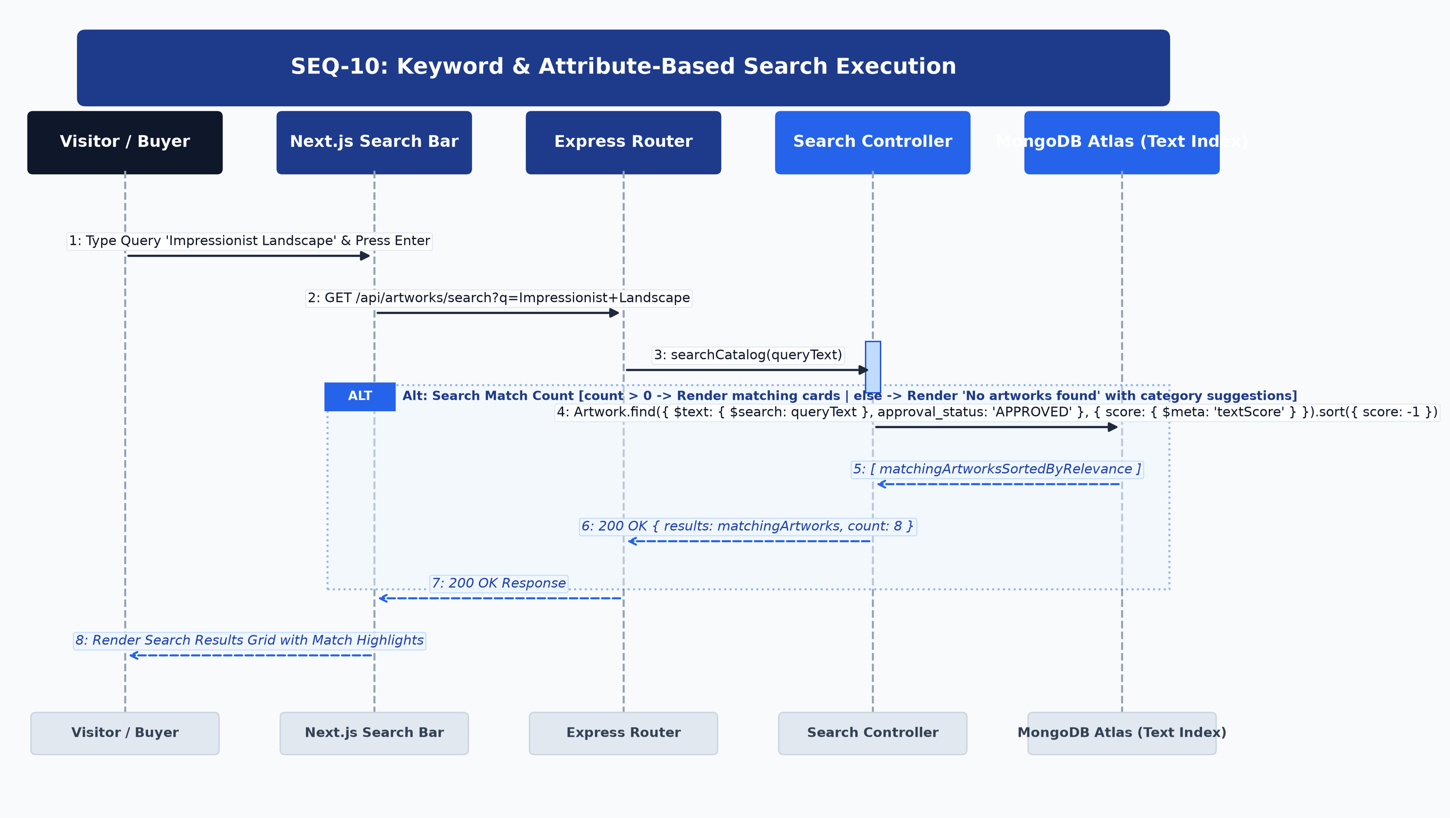
Figure: UML Sequence Diagram for SEQ-10
Architectural Lifelines & Participants: Visitor / Buyer -> Next.js Search Bar -> Express Router -> Search Controller -> MongoDB Atlas (Text Index)
Step | Source | Target | Message / Operation | Protocol / Status | Payload / Data
1 | User | Next.js UI | Type 'Impressionist Landscape' | Input Event | Debounced query text
2 | Next.js UI | Express Router | GET /api/artworks/search?q=Impressionist+Landscape | HTTP/REST | Search query
3 | Express Router | Search Controller | searchCatalog(query) | Internal Call | Sanitized search string
4 | Search Controller | MongoDB Atlas | Artwork.find({ $text: { $search: q }, approval_status: 'APPROVED' }) | Text Index Query | Sorted by textScore desc
5 | MongoDB Atlas | Search Controller | [ matchingArtworks ] | DB Result | Relevance ranked items
6 | Search Controller | Next.js UI | 200 OK Response | HTTP 200 | { results: [...], count: 8 }
7 | Next.js UI | User | Render Search Grid | DOM Update | Matching artwork cards displayed

[ALTERNATIVE & EXCEPTION FLOWS] If 0 matches found, server returns empty array; client displays 'No artworks found' with category suggestions.

SEQ-11: Artwork Social Media Deep-Link Sharing
Covers deep-link sharing and OpenGraph metadata generation. Next.js Server-Side Rendering dynamically generates OpenGraph and Twitter Card meta tags for rich social media feed unfurling.

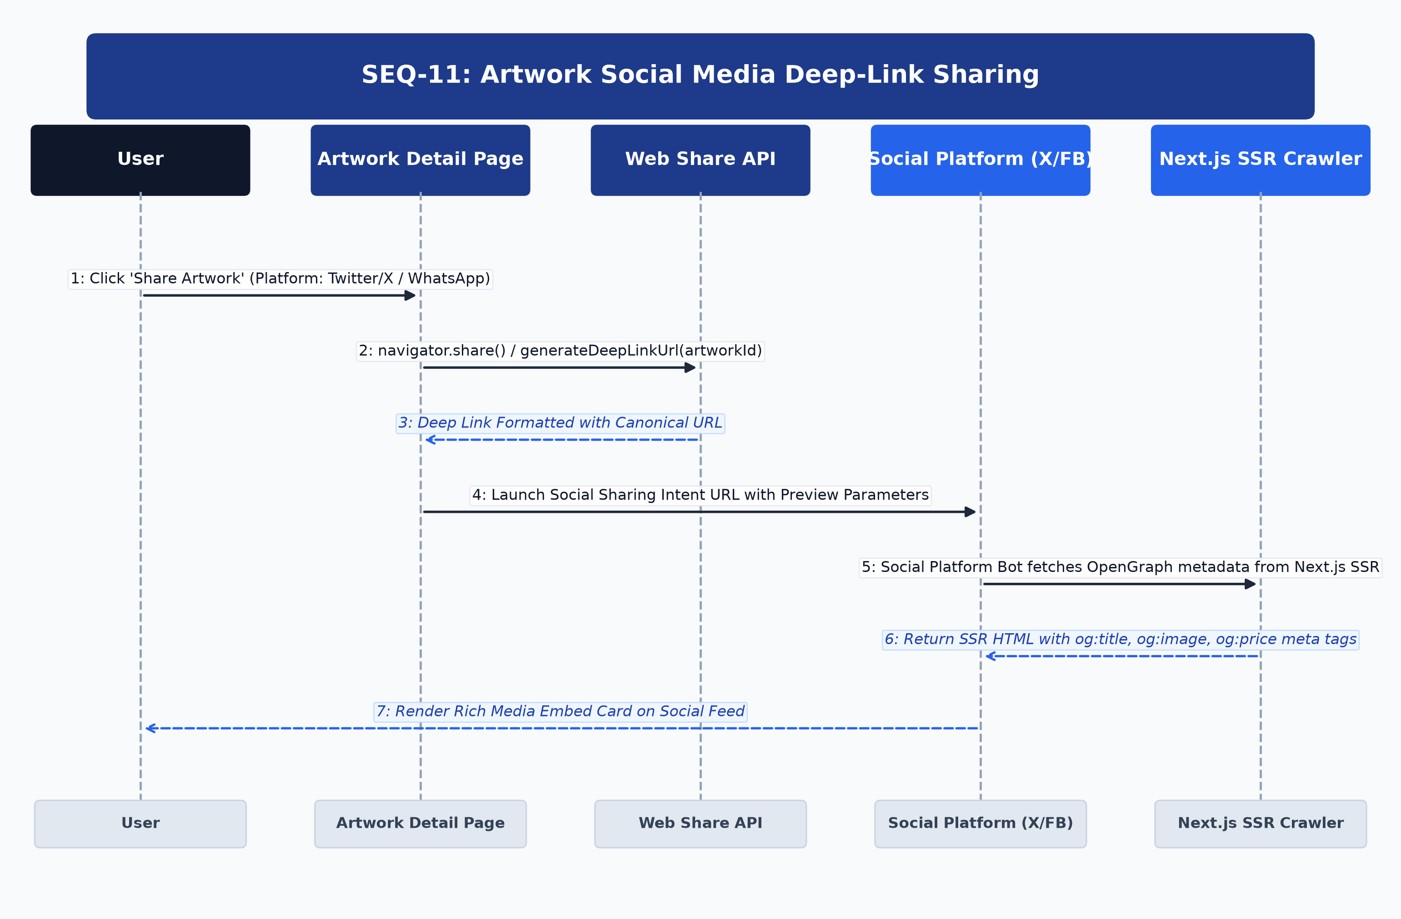
Figure: UML Sequence Diagram for SEQ-11
Architectural Lifelines & Participants: User -> Artwork Detail Page -> Web Share API -> Social Platform (X/FB) -> Next.js SSR Crawler
Step | Source | Target | Message / Operation | Protocol / Status | Payload / Data
1 | User | Detail Page | Click 'Share Artwork' | UI Action | Select Platform
2 | Detail Page | Web Share API | navigator.share() / generateDeepLinkUrl() | Browser API | Canonical URL generated
3 | Web Share API | Detail Page | Formatted Deep Link | Return URL | Canonical link string
4 | Detail Page | Social Platform | Open Social Intent URL | Web Intent | Params: url, text, hashtags
5 | Social Platform | Next.js SSR Crawler | Fetch Canonical HTML for OpenGraph | HTTPS Request | Social bot crawler
6 | Next.js SSR Crawler | Social Platform | Return SSR HTML with og:tags | HTML Stream | og:title, og:image, og:price
7 | Social Platform | User | Render Rich Media Embed Card | Feed Render | Rich preview displayed on feed

[ALTERNATIVE & EXCEPTION FLOWS] If Web Share API is unsupported in browser, custom fallback modal provides instant clipboard copy.

SEQ-12: Shopping Cart Management & Persistence
Details shopping cart additions and persistence. Verifies real-time artwork availability in MongoDB Atlas before updating the user Cart collection and synchronizing client localStorage.

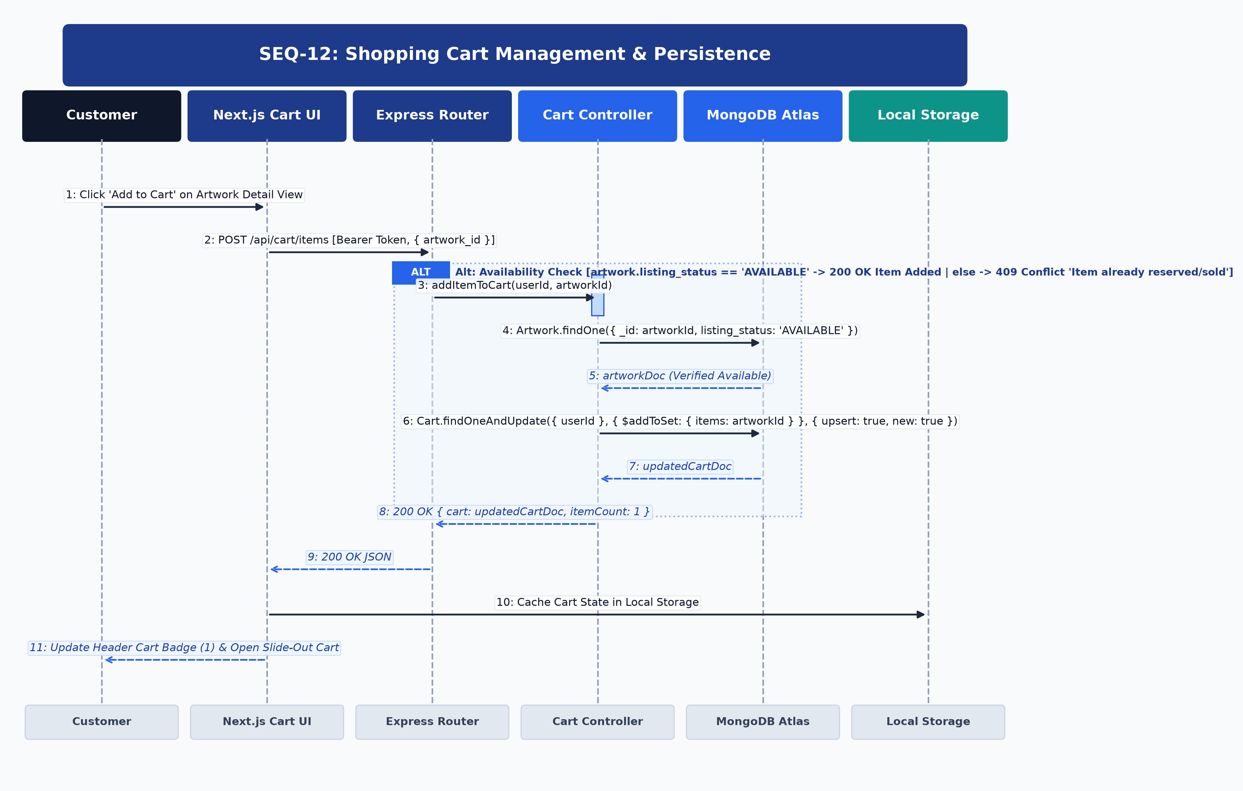
Figure: UML Sequence Diagram for SEQ-12
Architectural Lifelines & Participants: Customer -> Next.js Cart UI -> Express Router -> Cart Controller -> MongoDB Atlas -> Local Storage
Step | Source | Target | Message / Operation | Protocol / Status | Payload / Data
1 | Customer | Next.js UI | Click 'Add to Cart' | UI Action | { artwork_id }
2 | Next.js UI | Express Router | POST /api/cart/items | HTTP/REST | Header: Bearer <token>, Body: { artwork_id }
3 | Express Router | Cart Controller | addItemToCart(userId, artId) | Internal Call | Cart manipulation
4 | Cart Controller | MongoDB Atlas | Artwork.findOne({ _id: artId, listing_status: 'AVAILABLE' }) | Mongoose Query | Verify item availability
5 | MongoDB Atlas | Cart Controller | artworkDoc (Available) | DB Result | Item is available
6 | Cart Controller | MongoDB Atlas | Cart.findOneAndUpdate({ userId }, { $addToSet: { items: artId } }) | Mongoose Write | Upsert Cart document
7 | MongoDB Atlas | Cart Controller | updatedCartDoc | DB Result | Fresh cart record
8 | Cart Controller | Next.js UI | 200 OK Response | HTTP 200 | { cart: updatedCartDoc, count: 1 }
9 | Next.js UI | Local Storage | Sync Cart Cache | Storage Set | Saved to local cache
10 | Next.js UI | Customer | Open Slide-Out Cart Drawer | UI Update | Cart badge updated (1)

[ALTERNATIVE & EXCEPTION FLOWS] If item is already reserved or sold, server returns HTTP 409 Conflict; client shows 'Item no longer available' notification.

SEQ-13: Checkout Formulation & Shipping Validation
Details checkout initiation, address validation, and inventory locking. A 15-minute temporary reservation lock is acquired on the selected artwork to prevent race conditions during payment.

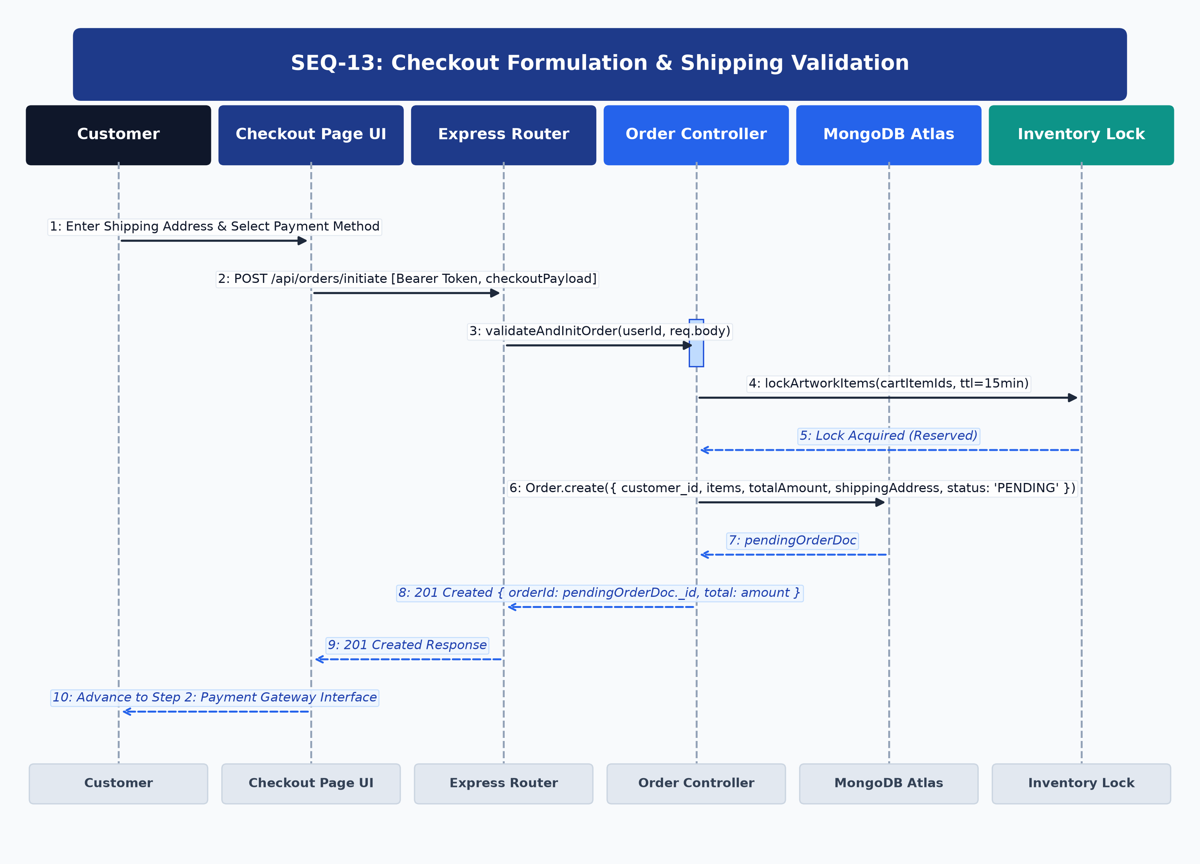
Figure: UML Sequence Diagram for SEQ-13
Architectural Lifelines & Participants: Customer -> Checkout Page UI -> Express Router -> Order Controller -> MongoDB Atlas -> Inventory Lock
Step | Source | Target | Message / Operation | Protocol / Status | Payload / Data
1 | Customer | Checkout UI | Enter Address & Select Payment | UI Action | { shippingAddress, paymentMethod: 'CARD' }
2 | Checkout UI | Express Router | POST /api/orders/initiate | HTTP/REST | Header: Bearer <token>, Body: checkoutPayload
3 | Express Router | Order Controller | validateAndInitOrder(userId, body) | Internal Call | Order formulation
4 | Order Controller | Inventory Lock | lockArtworkItems(items, ttl=15m) | Lock Manager | Temporary reservation lock
5 | Inventory Lock | Order Controller | Lock Acquired | Lock Result | Held for 15 minutes
6 | Order Controller | MongoDB Atlas | Order.create({ customer_id, items, total, status: 'PENDING' }) | Mongoose Write | PENDING order document
7 | MongoDB Atlas | Order Controller | pendingOrderDoc | DB Result | Order created
8 | Order Controller | Checkout UI | 201 Created Response | HTTP 201 | { orderId: pendingOrderDoc._id, total }
9 | Checkout UI | Customer | Advance to Payment Step | UI Stepper | Mounted Stripe Elements

[ALTERNATIVE & EXCEPTION FLOWS] If lock fails due to concurrent checkout, server returns HTTP 409 Conflict 'Artwork currently in checkout by another collector'.

SEQ-14: Online Card Payment Processing (Stripe Integration)
Demonstrates secure end-to-end card processing via Stripe. Backend generates PaymentIntent; customer enters card in Stripe Elements iframe; client confirms with Stripe; backend atomically updates Order to 'PROCESSING' and Artwork to 'SOLD'.

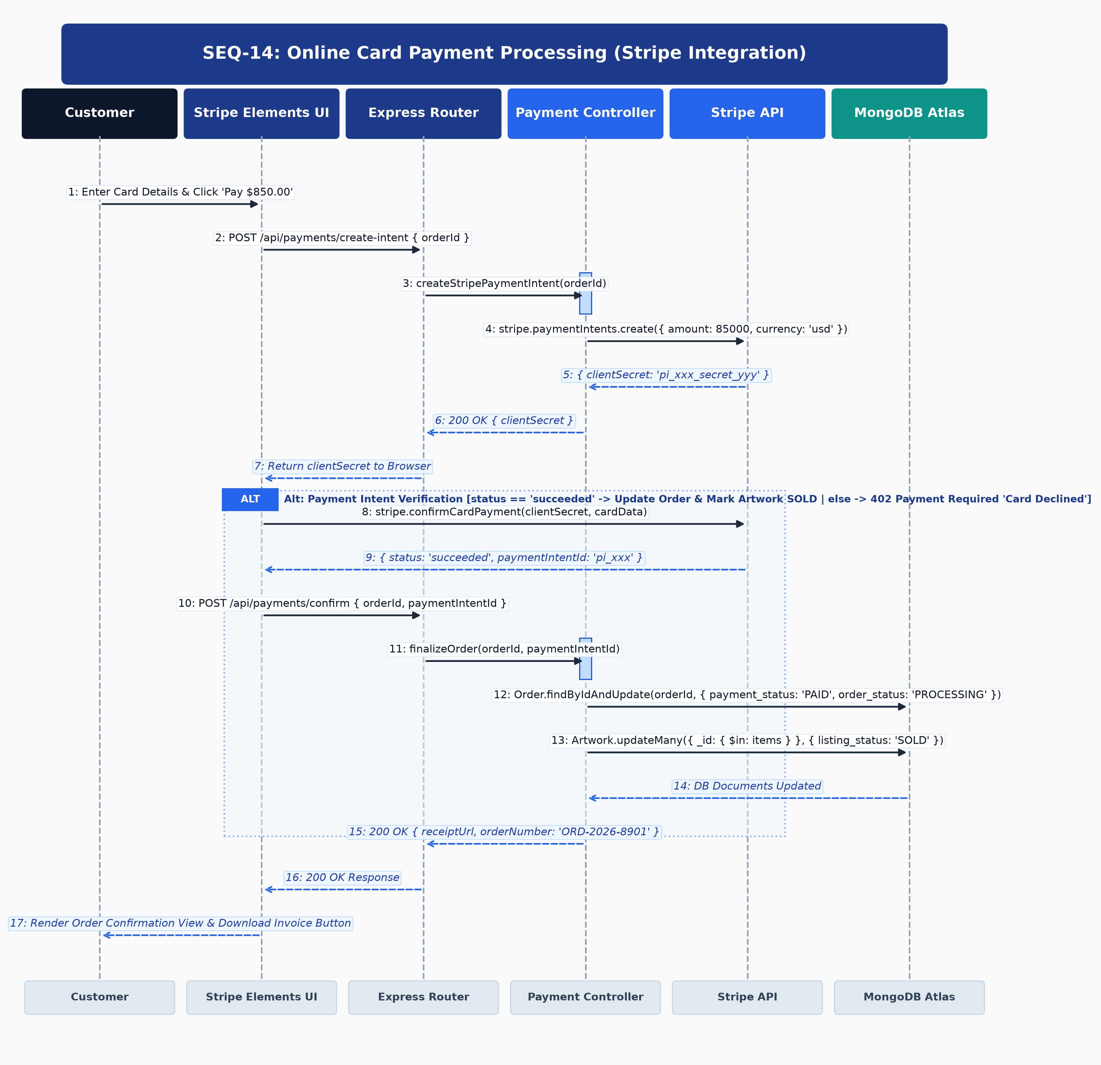
Figure: UML Sequence Diagram for SEQ-14
Architectural Lifelines & Participants: Customer -> Stripe Elements UI -> Express Router -> Payment Controller -> Stripe API -> MongoDB Atlas
Step | Source | Target | Message / Operation | Protocol / Status | Payload / Data
1 | Customer | Stripe Elements | Enter Card Details & Click Pay | UI Action | { cardNumber, exp, cvc }
2 | Stripe Elements | Express Router | POST /api/payments/create-intent | HTTP/REST | { orderId }
3 | Express Router | Payment Controller | createStripePaymentIntent(orderId) | Internal Call | Calculate exact cents
4 | Payment Controller | Stripe API | stripe.paymentIntents.create({ amount: 85000, currency: 'usd' }) | Stripe SDK | PaymentIntent creation
5 | Stripe API | Payment Controller | { clientSecret: 'pi_xxx_secret' } | API Response | Client secret token
6 | Payment Controller | Stripe Elements | 200 OK { clientSecret } | HTTP 200 | Relay to client
7 | Stripe Elements | Stripe API | stripe.confirmCardPayment(clientSecret) | Direct Tokenization | Secure banking capture
8 | Stripe API | Stripe Elements | { status: 'succeeded', paymentIntentId } | Stripe Result | Payment captured
9 | Stripe Elements | Express Router | POST /api/payments/confirm | HTTP/REST | { orderId, paymentIntentId }
10 | Express Router | Payment Controller | finalizeOrder(orderId, paymentIntentId) | Internal Call | Transactional finalize
11 | Payment Controller | MongoDB Atlas | Order.findByIdAndUpdate({ payment_status: 'PAID', order_status: 'PROCESSING' }) | Mongoose Write | Order finalized
12 | Payment Controller | MongoDB Atlas | Artwork.updateMany({ listing_status: 'SOLD' }) | Mongoose Write | Artwork marked SOLD
13 | Payment Controller | Stripe Elements | 200 OK Response | HTTP 200 | { receiptUrl, orderNumber }
14 | Stripe Elements | Customer | Render Order Confirmation | DOM Render | Invoice & confirmation receipt

[ALTERNATIVE & EXCEPTION FLOWS] If card is declined, Stripe returns error; Order remains PENDING; customer prompted with issuing bank reason code.

SEQ-15: Cash on Delivery (COD) Order Placement
Covers Cash on Delivery order execution. Validates verified contact phone, transitions Order to 'PROCESSING', marks Artwork 'RESERVED', and triggers order confirmation SMS/email notifications.

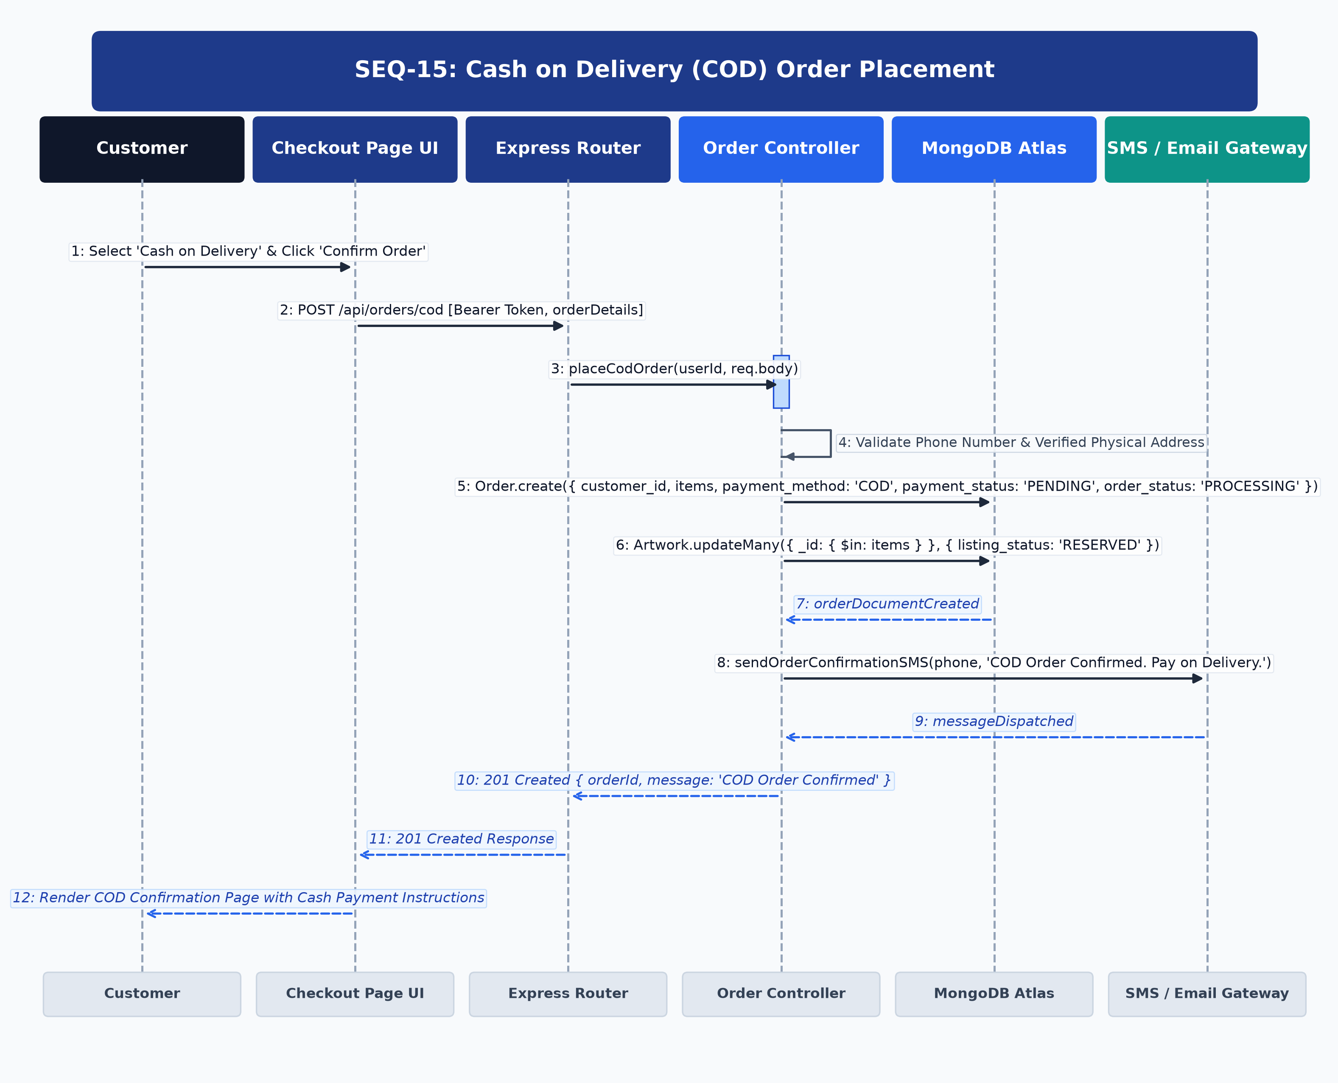
Figure: UML Sequence Diagram for SEQ-15
Architectural Lifelines & Participants: Customer -> Checkout Page UI -> Express Router -> Order Controller -> MongoDB Atlas -> SMS / Email Gateway
Step | Source | Target | Message / Operation | Protocol / Status | Payload / Data
1 | Customer | Checkout UI | Select 'COD' & Confirm Order | UI Action | Confirm Cash terms
2 | Checkout UI | Express Router | POST /api/orders/cod | HTTP/REST | Header: Bearer <token>, Body: orderDetails
3 | Express Router | Order Controller | placeCodOrder(userId, body) | Internal Call | Validate contact details
4 | Order Controller | MongoDB Atlas | Order.create({ payment_method: 'COD', payment_status: 'PENDING', order_status: 'PROCESSING' }) | Mongoose Write | COD Order document
5 | Order Controller | MongoDB Atlas | Artwork.updateMany({ listing_status: 'RESERVED' }) | Mongoose Write | Artwork reserved
6 | Order Controller | SMS / Email Gateway | sendConfirmationSMS(phone, 'COD Confirmed') | Async Gateway | Dispatched SMS notice
7 | SMS / Email Gateway | Order Controller | messageDispatched | Gateway Result | Queued
8 | Order Controller | Checkout UI | 201 Created Response | HTTP 201 | { orderId, message: 'COD Confirmed' }
9 | Checkout UI | Customer | Render COD Confirmation View | DOM Render | Cash payment delivery guidelines

[ALTERNATIVE & EXCEPTION FLOWS] If phone number is invalid, system returns HTTP 400 Bad Request; order is not placed until verified.

SEQ-16: Order Status Lifecycle & Shipment Tracking
Details order status transitions (PENDING -> PROCESSING -> SHIPPED -> DELIVERED) and logistics tracking number registration. Real-time updates populate the customer tracking progress timeline.

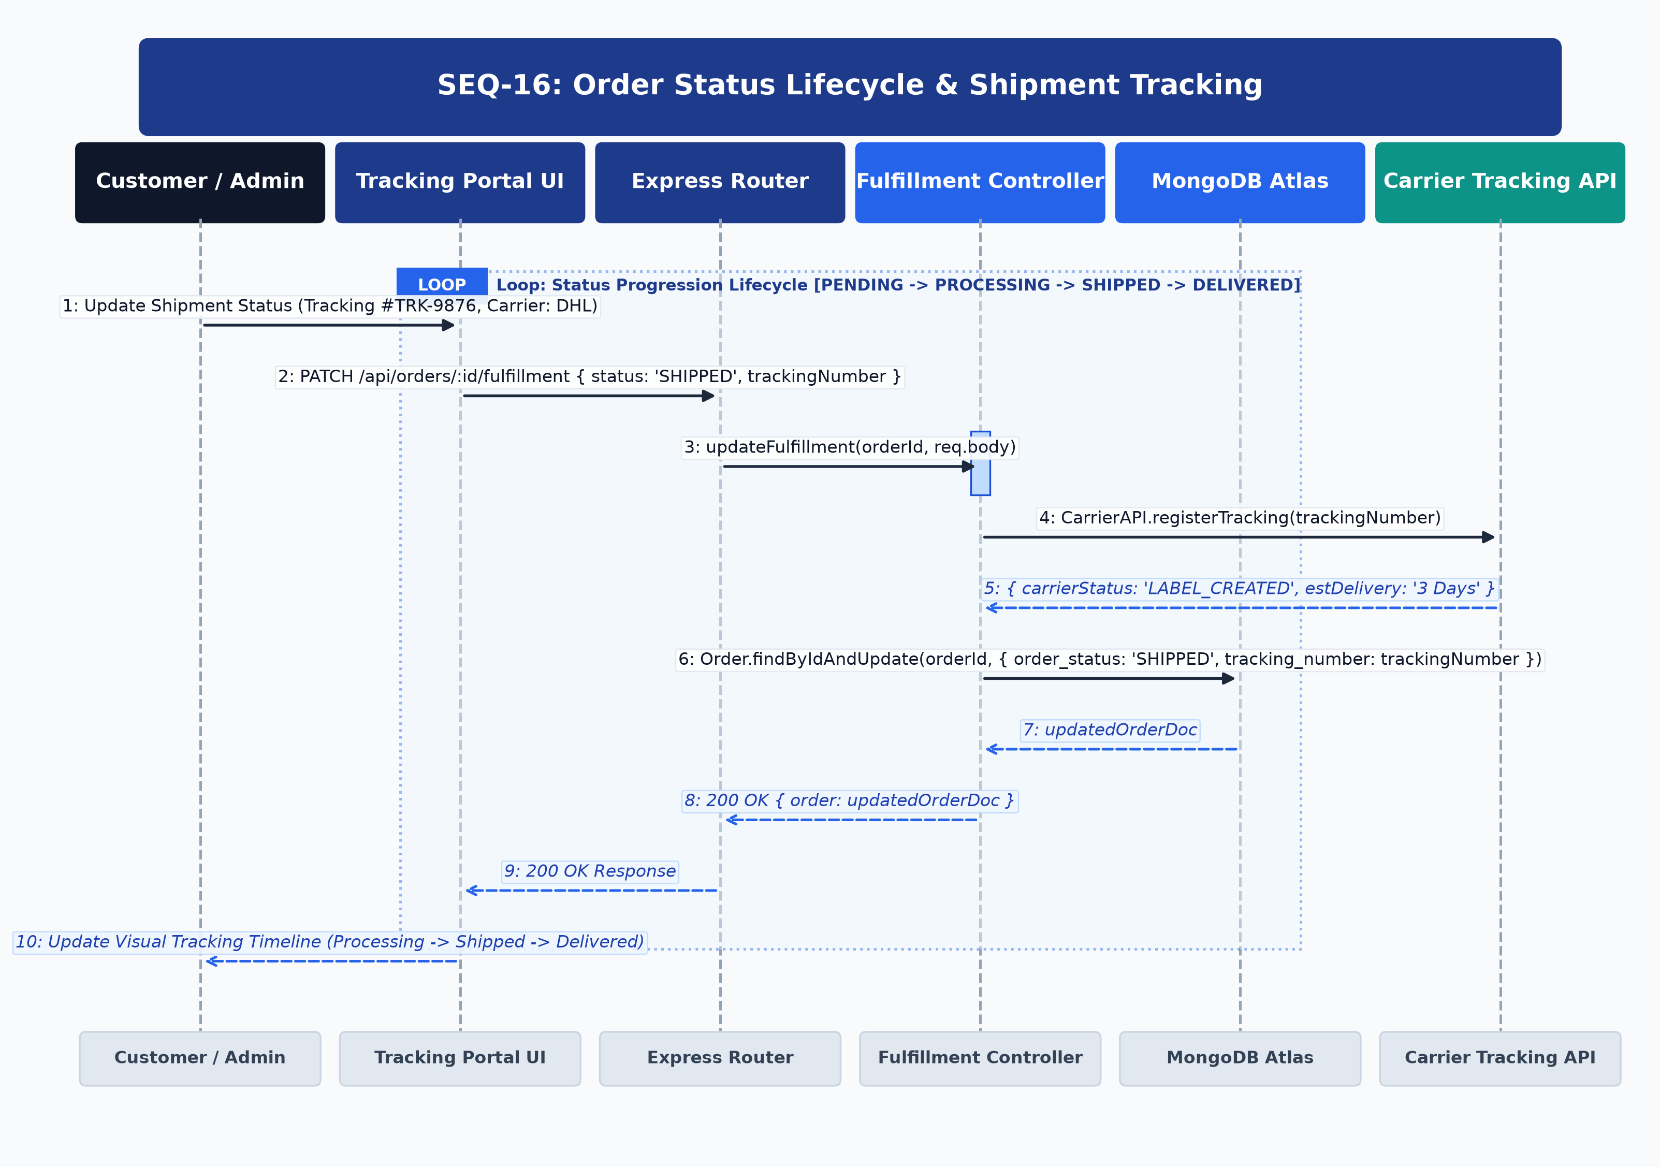
Figure: UML Sequence Diagram for SEQ-16
Architectural Lifelines & Participants: Customer / Admin -> Tracking Portal UI -> Express Router -> Fulfillment Controller -> MongoDB Atlas -> Carrier Tracking API
Step | Source | Target | Message / Operation | Protocol / Status | Payload / Data
1 | Admin | Tracking Portal | Update Status & Carrier Tracking | UI Action | { status: 'SHIPPED', trackingNumber: 'TRK-9876' }
2 | Tracking Portal | Express Router | PATCH /api/orders/:id/fulfillment | HTTP/REST | Header: Bearer <token>, Body: fulfillmentData
3 | Express Router | Fulfillment Controller | updateFulfillment(id, body) | Internal Call | Status transition
4 | Fulfillment Controller | Carrier Tracking API | CarrierAPI.registerTracking(trkNum) | Logistics API | Register carrier webhook
5 | Carrier Tracking API | Fulfillment Controller | { status: 'IN_TRANSIT', estDelivery } | API Result | Carrier confirmed
6 | Fulfillment Controller | MongoDB Atlas | Order.findByIdAndUpdate({ order_status: 'SHIPPED', trackingNumber }) | Mongoose Write | Order document updated
7 | Fulfillment Controller | Tracking Portal | 200 OK Response | HTTP 200 | { order: updatedOrderDoc }
8 | Tracking Portal | Customer | Update Milestone Stepper | UI Stepper | Timeline updated to 'Shipped'

[ALTERNATIVE & EXCEPTION FLOWS] Customer can view live tracking status; when carrier webhook delivers package, status automatically updates to DELIVERED.

SEQ-17: Verified Customer Review & Rating Submission
Covers verified customer review workflows. The Purchase Verification Guard checks MongoDB Orders to confirm the customer has a completed ('DELIVERED') order before permitting review creation and recalculating artist ratings.

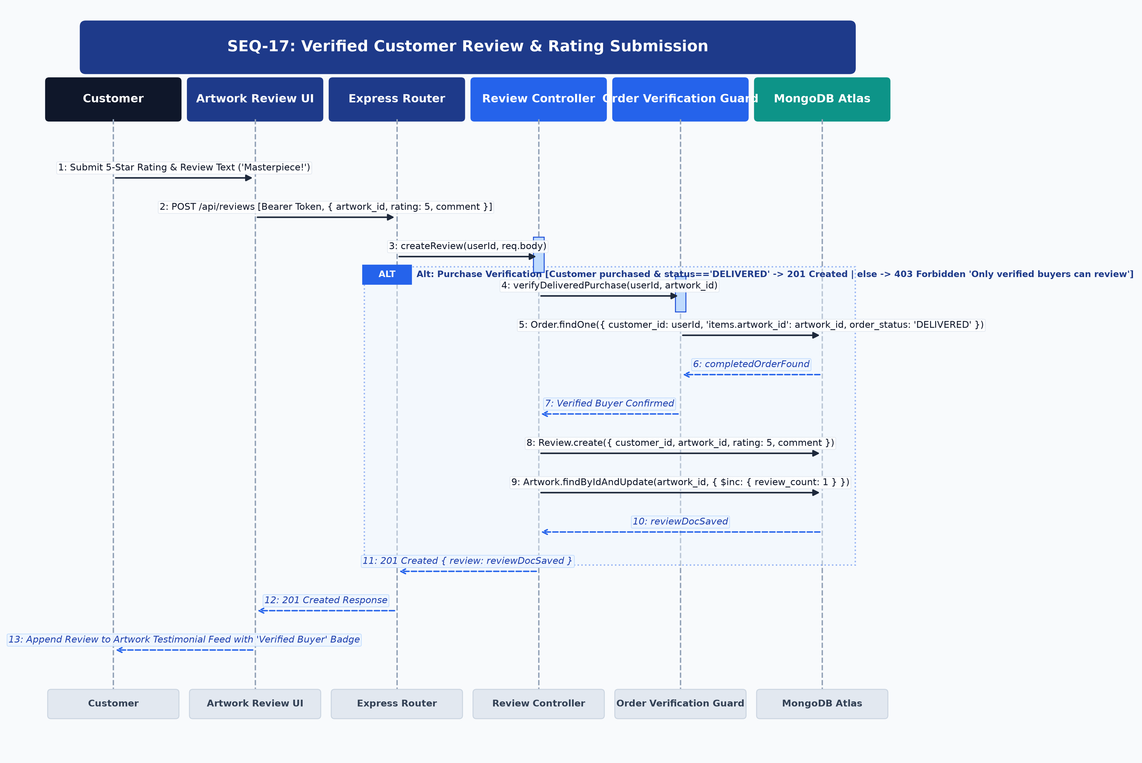
Figure: UML Sequence Diagram for SEQ-17
Architectural Lifelines & Participants: Customer -> Artwork Review UI -> Express Router -> Review Controller -> Order Verification Guard -> MongoDB Atlas
Step | Source | Target | Message / Operation | Protocol / Status | Payload / Data
1 | Customer | Review UI | Submit 5-Star Rating & Review | UI Action | { rating: 5, comment: 'Exceptional piece!' }
2 | Review UI | Express Router | POST /api/reviews | HTTP/REST | Header: Bearer <token>, Body: { artwork_id, rating, comment }
3 | Express Router | Review Controller | createReview(userId, body) | Internal Call | Review initiation
4 | Review Controller | Order Verification Guard | verifyDeliveredPurchase(userId, artId) | Security Guard | Verify completed purchase
5 | Order Verification Guard | MongoDB Atlas | Order.findOne({ customer_id: userId, 'items.artwork_id': artId, order_status: 'DELIVERED' }) | Mongoose Query | Check delivered order
6 | MongoDB Atlas | Order Verification Guard | completedOrderDoc (Confirmed) | DB Result | Verified buyer confirmed
7 | Order Verification Guard | Review Controller | Verification Passed | Guard Pass | Authorized
8 | Review Controller | MongoDB Atlas | Review.create({ customer_id, artwork_id, rating, comment }) | Mongoose Write | Save review document
9 | Review Controller | MongoDB Atlas | Artwork.findByIdAndUpdate({ $inc: { review_count: 1 } }) | Mongoose Write | Update aggregate metrics
10 | Review Controller | Review UI | 201 Created Response | HTTP 201 | { review: reviewDocSaved }
11 | Review UI | Customer | Append Review with Verified Badge | DOM Update | Rendered on artwork testimonials

[ALTERNATIVE & EXCEPTION FLOWS] If user did not purchase the piece or order is not delivered, Order Verification Guard returns HTTP 403 Forbidden 'Only verified buyers can review'.

SEQ-18: Gallery Executive Analytics & Revenue Dashboard
Details administrative aggregation pipelines. The Analytics Controller executes multi-stage MongoDB aggregations for gross settled revenue, sales volume, top artists, and active inventory metrics, with edge caching.

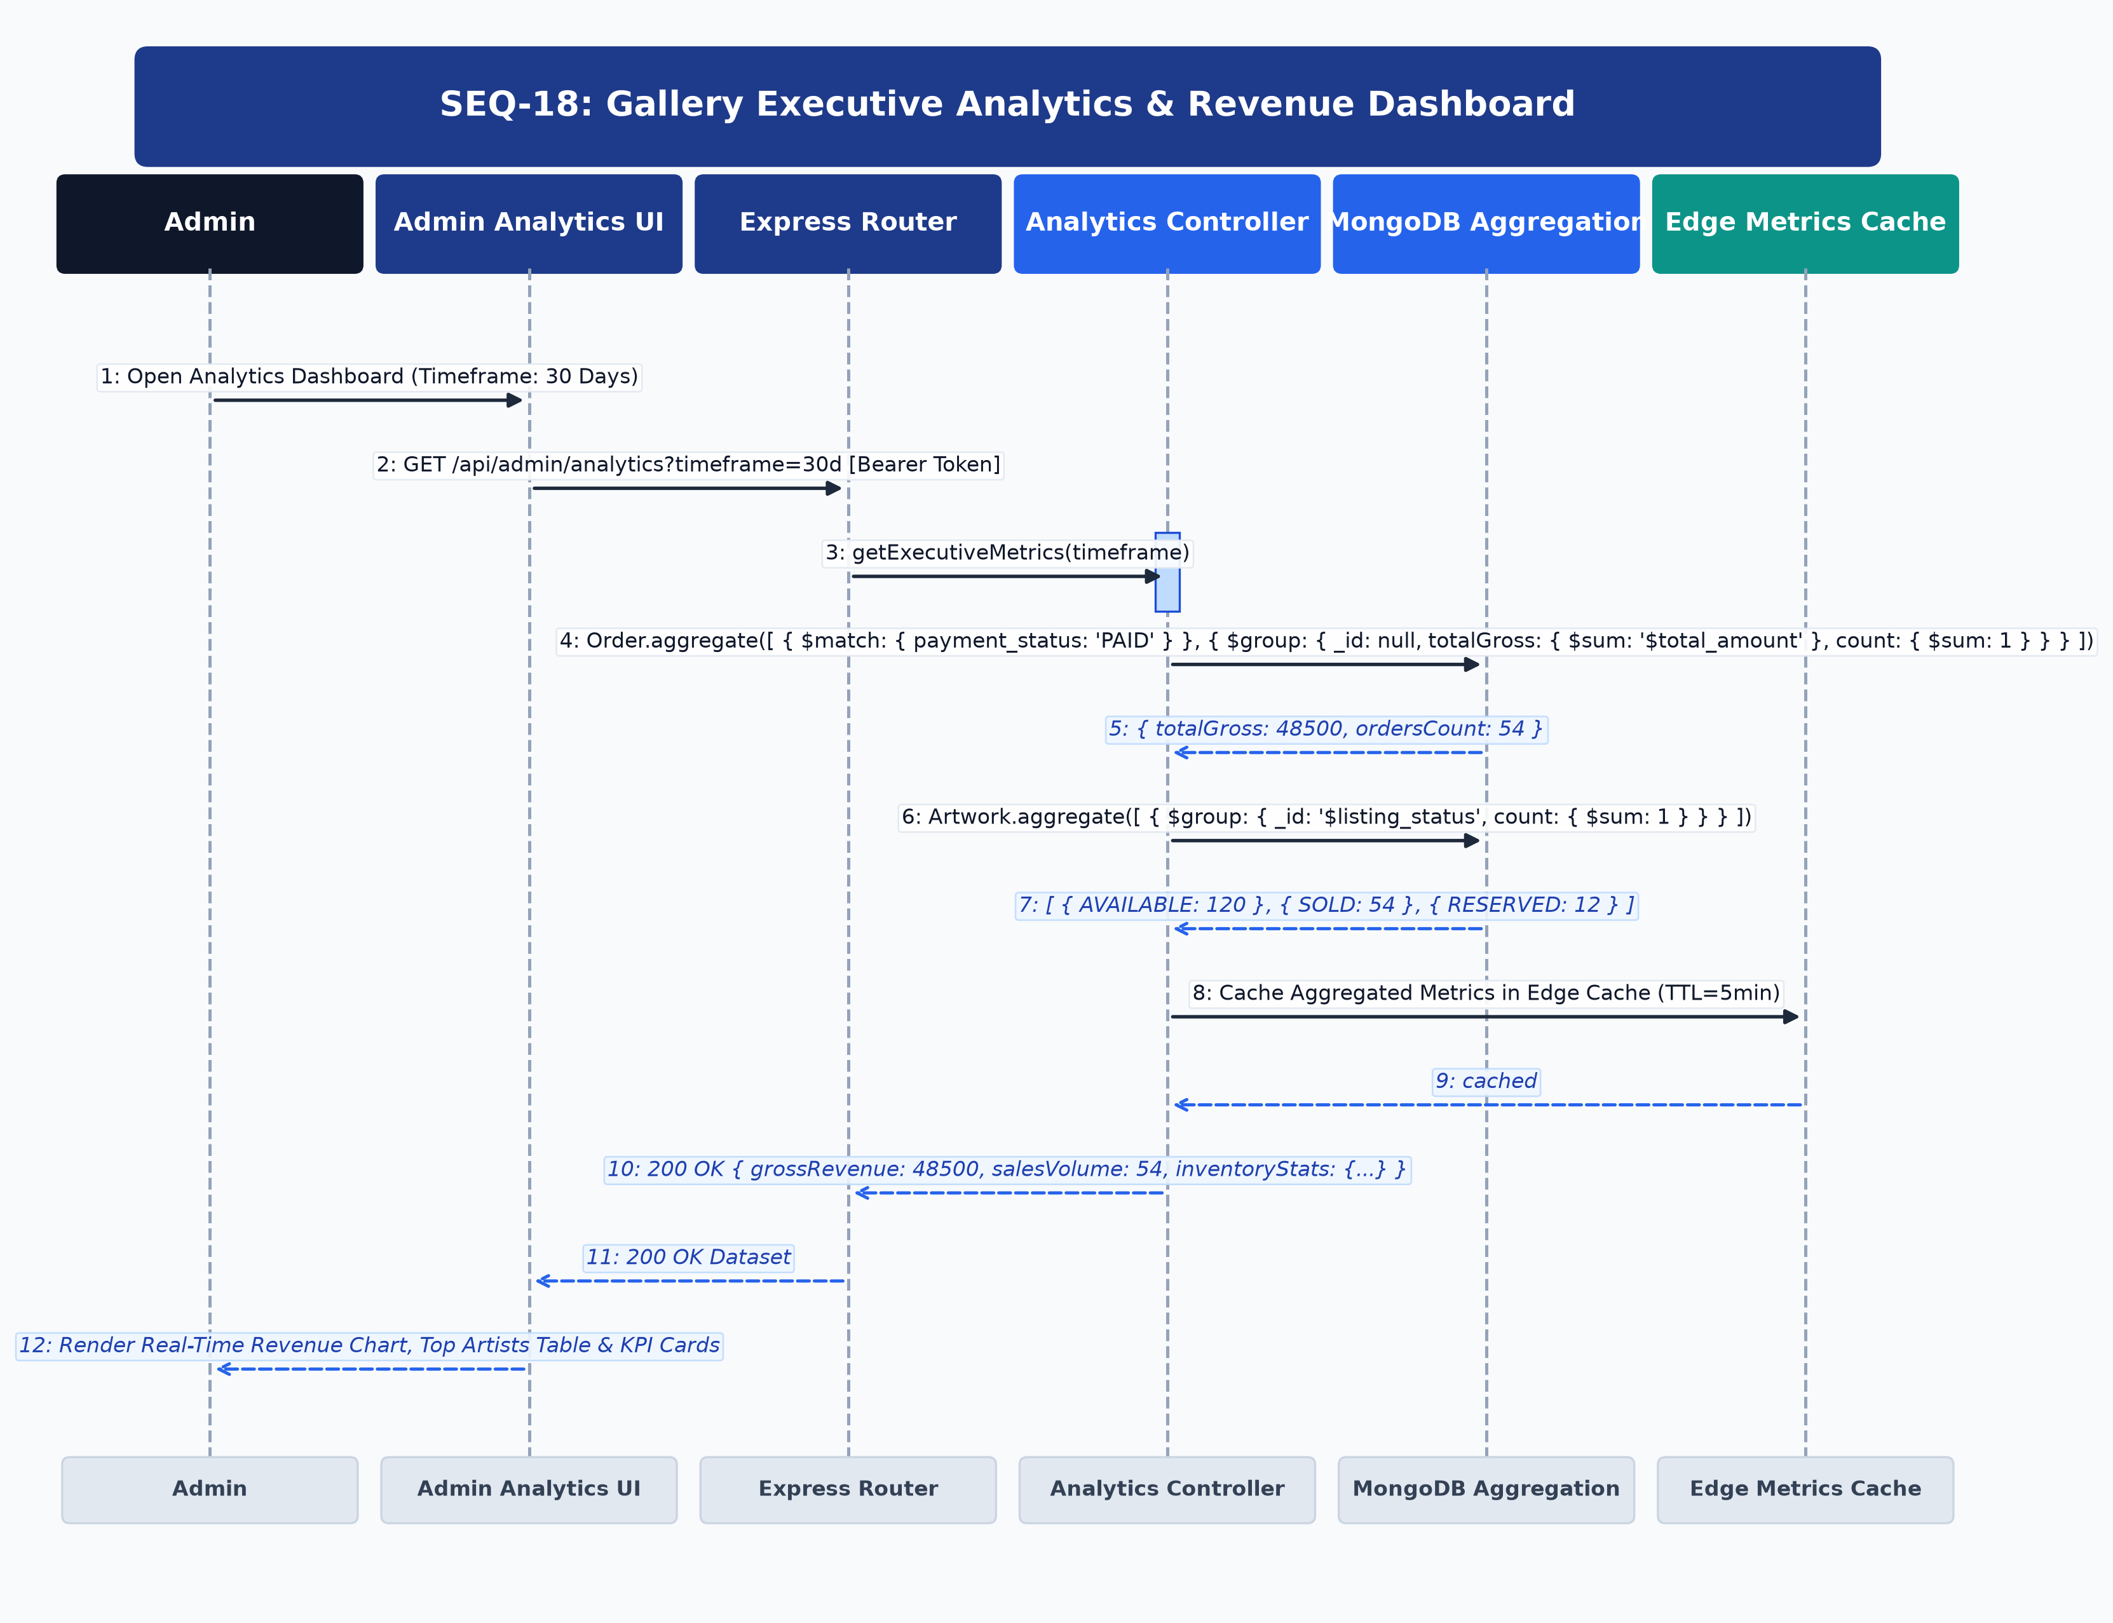
Figure: UML Sequence Diagram for SEQ-18
Architectural Lifelines & Participants: Admin -> Admin Analytics UI -> Express Router -> Analytics Controller -> MongoDB Aggregation -> Edge Metrics Cache
Step | Source | Target | Message / Operation | Protocol / Status | Payload / Data
1 | Admin | Analytics UI | Open Analytics (Timeframe: 30d) | UI Action | Select timeframe
2 | Analytics UI | Express Router | GET /api/admin/analytics?timeframe=30d | HTTP/REST | Header: Bearer <admin_token>
3 | Express Router | Analytics Controller | getExecutiveMetrics(timeframe) | Internal Call | Pipeline coordinator
4 | Analytics Controller | MongoDB Aggregation | Order.aggregate([ { $match: { payment_status: 'PAID' } }, { $group: { ... } } ]) | Aggregation Pipeline | Sum gross settled revenue
5 | MongoDB Aggregation | Analytics Controller | { totalGross: 48500, ordersCount: 54 } | DB Result | Settled totals
6 | Analytics Controller | MongoDB Aggregation | Artwork.aggregate([ { $group: { _id: '$listing_status', count: { $sum: 1 } } } ]) | Aggregation Pipeline | Inventory status breakdown
7 | MongoDB Aggregation | Analytics Controller | [ { AVAILABLE: 120 }, { SOLD: 54 }, { RESERVED: 12 } ] | DB Result | Inventory counts
8 | Analytics Controller | Edge Metrics Cache | Set Cached Metrics (TTL=5m) | Cache Set | In-memory / Redis cache
9 | Edge Metrics Cache | Analytics Controller | cached | Success | Cache warmed
10 | Analytics Controller | Analytics UI | 200 OK Response | HTTP 200 | { grossRevenue: 48500, salesVolume: 54, inventoryStats: {...} }
11 | Analytics UI | Admin | Render Revenue Area Chart & KPI Cards | DOM Render | Real-time analytics dashboard

[ALTERNATIVE & EXCEPTION FLOWS] If cached metrics are valid (within 5min TTL), Analytics Controller serves data directly from Edge Cache without querying database.

3. Cross-Cutting Architectural Patterns
- JWT Bearer Authorization Pattern: Every protected API endpoint invokes the verifyToken middleware. The middleware inspects req.headers.authorization, parses the Bearer string, verifies cryptographic signature against process.env.JWT_SECRET, and injects decoded claims into req.user.
- Stripe Payment Webhook Pattern: To prevent transaction drop-off if a user closes their browser before confirmation, the backend implements an asynchronous Stripe Webhook endpoint listening for payment_intent.succeeded events, validating the Stripe webhook signature header and updating the database.
- Signed Cloudinary Asset Upload Pattern: Large artwork media files bypass API server memory by using Cloudinary's signed direct-to-CDN upload protocol, returning CDN-backed secure URLs for lightweight storage in MongoDB documents.

4. Approval & Governance Sign-Off
Governance Role | Designated Lead / Authority | Sign-Off Status
Project Lead & Orchestration | Siesta (Lead Orchestrator) | [APPROVED] Sequence Models Validated
Systems Architecture & Backend | Kisuke Urahara (Backend Lead) | [APPROVED] 6-Tier Lifelines Verified
Executive Audit & Governance | Genryusai Shigekuni Yamamoto | [APPROVED] Structural Integrity Verified

