CLOSING DATA TRUST GAP IN AGENT DATA INJECTION

(Research & Development)
Final Year Project Proposal
Session Fall 2026
BS in CS

Department of CS
National University of Computer and Emerging Sciences
NUCES FAST, Karachi Campus
1st September 2026

Project Registration
Project ID (for office use)
Type of project |  |  | [ ] Traditional [ ] Industrial [ ] Continuing
Nature of project |  |  | [ ] Development [✔️] Research & Development [ ] Research
Sustainable Development Goals (SDGs) |  |  | [ ] Good Health and Well-Being [ ] Quality Education  [✔️] Industry , Innovation, and Infrastructure [ ] Gender Equality  [ ] Decent Work and Economic Growth [ ] Climate Action
Area of specialization |  |  | [✔️] Artificial Intelligence (AI) [ ] Data Science and Analytics  [ ] Internet of Things (IoT) [ ] Blockchain  [ ] Mobile App Development [ ] Web Development  [✔️] Cybersecurity [ ] Game Development  [ ] Natural Language Processing (NLP) [ ] Other
Project Group Members
Sr.# | Reg. # | Student Name |  | CGPA | Email ID | Phone # | Signature
(i) | Group Leader | Zain Saqib |  | 2.88 | k230588@nu.edu.pk | 0309 2137890 | xain
(ii) | Member | Tasbiha Nasir |  | 3.41 | k230528@nu.edu.pk | 0330 3979878
(iii) | Member | Madiha Aslam |  | 3.30 | k230846@nu.edu.pk | 0312 4449588
Declaration: FYP group members have cleared all prerequisite courses For FYP-I as per their degree requirements.

1. Project Abstract
Indirect prompt injection (IPI) occurs when attacker-controlled instructions are embedded in external content, web pages, emails, documents, API responses, or retrieved passages, and are processed by a tool-using LLM agent as if authorized, potentially triggering unintended tool calls or harmful actions. Agent Data Injection (ADI) is a structural sub-category of IPI in which malicious values are embedded in structured or semi-structured tool responses to manipulate an agent's control flow or tool arguments, exploiting the fact that LLMs have no formal mechanism to separate trusted instructions from untrusted data.
Existing defenses either rely on the LLM itself to judge trust, reintroducing the same probabilistic weakness ADI exploits, or constrain which tools are reachable without validating whether the data inside an allowed call is genuinely what it claims to be. None separate a field's content-trust such as does it look adversarial from its provenance-trust , is its trust label authentic?
This project proposes a bidirectional, provenance-aware detection pipeline, the Detector Agent, sitting between an agent and its tools on both the outgoing call and incoming response path. Raw tool traffic is deterministically parsed, tagged with system-issued provenance at ingestion, and mapped into a field-level trust-provenance graph adapted from IPIGuard's Tool Dependency Graph. A constrained, non-LLM classifier flags residual structural anomalies, nested-call mimicry or trust-tag forgery, which a risk gate (confidence × impact) routes to tiered human review when warranted.
Evaluation uses AgentDojo as the primary benchmark, InjecAgent as supporting, against Attack Success Rate, Benign Utility, Utility Under Attack, False Positive Rate, False Negative Rate, and Human Approval Accuracy. The project's core question is whether provenance-based detection can catch ADI-specific forgery without degrading benign-task utility, contributing a reproducible reference implementation and an empirical account of where deterministic, non-LLM detection holds up against this threat class.

2. Introduction
Organisations are rapidly deploying Large Language Model (LLM) agents into critical workflows with real-world side effects, such as sending emails, moving financial funds, merging code, and deleting database records. Consequently, a successful exploit carries direct financial, operational, or safety consequences rather than merely producing undesirable text outputs.
Historically, Indirect Prompt Injection (IPI) including direct Instruction Injection (II) ; has been used to compromise LLM-integrated systems. In July 2026, Agent Data Injection (ADI) was introduced as a specialized sub-category of IPI [1]. Unlike standard injections, ADI operates through structural attacks that exploit the data-trust gap arising from the probabilistic nature of LLM text completion.
LLM-driven agents plan multi-step tasks and maximize user utility by processing external data; web pages, emails, API responses, and RAG retriever outputs and acting on it through privileged tool calls. However, because a single tool call can carry both trusted system instructions and untrusted retrieved content, LLMs are left to resolve this boundary themselves: They operate directly on text and have no formal mechanism to separate instructions from data [2]. This structural limitation leaves the boundary between trusted and untrusted content easy to blur, and creates a wide surface for misinterpretation and exploitation. This is precisely the flaw that Probabilistic Delimiter Injection; a core ADI vector that exploits: a threat actor embeds malicious instructions inside an untrusted data field, and because the model's completion is probabilistic rather than boundary-aware, it self-authorizes the completion and executes the attacker's instructions as if they were legitimate. The same flexibility that allows LLMs to follow open-ended natural-language instructions is what leaves them unable to reliably reject instructions they were never meant to receive [5]. This architectural vulnerability constitutes the foundational Agent Data Injection problem.
The current situation is that most production agents rely on the LLM itself to distinguish trusted user instructions from untrusted data encountered during tool use. Because no formal separation exists, any tool response , a web page, an email body, a retrieved document can carry an embedded instruction the model may follow, a threat documented at scale by AgentDojo and InjecAgent and shown to defeat most published defenses under adaptive evaluation. Published defenses tend to fall short along one of three axes: they demand substantial model-training investment, generalize poorly beyond simple injection patterns, or degrade the agent's usefulness once an attack is present [4]. Prompting-only defenses (spotlighting, sandwiching, paraphrasing) and closed-loop LLM judges remain the dominant mitigation approaches in the literature, but neither offers a deterministic guarantee LLM-based judges reintroduce the same non-determinism and per-token cost that made the original problem hard to bound in the first place. A complementary line of work observes that a successful injection is detectable through its downstream effect on agent behaviour: once hijacked, an agent's subsequent actions grow more strongly correlated with the attacker's injected objective than with the user's original task [4].
Any effective defense must operate under the same constraints that make the attack possible: agents process unbounded natural-language content in real time, at scale, and on limited academic compute, ruling out solutions that depend on heavyweight model retraining or per-call LLM judgment. The key principle explored in recent structural defenses is to decouple the agent’s action planning from its direct interaction with external data [3]. This project adopts the same conceptual separation, aiming to detect and constrain potentially malicious data before it can influence privileged agent actions. This project implements this through a three-stage pipeline detailed in Sections 6 and 8.

3. Problem Statement
Existing IPI defenses either rely on the LLM itself to judge trust (prompting-based defenses, LLM-as-judge), which reintroduces the same probabilistic weakness the attack exploits, or restrict which tools can be reached (IPIGuard) without checking whether the data inside an allowed call is actually what it claims to be.
Choi et al. [1] report that off-the-shelf LLMs are vulnerable to probabilistic delimiter injection at 31.3 to 43.3 percent ASR on JSON data and 33.3 to 100 percent on web DOM data, across six models. Against state-of-the-art agent defenses, instruction injection is nearly neutralized (0 to 0.7 percent ASR), but ADI still succeeds up to 50 percent of the time [1]. These results indicate that defenses effective against instruction injection do not necessarily address provenance forgery in ADI.
This project therefore explores whether the isolation of Trusted and Untrusted data maintains Utility or degrades it using non-LLM detector rather than another probabilistic LLM component. The project is not claiming to solve ADI broadly. It is scoped to provenance forgery and structural mimicry , a field disguising itself as a trusted tag, or smuggling a nested tool call at the tool-call boundary, benchmarked primarily on AgentDojo with InjecAgent as supporting evaluation. It does not cover memory or cross-session persistence, unstructured prose injection outside the tagged-field model, or vision-based attack vectors. Utility preservation is measured against AgentDojo's paired benign/attack task structure rather than production deployment conditions.

4. Motivation
The motivation behind this project is to investigate a practical and empirically evaluable defense against the ADI/IPI problem in tool-using LLM agents. The project is motivated by the following concerns:
- External content risk: Malicious instructions in web pages, emails, documents, or API responses can trick LLM agents into making unauthorized tool calls.
- Limitations of current defenses: Prompting and LLM-based security judges can be bypassed and may add latency, cost, and unpredictability.
- Deterministic security controls: Apply fixed security checks at the tool-action and execution stages instead of relying only on the LLM.
- Constrained classifier: The architecture integrates a constrained topology classifier to proactively detect anomalies, while maintaining strict deterministic parsers and human-in-the-loop validation as core security safeguards.
- Comprehensive evaluation: Test using existing ADI benchmarks plus additional attacks such as delimiter manipulation and nested-field injection.
- Security and usefulness: Measure attack prevention, normal task performance, performance under attack, false positives/negatives, and system overhead.

4.1 Aims and Objectives
- Implement the three-stage detection pipeline: deterministic parser, tag-based provenance mapping via TDG, and constrained non-LLM classifier as an AgentDojo pipeline element that intercepts proposed tool calls before execution, structurally separating content-trust from provenance-trust at the field level.
- Design a risk-scoring mechanism where risk is calculated as confidence × impact, with confidence derived from the classifier's structural/provenance judgment and impact assigned through predefined per-tool-type severity tiers, routing higher-risk calls to human review.
- Build a human-in-the-loop evidence panel using deterministic templates with no LLM involvement, presenting the original user query, proposed tool call and arguments, relevant untrusted content, source and provenance, structural/regex warnings, classifier confidence, risk category, and expected side effect, with options to allow, deny or accept the content as evidence only.
- Evaluate the system on AgentDojo as the primary benchmark and InjecAgent as a supporting reference point, using a probabilistic-delimiter attack suite grounded in Choi et al. 's attack methodology [1].
- Measure the system against the metrics defined in Section 6.8.

4.2 Scope of the Project
This project is scoped specifically to Agent Data Injection (ADI), focusing on structural and provenance-forgery attacks that exploit the data-trust gap, rather than indirect prompt injection or instruction injection in general. JSON-format tool responses are the primary target for FYP-I because they support deterministic parsing and Choi et al. report a consistent ADI attack surface on JSON data [1].
The core deliverable is a three-stage detection pipeline consisting of a deterministic, format-specific parser, provenance tagging at data ingestion, and a field-level trust-provenance graph adapted from IPIGuard's TDG construction [3]. The graph operates on fields within a single call and is evaluated by a constrained, non-LLM classifier. The system also includes a deterministic human-in-the-loop evidence panel and a risk-scoring mechanism based on confidence × impact.
Evaluation uses AgentDojo as the primary benchmark and InjecAgent as supporting evaluation. The system is measured using Attack Success Rate, Benign Utility, Utility Under Attack, False Positive Rate, False Negative Rate, and Human Approval Accuracy, with particular focus on provenance integrity, field-level contamination, and false blocking.
Out of scope are memory or cross-session injection, unstructured prose injection without a structural field to tag, vision-based attack vectors such as fake CAPTCHAs, and multi-hop or transitive trust across sequential calls. The graph validates provenance at field entry within a single call rather than across longer interaction histories. This project is therefore not intended as a general-purpose IPI defense; it specifically targets provenance forgery as a complementary layer to existing defenses such as Task Shield and MELON.

5. Literature Review
Published defenses against indirect prompt injection in LLM agents fall into three broad approaches: benchmarking/environment work that establishes ground truth, graph- or control-flow-based structural defenses, and detection-based approaches that operate on content or task alignment.
AgentDojo [2] and InjecAgent [7] established the benchmarking methodology this project reuses. AgentDojo provides a real, executable multi-step agent environment specifically built to address the security limitations of earlier simulated benchmarks like ToolEmu, and is adopted here as the primary benchmark for exactly that reason. InjecAgent [7] focuses on single-turn, direct-harm and exfiltration scenarios and is treated as a supporting benchmark rather than the primary one, since it evaluates a narrower slice of agent behavior than AgentDojo's multi-step tool-use setting.
Within structural defenses, IPIGuard [3] constrains agent execution to a planned Tool Dependency Graph, using node and argument expansion so that a tool response cannot introduce a call outside the agent's original plan. This project adapts the TDG abstraction but at a different granularity: rather than modeling dependencies between successive tool calls, this project's graph models trust provenance between fields within a single proposed call, labeling each field trusted or untrusted based on a system-issued tag established at ingestion rather than inferring trust from call sequence on the cloned-tool call. CaMeL [6] takes a related but distinct approach, separating a privileged planning LLM from a quarantined LLM that only ever processes untrusted data, and enforcing capability-based policies through a custom interpreter; it solves 77% of AgentDojo tasks under a provable security guarantee, against an 84% undefended baseline, at the cost of requiring the developer to codify and maintain explicit security policies for every data flow.
Within detection-based defenses, Task Shield [8] asks at each step whether a proposed action still serves the user's declared goal, reporting a 2.07% attack success rate with 69.79% task utility preserved on GPT-4o, substantially outperforming other AgentDojo-evaluated defenses on this tradeoff. However, this task-alignment judgment is itself LLM-mediated, so it inherits the same non-determinism this project is specifically trying to avoid at the detection layer. MELON [4] observes that a successful injection is detectable through its downstream effect: once hijacked, an agent's subsequent actions correlate more strongly with the attacker's injected objective than with the user's original task, and detects this via masked re-execution, comparing trajectories with and without the original user instruction present.
On the classifier side, InjecGuard [9] demonstrates that trigger-word-driven prompt-guard classifiers systematically over-flag benign content containing common attack-associated words, with state-of-the-art guardrail accuracy dropping to near-random 60% on their NotInject benign-but-trigger-word-rich evaluation set.
Taken together, the literature motivates this project's central design choice: no existing defense separates a field's content-trust such as does this look adversarial from its provenance-trust , is this field's trust label authentic at the level of individual fields inside a tool call. IPIGuard's [3] TDG constrains which calls are reachable but does not validate whether the data inside an allowed call is genuinely what it claims to be. Task Shield [8] and MELON [4] judge behavior and alignment, not the authenticity of a field's trust metadata. And CaMeL's [6] capability-based enforcement, while structurally rigorous, depends on the developer correctly specifying policy for every data flow rather than deriving trust automatically from a system-issued provenance tag. This project's contribution sits specifically in that gap: a deterministic, tag-based provenance layer combined with a constrained, non-LLM classifier for the residual structural signal that pure content classifiers and pure graph-reachability constraints each miss on their own.

Work | Mechanism | Security Result | Limitation Relative to This Project
AgentDojo - Benchmark | Real-code, multi-step agent benchmark | 97 tasks, 629 security test cases | Benchmark, not a defense
InjecAgent-  Benchmark | Simulated single-turn IPI benchmark | 1,054 direct-harm/exfiltration cases | Narrower scope than AgentDojo; used as supporting benchmark
IPIGuard | Tool Dependency Graph, call-to-call reachability constraint | Reduces reachable out-of-plan calls | Does not validate provenance of data within an allowed call
CaMeL | Privileged/quarantined LLM split, capability-based interpreter | 77% AgentDojo tasks solved (84% undefended) | Requires manually specified policies per data flow
Task Shield | LLM-judged task-alignment check | 2.07% ASR, 69.79% utility (GPT-4o) | Alignment judgment is itself LLM-mediated, non-deterministic
MELON | Masked re-execution, trajectory comparison | Detects action-dominance shift under injection | Detects effect of hijack, not provenance forgery itself
InjecGuard | Trigger-word-debiased classifier (MOF training) | Restores accuracy on NotInject over-defense set | Content-only; does not address provenance authenticity

6. Proposed Methodology

6.1 Pipeline Overview
The agent's own reasoning loop is untouched:
User query → LLM → Agent → Pre-Hop Tool Call → Post-Hop Tool response → Back to agent.
A single detector module intercepts both directions of this loop, the outgoing proposed call and the incoming tool response, since untrusted content can enter at either point [1]. This is implemented as an AgentDojo [2] pipeline element positioned on both the request and response path; no part of the agent's own decision-making is modified, only what it is allowed to send and receive without review. Section 8.4 details the interception mechanics and the rationale for treating both directions identically.

6.2 Deterministic Parsing
Before any trust judgment happens, raw content on either path, an outgoing call's arguments or an incoming tool response is cloned , its tool-id mapped in Trust Verification Matrix (TVM) with assigned internal-id. This cloned call is passed through a deterministic, format-specific parser i.e; JSON formats. This stage does not trust evaluation; it only converts unstructured or semi-structured text into discrete, addressable fields that the later stages can tag and graph.This deterministic-first approach is a direct response to the underlying weakness Zverev et al. [11] and ToolLLM [10] identify: LLMs operate directly on text with no formal mechanism to separate instructions from data, so trust decisions in this pipeline are deliberately made before any model ever sees the content. If content doesn't parse against a known format, it is treated as untrusted by default rather than silently passed through. This stage produces structured_flag to evaluate deterministic and randomized delimiters.
S = min(1.0, ((Number of Injected/Illegal Delimiters) / (Total Expected JSON Keys/Boundaries))

6.3 Tagging
Parsed fields are then passed to the tagging module. Any field the system itself generates i.e; internal metadata, call structure is stamped with a Trust, establishing provenance trust while human controlled fields such as message bodies, user-provided file paths/url , free-form text arguments or custom HTTP headers or meta-data fields explicitly requested by users are tagged under Untrusted tag acting as label for nodes in Tool Dependency Graph in 6.4.

6.4 Trust-Provenance Mapping
The tagged and parsed content is mapped into a field-level trust-provenance graph, borrows the graph-based tool-call modeling of IPIGuard's Tool Dependency Graph construction [3] but applied at a different granularity: IPIGuard's TDG models dependencies between successive tool calls, this project's graph models trust relationships between fields within a single call or response. Each field becomes a node labeled <T> for provenance-trusted or <UT> for untrusted, human- or tool-supplied. Untrusted nodes are checked specifically for two failure patterns: structural matches to the grammar of a nested tool call such as an untrusted field attempting to trigger a second, unauthorized call, and mimicry of a trusted tag's shape.

6.5 Classifier
The per-call TDG from 6.4, with its <T>/<UT> node labels, is passed to a Weisfeiler-Lehman (WL) graph kernel [13] and SVM classifier. WL iteratively relabels nodes by hashing each node's current label with its neighbors' labels, producing a histogram over resulting labels as an explicit feature vector ; avoiding kernel comparison against the training set at inference, keeping classification CPU-viable per 7.2. The vector feeds an SVM, whose margin is converted to a calibrated probability via Platt scaling. This runs on every pre-hop and post-hop TDG, not only ones carrying a structural flag from 6.4, since content can be structurally clean and still adversarial conveying intent through plain language rather than nested-call syntax or tag mimicry.
The structural score 6.4 and classifier score from this stage are produced independently; they are combined in the confidence formula in 6.6. The classifier is non-authoritative over execution and cannot independently block a call.

6.6 Risk Scoring
Every flagged call or response is scored as
confidence = 1-(1-S)(1-C)
risk = confidence × impact
Where S = structural_score , C= Classifier_score
where confidence reflects both the structural anomaly detected in 6.4 and the classifier's output from 6.5. Impact¹ is a fixed, predefined severity tier assigned per tool type in advance and independent of the classifier: Following the quantitative risk assessment guidelines in NIST SP 800-30 [14] , these qualitative NIST tiers are mapped onto a discrete numerical scale:
- Low Impact (Value = 1): Read-only or non-side-effecting calls for e.g., system status checks, public data retrieval.
- Moderate Impact (Value = 5): Internal write operations or non-sensitive modifications for e.g., system configuration updates.
- High Impact (Value = 10): Sensitive, side-effecting operations such as sending external emails or modifying account access privileges.
6.6.1 Risk Evaluation & Policy Thresholds
The resulting quantitative risk score is mapped deterministically to a three-tier execution policy based on the following scale:
Risk Threshold | Risk Tier | Human Decision Options
0.00 to 0.99 | Low Risk | Proceeds automatically, logged for audit.  No escalation required.
1.00 to 4.99 | Moderate Risk | Flagged and logged.  Escalates to human operator with full discretionary option set available: Allow, Deny , Evidence-Only.
5.00 to 10.00 | High Risk | Paused and escalated.  The raw, unmodified "Allow" option is programmatically stripped from the human decision options. The operator may only choose Deny, or route via Evidence-Only.

6.7 Human-in-the-Loop Evidence Panel
For any escalated call or response, an evidence panel is generated through deterministic templating only; no LLM participates in its construction. The panel presents user with the following content based on the risk : the original user query, the pre/post hop tool call , the relevant raw untrusted content, its source and provenance, any structural/regex warnings raised during parsing, the classifier's confidence score and the specific risk category. The decision returns to the agent loop as a human decision, not the agent's own approval, preserving that distinction throughout.

6.8 Evaluation
6.8.1 Benchmarks
AgentDojo [2] is the primary benchmark, a real, executable multi-step environment built specifically to address the security-evaluation flaws of earlier simulated benchmarks like ToolEmu [12]. InjecAgent [7] is the supporting benchmark. A hand-written probabilistic-delimiter attack suite, grounded in Choi et al.'s attack methodology [1], supplements us to test ADI.

6.8.2 Evaluation Metrics
- Attack Success Rate
- Benign Utility
- Utility Under Attack
- False Positive Rate
- False Negative Rate
- Human Approval Accuracy

7. Functional and Non-Functional Requirements

7.1 Functional Requirements
- Parse and validate cloned tool calls (JSON) via deterministic, format-specific parsers.
- Tag every system-generated field on cloned tool-call.
- Map parsed, tagged fields into a trust-provenance graph (<T>/<UT>), flagging nested-call mimicry and tag-forgery patterns.
- Run the non-LLM classifier over the graph to score residual structural/semantic violations.
- Compute risk (confidence × impact) and route accordingly: low risk auto-proceeds; moderate/high risk escalate to human review, with raw "Allow" excluded at high risk.
- Generate the human evidence panel via deterministic templating , and return the human's decision to the agent loop as distinct from agent approval.

7.2 Non-Functional Requirements
- Determinism: parser, tagging, and graph-mapping are fully deterministic; the classifier holds routing authority only, never resolution authority; every flagged outcome resolves through human review, not automated classifier action.
- No LLM in decision support: evidence panel and risk scoring use deterministic templating only.
- Small-data, CPU-viable classifier: trains and runs on CPU-scale resources.

8. System Architecture
The proposed system is implemented as a middleware-based, defense-in-depth architecture. It places a security layer, the Detector Agent, between the Agent and the tools used during task execution. All trust labels, tags, and provenance metadata generated during detection remain internal to this layer: the Main LLM never sees them, and the content it eventually receives is identical whether a call or response passed automatically or was cleared after human review.

The architecture consists of the following components:

8.1 Trusted User Request
The system receives the user's task, defining the objective against which the agent's subsequent proposed actions are evaluated.

8.2 Main LLM
Interprets the user's request and makes the decision on what action or tool call is needed to progress the task. Responsible for planning and decision-making only and is never treated as the security authority. It passes its decision to the Agent for execution.

8.3 Agent
Receives the Main LLM's decision and issues the corresponding tool call. Maintains workflow state and forwards the proposed call onward. It does not itself validate or authorize the call; that happens at the Detector Agent. It also receives outcomes back from the Detector Agent, including denial signals, and surfaces these to the Main LLM as recoverable tool observations see 8.4.6.

8.4 Detector Agent - Middleware
Intercepts pre-hop and post-hop tool calls and clones them while keeping original intact ; see 6.1. Detector Agent consist of following modules,

8.4.1 Deterministic Parser
The cloned call is now passed through , Format-specific JSON parser validating whether the delimiters are structured or randomized . Content failing to parse against a known format is treated as untrusted by default with their calculated structural_score. See 6.2 for design rationale.

8.4.2 Tagging Module
Stamps every system-generated field with a Trusted tag and human-controlled field with Untrusted tag. See 6.3 for design rationale.

8.4.3 Trust-Provenance Mapping
Maps parsed, tagged fields into a field-level graph IPIGuard TDG [3]-adapted, see 6.4, labeling each <T>/<UT>. Untrusted fields are checked against nested-call grammar match and trusted-tag mimicry.

8.4.4 Constrained Classifier
Runs on every call and response passing through the Detector Agent and produces the classifier_score as defined in 6.5.

8.4.5 Risk-Based Execution Gate
Computes the risk flag as a product of computed confidence and impact, a fixed, predefined per-tool-type severity tier, independent of the classifier.The confidence threshold determines escalation is set empirically during evaluation. If the risk is low , the original tool-call is allowed to pass, otherwise human approval is required.

8.4.6 Human Review
When the risk gate 8.4.5 escalates, the human is presented the full evidence panel, the original user query, the proposed call or returned response, arguments/content, untrusted content and its provenance, structural warnings, classifier confidence, risk category, and expected side effect, generated through deterministic templating with no LLM involvement.
Decision options are as following:
- Deny: The call does not execute. The Detector Agent returns a structured denial signal to the Agent, which surfaces it to the Main LLM as a recoverable tool observation , an error message describing that the action was blocked and logged.
- Allow: The call proceeds and is logged.
- Evidence Only: The flagged content is deformed to inert text and retained as logged evidence; the call does not execute.

8.4.7 Decision Log
Records every call/response, structural_score, classifier_score, risk_score, validation result, provenance data, and human-review outcome, for reproducibility, attack analysis, and evaluation. Both the outgoing and response-path instances of the Detector Agent log to this same record.
8.5 Mediated Tool Execution
Calls or responses cleared by the Detector Agent , auto-passed or human-approved , are forwarded to the tool layer, the controlled interface between the Agent and the compatible AgentDojo, simulated, or sandboxed tools used in evaluation.
8.6 External or Attacker-Controlled Content
Tool responses are treated as untrusted by default, since they may carry malicious instructions, manipulated values, or forged metadata.
8.7 Response Handoff to Agent
After passing back through the Detector Agent, only calls/responses that clear the auto-passed or human-approved check are forwarded onward. The content returned to the Agent, and subsequently the Main LLM, is the original, unmodified response; all trust labels, tags, provenance metadata, and graph structure are internal to the Detector Agent.
8.8 System Architecture & Flow
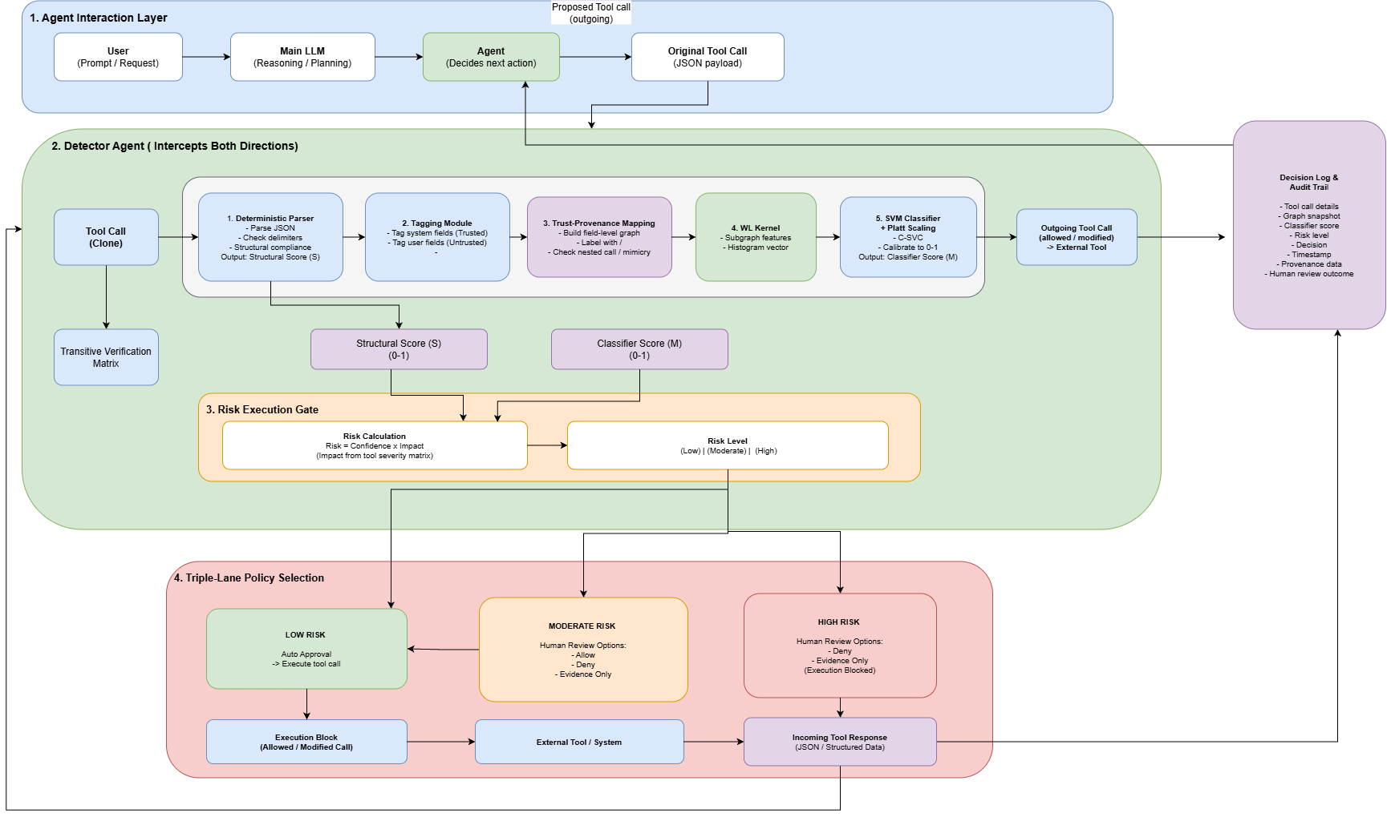
Fig.1.System-Architecture
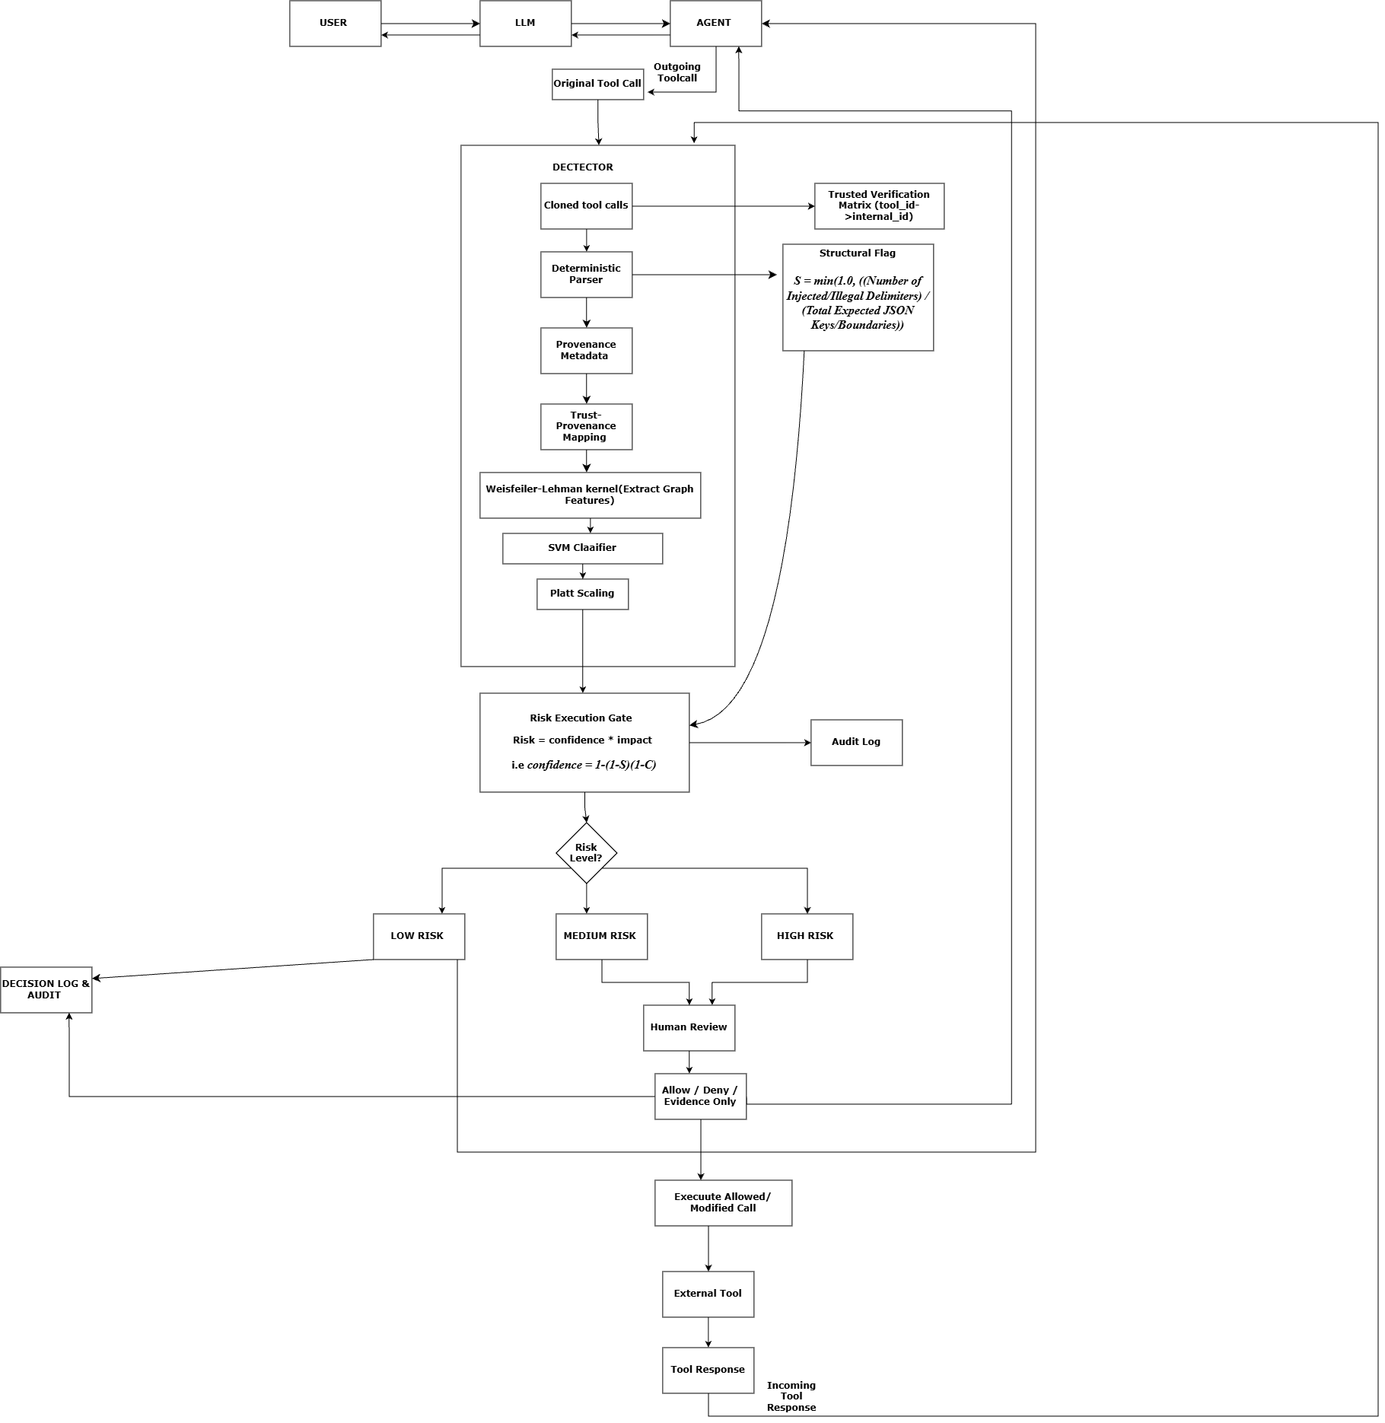
Fig. 2. System Flow Chart
9. Individual Tasks
 | Member | Work Package
1 | All | Research, literature review, proposal, documentation, integration, evaluation, analysis, finalization, defence
2 | Member 1 | Deterministic parsing, provenance tagging, AgentDojo integration.
3 | Member 2 | Trust-provenance graph, structural detection, attack dataset, AgentDojo integration
4 | Member 3 | Constrained classifier, risk scoring, human-in-the-loop panel, metrics and analysis

10. Gantt Chart

a) FYP I weekly plan

Following is the 16 -week FYP-I schedule. Weeks 1- 5 cover supervisor selection, idea finalisation and the proposal. The proposal defence is in week 6, setup and test preparation in weeks 7 – 11, Mid II evaluation in week 12, and the report in weeks 13 – 16.
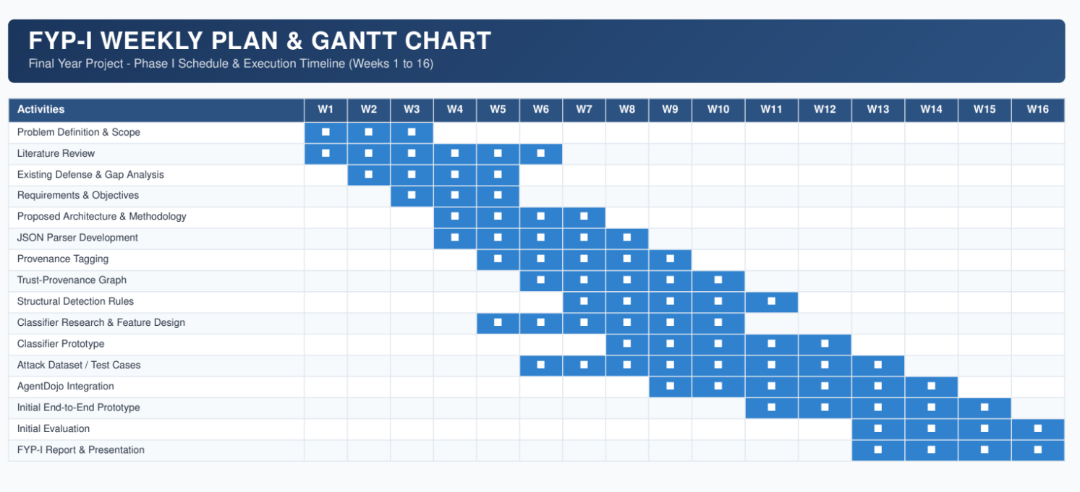
Fig. 3 FYP I schedule by teaching week

b) FYP II weekly plan

Following is a provisional second 16-week plan. It completes the application and leaves time for evaluation , writing and corrections.

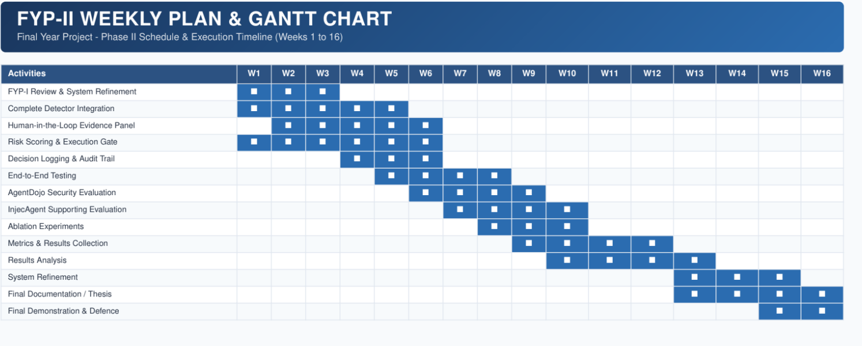
Fig. 4 Provisional FYP II schedule by teaching week

11. Tools and Technologies

Category | Technology / Tool | Purpose
Programming Language & Libraries | Python ,scikit-learn , pandas, Matplotlib, NetworkX | Core implementation, parsing, graph construction, classifier, evaluation and visualization
Agent Framework & Benchmark | AgentDojo | Primary agent environment for evaluation and testing.
Supporting Benchmark | InjecAgent | Supporting evaluation and comparison
Data Format | JSON | Primary structured tool-call and tool-response format
Classifier | Weisfeiler-Lehman-Support Vector Machine | Constrained non-LLM classification of graph-derived features
Version Control | Git / GitHub | Source-code management and experiment tracking
Development Environment | VS Code | Development and debugging

12. Expected Deliverables
- Whether the detector flags benign content purely for containing imperative language, tested directly against the failure mode InjecGuard [9] documents in existing guardrail classifiers.
- A working reference implementation of the proposed detection pipeline, integrated with the AgentDojo benchmark environment.
- An empirical evaluation report comparing system performance against the metrics and evaluation gaps defined in Section 6.8.

13. References

[1] W. Choi and B. Lee, “Agent Data Injection Attacks are Realistic Threats to AI Agents,” arXiv preprint arXiv:2607.05120, Jul. 2026.

[2] E. Debenedetti et al., “AgentDojo: A Dynamic Environment to Evaluate Prompt Injection Attacks and Defenses for LLM Agents,” arXiv preprint arXiv:2406.13352, 2024.

[3] H. An, J. Zhang, T. Du, C. Zhou, Q. Li, T. Lin, and S. Ji, “IPIGuard: A Novel Tool Dependency Graph-Based Defense Against Indirect Prompt Injection in LLM Agents,” in Proc. Conf. on Empirical Methods in Natural Language Processing (EMNLP), 2025, arXiv:2508.15310.

[4] K. Zhu, X. Yang, J. Wang, W. Guo, and W. Y. Wang, “MELON: Provable Defense Against Indirect Prompt Injection Attacks in AI Agents,” in Proc. 42nd Int. Conf. on Machine Learning (ICML), PMLR, vol. 267, pp. 80310–80329, 2025, arXiv:2502.05174.

[5] K. Hines, G. Lopez, M. Hall, F. Zarfati, Y. Zunger, and E. Kıcıman, “Defending Against Indirect Prompt Injection Attacks With Spotlighting,” arXiv preprint arXiv:2403.14720, 2024.

[6] E. Debenedetti, G. Severi, N. Carlini, C. A. Choquette-Choo, M. Jagielski, M. Nasr, E. Wallace, and F. Tramèr, “Defeating Prompt Injections by Design,” arXiv preprint arXiv:2503.18813, 2025.

[7] Q. Zhan, Z. Liang, Z. Ying, and D. Kang, “InjecAgent: Benchmarking Indirect Prompt Injections in Tool-Integrated Large Language Model Agents,” in Findings of the Association for Computational Linguistics: ACL 2024, Bangkok, Thailand, 2024, pp. 10471–10506.

[8] F. Jia, T. Wu, X. Qin, and A. Squicciarini, “The Task Shield: Enforcing Task Alignment to Defend Against Indirect Prompt Injection in LLM Agents,” in Proc. 63rd Annual Meeting of the Association for Computational Linguistics (ACL), pp. 29680–29697, Jul. 2025, arXiv:2412.16682.

[9] H. Li, X. Liu, and C. Xiao, “InjecGuard: Benchmarking and Mitigating Over-defense in Prompt Injection Guardrail Models,” arXiv preprint arXiv:2410.22770, 2024.

[10] Y. Qin et al., “ToolLLM: Facilitating Large Language Models to Master 16000+ Real-World APIs,” arXiv preprint arXiv:2307.16789, 2023.

[11] E. Zverev, S. Abdelnabi, M. Fritz, and C. H. Lampert, “Can LLMs Separate Instructions From Data? And What Do We Even Mean By That?,” arXiv preprint arXiv:2403.06833, 2024.

[12] Y. Ruan, H. Dong, A. Wang, S. Pitis, Y. Zhou, J. Ba, Y. Dubois, C. J. Maddison, and T. Hashimoto, “Identifying the Risks of LM Agents with an LM-Emulated Sandbox,” in Proc. Int. Conf. on Learning Representations (ICLR), 2024, arXiv:2309.15817.

[13] D. Kim and A. Oh, “Generalizing Weisfeiler-Lehman Kernels to Subgraphs,” arXiv preprint arXiv:2412.02181, Dec. 2024.

[14] R. Ross, “Guide for Conducting Risk Assessments,” NIST Special Publication 800-30 Rev. 1, National Institute of Standards and Technology, 2012.

