ICS3U Final Project

This game is developed by Alina Wu and Amy Li. Our idea come from a WeChat mini program, which is called “物理弹球”.

Time started: May 27, 2019

Time finished: June 15, 2019

**Set up process (in eclipse):**

1. Open eclipse
2. 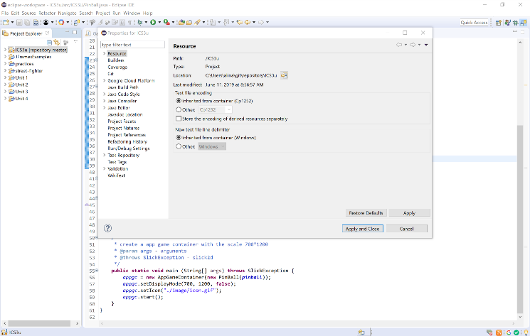Right click on the project 🡪 go to properties
3. 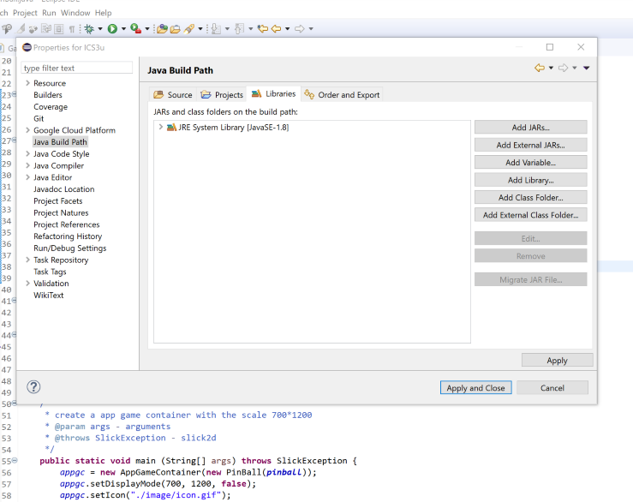Click java build path
4. Click Add JARs
5. 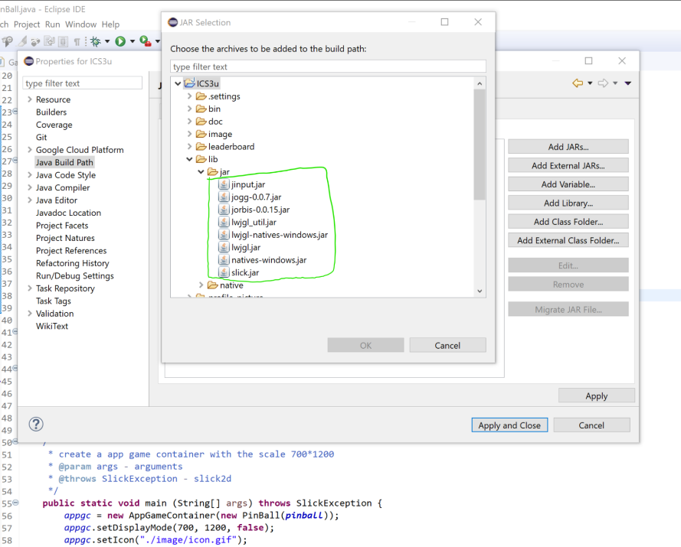Click the project 🡪 lib 🡪 jar 🡪 select all the “.jar” file in it
6. 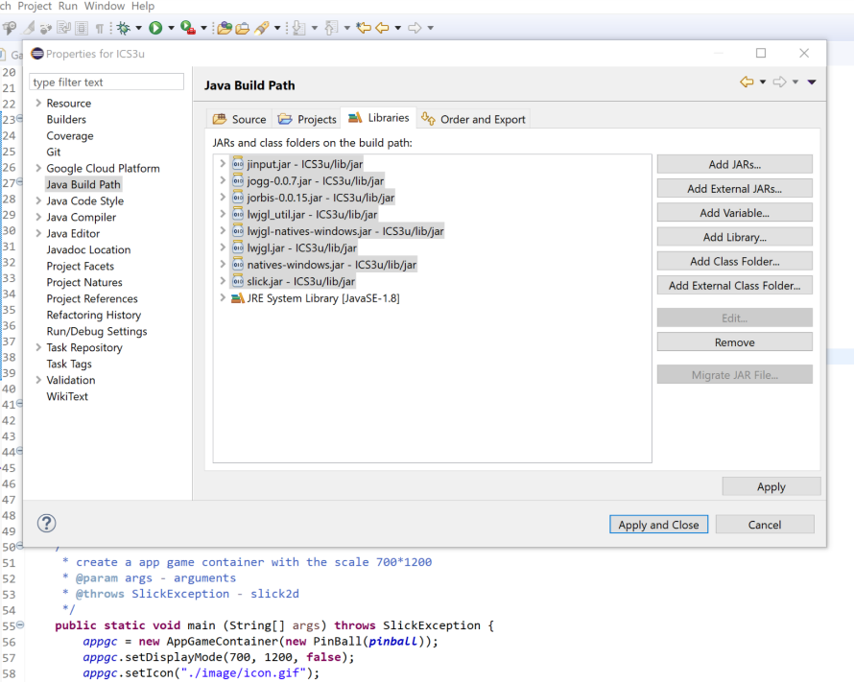Then you will see all the “.jar” file being added to the path
7. 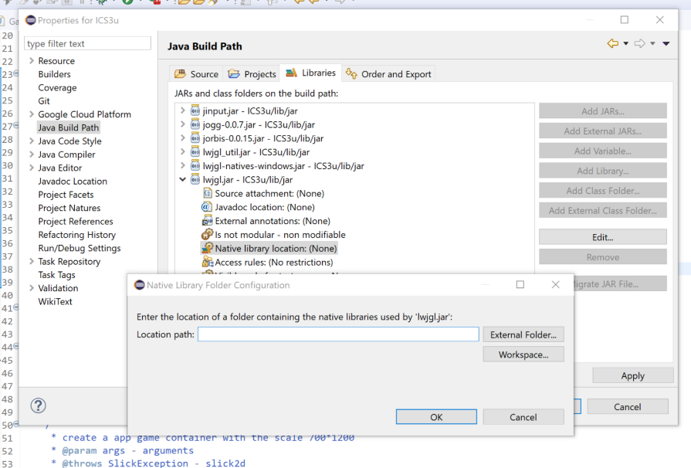Click the “>” beside “lwjgl.jar” 🡪 go to Native library location 🡪 click Edit
8. 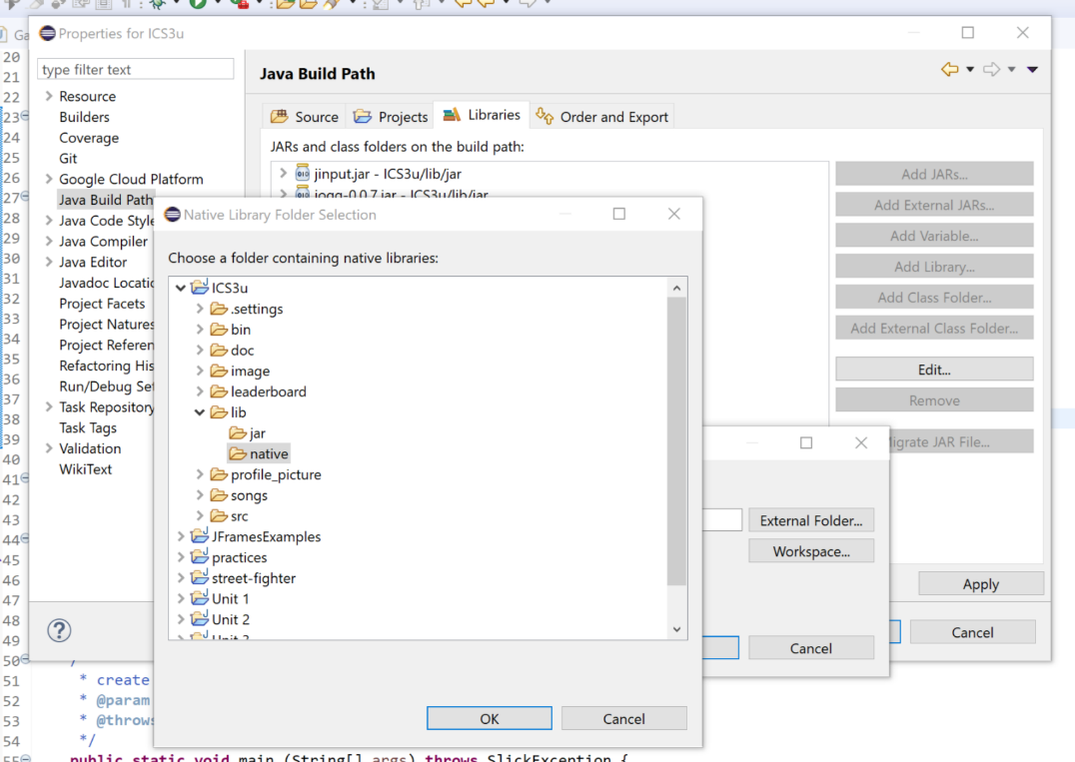Click workspace 🡪 the project 🡪 lib 🡪 select the “native” file
9. Click all the ok and click apply

**Some tips for the game**

1. Please click the  at the top of the screen to see the rules before you play the game
2. Try to click all the buttons and see what their function are.
3. If you want to exit the game, please click the A close up of a logo

   Description automatically generated at the top-right corner of the screen.
4. There is a special part in the game that is for Ms. Wong.
5. In the special part, you can’t mute the sound or click the screen. Just look at your screen and enjoy it (it may not be perfect).
6. If you have any suggestion for our game, please tell me! (some little bugs, maybe?)
7. THE MOST IMPORTANT: please keep the game – don’t delete it even you finish marking it!!!