Week 8 Lab – Basic Switch, VLANs and Inter-VLAN Routing Configuration

- Objectives
Part 1: Cable the Network and Configure Basic Network Device Settings
Part 2: Create VLANs and Assign Switch Ports
Part 3: Maintain VLAN Port Assignments and the VLAN Database
Part 4: Configure an 802.1Q Trunk between the Switches
Part 5: Configure Trunk-Based Inter-VLAN Routing

- Background / Scenario
Cisco switches can be configured with a special IP address known as Switched Virtual Interface (SVI). The SVI or management address can be used for remote access to the switch to display or configure settings. If the VLAN 1 SVI is assigned an IP address, by default, all ports in VLAN 1 have access to the SVI management IP address.
Modern switches use virtual local-area networks (VLANs) to provide segmentation services traditionally provided by routers in LAN configurations. VLANs address scalability, security, and network management. In general, VLANs make it easier to design a network to support the goals of an organization. Communication between VLANs requires a device operating at Layer 3 of the OSI model. Routers in VLAN topologies provide additional security and traffic flow management.
VLAN trunks are used to span VLANs across multiple devices. Trunks allow the traffic from multiple VLANS to travel over a single link, while keeping the VLAN identification and segmentation intact. A particular kind of inter-VLAN routing, called “Router-On-A-Stick”, uses a trunk from the router to the switch to enable all VLANs to pass to the router.
In this lab, you will first build a simple topology using Ethernet LAN cabling and configure basic switch settings. These basic switch settings include device name, console and vty passwords, message of the day (MOTD) banner, IP addressing, and demonstrating the use of a management IP address for remote switch management.
Then, you will create VLANs on both switches in the topology, assign VLANs to switch access ports, verify that VLANs are working as expected, create VLAN trunks between the two switches and between S1 and R1, and configure Inter-VLAN routing on R1 to allow hosts in different VLANs to communicate, regardless of which subnet the host resides.
- Build the Network and Configure Basic Device Settings
In Part 1, you will set up the network topology and configure basic settings on the PC hosts and switches.
- Topology
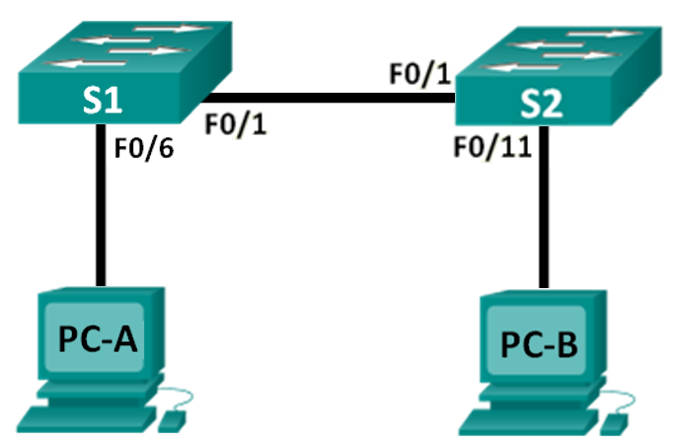
- Addressing Table
Device | Interface | IP Address | Subnet Mask | Default Gateway
S1 | VLAN 1 | 192.168.10.11 | 255.255.255.0 | 192.168.10.1
S2 | VLAN 1 | 192.168.10.12 | 255.255.255.0 | 192.168.10.1
PC-A | NIC | 192.168.10.3 | 255.255.255.0 | 192.168.10.1
PC-B | NIC | 192.168.10.4 | 255.255.255.0 | 192.168.10.1
  - Cable the network as shown in the topology.
Attach the devices as shown in the topology diagram, and cable as necessary.
  - Configure basic settings for each switch.
    - Disable DNS lookup.
    - Configure device names as shown in the topology.
    - Configure password encryption.
    - Assign class as the privileged EXEC password.
    - Assign cisco as the console and vty passwords.
    - Configure logging synchronous for the console line.
    - Configure a MOTD banner to warn users that unauthorized access is prohibited.
    - Set the SVI IP address of the switch. This allows remote management of the switch.
Before you can manage S1 remotely from PC-A, you must assign an IP address to the switch. The default configuration on the switch is to have the management of the switch controlled through VLAN 1. However, best practice for basic switch configuration is to change the management VLAN to a VLAN other than VLAN 1.
For this part we will use VLAN 1 as the switch management interface. In a later step of this lab, we will change the SVI to a newly created VLAN.
Set the IP address of the S1 to 192.168.10.11 and S2 to 192.168.10.12 with a subnet mask of 255.255.255.0 on the internal virtual interface VLAN 1.
S1# configure terminal
S1(config)# interface vlan 1
S1(config-if)# ip address 192.168.10.11 255.255.255.0
S1(config-if)# no shutdown
S1(config-if)# exit
S1(config)#

S2# configure terminal
S2(config)# interface vlan 1
S2(config-if)# ip address 192.168.10.12 255.255.255.0
S2(config-if)# no shutdown
S2(config-if)# exit
S2(config)#
    - Configure the IP default gateway for S1 and S2. If no default gateway is set, the switch cannot be managed from a remote network that is more than one router away. It does respond to pings from a remote network. Although this part does not include an external IP gateway, assume that you will eventually connect the LAN to a router for external access. Assuming that the LAN interface on the router is 192.168.10.1, set the default gateway for the switch. E.g.,
S1(config)# ip default-gateway 192.168.10.1

S2(config)# ip default-gateway 192.168.10.1
  - Configure IP addresses on PC-A and PC-B.
Assign the IP addresses and subnet masks to the PCs as shown in the Addressing Table.
Note that, a default gateway is not required for this step; however, you can enter 192.168.10.1, which is the gateway router’s address attached to S1 later.
  - Verify and Test Network Connectivity.
Verify and document the switch configuration, test end-to-end connectivity between PCs, S1 and S2, and test the switches’ remote management capability.
Note: It may be necessary to disable the PCs firewall to ping between PCs.
    - Use show interface command to verify the management VLAN 1 settings on S1.
S1# show interface vlan 1
Vlan1 is up, line protocol is up
Hardware is EtherSVI, address is 0cd9.96e2.3d41 (bia 0cd9.96e2.3d41)
Internet address is 192.168.10.11/24
MTU 1500 bytes, BW 1000000 Kbit, DLY 10 usec,
reliability 255/255, txload 1/255, rxload 1/255
Encapsulation ARPA, loopback not set
ARP type: ARPA, ARP Timeout 04:00:00
Last input 00:00:06, output 00:08:45, output hang never
Last clearing of "show interface" counters never
Input queue: 0/75/0/0 (size/max/drops/flushes); Total output drops: 0
Queueing strategy: fifo
Output queue: 0/40 (size/max)
5 minute input rate 0 bits/sec, 0 packets/sec
5 minute output rate 0 bits/sec, 0 packets/sec
175 packets input, 22989 bytes, 0 no buffer
Received 0 broadcasts (0 IP multicast)
0 runts, 0 giants, 0 throttles
0 input errors, 0 CRC, 0 frame, 0 overrun, 0 ignored
1 packets output, 64 bytes, 0 underruns
0 output errors, 0 interface resets
0 output buffer failures, 0 output buffers swapped out
What is the bandwidth on this interface? ____________________________
What is the VLAN 1 state? ____________
What is the line protocol state? ____________
    - Use show ip interface brief command to verify the management VLAN 1 settings on S2.
S2#sh ip int bri
Interface IP-Address OK? Method Status Protocol
FastEthernet0/1 unassigned YES manual up up
FastEthernet0/2 unassigned YES manual down down
FastEthernet0/3 unassigned YES manual down down
FastEthernet0/4 unassigned YES manual down down
FastEthernet0/5 unassigned YES manual down down
FastEthernet0/6 unassigned YES manual down down
FastEthernet0/7 unassigned YES manual down down
FastEthernet0/8 unassigned YES manual down down
FastEthernet0/9 unassigned YES manual down down
FastEthernet0/10 unassigned YES manual down down
FastEthernet0/11 unassigned YES manual up up
FastEthernet0/12 unassigned YES manual down down
FastEthernet0/13 unassigned YES manual down down
FastEthernet0/14 unassigned YES manual down down
FastEthernet0/15 unassigned YES manual down down
FastEthernet0/16 unassigned YES manual down down
FastEthernet0/17 unassigned YES manual down down
FastEthernet0/18 unassigned YES manual down down
FastEthernet0/19 unassigned YES manual down down
FastEthernet0/20 unassigned YES manual down down
FastEthernet0/21 unassigned YES manual down down
FastEthernet0/22 unassigned YES manual down down
FastEthernet0/23 unassigned YES manual down down
FastEthernet0/24 unassigned YES manual down down
GigabitEthernet0/1 unassigned YES manual down down
GigabitEthernet0/2 unassigned YES manual down down
Vlan1 192.168.10.12 YES manual up up
S2#
What is the VLAN 1 state? ____________
What is the line protocol state? ____________
    - From the command prompt on PCs, ping the SVI management addresses of S1 and S2. E.g.,
C:\Users\User1> ping 192.168.10.11
C:\Users\User1> ping 192.168.10.12
Because the PC needs to resolve the MAC address of the switches through ARP, the first packet may time out. If ping results continue to be unsuccessful, troubleshoot the basic device configurations. You should check both the physical cabling and logical addressing if necessary.
Note: It may be necessary to disable the PC firewall to ping between PCs.
  - Test and verify remote management of S1.
You will now use Telnet to remotely access the switch. In this lab, PC-A and S1 reside side by side. In a production network, the switch could be in a wiring closet on the top floor while your management PC is located on the ground floor. In this Step, you will use Telnet to remotely access switch S1 using its SVI management address. Telnet is not a secure protocol; however, you will use it to test remote access. With Telnet, all information, including passwords and commands, are sent across the session in plain text. In subsequent labs, you will use SSH to remotely access network devices.
    - With the cmd window still open on PC-A, issue a Telnet command to connect to S1 via the SVI management address. The password is cisco.
C:\Users\User1> telnet 192.168.10.11
    - After entering the password cisco, you will be at the user EXEC mode prompt. Access privileged EXEC mode.
    - Type exit to end the Telnet session.
  - Save the switch running configuration file.
Save the configuration.
S1# copy running-config startup-config
Destination filename [startup-config]? [Enter]
Building configuration...
[OK]
S1#
- Reflection
  - Why should you configure the vty lines for the switch?
_______________________________________________________________________________________
  - Why change the default VLAN 1 to a different VLAN number?
_______________________________________________________________________________________
  - How can you prevent passwords from being sent in plain text?
_______________________________________________________________________________________

- Create VLANs and Assign Switch Ports
In this Part, you will create Student, Faculty and Management VLANs on both switches. You will then assign appropriate switch ports to the VLANs and re-configure switch and PC IP addresses.
The Topology, Addressing Table and Switch Port Assignment for completing this task are shown as below.
- Topology
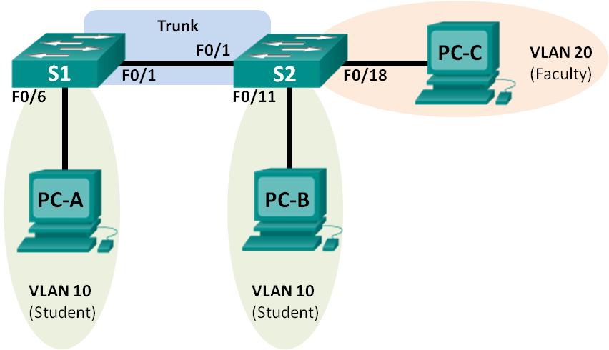
- Addressing Table
Device | Interface | IP Address | Subnet Mask | Default Gateway
S1 | VLAN 99 | 192.168.99.11 | 255.255.255.0 | 192.168.99.1
S2 | VLAN 99 | 192.168.99.12 | 255.255.255.0 | 192.168.99.1
PC-A | NIC | 192.168.10.3 | 255.255.255.0 | 192.168.10.1
PC-B | NIC | 192.168.10.4 | 255.255.255.0 | 192.168.10.1
PC-C | NIC | 192.168.20.3 | 255.255.255.0 | 192.168.20.1

Switch Port Assignment Specifications
Ports | Assignment | Network
S1 F0/1 | 802.1Q Trunk (Native VLAN 99) | N/A
S2 F0/1 | 802.1Q Trunk (Native VLAN 99) | N/A
S1 F0/6 | VLAN 10 – Students | 192.168.10.0/24
S2 F0/11 | VLAN 10 – Students | 192.168.10.0/24
S2 F0/18 | VLAN 20 – Faculty | 192.168.20.0/24

  - Connect PC-C in Fa0/18 of S2 and configure IP addresses on PC-C.
  - Create and Name VLANs on the switches.
    - Create VLAN 10 for Student VLAN, VLAN 20 for Faculty VLAN, and VLAN 99 as Management VLAN on both S1 and S2.
So, on S1:
S1(config)# vlan 10
S1(config-vlan)# name Student
S1(config-vlan)# vlan 20
S1(config-vlan)# name Faculty
S1(config-vlan)# vlan 99
S1(config-vlan)# name Management
S1(config-vlan)# end
Repeat the above commands for S2.
    - Issue the show vlan brief command to view the list of VLANs on both S1 and S2.
S1#sh vlan bri

VLAN Name Status Ports
---- -------------------------------- --------- -------------------------------
1 default active Fa0/1, Fa0/2, Fa0/3, Fa0/4
Fa0/5, Fa0/6, Fa0/7, Fa0/8
Fa0/9, Fa0/10, Fa0/11, Fa0/12
Fa0/13, Fa0/14, Fa0/15, Fa0/16
Fa0/17, Fa0/18, Fa0/19, Fa0/20
Fa0/21, Fa0/22, Fa0/23, Fa0/24
Gig0/1, Gig0/2
10 Student active
20 Faculty active
99 Management active
1002 fddi-default active
1003 token-ring-default active
1004 fddinet-default active
1005 trnet-default active
S1#
What is the default VLAN? ______________
Which ports are assigned to the default VLAN?
____________________________________________________________________________________
  - Assign switch ports to the correct VLANs.
    - Assign VLANs to the interfaces on S1 according to the Switch Port Assignment Specifications.
      - Assign PC-A to the Student VLAN (VLAN 10).
S1(config)# interface f0/6
S1(config-if)# switchport mode access
S1(config-if)# switchport access vlan 10
      - Remove the previously configured IP address for VLAN 1 on S1 and configure an IP address for VLAN 99 on S1 according to the Addressing Table. Change S1 default-gateway address accordingly.
S1(config)# interface vlan 1
S1(config-if)# no ip address
S1(config-if)# interface vlan 99
S1(config-if)# ip address 192.168.99.11 255.255.255.0
S1(config-if)# exit
S1(config)# ip default-gateway 192.168.99.1
    - Issue the show vlan brief command and verify that the VLANs are assigned to the correct interfaces.
S1# show vlan brief

VLAN Name Status Ports
---- -------------------------------- --------- -------------------------------
1 default active Fa0/1, Fa0/2, Fa0/3, Fa0/4
Fa0/5, Fa0/7, Fa0/8, Fa0/9
Fa0/10, Fa0/11, Fa0/12, Fa0/13
Fa0/14, Fa0/15, Fa0/16, Fa0/17
Fa0/18, Fa0/19, Fa0/20, Fa0/21
Fa0/22, Fa0/23, Fa0/24, Gi0/1
Gi0/2
10 Student active Fa0/6
20 Faculty active
99 Management active
1002 fddi-default act/unsup
1003 token-ring-default act/unsup
1004 fddinet-default act/unsup
1005 trnet-default act/unsup
    - Issue the show ip interfaces brief command.
What is the VLAN 99 state? ____________
What is the line protocol state? ____________
____________________________________________________________________________________
    - Use the Switch Port Assignment Table to assign VLANs to the appropriate ports on S2.
S2(config)# interface f0/11
S2(config-if)# switchport mode access
S2(config-if)# switchport access vlan 10
S2(config)# interface f0/18
S2(config-if)# switchport mode access
S2(config-if)# switchport access vlan 20
    - Remove the IP address for VLAN 1 on S2 and configure an IP address for VLAN 99 on S2 according to the Addressing Table. Change S2 default-gateway address accordingly.
S2(config)# interface vlan 1
S2(config-if)# no ip address
S2(config-if)# interface vlan 99
S2(config-if)# ip address 192.168.99.12 255.255.255.0
S2(config-if)# exit
S2(config)# ip default-gateway 192.168.99.1
    - Use the show vlan brief command to verify that the VLANs are assigned to the correct interfaces.
S2# show vlan brief

VLAN Name Status Ports
---- -------------------------------- --------- -------------------------------
1 default active Fa0/1, Fa0/2, Fa0/3, Fa0/4
Fa0/5, Fa0/7, Fa0/8
Fa0/9, Fa0/10, Fa0/12, Fa0/13
Fa0/14, Fa0/15, Fa0/16, Fa0/17
Fa0/19, Fa0/20, Fa0/21, Fa0/22
Fa0/23, Fa0/24, Gi0/1, Gi0/2
10 Student active Fa0/6, Fa0/11
20 Faculty active Fa0/18
99 Management active
1002 fddi-default act/unsup
1003 token-ring-default act/unsup
1004 fddinet-default act/unsup
1005 trnet-default act/unsup
____________________________________________________________________________________
    - Use the show ip interface brief command to verify the state of interface VLAN 99 on both S1 and S2.
What is the VLAN 99 state? ____________
What is the line protocol state? ____________
Is S1 able to ping S2? Why? ____________
Is PC-A able to ping PC-B? Why? ____________
PS. The above two pings should not be successful at this point.
Note that, in order for a switch’s SVI to be ‘up/up’, there must be at least one active port that belongs to the VLAN of the SVI, or an active trunk link.
- Maintain VLAN Port Assignments and the VLAN Database
In this Part, you will practice changing VLAN assignments to ports and removing VLANs from the VLAN database. Try to answer the following questions when completing each step.
  - Assign multiple switch ports to a VLAN.
    - On S1, assign interfaces F0/11 – 24 to VLAN 10.
S1(config)# interface range f0/11-24
S1(config-if-range)# switchport mode access
S1(config-if-range)# switchport access vlan 10
S1(config-if-range)# end
    - Issue the show vlan brief command to verify VLAN assignments.
    - Reassign F0/11 and F0/21 to VLAN 20.
    - Verify that VLAN assignments are correct.
  - Remove a VLAN assignment from an interface.
    - Use the no switchport access vlan command to remove the VLAN 10 assignment on F0/24.
S1(config)# interface f0/24
S1(config-if)# no switchport access vlan
S1(config-if)# end
    - Verify that the VLAN change was made.
Which VLAN is F0/24 is now associated with? ______________
  - Remove a VLAN ID from the VLAN database.
    - Add VLAN 30 to interface F0/24 without issuing the VLAN command.
S1(config)# interface f0/24
S1(config-if)# switchport access vlan 30
% Access VLAN does not exist. Creating vlan 30
Note: Current switch technology no longer requires that the vlan command be issued to add a VLAN to the database. By assigning an unknown VLAN to a port, the VLAN adds to the VLAN database.
    - Verify that the new VLAN is displayed in the VLAN table.
S1# show vlan brief

VLAN Name Status Ports
---- -------------------------------- --------- -------------------------------
1 default active Fa0/1, Fa0/2, Fa0/3, Fa0/4
Fa0/5, Fa0/6, Fa0/7, Fa0/8
Fa0/9, Fa0/10, Gi0/1, Gi0/2
10 Student active Fa0/12, Fa0/13, Fa0/14, Fa0/15
Fa0/16, Fa0/17, Fa0/18, Fa0/19
Fa0/20, Fa0/22, Fa0/23
20 Faculty active Fa0/11, Fa0/21
30 VLAN0030 active Fa0/24
99 Management active
1002 fddi-default act/unsup
1003 token-ring-default act/unsup
1004 fddinet-default act/unsup
1005 trnet-default act/unsup
What is the default name of VLAN 30? ______________
    - Use the no vlan 30 command to remove VLAN 30 from the VLAN database.
S1(config)# no vlan 30
S1(config)# end
    - Issue the show vlan brief command. F0/24 was assigned to VLAN 30.
After deleting VLAN 30, what VLAN is port F0/24 assigned to? What happens to the traffic destined to the host attached to F0/24?
____________________________________________________________________________________
S1# show vlan brief

VLAN Name Status Ports
---- -------------------------------- --------- -------------------------------
1 default active Fa0/1, Fa0/2, Fa0/3, Fa0/4
Fa0/5, Fa0/6, Fa0/7, Fa0/8
Fa0/9, Fa0/10, Gi0/1, Gi0/2
10 Student active Fa0/12, Fa0/13, Fa0/14, Fa0/15
Fa0/16, Fa0/17, Fa0/18, Fa0/19
Fa0/20, Fa0/22, Fa0/23
20 Faculty active Fa0/11, Fa0/21
99 Management active
1002 fddi-default act/unsup
1003 token-ring-default act/unsup
1004 fddinet-default act/unsup
1005 trnet-default act/unsup
    - Issue the no switchport access vlan command on interface F0/24.
    - Issue the show vlan brief command to determine the VLAN assignment for F0/24. To which VLAN is F0/24 assigned?
____________________________________________________________________________________
Note: Before removing a VLAN from the database, it is recommended that you reassign all the ports assigned to that VLAN.
Why should you reassign a port to another VLAN before removing the VLAN from the VLAN database?
____________________________________________________________________________________
____________________________________________________________________________________
____________________________________________________________________________________

- Configure an 802.1Q Trunk Between the Switches
In this Part, you will manually configure interface F0/1 on S1 as a trunk.
  - Manually configure trunk interface F0/1 and designate the native VLAN for the trunk.
The switchport mode trunk command is used to manually configure a port as a trunk. This command should be issued on both ends of the link.
    - Change the switchport mode on interface F0/1 to force trunking and designate the native VLAN for the trunks. Make sure to do this on both switches.
S1(config)# interface f0/1
S1(config-if)# switchport mode trunk
S1(config-if)# switchport trunk native vlan 99

S2(config)# interface f0/1
S2(config-if)# switchport mode trunk
S2(config-if)#switchport trunk native vlan 99
    - Issue the show interfaces trunk command to view the trunk mode. Notice that the mode changed from desirable to on.
S2# show interfaces trunk
Port Mode Encapsulation Status Native vlan
Fa0/1 on 802.1q trunking 99

Port Vlans allowed on trunk
Fa0/1 1-4094

Port Vlans allowed and active in management domain
Fa0/1 1,10,20,99

Port Vlans in spanning tree forwarding state and not pruned
Fa0/1 1,10,20,99
Why might you want to change the native VLAN on a trunk?
Type your answer here.
Close configuration window
Close configuration window
    - Use the show ip interface brief command to verify the state of interface VLAN 99 on both S1 and S2.
What is the VLAN 99 state? ____________
What is the line protocol state? ____________
Is S1 able to ping S2? Why? ____________
Is PC-A able to ping PC-B? Why? ____________
Is PC-A able to ping PC-C? Why? ____________
Is PC-A able to ping S1 or S2? Why? ____________
____________________________________________________________________________________
Now that the link between two switches is trunking, PC-A and PC-B should be able to ping each other. Also, both switches’ SVIs turn ‘up/up’ since the trunk link becomes active and so S1 should be able to ping S2. However, since the two SVIs, PC-A/PC-B, PC-C are on different VLANs, they cannot ping each other at this point.

- Reflection
  - What is needed to allow hosts on VLAN 10 to communicate to hosts on VLAN 99?
Type your answer here.
  - What are some primary benefits that an organization can receive through effective use of VLANs?
Type your answer here.

- Configure Trunk-Based Inter-VLAN Routing
In this Part, you will add a router R1 and configure the router to route to multiple VLANs by creating sub-interfaces for each VLAN. This method of inter-VLAN routing is called router-on-a-stick.
The following Addressing Table includes additional address information that you will need for this task.
- Addressing Table
Device | Interface | IP Address | Subnet Mask | Default Gateway
R1 | Fa0/1.99 | 192.168.99.1 | 255.255.255.0 | N/A
 | Fa0/1.10 | 192.168.10.1 | 255.255.255.0 | N/A
 | Fa0/1.20 | 192.168.20.1 | 255.255.255.0 | N/A
 | Lo0 | 209.165.200.225 | 255.255.255.224 | N/A
S1 | VLAN 99 | 192.168.99.11 | 255.255.255.0 | 192.168.99.1
S2 | VLAN 99 | 192.168.99.12 | 255.255.255.0 | 192.168.99.1
PC-A | NIC | 192.168.10.3 | 255.255.255.0 | 192.168.10.1
PC-B | NIC | 192.168.10.4 | 255.255.255.0 | 192.168.10.1
PC-C | NIC | 192.168.20.3 | 255.255.255.0 | 192.168.20.1
  - Connect the Switch S1 with a Router R1.
Using an Ethernet straight-through cable to connect the router R1 Fa0/1 and the switch S1 Fa0/5.
The completed topology now is shown as below.
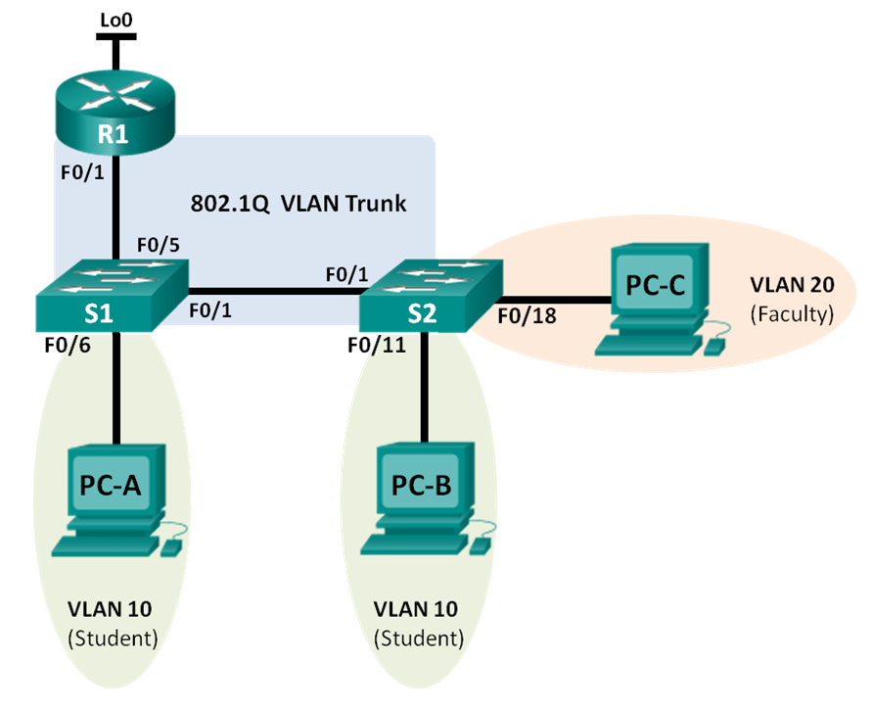
  - Manually configure trunk interface F0/5 on S1.
The switchport mode trunk command is used to manually configure a port as a trunk.
    - Change the switchport mode on Port F0/5 to force trunking and designate the native VLAN for the trunks. Designate VLAN 99 as native for the trunk.
S1(config)# interface f0/5
S1(config-if)# switchport mode trunk
S1(config-if)# switchport trunk native vlan 99
S1(config-if)#
  - Configure Inter-VLAN Routing on the Router.
      - Activate interface Fa0/1 on the router.
R1(config)# interface f0/1
R1(config-if)# no shutdown
      - Configure sub-interfaces for VLAN 10, 20, and 99 with the addresses from the Addressing Table. Designate VLAN 99 as native for the trunk.
R1(config-if)# interface f0/1.10
R1(config-subif)# encapsulation dot1Q 10
R1(config-subif)# ip address 192.168.10.1 255.255.255.0
R1(config-subif)# interface f0/1.20
R1(config-subif)# encapsulation dot1Q 20
R1(config-subif)# ip address 192.168.20.1 255.255.255.0
R1(config-subif)# interface f0/1.99
R1(config-subif)# encapsulation dot1Q 99 native
R1(config-subif)# ip address 192.168.99.1 255.255.255.0

NOTE the following points in the above configurations:
- The physical interface is enabled using the no shutdown command, because router interfaces are down by default. The virtual interfaces are up by default.
- The subinterface can use any number that can be described with 32 bits, but it is good practice to assign the number of the VLAN as the interface number, as has been done here.
- The native VLAN is specified on the L3 device so that it is consistent with the switches. Otherwise, VLAN 1 would be the native VLAN by default, and there would be no communication between the router and the management VLAN on the switches.
      - Use the show ip interface brief command to verify the sub-interfaces are operational.
R1# show ip interface brief
Interface IP-Address OK? Method Status Protocol
FastEthernet0/0 unassigned YES unset Administratively down down
FastEthernet0/1 unassigned YES unset up up
FastEthernet0/1.10 192.168.10.1 YES manual up up
FastEthernet0/1.20 192.168.20.1 YES manual up up
FastEthernet0/1.99 192.168.99.1 YES unset up up
  - Verify connectivity.
Enter the command to view the routing table on R1. What networks are listed?
_______________________________________
From PC-A, is it possible to ping the default gateway for VLAN 10? _____________
From PC-A, is it possible to ping PC-B? _____________
From PC-A, is it possible to ping Lo0? _____________
From PC-A, is it possible to ping S2? _____________
If the answer is no to any of these questions, troubleshoot the configurations and correct any errors.
- Reflection
What ensures a switch’s SVI turn ‘up/up’?
_________________________________________________________________________________

