Vietnam General Confederation of Labor

**TON DUC THONG UNIVERSITY**

**FACULTY OF INFORMATION TECHNOLOGY**



**APPLICATION PROJECT**

**FINAL REPORT ON .NET TECHNOLOGY FINAL PROJECT**

Instructor: **Thầy Nguyễn Ngọc Phiên**

Executor: **Nguyễn Tuấn Anh**

Class **: 20H50205**

Courses **: 24**

**HO CHI MINH CITY, 2023**

Vietnam General Confederation of Labor

**TON DUC THONG UNIVERSITY**

**FACULTY OF INFORMATION TECHNOLOGY**



**APPLICATION PROJECT**

**FINAL REPORT ON .NET TECHNOLOGY FINAL PROJECT**

Instructor: **Thầy Nguyễn Ngọc Phiên**

Executor: **Nguyễn Tuấn Anh**

Class **: 20H50205**

Courses **: 24**

**HO CHI MINH CITY, 2023**

**THANK YOU**

First of all, with the deepest and most sincere feelings, allow me to express my gratitude to all the individuals and organizations that have facilitated and supported me throughout my study. Although the time is not much, but I have learned many practical experiences that I did not know when I was in school.

I would also like to express my gratitude to the leadership of Ton Duc Thang University and Mr. Nguyen Ngoc Phien for directly and indirectly helping me during my study and research on this topic.

Given the limited time and experience of a practitioner, this report cannot avoid shortcomings. I look forward to receiving the guidance and comments of the teachers so that I have the opportunity to supplement, improve my awareness, improve and draw experience for future reports, if any.

Once again I sincerely thank !

*Ho Chi Minh City, date 20*

*Author*

*(Signature and full name)*

*Nguyen Tuan Anh*

**WORK IS COMPLETED**

**AT TON DUC THONG UNIVERSITY**

I hereby declare that this is my own research work and is under the scientific guidance of Mr. Nguyen Ngoc Phien. The research contents and results in this topic are honest and have not been published in any form before. The data in the tables for analysis, comments and evaluation are collected by the author himself from different sources, clearly stated in the reference section.

In addition, the thesis also uses some comments, assessments as well as data of other authors, other agencies and organizations, all with citations and source annotations.

**If I find any fraud, I will take full responsibility for the content of my thesis.** Ton Duc Thang University is not related to copyright and copyright violations caused by me during the implementation process (if any).

*Ho Chi Minh City, date 20*

*Author*

*(Signature and full name)*

*Nguyen Tuan Anh*

**TEACHER'S CONFIRMATION AND ASSESSMENT SECTION**

**The confirmation part of the instructor** _____________________________________________________________________________________________________________________________________________________________________________________________________________________________________________________________________________________________________________________________________________________________________________________________________________________

City.Ho Chi Minh, day month year

(signature and full name)

**The evaluation part of the teacher marks the test** _____________________________________________________________________________________________________________________________________________________________________________________________________________________________________________________________________________________________________________________________________________________________________________________________________________________

City.Ho Chi Minh, day month year

(signature and full name)

**Table of Contents**

Contents

List of drawings vi

LIST OF ABBREVIATIONS vii

CHAPTER 1 – THE BEGINNING 7

1.1 Requirement 7

1.1.1 Project Management Plan 7

1.1.2. Requirement Specifications 2

1.1.3. Architecture 2

1.1.4. Design 2

1.1.5. Test Plan 2

1.1.6. Demo 2

CHAPTER 2 - ANSWER QUESTIONS 3

2.1 Answer the question 3

2.1.1 Project Organization 4

2.1.2 LIFECYCLE MODEL USED 4

2.1.3 RISK ANALYSIS 6

2.1.4 HARDWARE AND SOFTWARE RESOURCE REQUIREMENTS 7

2.1.5 DELIVERABLES, SCHEDULE 7

2.1.6 MONITORING, REPORTING, AND CONTROLLING MECHANISMS 8

2.1.7 References 8

3.1.1 Stakeholders for the system 9

3.1.2 Use case model 9

3.3.3 Functional requirements 10

3.3.4 Non-Functional requirements 10

5.1.1 Database 11

5.1.2 Class Diagram 11

5.1.3 Sequence Diagram 12

5.1.4 Retionable 13

7.1.1 Database 13

7.1.2 Testing 13

7.1.3 Git 19

REFERENCES 20

# **List of drawings**

Picture 1 : LifeCycle of Sale Process 4

Picture 2 : Use case 8

Picture 3 : Database 10

Picture 4 : Class Diagram 11

Picture 5 : Sequence Diagram 12

Picture 6 : Database 12

Picture 7 : Main Page 13

Picture 8 : Add Product 13

Picture 9 : List Product 14

Picture 10 : Status 14

Picture 11 : Edit 15

Picture 12 : View 16

Picture 13 : Trash 17

Picture 14 : List Type Of Product 17

Picture 15 : Check Trash 18

Picture 16 : Home Page 19

Picture 17 : Git 19

# **LIST OF ABBREVIATIONS**

**PO Purchase Order**

# 

# **CHAPTER 1 – THE BEGINNING**

## **1.1 Requirement**

- In this report, We was assigned to perform the exercise with the following parts:

### **1.1.1 Project Management Plan**

* Project Organization
* Lifecycle Model Used
* Risk Analysis
* Hardware and Software Resource Requirements
* Deliverables and Schedule
* Monitoring, Reporting, and Controlling Mechanisms
* Professional Standards
* Evidence all the artifacts have been placed under configuration management
* Impact of the project on individuals and organizations

### **1.1.2. Requirement Specifications**

* Stakeholders for the system
* Use case model
* Graphical use case model
* Textual Description for each use case
* Functional requirements
* Non-functional requirements

### **1.1.3. Architecture**

* Architectural style used
* Architectural model
* Technology, software, and hardware used
* Rationale for your architectural style and model

### **1.1.4. Design**

* Database design
* Static model – class diagrams
* Dynamic model – sequence diagrams
* Rationale for your detailed design model
* Traceability from requirements to detailed design model

### **1.1.5. Test Plan**

* Requirements/specifications-based system level test cases
* Traceability of test cases to use cases
* Techniques used for test generation
* Assessment of the goodness of your testsuite (Which metrics were used for such
* assessment?)

### **1.1.6. Demo**

* Database
* Testing
* Git

# **CHAPTER 2 - ANSWER QUESTIONS**

## **2.1 Answer the question**

### **2.1.1 Project Organization**

* The project will be a sales website with functional chains included in the requirements, including:
  + Develop the function of creating receipts
  + Developing the function for accountants to make delivery notes
  + Developing a function for accountants to review the statistics of incoming and outgoing goods, best-selling items, and monthly revenue.
* **Rationale** 
  + Sales is the realization of value and the transfer of ownership of goods.
  + At the end of this process the buyer receives the goods and the seller receives the money (or has a legal basis to receive the money).

### **2.1.2 LIFECYCLE MODEL USED**

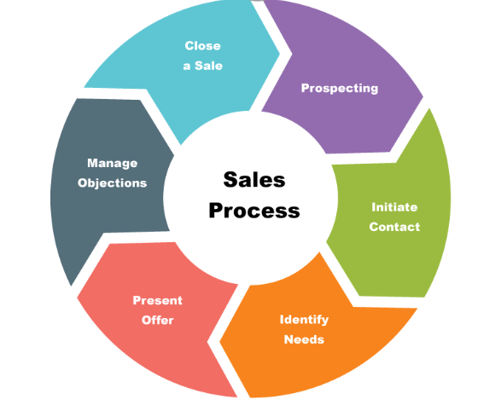

**Picture 1 : LifeCycle of Sale Process**

* **Rationale** 
  + **For society** 
    - Selling is an activity that directly performs the function of goods circulation, contributing to the process of reproduction and serving social life.
  + **For Businesses**
    - Sales is the last step to end the process of goods circulation. The concern is that in today's era with the explosion of information, the rapid development in the field of science and technology, sales are always competitive from many sides.
* **For consumers**
  + Sales activities become an intermediary bridge to help the goods produced by enterprises can reach consumers and satisfy their needs or desires.

### **2.1.3 : RISK ANALYSIS**

* **For purchase orders (PO) issued by customers:**
  + Signature: Should have at least 2 signatures (customer and authorized person for approval)
  + Purpose: customers sign to confirm the order quantity, unit price, specification. At the same time, the authorized person signs and approves the sale
* **Ex-warehousing slip issued by sales accountant:**
  + Ensure all 5 signatures: Maker (signature to confirm the making), Chief Accountant (signs to confirm control), Storekeeper (signs to confirm the release of warehouse), customer (signs to confirm receipt of correct), enough goods), Director (signing for approval for sale).
* **Financial invoices made by accountants or sales staff:**
  + Ensure 5 signatures: invoicer, customer (signed to confirm purchase), director (approved for sale)
* **Receipts made by the payment accountant:**
  + There are 5 signatures: maker, chief accountant (confirmation of checking for correct, sufficient and timely collection), treasurer (confirmation of payment), payer (confirmation of payment), director .
* **Rationale** 
  + Risk exists everywhere while selling, it can happen that we don't anticipate
  + Statistically defined risk is the probability of random occurrence of a measurable fixed variable

### **2.1.4 HARDWARE AND SOFTWARE RESOURCE REQUIREMENTS**

* General requirements
  + 2000 MB of free disk space on the hard drive
  + Processors that support SSE2
  + Internet access
  + Microsoft Windows Installer 4.5 or higher
  + Microsoft.NET Framework 4 or higher
* **Rationale** 
  + software and hardware requirements to meet the criteria for configuring the sales site

### **2.1.5 DELIVERABLES, SCHEDULE**

* **Describe the activities**
* Enhance product quality
* Create a strategic report
* Design a product prototype
* Draft a progress report
* Improve customer experience
* Create a product prototype
* Improve response procedures
* Create a usability report
* Complete a design review
* Estimated time
* 864 hours (5 weeks)
* 35 hours break
* 22 hours group meeting
* 50 hours of hiatus due to personal work
* 250 hours for schoolwork
* 507 hours left (59%)
* **Rationale**
  + Work schedule to be able to determine the time and arrange the work of all members in the group

### **2.1.6 MONITORING, REPORTING, AND CONTROLLING MECHANISMS**

* Receive orders, deposit and put those orders in the record book
* Receive sales invoices and save them
* Make a warranty card for all items and save it
* Calculation of sales, debt
* Monitor the status of goods in stock
* Print daily report
* Rationale
  + Monitoring and evaluation aims to assess the level of customer satisfaction, and at the same time evaluate the level of success in sales. In addition, the monitoring also aims to detect adverse situations, inappropriate situations in order to promptly overcome.

### **3.1.1 Stakeholders for the system**

* Suppliers
* Owners
* Investors
* Employees
* Customers

### **3.1.2 Use case model**

## **Picture 2 : Use case**

* Textual Description for each use case
* Employee is an employee with the role of logging in and entering invoices
* Owner has the role of import manager , export management , employee management and statistical data in the company
* Warehouse will play a very important role when creating goods receipt , creating goods for shipment , product inventory , creating vouchers.
* In addition, warehouse must accept the import management and export management roles as owners.

### **3.3.3 Functional requirements**

* A webpage to track all transactions
* System software requires users to enter their financial information upon creating an account.
* Users can navigate the software easily by using buttons that show where to locate specific products.

### **3.3.4 Non-Functional requirements**

* Usubility :
  + No matter the size of the business, website should be intuitive and easy-to-use
* Security :
  + Security is an important factor in handling currency and data transactions
  + Can create, view, copy, delete, edit information
* Maintainability
  + Striving to make the website maintainable from the initial development phase means cutting the time and cost to identify and resolve the system faults in the future.

### **5.1.1 Database**

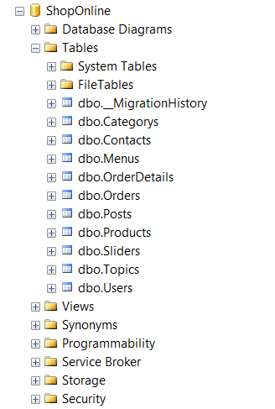

## **Picture 3 : Database**

* + 1. **Class Diagram**

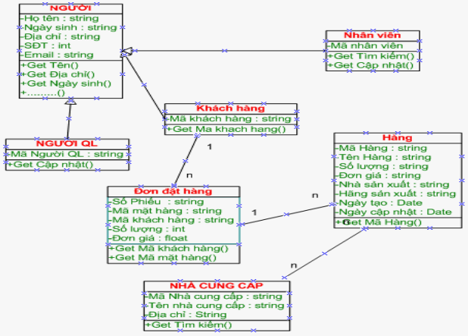

## **Picture 4 : Class Diagram**

* + 1. **Sequence Diagram**

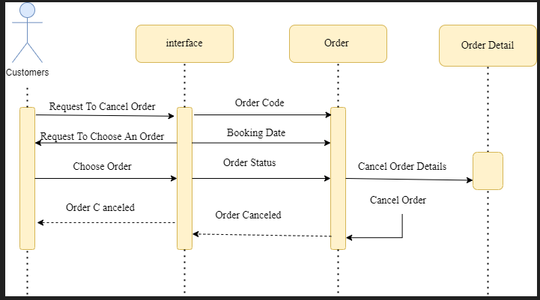

## **Picture 5 : Sequence Diagram**

* + 1. **Retionable**
  + Define sales goals
  + sales planning
  + Sales force organization
  + Sales force operations management
  + Control, evaluation and adjustment results

### **7.1.1 Database**

* All the data in Models will be passed and saved in SQL like Figure 3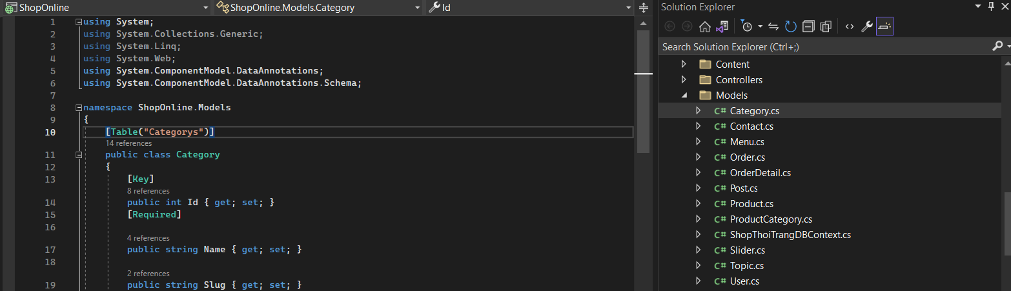

## **Picture 6 : Database**

### **7.1.2 Testing**

- F5 to run code and press /admin to enter project

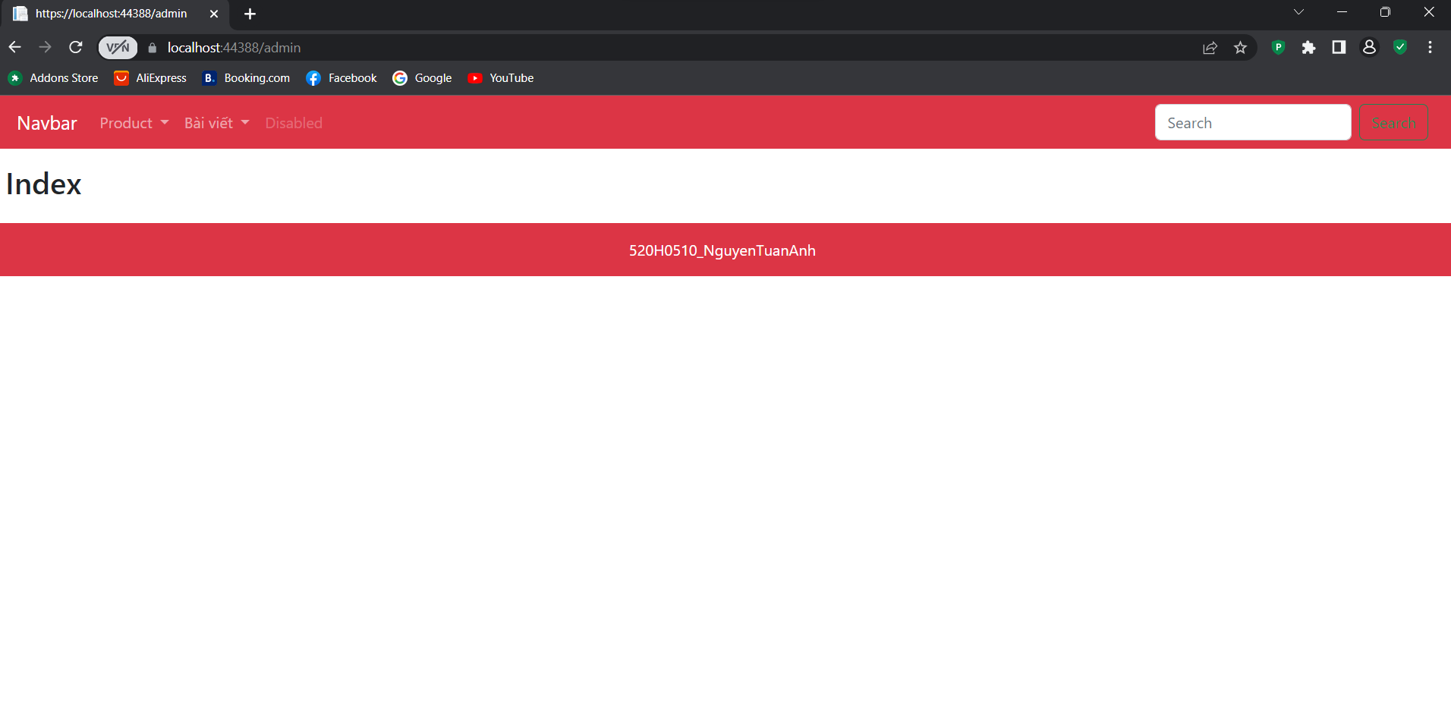

## **Picture 7 : Main Page**

* In the Product section, click Add sản phẩm to create more products

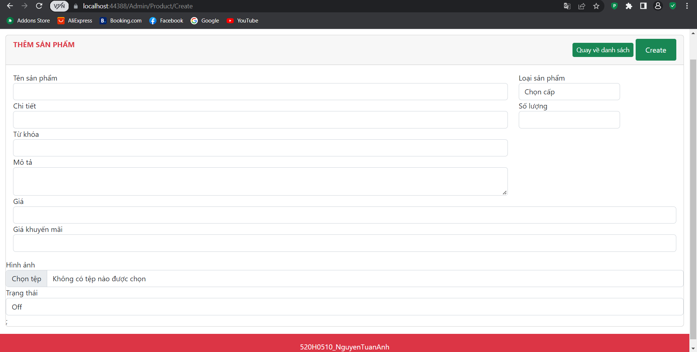

**Picture 8 : Add Product**

* After adding the products, we have a list of products when clicking on the product list

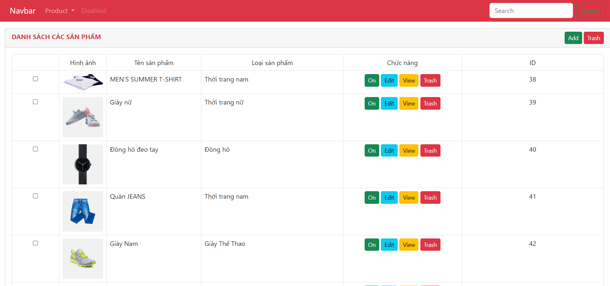

## **Picture 9 : List Product**

* In the product list, you can see that we will have 4 colored buttons in the function section
* The first function is On / Off state when we click it will change

## **Picture 10 : Status**

* Next is Edit, we will edit the product information
* After finish, we press Update .
* And if we don't want to update anymore, we will press back to the list

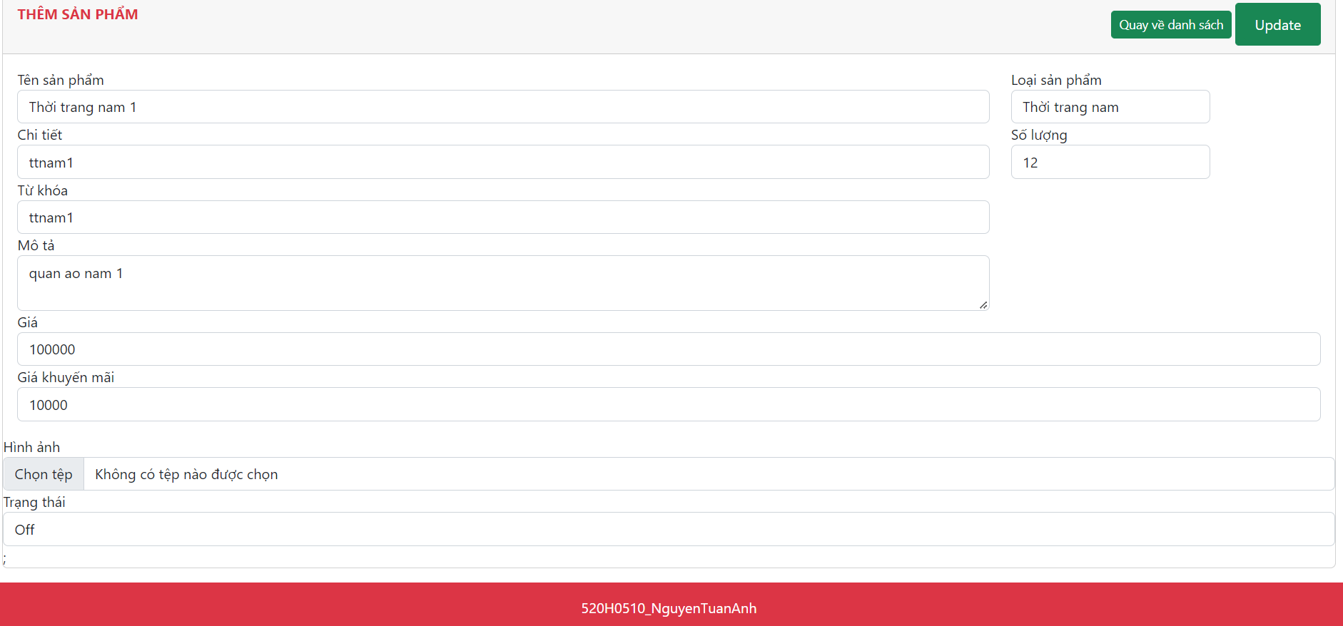

## **Picture 11 : Edit**

* Next will be the View section to see product information
* Below we can move directly to the Edit section or we can return to the arbitrary list

****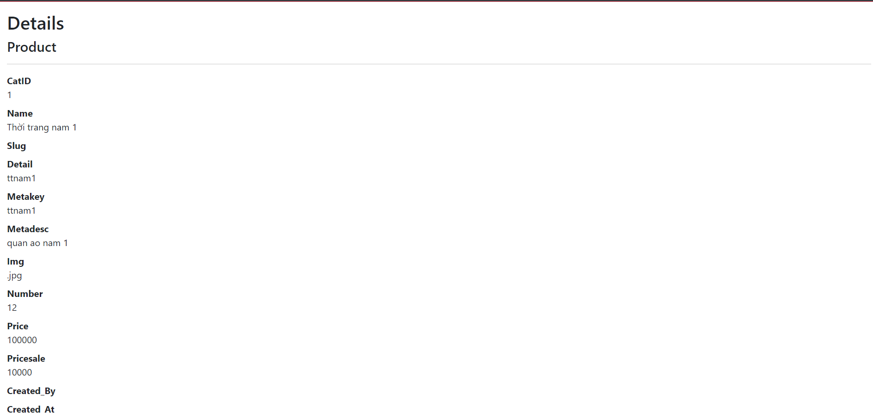

**Picture 12 : View**

* The last function is to delete and after pressing Trash the product will disappear
* Giày nữ was deleted

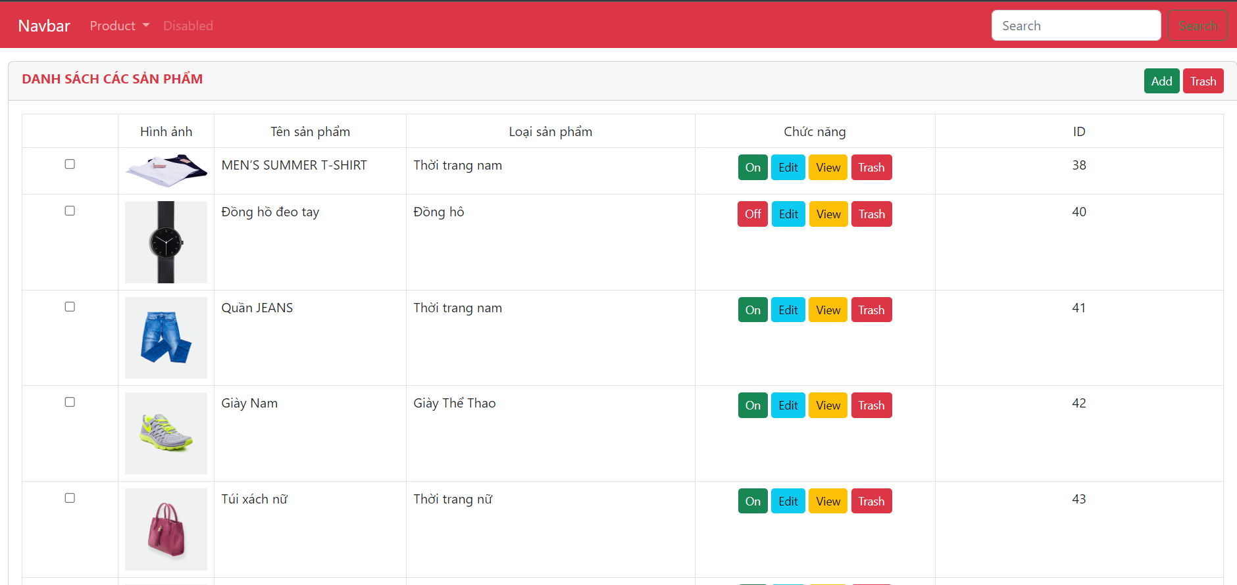

## **Picture 13 : Trash**

* Continuing in the Product section, there will be an add item for the same type of product

## **Picture 14 : List Type Of Product**

* When we delete a product, there will still be the product we just deleted in the trash
* You can choose to completely delete or retrash the product

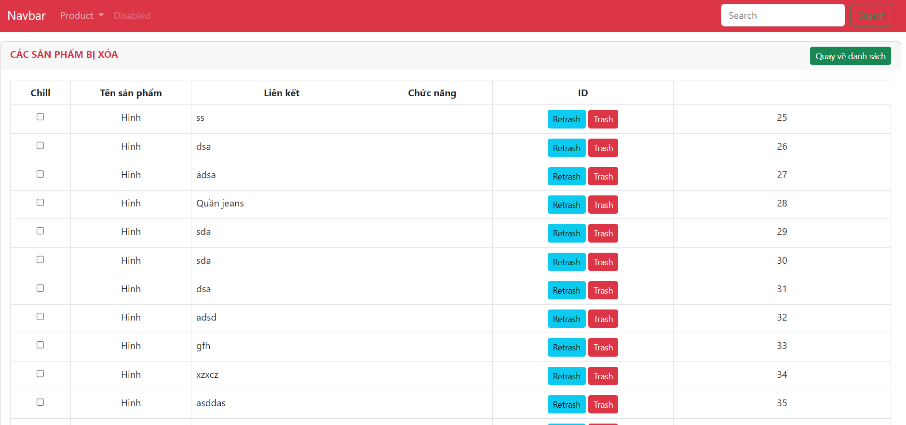

## **Picture 15 : Check Trash**

* 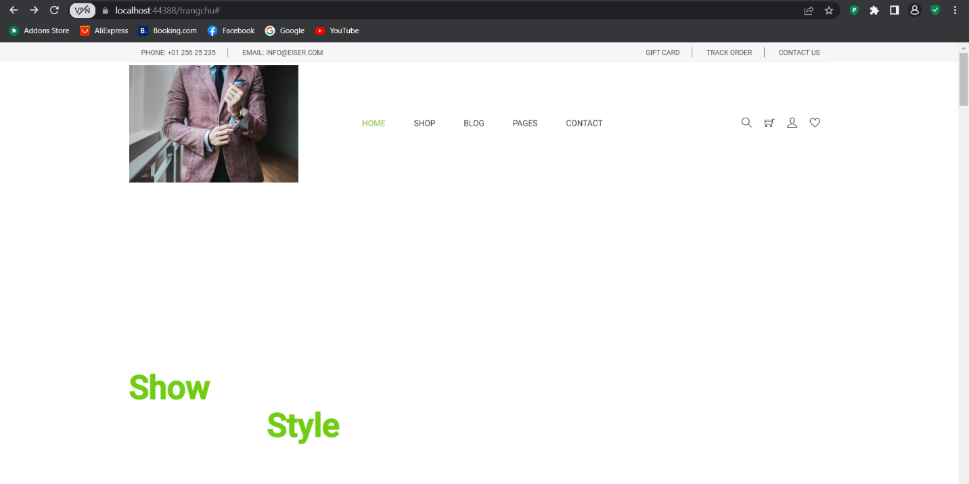Now we will open the template of a sales shop with the address localhost:44388 as the default when running the code and then press /trangchu de to go to the shop page

## **Picture 16 : Home Page**

### **7.1.3 Git**

## **Picture 17 : Git**

# **REFERENCES**

1. Dr. Ivar Jacobson; Ian Spence; Kurt Bittner (December 2011). [*"Use-Case 2.0 ebook"*](https://www.ivarjacobson.com/publications/white-papers/use-case-ebook). Ivar Jacobson International. p. 4*. Retrieved 9 August 2020*.
2. ^ [Jump up to:***a***](https://en.wikipedia.org/wiki/Use_case#cite_ref-:2_2-0) [***b***](https://en.wikipedia.org/wiki/Use_case#cite_ref-:2_2-1) Jacobson, Ivar (1 December 1987). [*"Object-oriented development in an industrial environment"*](http://portal.acm.org/citation.cfm?doid=38807.38824). ACM SIGPLAN Notices. **22** (12): 183–191. [*doi*](https://en.wikipedia.org/wiki/Doi_(identifier)):[*10.1145/38807.38824*](https://doi.org/10.1145%2F38807.38824).
3. [**^**](https://en.wikipedia.org/wiki/Use_case#cite_ref-cockburn_3-0) Cockburn, Alistair (March 2002). [*"Use cases, ten years later"*](https://web.archive.org/web/20080915162727/http:/alistair.cockburn.us/index.php/Use_cases%2C_ten_years_later). Alistair.cockburn.us. Alistair Cockburn. Archived from [*the original*](http://alistair.cockburn.us/index.php/Use_cases%2C_ten_years_later) on 15 September 2008*. Retrieved 17 April 2013*.
4. [System Sequence Diagrams](http://www.cse.lehigh.edu/~glennb/oose/ppt/06SystemSequenceDiagrams.ppt)
5. [**^**](https://en.wikipedia.org/wiki/Sequence_diagram#cite_ref-2) OMG (2011). [OMG Unified Modeling Language (OMG UML), Superstructure, V2.4.1](http://www.omg.org/spec/UML/2.4.1/Superstructure/PDF), p. 507.
6. [**^**](https://en.wikipedia.org/wiki/Sequence_diagram#cite_ref-3) OMG (2008). [OMG Unified Modeling Language (OMG UML), Superstructure, V2.1.2](http://www.omg.org/spec/UML/2.1.2/Superstructure/PDF), p. 485.
7. [**^**](https://en.wikipedia.org/wiki/Sequence_diagram#cite_ref-4) OMG (2007). [OMG Unified Modeling Language (OMG UML), Superstructure, V2.1.2](http://www.omg.org/spec/UML/2.1.2/Superstructure/PDF). p. 467.
8. [*"Theories"*](https://github.com/junit-team/junit4/wiki/Theories). [*GitHub*](https://en.wikipedia.org/wiki/GitHub).
9. [**^**](https://en.wikipedia.org/wiki/Unit_testing#cite_ref-9) [*"Parameterized tests"*](https://github.com/junit-team/junit4/wiki/Parameterized-tests). [*GitHub*](https://en.wikipedia.org/wiki/GitHub).
10. [**^**](https://en.wikipedia.org/wiki/Unit_testing#cite_ref-10) [*Boehm, Barry W.*](https://en.wikipedia.org/wiki/Barry_Boehm); Papaccio, Philip N. (October 1988). [*"Understanding and Controlling Software Costs"*](http://faculty.ksu.edu.sa/ghazy/Cost_MSc/R6.pdf) *(PDF)*. IEEE Transactions on Software Engineering. **14** (10): 1462–1477. [*doi*](https://en.wikipedia.org/wiki/Doi_(identifier)):[*10.1109/32.6191*](https://doi.org/10.1109%2F32.6191)*. Retrieved 13 May 2016*.