Lab 78910

**2. Database to create following tables and Winform**

1. Item(ItemID, ItemName, Size,…..)

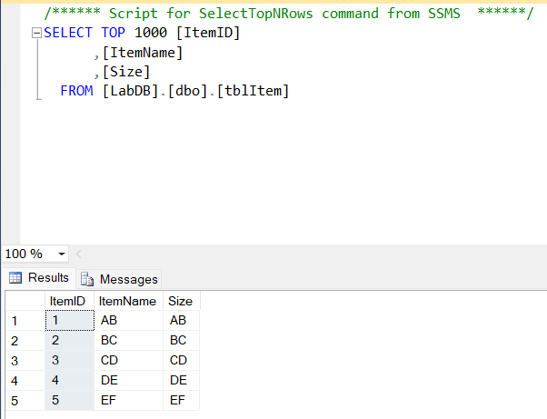

**Hình 1 : Item**

* First, when running on winform, a Login panel will appear
* Account and Password for this login will use all 5 Items in picture 1 with account will be Item ID and password will be Size
* Example in the picture below I will get Item 1 with account 1 and password AB

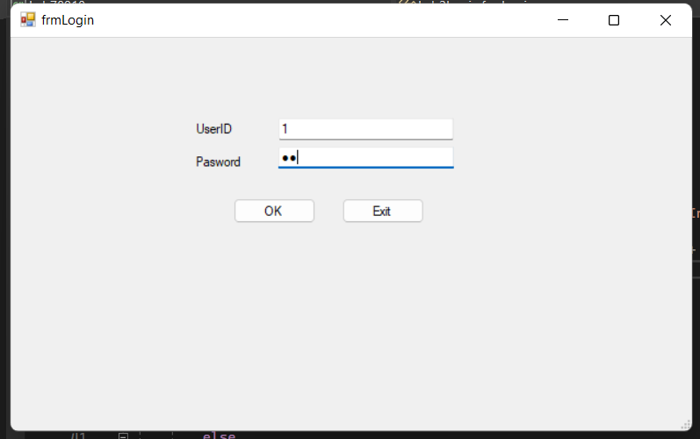

**Hình 2 : Login Item**

* 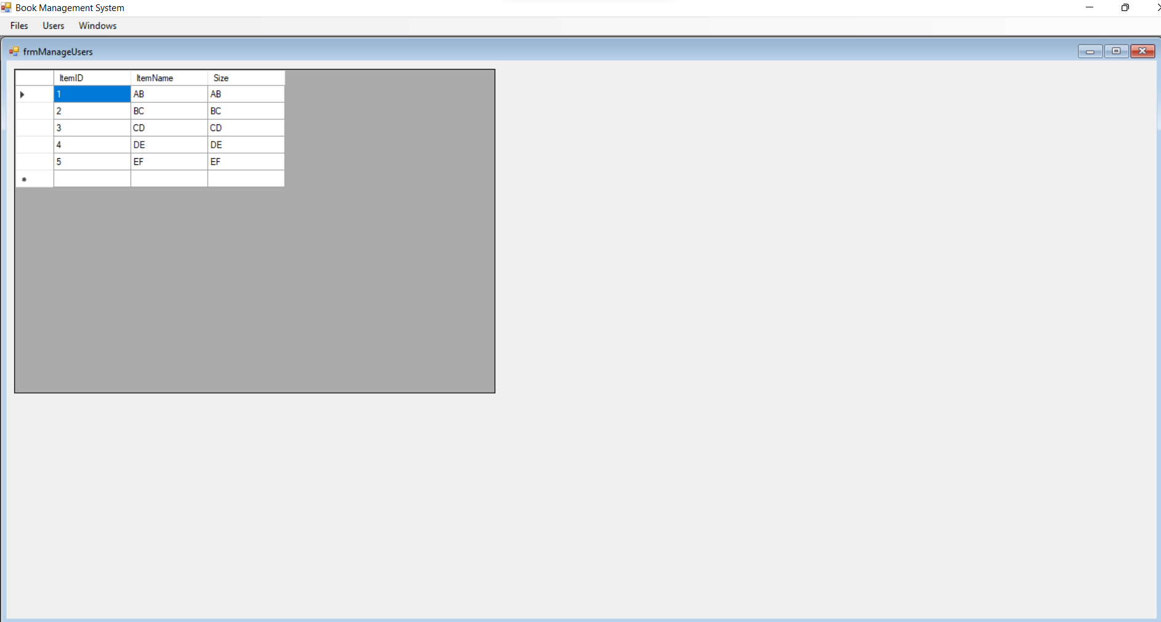After successful login, a table will appear with the information of the Item that we have done in the database

**Hinh 3 : Item in Winform**

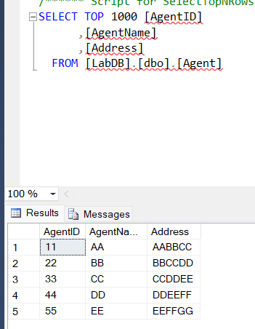2. Agent(AgenID, AgentName, Address)

**Hinh 4 : Agent**

* First, when running on winform, a Login panel will appear
* Account and Password for this login will use all 5 Items in picture 4 with account will be AgentID and password will be AgentName
* Example in the picture below I will get Item 1 with account 11 and password AA

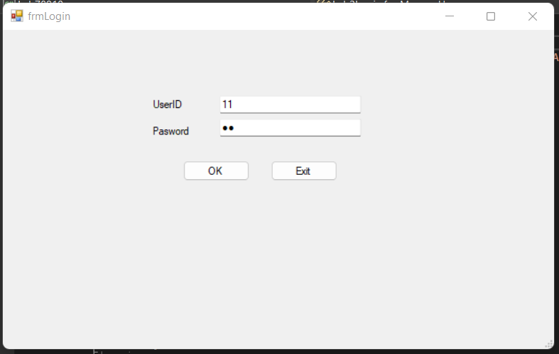**Hinh 5 : Login Agent**

* After successful login, a table will appear with the information of the Item that we have done in the database

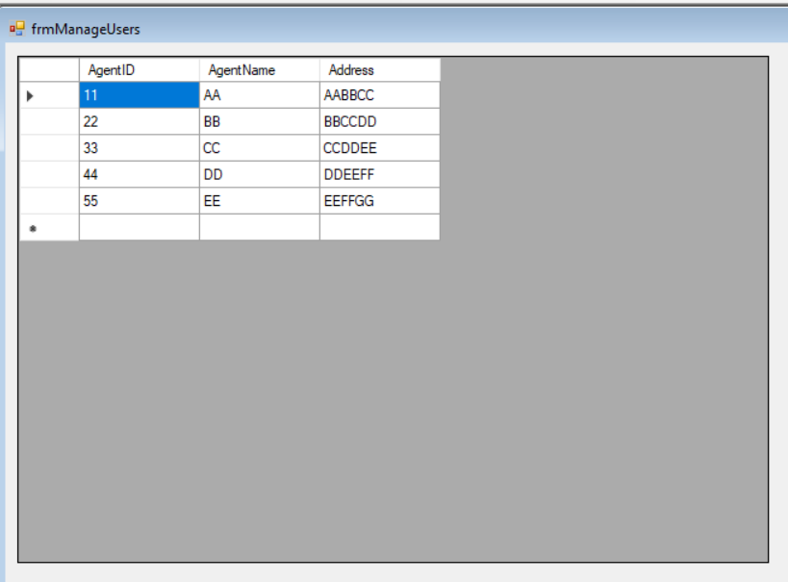

**Hinh 6 : Agent in Winform**

3. Order(OrderID, OrderDate, AgentID)

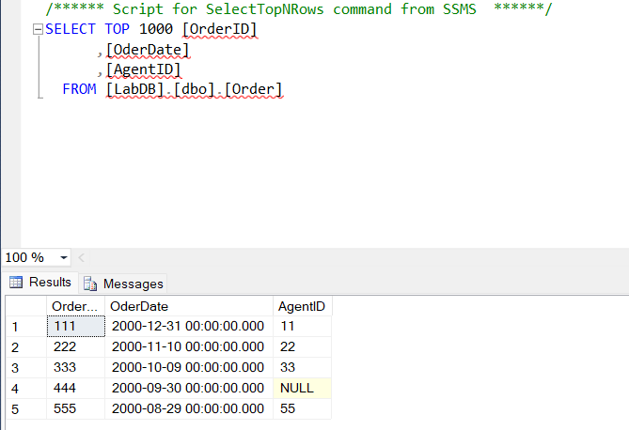

**Hinh 7 : Order**

1. OrderDetail(ID, OrderID, ItemID, Quantity, UnitAmount)

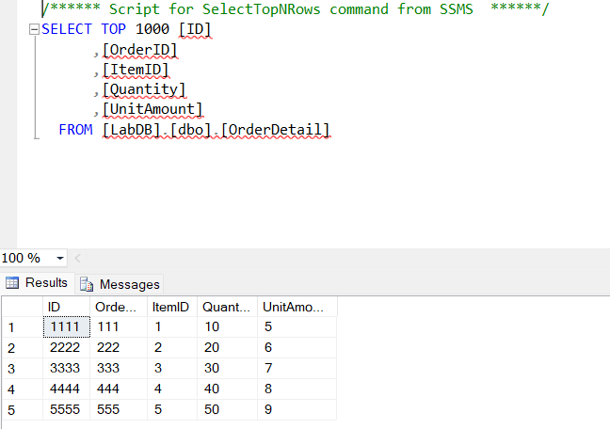

**Hinh 10 : OrderDetail**

* First, when running on winform, a Login panel will appear
* Account and Password for this login will use all 5 Items in picture 10 with account will be ID and password will be ItemID
* Example in the picture below I will get Item 1 with account 1111 and password 1

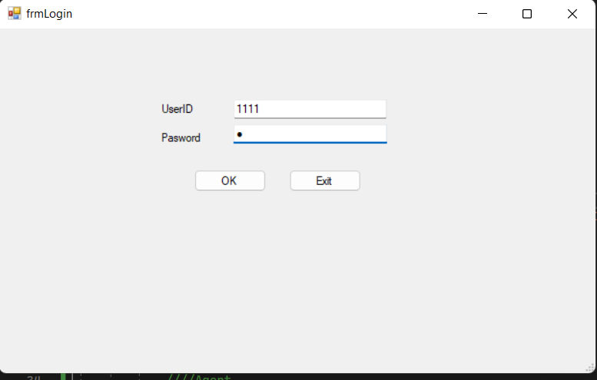**Hinh 11 : Login OrderDetail**

* After successful login, a table will appear with the information of the Item that we have done in the database

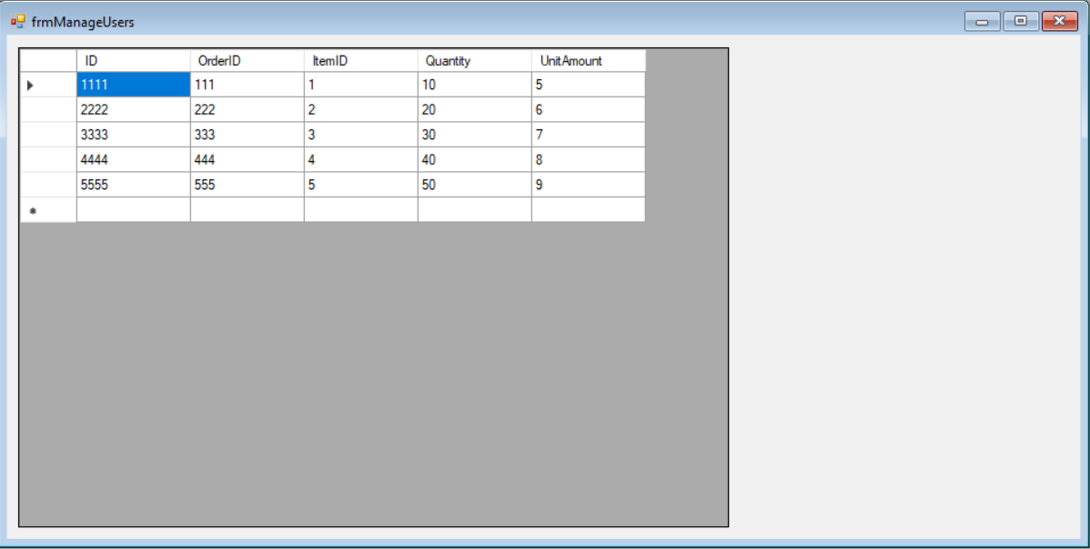**Hinh 12 : OrderDetail in Winform**

**3. MVC Project**

- First we will create an MVC web in Visual Studio

- Then we will go to View => Homes to edit the interface in the Index.cshtml section and this is my interface after editing.

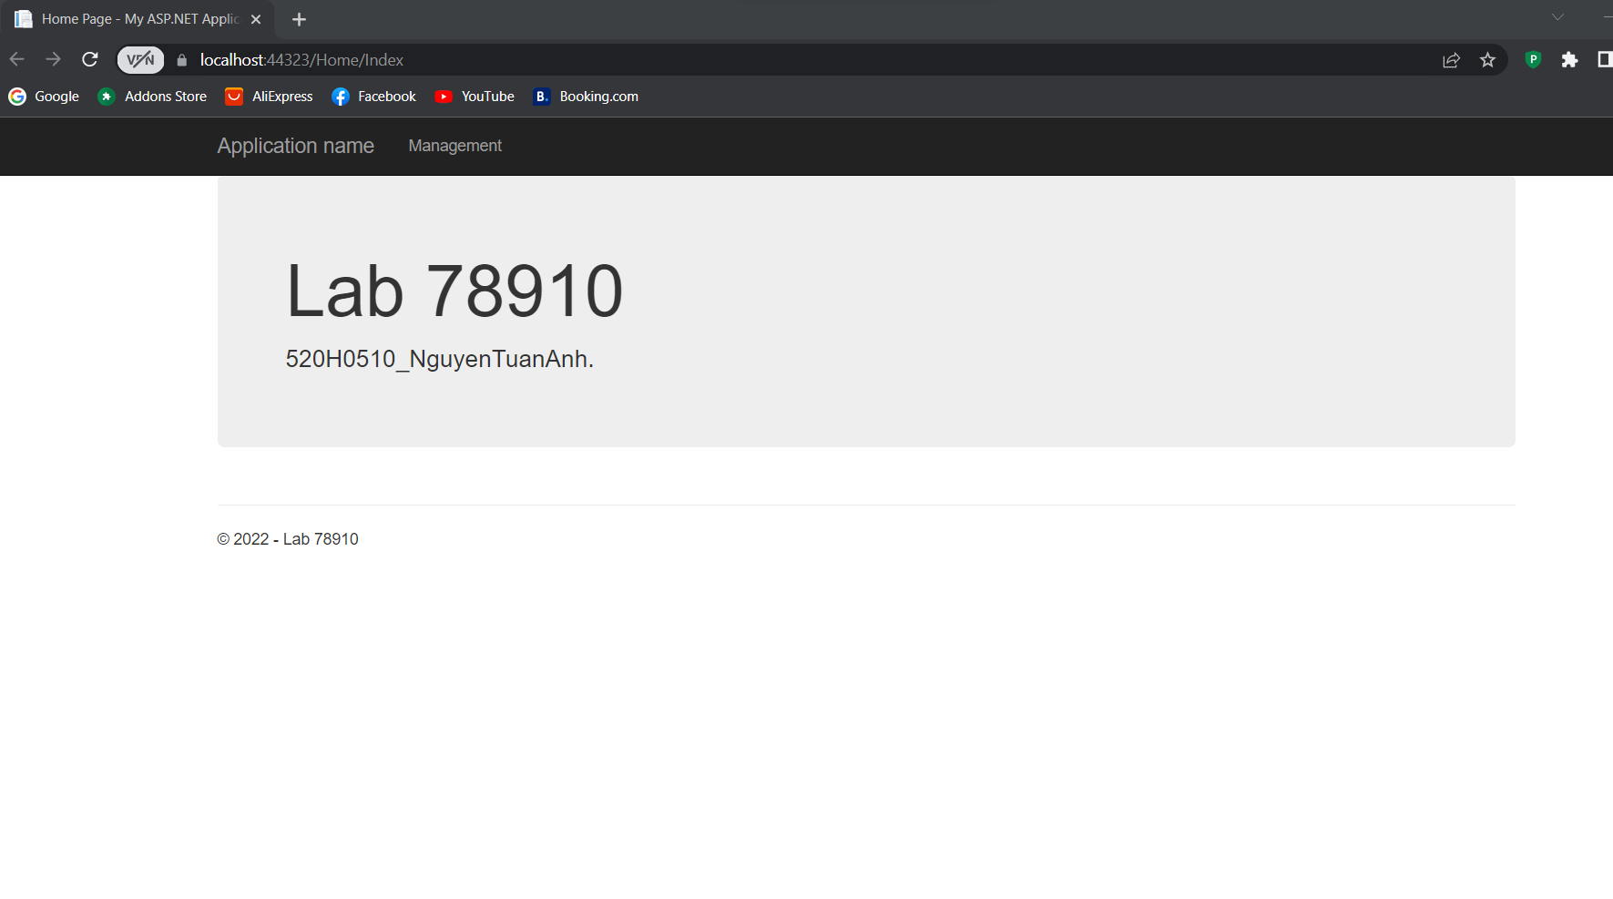

**Hinh 13 : MVC MainPage**

* Then will add the Controller from the database.

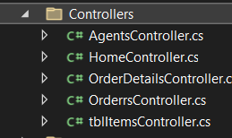

**Hình 14 : Controller**

* 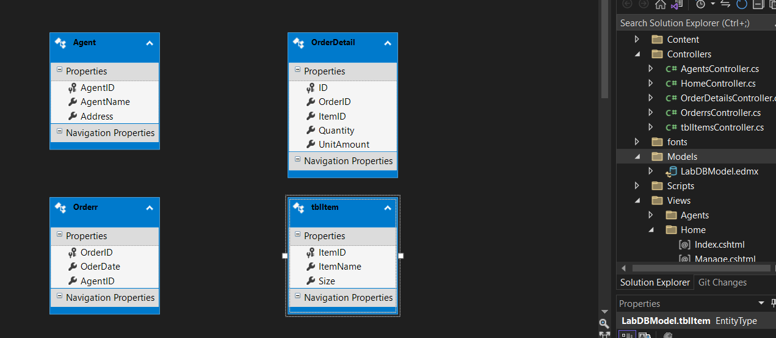Continue , Add Data Model into folder Model

**Hinh 15 : Model**

* Finally, we will run the code and will display the interface as shown in Figure 13
* 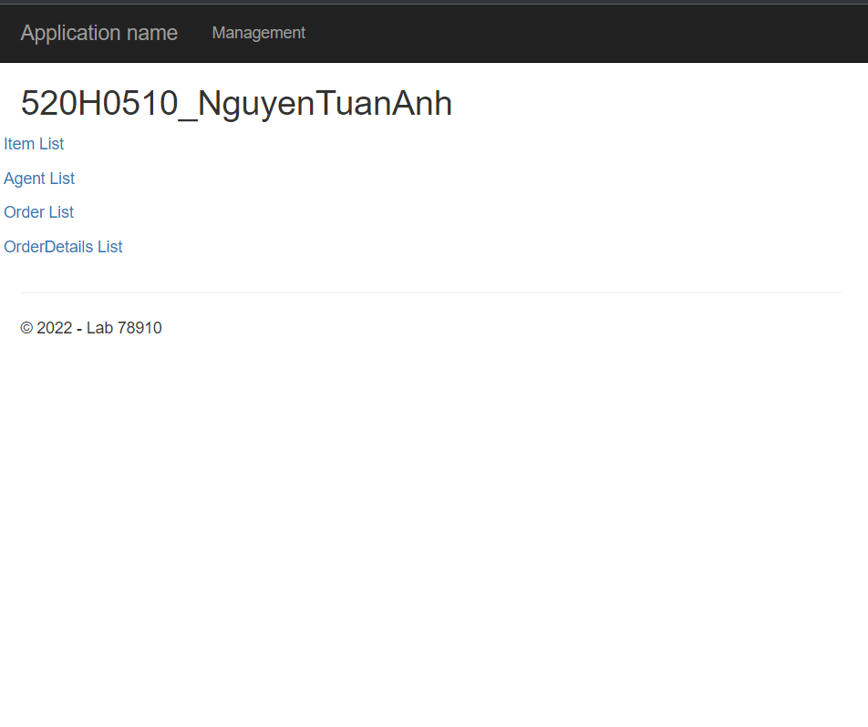Then we will click on Management to access the data we have transferred

**Hình 16 : Manage List**

* Each List will contain a list of information such as ID , Size , Address , Quantity , ...

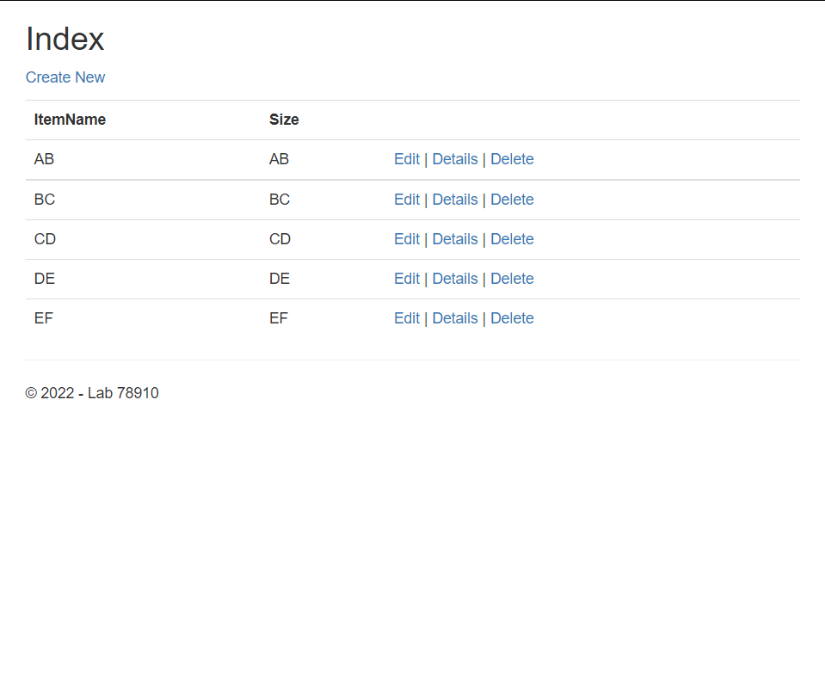

**Hinh 17 : Item List**

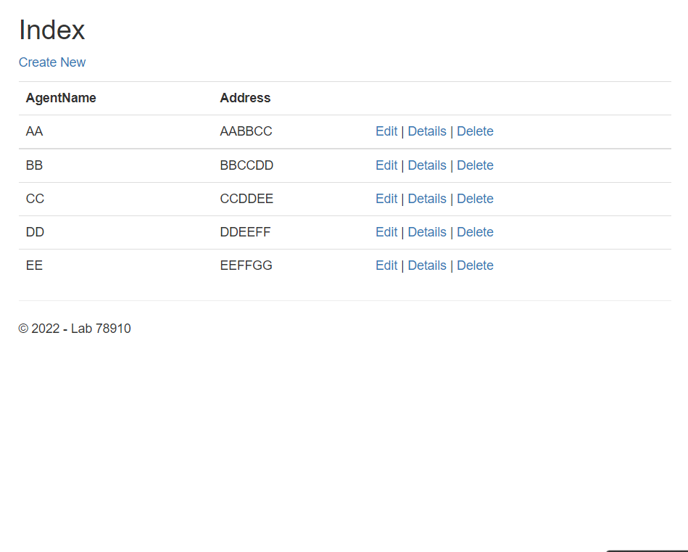**Hình 18 : Agent List**

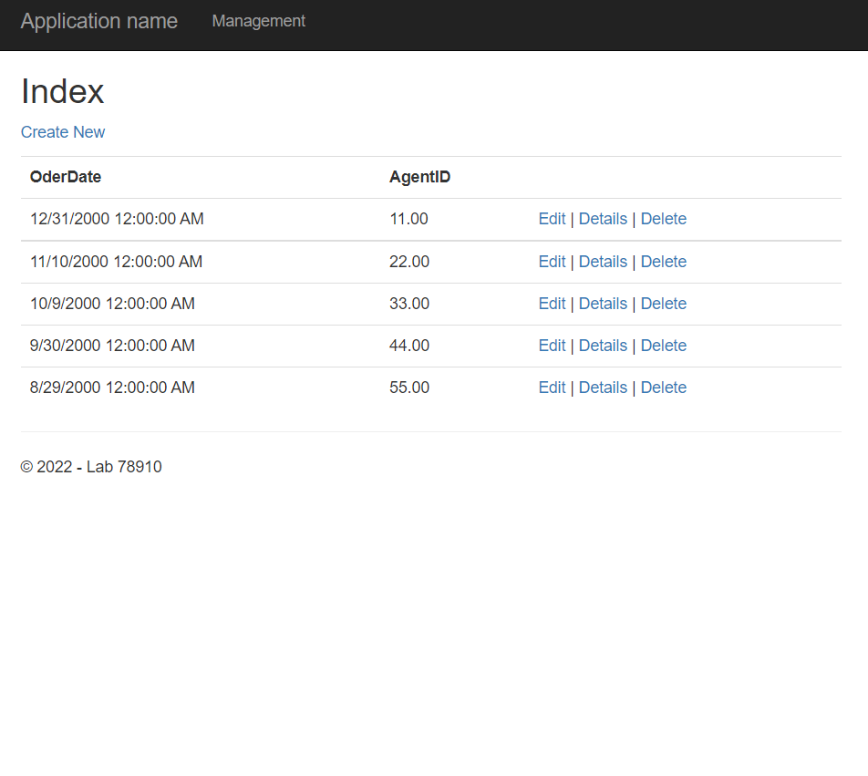

**Hình 19 : Order List**

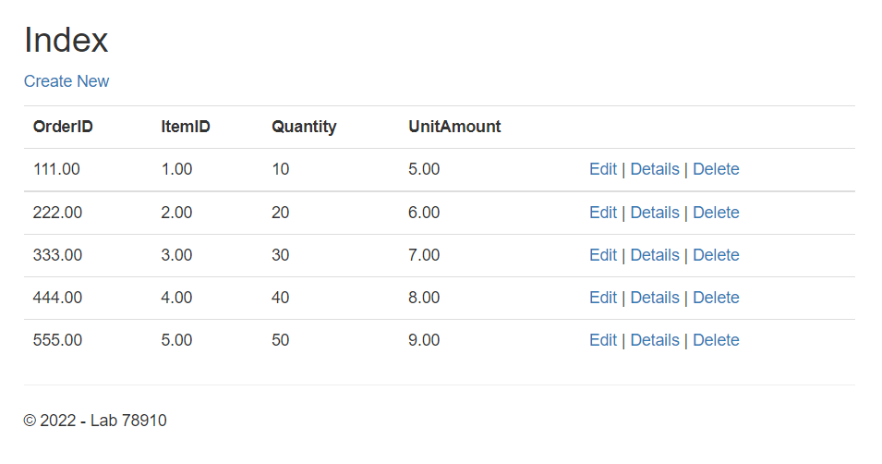

**Hinh 20 : Order Detail List**

* As you can see each list has Create , Edit , Detail and Delete entries
* Now I will try to create a 6th Item as shown in Figure 17

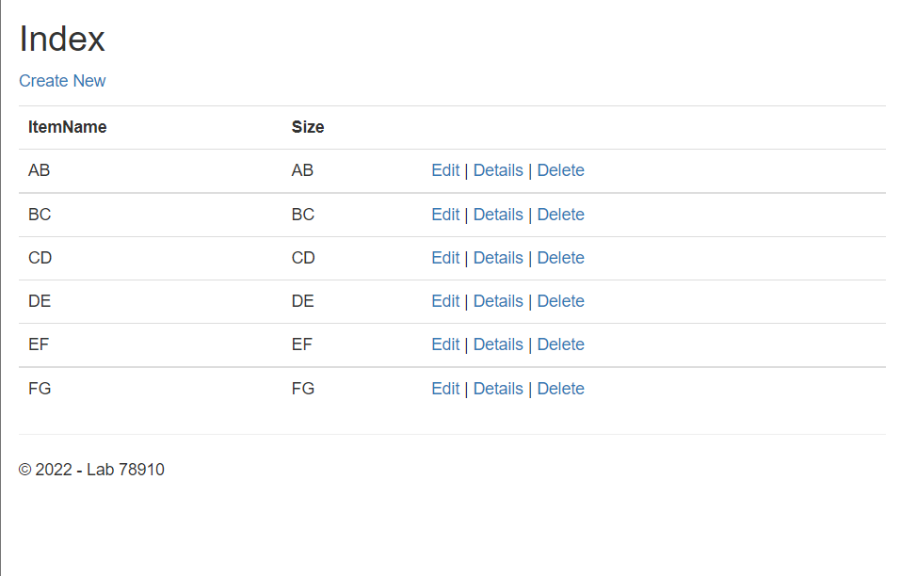**Hình 21 : Create**

* Now I will try editing by changing FG's Item Name to GF

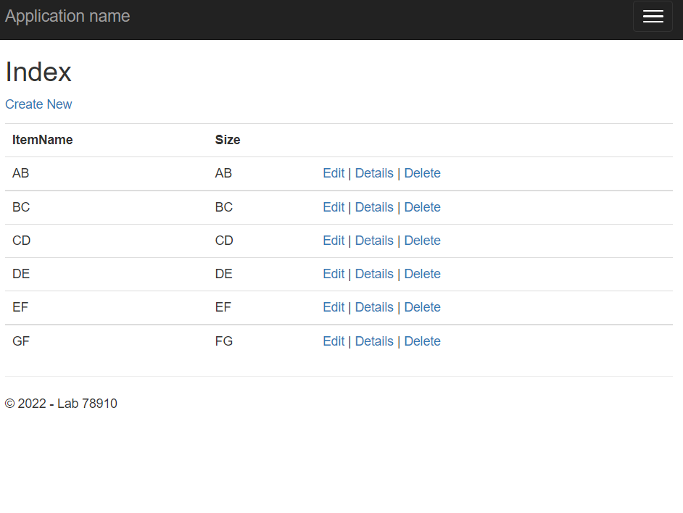Hình 22 : Edit

* Now I will try deleting all the Item and leaving only 1 Item Name which is CD

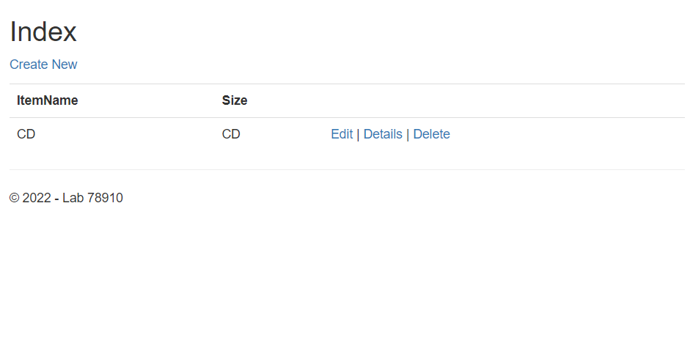**Hình 23 : Delete**