SQL+OUTCOMES

Table Creation:
-- Use the database
USE TrainTicketSalesDB;
GO

-- Create TouristCenter table
CREATE TABLE TouristCenter (
CenterID INT PRIMARY KEY,
Name NVARCHAR(100),
CommissionRate DECIMAL(5, 2),
ContractNumber NVARCHAR(50)
);

-- Create Train table
CREATE TABLE Train (
TrainID INT PRIMARY KEY,
TrainName NVARCHAR(100),
DepartureDate DATE,
CenterID INT,
FOREIGN KEY (CenterID) REFERENCES TouristCenter(CenterID)
);

-- Create Wagon table
CREATE TABLE Wagon (
WagonID INT PRIMARY KEY,
WagonType NVARCHAR(50), -- Men, Women, Family, Freight
TrainID INT,
FOREIGN KEY (TrainID) REFERENCES Train(TrainID)
);

-- Create Coupe table
CREATE TABLE Coupe (
CoupeID INT PRIMARY KEY,
WagonID INT,
CoupeType NVARCHAR(50), -- Normal, Royal
SeatCount INT,
FOREIGN KEY (WagonID) REFERENCES Wagon(WagonID)
);

-- Create Passenger table
CREATE TABLE Passenger (
PassengerID INT PRIMARY KEY,
Name NVARCHAR(100),
Age INT,
Gender NVARCHAR(10),
SeatNumber NVARCHAR(10),
CoupeID INT,
FOREIGN KEY (CoupeID) REFERENCES Coupe(CoupeID)
);

-- Create Ticket table
CREATE TABLE Ticket (
TicketID INT PRIMARY KEY,
PassengerID INT,
Price DECIMAL(10, 2),
CenterID INT,
SeatNumber NVARCHAR(10),
CoupeID INT,
FOREIGN KEY (CoupeID) REFERENCES Coupe(CoupeID),
FOREIGN KEY (PassengerID) REFERENCES Passenger(PassengerID),
FOREIGN KEY (CenterID) REFERENCES TouristCenter(CenterID)
);

-- Create Vehicle table
CREATE TABLE Vehicle (
VehicleID INT PRIMARY KEY,
OwnerName NVARCHAR(100),
LicensePlate NVARCHAR(50),
PassengerID INT,
FOREIGN KEY (PassengerID) REFERENCES Passenger(PassengerID)
);
Outcome:
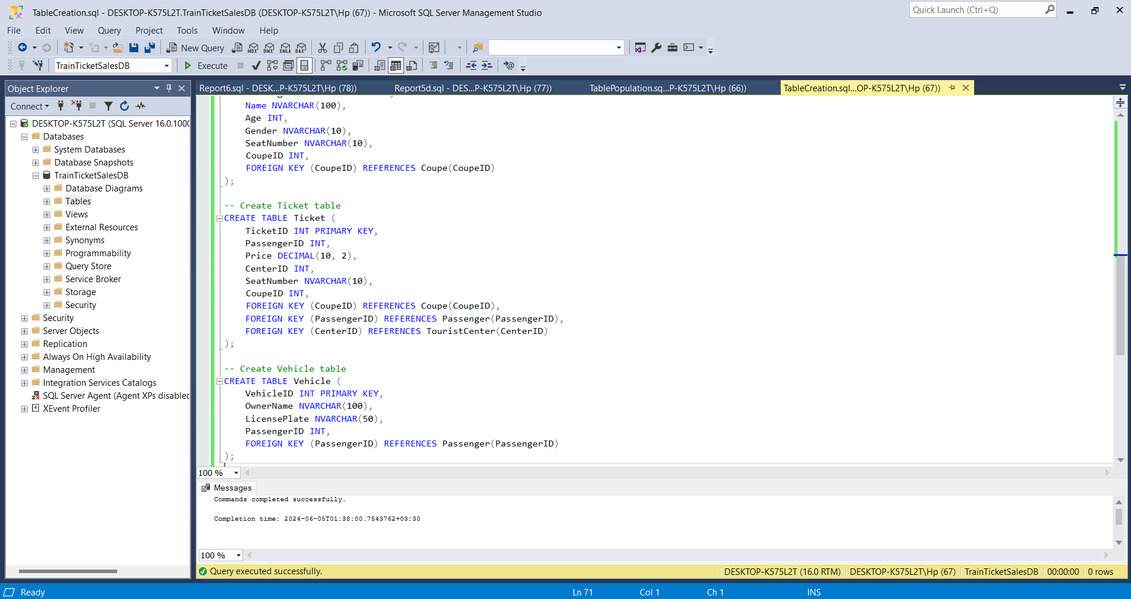
Populating the tables:
-- Use the database
USE TrainTicketSalesDB;
GO

-- Populate TouristCenter table
INSERT INTO TouristCenter (CenterID, Name, CommissionRate, ContractNumber)
VALUES
(1, 'Center A', 0.05, 'ABC123'),
(2, 'Center B', 0.07, 'XYZ456'),
(3, 'Center C', 0.06, 'DEF789');

-- Populate Train table
INSERT INTO Train (TrainID, TrainName, DepartureDate, CenterID)
VALUES
(101, 'Express 1', '2024-06-10', 1),
(102, 'Speedy 2', '2024-06-12', 2),
(103, 'Rapid 3', '2024-06-15', 3);

-- Populate Wagon table
INSERT INTO Wagon (WagonID, WagonType, TrainID)
VALUES
(201, 'Men', 101),
(202, 'Women', 101),
(203, 'Family', 101),
(204, 'Freight', 101),
(205, 'Men', 102),
(206, 'Women', 102),
(207, 'Family', 102),
(208, 'Freight', 102),
(209, 'Men', 103),
(210, 'Women', 103),
(211, 'Family', 103),
(212, 'Freight', 103);

-- Populate Coupe table
INSERT INTO Coupe (CoupeID, WagonID, CoupeType, SeatCount)
VALUES
(301, 201, 'Normal', 4),
(302, 201, 'Royal', 2),
(303, 202, 'Normal', 4),
(304, 203, 'Normal', 6),
(305, 204, 'Freight', NULL),
(306, 205, 'Normal', 4),
(307, 206, 'Normal', 4),
(308, 207, 'Family', 8),
(309, 208, 'Freight', NULL),
(310, 209, 'Normal', 4),
(311, 210, 'Royal', 2),
(312, 211, 'Normal', 6),
(313, 212, 'Freight', NULL);

-- Populate Passenger table
INSERT INTO Passenger (PassengerID, Name, Age, Gender, SeatNumber, CoupeID)
VALUES
(401, 'John Doe', 35, 'Male', 'A1', 301),
(402, 'Jane Doe', 30, 'Female', 'A2', 301),
(403, 'Alice Smith', 25, 'Female', 'B1', 303),
(404, 'Bob Johnson', 40, 'Male', 'B2', 303),
(405, 'Charlie Brown', 50, 'Male', 'C1', 306),
(406, 'Diana Prince', 28, 'Female', 'C2', 306),
(407, 'Eve Green', 45, 'Female', 'D1', 307),
(408, 'Frank White', 55, 'Male', 'D2', 307),
(409, 'Grace Kelly', 35, 'Female', 'E1', 310),
(410, 'Harry Potter', 22, 'Male', 'E2', 310),
(411, 'Ivy Lee', 29, 'Female', 'F1', 311),
(412, 'Jack Black', 31, 'Male', 'F2', 311),
(413, 'Kelly Clarkson', 37, 'Female', 'G1', 312),
(414, 'Larry King', 60, 'Male', 'G2', 312);

-- Populate Ticket table
INSERT INTO Ticket (TicketID, PassengerID, Price, CenterID, SeatNumber, CoupeID)
VALUES
(501, 401, 50.00, 1, 'A1', 301),
(502, 402, 50.00, 1, 'A2', 301),
(503, 403, 60.00, 1, 'B1', 303),
(504, 404, 60.00, 1, 'B2', 303),
(505, 405, 40.00, 2, 'C1', 306),
(506, 406, 40.00, 2, 'C2', 306),
(507, 407, 45.00, 2, 'D1', 307),
(508, 408, 45.00, 2, 'D2', 307),
(509, 409, 55.00, 3, 'E1', 310),
(510, 410, 55.00, 3, 'E2', 310),
(511, 411, 65.00, 3, 'F1', 311),
(512, 412, 65.00, 3, 'F2', 311),
(513, 413, 75.00, 3, 'G1', 312),
(514, 414, 75.00, 3, 'G2', 312);

-- Populate Vehicle table
INSERT INTO Vehicle (VehicleID, OwnerName, LicensePlate, PassengerID)
VALUES
(601, 'John Doe', 'ABC123', 401),
(602, 'Jane Doe', 'XYZ456', 402),
(603, 'Alice Smith', 'DEF789', 403),
(604, 'Bob Johnson', 'GHI101', 404),
(605, 'Charlie Brown', 'JKL202', 405),
(606, 'Diana Prince', 'MNO303', 406),
(607, 'Eve Green', 'PQR404', 407),
(608, 'Frank White', 'STU505', 408),
(609, 'Grace Kelly', 'VWX606', 409),
(610, 'Harry Potter', 'YZA707', 410),
(611, 'Ivy Lee', 'BCD808', 411),
(612, 'Jack Black', 'EFG909', 412),
(613, 'Kelly Clarkson', 'HIJ010', 413),
(614, 'Larry King', 'KLM111', 414);
Outcome:
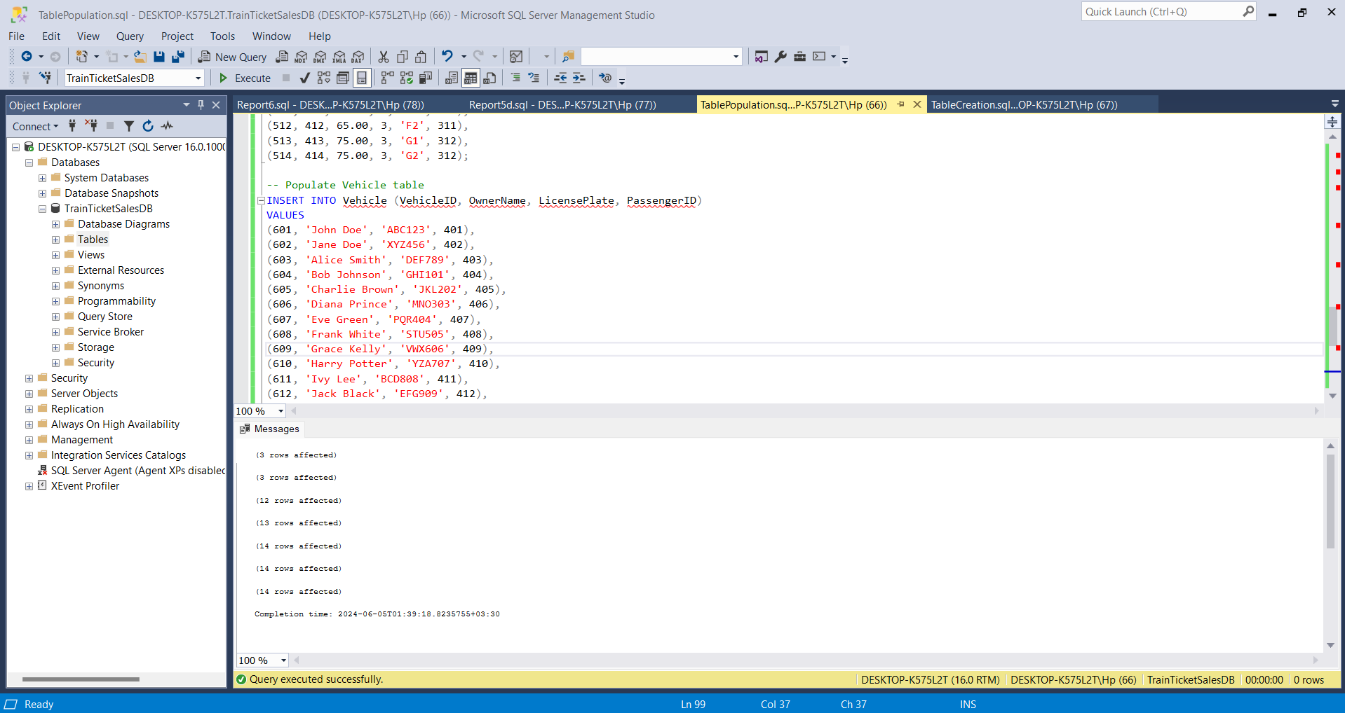

SQL Queries:
1. A report of the names of passengers, wagons, coupes, gender:
-- Use the database
USE TrainTicketSalesDB;
GO

SELECT
p.Name AS PassengerName,
w.WagonType AS WagonType,
c.CoupeType AS CoupeType,
p.Gender
FROM
Passenger p
JOIN
Coupe c ON p.CoupeID = c.CoupeID
JOIN
Wagon w ON c.WagonID = w.WagonID;
Outcome:

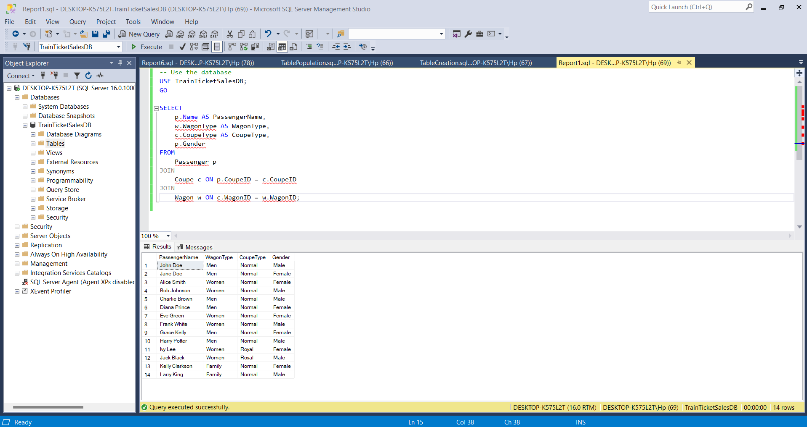
2. Report of vehicles delivered for transportation including owner name, license plate
number, passenger name, wagon, coupe:
-- Use the database
USE TrainTicketSalesDB;
GO

SELECT
v.OwnerName AS VehicleOwner,
v.LicensePlate,
p.Name AS PassengerName,
w.WagonType AS WagonType,
c.CoupeType AS CoupeType
FROM
Vehicle v
JOIN
Passenger p ON v.PassengerID = p.PassengerID
JOIN
Coupe c ON p.CoupeID = c.CoupeID
JOIN
Wagon w ON c.WagonID = w.WagonID;
Outcome:
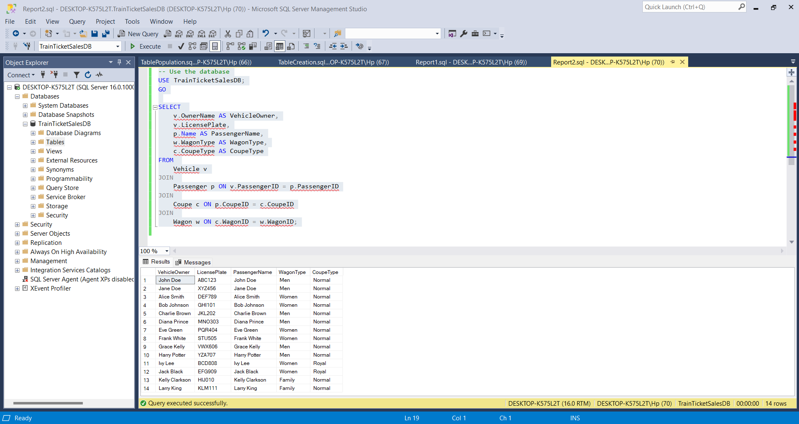
3. A report on the number of filled wagons and filled coupes:
-- Use the database
USE TrainTicketSalesDB;
GO

-- Step 1: Identify filled coupes
WITH FilledCoupes AS (
SELECT
c.CoupeID,
c.WagonID,
c.CoupeType,
COUNT(p.PassengerID) AS NumPassengers,
CASE
WHEN c.CoupeType = 'Normal' AND COUNT(p.PassengerID) = 6 THEN 1
WHEN c.CoupeType = 'Royal' AND COUNT(p.PassengerID) = 4 THEN 1
ELSE 0
END AS IsFilled
FROM
Coupe c
LEFT JOIN
Passenger p ON c.CoupeID = p.CoupeID
GROUP BY
c.CoupeID, c.WagonID, c.CoupeType
),
-- Step 2: Identify filled wagons
FilledWagons AS (
SELECT
w.WagonID,
w.WagonType,
COUNT(fc.IsFilled) AS FilledCoupes,
CASE
WHEN w.WagonType != 'Freight' AND COUNT(fc.IsFilled) = 2 THEN 1
ELSE 0
END AS IsFilled
FROM
Wagon w
LEFT JOIN
FilledCoupes fc ON w.WagonID = fc.WagonID AND fc.IsFilled = 1
GROUP BY
w.WagonID, w.WagonType
)
-- Step 3: Aggregate the results
SELECT
'Filled Coupes' AS Category,
fc.CoupeType AS Type,
COUNT(*) AS Count
FROM
FilledCoupes fc
WHERE
fc.IsFilled = 1
GROUP BY
fc.CoupeType

UNION ALL

SELECT
'Filled Wagons' AS Category,
fw.WagonType AS Type,
COUNT(*) AS Count
FROM
FilledWagons fw
WHERE
fw.IsFilled = 1
GROUP BY
fw.WagonType;
Outcome:
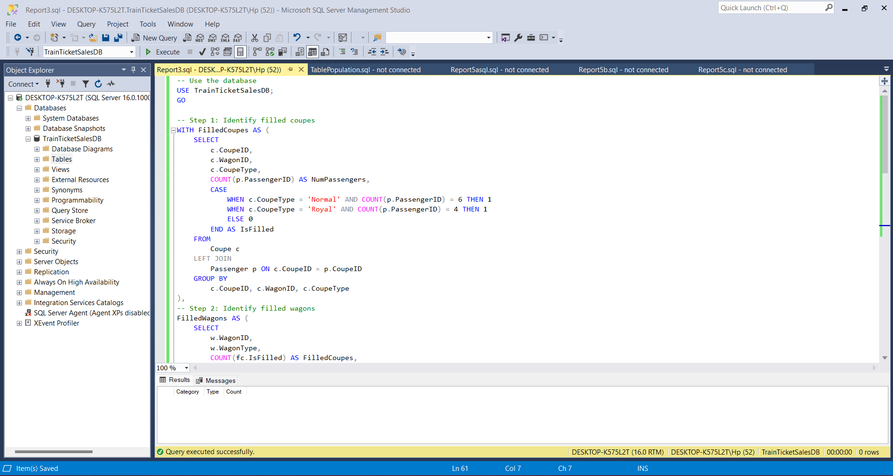
“Filled” means wagons and coupes that have filled their capacities. A coupe has two types: Normal and Royal. A Normal coupe is filled when all of its 6 seats have a passenger assigned to it. Similarly, a Royal coupe is filled when all of its 4 seats have a passenger assigned to it. A wagon has 4 types: Men, Women, Family, and Freight. All of them have 2 coupes each, Normal and Royal, except for Freight which has none. A wagon has filled its capacity if its two coupes have filled their capacity. In this database, neither wagon or coupe is filled, so there are no records in the outcome.
4. Report of empty seats: seat number, coupe name, wagon name, gender assigned to the wagon:
-- Use the database
USE TrainTicketSalesDB;
GO

SELECT
p.SeatNumber,
c.CoupeType AS CoupeName,
w.WagonType AS WagonName,
p.Gender
FROM
Passenger p
JOIN
Coupe c ON p.CoupeID = c.CoupeID
JOIN
Wagon w ON c.WagonID = w.WagonID
WHERE
p.Name IS NULL;
Outcome:
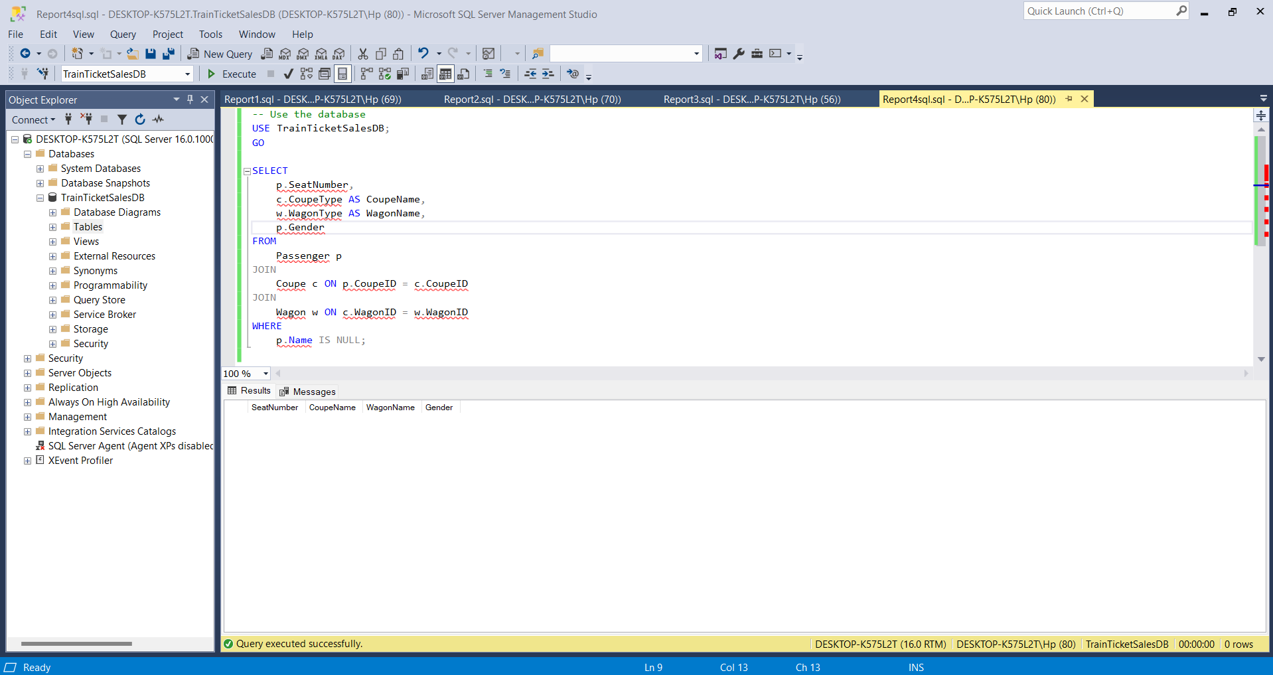
There are no records in this SQL query outcome because there are no empty seats.
5. Different financial reports such as:
a. Ticket sales:
-- Use the database
USE TrainTicketSalesDB;
GO

SELECT
SUM(Price) AS TotalSales
FROM
Ticket;
Outcome:
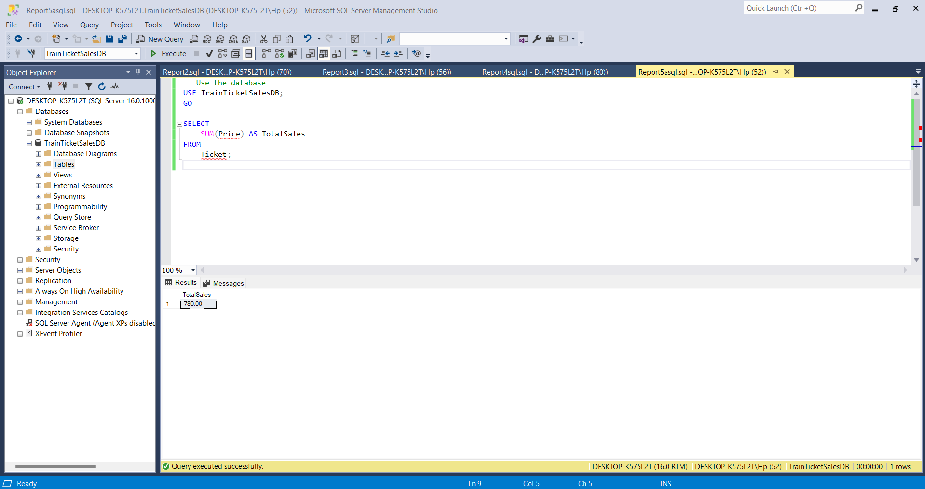
b. Commissions allocated to each tourist center:
-- Use the database
USE TrainTicketSalesDB;
GO

SELECT
tc.CenterID,
SUM(t.Price * tc.CommissionRate) AS TotalCommission
FROM
Ticket t
JOIN
TouristCenter tc ON t.CenterID = tc.CenterID
GROUP BY
tc.CenterID;
Outcome:
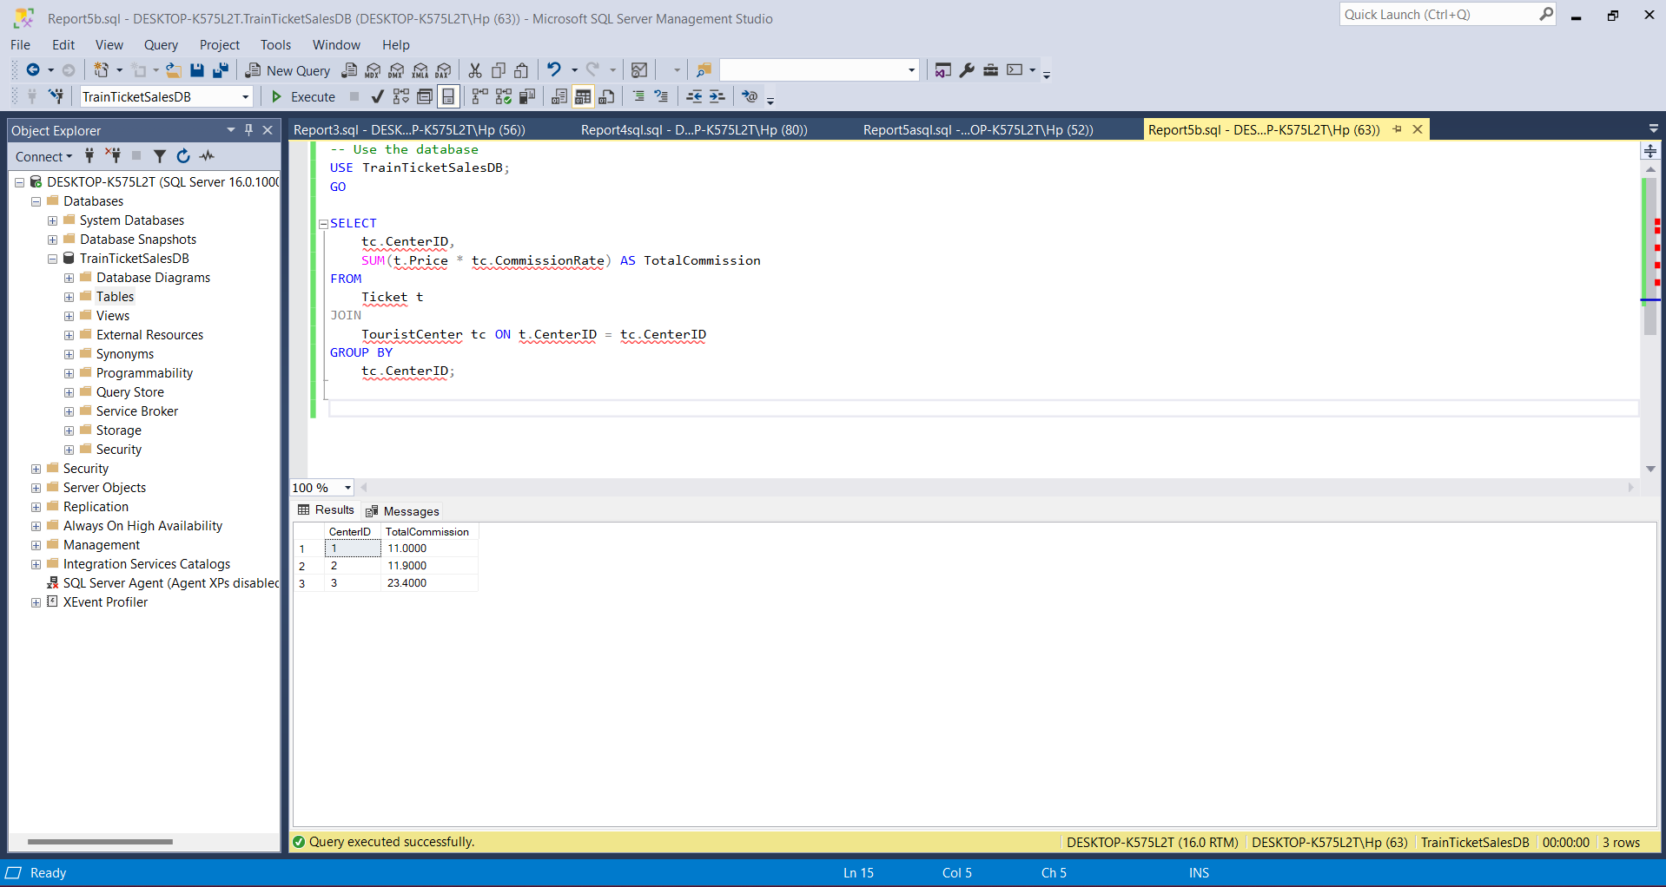
c. Number of passengers by gender plus costs:
-- Use the database
USE TrainTicketSalesDB;
GO

SELECT
Gender,
COUNT(*) AS NumPassengers,
SUM(Price) AS TotalCost
FROM
Passenger p
JOIN
Ticket t ON p.PassengerID = t.PassengerID
GROUP BY
Gender;
Outcome:
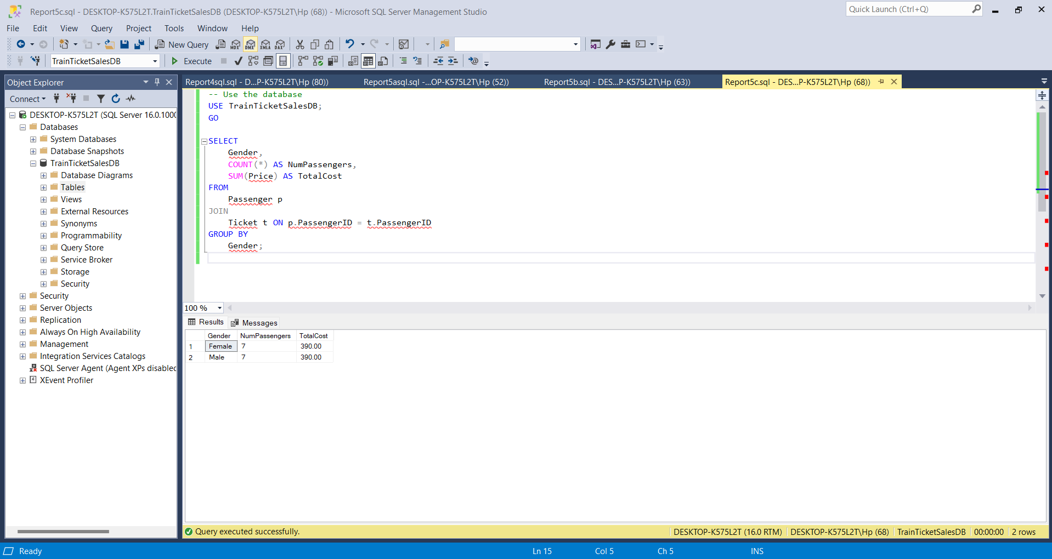
d. Time of departure, number of wagons and name of train:
-- Use the database
USE TrainTicketSalesDB;
GO

SELECT
t.DepartureDate,
COUNT(*) AS NumWagons,
t.TrainName
FROM
Train t
JOIN
Wagon w ON t.TrainID = w.TrainID
GROUP BY
t.DepartureDate, t.TrainName;
Outcome:
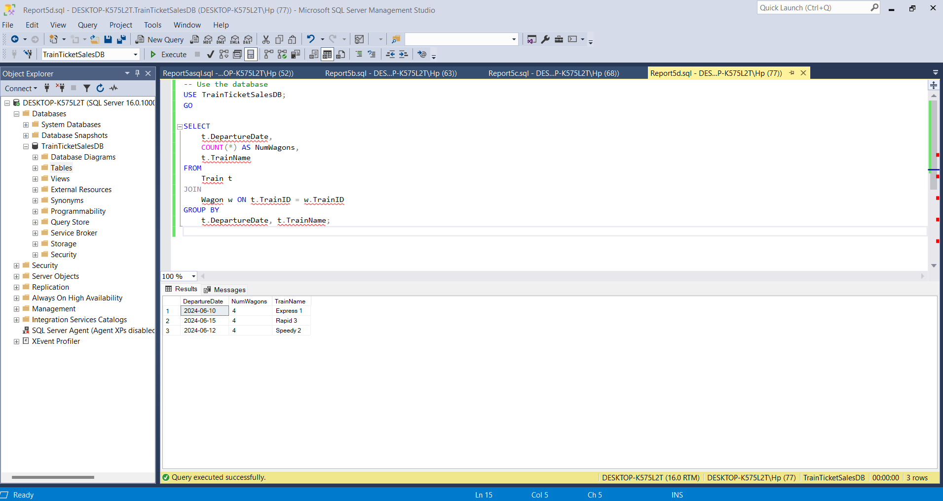
6. A report on the number of tractors required to carry the wagons of a train:
-- Use the database
USE TrainTicketSalesDB;
GO

WITH TractorCounts AS (
SELECT
TrainID,
CEILING(CAST(SUM(CASE WHEN WagonType = 'Passenger' THEN 1 ELSE 0 END) AS DECIMAL) / 13) AS NumPassengerTractors,
CEILING(CAST(SUM(CASE WHEN WagonType = 'Freight' THEN 1 ELSE 0 END) AS DECIMAL) / 6) AS NumFreightTractors
FROM
Wagon
GROUP BY
TrainID
)
SELECT
TrainID,
CASE
WHEN MAX(NumPassengerTractors) > MAX(NumFreightTractors) THEN MAX(NumPassengerTractors)
ELSE MAX(NumFreightTractors)
END AS NumTractorsRequired
FROM
TractorCounts
GROUP BY
TrainID;
Outcome:
