To access the website, open your computer’s CMD (command prompt)
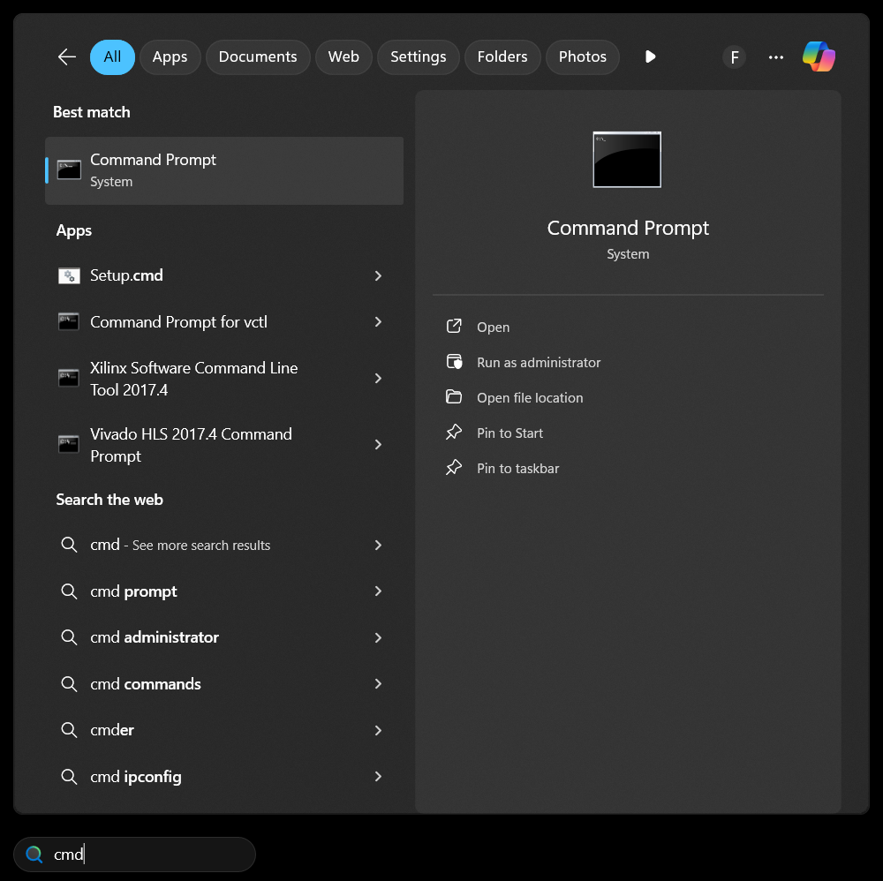
Go to the project directory (gp) using cd command (cd C:\file path to the project directory gp)
Then run this command: python manage.py runserver
Then click+ CTRl on the http://127.0.0.1:8000/
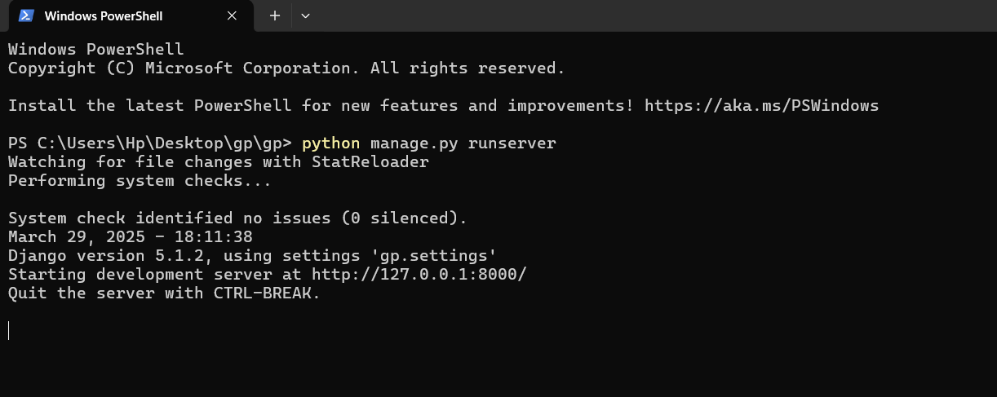
Your browser will open the website.
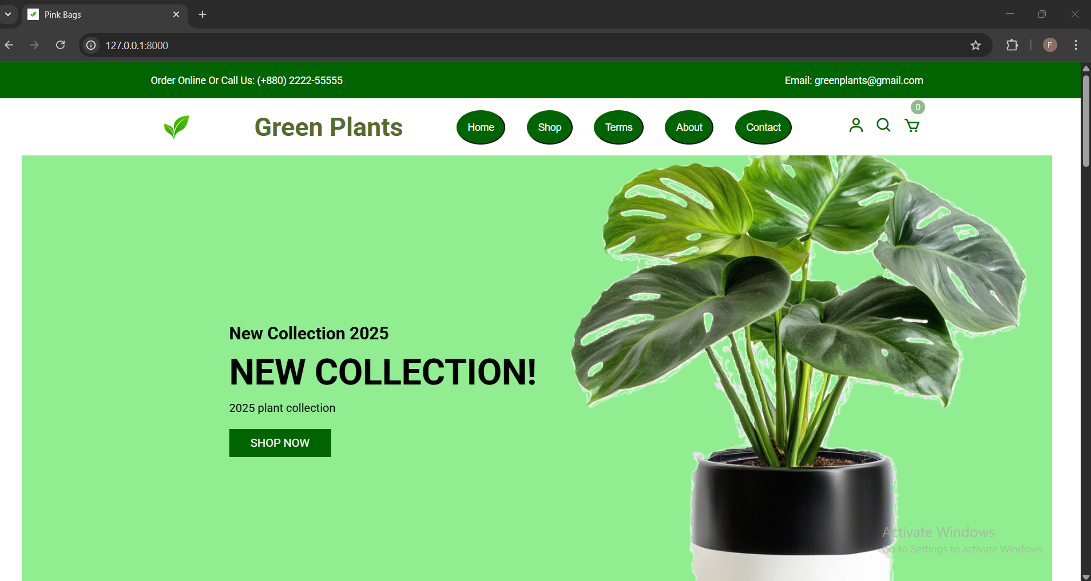
Do not close the cmd while accessing your website. When you are finished you should just press CTRL+C to quit, then close the cmd and then the website.

To login to your website, write https://127.0.0.1:8000/admin in the search bar.
Username: parvin
password: plant
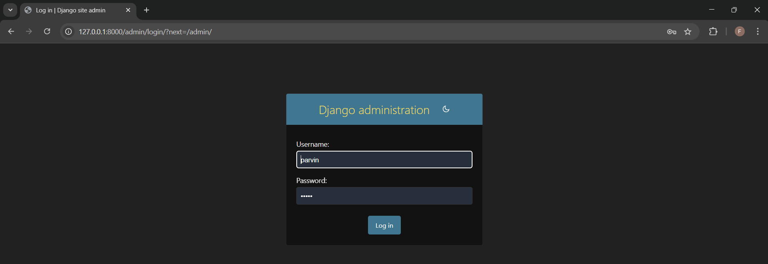
You can go back to the website after logging in by clicking on “view site” on the top right side of the login panel.

