DAT602 Tile Wars

Xander Crocker

**Table of Contents**

Milestone One 6

1. Game Description 6

1.2 Game Idea 6

1.3 Gameplay 6

1.3.1 Gameboard / Movement 6

1.3.2 Player 6

1.3.3 Items 6

1.3.4 Scoring 6

1.4 Administrators 6

2. Storyboards 7

2.1 Design 7

2.1.1 Login Screen 7

2.1.2 User Not Found (Popup Message) 7

2.1.3 Password Incorrect (Error Message) 8

2.1.4 Account Locked (Message) 8

2.1.5 Registration Screen 9

2.1.6 Main Screen 10

2.1.7 Gameplay Screen 11

2.1.8 Gameplay Screen (Item Placement) 12

2.1.9 Gameplay Screen (Player Movement) 13

2.1.10 Item Collected / Score (Popup Message) 13

2.1.11 Opponent Collected an Item (Popup Message) 14

2.1.12 You Win (Popup Message) 14

2.1.13 You Loose (Popup Message) 15

2.1.14 Administrator Screen 15

2.1.15 Administrator Create / Edit User Screen 16

2.2 Screen Design Rationale 17

2.2.1 Login / Registration Screens 17

2.2.2 Main Screen 17

2.2.3 Gameplay Screen 17

2.2.4 Administrator Screens 18

3. Entity Relationship Diagram 19

3.1 ERD 19

3.2 ERD Rationale 19

3.2.1 Player, Player / Board, and Board 19

3.2.2 Player, Session, and Game 19

3.2.3 Board, Game / Board, and Game 20

3.2.4 Board Tile, Item Tile / Tile, and ItemType 20

4. CRUD 21

4.1 CRUD Table 21

4.2 CRUD Analysis 23

4.2.1 Player Check Username 23

4.2.2 Player Check Password 23

4.2.3 Player Lock Account 23

4.2.4 Player Registration 23

4.2.5 Player Deleting Their Account 23

4.2.6 Successful Login 23

4.2.7 Starting New Game 24

4.2.8 Laying out tiles on a Gameboard 24

4.2.9 Placing an Item on a Tile 24

4.2.10 Player Movement 24

4.2.11 Collecting an Item and Scoring 24

4.2.12 Game Ends 25

4.2.13 Player Log Off 25

4.2.14 Admin Kill running games 25

4.2.15 Admin Add new players 25

4.2.16 Admin Update Player Data 25

4.2.17 Admin Delete a User Account 25

5. SQL 26

5.1 DDL 26

5.1.1 Player Table 26

5.1.2 Board Table 27

5.1.3 Player / Board Table 27

5.1.4 Game Table 27

5.1.5 Game / Board Table 27

5.1.6 Session Table 27

5.1.7 Board Tile Table 28

5.1.8 Item Table 28

5.1.9 Item Tile Table 28

Milestone Two 29

1. Updated ERD: 29

2. Updated CRUD: 30

3. Procedures: 31

4. Player DOA: 34

5. Login DOA: 35

Milestone Three 36

1. Error Management: 36

2. Concurrency Management: 37

3. Screenshots: 38

# Milestone One

# 1. Game Description

## 1.2 Game Idea

The objective of the game is to gather more items than your opponent. Each item collected by a player will give them a point. Items will be randomly placed on the gameboard one at a time, each player will need to get to the tile before their opponent to collect the item and receive a point. The game will end when one player has reached the point limit of 5.

## 1.3 Gameplay

### 1.3.1 Gameboard / Movement

The gameboard will be a 10x10 grid of squares. Players will be able to move up, down, left, and right along the gameboard. Players will not be able to move diagonally along the grid. The player's movement will be controlled with the four arrow keys.

### 1.3.2 Player

When the game starts players will be placed in either the top right or bottom left corners of the gameboard. Once the game starts players will be able to move freely around the gameboard using the arrow keys.

### 1.3.3 Items

Items will be randomly placed on the gameboard one at a time. The next item will appear when the current item is collected by a player. The players will then be reset on their starting tiles for the next round. To collect an item a player must get to and stand on the tile where the item has spawned before their opponent.

### 1.3.4 Scoring

Scores are calculated by the number of items each player collects. Each item collected will give the player a point. The game will end when one player has 5 points.

## 1.4 Administrators

Administrators will have special privileges; these privileges will allow them to create new users, edit existing user’s details, delete existing users from the database, kill running games, and lock or unlock accounts.

# 2. Storyboards

## 2.1 Design

### 2.1.1 Login Screen

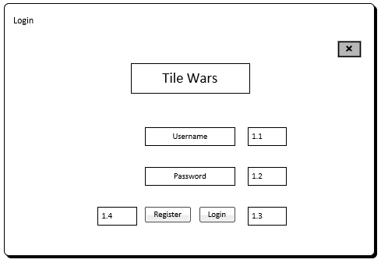

**1.1 Username:**

Textbox for username input.

**1.2 Password:**

Textbox for password input.

**1.3 Login Button:**

Button that when clicked checks if username and password exist in the database.

**1.4 Register Button:**

Button that sends the user to the registration screen.

### 2.1.2 User Not Found (Popup Message)

**2.1 Error Message:**

Message that appears if the username or password does not match an existing entry in the player table in the database.

**2.2 Close Button:**

Button that when clicked closes the message.

### 2.1.3 Password Incorrect (Error Message)

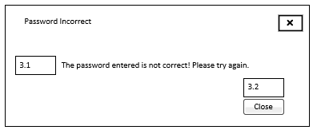

**3.1 Error Message:**

Message that appears if the username or password does not match an existing entry in the player table in the database.

**3.2 Close Button:**

Button that when clicked closes the message.

### 2.1.4 Account Locked (Message)

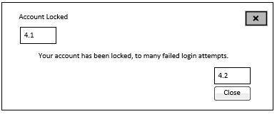

**4.1 Account Locked Message:**

Message that appears when the user's account is locked due to three failed login attempts.

**4.2 Close Button:**

Button that when clicked closes the message.

### 2.1.5 Registration Screen

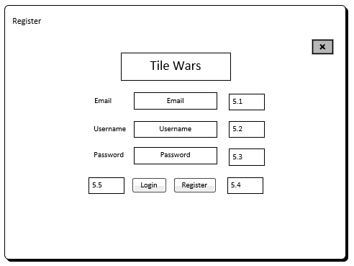

**5.1 Email:**

Textbox for the user to input their email.

**5.2 Username:**

Textbox for the user to input the username they wish to be recognised by in game.

**5.3 Password:**

Textbox for the user to input their preferred password.

**5.4 Register Button:**

Button that when clicked will complete the registration and save the user’s details in the player's table in the database.

**5.5 Login Button:**

Button that when clicked will send the user to the login screen.

### 2.1.6 Main Screen

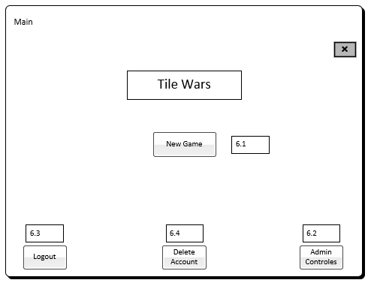

**6.1 New Game:**

Button that when clicked starts a new game.

**6.2 Admin Controls:**

Button that when clicked opens the administrative controls. This button will only open the administrative console when the player has administrative permissions.

**6.3 Logout:**

Button that when clicked logs the user out of their account and sends them back to the login screen.

**6.4 Delete Account:**

Button that when clicked deletes the logged in users account.

### 2.1.7 Gameplay Screen

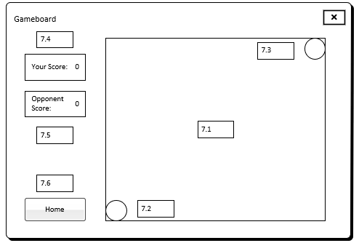

**7.1 Gameboard:**

This is a 10x10 grid of tiles that both player’s shear.

**7.2 Player One:**

Player One’s starting position.

**7.3 Player Two:**

Player Two’s starting position.

**7.4 Your Score:**

Displays the current user's score.

**7.5 Opponents Score:**

Displays the current opponent's score.

**7.6 Home Button:**

Button that when clicked sends the player back to the main window

### 2.1.8 Gameplay Screen (Item Placement)

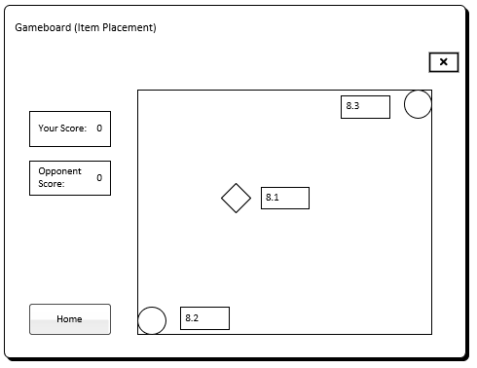

**8.1 Item:**

Items will be placed randomly on the gameboard one at a time. Once the current item is collected another will be placed randomly on the gameboard.

**8.2 Player One:**

Player One’s starting position.

**8.3 Player Two:**

Player Two’s starting position.

### 2.1.9 Gameplay Screen (Player Movement)

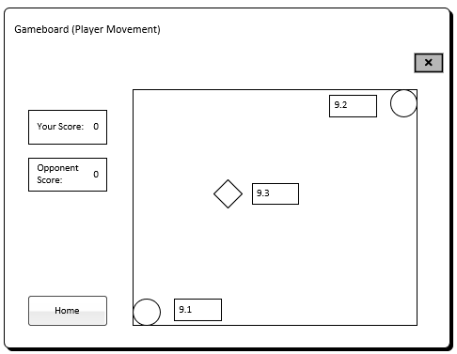

**9.1 Item:**

Items will be placed randomly on the gameboard one at a time. Once the current item is collected another will be placed randomly on the gameboard.

**9.2 Player One:**

Player One’s starting position. Players will only be able to move up, down, left, and right one tile at a time.

**9.3 Player Two:**

Player Two’s starting position. Players will only be able to move up, down, left, and right one tile at a time.

### 2.1.10 Item Collected / Score (Popup Message)

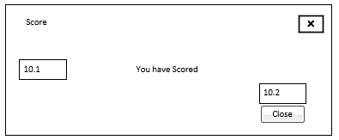

**10.1 Message:**

Message that appears and tells the player they have scored a point.

**10.2 Close Button:**

Button that when clicked closes the message.

### 2.1.11 Opponent Collected an Item (Popup Message)

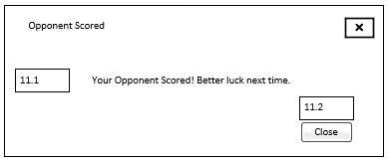

**11.1 Message:**

Message that appears and tells the player their opponent has scored a point.

**11.2 Close Button:**

Button that when clicked closes the message.

### 2.1.12 You Win (Popup Message)

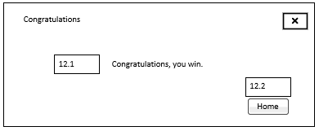

**12.1 Message:**

Message that tells the player that they have won the game.

**12.2 Home Button:**

Button that when clicked sends the player back to the main window.

### 2.1.13 You Loose (Popup Message)

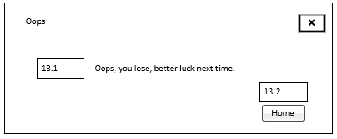

**13.1 Message:**

Message that tells the player that they have lost the game.

**13.2 Home Button:**

Button that when clicked sends the player back to the main window.

### 2.1.14 Administrator Screen

**9.1 Current Active Games:**

List box displaying the current active games and the two players in each game.

**9.2 Kill Current Active Game Button:**

Button that when clicked kills the selected game.

**9.3 Registered Users:**

List box of currently registered users in the player's table of the database.

**9.4 Create Button:**

Button that when clicked opens the Administrator Editor screen. From the editor screen an administrator can create a new user and the new user’s details will be created in the player table of the database.

**9.5 Edit Button:**

Button that when clicked opens the Administrator Editor screen for a selected user. From the editor screen an administrator can edit and update a user’s details.

**9.6 Delete Button:**

Button that when clicked deletes selected registered user.

### 2.1.15 Administrator Create / Edit User Screen

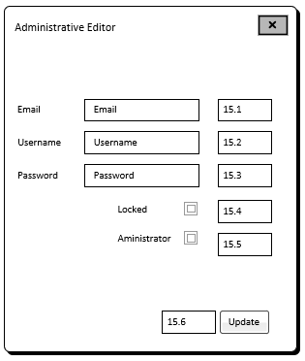

**15.1 Email:**

Input where an administrator can enter the user's email address.

**15.2 Username:**

Input where an administrator can enter the user’s username.

**15.3 Password:**

Input where an administrator can enter the user’s password.

**15.4 Lock Account Checkbox:**

Checkbox that an administrator can check to lock or uncheck to unlock a user’s account.

**15.5 Administrative Permissions Checkbox:**

Checkbox that an administrator can check to give a user administrative permission or uncheck to remove a user’s administrative permission.

**15.6 Update Button:**

Button that when clicked will update or create the user’s details in the player's table of the database.

## 2.2 Screen Design Rationale

### 2.2.1 Login / Registration Screens

The login screen was designed to have a simple reusable layout where users simply need to input their username and password to log into their accounts. When the login button is clicked the username and password are then referenced in the database to see if they exist, if they exist and match, the player will login. If not, the application will throw the user an error asking them to register or try again.

The registration screen follows the same simple and reusable layout allowing a user to input the required details to create a new account in the database. Once the user has registered their account, they will be sent back to the login screen to login to their new account.

When a user logs into their account they will be redirected to the main screen.

### 2.2.2 Main Screen

The main window was designed to be simplistic giving the user only four options to choose from. The user can choose to start a new game being randomly matched with another player doing the same. The last three options are for accessing the administrative functionality, logging out of their account, or deleting the logged-in account.

### 2.2.3 Gameplay Screen

The gameboard design was designed to show the player all the relevant information in a simple layout. The player can see the gameboard they are playing on (a 10x10 grid), their current score and their opponent’s current score. The player also has a way of exiting the game by clicking the home button at the bottom left of the screen. This will take the user back to the main window.

### 2.2.4 Administrator Screens

Any user with administrative permissions can access the administrative console by clicking the admin console button at the bottom right of the main screen. From this console, the administrative user can do one of four things. They can kill a currently running game, create a new user, edit a current user’s details, and delete a user from the database.

# 3. Entity Relationship Diagram

## 3.1 ERD

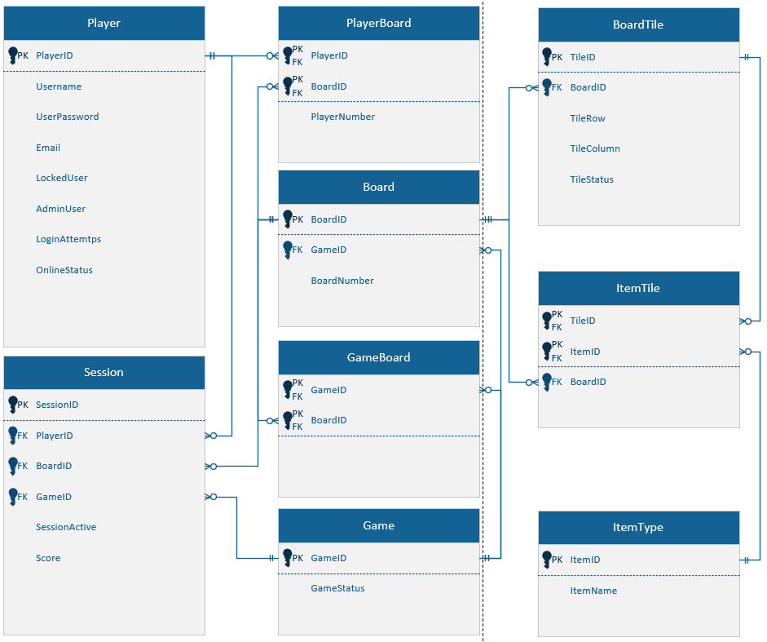

## 3.2 ERD Rationale

### 3.2.1 Player, Player / Board, and Board

The relationship between the player and board requires a joining table to track which players are on which board.

### 3.2.2 Player, Session, and Game

When a player starts a new game there needs to be to be a way to link the player to a game. The session table creates the join between the player, board, and game tables. The session table provides a way to connect the player to the game and board tables.

### 3.2.3 Board, Game / Board, and Game

This relationship between the game and board tables allows the database to keep track of where each player is on while on the board. As a game board has many tiles there needs to be a foreign key that refers the game table to the board table.

### 3.2.4 Board Tile, Item Tile / Tile, and ItemType

There can be more than one item on the board at a time but can only exist on one tile at a time. The item table determines where the item is and whether it has been collected or not and links items to the tiles on the board.

# 4. CRUD

## 4.1 CRUD Table

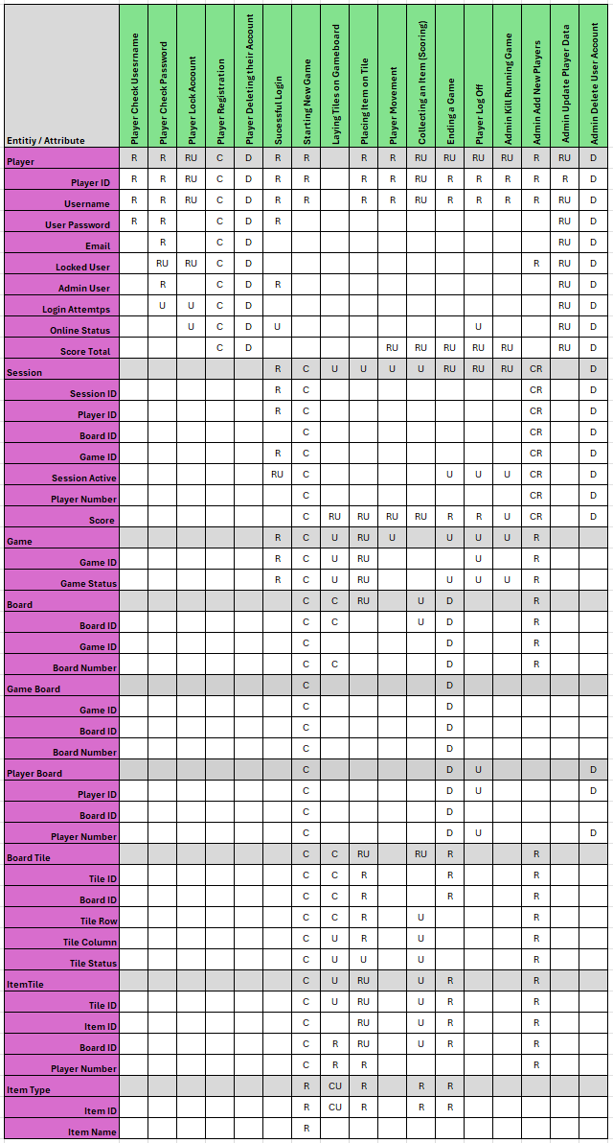





## 4.2 CRUD Analysis

### 4.2.1 Player Check Username

When a player logs in, their username will be checked in the database to see if it currently exists in the player table. If the username does not exist, the player will be asked to register or try again. If the login attempt fails 5 times, the player's account will be locked and will have to be unlocked by an administrative user.

### 4.2.2 Player Check Password

When a player logs in with their username their password will also be checked if it exists in the database and matches the username being used. If the user’s password does not match the records in the player table of the database, the user’s login attempts will be increased by one. When a user’s login attempts increase to three their account will be locked and will have to be unlocked by an administrative user.

### 4.2.3 Player Lock Account

If a player attempts to login to their account and fails up to 5 times the player attempting to login to their account will have their account locked. The only way for a player to get their account unlocked is to contact a player who has administrative permissions.

### 4.2.4 Player Registration

A user can register by inputting the required details. The details will then be cross-referenced to the existing details within the database, if no records are found the account will then be created.

### 4.2.5 Player Deleting Their Account

Once a player is logged into their account, on the main screen, the player has the option to delete their account by clicking the delete account button at the bottom middle of the screen.

### 4.2.6 Successful Login

If a player logs in successfully, they will be directed to the main screen where the player can start playing by clicking the new game button.

### 4.2.7 Starting New Game

When a player starts a new game the game table will create a new game with a unique ID in the game table. The board tile table will then populate the board table with tiles and an item will be placed on a random tile location. When this happens, the player will join the game via the unique ID, and the player board and session tables will then update and link the player to the game through the game board table.

### 4.2.8 Laying out tiles on a Gameboard

Laying out the tiles on the gameboard will be important to determine where each player is on the gameboard and where each item is placed. This is also important for player movement. Without a way to determine what tile a player or item is on, there will be no way to determine if the player can move in a certain direction or if the player has collected an item.

### 4.2.9 Placing an Item on a Tile

When the game starts an item will be randomly placed on the gameboard. Players will then be able to race to the tile that contains the item to score a point. This will happen each round until a player has a score of 5.

### 4.2.10 Player Movement

When a player moves around the board from tile to tile, the game table needs to be updated to show that the player has moved. If a player moves onto a tile with an item on it the item table needs to be updated to show that a player has collected that item and give them a point for doing so.

### 4.2.11 Collecting an Item and Scoring

S Once a player has collected an item, a popup will appear to each player telling them if they scored a point or their opponent scored a point. Once each popup message is closed each player will be reset to their starting tiles and another item will be placed on a tile randomly and the process will start again.

### 4.2.12 Game Ends

When one of the two players reaches a score of 5 (collected ten items) the game will end resulting in a win or loss. However, either player can click the ‘Home’ button on the gameboard screen at any time to end the game.

### 4.2.13 Player Log Off

When a player logs out of their account their details will be removed from any current games. Their player board, items, and status will disappear, and the player will become inactive.

### 4.2.14 Admin Kill running games

An administrative user can kill a game while it is running and force the players back to the main screen. This will be achieved by an administrative user accessing the admin controls on the main screen and selecting the game they wish to end and clicking the kill game button.

### 4.2.15 Admin Add new players

A new player can be created by an administrative user. When the new player's details are placed within the required fields the details will be cross-referenced to any existing data in the player table of the database. If there is no record of the user, the player will be registered. If there are any conflicts an error will occur.

### 4.2.16 Admin Update Player Data

From the administrators window an administrative user can edit a player’s details; this will update the player table in the database with the user’s new information. Before the process is complete the new information will be cross-referenced with any existing data in the database, if any data already exists an error will occur, if not the details will be updated.

### 4.2.17 Admin Delete a User Account

An administrative user can delete a user from the player table in the database. This is achieved by navigating to the main screen and clicking the admin controls button. From the admin console, the administrative user can select a player from the list of active users and click the delete button.

# 5. SQL

Attached File:

## 5.1 DDL

### 5.1.1 Player Table

**Player ID:**

The player ID is the primary key and is used to identify users within the database and game. The player ID is also used as a foreign key in other tables. This field is set to auto-increment each user as a new registration is created.

**Username:**

The username field is used to store the user’s username, this is what players will use to recognise other players in the game. This field has a unique constraint so that users cannot have the same username. This field is set to NOT NULL and is set to VARCHAR(45).

**Password:**

The password field is where users store their password for their account. This field is set to NOT NULL and is set to VARCHAR(45).

**Email:**

The Email field is used to store the user's email within the database. This field is set to NOT NULL and is set to VARCHAR(60).

**Locked User:**

Lockout is a field that checks if the user is locked out of their account due to many failed login attempts. This field is set to a Boolean value and is treated as a true or false statement.

**Admin User:**

Login Attempts is a field that checks if the user is locked out of their account due to many failed login attempts. This field is set to a Boolean value and is treated as a true or false statement.

**Login Attempts:**

Login Attempts is a field that checks how many login attempts the user still has. This field is set to have 5 default attempts before their account is locked.

**Online Status:**

The Online Status is a Boolean attribute that allows the administrator to see who is online.

### 5.1.2 Board Table

**Board ID:**

The Board ID is an auto-incremented number that is the primary key for the Board Table. This allows the Board table to communicate with the Game Table.

**Game ID:**

The Game ID is a foreign key from the Game Table that connects the Board Table to a Game in the Game Table.

### 5.1.3 Player / Board Table

The player/board table is a joining table that will link two players to a certain board. As games are started and ended the player/board table will update or delete data.

### 5.1.4 Game Table

**Game ID:**

This is an auto-incremented identifier that is used as a primary key for each new or existing game.

**Game Status:**

The game status is used to show if a game is active or not.

### 5.1.5 Game / Board Table

This table is a joining table that allows a board from the board table to connect with a game in the game table.

### 5.1.6 Session Table

**Session ID:**

The session ID is the primary key that is auto-incremented.

**Player ID, Board ID, and Game ID:**

The Player ID is a foreign key to identify which players are currently in a game or not. The Game ID is a foreign key that is used to identify which game is currently ongoing. The Board ID is a foreign key that connects the player to the Game.

**Session Active:**

This is a Boolean attribute that shows if the logged-in player is in an active session.

**Score:**

The score attribute is used to determine the score of the player.

### 5.1.7 Board Tile Table

**Tile ID:**

The Tile ID is the primary key of the Board Tile table that is auto-incremented.

**Board ID:**

This is a foreign key that comes from the Board table that connects the board and tile table to each other.

**Tile Row:**

This field creates the tiles for the X-axis of the grid.

**Tile Column:**

This field creates the tiles for the Y-axis of the grid.

**Tile Status:**

The tile status attribute allows the database to know if the tile has an item on it or not.

### 5.1.8 Item Table

The item ID is the primary key for each item that is used in the game.

### 5.1.9 Item Tile Table

This table is used to track the items that will be placed on random tiles as the game goes on.

# Milestone Two

## 1. Updated ERD:

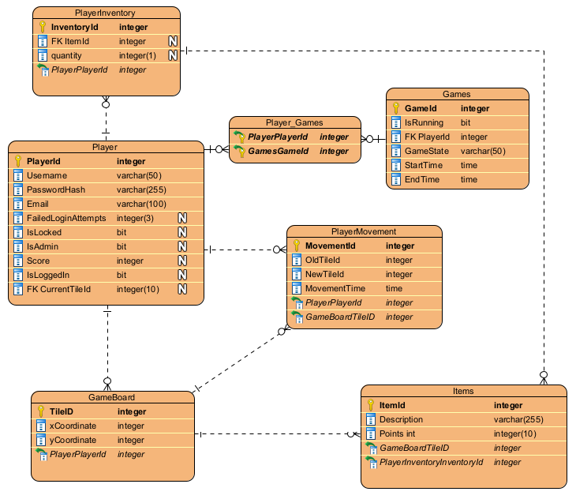

## 2. Updated CRUD:

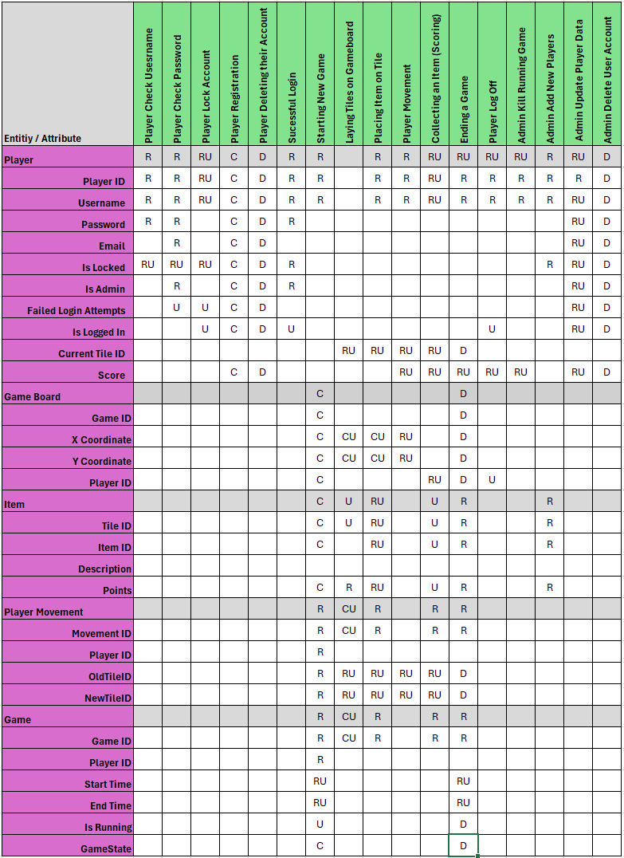

## 3. Procedures:

**3.1 Player Login**

This procedure validates the user’s login details and returns if successful. It does this by checking if the username and password match the record in the player table.

**3.2 Register Player**

This procedure allows a new user to register an account. It makes sure that the username is unique before inserting the new record with the relevant details such as username, password, and email address. If a record already exists the user will encounter an error.

**3.3 Update Player**

This updates the user's details and rewrites the details to the database based on the user’s username. The user has to be logged in before they can edit their details. The details the user can change include username, password, and email address.

**3.4 Delete Player**

This procedure allows a user to delete their account based on their username. Only when the user is logged in can they delete their account.

**3.5 Set User Logged-In Status**

This procedure updates the logged-in user status from logged out to logged in. This happens when the user logs in through the login screen.

**3.6 Lock Unlock Account**

This procedure locks a user's account when they input their password incorrectly too many times. It achieves this by checking the user's login attempts count and if there is none the user will have their account set to locked and they will not be able to log in until an administrator unlocks their account manually.

**3.7 Increment Fail Login Attempts**

This procedure allows the login attempts count to decrease by one each time a user incorrectly attempts to log in to their account. It does this by checking and then updating the Failed Login Attempts in the player table. Then if the count reaches zero the Is Locked will be set to true.

**3.8 Get All Players**

The purpose of this procedure is to retrieve all user's details in the player's table. It selects the attributes from the player's table and returns them to the application.

**3.9 Get Player By Username**

This procedure allows the retrieval of users by their username. It retrieves the user information from the player's table including all attributes.

**3.10 Get logged-in users**

This procedure allows the Is Logged In status to be changed as the user logs in and logs out. It does this by modifying the Is Logged In attribute in the player's table when a user successfully logs in and changes it again when the user logs out of the application.

**3.11 Get All Items**

This procedure allows all the items in the items table to be retrieved from the database. It does this by retrieving all attributes of the items table for use in the application.

**3.12 Create Game Board**

This procedure creates the gameboard by adding tiles in a 10 by 10 grid. It inserts all the tiles using their given X and Y coordinates and lays out the gameboard for use in the application.

**3.13 Move Player**

This procedure allows players to move around the gameboard from tile to tile. It checks if the tile is legal to move to then updates the player's location. When a player moves this procedure then logs the movement to the Player Movement table.

**3.14 Update Tile State**

This procedure allows players to move to a new tile if the tile is unoccupied. It checks if the tile is occupied and updates the player’s current tile. If the tile is occupied an error will be shown to the player.

**3.15 Place Item**

This procedure allows items to be placed on the gameboard to a specified tile. It inserts a new item record with the given tile ID.

**3.16 Collect Item**

This procedure allows players to collect items when they land on the same tile as an item. It does this by marking the item as collected and clearing it from the gameboard using the tile ID.

**3.17 Update Player Score**

This procedure updates the player’s score based on the item's value that is collected. It retrieves the item’s value and adds it to the player's current score.

**3.18 Kill Running Game**

This allows a user with administrator privileges to stop a currently running game. And update the game state to cancel in the database records.

**3.19 End Game And Reset Scores**

This procedure allows the player's score to reset then the game ends. It does this by setting the game to enabled when the game starts and resets the score when a game ends.

## 4. Player DOA:

**4.1 Set User Login Status**

This function updates the login status of the user in the database by calling the procedure when the user logs in to their account. It does this by using the user’s username and login status.

**4.2 Get All Player’s**

This function retrieves all players in the player's table from the database using the Get All Players procedure. The function then maps the players into a list for later use.

**4.3 Get Player By Username**

This function fetches all players in the player's table in the database using the get player by username procedure. If the player exists then it will return the player object with the user's details.

**4.4 Get All Tiles**

This function retrieves all the tiles in the gameboard table in the database using the get all tiles procedure and maps the tiles to a list of objects. It then allows the tiles to be populated with items and players. If the data has already been retrieved it will store the pulled data and update the tiles instead of creating new objects.

**4.5 Get All Items**

This function retrieves all the items in the item table from the database using the get all items procedure.

**4.6 Delete Player**

This function allows the user to be deleted from the database using the delete player procedure.

**4.7 Move Player**

This function allows players to move to new tiles by calling the move player procedure. It does this by checking the player ID and the tile ID.

**4.8 Update Player Tile**

This function updates the player’s current tile from the player's table using the update player tile procedure.

## 5. Login DOA:

**5.1 Login**

This function verifies the user's details such as username and password using the player login procedure.

**5.2 Register**

This function allows users to register an account and save the details to the database using the register player procedure.

# Milestone Three

## 1. Error Management:

**1.1 Login**

**SQL:**

* If the Player Login procedure fails the exception is caught.
* If nothing is returned a message will be logged that the attempts failed due to incorrect credentials.

**Account Lock Status:**

* Before the Lock Status procedure is called the procedure checks if the account is locked using Is Locked. If the account is locked the user will receive a message and they will not be allowed to proceed any further.

**1.2 Registration**

**SQL:**

* If the transaction fails it is rolled back to prevent any corruption in the database.
* If the username entered is detected in the database the error will be caught and a message will be sent to the user stating that the username is already in use.

## 2. Concurrency Management:

Concurrency management is the process of managing multiple tasks at the same time. In a system that has concurrency tasks can be executed at the same time. This can be done on separate threads or by making the processes flow in parallel with each other. Concurrency manages the state of the application improves the responsiveness and allows developers to utilize resources better. This is especially effective when an application has a long run time. A popular technique for concurrency management is multithreading. This technique allows multiple threads to be processed at the same time executing several tasks simultaneously. Concurrency management can be a difficult task but is a powerful way to scale applications to a high level (Galande, 2024).

## 3. Screenshots:

**3.1 Login**

**3.2 Registration**

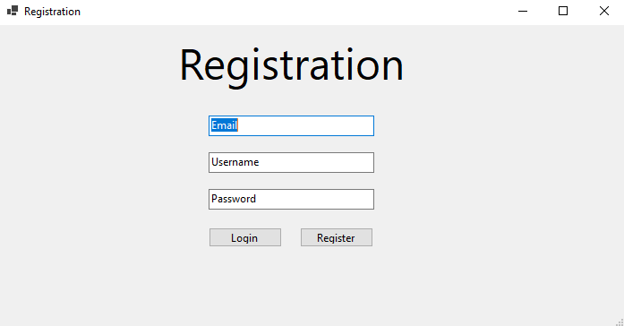

**3.3 Main Screen**

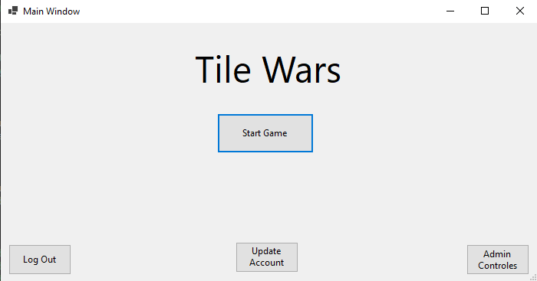

**3.4 Update User**

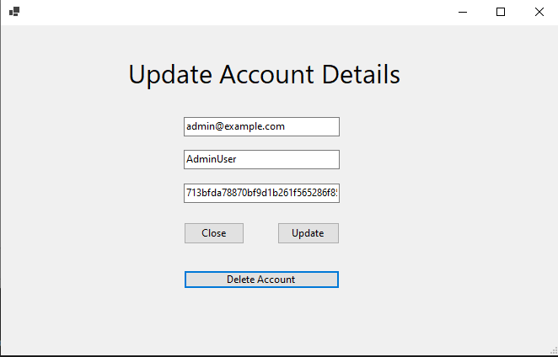

**3.5 Gameboard**

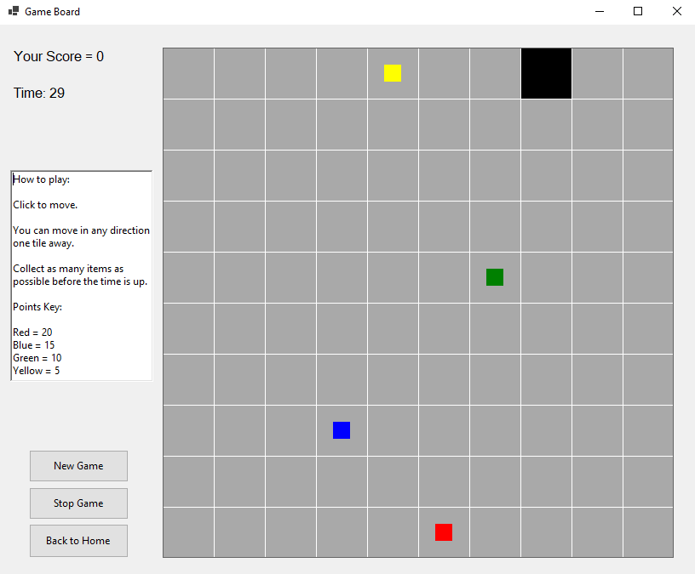

**3.6 Admin Console**

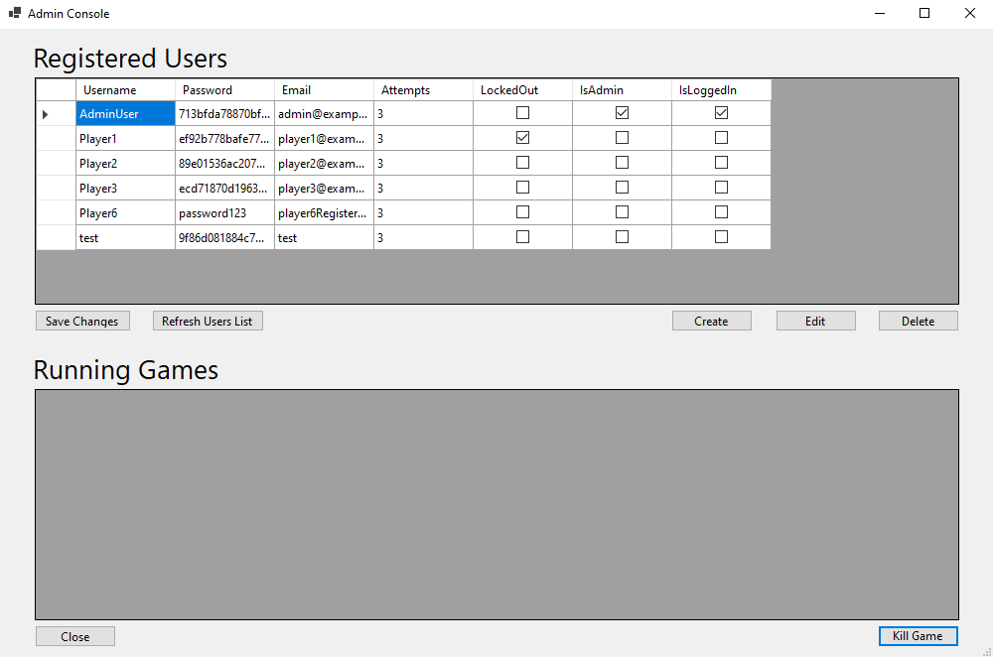

**3.7 Admin Editor**

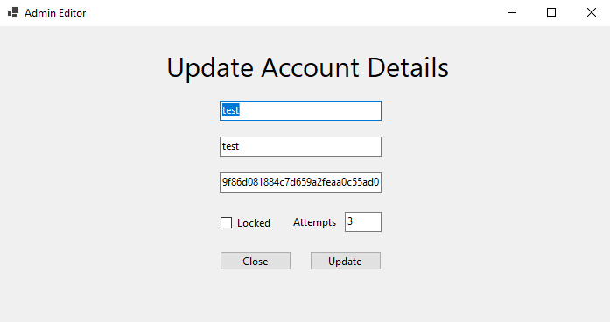

# References

Galande, S. (2024, September 2). *Handling Concurrency in C#: A Guide to Multithreading and Parallelism*. DEV Community. <https://dev.to/soham_galande/handling-concurrency-in-c-a-guide-to-multithreading-and-parallelism-446>