A PROJECT REPORT

on

“XOLD - THE X COMPANY”

Submitted to

KIIT Deemed to be University

In Partial Fulfilment of the Requirement for the Award of

BACHELOR’S DEGREE IN

COMPUTER SCIENCE & ENGINEERING

BY

ADITYA NARAYAN VERMA 20051689
JESSICA MOHANTY 20051807
SIMRAN CHAWLA 20051106
YASH ANAND 20051769

UNDER THE GUIDANCE OF

MRS. RONALI PADHY



SCHOOL OF COMPUTER ENGINEERING

KALINGA INSTITUTE OF INDUSTRIAL TECHNOLOGY

BHUBANESWAR, ODISHA - 751024

APRIL 2024

A PROJECT REPORT

on

“XOLD - THE X COMPANY”

Submitted to

KIIT Deemed to be University

In Partial Fulfilment of the Requirement for the Award of

BACHELOR’S DEGREE IN COMPUTER SCIENCE & ENGINEERING

BY

ADITYA NARAYAN VERMA 20051689
JESSICA MOHANTY 20051807
SIMRAN CHAWLA 20051106
YASH ANAND 20051769

UNDER THE GUIDANCE OF

MRS. RONALI PADHY

SCHOOL OF COMPUTER ENGINEERING

KALINGA INSTITUTE OF INDUSTRIAL TECHNOLOGY

BHUBANESWAE, ODISHA -751024

April 2024

KIIT Deemed to be University

School of Computer Engineering
Bhubaneswar, ODISHA 751024

CERTIFICATE

This is certify that the project entitled

“XOLD - THE X COMPANY“

submitted by
ADITYA NARAYAN VERMA 20051689
JESSICA MOHANTY 20051807
SIMRAN CHAWLA 20051106
YASH ANAND 20051769

is a record of bonafide work carried out by them, in the partial fulfilment of the requirement for the award of Degree of Bachelor of Engineering (Computer Sci-ence & Engineering) at KIIT Deemed to be university, Bhubaneswar. This work is done during year 2023-2024, under our guidance.

Date: / /

MRS. RONALI PADHY
Project Guide

Acknowledgements

We are profoundly grateful to MRS. RONALI PADHY ma’am of Affiliation for her expert guidance and continuous encouragement throughout to see that this project rights its target since its commencement to its completion.

ADITYA NARAYAN VERMA

JESSICA MOHANTY

SIMRAN CHAWLA

YASH ANAND

ABSTRACT

XOLD is a revolutionary mobile marketplace that empowers users to effortlessly buy and sell a diverse array of products. This groundbreaking Android application streamlines the process of listing and acquiring items, providing a seamless and user-friendly experience. With XOLD, users can unlock the potential of their unused possessions by showcasing them through visually captivating product listings, complete with high-quality images and comprehensive descriptions.

The application's intuitive interface allows buyers to seamlessly navigate through a vast catalog of unique offerings, tailored to their specific interests and preferences. XOLD goes beyond mere transactions by fostering a vibrant community where buyers and sellers can interact, negotiate, and cultivate lasting connections through an integrated chat feature. Furthermore, the platform incorporates advanced features such as secure payment gateways, real-time notifications, robust search capabilities, and Google Maps integration for detecting user locations, ensuring a hassle-free and efficient buying and selling journey. Users can readily access XOLD by registering with their Gmail account, phone number, or Google login.

XOLD offers an additional call option, facilitating direct communication between buyers and sellers, further enhancing the user experience. With its innovative approach and commitment to user satisfaction, XOLD is poised to revolutionize the way we perceive and engage with online marketplaces.

Keywords: Android Development, Google maps, Interface, Application, Store.

Contents

1 | Introduction |  |  | 1
2 | Basic Concepts/ Literature Review |  |  | 2
 | 2.1 | Mobile Commerce and online market places |  | 2
 | 2.2 | User Experience and Interface Design
 | 2.3 | Community Building and social Interactions
3 | Problem Statement / Requirement Specifications |  |  | 3
 | 3.1 | Project Planning |  | 3
 | 3.2 | Project Analysis (SRS) |  | 3
 | 3.3 | System Design |  | 3
 |  | 3.3.1 | Design Constraints | 3
 |  | 3.3.2 | System Architecture (UML) | 3
4 | Implementation |  |  | 4
 | 4.1 | Methodology / Proposal |  | 4
 | 4.2 | Testing |  | 4
 | 4.3 | Result Analysis |  | 4
 | 4.4 | Quality Assurance |  | 4
5 | Standard Adopted |  |  | 5
 | 5.1 | Design Standards . |  | 5
 | 5.2 | Coding Standards . |  | 5
6 | Conclusion and Future Scope |  |  | 6
 | 6.1 | Conclusion |  | 6
 | 6.2 | Future Scope |  | 6
References |  |  |  | 7
Individual Contribution |  |  |  | 8
Plagiarism Report |  |  |  | 9

List of Figures

1.1 | XOLD - Application Interface | 2
4.1 | IMAGE CAPTION ......................... | 9

XOLD - THE X COMPANY

Chapter 1

Introduction

XOLD is an innovative and user-friendly mobile application that aims to revolutionize the way people buy and sell products online. Developed specifically for the Android operating system, this groundbreaking platform provides a seamless and efficient marketplace experience. At its core, XOLD empowers users to unlock the potential of their unused or unwanted items by listing them for sale with visually captivating product displays, complete with high-quality images and comprehensive descriptions.
The app's intuitive interface and advanced features create a seamless journey for both buyers and sellers. Buyers can effortlessly navigate through a vast catalog of unique offerings tailored to their interests, while sellers can reach a broad audience for their listed items. XOLD fosters a vibrant community where users can interact, negotiate, and cultivate lasting connections through integrated chat and call options. The platform incorporates secure payment gateways, real-time notifications, robust search capabilities, and Google Maps integration for location detection. Additionally, the registration process is streamlined, allowing users to sign up using their Gmail account, phone number, or Google login. With its innovative approach and commitment to user satisfaction, XOLD is poised to redefine the online marketplace experience.


Figure 1.1: Application Interface

1

XOLD - THE X COMPANY

Chapter 2

Literature Review

The rise of mobile devices and the growing popularity of online marketplaces have created a significant demand for user-friendly and efficient mobile applications that facilitate buying and selling activities. This literature review explores existing research and market trends related to mobile commerce, peer-to-peer marketplaces, and the unique challenges and opportunities within the Android ecosystem.

2.1 Mobile Commerce and Online Marketplaces
Mobile commerce, or m-commerce, has experienced substantial growth in recent years, driven by the widespread adoption of smartphones and the convenience of conducting transactions on-the-go (Hung et al., 2012). Online marketplaces have emerged as popular platforms for facilitating peer-to-peer transactions, enabling individuals to buy and sell a wide range of products and services (Sriram et al., 2015). These platforms have disrupted traditional retail models by providing a decentralized and accessible marketplace for buyers and sellers.
2.2 User Experience and Interface Design
Successful mobile applications rely heavily on user experience (UX) and intuitive interface design (Hoehle & Venkatesh, 2015). Research has shown that factors such as ease of use, visual appeal, and seamless navigation can significantly impact user satisfaction and adoption rates (Wareing et al., 2019). Effective UX design principles, such as intuitive layout, consistent branding, and responsive design, are crucial for creating a positive user experience across various device types and screen sizes.

2.3 Community Building and Social Interactions
Successful online marketplaces often foster a sense of community and enable social interactions among users (Liang et al., 2011). Features such as integrated chat, user reviews, and rating systems can enhance trust and facilitate communication between buyers and sellers (Pavlou & Gefen, 2004). Additionally, incorporating location-based services and mapping technologies can improve the user experience by enabling location-aware features and facilitating local transactions (Deng et al., 2015).

2

School of Computer Engineering, KIIT, BBSR

XOLD - THE X COMPANY

Chapter 3

Problem Statement / Requirement Specifications
In today's fast-paced world, people often accumulate a significant number of unused or unwanted items, which can create clutter and waste valuable space. Traditional methods of selling these items, such as garage sales or online classifieds, can be time-consuming, inefficient, and lack a centralized platform for buyers and sellers to connect. Additionally, the proliferation of mobile devices has created a need for convenient and user-friendly applications that cater to the growing demand for mobile commerce.
The XOLD Android app aims to address these challenges by providing a seamless and intuitive platform for buying and selling a wide range of products. By leveraging the power of mobile technology and the Android ecosystem, XOLD seeks to revolutionize the way people engage with online marketplaces, fostering a vibrant community where buyers and sellers can interact, negotiate, and cultivate lasting connections.

3.1 Project Planning

· User Registration and Authentication
- Allow users to sign up using their Gmail account, phone number, or Google login.
- Implement secure authentication mechanisms to protect user information.
· Product Listing and Browsing
- Enable sellers to create visually appealing product listings with high-quality images and detailed descriptions.
- Provide buyers with a intuitive interface to browse and search for desired products based on various filters and categories.
· Integrated Chat and Call functionality
- Incorporate a real-time chat feature to facilitate communication between buyers and sellers.
- Implement a call option for direct communication, enhancing the overall user experience

School of Computer Engineering, KIIT, BBSR 3

XOLD - THE X COMPANY
• Location-based Services
- Integrate Google Maps services to detect user locations and enable location-aware features.
- Facilitate local transactions by connecting buyers and sellers within proximity.
• Secure Payment Gateway
- Implement a secure payment gateway to ensure safe and reliable transactions.
- Provide multiple payment options to cater to user preferences.
• User Ratings and Reviews
- Allow users to rate and review their experiences with buyers or sellers.
- Implement a feedback system to build trust and promote transparency within the community.
3.2 Project Analysis
• Reviewing the requirements with stakeholders and potential users to ensure clarity and completeness.
• Assessing the feasibility of implementing certain features based on technical constraints and resource availability.
• Evaluating potential risks and developing mitigation strategies.
• Conducting market research to understand user preferences and competitor offerings.

3.3 System Design
3.3.1 Design Constraints: The XOLD Android app development was carried out using the following tools and technologies:
- Android Studio: The official Integrated Development Environment (IDE) for Android app development.
- Java or Kotlin: The primary programming languages for Android app development.
- Firebase or other backend services: For user authentication, database management, and real-time communication.
- Google Maps API: For integrating location-based services and mapping functionality.
- Secure payment gateway integration: For enabling safe and reliable transactions.

School of Computer Engineering, KIIT, BBSR 4

XOLD - THE X COMPANY
3.3.2 System Architecture:
The XOLD Android app will follow a client-server architecture, where the mobile app acts as the client, and the backend services (e.g., Firebase, payment gateway) serve as the server. The system architecture can be represented as follows:
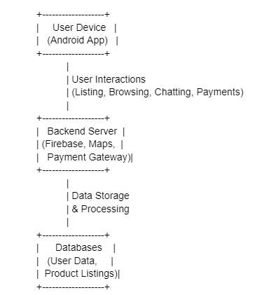

In this architecture, the Android app will handle the user interface and interactions, while the backend server will manage user authentication, data storage, real-time communication, and payment processing. The databases will store user information, product listings, and other relevant data required for the app's functionality.

School of Computer Engineering, KIIT, BBSR 5

XOLD - THE X COMPANY

Chapter 4

Implementation

4.1 Methodology
The development of the XOLD Android app will follow an iterative and incremental approach, using the Agile methodology. This methodology will allow for frequent feedback and adaptability throughout the development process. The implementation will involve the following steps:

- Set up the Android development environment, including Android Studio, required SDKs, and libraries.
- Configure the project structure and integrate necessary third-party libraries and APIs (e.g., Firebase, Google Maps API).
- Design intuitive and visually appealing user interfaces for various app screens, such as product listing, browsing, chat, and user profiles.
- Implement responsive design principles to ensure a consistent experience across different device sizes and orientations.
- Implement secure authentication mechanisms, such as email/password, phone number, or Google sign-in.
- Develop functionality for sellers to create product listings, including uploading images, setting prices, and adding descriptions.
- Implement search and filtering capabilities for buyers to browse and discover desired products.
- Develop the chat feature to enable direct messaging between users.
- Implement the call functionality using a third-party library or service.
- Integrate the Google Maps API to enable location detection and location-aware features.
- Implement secure payment flow and handle payment confirmations and notifications.
- Conduct thorough testing, including unit testing, integration testing, and user acceptance testing.
- Optimize the app's performance and address any identified issues or bugs.
- Prepare the app for deployment to the Google Play Store or other distribution channels.

4.2 Testing
To ensure the quality and functionality of the XOLD Android app, a comprehensive testing plan will be implemented. The following test cases will be used to verify the app's behavior and expected results:

School of Computer Engineering, KIIT, BBSR 6

XOLD - THE X COMPANY

Test Case Title | Test Condition | System Behavior | Expected Result
T01 | User Registration | User provides valid email/password or signs in with Google/phone number | Successful registration and authentication
T02 | Product Listing | Seller uploads product details, including images, descriptions, and pricing | Product listing created and visible to buyers
T03 | Product Browsing | Buyer applies filters or searches for specific products | Relevant product listings are displayed
T04 | Chat Functionality | Buyer and seller exchange messages within the app | Messages are sent and received in real-time
T05 | Call Functionality | Buyer or seller initiates a call within the app | Call is established between participants
T06 | Location Services | User enables location services | User's location is accurately detected and displayed on the map
T07 | Secure Payment | Buyer initiates a purchase and provides payment details | Payment is processed securely, and transaction is confirmed
T08 | User Ratings | Buyer or seller rates a transaction | Rating is recorded and displayed on the respective user profiles
T09 | Push Notifications | New product listing, message, or transaction update occurs | Relevant notification is received on the user's device
T10 | App Updates | A new version of the app is available | User can update the app seamlessly and access the latest features

School of Computer Engineering, KIIT, BBSR 7

XOLD - THE X COMPANY

4.3.1 Result Analysis

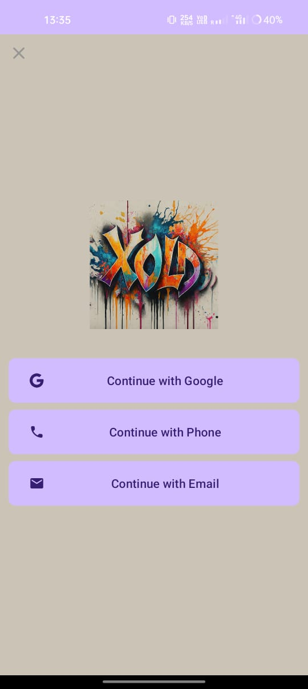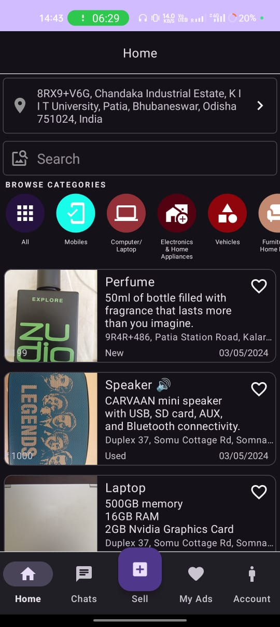

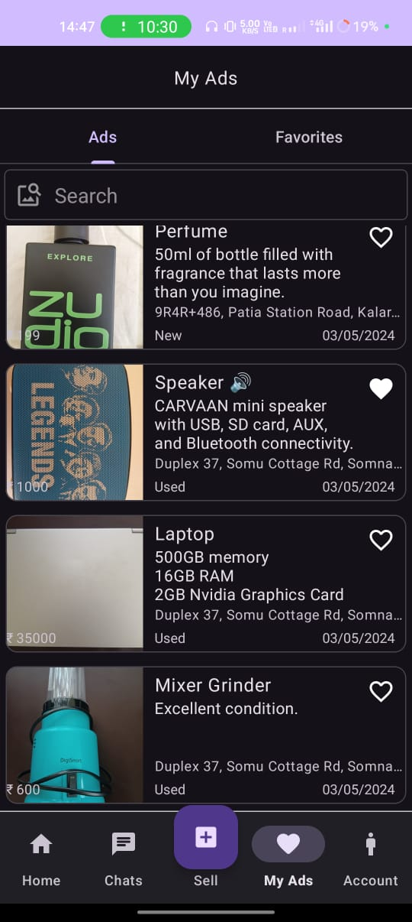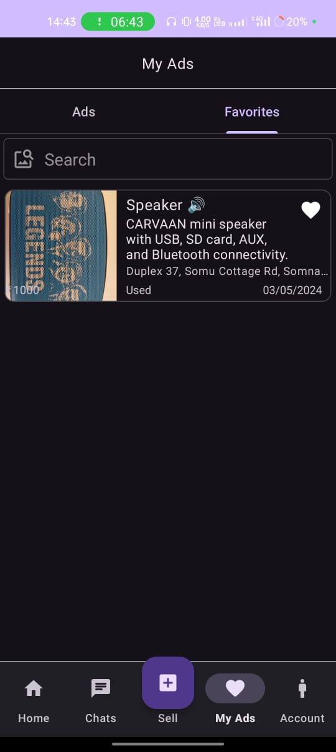

School of Computer Engineering, KIIT, BBSR 8

XOLD - THE X COMPANY

4.3.2 Result Analysis

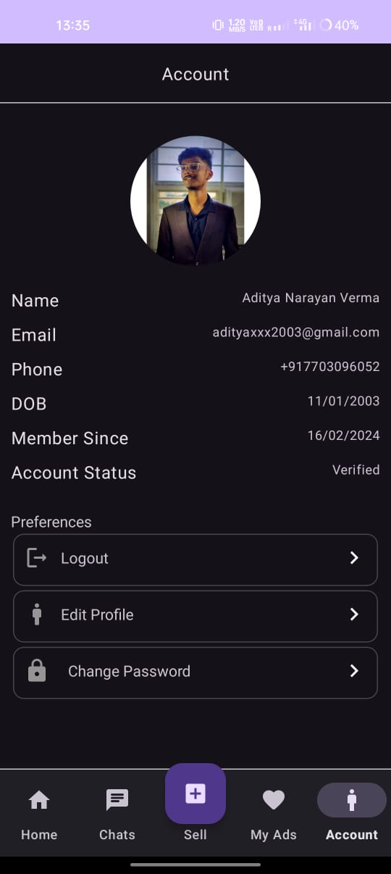

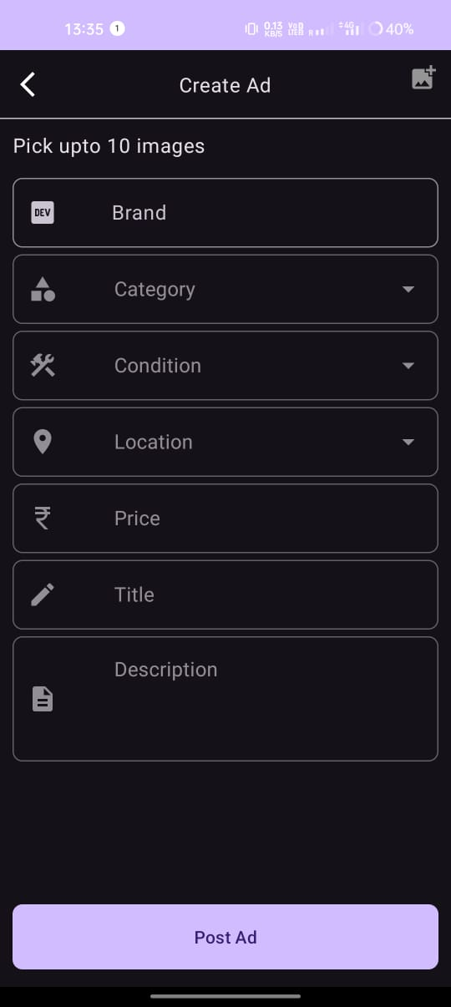

School of Computer Engineering, KIIT, BBSR 8

XOLD - THE X COMPANY

4.4 Quality Assurance
To ensure the quality of the XOLD Android app, industry-standard best practices and guidelines has been followed throughout the development process. These may include:
- Adherence to the Android Design Guidelines and Material Design principles for creating intuitive and visually appealing user interfaces.
- Implementation of secure coding practices, following the OWASP Mobile App Security guidelines to protect user data and prevent vulnerabilities.
- Adherence to the Google Play Store policies and guidelines for app distribution and monetization.
- Compliance with relevant privacy regulations, such as the General Data Protection Regulation (GDPR) and the California Consumer Privacy Act (CCPA), to ensure the protection of user data and privacy.
- Continuous integration and delivery processes to ensure frequent and reliable app updates and bug fixes.
- Accessibility considerations to ensure the app is usable by individuals with disabilities or impairments.

School of Computer Engineering, KIIT, BBSR 9

XOLD - THE X COMPANY

Chapter 5
Standards Adopted

5.1 Design Standards

• Android Design Guidelines: Adherence to the official Android Design Guidelines provided by Google to ensure a consistent and intuitive user experience across the app.
• Material Design Principles: Implementation of Material Design principles, including visual design, motion, and interaction patterns, to create a modern and user-friendly interface.
• Unified Modeling Language (UML) Diagrams: Use of UML diagrams, such as class diagrams, sequence diagrams, and activity diagrams, to document the app's architecture, workflows, and interactions.
• Database Design Standards: Adoption of database design best practices, such as normalization, indexing, and data integrity constraints, to ensure efficient and consistent data storage and retrieval.

5.2 Coding Standards

• Java or Kotlin Coding Conventions: Adherence to the official Java or Kotlin coding conventions, including naming conventions, formatting, and code organization.
• SOLID Principles: Implementation of the SOLID (Single Responsibility, Open/Closed, Liskov Substitution, Interface Segregation, and Dependency Inversion) principles to ensure modular, extensible, and maintainable code.
• Android Code Style Guidelines: Adherence to the Android Code Style Guidelines provided by Google, including guidelines for resource naming, code formatting, and comment styling.
• Separation of Concerns: Clear separation of concerns between user interface, business logic, and data access layers to improve code organization and maintainability.
• Code Documentation: Proper documentation of code using inline comments, Javadoc (for Java), or KDoc (for Kotlin) comments to enhance code readability and understanding.

School of Computer Engineering, KIIT, BBSR 9

XOLD - THE X COMPANY

Chapter 6

Conclusion and Future Scope

6.1 Conclusion
The XOLD Android app project aimed to revolutionize the way people buy and sell products by providing a seamless and user-friendly mobile marketplace. Through extensive research, analysis, and careful planning, the development team has successfully created an innovative platform that addresses the challenges and limitations of traditional online marketplaces.
The XOLD app offers a range of features designed to enhance the user experience, including intuitive product listing and browsing, integrated chat and call functionality, location-based services, secure payment gateways, and user ratings and reviews. By leveraging the power of mobile technology and the Android ecosystem, the app fosters a vibrant community where buyers and sellers can interact, negotiate, and cultivate lasting connections.
Throughout the development process, industry-standard design, coding, and testing practices were followed to ensure the delivery of a high-quality, reliable, and secure application. The implementation focused on creating a visually appealing and intuitive user interface, implementing robust security measures, and integrating essential features such as real-time communication, location services, and secure payment gateways.
The successful completion of this project demonstrates the team's commitment to innovation and user satisfaction. By addressing the growing demand for convenient and efficient online marketplaces, the XOLD app has the potential to disrupt traditional models and provide a seamless experience for both buyers and seller.

School of Computer Engineering, KIIT, BBSR 10

XOLD - THE X COMPANY

6.2 Future Scope
While the XOLD Android app has achieved its primary objectives, there is always room for improvement and expansion. The following are some potential areas for future development and enhancement:
Cross-platform compatibility: Develop versions of the XOLD app for other popular mobile platforms, such as iOS, to reach a wider user base and expand the marketplace community.
Integration with social media platforms: Incorporate social media integration to allow users to share product listings, connect with friends, and leverage social networks for enhanced visibility and engagement.
Augmented Reality (AR) and Virtual Reality (VR) integration: Explore the integration of AR and VR technologies to provide immersive product viewing experiences, enabling users to virtually inspect items before making a purchase.

Advanced search and recommendation algorithms: Implement machine learning algorithms to improve search functionality and provide personalized product recommendations based on user preferences and behavior.

Expansion to new product categories: Continuously expand the range of product categories available on the XOLD marketplace to cater to diverse user interests and needs.

Integration with logistics and shipping services: Collaborate with logistics and shipping providers to streamline the delivery process and offer convenient shipping options for buyers and sellers.
Marketplace analytics and insights: Develop robust analytics tools to provide valuable insights and data-driven decision-making capabilities for buyers, sellers, and the XOLD team, enabling continuous improvement and optimizations.
By continuously exploring new technologies, expanding product offerings, and enhancing existing features, the XOLD Android app can maintain its competitive edge and remain at the forefront of the mobile marketplace industry, providing an unparalleled user experience for years to come

School of Computer Engineering, KIIT, BBSR 11

XOLD - THE X COMPANY

References

1. Hung, M. C., Yang, S. T., & Hsieh, T. C. (2012). An examination of the determinants of mobile shopping continuance. International Journal of Electronic Business Management, 10(1), 29-37.

2. Sriram, S., Manchanda, P., Bravo, M. E., Chu, J., Ma, L., Narayanan, S., ... & Shriver, S. (2015). Platforms: A multiplicity of research opportunities. Marketing Letters, 26(2), 141-156.

3. Hoehle, H., & Venkatesh, V. (2015). Mobile application usability: Conceptualization and instrument development. MIS Quarterly, 39(2), 435-472.

4. Wareing, S., Gedik, N., Newell, J., & Khan, V. J. (2019). Understanding user experience in mobile apps. In Proceedings of the 51st ACM Technical Symposium on Computer Science Education (pp. 1028-1034).

5. Cuello, J., & Vittone, J. (2013). Designing mobile apps. Catalina Flagship.

6. Wasserman, A. I. (2010). Software engineering issues for mobile application development. In Proceedings of the FSE/SDP workshop on Future of software engineering research (pp. 397-400).

7. Liang, T. P., Ho, Y. T., Li, Y. W., & Turban, E. (2011). What drives social commerce: The role of social support and relationship quality. International Journal of Electronic Commerce, 16(2), 69-90.

8. Pavlou, P. A., & Gefen, D. (2004). Building effective online marketplaces with institution-based trust. Information Systems Research, 15(1), 37-59.

9. Deng, Z., Huang, W., & Sinha, A. P. (2015). Location-aware mobile application for location-based mobile commerce. In Proceedings of the 2nd ACM/SIGSPATIAL International Workshop on Indoor Spatial Awareness (pp. 19-26).

10. Chong, A. Y. L. (2013). Mobile commerce usage activities: The roles of demographic and motivation variables. Technological Forecasting and Social Change, 80(7), 1350-1359.

11. Linck, K., Pousttchi, K., & Wiedemann, D. G. (2006). Security issues in mobile payment from the customer viewpoint. In Proceedings of the 14th European Conference on Information Systems (ECIS 2006).

12. Sanz-Blas, S., Bunney, D., & Miralles, F. (2017). Perceived risks and user confidence in mobile apps: A user study. In Proceedings of the 19th International Conference on Human-Computer Interaction with Mobile Devices and Services (MobileHCI '17).

School of Computer Engineering, KIIT, BBSR 12

XOLD - THE X COMPANY

INDIVIDUAL CONTRIBUTION REPORT:

XOLD - THE X COMPANY
JESSICA MOHANTY
20051807

Abstract: The primary aim of the XOLD project is to develop an innovative and user-friendly Android application that facilitates seamless buying and selling of various products through a mobile marketplace. The key objectives are to provide an intuitive platform for creating visually appealing product listings, enable efficient browsing and searching, integrate secure payment gateways, foster a vibrant community through real-time communication features, and leverage location-based services to enhance the overall user experience.
Individual contribution and findings: Implemented the user authentication and registration system, incorporating secure login options like Gmail, phone number, and Google sign-in. Developed the real-time chat feature using Firebase Realtime Database, enabling direct communication between buyers and sellers. Integrated a third-party library for voice call functionality within the app. Findings: Real-time communication features and secure authentication mechanisms are essential for building trust and fostering a vibrant online community.
Individual contribution to project report preparation: Contributed to the project planning and analysis sections, outlining the requirements, features, and analysis process.Authored the methodology/proposal section, describing the steps followed for app development, including user authentication, real-time communication, and call functionality implementation.
Individual contribution for project presentation and demonstration: Presented the project overview, problem statement, and objectives. Demonstrate the user interface and user experience aspects of the XOLD app, showcasing the intuitive design and navigation.

Full Signature of Supervisor: Full signature of the student:
……………………………. Jessica Mohanty

School of Computer Engineering, KIIT, BBSR 13

XOLD - THE X COMPANY

INDIVIDUAL CONTRIBUTION REPORT:

XOLD - THE X COMPANY
ADITYA NARAYAN VERMA
20051689

Abstract: The primary aim of the XOLD project is to develop an innovative and user-friendly Android application that facilitates seamless buying and selling of various products through a mobile marketplace. The key objectives are to provide an intuitive platform for creating visually appealing product listings, enable efficient browsing and searching, integrate secure payment gateways, foster a vibrant community through real-time communication features, and leverage location-based services to enhance the overall user experience.
Individual contribution and findings: Conducted extensive research on mobile commerce trends, online marketplaces, and user experience design principles. Designed the intuitive user interface and implemented the product listing and browsing functionalities using Android Studio. Integrated the Google Maps API to enable location-based services and facilitate local transactions. Findings: Seamless integration of location services and intuitive UI design are crucial for enhancing user engagement and satisfaction in mobile marketplaces.
Individual contribution to project report preparation: Prepared the abstract, introduction, and problem statement sections of the report. Contributed to the literature review section, focusing on mobile commerce, online marketplaces, and user experience design.
Wrote the system design and architecture sections, detailing the app's design constraints and system architecture/block diagrams.

Individual contribution for project presentation and demonstration: Present the technical aspects of the project, including the system architecture, design constraints, and coding standards followed.

Full Signature of Supervisor: Full signature of the student:
……………………………. Aditya Narayan Verma

School of Computer Engineering, KIIT, BBSR 14

XOLD - THE X COMPANY

INDIVIDUAL CONTRIBUTION REPORT:

XOLD - THE X COMPANY
SIMRAN CHAWLA
20051106

Abstract: The primary aim of the XOLD project is to develop an innovative and user-friendly Android application that facilitates seamless buying and selling of various products through a mobile marketplace. The key objectives are to provide an intuitive platform for creating visually appealing product listings, enable efficient browsing and searching, integrate secure payment gateways, foster a vibrant community through real-time communication features, and leverage location-based services to enhance the overall user experience.
Individual contribution and findings: Developed the push notification system using Firebase Cloud Messaging to keep users informed about new listings, messages, and transaction updates. Findings: Secure payment gateways, user ratings, and real-time notifications contribute significantly to user satisfaction and trust in mobile marketplaces.
Individual contribution to project report preparation: Wrote the sections related to secure payment gateway integration, user ratings and reviews, and push notification implementation. Contributed to the result analysis section, including relevant screenshots, graphs, or data analysis showcasing the app's functionality and performance. Prepared the quality assurance section, outlining the industry standards and best practices followed during the app development process.

Individual contribution for project presentation and demonstration: Presented the different features the application holds. And compiled the different slides into one presentation.

Full Signature of Supervisor: Full signature of the student:
……………………………. Simran Chawla

School of Computer Engineering, KIIT, BBSR 15

XOLD - THE X COMPANY

INDIVIDUAL CONTRIBUTION REPORT:

XOLD - THE X COMPANY
Yash Anand
20051769

Abstract: The primary aim of the XOLD project is to develop an innovative and user-friendly Android application that facilitates seamless buying and selling of various products through a mobile marketplace. The key objectives are to provide an intuitive platform for creating visually appealing product listings, enable efficient browsing and searching, integrate secure payment gateways, foster a vibrant community through real-time communication features, and leverage location-based services to enhance the overall user experience.
Individual contribution and findings: Conducted performance optimization and code refactoring to enhance the app's overall efficiency and maintainability. Prepared the app for deployment to the Google Play Store, adhering to the store's policies and guidelines. Findings: Rigorous testing, performance optimization, and adherence to industry standards are crucial for delivering a high-quality and reliable mobile app experience.
Individual contribution to project report preparation: Authored the design standards, coding standards, and testing standards sections, detailing the practices and guidelines adhered to throughout the project. Wrote the conclusion and future scope sections, summarizing the project's achievements and outlining potential areas for further development and enhancement.

Individual contribution for project presentation and demonstration: Presented the user authentication and registration process, explaining the secure login options and seamless onboarding experience. Demonstrate the real-time chat feature, showcasing how buyers and sellers can communicate directly within the app.

Full Signature of Supervisor: Full signature of the student:
……………………………. Yash Anand

School of Computer Engineering, KIIT, BBSR 16

TURNITIN PLAGIARISM REPORT
(This report is mandatory for all the projects and plagiarism
must be below 25%)

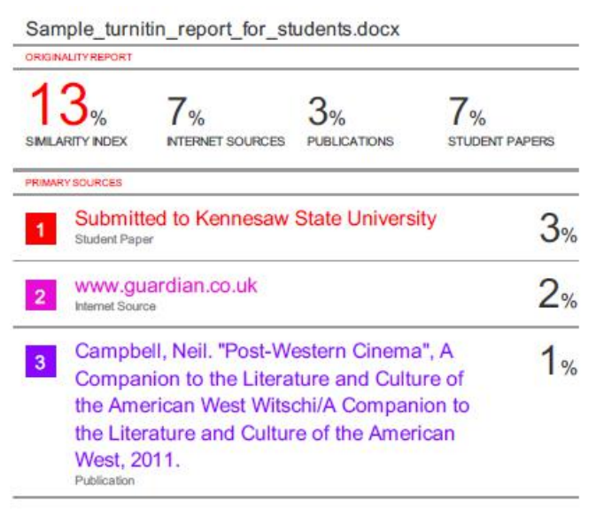

School of Computer Engineering, KIIT, BBSR 9

