**Matt Calvert**

2 Shepherds Walk, Farnborough, Hampshire, GU14 9EY

**Profile:**

My current role working as a Deputy General Manager at Nuffield Health I am directly managing both the sales and front of house teams. This helps me focus on the member journey from first enquiry to ongoing interaction. This particular role has been incredibly stimulating, fun and provided me with some dynamic and challenging obstacles to overcome with each new member of staff who joins me in my teams. This career move has been a great opportunity for me to really grow as a person and develop my skills and knowledge of the fitness industry from a managerial perspective. Within my role I find the most rewarding aspects teaching, coaching and developing my team I am eager to progress my career path to find a role which incorporates these skills which I enjoy that still provides further stimulation, stretching targets and an environment with new obstacles and rejections to overcome. I am motivated by leading by example in my actions and seeing those I coach and develop excel in their roles. I surpass in excellence achieving targets, selling, providing unequivocal customer service and furthermore teaching my team to do the same.

**Employment History:**

**I am looking forward to my next challenge and am driven to exceed my performance targets. I have consistently delivered my best performance in my previous sales roles and my previous roles that were customer facing. I am a reliable and articulate communicator with experience in dealing with a range of personalities and situations, regarding all opportunities as members to interact with. I have a good understanding of working as part of a team and focusing on my own personal needs to meet the target and exceeding it.**

**Deputy General Manager (Nuffield Health Friern Barnet): 1st August 2018 – Present**

**Targets:** Manage and develop the sales and front of house teams.Ensuring the club sales targets, Net Member Movement and Debt targets are achieved each month. 

**Achievements: In my first month I achieved the club sales target after the previous months of the year the club was not hitting target. Continuing to hit these targets in my consecutive months.**

* Training and developing staff in the best practice sales process for the site from when the customer first visits to ongoing customer service. Including training on tour, objection management and price presenting.
* Taking ownership of the clubs sales targets as well as member retention and debt. Managing the sales team as well as the other members of staff that sell in addition to their job roles.
* Planning and writing the sales planner for the club and ensuring it effectively is followed.
* Managing the front of house team including; hiring, performance reviews, 1-2-1s and rotas. Using the customer satisfaction surveys to improve my team and the customer’s experience.
* Taking charge of the profit and loss for food and beverage in the club. Furthermore working with the central team to see how we can maximise those revenue lines.
* Continuingly developing my own skill sets by learning from my General Manager about how best to improve myself professionally in my job role.

**Senior Sales Executive (Nuffield Health Stockley Park): 12th June 2016 – 25th September 2017 & 21st February 2018 – 31st July 2018**

**Targets:** Achieve individual sales targets as well as club targets. Ensure outreach and inreach is done effectively using resources available. 

**Achievements: In January 2017 I sold 153 memberships which was 51% of overall club target. February 132 which was 53%. March 196 which was 87%. April 104 which was 53%. May 86 which was 43%. I was promoted to the role of Senior Sales Executive which means I am responsible for the sales team in addition to managing my own individual targets. On my return to the company I quickly settled back in and hit top of region for my last 3 months.**

* I regularly liaise with local corporate company HR and Wellbeing teams of various sizes to help them encourage their members of staff to get into the gym and active. This involves coming up with action plans from first contact to getting the employees into the club and maintaining a working relationship with the company.
* Taking time to train new members of the sales team in process and product knowledge to help the team develop and continue to develop themselves.
* Building the sales planner for the month with the Deputy General Manager which meets the requirements of the month in terms of sales and leads needed to hit target.
* Organising outreach and inreach for the team and club to do. This involves leaflet drops and brand awareness in our local community as well as supporting events that are being run on the business park.
* Managing my own prospect database and making use of the CRM program to the full extent so I can use my time effectively and in the resources that are going to give the best rewards.

**Regional Account Executive (Monsoon Valley Wines under Red Bull): 2nd October 2017 – 2nd February**



**Targets:** Working with Restaurants who currently stock our wines to increase sales and winning new accounts to list our wine.

**Achievements: In my short time in the role I have been winning new accounts and been working with existing accounts to launch our National campaigns.**

* Regularly visiting restaurants and having meetings with owners and managers throughout the day. I am also doing my own route planning to maximise my productivity.
* Working with restaurants and their owners so that I know how best we can work together to increase the sales of our wine.
* Being the face of the brand to the restaurants and effectively building rapport with the owners and managers.
* Managing my own database and making use of the CRM system to the full extent so I can use my time effectively and in the resources that are going to help me use my time as efficiently as possible.
* Taking time to increase my product and industry knowledge so that I can be more confident in my meetings.

**Service Manager (Virgin Active Stockley Park and Northwood Riverside): 2nd August 2015 – 11th June 2016**

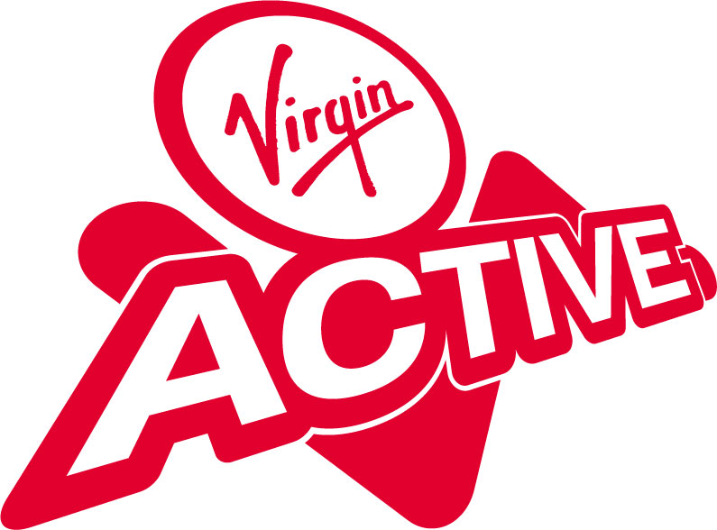

**Targets:** Ensure the club is running on a day to day basis. In charge of the lifeguard teams directly and presentation of the club in terms of standards and cleanliness.

**Achievements:** Hired lifeguards and redesigned rota system so that they work more effectively as a team. Worked with the other members of the teams to help raise brand standards across both clubs I worked at under Virgin Active.

* Worked with the Operations and General Managers to create an action plan to help improve the clubs performance, cleanliness and customer satisfaction.
* Holding 1-2-1 meetings with Lifeguards and Cleaners on regular basis assessing performance and feedback to help develop themselves. Progressed cleaners to Lifeguards and a PT onto Personal Training.
* Key holder for the sites as well and doing banking at the start and end of day.
* Responsibility for Health and Safety on a day to day basis. Taking charge of incidents under my watch and delivering first aid when needed.
* Taking charge of chemical ordering and stock check. Ensuring we will have enough for the coming week and that they are being used effectively by the team.

**Freelance Nightclub Photographer (various in Birmingham and Wolverhampton): August 2013 - January 2015**



**Targets:** Produce photos of the event in the club that would be posted on social media to be used for marketing and organic interaction with people tagging themselves from the night out.



**Achievements:** Helped launch Levana in the Birmingham Arcadian being their first resident photographer.

* Interacting with patrons of the clubs I was shooting and organising them on the fly for the best photo.
* Helping manage social media and how the night was presented.
* Working with organisers to capture the image style they want and how they want the nights represented on social media.

**Duty Supervisor (Farnborough Leisure Centre): February 2015 - August 2015**

**Targets:** Alongside the Duty Manager ensure the building is operating efficiently and safely

**Achievements:** Assisted in training new Lifeguards. Introduced and ran ‘Lifeguard of the month’

* I Was working within a Duty Manager role, managing a team of over 40 staff.
* In charge of the lifeguard team and the operations of poolside and the building on a day to day basis.
* Taking a lead in the operations team and regularly liaising with other departments in the leisure centre, helping each manage their resource needs as needs be.
* Managing the inventory of the safe on site.
* Ensuring that the building is open and ready for use by customers in the morning and is closed correctly and secured after the end of the late shift.
* Taking a lead in emergency situations and organising the staff on shift.

**Lifeguard (Farnborough Leisure Centre & Aldershot Pools): August 2007 - February 2015** 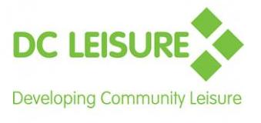

**Targets:** Ensure pool safety and cleanliness of the facilities with the team.

**Achievements:** Only performed two rescues during my time lifeguarding.

* Competently respond to emergency situations in both team and individual situations.
* Deal with customers’ queries and complaints effectively as well as working proactively so that their experience in the centre is as pleasant as possible.
* Assist in induction of new members of staff.
* Worked part time while through education and have worked contracted full time during summers.
* Cleaning duties to help maintain and promote high professional standards of the company.

**Summary of Key Strengths**

**Technical skills:**

* Knowledge and confidence with Microsoft Office, Word, PowerPoint, Excel, and Outlook. Adobe Photoshop, Lightroom, and learning Premiere Pro. Various CRM systems that have been provided by Nuffield and Virgin Active.
* Experienced in time-management, prioritising and organising work to reflect current workload.
* Extensive knowledge of the Nikon DSLR camera ecosystem and knowledge of Canon DSLR systems in addition.

**Communication:**

* Use strong negotiation and influencing skills to help sell the product I'm representing and deal with issues that arise with customer service.

**Responsibility and Teamwork:**

* Taking charge of situations in the variety of roles I have had including; First Aid, Customer service,and Training new staff.

**Problem Solving and Reasoning:**

* Helping people to overcome objections when is comes to buy decisions in relation to the gym membership and other services we provide.
* Using extensive product knowledge of not only the gym I'm working in but the competition of other gyms in the area.

**Education & Qualifications**

**University College Birmingham: 2011 - 2015**

* BSc Sports Therapy (hons)

**Farnborough College of Technology: 2009 - 2011**

* Sports Science - Distinction Merit Merit

**Farnborough Sixth Form College: 2007 - 2009**

* A Levels – Art (Sculpture), Music Technology, Electronics
* AS Levels – Archeology, General Studies

**Fernhill School and Language College: 2002 - 2007**

* 8 GCSEs B-D

**Qualifications and additional information**:

* Full First aid at work
* Defib trained
* Food Safety Level 2
* Full Clean UK Driving Licence

References available on request.