Biography of Linus Torvalds

Early life and career:

Linus Torvalds is a Finnish-American software engineer who is commonly known as the creator of Linux, an open source operating system based on Unix. He’s also the creator of git, a version control system which allows people to work together through commits and pull requests.
He began programming software at an early age because he used his grandfather’s VIC-20 commodore. It was the first personal computer available in Europe that you didn’t have to put together yourself and was reasonably cheap considering the time period. There weren’t many games available on it so Linus started programming on his own in machine code. He only figured out what assemblers were 5 years later.

Since he used to work on an 6502 based machine like the vic-20 or the apple 2 he didn’t get the pc architecture and didn’t upgrade to it later on. After the commodore he started using a Sinclair QL machine. This machine wasn’t supported in Finland since it was mainly used in the UK. Which means that he didn’t have many readymade programs and had to program everything by himself. In his own words: ”I never had any readymade programs I always had to write my own, which kind of explains why I eventually ended up writing my own operating system - because hey that’s just what you did. If I had gotten a sane machine like the amiga or something like that I would probably have gotten used to using programs written by someone else. I never had that possibility. So you should be happy that you have never used a machine like the Sinclair QL but at the same time think of what you have lost.”
This puts into context why he was able to start his own operating system based on a book written by Tanenbaum describing operating systems specifically MINIX. The annoyances he had with his QL and his skills developed at an early age made it possible for him to start programming his own OS in C. He called it Linux (Based on his name and MIMIX: Linux’s MIMIX). He made it open source by putting his code online with the help of his friend Ari Lemmke, the administrator for ftp.funet.fi. He wanted to call it Freax but Lemmke already made the directory and called it Linux.
He also posted his code under the GPL licensing (GNU general public license) made by Richard Stallman. This is what allowed everyone to help develop Linux in its earliest stages. He based Linux on Unix because this was the OS used in his university in Helsinki.

After he finished his college degree in eight and a half years (he served his military for two years) he started working for Transmeta. While working there he kept working on Linux as a hobby and his work allowed him to take time during work hours for his hobby. During his time at Trasmeta he worked on making the X86 architecture translatable like java, making a “mobile linux”, working on low power consumption for the architecture and general workarounds for the X86.
The reason he worked for Transmeta was that it allowed him to work with interesting technologies and a technical view to approach the problems. Linus is known for only loving the best way to program/engineer things. So to work with these people and the technologies present made him motivated to keep working there.
“The reason I work for Transmeta is that I think the approach is so studly from a technical view. We should have shown technical people real demos of all these tools that show: what's the original x86 code? What did we change it into? Half of what the software group has done is just these tools, for visualization, for figuring out what things we missed, so we can be better at not missing those things. That's just incredibly cool, whether it's mobile or not.
Basically it's a lot of interesting technology that I don't think anybody has done before. A lot of people have done just in time compilers, and Digital used to do FX!32, which was translating x86 to Alpha. But nobody has done something in this kind of real environment. You didn't have real-time applications with real real-time guarantees, including the whole OS working. So that's what made me want to work with Transmeta in the first place. And then the fact that yes, I think mobile and wireless communications are good and I want more of that. For now it just makes me really happy to be able to say yes, we can do this. I don't have to be ashamed about what Transmeta does. They have all this cool technology.” -Linus during an interview when transmeta went public about their technologies.
After he resigned at Transmeta because he felt that was doing not enough real work for them and instead focusing mainly on Linux he worked for Open Source Development Lab where he could finally focus exclusively on Linux. Later on this lab merged with Free standards group and turned into the Linux Foundation who he still works for today. He recently took a break from Linux to focus on personal problems he found working with other people.

Contributions:
As stated heavily in his career, Linus was the inspiration for Linux which is heavily used in computers and server rooms today. It is a free and stable operating system competing with the other market players like windows and IOS. It is estimated that Linus wrote two percent of the entire Linux project. This may not seem as a big contribution to the distributions it still is a lot of work considering that the repository consists of millions lines of code. Linus himself focused mainly on the kernel aspect of the OS.
This is not the only thing that makes an operating system work. So it is unfair to say that Linus was the only person to make Linux possible. But the way he went about distributing his first version of Linux was the right choice and let up to his influence and importance now. The first version of Linux was heavily based upon the MINIX architecture described by the book Operating Systems: Design and Implementation by Andrew Tanenbaum. He also used already existing software like GNU, bash, GCC, Berkeley Unix distribution and X windows project. Some of these software systems were developed by Richard Stallman. He is a programmer actively leading for free software.

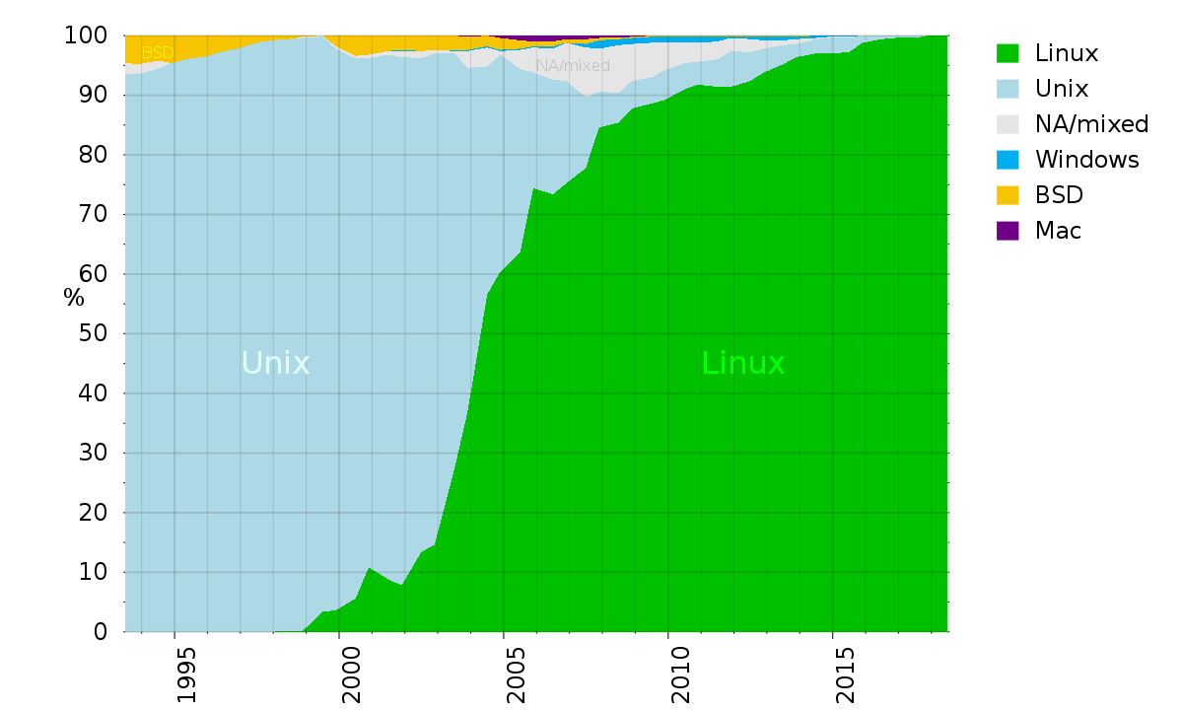
This picture shows the operating systems used for the 500 fastest supercomputers. As you can see at the moment they all use Linux OS. This research was done by the TOP500 project. It keeps an updated list of the 500 fastest non-distributed systems.

There are also many other distributions based on the Linux OS. Some of the more known ones are Debian and Ubuntu. These distributions make the Linux OS more specialized for certain aspects of software systems.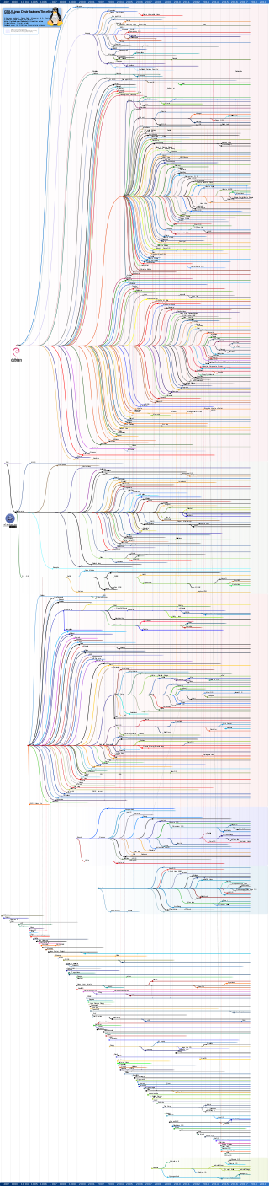.
The image above shows all the different distros based on Linux.
His other big contribution to software engineering was git. Git makes it possible for thousands of people to work together on a project while maintaining code changes and trees, so that easy reverts can be made when bugs are introduced. Without easy project control systems like git working together on big projects would be an awful experience. This doesn’t mean that git is the only version control system out there but it was one of the best and most easy to use. Which is why we also github for many of our assignments today.
Github itself is not created by Linus. He even explicitly states that he doesn’t approve of how they use git. But he do sees it as a good hosting site and a good way to introduce people to git. The main issues he has is the way they broke the commit system and how people can inject commits from external sources.
Reason for picking Linus:
The reason I chose Linus as my important software engineer was not because I’m a huge fan of Linux. In fact I have never used Linus until recently. I find him very influential because he stands for coding the best code out there and not taking any shortcuts in making software. For him it’s a meritocracy where only the good programmers are to be respected and he doesn’t care who writes the code only that the code written is the best it can be.

Bibliography:

Linux information project (2004) Linus Torvalds: A Very Brief and
Completely Unauthorized Biography [Online] Linfo. Available at:
http://www.linfo.org/linus.html
Computer history museum (2001) Documentary and public Q&A with linus Torvalds [Online]
Youtube. Available at:
https://www.youtube.com/watch?v=WVTWCPoUt8w&t=639s
Linus Torvalds Wikipedia
https://en.wikipedia.org/wiki/Linus_Torvalds#Life_and_career
Usage share of operating systems
https://en.wikipedia.org/wiki/Usage_share_of_operating_systems
Andrew Orlowski (2003) Linus leaves Transmeta. [online] the register. Available at:
https://www.theregister.co.uk/2003/06/17/linus_torvalds_leaves_transmeta/

