The Currency Network: A Stochastic Network Model of Global FX Dynamics
Alexander Robbins
University of Florida ‘26
9/28/25

Abstract
We propose a novel dynamic network model for foreign exchange (FX) markets, inspired by spring-mass systems in physics. Currencies are represented as nodes with economic "mass," interconnected via dynamic springs reflecting trade intensity, correlation, and sentiment. The model incorporates damping, stochastic shocks, and nonlinear spring forces to realistically simulate volatility, mean-reversion, and crisis propagation. Hierarchical and constrained network structures ensure stability, triangle arbitrage compliance, and relevance for small currencies. Empirical validation demonstrates potential for predicting volatility clusters, systemic risk, and the effects of policy interventions.

1. Introduction
FX markets are highly interconnected, with currencies reacting simultaneously to macroeconomic factors, trade flows, and policy decisions. Traditional models (e.g., factor models, GARCH, and copulas) capture correlations but often fail to account for dynamic network effects and the propagation of shocks.
We introduce the Currency Spring Network (CSN-S) model, inspired by spring-mass physics, to provide an interpretable, dynamic, and stochastic framework. By assigning economic mass, spring forces, and damping to currencies, we simulate realistic FX behavior, including crises, volatility clustering, and mean-reversion, while enforcing no-arbitrage constraints.

2. Theoretical Framework

2.1 Nodes: Currency Mass and Position
Each currency  is represented as a node with:
Mass : normalized combination of FX reserves and trade volume:
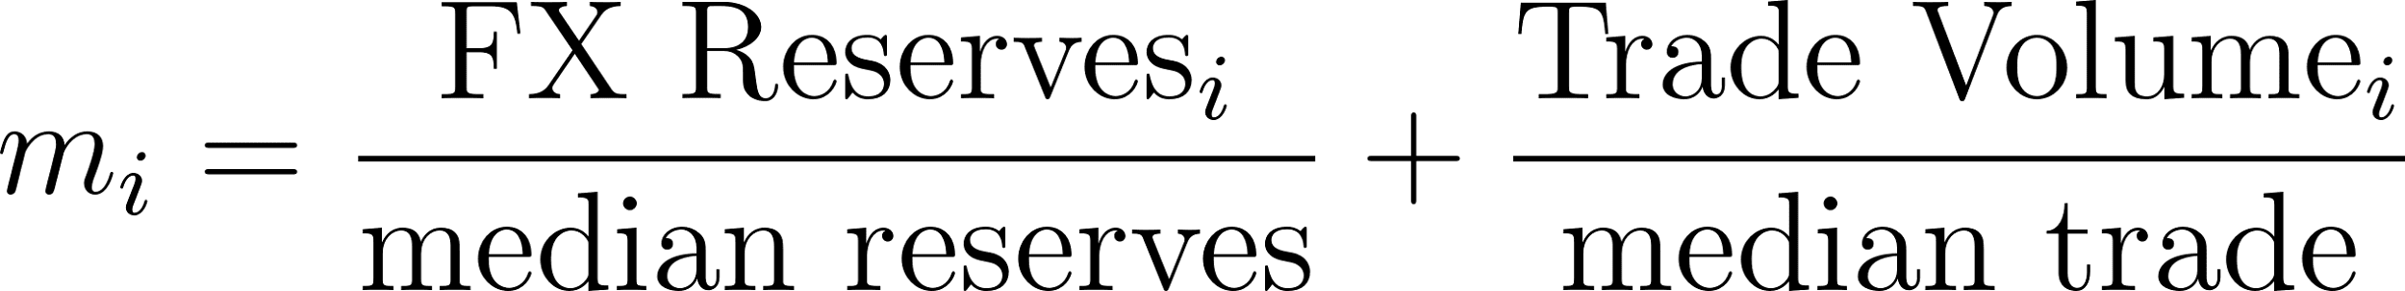
Position 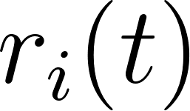: log-deviation from equilibrium exchange rate:
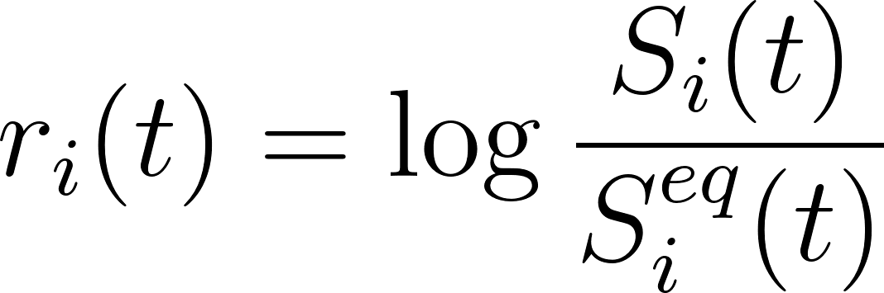
Velocity 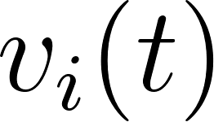:
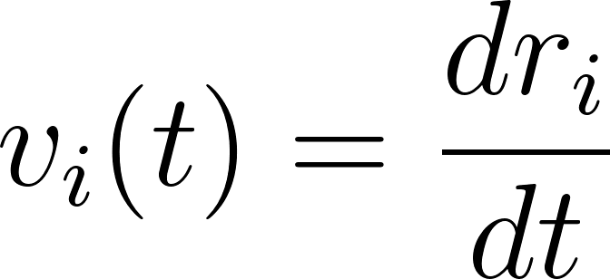
Positions are dimensionless, ensuring consistent units across the network.

2.2 Equilibrium Exchange Rates
Equilibrium 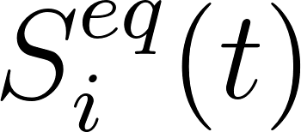 serves as the reference point for spring forces. It is defined as a hybrid of PPP, interest rate parity (IRP), and historical averages:

2.3 Spring Forces Between Currencies
Currencies and  are connected via dynamic, potentially nonlinear springs:
Linear term 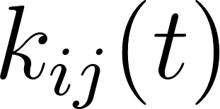: time-varying coupling based on trade and macro correlation:
Nonlinear term 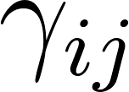: captures extreme co-movements and crises.
Sparsity: only top  connections per currency are retained.

2.4 Damping and External Forces
FX markets are dissipative and subject to shocks:
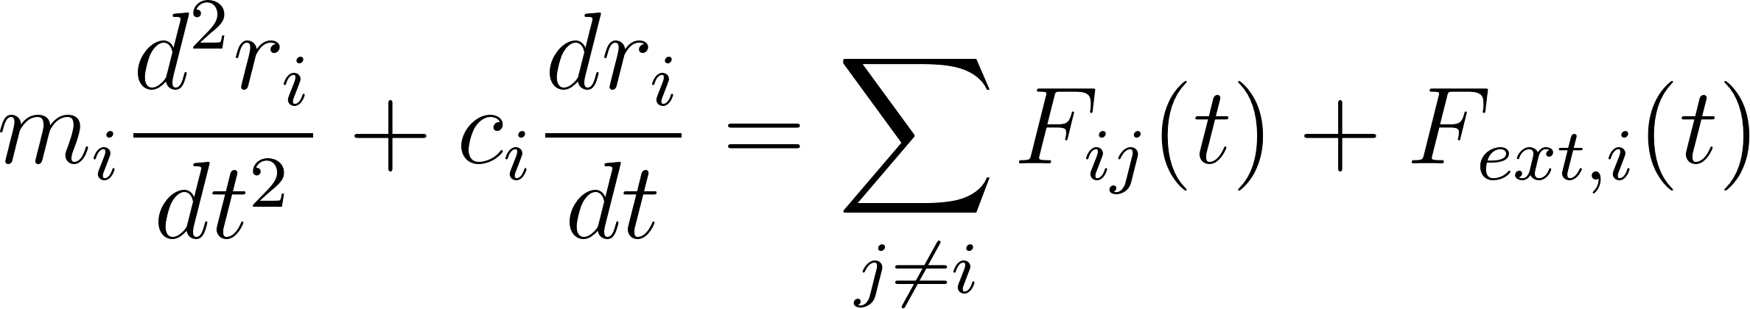
Damping : liquidity-based
External force 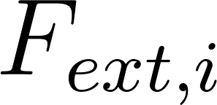: stochastic shocks and policy interventions
where:
- : Gaussian noise
- : Poisson jump (crises)

2.5 Network Hierarchy and No-Arbitrage
To respect triangle arbitrage constraints, USD is treated as central node, others orbit relative to USD.
Log-deviations ensure:
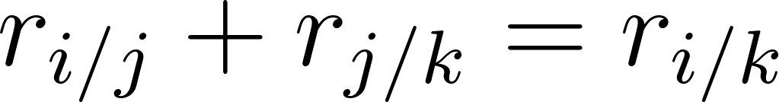
Pegged or managed currencies have high damping and strong restoring forces. Free-floating currencies are subject to normal stochastic dynamics.

3. Mathematical Formulation
The full SDE network is:
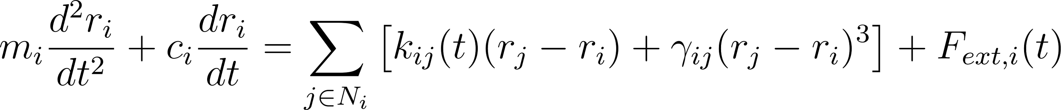
where : set of connected currencies
Eigenvalue analysis of the linearized system ensures stable dynamics.

3.1 Parameter Estimation
- Mass : normalized FX reserves + trade volume
- Spring constants : macro correlations × trade intensity
- Nonlinear term : tail dependence in co-movements
- Damping : proportional to liquidity
- External shocks: historical volatility and jump frequency
Parameters can be estimated using Bayesian inference or maximum likelihood.

4. Implementation and Simulation

4.1 Computational Approach
- Initialize sparse network of 10–20 major currencies
- Compute normalized mass, damping, and initial spring constants
- Numerically integrate SDEs using Euler-Maruyama or stochastic Runge-Kutta
- Introduce stochastic jumps and regime switching for pegged currencies
- Simulate multi-step forecast, monitoring stability and triangle arbitrage compliance

4.2 Hierarchical Expansion
- Phase 1: G10 currencies only
- Phase 2: Include smaller periphery currencies
- Phase 3: Full network of ~200 currencies, with USD/EUR as central nodes

5. Model Features and Insights
- Mean Reversion: Heavy currencies act as gravitational wells
- Volatility Clustering: Oscillations propagate through springs
- Crisis Simulation: Nonlinear springs + jump processes replicate rare events
- Systemic Risk: Centrality measures identify systemically important currencies
- Policy Experiments: Adjust damping to simulate central bank interventions

6. Empirical Validation
Test on historical FX data for major crises (2008, 2010 Eurozone, COVID-19). Metrics:
- Mean-reversion accuracy
- Volatility clustering (autocorrelation of squared returns)
- Extreme co-movement replication
- Triangle arbitrage consistency
Compare predictions against factor models, GARCH, and copula networks.

7. Limitations and Extensions
- Calibration requires careful estimation to avoid overfitting
- Small currencies may still be dominated by large currencies
Future work:
- Include derivative markets (FX options)
- Cross-asset networks (FX + bonds + equities)
- Data-driven regime switching using machine learning

8. Conclusion
The Currency Spring Network (CSN-S) model offers a physics-inspired, stochastic, network-based framework for FX dynamics. By combining economic mass, dynamic springs, damping, and stochastic shocks, it provides:
- Interpretable dynamics
- Predictive potential for volatility and crises
- Compliance with no-arbitrage constraints
- Flexibility to simulate policy interventions

References
- Engle, R. F. (1982). Autoregressive Conditional Heteroskedasticity with Estimates of the Variance of UK Inflation. Econometrica.
- Diebold, F. X., & Yilmaz, K. (2014). On the Network Topology of Variance Decompositions: Measuring the Connectedness of Financial Firms. Journal of Econometrics.
- Mantegna, R. N., & Stanley, H. E. (2000). An Introduction to Econophysics.
- Bouchaud, J. P., & Potters, M. (2003). Theory of Financial Risk and Derivative Pricing.

