MCCP6010 / GROUP 6 / 15 MINUTE LESSON

Understanding Your
TikTok For You Feed
  - Student learning guide
Why does TikTok know what you like? Explore how your actions and video content can help a recommendation system predict what you may enjoy. Use this guide to record ideas, calculate scores and explain your choices.
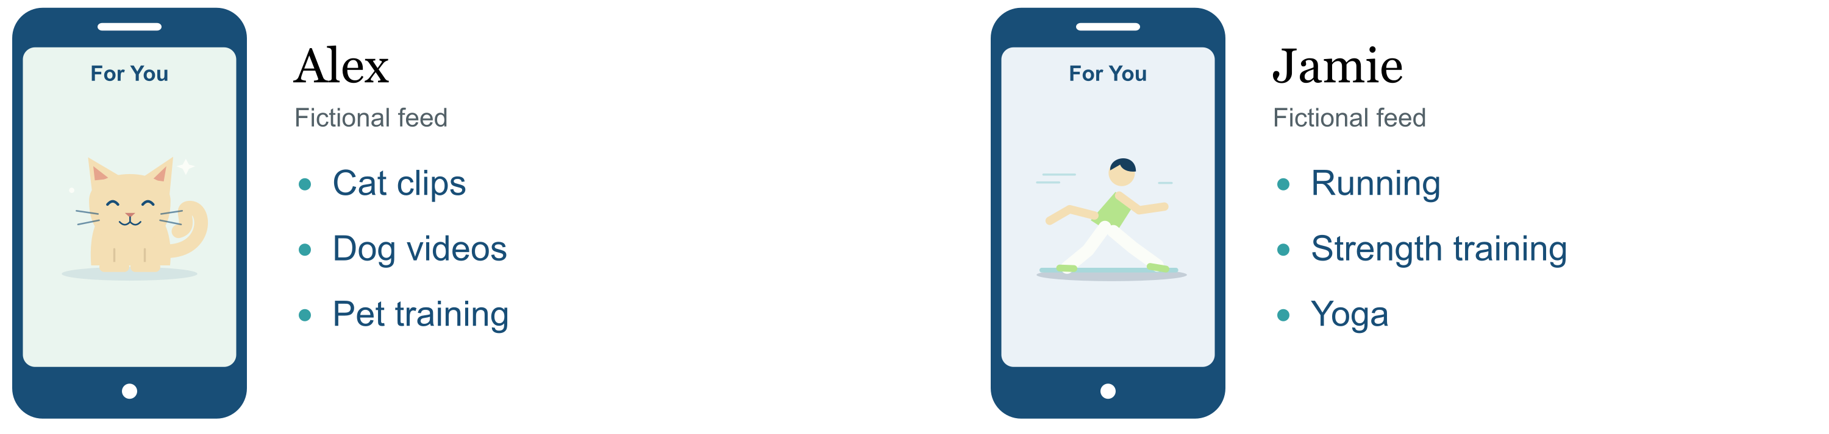

Our route through the lesson
Collect signals → Understand content → Rank videos → Update recommendations

By the end you can
01 Identify at least two user behavior signals and distinguish them from content clues.
02 Apply and justify a ranking rule to put three videos in order and explain your choice.
03 Explain how new feedback can change future recommendations.

Predict the feeds 02 Part 3
Compare Alex’s and Jamie’s feeds. Why might the same app show different videos? Share one idea with a partner when the teacher starts the 15 second timer.
________________________________________________________________________
________________________________________________________________________
Name ____________________________ Partner ____________________________

STUDENT LEARNING GUIDE / 02 SIGNALS AND CONTENT / 02–06 MIN

Find the clues
A recommendation system uses evidence to predict interests. First separate what a viewer does from what a video contains.
Type of clue | Examples | What it describes
Explicit feedback | Like · Share · Follow | Actions that directly express a response
Implicit feedback | Watch time · Skip · Rewatch | How someone watches
Content information | Topic · Title or caption  Hashtags · Sound | What the video contains

Signals in context 04 Parts 3 and 4
Viewer A presses Like, then skips after 2 seconds. Viewer B does not press Like, but watches to the end.
Which gives stronger evidence of interest? What else would you need to know? Discuss before writing a short reason.
________________________________________________________________________
________________________________________________________________________
________________________________________________________________________
Consider the video length, whether it is a repeat view and the viewer’s earlier actions. Interpret signals together; a single action does not tell the whole story.

Content clues 05 Parts 1 and 2
A video is titled “A kitten’s first jump”. Its hashtags are #cats and #pets, and it uses playful piano music.
Name one content clue and one user action that could happen while watching it.
Content clue ____________________ User action ____________________

Shared interests 05 Parts 3 and 4
Alex and Jamie both interacted with Videos 1 and 2. Jamie also liked Video 3. Their shared interests suggest Video 3 as a possible candidate for Alex.
A candidate is a video being considered for recommendation. What makes Video 3 worth considering? Explain to your partner.
________________________________________________________________________
________________________________________________________________________

STUDENT LEARNING GUIDE / 03 RANKING / 06–10 MIN

Be the algorithm
Work with a partner using the supplied ratings. Begin when the teacher starts the 60 second timer on 07 Part 3.

Classroom rule 06 Parts 2 to 6
Score = 2 × Interest Match + Predicted Engagement
Interest Match describes how well a video fits inferred interests. Predicted Engagement estimates how likely the viewer is to watch or interact.
Both ratings use a 1–5 scale. The formula and all scores are classroom simulations, rather than TikTok’s actual ranking formula.
Worked example Match 3 and Engagement 2 → 2 × 3 + 2 = 6 + 2 = 8

Calculate and rank 07 Parts 1 to 3
Alex’s recent viewing includes several pet videos, plus fitness and cooking. The ratings below are provided for this activity. Calculate each score, then rank from highest to lowest.
Candidate video | Interest  Match | Predicted  Engagement | Your calculation  and score
Pets | 4 | 3 | 2 × ____ + ____ = ____
Fitness | 2 | 5 | 2 × ____ + ____ = ____
Cooking | 3 | 2 | 2 × ____ + ____ = ____

Our ranking is __________________ → __________________ → __________________
because ______________________________________________________________

Explain your decision 08 Parts 6 and 7
Fitness has the highest Predicted Engagement rating. Why might another video still rank above it? Use the formula in your explanation.
________________________________________________________________________
________________________________________________________________________
________________________________________________________________________
Pair work Calculate · Rank · Explain | 60 seconds

STUDENT LEARNING GUIDE / 04 FEEDBACK AND REFLECTION / 10–15 MIN

What changes next

Update the prediction 09 Parts 3 to 7
Alex watches a cooking video to the end. In our simulation, Cooking’s Interest Match rises from 3 to 5. Its Predicted Engagement stays at 2. Keep the other scores unchanged.
New Cooking score = 2 × ____ + ____ = ____
New order __________________ → __________________ → __________________
Explain the change New behavior provides ______________________________
This numerical update is set for the activity. In practice, new feedback can affect recommendations, but one full viewing does not guarantee a particular change.

Different content 10 Parts 1 to 5
Repeated recommendations may reduce exposure to other topics. Platforms can introduce different content through exploration. You can also influence your feed by using Not interested, adjusting Manage topics or exploring other subjects. [1]
Think 5 s, pair 20 s, share 15 s on 10 Part 4. Wait for the teacher to start the timer. Choose one action to change a pet-heavy feed and explain why.
________________________________________________________________________
________________________________________________________________________

Final check Slide 11
Use these prompts during the final quiz on slide 11, or revisit them afterwards. The teacher will open Kahoot or the on-screen quiz.
1 Identify Write two user behavior signals.
________________________________________________________________________
2 Apply Using the same rule, which video ranks first? Sports has Match 2 and Engagement 3; Music has 3 and 2; Movies has 1 and 4.
First video __________________ Score __________________
3 Explain Why might watching a new topic change later recommendations?
________________________________________________________________________
________________________________________________________________________
[1] TikTok Help Center, For You. Read more about feed controls at the link below.
TikTok Help Center · For You | Open the online lesson

