**MODERN MATRIX CALCULATOR**

**Class:20ECE-1 Group No.: A**

**Group Members Details**

|  |  |  |
| --- | --- | --- |
| **S. No.** | **Name** | **UID** |
| **1** | **Subhadeep chatterjee** | **20BEC1059** |

**Problem Statement**

* In this program I have tried to make a modern matrix calculator which will perform some matrix operations, with the help of AI features.

**Key Features/Benefits**

* It calculates the matrix operation via sound input given by the microphone of the user.
* If the input sound quality is good the output (or) the answer you expect from it will be given soon.
* It is very useful for the physically disabled person as it takes every input by voice.

**List of Software Used**

* pip install speechrecognition
* pip install pipwin
* pipwin install pyaudio
* pip install gTTs
* pip install pyttsx3
* pip install numpy

**Deliverables**

**https://drive.google.com/drive/folders/1j1vc3z22Wqlvm9ATJfgGWpllresZH4zZ?usp=sharing**

**Workflow**

**Step – 1:**

Firstly the code will give a welcome message about the operations it can perform on the matrices.

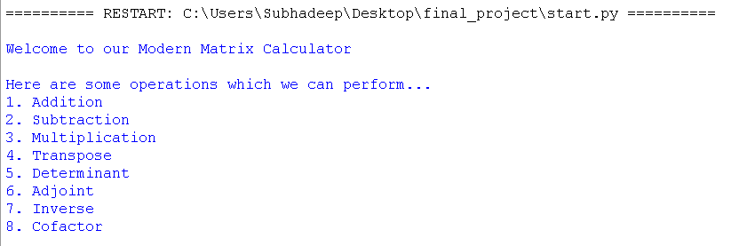

**Step – 2:**

In the next step it will ask you the operation you want to perform and to enter the rows and columns needed for the operation.

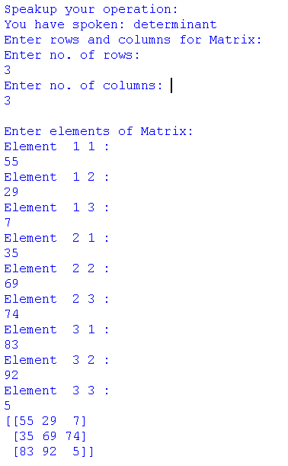

**Step – 3:**

Now you have to speak up each element in matrix then it will form the matrix and perform the operation which you have mentioned and gives you the correct output.

