GSM Passive Interception
Bands:
Frequency bands usually found in the 900 MHz or 1800 MHz bands (some countries use 850 MHz and 1900 MHz or very rarely 400 MHz and 450 MHz if these frequencies were already allotted).
Recognition:
Multiple distinct lines across waterfall at regular intervals (approximately 200Khz wide).
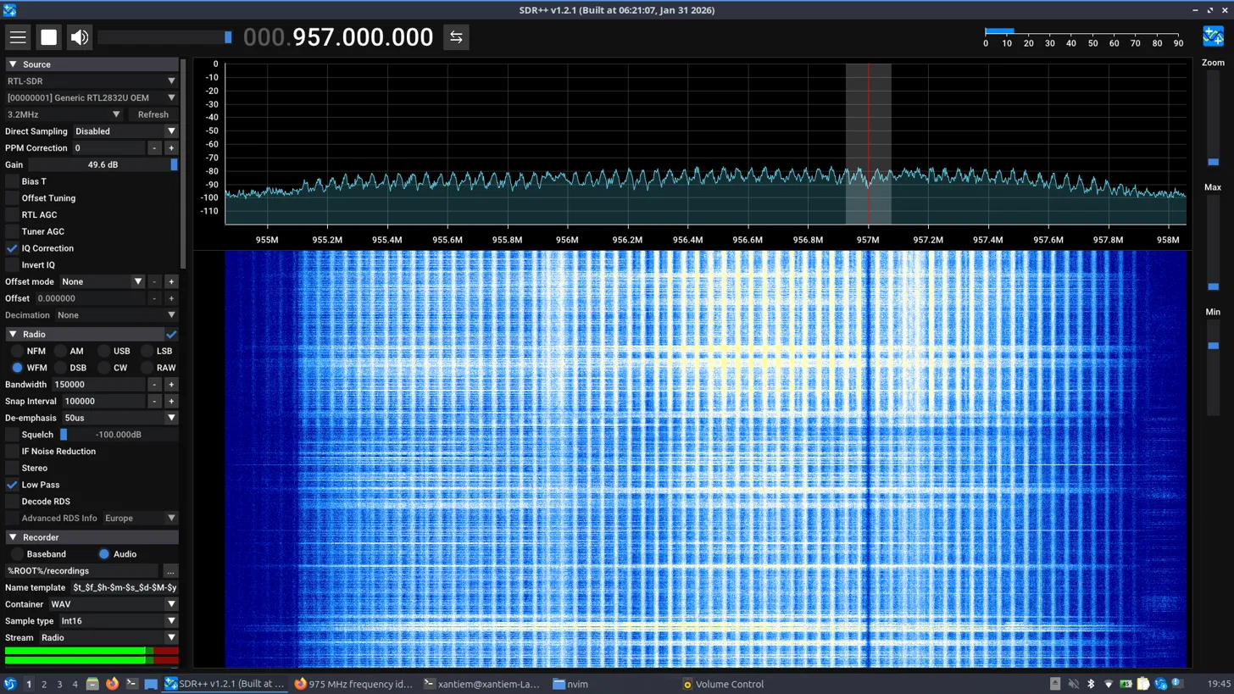
Individual waterfalls do not sound that different from dial-up.
Technical breakdown:
Each signal is divided into time-slots for each phone. This allows for eight full-rate or sixteen half rate speech channels per radio frequency. These burst periods (timeslots) are grouped into a TDMA frame while half-rate channels use alternate frames in the same timeslot. Channel data rate for all 8 channels is 270.833 kbit/s and the frame duration is 4.615 ms.
Reception and decryption:
The gr-gsm package provides utilities. Needed to retrieve signal.
Scanning mode: grgsm_scanner
Use the -h flag for help. This includes available frequency bands.
> grgsm_scanner -b GSM900 -g 49
Try scan CCCH on 975-1023 arfcn`s: Scanning: 0.00% done..
Found CCCH arfcn: 977
ARFCN: 977, Freq: 925.6M, CID: 34694, LAC: 1303, MCC: 206, MNC: 20, Pwr: -43
|---- Configuration: 1 CCCH, not combined
|---- Cell ARFCNs: 978, 979, 980, 1018, 1019, 1020
|---- DCCHs:
|-------- #1 SDCCH/8, Timeslot: 2, Training Sequence: 2, MAIO: 0, HSN: 0, A5/1 Version: ?, this CCCH is not present in hopping list | possible signal imposition
|---- Neighbour Cells: 787, 788, 789, 883, 884, 885, 975, 976, 977, 1021, 1022, 1023

Live reception mode: grgsm_livemon
Live decoding of a GSM signal. Help available via -h flag. Graphical mode pictured below:
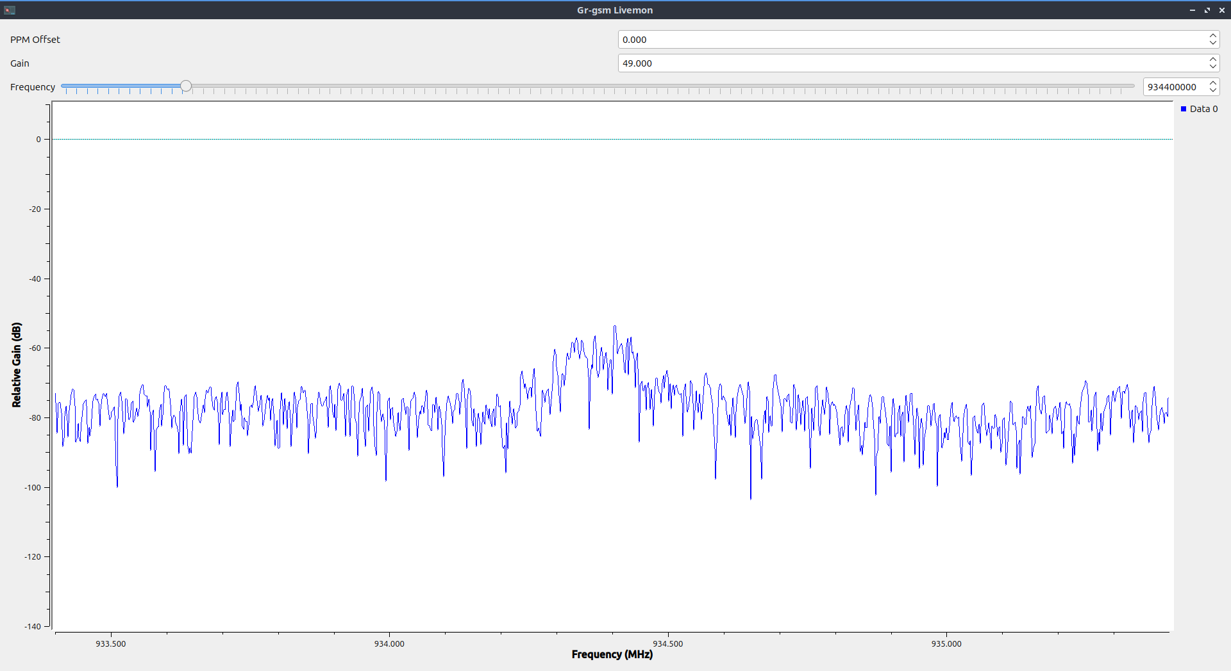
>grgsm_livemon -f 934400000 -g 49
00 00 00 00 00 00 00 00 00 00 00 00 08 00 45 00
00 43 36 e3 40 00 40 11 05 c5 7f 00 00 01 7f 00
00 01 92 4a 12 79 00 2f fe 42 02 04 01 00 03 fd
d1 00 00 0c ec 54 02 be 04 bb 15 06 21 00 01 f0
2b 30 2b 2b 2b 2b 2b 2b 2b 2b 2b 2b 2b 2b 2b 2b
2b

This can then be decoded by Wireshark:
>sudo wireshark -k -Y 'gsmtap' -i lo

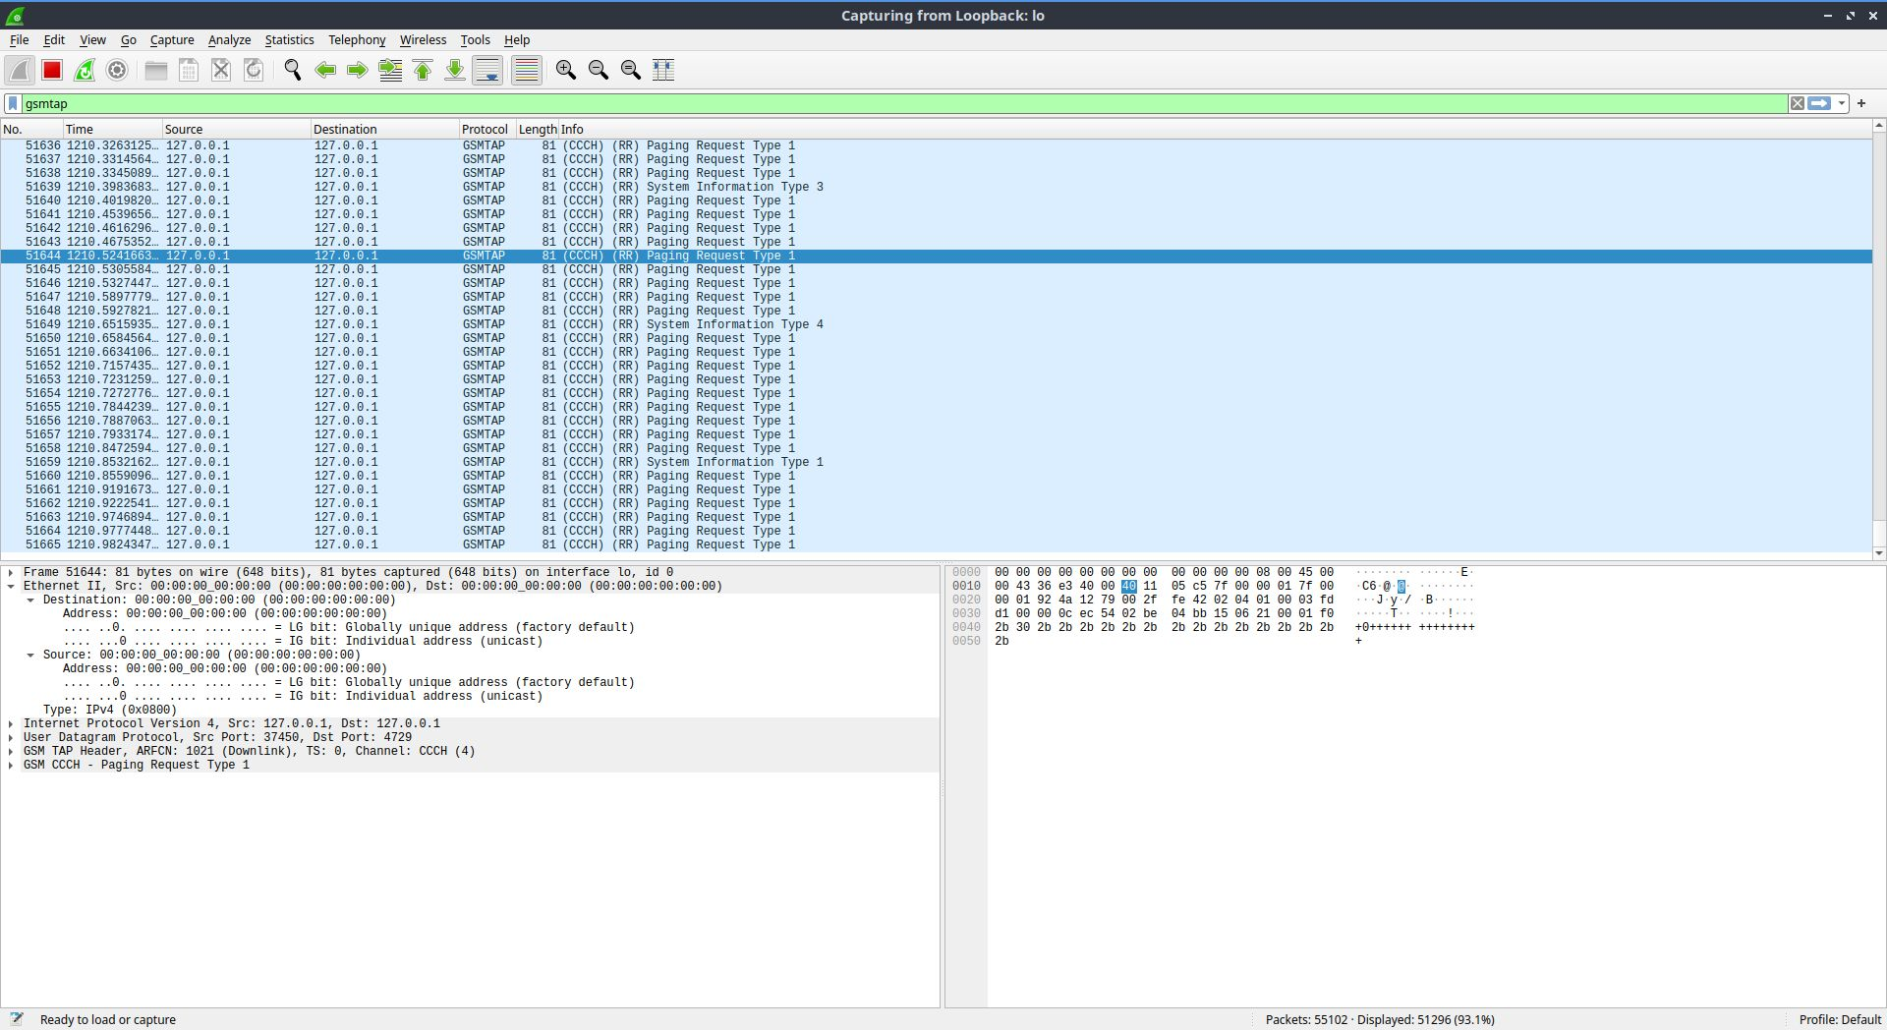
Values can be read from within wireshark itself.
Saving to file: grgsm_capture
Example: grgsm_capture -f 935.2M -o capture.cfile
Use -h flag for options.
Decoding from file: grgsm_decode
grgsm_decode -c capture.cfile -f 935.2M -s 2e6 –cch
Wireshark can then be used for analysis.
Flag | Channel | Decodes
--cch | Control Channels | BCCH, CCCH, SCH, FCCH (broadcasting and paging)
--sdcch | Standalone Dedicated Control Channel | Per-device signalling, SMS, call setup, authentication
--tch-f | Traffic Channel Full-rate | Full-rate voice (13kbps codec)
--tch-h | Traffic Channel Half-rate | Half-rate voice (6.5kbps codec)
--pacch | Packet Associated Control Channel | GPRS control
--pdtch | Packet Data Traffic Channel | GPRS data bursts

Resources:
Wikipedia: GSM
Wikipedia: TDMA
Wikipedia: GSM frequency bands
Github: gr-gsm
Scribd: GSM System Information Details

