Treball de Fi de Màster

Màster en Neuroenginyeria i Rehabilitació

Generation of real-time control commands from EEG signals

REPORT

Author: Ferran Franco i Moral
Director: Joan Francesc Alonso López
Co-director: Andres El-Fakdi Sencianes
Co-director: Alicia Casals Gelpí
Date: February 2025



Escola Tècnica Superior
d’Enginyeria Industrial de Barcelona


Resum
Les interfícies cervell-ordinador (BCI) han estat investigades durant dècades pel seu potencial per controlar dispositius a través del monitoratge de l'activitat cerebral. En particular, els sistemes BCI basats en Motor Imagery (MI) han demostrat una gran efectivitat en el camp de la neurorehabilitació, ja que els patrons cerebrals generats són similars als produïts durant els moviments reals. En aquest context, aquest treball proposa un protocol per a l’adquisició i anàlisi de dades BCI utilitzant el dispositiu Bitbrain Hero Helmet.
El projecte de final de màster forma part del projecte POSMOFYA, acrònim de la Plataforma Híbrida Órtesis-Silla para hacer compatible la Movilidad, Funcionalidad y Aceptabilidad de aplicación en entornos domésticos. Aquest projecte es centra en l’automatització d’una cadira de rodes, controlada mitjançant seguiment ocular (eye tracking), i en l’ús dels resultats obtinguts en aquest treball per permetre el control d’un braç robòtic integrat. Aquesta funcionalitat inclou la capacitat de canviar entre diferents modes de funcionament, com ara la conducció, la inclinació de la cadira o el moviment del braç robòtic.
Aquest projecte es divideix en diverses fases. La primera consisteix en el disseny d’un experiment que utilitza el programari PsychoPy i LabStreaming Layer (LSL) per dur a terme sessions d’adquisició de senyals MI de dues classes: la flexió del canell dret i la flexió del braç esquerre. S’han realitzat 10 sessions de 40 repeticions cadascuna per a cada hemisferi cerebral, amb l’objectiu d’extreure característiques de les senyals per entrenar un sistema de Machine Learning (ML). Aquest sistema ha de ser capaç de reconèixer, en temps real i amb una certesa suficient, les intencions de moviment per controlar la cadira de rodes del projecte POSMOFYA.
Els resultats mostren que l'algorisme d'Arbre de Decisió, aplicat a les característiques generades a través de Common Spatial Patterns (CSP), va obtenir una precisió de validació del 42,9% en la classificació de senyals en mode offline, reflectint els desafiaments de la classificació de motor imagery basada en EEG i la gran variabilitat entre sessions. Per a les característiques basades en la literatura, el KNN va assolir una precisió lleugerament superior del 51,0%, però les matrius de confusió van indicar prediccions esbiaixades cap a una sola classe, demostrant una discriminació limitada de les característiques. Tot i que el codi de proves online era funcional, les baixes precisions van limitar-ne l'aplicació pràctica, i els resultats es van excloure per la seva manca d'informació rellevant. Aquestes troballes destaquen la necessitat de millorar els sistemes EEG i les tècniques d'aprenentatge automàtic per augmentar-ne la fiabilitat.

Resumen
Las interfaces cerebro-ordenador (BCI) han sido investigadas durante décadas por su potencial para controlar dispositivos mediante el monitoreo de la actividad cerebral. En particular, los sistemas BCI basados en motor imagery (MI) han demostrado ser altamente efectivos en el ámbito de la neurorrehabilitación, ya que los patrones cerebrales generados son similares a los producidos durante los movimientos reales. En este contexto, este trabajo propone un protocolo para la adquisición y el análisis de datos BCI utilizando el dispositivo Bitbrain Hero Helmet.
El proyecto de fin de máster forma parte del proyecto POSMOFYA, acrónimo de la Plataforma Híbrida Órtesis-Silla para hacer compatible la Movilidad, Funcionalidad y Aceptabilidad de aplicación en entornos domésticos. Este proyecto se centra en la automatización de una silla de ruedas, controlada mediante seguimiento ocular (eye tracking), y en el uso de los resultados obtenidos en este trabajo para permitir el control de un brazo robótico integrado. Esta funcionalidad incluye la capacidad de cambiar entre diferentes modos de funcionamiento, como la conducción, la inclinación de la silla o el movimiento del brazo robótico.
Este proyecto consta de varias fases. La primera consiste en el diseño de un experimento que emplea el software PsychoPy y LabStreaming Layer (LSL) para realizar sesiones de adquisición de señales MI de dos clases: la flexión de la muñeca derecha y la flexión del brazo izquierdo. Se han realizado 10 sesiones de 40 repeticiones cada una por cada hemisferio cerebral, con el objetivo de extraer características de las señales y entrenar un sistema de Machine Learning (ML). Este sistema debe ser capaz de reconocer, en tiempo real y con una precisión suficiente, las intenciones de movimiento para controlar la silla de ruedas del proyecto POSMOFYA.
Los resultados muestran que el algoritmo de Árbol de Decisión, aplicado a las características generadas a través de Common Spatial Patterns (CSP), alcanzó una precisión de validación del 42,9% en la clasificación de señales en modo offline, reflejando los desafíos de la clasificación de imaginación motora basada en EEG y la alta variabilidad entre sesiones. Para las características basadas en la literatura, el KNN logró una precisión ligeramente superior del 51,0%, pero las matrices de confusión indicaron predicciones inclinadas hacia una sola clase, demostrando una discriminación limitada. Aunque el código de pruebas online era funcional, las bajas precisiones limitaron su aplicación práctica, y los resultados se excluyeron por su falta de valor informativo. Estos hallazgos subrayan la necesidad de mejorar los sistemas EEG y las técnicas de aprendizaje automático para incrementar la fiabilidad.

Abstract
Brain-computer interfaces (BCIs) have been studied for decades for their potential to control devices by monitoring brain activity. Specifically, MI-based BCI systems (motor imagery) have proven highly effective in the field of neurorehabilitation, as the brain patterns generated closely resemble those produced during actual movements. In this context, this work proposes a protocol for BCI data acquisition and analysis using the Bitbrain Hero Helmet device.
The master’s thesis is part of the POSMOFYA project, an acronym for the Hybrid Platform of Orthosis-Wheelchair to ensure compatibility of Mobility, Functionality, and Acceptability for use in domestic environments. This project focuses on automating a wheelchair controlled through eye tracking and applying the results obtained in this work to enable control of an integrated robotic arm. This functionality includes the ability to switch between different operating modes, such as driving, adjusting the wheelchair’s tilt, or moving the robotic arm.
This project consists of several phases. The first phase involves designing an experiment using PsychoPy software and LabStreaming Layer (LSL) to conduct sessions for acquiring MI signals of two classes: right wrist flexion and left arm flexion. A total of 10 sessions with 40 repetitions each were conducted for each brain hemisphere to extract signal features and train a Machine Learning (ML) system. This system must be able to recognize movement intentions in real time with sufficient accuracy to control the POSMOFYA project’s wheelchair.
The results show that the Decision Tree algorithm, applied to Common Spatial Patterns (CSP) features, achieved a validation accuracy of 42.9% in offline signal classification, reflecting the challenges of EEG-based motor imagery classification and high variability across sessions. For literature-based features, the KNN algorithm reached a slightly higher accuracy of 51.0%, but confusion matrices indicated most predictions were skewed toward a single class, demonstrating limited feature discriminability. Although online testing code was functional, the models' low accuracies limited practical application, and the results were excluded as they provided little insight. These findings highlight the need for improved EEG systems and machine learning techniques to enhance reliability.

Contents
Resum 3
Resumen 4
Abstract 5
Contents 7
Glossary 10
List of figures 11
List of tables 13
1. Preface 15
1.1. How the project originated 15
1.2. Motivation 15
2. Introduction 16
2.1. Problem Statement 16
2.2. Justification 16
2.3. Scope 17
2.4. Prerequisites 17
2.5. Objectives 18
3. Theoretical Framework 19
3.1. Movement-Limiting Disorders 19
3.2. Electroencephalography (EEG) 19
3.2.1. Frequency Bands 20
3.2.2. 10-20 system 21
3.3. Brain-Computer Interfaces (BCI) 22
3.4. Overview of Motor Imagery-Based BCIs 23
3.4.1. Challenges in MI signal Classification 23
3.4.2. Dry EEG Systems in BCIs 23
3.4.3. Applications in Assistive Technologies 24
3.5. Key Features 24
3.5.1. Generic Features based on Literature 24
3.5.2. Common Spatial Patterns (CSP) 26
3.5.3. Limitations 26
3.6. Lab Streaming Layer (LSL) protocol 28
3.7. PsychoPy 30
4. Methodology and Equipment 31
4.1. Participants 31
4.2. Experimental Design 31
4.3. Signal Acquisition 32
4.4. Experimental paradigm 32
4.4.1. Software 33
4.5. EEG Preprocessing 40
4.6. Feature extraction 41
4.6.1. Literature based features 41
4.6.2. Common Spatial Patterns 41
4.6.3. Summary of Feature Extraction Implementation 42
4.7. Machine Learning Analysis 43
4.7.1. Features Based on Literature 43
4.7.2. Common Spatial Patterns 45
5. Results 47
5.1. Literature-Based Features 47
5.1.1. Data Overview 47
5.1.2. Feature Extraction and Analysis 48
5.1.3. Classification Results 51
5.2. Common Spatial Patterns (CSP) 54
5.2.1. Data Overview 54
5.2.2. Feature Extraction and Analysis 54
5.2.3. Classification Results 56
6. Discussion and Future Work 59
6.1. Literature-based Features 59
6.2. Common Spatial Patterns (CSP) 60
6.3. Comparison of Classifier Performance 60
7. Limitations 62
8. Planning 63
9. Environmental impact analysis 64
10. Economic analysis 65
11. CONCLUSIONS 66
12. Acknowledgments 67
13. Bibliography 68
14. Additional bibliography 75

Glossary
TFM Treball fi de grau (Final Master Thesis in Catalan)
EEG Electroencephalography
BCI Brain-Computer interface
MI Motor Imagery
ICA Independent Component Analysis
SCI Spinal cord injury
ALS Amyotrophic lateral sclerosis
LSL Lab streaming layer
ML Machine learning
SVM Support vector machine
KNN K-Nearest Neighbors
RMS Root Mean Square
PTP Peak-to-Peak Amplitude
LZ Lempel-Ziv Complexity
POSMOFYA Plataforma Híbrida Órtesis-Silla para hacer compatible la Movilidad, Funcionalidad y Aceptabilidad de aplicación en entornos domésticos.
PNS Peripheral Nervous System
CNS Central Nervous System
SCI Spinal Cord Injury
LAN Local Area Network
NTP Network Time Protocol
XDF Extensible Data Format

List of figures
Fig 1. EEG rhythms [25] …………………………………………………………………… 19
Fig 2. 10-20 system [27] …………………………………………………………………… 20
Fig 3. Brain-Computer Interface scheme [35] ……………………………………………. 21
Fig 4. Lab Streaming Layer (LSL) Workflow. …………………………………………….. 27
Fig 5. Lab Recorder interface ..…………………………………………………………….. 28
Fig 6. BitBrain Hero Helmet ………………………………………………………………… 31
Fig 7. Wrist flexion and extension [65] …………………………………………………….. 32
Fig 8. PsychoPy pipeline followed to obtain EEG MI data in this project ………………. 33
Fig 9. Images that can appear on the task from the PsychoPy pipeline that has been followed. …………………………………………………………………………………….... 34
Fig 10. PsychoPy routine blocks …………………………………………………………… 35
Fig 11. PsychoPy pipeline followed to obtain resting-state EEG data in this project ….. 36
Fig 12. Images that can appear on the task from the PsychoPy pipeline that has been followed for resting-state…………………………………………………………………….. 37
Fig 13. Bitbrain Viewer app main screen visualization ………………………………….. 38
Fig 14. Histogram and Box plot of RMS by side………………………………………….. 47
Fig 15. Histogram and Box plot of PTP by side…………………………………………… 47
Fig 16. Histogram and Box plot of alpha power by side ………………………………… 48
Fig 17. Histogram and Box plot of beta power by side ………………………………….. 48
Fig 18. Histogram and Box plot of sample entropy by side ………………………………49
Fig 19. Histogram and Box plot of permutation entropy by side ………………………… 49
Fig 20. Training vs Validation Metrics comparison for Literature Based features …….. 51
Fig 21. Training vs Validation ROC Curves comparison for Literature Based features . 52
Fig 22. Class Distribution in Training Data ………………………………………………... 53
Fig 23. Training CSP Feature Distribution ………………………………………………… 54
Fig 24. Comparison of CSP Feature Distributions (Training vs. Validation) …………… 54
Fig 25. Training vs Validation Metrics comparison for CSP Features ………………….. 56
Fig 26. Training vs Validation ROC Curves comparison for CSP features ……………. 57
Fig 27. KNN confusion matrices comparison between Training (left) and Validation (right) for Literature-based features ………………………………………………………………. 60
Fig 28. DT confusion matrices comparison between Training (left) and Validation (right) for CSP-based features ……………………………………………………………………. 60
Fig 29. Gantt chart showing the achieved timeline for this project …………………….. 62

List of tables
Table 1. Commonly used EEG features for BCI systems based on MI [43,44,45,46,47,48] …………………………………………………………………….................................. 23.
Table 2. Interesting PsychoPy features [57, 58] …………………………………….. 29
Table 3. Machine Learning Classifiers on training dataset for Literature based features ……………………………………………………………………………………………. 50
Table 4. Machine Learning Classifiers on validation dataset for Literature based features ……………………………………………………………………………………………. 51
Table 5. Machine Learning Classifiers on training dataset for CSP features …….. 55
Table 6. Machine Learning Classifiers on validation dataset for CSP features ….. 56
Table 7. Personal costs of the study …………………………………………………. 64
Table 8. Software costs ……………………………………………………………….. 64
Table 9. Material costs ………………………………………………………………... 64
Table 10. Office related costs ………………………………………………………… 64

Preface
This preface is written in the first person to provide readers with insights into the origins and motivations behind this Master's thesis. Sharing my journey aims to clarify the challenges and aspirations that shaped this work.

How the project originated
During my Master's program in Neuroengineering and Rehabilitation at the Universitat Politècnica de Catalunya (UPC), I became fascinated by the intersection of neuroscience and assistive technologies. My studies highlighted the potential of brain-computer interfaces (BCIs) to enhance mobility for individuals with disabilities.
At the Tecsalut laboratory, under the guidance of Professors Alicia Casals and Andrés El-Fakdi Sencianes (who was at that time collaborating with the laboratory), and in coordination with Professor Joan Francesc Alonso, I had the opportunity to contribute to the POSMOFYA project—a Hybrid Platform of Orthosis-Wheelchair designed for domestic environments. This innovative initiative focused on integrating wheelchair and robotic arm control through advanced technologies such as eye-tracking and brain-computer interfaces (BCI). The experience allowed me to apply classroom knowledge to practical research, deepening my enthusiasm for cutting-edge technological solutions in assistive devices.

Motivation
Motor Imagery (MI)-based BCIs are transformative for neurorehabilitation and assistive devices, enabling users to control systems through imagined movements. Advances like the dry EEG Bitbrain Hero Helmet [1] make such systems more accessible, despite challenges in signal quality.
As part of POSMOFYA project, this thesis seeks to address key issues of autonomy and adaptability in assistive technologies. By advancing hybrid systems for mobility and functionality, it aspires to improve the quality of life for individuals with severe motor impairments through the use of accessible technologies like the Bitbrain Hero Helmet, aiming to develop a reliable and fast BCI system.

Introduction
Brain-Computer Interfaces (BCIs) are transformative systems that enable users to interact with external devices using brain activity [2]. These systems interpret neural signals, often via electroencephalography (EEG) and is often combined with AI-powered algorithms that are able to obtain brain states to execute multiple tasks such as speller programs [3], virtual games, and wheelchairs [4,5] among other assistive devices [6]. BCIs hold significant potential to restore autonomy and improve quality of life for individuals with severe motor impairments.

Problem Statement
Despite significant advancements, BCI technology still faces substantial challenges that limit its widespread adoption. One primary issue is the variability in EEG signal quality, which can differ across sessions and users, affecting the system’s reliability [7,8]. Additionally, real-time signal processing and adaptability to diverse user needs remain critical obstacles. These limitations are particularly pronounced when integrating BCIs into domestic environments, where robustness and ease of use are essential [9].
Furthermore, accessibility is another major barrier. While BCIs offer immense potential for improving the lives of individuals with conditions such as amyotrophic lateral sclerosis (ALS), strokes, and high spinal cord injuries, the cost and complexity of these systems often prevent their adoption on a larger scale [10]. Lastly, user adaptability to these systems requires improvements in interface design and feedback mechanisms to ensure sustained engagement and ease of operation [11].
This project addresses these challenges within the framework of the POSMOFYA initiative by leveraging Motor Imagery (MI)-based BCIs. The goal is to develop a hybrid platform that integrates wheelchair and robotic arm control, focusing on enhancing signal processing, user adaptability, and system robustness. By tackling these challenges, this project aims to make BCI technologies more practical and impactful in real-world scenarios.

Justification
Given the variability in EEG signal quality, the question arises as to whether it is possible to create a BCI system with Dry EEG helmets. Dry EEG helmets have been actively researched by multiple studies trying to find if this technique can be able to provide good results compared with wet EEG helmets [11,12,13].
In addition to addressing the limitations of dry EEG systems, this project is justified by the growing demand for non-invasive, portable, and user-friendly solutions in neurorehabilitation and assistive technologies [14]. Wet EEG helmets, while providing high-quality signals, require labour-intensive preparation and maintenance, limiting their applicability in daily life scenarios and large-scale implementations [15]. Dry EEG systems offer a practical alternative by significantly reducing setup time and enabling broader adoption, provided their performance can be optimized [15].

Scope
The scope of this project is to develop and validate a dry EEG-based BCI system that serves as an additional control tool for the POSMOFYA initiative. This system is designed to demonstrate acceptable accuracy in performing MI tasks, with the long-term aim of integrating and testing it on the actual POSMOFYA wheelchair. Temporally, the project spans from initial algorithm design to experimental validation within controlled environments. The spatial application focuses on assistive device integration, ensuring compatibility with existing POSMOFYA components.
Technologically, the project emphasizes optimizing signal processing and machine learning techniques to address the inherent limitations of dry EEG helmets. While this work does not extend to hardware production or large-scale deployment, it aims to establish a scalable framework for future real-world applications. By focusing on usability and adaptability, this project seeks to pave the way for more accessible and effective BCI-driven assistive technologies.

Prerequisites
Several prerequisites were established to ensure the project’s feasibility and success:
- Equipment Selection: The Bitbrain Hero Helmet was chosen for its dry electrode technology, which simplifies setup while providing high-resolution EEG signal acquisition. Utilizing dry electrode technology offers an economical and efficient solution to the problem being addressed.

- Software Tools: PsychoPy was selected for experiment design, while the LabStreaming Layer (LSL) was employed for synchronized data collection and streaming.
- Signal Processing Knowledge: Familiarity with EEG preprocessing techniques, such as filtering, artifact removal, and feature extraction methods (e.g., Event-Related Desynchronization (ERD) and Event-Related Synchronization (ERS)), was essential. This expertise was acquired during the Master’s program in Neuroengineering and Rehabilitation, with this project serving as the final master’s thesis.
- Machine Learning Expertise: Familiarity in implementing classifiers for real-time signal decoding was crucial, with a focus on algorithms suitable for EEG data, such as Support Vector Machines (SVMs) and neural networks.

Objectives
In this exploratory project, the goal is to develop a robust BCI system using a dry EEG helmet to contribute to the POSMOFYA project. The specific objectives are:
- Signal Acquisition and Analysis: Design a protocol for acquiring and analysing motor imagery (MI) data using the Bitbrain Hero Helmet, focusing on two movement classes: right wrist flexion and left wrist flexion.
- Machine Learning Integration: Implement a machine learning pipeline for real-time classification of MI signals, ensuring accurate and reliable predictions for control tasks.
- Usability and Practicality: Demonstrate the feasibility of using dry electrode EEG systems in practical applications by optimizing setup efficiency without compromising signal quality, paving the way for integration with the POSMOFYA wheelchair in future iterations.

Theoretical Framework
This chapter provides a thorough overview of the foundational knowledge essential for understanding the research conducted in this work. It begins by defining neuromuscular disorders and exploring the tools designed to address the movement limitations they impose. The discussion then shifts to the principles of EEG, its role in Brain-Computer Interfaces (BCI), and the significance of Motor Imagery (MI). Furthermore, the chapter examines the tools and methodologies employed in BCI development, along with the key features integral to working with MI and BCI systems.

Movement-Limiting Disorders
Movement disorders represent a complex group of neurological conditions encompassing a wide spectrum of impairments, ranging from reduced movement (hypokinesia) to excessive movement (hyperkinesia) [16]. While Parkinson’s disease is often regarded as the classical example of movement disorder, many other pathologies fall within this category. For instance, Huntington’s disease, a condition with a strong genetic basis, also qualifies as a movement disorder [16].
In addition to these classic examples, conditions such as spinal cord injury (SCI) can also be classified as movement-limiting disorders. SCI involves a lesion to the spinal cord resulting from causes such as falls, motor vehicle accidents, or acts of violence. These injuries lead to varying degrees of dysfunction in sensory, motor, and autonomic functions due to the partial or complete loss of communication between the brain and body regions below the site of injury [17,18,19]. SCI is further associated with a range of secondary complications of varying severity, significantly affecting quality of life and contributing to increased morbidity and mortality [17,19].

Electroencephalography (EEG)
Electroencephalography (EEG) is a non-invasive neurophysiological method that measures the brain's electrical activity through electrodes placed on the scalp. It captures the synchronous firing of large populations of neurons, offering a temporally precise measure of brain function with millisecond resolution [20].
Despite the development of advanced imaging techniques, EEG remains a cornerstone in clinical and research applications. It is indispensable for evaluating seizures, distinguishing seizure types, and investigating conditions that mimic seizures. Additionally, it is employed in assessing comatose patients, monitoring encephalopathies, and exploring sensory, perceptual, and cognitive processes. [21]
The electrical properties of the brain were first discovered by English scientist Richard Caton in 1875, and approximately 50 years later, German psychiatrist Hans Berger recorded the first human EEG, marking a pivotal advancement in neuroscience [22, 23].

Frequency Bands
The frequency range of interest in EEG recordings typically spans from 0.5 to 30 Hz. Since the early use of this technology, five frequency rhythms have been identified as being associated with different types of brain activity [24].
- Delta rhythm (0.5–4 Hz): Characterized by high-amplitude waves, these are typically observed in infants or during slow-wave sleep in adults.
- Theta rhythm (4–8 Hz): Linked to drowsiness in adults and teenagers, this rhythm is more pronounced in children. It is also associated with pleasurable states and is predominantly found in the parietal and temporal lobes.
- Alpha rhythm (8–13 Hz): Present in awake, relaxed individuals, this rhythm is associated with eye closure and brain-wide inhibition control. When occurring over the motor cortex, it is referred to as the mu rhythm, which is notably suppressed during motor actions.
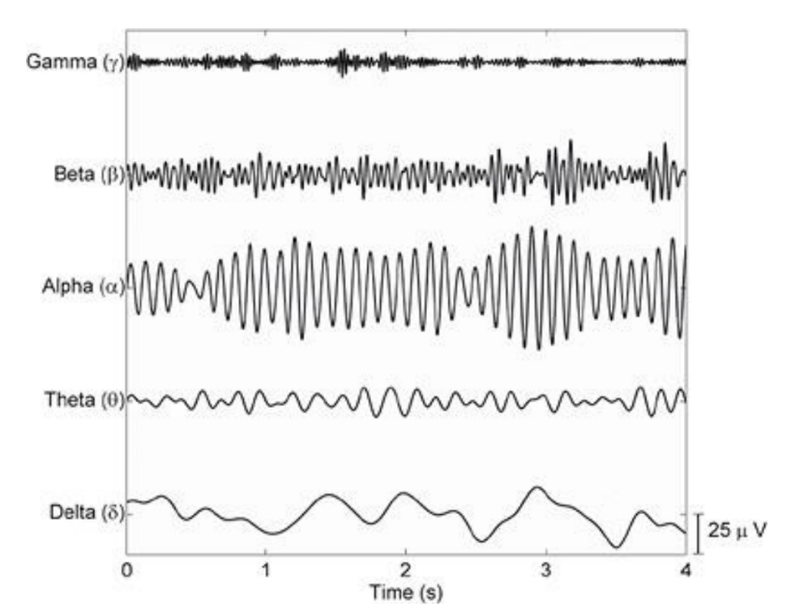
- Beta rhythm (13–30 Hz): Active during states ranging from calm alertness to mild obsessive focus, this rhythm is associated with active thinking, attention, focus, and both physical and high-concentration activities.
Fig 1. EEG rhythms [25]

10-20 system
The 10-20 system is a globally recognized standard for electrode placement on the scalp. Its primary purpose is to provide a standardized approach to EEG acquisition, ensuring studies can be consistently reproduced and accurately analysed [26].
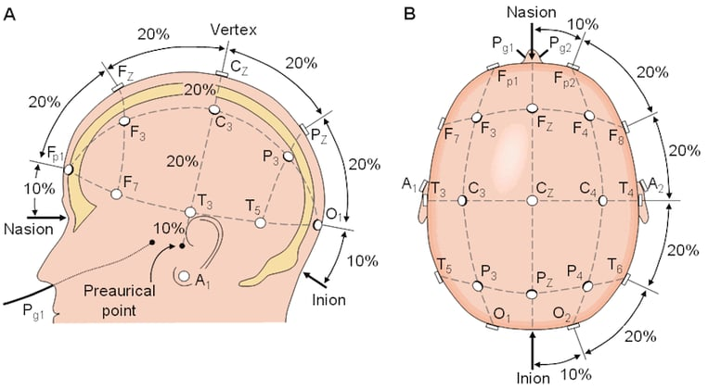
The numbers "10" and "20" refer to the percentage distances between adjacent electrodes, measured relative to the total front-to-back or right-to-left span of the head. See Fig. 2.
Fig 2. 10-20 system [27]
In addition to the 10-20 system, several other electrode placement systems are used for EEG recordings, depending on the desired spatial resolution and application [28]:
- 10-10 System: An extension of the 10-20 system, offering higher resolution with 81 positions for more detailed scalp coverage.
- 10-5 System: A further refinement of the 10-10 system, providing even more electrode positions for enhanced precision.
- High-Density Systems: These include setups like the EGI 64 and 128-channel Geodesic Sensor Nets, designed for advanced studies requiring detailed spatial resolution.
- Customizable Placement: Tailored electrode arrangements are used in specific research or clinical applications, particularly in neurotechnology.
- Ear-Based Systems: Specialized setups focused on detecting frequency components using sensors placed in or around the ears.
These systems allow for flexibility and precision tailored to the specific needs of various EEG studies and applications.

Brain-Computer Interfaces (BCI)
A brain-computer interface (BCI) system establishes a direct communication pathway between the brain and an external device [29]. These systems have been under development for decades, with the choice of BCI technology largely dictated by its intended application [30]. Among the non-invasive BCI paradigms reported in the literature, the most prominent and effective approaches are based on evoked responses (P300), steady-state visually evoked potentials (SSVEP), and motor imagery (MI) [31]. Despite this, research focusing on EEG-based MI for lower limb movements in BCI-controlled applications remains relatively limited [32, 33]. Many such studies have been confined to offline scenarios due to the complexities involved in the movements and the experimental setups, which often generate EEG signals that differ significantly from those obtained in realistic online environments [34].
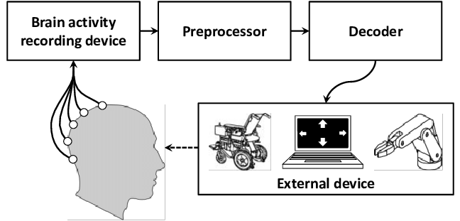
Fig 3. Brain-Computer Interface scheme [35]
BCI operates following four main stages [36]:
  - Signal Acquisition and Pre-Processing: Brain signals are recorded using sensors and amplified to prepare them for further processing. Filtering may also be applied to enhance desirable characteristics and reduce noise.
  - Feature Extraction and Selection: The recorded signals are analysed to identify specific features that correlate with the user’s intended actions.
  - Feature Translation: These extracted features are then transformed into actionable commands for the output device.
  - Control Interface: The operation of the device provides feedback to the user, creating a closed-loop control system.

Overview of Motor Imagery-Based BCIs
Motor Imagery (MI) is a mental process where individuals simulate motor movements without physically executing them. This mental rehearsal triggers similar neural patterns to those of actual movements, which can be captured non-invasively using EEG. MI-based BCIs have demonstrated immense potential in enabling motor rehabilitation, enhancing neuroplasticity, and providing control mechanisms for robotic systems [37, 38]​​.
Key elements of MI-based BCIs include:
- Event-Related Desynchronization (ERD) and Synchronization (ERS): These neural patterns, detectable through EEG, serve as biomarkers for motor intention and are crucial for feature extraction​​ [38, 39].
- Machine Learning for Classification: Modern approaches employ deep learning and traditional classifiers to decode MI signals. Deep learning methods, such as Convolutional Neural Networks (CNNs), have shown promising results in handling EEG's high-dimensional and noisy nature [39]​.

Challenges in MI signal Classification
Despite significant advancements, several challenges persist:
- Noise and Artifacts: EEG signals are highly susceptible to artifacts from muscle movements, eye blinks, and environmental factors​ [39].
- Inter-subject Variability: Differences in neural patterns across individuals necessitate robust and generalizable classifiers ​​[37,39].
- Real-Time Processing: Achieving low-latency and accurate signal decoding is critical for practical applications​ [38].
This project builds upon these theoretical foundations, leveraging advancements in EEG technology and machine learning to address these challenges and push the boundaries of MI-based BCI applications.

Dry EEG Systems in BCIs
The transition from wet to dry EEG systems addresses several challenges in practical applications, such as setup complexity and user comfort. Studies have highlighted the feasibility and accuracy of dry systems, demonstrating their capability in capturing MI-related signals​ [38]. These systems ensure portability and ease of use, making them suitable for real-world environments​ [40].

Applications in Assistive Technologies
MI-based BCIs are increasingly used in assistive technologies, particularly for controlling robotic wheelchairs and arms. The integration of BCIs with mobility solutions has been extensively researched, with emphasis on real-time control, adaptability, and user acceptance [39, 40]​​. For instance, EEG-based control systems have been deployed in navigating real-world environments and performing complex tasks like object manipulation using robotic arms [38, 39]​​.

Key Features
Understanding the core features of BCI systems is crucial for their effective design and application. To develop a functional and accurate BCI system, specific features must be selected to serve as input for machine learning algorithms. This section is divided into two subsections: the first addresses Generic Features based on Literature, emphasizing commonly recognized characteristics and methodologies reported in academic research. The second explores into Common Spatial Patterns (CSP), a widely adopted technique for feature extraction and classification in BCI systems [41, 42]. Together, these subsections provide a comprehensive foundation for selecting and utilizing features essential for building robust BCI systems.

Generic Features based on Literature
The success of BCI systems in MI tasks relies on the ability to identify and extract robust EEG features. These features, can be drawn from time, frequency and entropy domains and they offer significant insights into neural activity. Many papers appeared on the last years trying to find which are or could be some of the most interesting features to study MI and have a successful BCI system [43,44,45,46,47,48]. Here are some of the most commonly used features:
Table 1. Commonly used EEG features for BCI systems based on MI [43,44,45,46,47,48].
Features | Definition
Time domain Features
Root Mean Square (RMS) | Provides an estimate of the signal’s amplitude and is used to evaluate overall signal strength [43,44].
Peak-to-Peak Amplitude (PTP) | Assesses amplitude variability, aiding in identifying neural activity differences across MI states [44,45].
Fractal Dimension (FD), Hurst Exponent, Skewness and Kurtosis | These metrics measure the complexity and statistical properties of EEG signals, essential for distinguishing MI patterns [43,46].
Frequency Domain Features
Delta, Theta, Alpha, Beta and Gamma Power | These frequency bands are closely associated with cognitive and motor tasks, with changes observed during MI in the corresponding motor and sensory regions [44,45].
Power Spectral Density (PSD) | Commonly used to quantify event-related desynchronization/synchronization (ERD/ERS) during MI tasks [43,45].
Entropy and Complexity Features
Sample Entropy, Shannon Entropy and Permutation Entropy | These measures quantify irregularity and unpredictability in EEG, offering insights into neural dynamics using MI [44,46,47].
Lempel-Ziv Complexity | Reflects the compressibility of EEG signals, highlighting their randomness and underlying neural processing efficiency [45,46].
Advanced Feature Extraction Techniques
Common Spatial Patterns (CSP) | A widely used method for spatial filtering, CSP effectively discriminates between MI tasks by optimizing the variance of EEG signals [45,46,47].
Wavelet Transform (WT) | Often combined with CSP, WT enhances feature extraction by decomposing EEG signals into the time-frequency domain [45,46].
These EEG features have been extensively validated in various MI-based BCI frameworks, showcasing their utility in improving classification accuracy and system performance. Additionally, integrating these features into modern machine learning methods amplifies their effectiveness in real-world applications [43, 44, 45, 46].

Common Spatial Patterns (CSP)
Among the advanced techniques for EEG feature extraction, Common Spatial Patterns (CSP) stands out as one of the most powerful and widely used methods in the domain of BCIs [49]. CSP is specifically designed to extract discriminative spatial features by optimizing the variance differences between two or more classes of motor imagery tasks [49]. This optimization enables effective spatial filtering of EEG signals, often leading to significant improvements in classification accuracy for motor imagery tasks [50].
CSP operates by learning spatial filters that maximize the variance for one class while minimizing it for another. This approach emphasizes the spatial patterns most relevant to the differences in brain activity associated with the motor tasks. By transforming the EEG data into a space where these patterns are highlighted, CSP facilitates the extraction of features that are highly informative for classification [51].
Over the years, CSP has seen numerous variations and enhancements to address its limitations, such as susceptibility to noise, overfitting in high-dimensional data, and dependence on specific experimental setups.
- Filter Bank CSP (FBCSP) incorporates band-pass filtering to isolate frequency bands of interest, often improving robustness [50].
- Regularized CSP (R-CSP) applies regularization techniques to mitigate overfitting, especially in datasets with a small number of trials [51].
- Riemannian Geometry-based CSP (RG-CSP) projects covariance matrices onto a Riemannian manifold, leveraging the intrinsic geometric properties of these matrices to enhance feature extraction [51].
Recent research has also integrated CSP with deep learning frameworks to combine its feature extraction capabilities with the pattern recognition strength of neural networks. These hybrid approaches have shown promise in improving classification accuracy and reducing dependency on manual feature engineering [50].

Limitations
Firstly, the frequent use of healthy subjects in BCI studies can lead to unrealistic results, as it has been shown that target users (e.g., individuals with motor disabilities) typically perform worse [51].
Additionally, MI-BCIs require users to undergo extensive training sessions for calibration, which can become excessively time-consuming. This prolonged training often leads to fatigue, further diminishing performance, particularly in patients [52].

Although EEG is suitable for BCI systems (as discussed in Section 3.4), its standard configuration's low spatial resolution (5 to 9 cm) presents challenges for MI detection. This is because EEG primarily captures relatively rough brain signal changes. Moreover, the non-linear and artifact-prone nature of EEG signals complicates the development of robust feature extraction and selection techniques [53].
Finally, a challenge affecting BCIs broadly, including MI-BCIs, is the phenomenon of "brain illiteracy," where some users cannot achieve adequate accuracy levels [52]. This highlights the user-dependent nature of MI-BCIs, as the ability to perform motor imagery effectively varies across individuals. Bridging the performance gap between proficient and less proficient users remains a critical challenge, requiring attention to both technological improvements and human factors (e.g., elements that influence the creation of quality EEG patterns).
These challenges underscore the need for continued research in BCIs in general and MI-based BCIs in particular.

Lab Streaming Layer (LSL) protocol
The Lab Streaming Layer (LSL) protocol is an open-source system developed to facilitate real-time synchronization and the exchange of time-series data across multiple devices, particularly in neuroscience and experimental psychology research [52]. Its primary purpose is to streamline data collection and integration in multimodal setups, ensuring that different streams of data from various devices and software are seamlessly aligned in both time and content [55].
LSL enables real-time data streaming by allowing acquisition devices or software to generate data streams accompanied by metadata, such as sampling rate and channel information [54]. These streams are published to the network using “outlets”, making them discoverable by other devices on the same local area network (LAN). Once discovered, collection devices can subscribe to these streams using "inlets," allowing for a direct and continuous flow of data. To ensure precise timing, LSL assigns each data sample a timestamp based on a common clock, leveraging the Network Time Protocol (NTP) to maintain synchronization and compensate for network delays and jitter. [55,56]
It supports a wide range of programming languages, including C, C++, Python, and MATLAB, ensuring accessibility to a diverse user base, feature that has been crucial for this work. For data storage, LSL uses the Extensible Data Format (XDF), which preserves synchronization information and achieves sub-millisecond accuracy in data recording. This feature is critical for studies requiring high temporal precision [52,56].
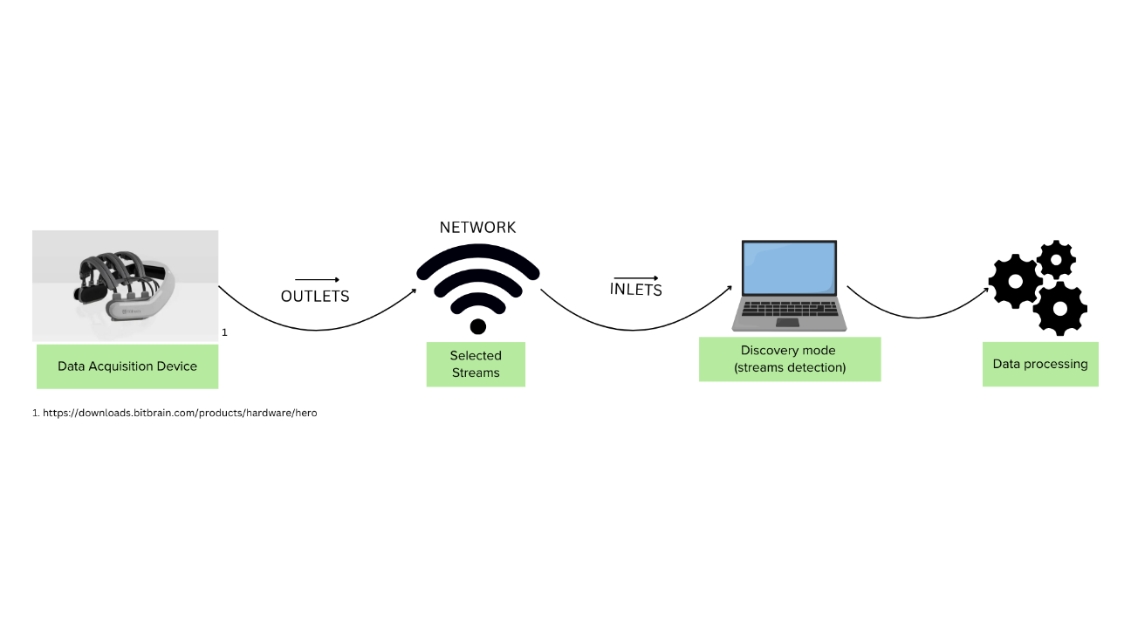
Fig 4. Lab Streaming Layer (LSL) Workflow.
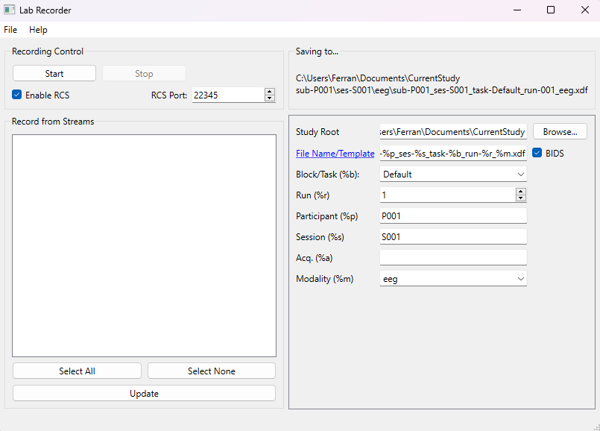
Fig 5. Lab Recorder interface.

PsychoPy
PsychoPy is a free, open-source software package developed primarily for research in neuroscience and experimental psychology. Written in Python, it leverages entirely free libraries to provide a versatile and accessible platform for designing experiments in areas such as psychophysics, cognitive psychology, and neuroscience [57, 58].
Its functionality makes it a powerful tool for experimental design and execution, offering several key features:
Table 2. Interesting PsychoPy features [57, 58]
PsychoPy Features | Explanation
Graphical Builder and Scription Options | Allows users to design experiments via an intuitive graphical interface, making it accessible to individuals without programming expertise. For more advanced designs, users can write custom Python scripts.
Stimulus Presentation | Supports the presentation of a wide range of stimuli, including images, text, audio, video, and custom dynamic stimuli, enabling diverse experimental paradigms.
Real-Time Experiment Control | Offers precise control over stimulus timing and response collection, critical for experiments in psychophysics and reaction time studies.
Integration with Hardware | Integrates seamlessly with external devices, such as eye trackers, EEG systems, and response boxes, facilitating complex experimental setups.
Data Collection and Analysis | Collects detailed response data, such as keypresses, mouse clicks, and reaction times, and outputs results in formats compatible with statistical analysis tools.

Methodology and Equipment
This section describes the experimental procedure followed in the study is described, along with details on the materials and equipment used, the protocol for the experimental sessions, and the data pre-processing, processing, and feature extraction techniques employed to explore potential outcomes. This comprehensive overview provides a structured view of how the research was carried out, ensuring that each step is clearly articulated to facilitate understanding and replication of the study.

Participants
One subject was recruited for this study: a 23-year-old male with no prior experience with electroencephalography (EEG) or motor imagery (MI) tasks. Initially, three participants were selected; however, due to logistical challenges in acquiring EEG data, the study was conducted with only one subject. This approach is consistent with the project's exploratory objectives, prioritizing the development of a robust proof-of-concept Brain-Computer Interface (BCI) system for wheelchair control tailored to a specific individual.

Experimental Design
This Master’s thesis is part of the broader POSMOFYA research project conducted by the Tecsalut group at UPC, led by Professor Alicia Casals and her team. The POSMOFYA project aims to develop innovative control strategies for motorized wheelchairs equipped with robotic arms, enhancing mobility and functionality for individuals with motor impairments. Within this framework, the thesis explores one of the research paths to contribute to the overall project objectives.
The study was conducted from October 2, 2024, to January 20, 2025, and involved the design and implementation of an experimental protocol from scratch. The process included acquiring electroencephalography (EEG) data, preprocessing it, extracting meaningful features, training a machine learning model, and evaluating its performance through both offline and online tests. The following sections describe each of these steps in detail, providing a structured overview of the research methodology and equipment used in this project.

Signal Acquisition
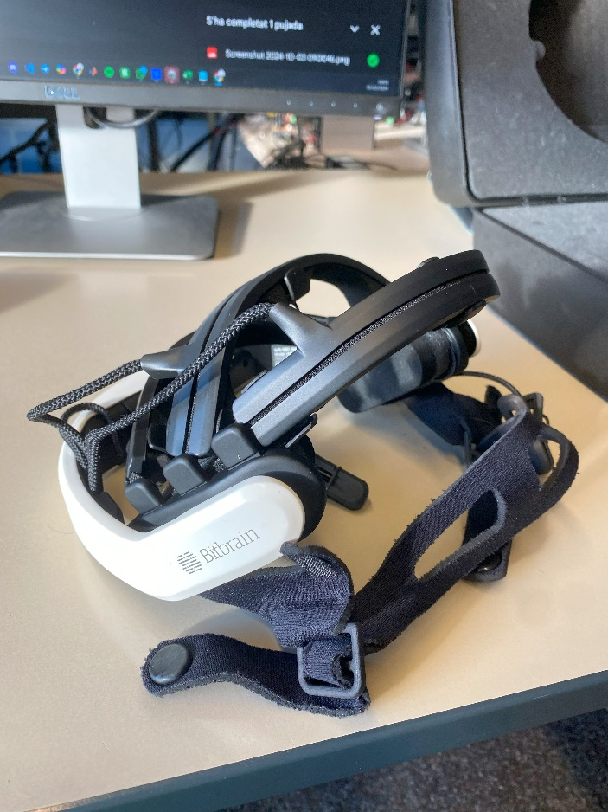
The EEG data were acquired using the Bitbrain Hero Helmet, a dry EEG system equipped with ten electrodes positioned according to the 10-20 system (F3, Fz, F4, C3, Cz, C4, P3, Pz, P4, GND). The EEG data were recorded with 24-bit resolution at a sampling rate of 250 Hz. The data were then transmitted via Bluetooth (2.1 interface) to recording software on a laptop (Lenovo Yoga Pro 9i). For streaming and synchronization, the Bitbrain Viewer and LSL tools were used in tandem (see Section 4.4.1).

FFig 6. BitBrain Hero Helmet

Experimental paradigm
The entire task was conducted across multiple sessions, with distinct data collection phases to ensure the acquisition of a comprehensive dataset. Building upon insights from successful motor imagery (MI) research papers [59, 60, 61] and design elements derived from BCI competition datasets [62, 63], the study employed structured trials of at least 2 seconds for MI tasks, a standard that has shown efficacy in such paradigms.
The PsychoPy motor imagery tasks were performed over 10 separate days, with a balanced schedule to minimize participant fatigue. Each day involved the collection of data for one type of task (Left, Right, or Random), presented in a randomized order to avoid predictable patterns and potential fatigue effects. Over the course of these 10 days, the participant completed the following:
- 10 folders of Right events: Each containing 40 trials of 2.5-second segments, separated by 2-second fixation intervals, where the participant imagined performing wrist flexion and extension with their right hand.
- 10 folders of Left events: Each containing 40 trials of 2.5-second segments, separated by 2-second fixation intervals, where the participant imagined performing wrist flexion and extension with their left hand.
- 10 folders of Random events: Each containing 40 trials of 2.5-second segments, separated by 2-second fixation intervals, with a balanced 20/20 ratio of right- and left-hand imagery.
The use of wrist flexion and extension for motor imagery tasks was selected as it involves fewer muscles, making it more suitable for untrained participants. While hand opening and closing are often used in MI-based BCI studies for their functional relevance, similar accuracy is achieved with wrist movements [64]. These design choices align with prior MI studies that have highlighted the importance of simplicity and repeatability in task selection for achieving reliable neural patterns.
Additionally, resting-state data was recorded on separate days to capture the participant's baseline neural activity. This phase consisted of six sessions, with each session comprising 10 minutes of recording divided equally into 5 minutes with eyes open and 5 minutes with eyes closed.
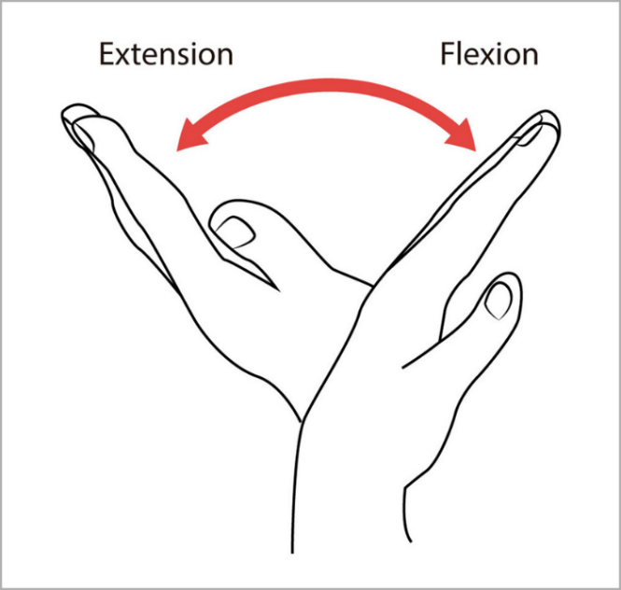
The final dataset, therefore, consisted of structured data from 10 days of motor imagery tasks and 6 sessions of resting-state recordings. This multi-day, multi-condition approach had the intention to provide a robust dataset for analysis, enabling the differentiation of task-specific neural patterns from baseline activity and accounting for potential day-to-day variability in brain activity. Such a dataset should ensure reliability in detecting subtle changes in neural activity while supporting the development of accurate and generalizable BCI systems.
Fig 7. Wrist flexion and extension [65]

Software
The BitBrain Hero helmet supports integration with various BCI applications beyond its default suite, thanks to its available APIs (e.g., Python, C++, and other interfaces) for data access and processing. For the purpose of developing a motor imagery (MI) experiment, it was necessary to design an experimental protocol that could generate MI triggers (left and right) and ensure their synchronization with EEG data. PsychoPy was employed to create this protocol, providing precise timing and alignment between the presented stimuli and the recorded neural signals.

PsychoPy
To administer the experimental tasks, a custom experimental pipeline was developed within PsychoPy (see section 3.7), enabling the design of a motor imagery experiment based on the guidelines outlined in point 4.4. The structure shown in Fig. 8 was implemented to organize the task sequence.

Fig 8. PsychoPy pipeline followed to obtain EEG MI data in this project.
Pipeline Explanation
- LSL Definition: The initial stage establishes the connection between the EEG recording software and the PsychoPy tool via the Lab Streaming Layer (LSL). During this step, the LabRecorder [61] software is used to synchronize the data streams (see section 3.6).
- Pause: After confirming the connection, participants are prompted to press the "space" key to proceed to the next stage. This ensures that the participant is ready before the task begins (see Fig. 9.A).
- Presentation: At this stage, participants are presented with the instructions for the task. The following message is displayed on the screen:
"Welcome. Please think of moving the hand indicated by the blue arrows that will appear." This step ensures participants understand the task before proceeding (see Fig. 9.B).
- Fixation: A fixation cross is displayed on the screen for 10 seconds (see Fig. 9.C). This step serves to center the participant's attention and prepare them for the task.
- Task Loop: Following the fixation phase, the main task is repeated 40 times in a loop. Depending on the specific exercise being conducted, the participants are shown a blue arrow pointing either to the left, the right, or in a randomized direction (see Fig. 9.D and Fig 9.E). Participants are instructed to imagine extending their hand in the direction indicated by the arrow. This process is performed through a 2.5 second time. The inclusion of three different types of exercises—left-hand movement, right-hand movement, and random direction—provides diverse neural data for analysis. (see Fig 10.C and 10.D)





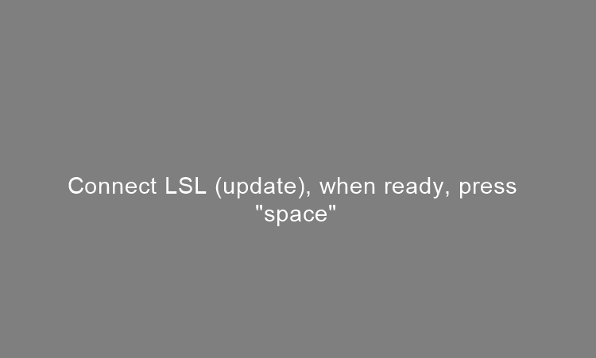
- Closure: At the end of the task, a message is displayed on the screen:
"Thank you for your time." This message signals the conclusion of the experiment and formally ending the task.
E
F
C
D
A
B

Fig 9. Images that can appear on the task from the PsychoPy pipeline that has been followed.
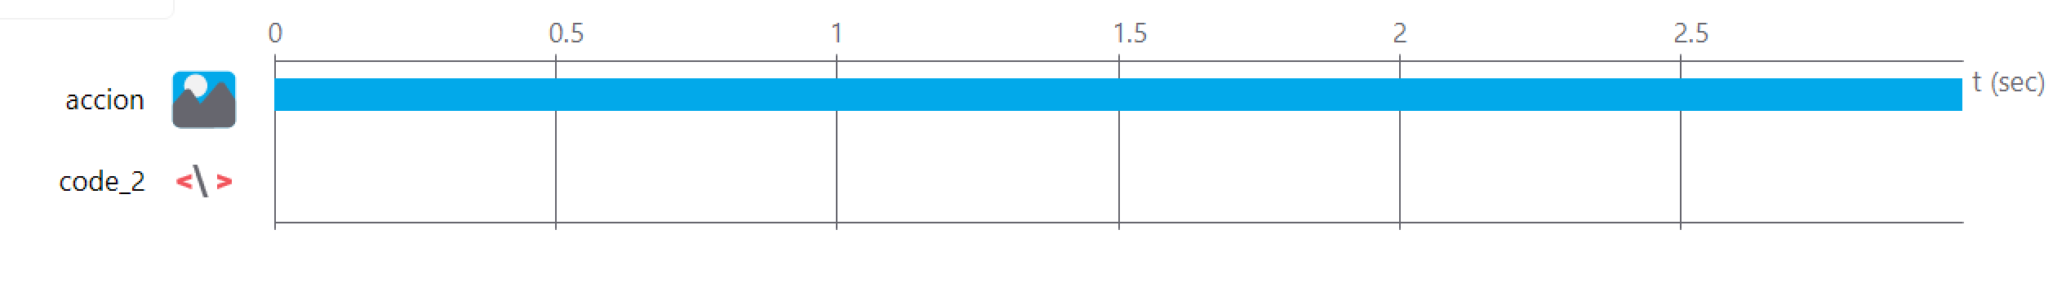
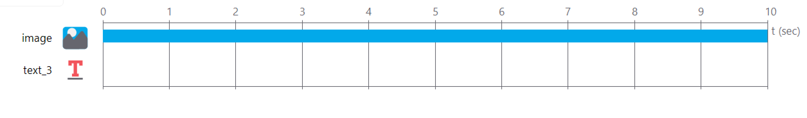
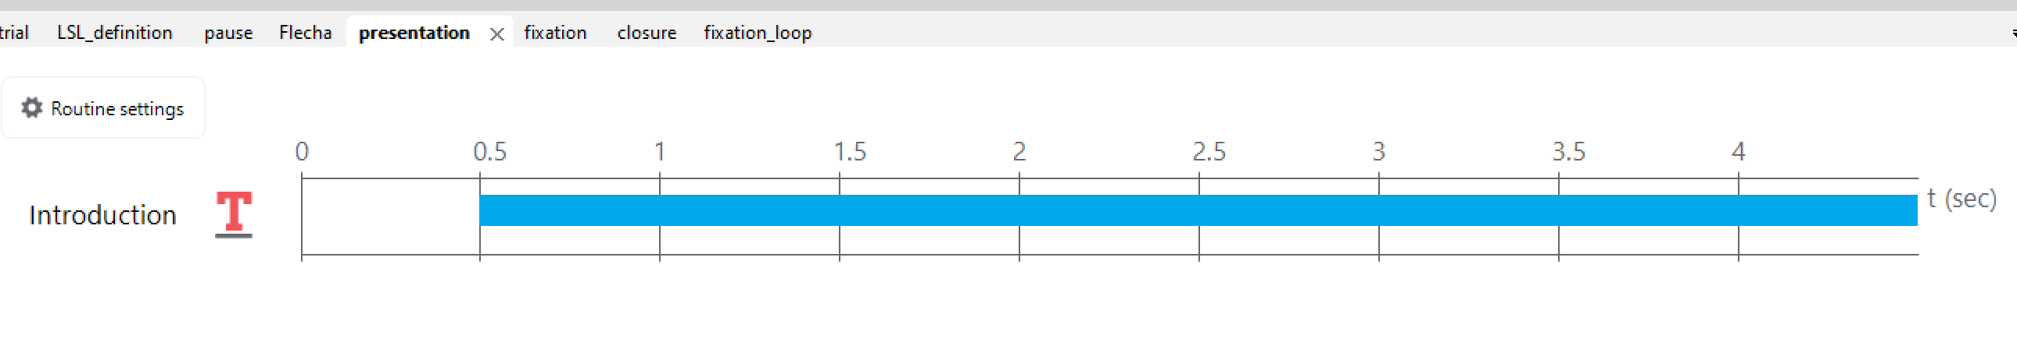
E. Trial routine
D. Trial routine
C. Fixation-loop routine
B. Fixation routine
A. Presentation routine
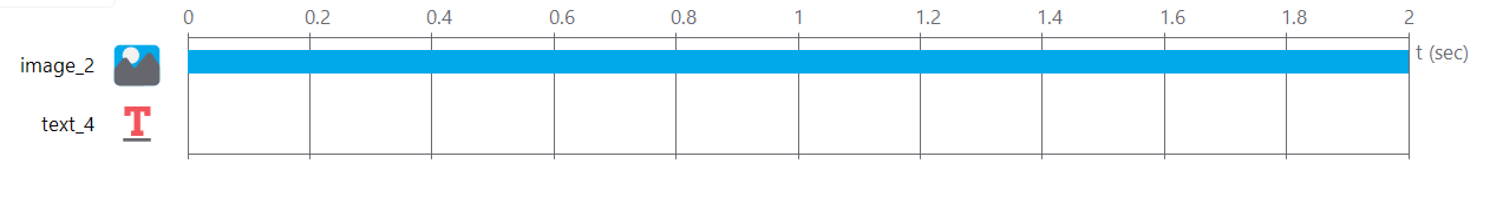
Fig 10. PsychoPy routine blocks

E. Closure routine

In addition to the task pipeline described, the study included a baseline recording phase to account for the participant's "resting-state" neural activity (see Fig 11). This phase was conducted in two conditions: 5 minutes with eyes open and 5 minutes with eyes closed. During the eyes-open condition, the participant was instructed to focus on a fixation cross displayed on the screen, while in the eyes-closed condition, the participant was asked to relax without any visual stimuli. This baseline data was essential for preprocessing, as it facilitated the identification and removal of noise and artifacts inherent to the dry EEG helmet. By comparing task-related signals to these baseline recordings, the analysis aimed to isolate motor-related neural patterns with greater accuracy.

Fig 11. PsychoPy pipeline followed to obtain resting-state EEG data in this project
This PsychoPy pipeline starts as the other one, the only differences are related with the following points:
  - Presentation: At this stage, participants are presented with the instructions for the task. The following message is displayed on the screen:
"Welcome, please stand still and relax. When 'EO' appears on the screen, keep looking at it. When it changes to 'EC,' close your eyes and wait until the end of the test to open them again. Thank you." This step ensures participants understand the task before proceeding (see Fig. 12.A).

  - Fixation_EO: A fixation cross will appear on the screen for 5 minutes (see Fig. 12.B). During this time, the participant is instructed to maintain focus on the cross until the next block appears.

  - Hold_Up: Participants are presented with instructions to close their eyes. The following message is displayed: "Now let's change to EC. You will wait here for 5 minutes. Please set your timer." Since the task was performed by a single subject without external monitoring, the participant was allowed time to set a 5-minute timer to know when to finish the eyes-closed block. (see Fig. 12.C).

  - Fixation_EC: A fixation cross will appear on the screen for 5 minutes (see Fig. 12.D). However, the participant will not see this image because their eyes should remain closed during this block.

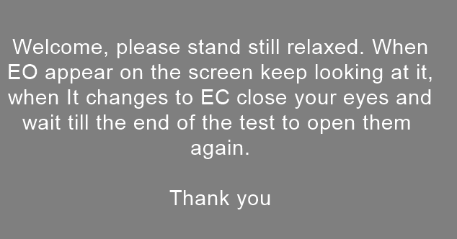
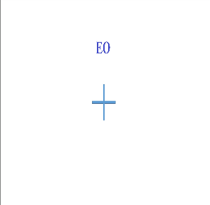
B
A
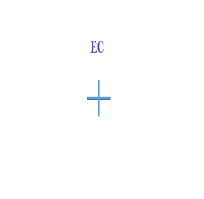
5
5
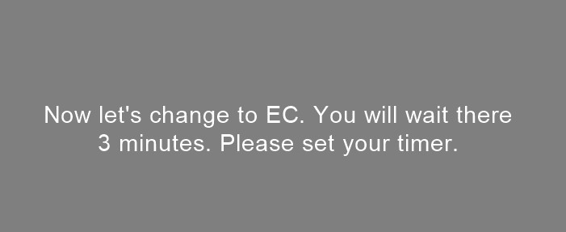
D
C
C

Fig 12. Images that can appear on the task from the PsychoPy pipeline that has been followed for resting-state.

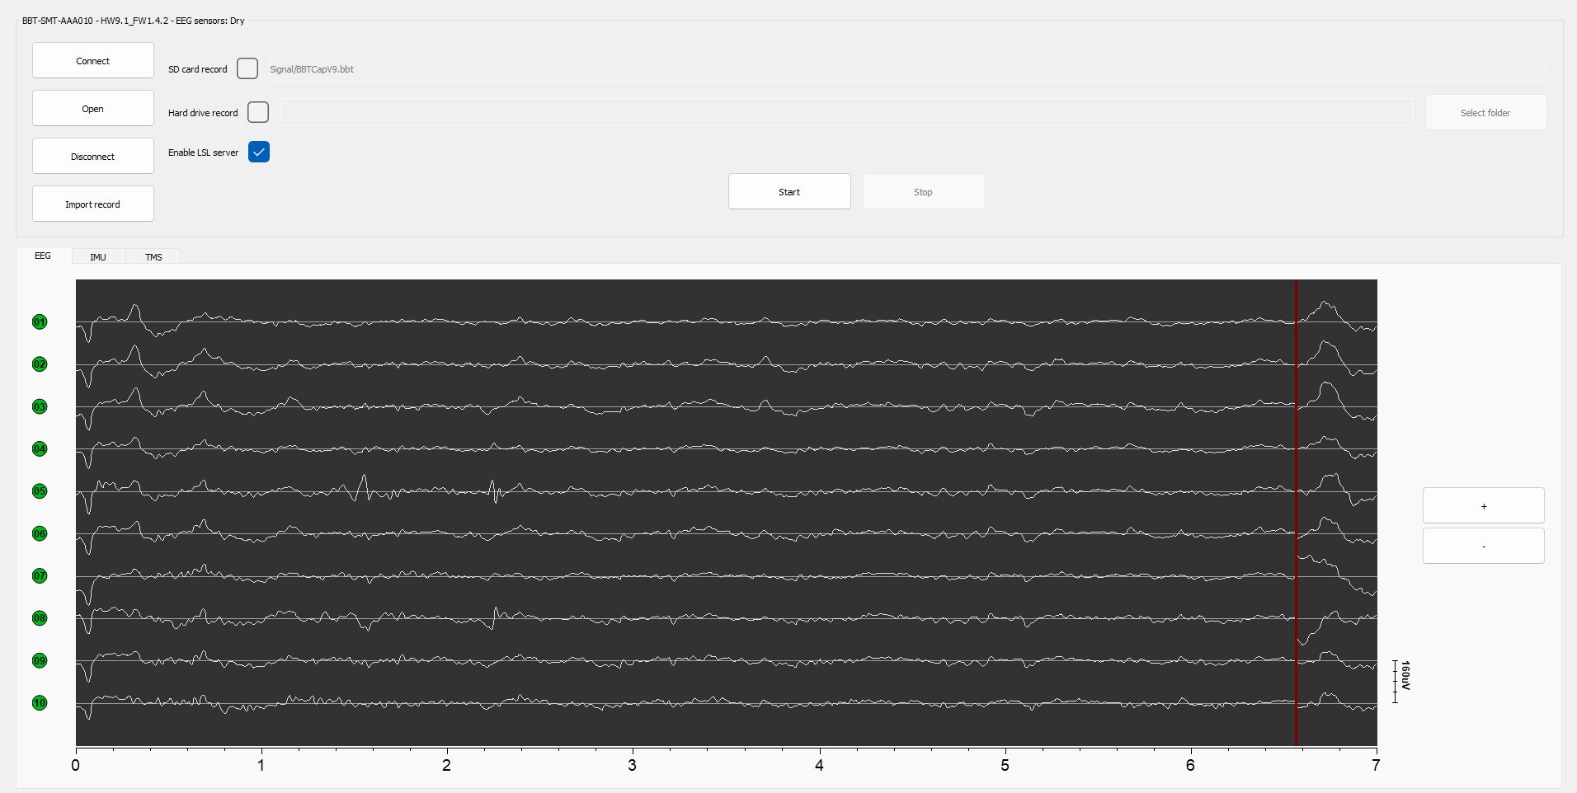
Data acquisition was synchronized using the Lab Streaming Layer (LSL) protocol, ensuring precise timing and seamless integration between the EEG system and the PsychoPy tool. During each session, real-time monitoring was employed to ensure data quality, allowing for any necessary adjustments to maintain signal integrity and reduce noise. This approach guaranteed the reliability and accuracy of the recorded neural data, supporting subsequent analysis and interpretation.
Fig 13. Bitbrain Viewer app main screen visualization
This structured sequence was designed to ensure clarity, consistency, and robust data collection while optimizing the participant’s experience.

EEG Preprocessing
The collected EEG data underwent comprehensive preprocessing to remove noise and artifacts, ensuring its suitability for subsequent analysis. These steps were implemented using Python, a versatile and widely-used programming language renowned for its robust libraries and tools in data analysis, signal processing, and scientific computing. The codes used in order to follow this pipeline can be found on the Github repository [66]. Below are the various steps followed to preprocess the data:
- Data Loading and Integration: EEG data streams were loaded from .xdf files using the pyxdf library, ensuring synchronization with event markers provided by the Lab Streaming Layer (LSL). Each stream's sampling rate, channel count, and data shape were logged to verify integrity.
- Baseline Correction: A 10-second baseline signal was calculated from the initial samples of the EEG data (in on-line mode). The average baseline value was subtracted from the entire dataset to correct for baseline shifts and minimize low-frequency drifts (in offline mode).
- Band-Pass and Notch Filtering: A band-pass filter (0.3–30 Hz) was applied to retain neural activity within the frequency range relevant to motor imagery [50]. Additionally, a notch filter was used to eliminate 50 Hz line noise caused by electrical interference.
- Independent Component Analysis (ICA): Fast Independent Component Analysis (FastICA) was performed on the EEG data to isolate and remove artifacts, such as eye blinks or muscle movements. FastICA was specifically chosen for this preprocessing step due to its suitability for real-time applications, allowing artifact removal to be performed online. This ensured that task-related neural signals were preserved and not contaminated by extraneous noise, while enabling efficient preprocessing in dynamic experimental setups.
- Event Identification and Segmentation: Event markers embedded in the data streams were identified and matched to the corresponding experimental conditions. EEG data was segmented into 1.5-second epochs based on these markers, aligning the neural data with the motor imagery tasks (e.g., left-hand, right-hand, or random trials).
- Uniform Length Adjustment: To ensure consistency in data dimensionality, all 1.5-second epochs were either truncated or zero-padded to maintain a fixed number of samples across trials.

- Data Storage: Processed data and event labels were saved in .json files for further analysis. Additionally, filtered raw data and ICA-filtered data were saved in .fif files for reproducibility and compatibility with MNE-based pipelines.

Feature extraction
Feature extraction plays a critical role in identifying and isolating patterns within EEG data that correlate with motor imagery tasks. This process is essential for the success of EEG motor imagery classification and was carried out using two complementary strategies: Literature-Based Features and Common Spatial Patterns (CSP). Both methods aimed to enhance the discriminative power of the data, providing robust representations for subsequent classification tasks. Below is an explanation of each approach.

Literature based features
Features commonly reported in EEG studies were extracted to capture both time-domain and frequency-domain properties of the signals [43,44,45,46,47,48]:
- Time-Domain Features
- Root Mean Square (RMS): This feature evaluates the overall strength of the EEG signal and is commonly used in motor imagery research.
- Peak-to-Peak Amplitude (PTP): Measures the variability in signal amplitude, providing insights into the dynamic range of neural activity.
- Frequency-Domain Features
- Power Spectral Density (PSD): The PSD was calculated for key frequency bands (delta, theta, alpha, beta, gamma) to isolate motor imagery-related oscillations.
- Entropy and Complexity Measures
- Sample Entropy: Quantifies the irregularity in neural signals, which may indicate the complexity of cognitive processing.
- Lempel-Ziv Complexity: Measures randomness in EEG data, reflecting neural processing efficiency.

Common Spatial Patterns
CSP is a popular method for extracting discriminative spatial features from EEG signals, specifically designed for motor imagery classification [48, 49, 50]. The technique optimizes spatial filters to enhance the variance of one class (e.g., left-hand imagery) while suppressing the variance of the other class (e.g., right-hand imagery). Key aspects include:
- Variance Optimization: CSP maximizes variance for one class while minimizing it for the other.
- Spatial Pattern Identification: It highlights patterns most relevant for classification.
- Regularization: Variants like Regularized CSP (R-CSP) mitigate overfitting by introducing constraints in high-dimensional datasets.
CSP calculation was performed through a Python code that follows the next pipeline:
- Preprocessing: Applies ICA, baseline correction, and filtering.
- Event Segmentation: Splits the EEG data into 1.5-second segments based on event markers.
- CSP Training and Transformation:
  - Computes spatial filters.
  - Applies these filters to the segmented data to extract CSP features.
- Saving Results: Stores CSP features and corresponding labels for machine learning classification.

Summary of Feature Extraction Implementation
The features were extracted using a Python-based implementation, designed to support both online and offline workflows. This dual-mode approach ensures compatibility with real-time experimental setups and post hoc analyses, leveraging the following steps:
- Data Acquisition: EEG signals were streamed live via LSL for real-time processing or retrieved from pre-recorded .fif files for offline analyses.
- Baseline Subtraction: A baseline correction step was performed to normalize the EEG data and mitigate low-frequency drifts.
- Filtering: Band-pass and notch filters were applied to retain task-relevant frequencies while eliminating noise and artifacts.

- Feature Computation: Both literature-based features (e.g., RMS, PTP, PSD, Sample Entropy, and Lempel-Ziv Complexity) and CSP-derived features were calculated to capture time-domain, frequency-domain, and spatial patterns.
- Result Storage: Extracted features and their associated labels were saved in structured formats (.json for tabular features and .fif for spatial filters) to facilitate subsequent machine learning classification and reproducibility.
This comprehensive feature extraction pipeline ensured that the processed EEG data preserved essential information for motor imagery classification, forming a robust foundation for further analysis and model training. The integration of both classical feature engineering methods and advanced spatial pattern extraction highlights the adaptability and depth of this approach.

Machine Learning Analysis

Features Based on Literature
The exploration of features based on literature involved rigorous preprocessing and analysis steps to identify the most relevant attributes for motor imagery classification. The procedures applied to the dataset were designed to ensure its integrity, normalize its scale, and isolate features with the highest discriminative potential. These steps included:
- Data Preprocessing:
  - Standardization: All numerical features were standardized using a StandardScaler to ensure they had a mean of zero and a standard deviation of one. This step mitigates the effect of varying scales across features.
  - Outlier Detection: Outliers were identified and addressed to reduce their impact on model training. Techniques like z-score analysis and clustering-based detection (e.g., DBSCAN) were used to flag anomalous data points.
  - Imputation: Missing values were filled using a SimpleImputer with a mean-based strategy to maintain dataset completeness.
- Feature Analysis:
  - Correlation Analysis: A correlation heatmap was generated to assess relationships between features and detect redundancies. Highly correlated features were evaluated for potential removal to minimize multicollinearity.

  - Variance Thresholding: Features with low variance, providing little discriminative information, were excluded from further analysis.
  - Feature Selection: Recursive Feature Elimination (RFE) and mutual information scoring were applied to rank the features based on their importance to classification tasks.
- Model Evaluation:
  - The refined dataset was tested with multiple classifiers, including:
    - Linear Discriminant Analysis (LDA): A statistical method used to find a linear combination of features that separates classes effectively.
    - Support Vector Machines (SVMs): Evaluated linear and kernel-based models to assess the boundary-separating power of the features.
    - Decision Trees (DT): Utilized to model the data in a tree-based structure, evaluating feature splits and class prediction.
    - K-Nearest Neighbors (KNN): A distance-based algorithm evaluating feature effectiveness in local neighborhood contexts.
  - Performance Metrics:
    - Accuracy, precision, recall, and ROC AUC were computed for each classifier to benchmark feature sets.
    - Cross-validation ensured robustness and minimized overfitting risks.
- Feature Prioritization:
  - After classifier evaluation, the most impactful features were identified based on their contribution to classification performance. These insights guided the selection of a final feature subset for integration into the BCI pipeline.

Common Spatial Patterns
The Common Spatial Patterns (CSP) technique was employed to extract discriminative spatial features from EEG data for motor imagery classification. This method leverages the spatial covariance structure of the EEG signals to isolate patterns that maximize variance for one task (e.g., left-hand imagery) while minimizing it for the other (e.g., right-hand imagery). The notebook's methodology follows a structured pipeline to compute and evaluate CSP features.
Pipeline Overview:
- CSP Feature Extraction:
  - Covariance Matrix Calculation: The EEG signals were divided into two classes based on event markers, and the covariance matrices for each class were computed. This step forms the basis for spatial filter computation.
  - Generalized Eigenvalue Decomposition: A generalized eigenvalue problem was solved using the class-specific covariance matrices to derive spatial filters. These filters are optimized to enhance class discriminability by maximizing variance for one class while minimizing it for the other.
  - Feature Generation: The spatial filters were applied to the EEG data, projecting it into a feature space where class-specific variances were extracted. A logarithmic transformation of these variances was performed to stabilize their distribution.
- Feature Evaluation:
  - Feature Distribution Analysis: The CSP features were visualized to confirm their separability between the motor imagery tasks.
  - Physiological Plausibility: The spatial patterns corresponding to the CSP filters were visualized to validate their alignment with expected neural activity associated with motor imagery.
- Classifier Testing:
  - The CSP-derived features were tested using various classifiers, including:
    - Linear Discriminant Analysis (LDA): A statistical method used to find a linear combination of features that separates classes effectively.
    - Support Vector Machines (SVMs): Evaluated linear and kernel-based models to assess the boundary-separating power of the features.
    - Decision Trees (DT): Utilized to model the data in a tree-based structure, evaluating feature splits and class prediction.
    - K-Nearest Neighbors (KNN): A distance-based algorithm evaluating feature effectiveness in local neighborhood contexts.
  - Performance Metrics:
    - Metrics such as accuracy, precision, recall, and ROC AUC were calculated to benchmark the effectiveness of the CSP-based feature set.
    - Confusion matrices and ROC curves were generated to provide a detailed view of classification performance.
The methods used for both literature-based features and Common Spatial Patterns (CSP) were designed to carefully process and analyse the EEG data, ensuring that the most important patterns and characteristics were captured. These steps helped organize the data in a way that made it ready for machine learning models to analyse. By following clear and structured workflows, the study set up a solid starting point for examining how well these features can help distinguish different motor imagery tasks. The results of these efforts will be explored in the next section.
All the codes and documents related to this final master thesis can be found on a Github Repository [66].

Results
This section provides an in-depth account of the results derived from analysing EEG data using two primary methodologies: literature-based features and Common Spatial Patterns (CSP). The results include insights into the dataset characteristics, feature classifications, and machine learning classifier performance for both training and validation datasets. Each subsection expands on the analysis conducted and the findings obtained.

Literature-Based Features

Data Overview
The EEG dataset was collected using the Bitbrain Hero Helmet, which employs dry electrodes for non-invasive signal acquisition. The dataset included signals from multiple channels, preprocessed for artifact removal and noise reduction. Features extracted from the dataset were based on established methodologies in the literature, as explained in Section 3.5.1 of this thesis and supported by references [43, 44, 45, 46, 47, 48]. These features include:
- Statistical Features: Root Mean Square (RMS), Peak-to-Peak Amplitude (PTP), skewness, and kurtosis.
- Frequency Features: Power Spectral Density (PSD) in alpha, beta, and gamma bands.
- Complexity Features: Entropy measures, including Sample Entropy, Permutation Entropy, and Lempel-Ziv Complexity.
The data was balanced across motor imagery tasks, with approximately equal samples for left-hand and right-hand movements being 3510 and 3030 data samples respectively. Additionally, the absence of null values ensures the dataset is well-suited for feature analysis and classification.

Feature Extraction and Analysis
The extracted features were analysed to evaluate their distributions and separability across motor imagery tasks. The histograms and box plots provided key insights into the differences between the "left" and "right" classes:
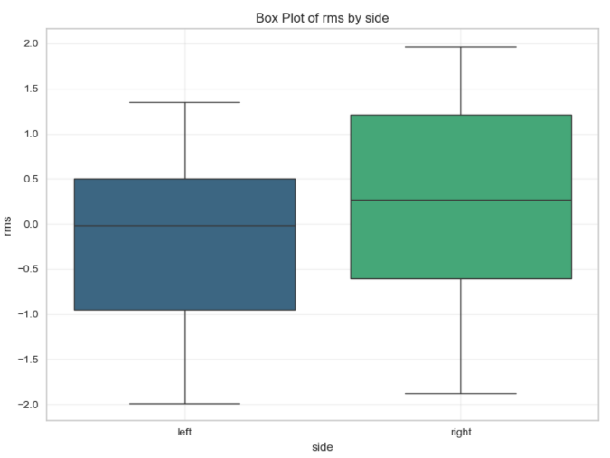
- RMS and PTP: The histograms and box plots for RMS and PTP demonstrate partial distinctions between the two classes. While the distributions overlap significantly, subtle shifts in medians and spreads are evident in the box plots, with "right" motor imagery generally showing higher RMS values compared to "left" (see Figures 14 and 15).
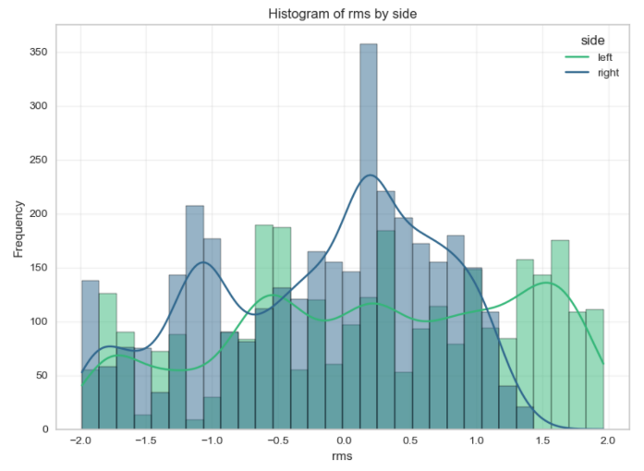
Fig 14. Histogram and Box plot of RMS by side

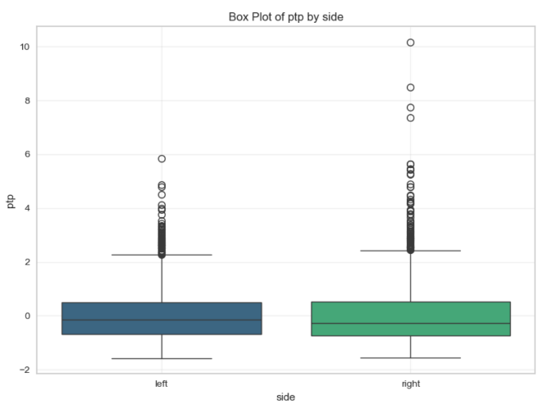
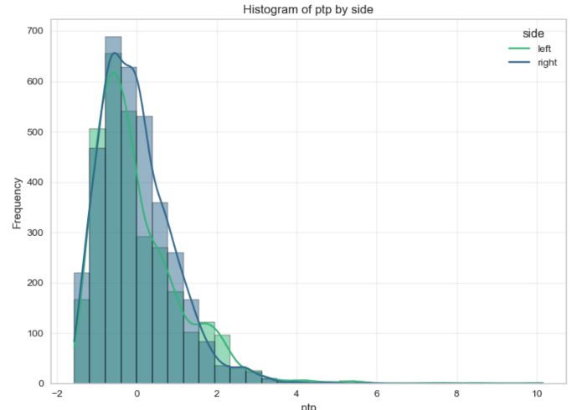
Fig 15. Histogram and Box plot of PTP by side

- Alpha and Beta Power: The frequency features (Alpha and Beta power) exhibit highly skewed distributions with significant outliers. However, both histograms and box plots reveal that these features are concentrated near the lower range, showing minimal differentiation between motor imagery classes in the observed data (see Figures 16 and 17).
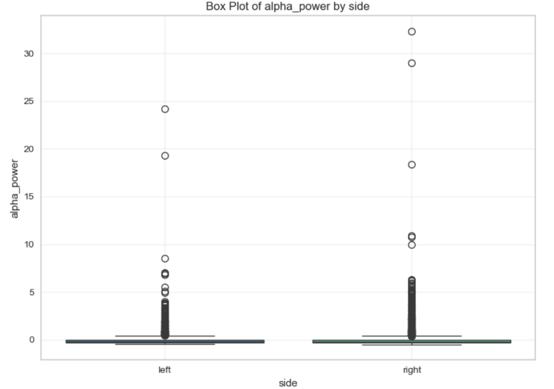
Fig 16. Histogram and Box plot of alpha power by side

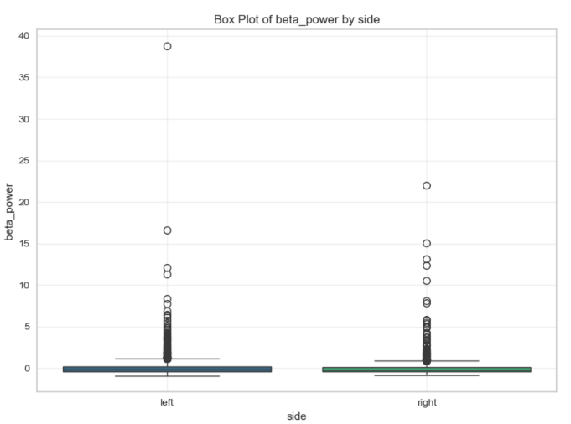
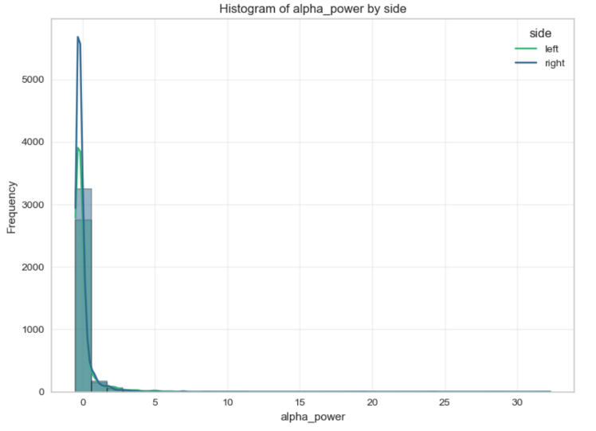
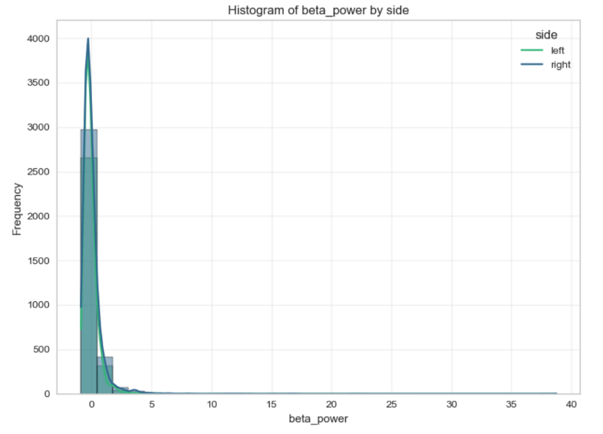
Fig 17. Histogram and Box plot of beta power by side

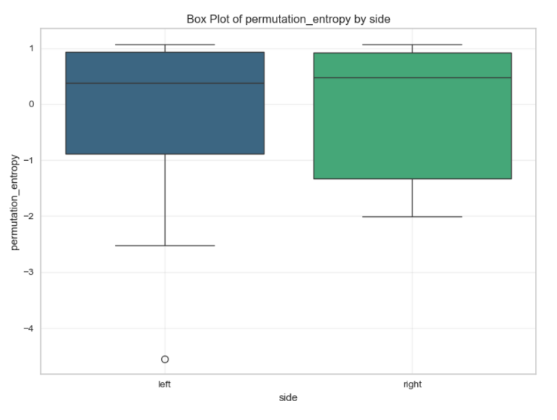
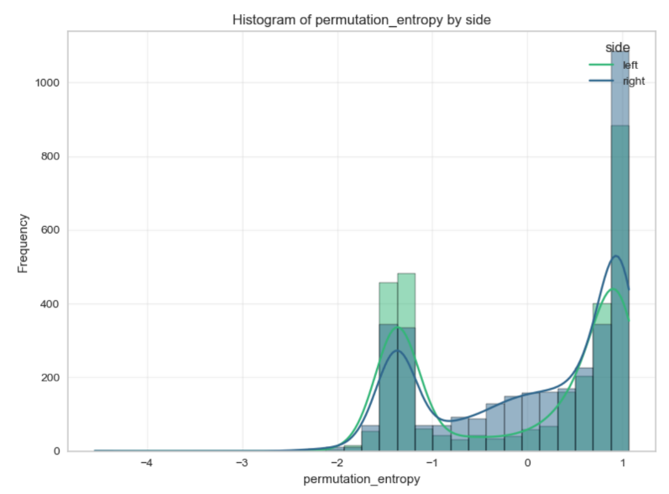
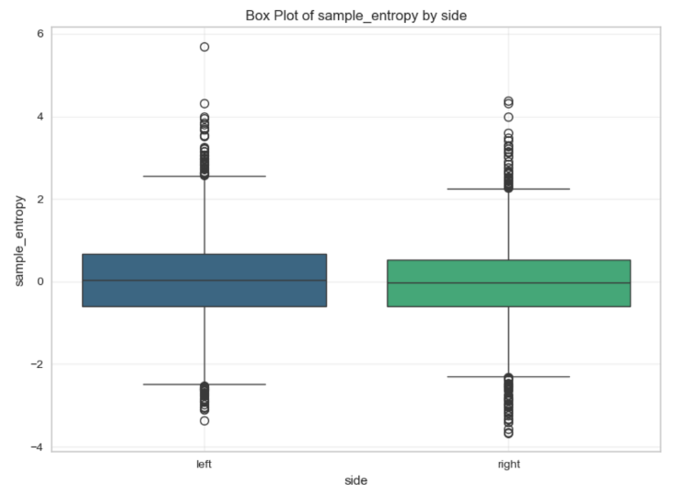
- Entropy Features: Sample entropy and permutation entropy show more symmetrical distributions. Box plots reveal minor variations in medians between "left" and "right" classes. Permutation entropy, in particular, appears to have slightly more distinguishable distributions between the two classes (see Figures 18 and 19).
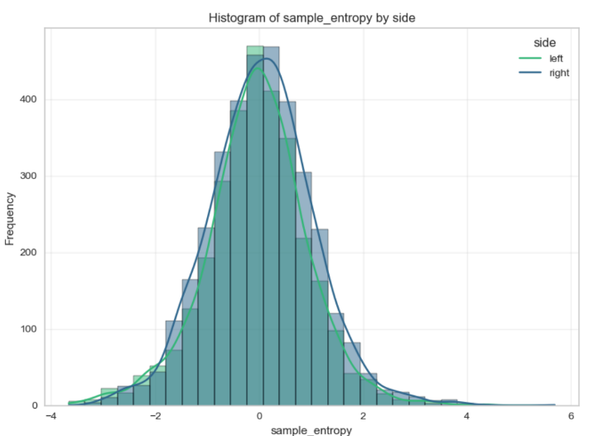
Fig 19. Histogram and Box plot of permutation entropy by side

Fig 18. Histogram and Box plot of sample entropy by side

The statistical and visual analyses of these features suggest that while some features (e.g., RMS, PTP, and entropy measures) provide moderate separability, others (e.g., Alpha and Beta power) show considerable overlap, indicating limited discriminative power for motor imagery classification in their current form.

Classification Results
Machine learning classifiers were evaluated to analyse the discriminative power of extracted features in the context of motor imagery tasks. The analysis included both training and validation phases, utilizing classifiers such as Linear Discriminant Analysis (LDA), Support Vector Machines (SVM), Decision Trees (DT), and K-Nearest Neighbours (KNN). Evaluation metrics, including accuracy, precision, recall, and ROC AUC, were calculated, alongside visualizations like ROC curves, confusion matrices, and classification reports.
Training Phase Results
The performance of machine learning classifiers was evaluated on the training dataset to assess their ability to learn patterns from the data. This analysis provides insights into how well each model captures the relationships between features and motor imagery tasks, with metrics such as accuracy, precision, recall, and ROC AUC serving as indicators of training performance.
The following table summarizes the results of the machine learning classifiers on the training dataset (Table 3). The training performance metrics are also visualized in Figure 20 (top panel), showing a bar plot comparison of accuracy, precision, recall, and ROC AUC for each model. Additionally, the corresponding training ROC curves for the classifiers are illustrated in Figure 21 (top panel).
Table 3. Machine Learning Classifiers on training dataset for Literature based features
Classifier | Accuracy (%) | Precision (%) | Recall (%) | ROC AUC
LDA | 60.2 | 58.9 | 46.2 | 0.62
SVM | 76.1 | 75.2 | 72.1 | 0.82
DT | 85.2 | 84.1 | 83.8 | 0.85
KNN | 75.0 | 74.1 | 70.9 | 0.82

Validation Phase Results
To evaluate the generalization performance of the classifiers, their accuracy, precision, recall, and ROC AUC were assessed on the validation/test dataset. This step ensures that the models are not overfitting to the training data and provides a realistic assessment of their predictive capabilities on unseen data.
The following table presents the performance of the classifiers on the validation/test dataset (Table 4). Validation performance metrics are visualized in Figure 20 (bottom panel), providing a bar plot comparison of accuracy, precision, recall, and ROC AUC for the models. The validation ROC curves are depicted in Figure 21 (bottom panel) to further illustrate the generalization performance.
Table 4. Machine Learning Classifiers on validation dataset for Literature based features
Classifier | Accuracy (%) | Precision (%) | Recall (%) | ROC AUC
LDA | 50.0 | 50.0 | 100.0 | 0.50
SVM | 50.0 | 50.0 | 100.0 | 0.50
DT | 50.0 | 50.0 | 100.0 | 0.50
KNN | 51.0 | 50.7 | 80.4 | 0.50
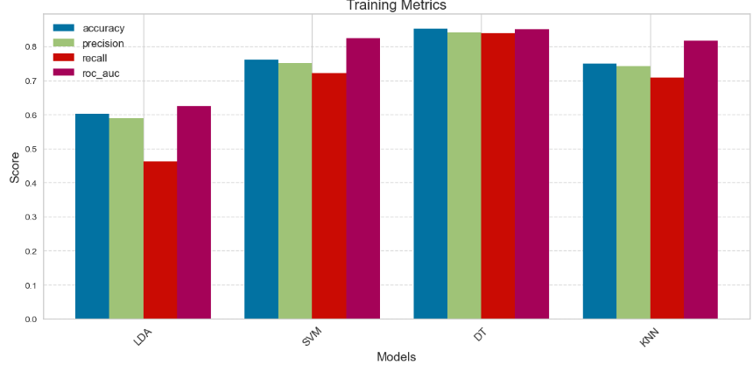

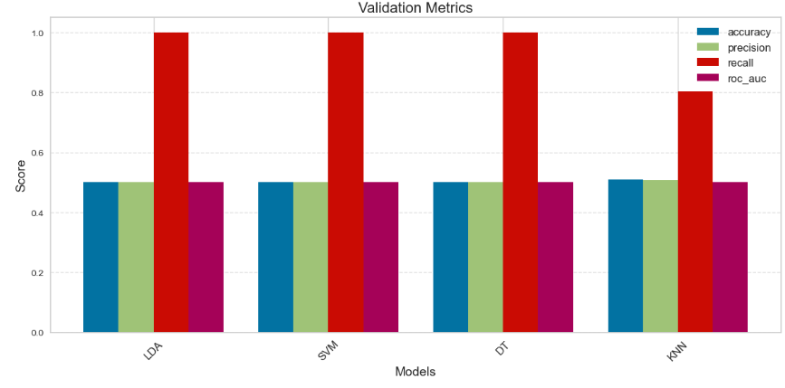

Fig 20. Training vs Validation Metrics comparison for Literature Based features

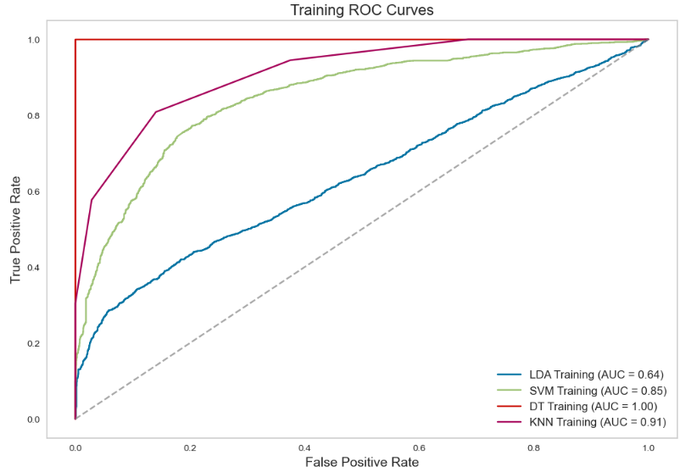

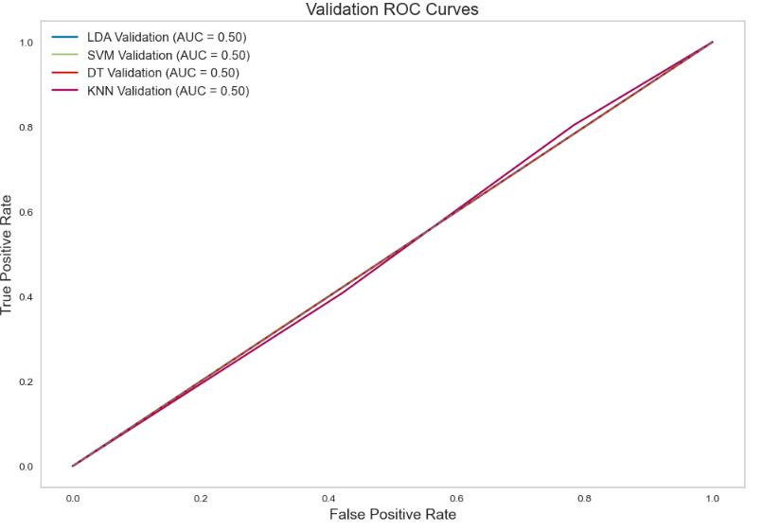

Fig 21. Training vs Validation ROC Curves comparison for Literature Based features

Common Spatial Patterns (CSP)

Data Overview
The EEG data analysed using Common Spatial Patterns (CSP) were acquired during motor imagery (MI) tasks involving right- and left-hand movements. The data were recorded over ten sessions, with 40 trials per class per session. This resulted in a dataset comprising balanced class distributions of 400 trials each for right-hand and left-hand motor imagery.
The CSP features were extracted by applying spatial filters optimized to maximize the variance differences between the two classes. The dataset was divided into:
- Training Set: 651 trials (60% of the total data), balanced across classes.
- Validation Set: 240 trials (40% of the total data), balanced across classes.

Feature Extraction and Analysis
Features Distribution
The CSP method transformed the EEG data into a four-dimensional feature space, with each dimension representing a spatial filter optimized for class discrimination. The distributions of these features for the training and validation sets were analyzed and visualized.
CSP Training Features
Figure 22 displays the class distribution in the training dataset. The two classes, corresponding to motor imagery of right- and left-hand movements, are balanced with nearly equal representation in the dataset.
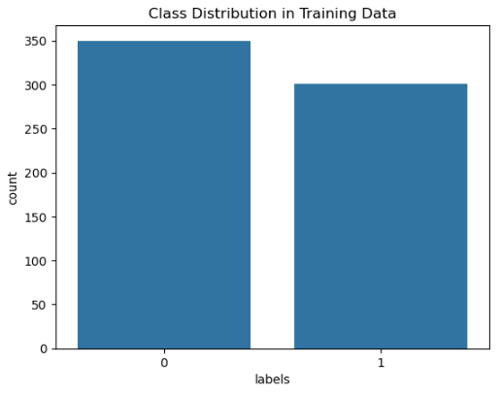
Fig 22. Class Distribution in Training Data

Figure 23 illustrates the distributions of the four CSP components extracted from the training dataset. Each component corresponds to a spatial filter optimized for discriminating between the two motor imagery classes. These histograms show that the CSP features are well-distributed, with distinct separability between the classes for certain components.
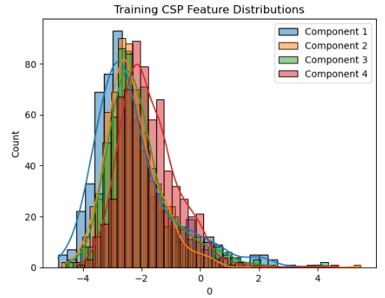

Fig 23. Training CSP Feature Distribution

Comparison of Training and Validation CSP Features
To evaluate whether the CSP features generalize across datasets, Figure 24 compares the density distributions of CSP components in the training and validation datasets.
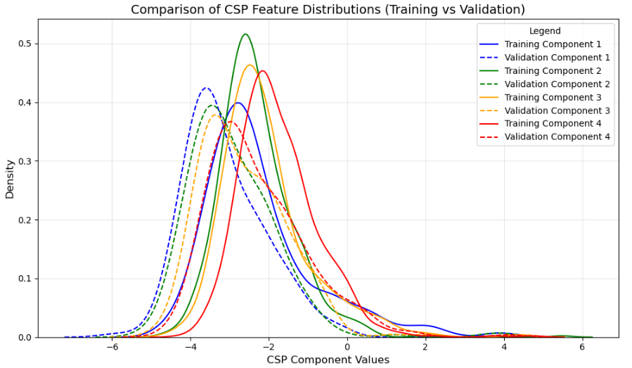

Fig 24. Comparison of CSP Feature Distributions (Training vs. Validation)

Classification Results
The classification performance of the CSP features was evaluated using four models: Linear Discriminant Analysis (LDA), Support Vector Machine (SVM), Decision Tree (DT), and K-Nearest Neighbours (KNN). The results for both training and validation phases are summarized below.
Training Phase Results
The performance of machine learning classifiers was evaluated on the training dataset to assess their ability to learn patterns from the data. This analysis provides insights into how well each model captures the relationships between features and motor imagery tasks, with metrics such as accuracy, precision, recall, and ROC AUC serving as indicators of training performance.
The following table summarizes the results of the machine learning classifiers on the training dataset (Table 5). The training performance metrics are also visualized in Figure 25 (top panel), showing a bar plot comparison of accuracy, precision, recall, and ROC AUC for each model. Additionally, the corresponding training ROC curves for the classifiers are illustrated in Figure 26 (top panel).
Table 5. Machine Learning Classifiers on training dataset for CSP features
Classifier | Accuracy (%) | Precision (%) | Recall (%) | ROC AUC
LDA | 92.4 | 94.3 | 93.7 | 0.95
SVM | 90.6 | 92.1 | 92.8 | 0.93
DT | 89.3 | 91.8 | 92.4 | 0.91
KNN | 88.1 | 90.2 | 89.1 | 0.89
Validation Phase Results
To evaluate the generalization performance of the classifiers, their accuracy, precision, recall, and ROC AUC were assessed on the validation/test dataset. This step ensures that the models are not overfitting to the training data and provides a realistic assessment of their predictive capabilities on unseen data.
The following table presents the performance of the classifiers on the validation/test dataset (Table 6). Validation performance metrics are visualized in Figure 25 (bottom panel), providing a bar plot comparison of accuracy, precision, recall, and ROC AUC for the models. The validation ROC curves are depicted in Figure 26 (bottom panel) to further illustrate the generalization performance.
Table 6. Machine Learning Classifiers on validation dataset for CSP features
Classifier | Accuracy (%) | Precision (%) | Recall (%) | ROC AUC
LDA | 38.8 | 43.4 | 74.2 | 0.18
SVM | 28.8 | 31.9 | 37.5 | 0.22
DT | 42.9 | 43.5 | 47.5 | 0.43
KNN | 34.6 | 39.4 | 57.5 | 0.36
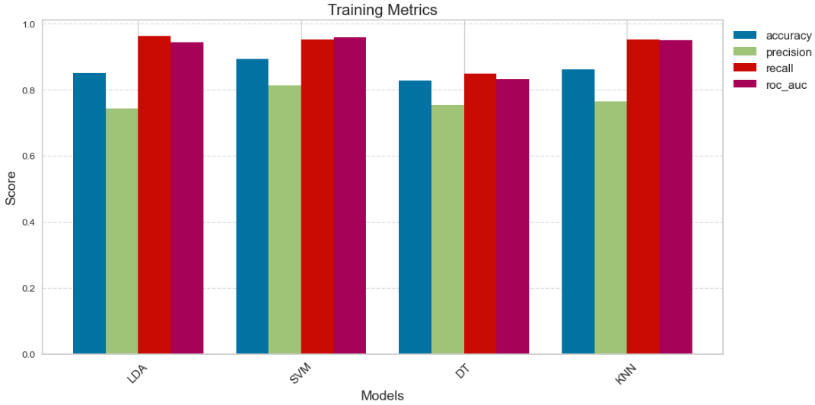
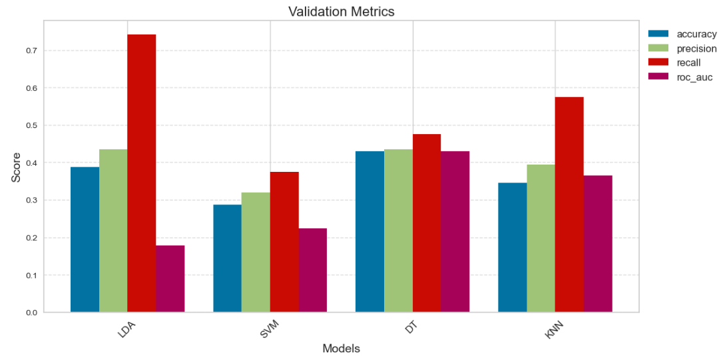
Fig 25. Training vs Validation Metrics comparison for CSP Features

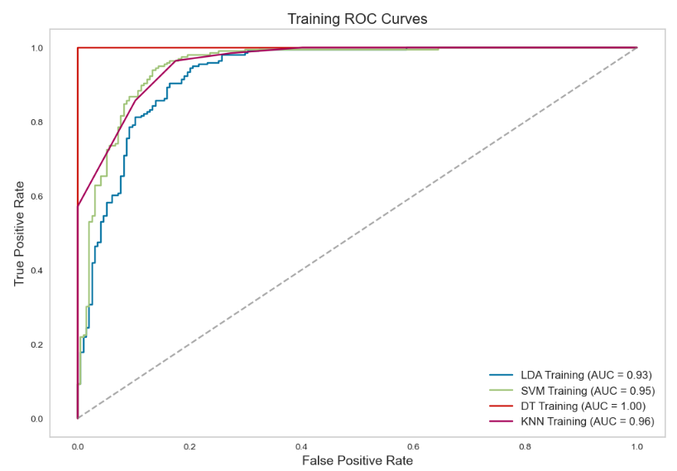
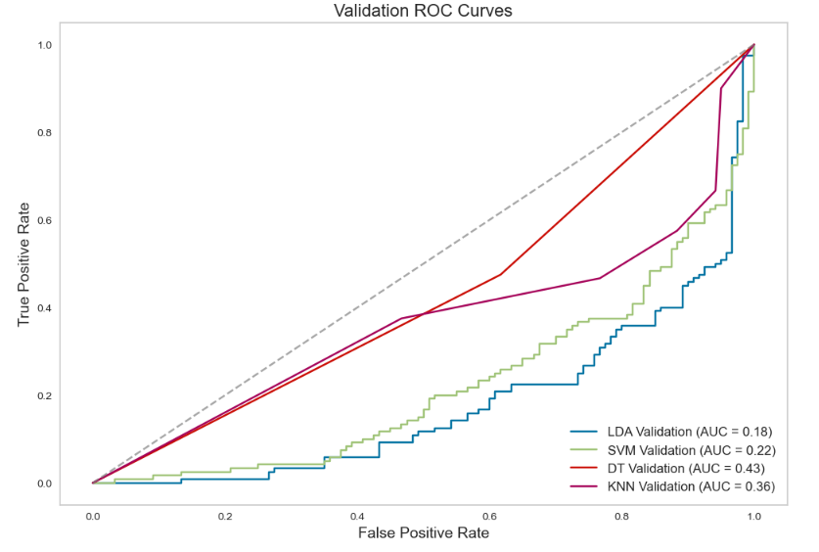
Fig 26. Training vs Validation ROC Curves comparison for CSP features

Discussion and Future Work

Literature-based Features
The analysis of literature-based features provided insights into their effectiveness and limitations in motor imagery classification. Time-domain features such as Root Mean Square (RMS) and Peak-to-Peak Amplitude (PTP) demonstrated partial separability between motor imagery tasks, as observed in Figures 14 and 15. These figures show a shift in median values for 'right' motor imagery, with higher RMS values compared to 'left' tasks. However, the overlap in distributions indicates that these features alone might not be sufficient for robust classification.
Frequency-domain features, such as Alpha and Beta power, presented in Figures 16 and 17, revealed skewed distributions with minimal differentiation between motor imagery classes. These features, concentrated near the lower range, highlight the challenges of using frequency-specific measures in the current experimental setup. The overlap in these features reduces their discriminative power, necessitating the exploration of alternative or combined feature sets.
Entropy-based features, including Sample Entropy and Permutation Entropy, as shown in Figures 18 and 19, displayed more symmetrical distributions with slight separability between classes. Permutation Entropy, in particular, appeared more distinguishable, suggesting its potential as a useful feature in motor imagery classification. However, the moderate separability observed across all feature types indicates that literature-based features alone may not provide the level of robustness required for real-world applications.
The classification results further underscore the limitations of literature-based features. While classifiers like Decision Trees achieved high accuracy in the training phase, their validation performance, depicted in Figures 20 and 21, showed significant overfitting. The generalization gap highlights the need for better feature engineering, dimensionality reduction, or regularization techniques. Future work should consider integrating these features with advanced machine learning models to improve robustness and reliability.

Common Spatial Patterns (CSP)
The application of Common Spatial Patterns (CSP) provided valuable insights into their effectiveness for motor imagery classification. CSP features demonstrated significant separability between classes, as shown in Figure 23, where the distributions of CSP components highlight clear distinctions. This improved separability translated into high training accuracies, with classifiers like LDA achieving over 90% accuracy, as depicted in Table 5 and Figures 25 and 26.
However, the generalization performance on the validation dataset, detailed in Table 6 and Figures 25 and 26, was notably poorer. The reduced validation accuracy and increased variability between sessions and participants underscore the challenges of using CSP-based features in practical applications. This performance drop highlights the variability inherent in EEG signals and the influence of session-dependent factors.
To address these challenges, regularization techniques and advanced CSP variants, such as Filter Bank CSP (FBCSP) or Regularized CSP (R-CSP), should be explored. These methods can enhance robustness by mitigating overfitting and improving generalization across datasets. Additionally, individual calibration protocols and hybrid approaches combining CSP with deep learning models could further optimize feature extraction and classification accuracy.
The visualization of CSP features, as seen in Figures 22 and 24, emphasizes the potential of this method for capturing task-specific neural patterns. Future work should focus on refining CSP implementations and integrating these features into adaptive systems to enhance reliability and usability in real-world scenarios.

Comparison of Classifier Performance
Analyzing the confusion matrices of the classifiers reveals significant differences in their behavior when using literature-based features versus Common Spatial Patterns (CSP).
For the K-Nearest Neighbors (KNN) classifier applied to literature-based features, as shown in Figure 27 (left for training and right for validation), both confusion matrices highlight a failure to perform meaningful classifications. The model primarily predicts one class (e.g., ‘left’ or 'right'), leading to imbalanced predictions that do not reflect the actual task distribution. This limitation aligns with the poor validation performance metrics seen in accuracy, precision, and recall for this feature set.
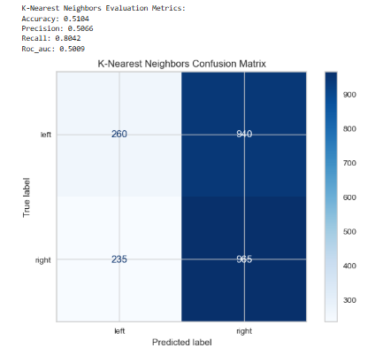
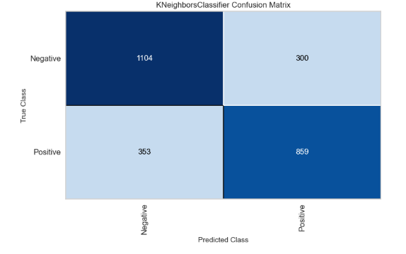
Fig 27. KNN confusion matrices comparison between Training (left) and Validation (right) for Literature-based features
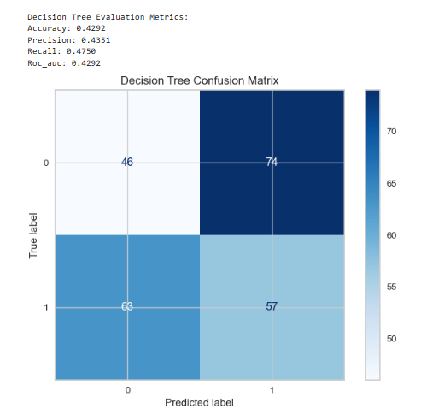
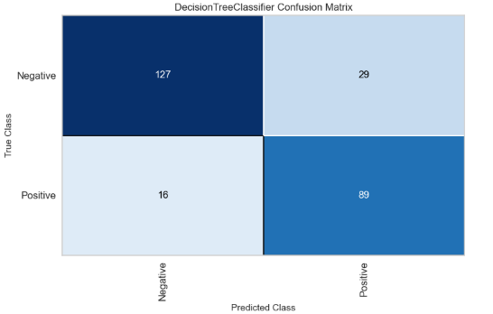
Conversely, the Decision Tree (DT) classifier applied to CSP features, illustrated in Figure 28 (left for training and right for validation), demonstrates an ability to classify tasks with more balance during training, achieving a training accuracy of over 90%. However, the validation confusion matrix reveals challenges in generalization. While it does not exhibit the extreme imbalance seen with the KNN model on literature-based features, its performance still suffers from misclassifications, reflecting session variability and the inherent complexity of EEG signals.
Fig 28. DT confusion matrices comparison between Training (left) and Validation (right) for CSP-based features

Limitations
Along this project this project, several limitations were encountered that highlight the inherent challenges of working with EEG-based brain-computer interfaces (BCIs):
1. Signal Quality: One of the primary limitations was the difficulty in obtaining high-quality EEG signals using the dry electrode system. While the Bitbrain Hero Helmet simplifies setup, its dry electrodes are more prone to noise and artifacts compared to traditional wet systems. This limitation can affect the reliability of extracted features and, consequently, the performance of the classifiers.
2. Variability Between Sessions: Significant variability was observed between EEG recordings across sessions, days, and even within the same day. This variability, influenced by factors such as changes in electrode placement, environmental conditions, and the participant's mental and physical state, posed challenges for consistent feature extraction and classification. These variations underscore the need for robust calibration and adaptation strategies.
3. Limited Generalization: The validation results revealed a notable performance gap, with models performing well during training but struggling to generalize to unseen data. This highlights the need for advanced techniques such as regularization, transfer learning, or domain adaptation to improve model robustness.
4. Single-Participant Study: Due to logistical constraints, the study was conducted with only one participant. While this approach aligns with the exploratory nature of the project, the lack of diverse participant data limits the generalizability of the findings. Future studies should aim to include a larger and more diverse cohort to validate the results.
5. Limited Real-Time Testing: Although the project included functional code for online testing, these tests were not conducted due to the low accuracies achieved by the trained models. The existing models were not reliable enough for practical application in a real-time scenario. Consequently, the online testing code, while operational, has not been detailed in this report, as it does not provide valuable insights or contribute meaningfully to the findings. Future improvements in model accuracy are necessary before real-time testing can yield practical results.

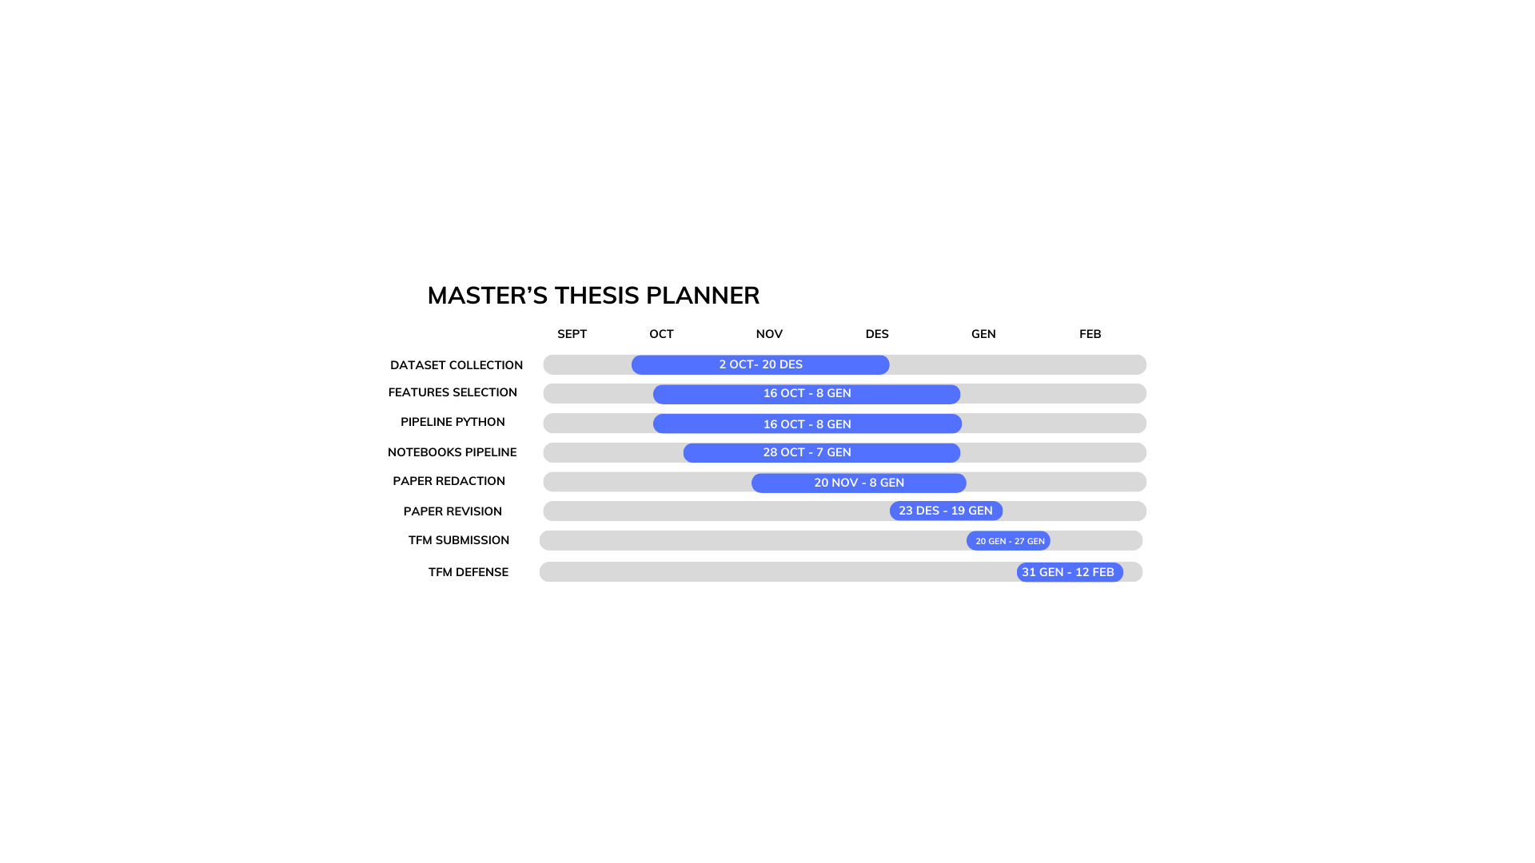
Planning
Fig 29. Gantt chart showing the achieved timeline for this project

Environmental impact analysis
The environmental impact of developing this project has been evaluated, considering the resources and equipment utilized.
In addition, the manufacturing of these devices contributes significantly to their carbon footprint. For example, the production of electronic devices releases approximately 22.7 kg of CO2 per kilogram of equipment​. Laptops, which typically weigh around 2 kg, have an estimated manufacturing footprint of 110 kg CO2e​. While these figures are substantial, it is important to note that the equipment used in this project was not acquired specifically for this purpose, thereby reducing its direct environmental impact on the project.
A key environmental benefit of this project is the use of the Bitbrain Hero Helmet, which employs dry electrodes instead of disposable adhesive ones. This eliminates the need for single-use electrodes, significantly reducing waste typically associated with EEG data acquisition. In projects using adhesive electrodes, hundreds of units may be disposed of, contributing to environmental degradation. The use of dry electrodes thus represents a more sustainable and eco-friendly approach.
Additionally, while the carbon footprint of manufacturing the devices involved in this project must be acknowledged—estimated at approximately 1 ton of CO2 for 1000€ worth of technology—the devices were not acquired solely for this project, which mitigates their direct environmental impact.
Lastly, all transportation related to this project prioritized public transport, avoiding private vehicle use and minimizing travel-related carbon emissions.

Economic analysis
A description of the budget spent on this study, involving personal, software, material and office-related costs is detailed below.
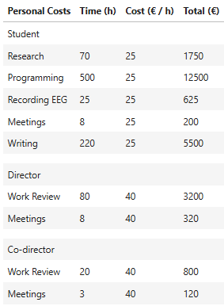
Table 7. Personal costs of the study
Table 8. Software costs
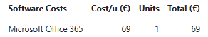
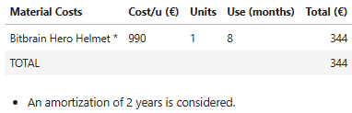
Table 9. Material costs
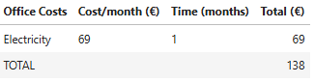
Table 10. Office related costs

CONCLUSIONS
This project explored the feasibility of developing a Brain-Computer Interface (BCI) system using a dry EEG helmet to classify motor imagery (MI) tasks. The results highlight both the potential and limitations of such systems. The classification performance differed depending on the approach used.
For literature-based features, the K-Nearest Neighbors (KNN) algorithm achieved a validation accuracy of 51.0%. However, the confusion matrices indicated significant limitations, as the model predominantly predicted a single class, reducing its practical discriminative ability. On the other hand, applying Common Spatial Patterns (CSP) features with a Decision Tree classifier showed some improvement, achieving a validation accuracy of 42.9%. While this approach demonstrated better balance in predictions, it still faced challenges related to generalization and overfitting.
The use of a dry EEG system introduced notable obstacles. Signal quality was compromised due to the sensitivity of dry electrodes to noise and artifacts, which affected the reliability of feature extraction and classification. Furthermore, variability in EEG signals across sessions and even within the same day posed additional challenges. This variability, influenced by factors such as electrode placement and participant state, highlighted the importance of robust calibration protocols to ensure consistency.
Although the project included functional code for real-time testing, the low accuracies achieved by the trained models limited their practical application. As a result, online tests were not extensively conducted, as they did not offer meaningful insights. Despite these limitations, this work provides a foundation for future advancements in BCI systems. Integrating more advanced EEG technologies, improved feature extraction methods, and robust machine learning techniques could significantly enhance system reliability and adaptability, paving the way for more practical and impactful applications in assistive technologies.

Acknowledgments
I would like to express my deepest gratitude to the individuals who have been crucial in the successful completion of this project.
First, a huge thanks to my master’s project Director, Joan Francesc Alonso López, for sharing his expertise, offering his support, and always guiding me in the right direction. His help has been crucial in shaping this work.
I also want to deeply thank my Co-director, Andres El-Fakdi Sencianes, for his dedication, encouragement, and constant motivation. His support kept me going, even when things got tough, and his guidance made a huge difference in reaching our goals.
A big thank you as well to my Co-director, Alicia Casals Gelpí, and the rest of the Tecsalut team, for their guidance and for giving me the tools and facilities to make this project happen.
Lastly, I’m beyond grateful to my partner, my family, and my closest friends. Your love, support, and encouragement were exactly what I needed whenever things felt overwhelming. Their presence and understanding have been a source of strength during challenging times, and I am grateful for their love and belief in me.

Bibliography
- https://www.bitbrain.com/es/productos-neurotecnologia/dry-eeg/hero
- R. Sharma, M. Kim, and A. Gupta, “Motor imagery classification in brain-machine interface with machine learning algorithms: Classical approach to multi-layer perceptron model,” *Biomed. Signal Process. Control*, vol. 71, p. 103101, 2022, doi: 10.1016/j.bspc.2021.103101.
- H.-J. Hwang, J.-H. Lim, Y.-J. Jung, H. Choi, S.-W. Lee, and C.-H. Im, “Development of an SSVEP-based BCI spelling system adopting a QWERTY-style LED keyboard,” J. Neurosci. Methods, vol. 208, no. 1, pp. 59–65, Apr. 2012, doi: 10.1016/j.jneumeth.2012.04.011.
- A. C. Lopes, G. Pires, and U. Nunes, “Assisted navigation for a brain-actuated intelligent wheelchair,” Rob. Auton. Syst., vol. 61, no. 3, pp. 245–258, Mar. 2013, doi: 10.1016/j.robot.2012.11.002.
- T. Carlson and J. R. Millán, “Brain-controlled wheelchairs: a robotic architecture,” IEEE Rob. Autom. Mag., vol. 20, no. 1, pp. 65–73, Mar. 2013, doi: 10.1109/MRA.2012.2229936.
- J. L. Collinger, B. Wodlinger, J. E. Downey, W. Wang, E. C. Tyler-Kabara, D. J. Weber, et al., “High performance neuroprosthetic control by an individual with tetraplegia,” Lancet, vol. 381, no. 9866, pp. 557–564, Feb. 2013, doi: 10.1016/S0140-6736(12)61816-9.
- G. Huang, Z. Zhao, S. Zhang, Z. Hu, J. Fan, M. Fu, J. Chen, Y. Xiao, J. Wang, and G. Dan, “Discrepancy between inter- and intra-subject variability in EEG-based motor imagery brain-computer interface: Evidence from multiple perspectives,” Front. Neurosci., vol. 17, p. 1122661, 2023, doi: 10.3389/fnins.2023.1122661.
- J. Ma, B. Yang, W. Qiu, Y. Li, S. Gao, and X. Xia, “A large EEG dataset for studying cross-session variability in motor imagery brain-computer interface,” Sci. Data, vol. 9, no. 1, 2022, doi: 10.1038/s41597-022-01647-1
- A. Piszcz, I. Rojek, and D. Mikołajewski, “Impact of Virtual Reality on Brain–Computer Interface Performance in IoT Control—Review of Current State of Knowledge,” Appl. Sci., vol. 14, no. 22, p. 10541, 2024, doi: 10.3390/app142210541.

- A. Palumbo, V. Gramigna, B. Calabrese, and N. Ielpo, “Motor-Imagery EEG-Based BCIs in Wheelchair Movement and Control: A Systematic Literature Review,” Sensors, vol. 21, no. 18, p. 6285, Sep. 2021, doi: 10.3390/s21186285.
- T. O. Zander, M. Lehne, K. Ihme, S. Jatzev, J. Correia, C. Kothe, B. Picht, and F. Nijboer, “A dry EEG-system for scientific research and brain-computer interfaces,” Front. Neurosci., vol. 5, p. 53, May 2011, doi: 10.3389/fnins.2011.00053.
- T. O. Zander, L. M. Andreessen, A. Berg, M. Bleuel, J. Pawlitzki, L. Zawallich, L. R. Krol, and K. Gramann, “Evaluation of a dry EEG system for application of passive brain-computer interfaces in autonomous driving,” Front. Hum. Neurosci., vol. 11, p. 78, 2017, doi: 10.3389/fnhum.2017.00078.
- C. Guger, G. Krausz, and G. Edlinger, “Brain-computer interface control with dry EEG electrodes,” 2011.
- M. Spüler, “A high-speed brain-computer interface (BCI) using dry EEG electrodes,” PLoS ONE, vol. 12, no. 2, p. e0172400, 2017, doi: 10.1371/journal.pone.0172400.
- H. Hinrichs, M. Scholz, A. K. Baum, J. W. Y. Kam, R. T. Knight, and H. Heinze, “Comparison between a wireless dry electrode EEG system with a conventional wired wet electrode EEG system for clinical applications,” Sci. Rep., vol. 10, no. 1, 2020, doi: 10.1038/s41598-020-62154-0.
- Chaudhuri, P. K. R., & Ondo, W. (2010). “Movement disorders in clinical practice. Springer”. https://books.google.es/books?id=bW8sPxMAG3AC
- M. N. Hatch, T. R. Cushing, G. D. Carlson, and E. Y. Chang, “Neuropathic pain and SCI: Identification and treatment strategies in the 21st century,” J. Neurol. Sci., vol. 384, pp. 75–83, Jan. 2018, doi: 10.1016/j.jns.2017.11.018.
- R. Shiao and C. A. Lee-Kubli, “Neuropathic Pain After Spinal Cord Injury: Challenges and Research Perspectives,” Neurotherapeutics, vol. 15, no. 3, pp. 635–653, Jul. 2018, doi: 10.1007/s13311-018-0633-4.
- E. M. Hagen and T. Rekand, “Management of Neuropathic Pain Associated with Spinal Cord Injury,” Pain Ther., vol. 4, no. 1, pp. 51–65, Jun. 2015, doi: 10.1007/s40122-015-0033-y.
- G. A. Light, L. E. Williams, F. Minow, J. Sprock, A. Rissling, R. Sharp, N. R. Swerdlow, and D. L. Braff, “Electroencephalography (EEG) and event-related potentials (ERPs) with human participants,” Curr. Protoc. Neurosci., vol. Chapter 6, pp. Unit 6.25.1–24, Jul. 2010, doi: 10.1002/0471142301.ns0625s52. PMID: 20578033; PMCID: PMC2909037.
- A. Rayi and N. I. Murr, "Electroencephalogram," in StatPearls [Internet], Treasure Island (FL): StatPearls Publishing, 2024 Jan–. Available from: https://www.ncbi.nlm.nih.gov/books/NBK563295/.
- L. F. Haas, “Hans Berger (1873–1941), Richard Caton (1842–1926), and electroencephalography,” J. Neurol. Neurosurg. Psychiatry, vol. 74, no. 1, p. 9, Jan. 2003, doi: 10.1136/jnnp.74.1.9. PMID: 12486257; PMCID: PMC1738204.
- M. Tudor, L. Tudor, and K. I. Tudor, “Hans Berger (1873–1941)–povijest elektroencefalografije [Hans Berger (1873–1941)–the history of electroencephalography],” Acta Med Croatica, vol. 59, no. 4, pp. 307–313, 2005. Croatian. PMID: 16334737.
- M. Roohi-Azizi, L. Azimi, S. Heysieattalab, and M. Aamidfar, “Changes of the brain’s bioelectrical activity in cognition, consciousness, and some mental disorders,” Med. J.Islam. Repub. Iran, vol. 31, no. 1, p. 53, 2017.
- P. Campisi, D. La Rocca, and G. Scarano, “EEG for automatic person recognition,” Computer (Long. Beach. Calif)., vol. 45, no. 7, pp. 87–89, 2012.
- R. Lesser and T. W. Picton, “American Electroencephalographic Society Guidelines for Standard Electrode Position Nomenclature1,” J. Clin. Neurophysiol., vol. 8, no. 2, pp. 200–202, 1991.
- N. Foldvary-Schaefer and M. M. Grigg-Damberger, “Identifying interictal and ictal epileptic activity in polysomnograms,” Sleep Med. Clin., vol. 7, no. 1, pp. 39–58, 2012.
- G. Reynolds and J. Richards, “Cortical source localization of infant cognition,” Dev. Neuropsychol., vol. 34, no. 3, pp. 312–329, 2009.
- N. Triana-Guzman, A. D. Orjuela-Cañon, A. L. Jutinico, O. Mendoza-Montoya, and J. M. Antelis, “Decoding EEG rhythms offline and online during motor imagery for standing and sitting based on a brain-computer interface,” Front. Neuroinform., vol. 16, 2022, doi: 10.3389/fninf.2022.961089.
- F. Lotte and C. Guan, “Regularizing common spatial patterns to improve BCI designs: unified theory and new algorithms,” IEEE Trans. Biomed. Eng., vol. 58, pp. 355–362, 2011, doi: 10.1109/TBME.2010.2082539.
- M. H. Lee, O. Y. Kwon, Y. J. Kim, H. K. Kim, Y. E. Lee, J. Williamson, et al., “EEG dataset and OpenBMI toolbox for three BCI paradigms: an investigation into BCI illiteracy,” Gigascience, vol. 8, pp. 1–16, 2019, doi: 10.1093/gigascience/giz002.
- E. V. Bobrova, V. V. Reshetnikova, A. A. Frolov, and Y. P. Gerasimenko, “Use of imaginary lower limb movements to control brain-computer interface systems,” Neurosci. Behav. Physiol., vol. 50, pp. 585–592, 2020, doi: 10.1007/s11055-020-00940-z.
- V. Asanza, E. Peláez, F. Loayza, L. L. Lorente-Leyva, and D. H. Peluffo-Ordóñez, “Identification of lower-limb motor tasks via brain-computer interfaces: a topical overview,” Sensors, vol. 22, pp. 1–24, 2022, doi: 10.3390/s22052028.
- M. Rodríguez-Ugarte, E. Iáñez, M. Ortíz, and J. M. Azorín, “Personalized offline and pseudo-online BCI models to detect pedaling intent,” Front. Neuroinform., vol. 11, p. 45, 2017, doi: 10.3389/fninf.2017.00045.
- A. Mora-Cortes, N. Manyakov, N. Chumerin, and M. Van Hulle, “Language model applications to spelling with brain-computer interfaces,” Sensors (Basel), vol. 14, no. 4, pp. 5967–5993, 2014.
- J. J. Shih, D. J. Krusienski, and J. R. Wolpaw, “Brain-computer interfaces in medicine,” Mayo Clin. Proc., vol. 87, no. 3, pp. 268–279, 2012.
- E. M. Smith, M. L. Toro Hernandez, I. D. Ebuenyi, *et al.*, “Assistive technology use and provision during COVID-19: results from a rapid global survey,” *Int. J. Health Policy Manag.*, vol. 11, no. 6, pp. 747–756, 2022, doi: 10.34172/ijhpm.2020.210.
- Ceradini, M., Lassi, M., Losanno, E., et al. (2023). Feasibility and Accuracy of a Dry and Wireless EEG Helmet for Upper Limb Motor Imagery-Based Brain-Computer Interfaces. IEEE International Conference on Metrology for eXtended Reality, Artificial Intelligence, and Neural Engineering (MetroXRAINE). https://doi.org/10.1109/METROXRAINE58569.2023.1040554&#8203;:contentReference[oaicite:2]{index=2}.
- Altaheri, H., Muhammad, G., Alsulaiman, M., et al. (2023). Deep learning techniques for classification of electroencephalogram (EEG) motor imagery (MI) signals: A review. Neural Computing and Applications, 35, 14681–14722. https://doi.org/10.1007/s00521-021-06352-5&#8203;:contentReference[oaicite:3]{index=3}.
- Palumbo, A., Gramigna, V., Calabrese, B., & Ielpo, N. (2021). Motor-Imagery EEG-Based BCIs in Wheelchair Movement and Control: A Systematic Literature Review. Sensors, 21(18), 6285. https://doi.org/10.3390/s21186285&#8203;:contentReference[oaicite:1]{index=1}.
- W. Huang, X. Liu, W. Yang, Y. Li, Q. Sun, and X. Kong, “Motor Imagery EEG Signal Classification Using Distinctive Feature Fusion with Adaptive Structural LASSO,” Sensors (Basel), vol. 24, no. 12, p. 3755, Jun. 2024, doi: 10.3390/s24123755. PMID: 38931540; PMCID: PMC11207242.
- X. Wang, X. Dai, Y. Liu, X. Chen, Q. Hu, R. Hu, and M. Li, “Motor imagery electroencephalogram classification algorithm based on joint features in the spatial and frequency domains and instance transfer,” Front. Hum. Neurosci., vol. 17, 2023, doi: 10.3389/fnhum.2023.1175399.
- N. K. Al-Qazzaz, Z. A. A. Alyasseri, K. H. Abdulkareem, N. S. Ali, M. N. Al-Mhiqani, and C. Guger, "EEG feature fusion for motor imagery: A new robust framework towards stroke patients rehabilitation," Computers in Biology and Medicine, vol. 137, 2021, doi: 10.1016/j.compbiomed.2021.104799.
- W. Yi, S. Qiu, H. Qi, L. Zhang, B. Wan, and D. Ming, "EEG feature comparison and classification of simple and compound limb motor imagery," Journal of NeuroEngineering and Rehabilitation, vol. 10, no. 106, 2013, doi: 10.1186/1743-0003-10-106.
- X. Geng, D. Li, H. Chen, P. Yu, H. Yan, and M. Yue, "An improved feature extraction algorithm of EEG signals based on motor imagery brain-computer interface," Alexandria Engineering Journal, vol. 61, no. 11, pp. 4807–4820, 2022, doi: 10.1016/j.aej.2021.10.034.
- X. Zhao, D. Liu, L. Ma, Q. Liu, K. Chen, S. Xie, and Q. Ai, "Deep CNN model based on serial-parallel structure optimization for four-class motor imagery EEG classification," Biomedical Signal Processing and Control, vol. 72, 2022, doi: 10.1016/j.bspc.2021.103338.
- W. Huang, X. Liu, W. Yang, Y. Li, Q. Sun, and X. Kong, "Motor Imagery EEG Signal Classification Using Distinctive Feature Fusion with Adaptive Structural LASSO," Sensors (Basel), vol. 24, no. 12, p. 3755, Jun. 2024, doi: 10.3390/s24123755. PMID: 38931540; PMCID: PMC11207242.
- X. Wang, X. Dai, Y. Liu, X. Chen, Q. Hu, R. Hu, and M. Li, "Motor imagery electroencephalogram classification algorithm based on joint features in the spatial and frequency domains and instance transfer," Frontiers in Human Neuroscience, vol. 17, 2023, doi: 10.3389/fnhum.2023.1175399.
- Y. Wang, X. Gao, S. Gao, & Z. Kuang, “Common Spatial Pattern Method for Channel Selection in Motor Imagery Based Brain-Computer Interface,” Proc. IEEE Eng. Med. Biol. Soc. Conf., pp. 5392–5395, 2005. doi: 10.1109/IEMBS.2005.1615701.
- S. Omari, A. Omari, & M. Abderrahim, “Multiple tangent space projection for motor imagery EEG classification,” Appl. Intell., vol. 53, pp. 21192–21200, 2023. doi: 10.1007/s10489-023-04551-2.
- M. R. Nuwer, “10-10 electrode system for EEG recording,” Clin. Neurophysiol., vol. 129, no. 5, p. 1103, May 2018.
- S. Park, J. Ha, D. H. Kim, and L. Kim, “Improving Motor Imagery-Based Brain- Computer Interface Performance Based on Sensory Stimulation Training: An Approach Focused on Poorly Performing Users,” Front. Neurosci., vol. 15, no. November, pp. 1–12, 2021.
- N. Padfield, J. Zabalza, H. Zhao, V. Masero, and J. Ren, “EEG-based brain-computer interfaces using motor-imagery: Techniques and challenges,” Sensors (Switzerland), vol. 19, no. 6, pp. 1–34, 2019.
- A. Saibene, M. Caglioni, S. Corchs, & F. Gasparini, “EEG-Based BCIs on Motor Imagery Paradigm Using Wearable Technologies: A Systematic Review,” Sensors, vol. 23, no. 5, p. 2798, Mar. 2023. doi: 10.3390/s23052798. PMID: 36905004; PMCID: PMC10007053.
- C. Kothe, S. Y. Shirazi, T. Stenner, D. Medine, C. Boulay, M. I. Grivich, T. Mullen, A. Delorme, and S. Makeig, “The Lab Streaming Layer (LSL): A software system for multimodal real-time data acquisition, synchronization, and storage in neuroscience applications,” bioRxiv, 2024. doi: 10.1101/2024.02.13.580071.
- https://labstreaminglayer.readthedocs.io/info/user_guide.html
- https://www.psychopy.org/
- J. W. Peirce, “PsychoPy—Psychophysics software in Python,” J. Neurosci. Methods, vol. 162, no. 1–2, pp. 8–13, 2007, doi: 10.1016/j.jneumeth.2006.11.017.
- S. Pattnaik, M. Dash, and S. K. Sabut, “DWT-based feature extraction and classification for motor imaginary EEG signals,” 2016 Int. Conf. Syst. Med. Biol. ICSMB 2016, no. January, pp. 186–201, 2017.
- P. Rithwik, V. K. Benzy, and A. P. Vinod, “High accuracy decoding of motor imagery directions from EEG-based brain computer interface using filter bank spatially regularised common spatial pattern method,” Biomed. Signal Process. Control, vol.72, no. PA, p. 103241, 2022.

- J. Kalcher, D. Flotzinger, C. Neuper, S. Gölly, and G. Pfurtscheller, “Graz brain-computer interface II: Towards communication between humans and computers based on online classification of three different EEG patterns,” Med. Biol. Eng. Comput., vol. 34, no. 5, pp. 382–388, 1996.
- C. Brunner, R. Leeb, G. R. Müller-Putz, A. Schlögl, and G. Pfurtscheller, “BCI Competition 2008-Graz data set A Experimental paradigm.”
- A. Suwannarat, S. Pan-ngum, and P. Israsena, “Comparison of EEG measurement of upper limb movement in motor imagery training system,” Biomed. Eng. Online, vol.17, no. 1, pp. 1–22, 2018.
- L. Takayama, G. Merino, E. Merino, L. Garcia, J. Cunha, and S. Domenech, “Hand tool project requirements: The case of banana cultivation and its physical demands (OWAS),” Prod. Manag. Dev., vol. 13, pp. 119–130, 2015.
- https://github.com/labstreaminglayer/App-LabRecorder
- https://github.com/Xarcu/TFM_EEG.git

Additional bibliography

- J. Xu, H. Zheng, J. Wang, D. Li, and X. Fang, “Recognition of EEG signal motor imagery intention based on deep multi-view feature learning,” Sensors (Basel), vol. 20, no. 12, p. 3496, Jun. 2020, doi: 10.3390/s20123496.

