**Section 1:**

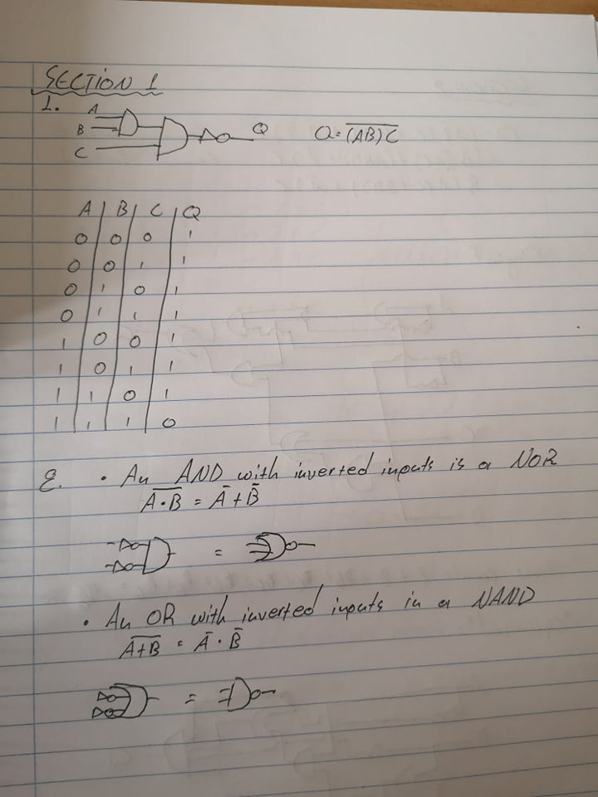

**Section 2:**

**Normal:**

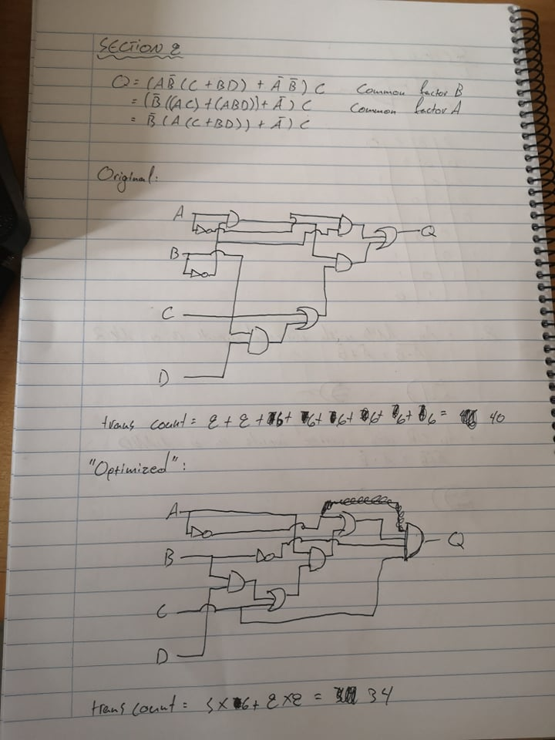

**Alternative:**

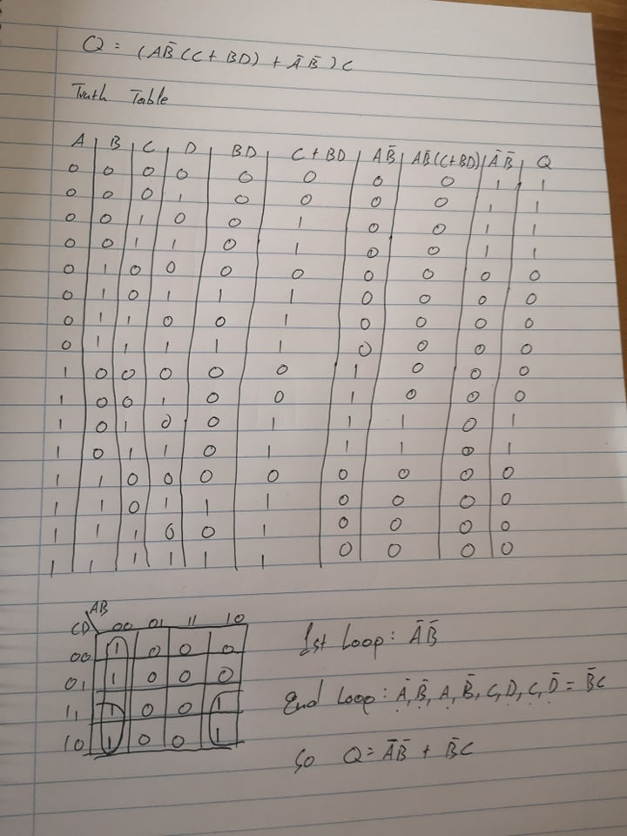

**Optimized**

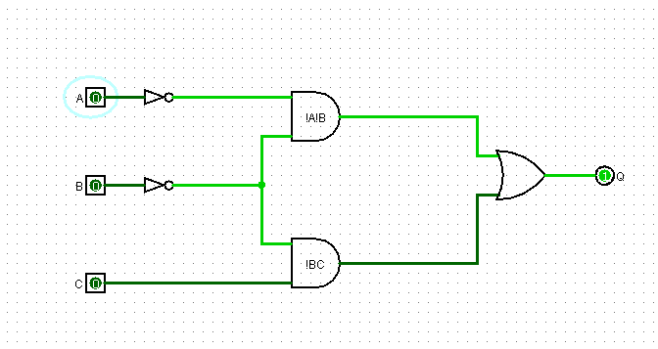

**NAND Only:**

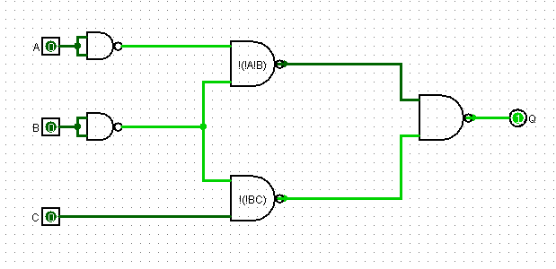

**Trans count for optimized circuit: 3*7 + 2*2= 25**

**Trans count for NAND circuit: 5*5 = 25**

**Section 3:**

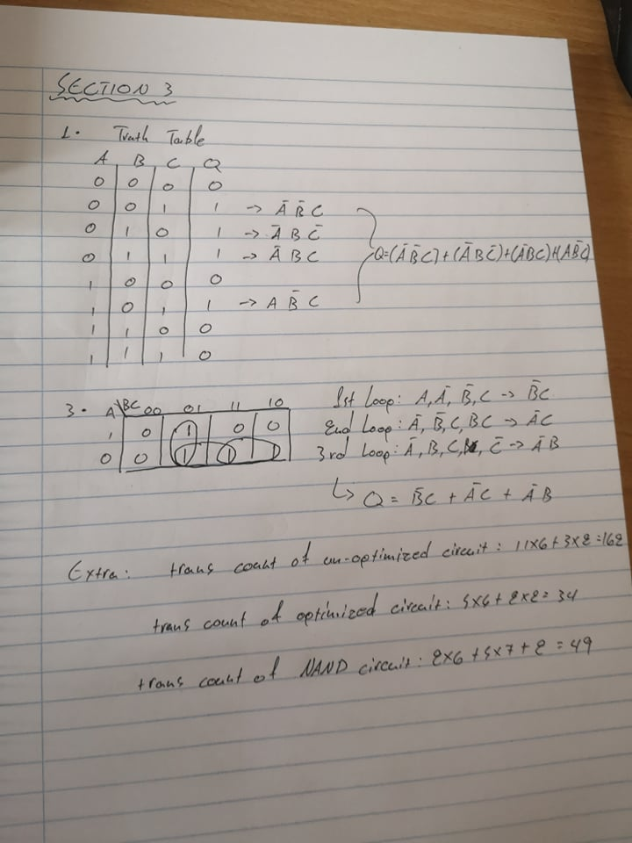

**3.2- Non-Optimized**

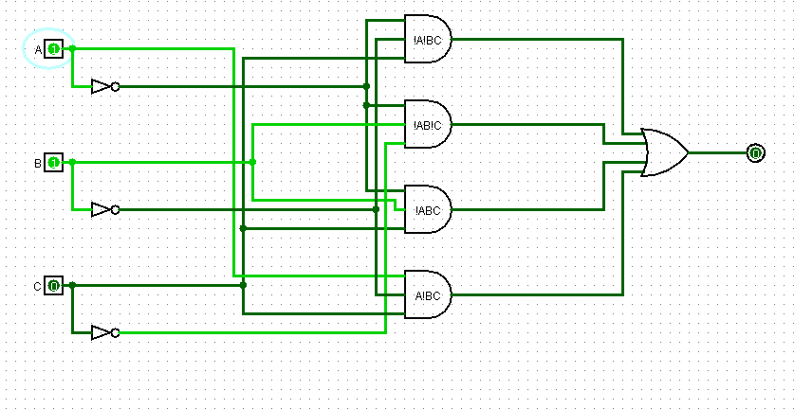

**3.4- Optimized**

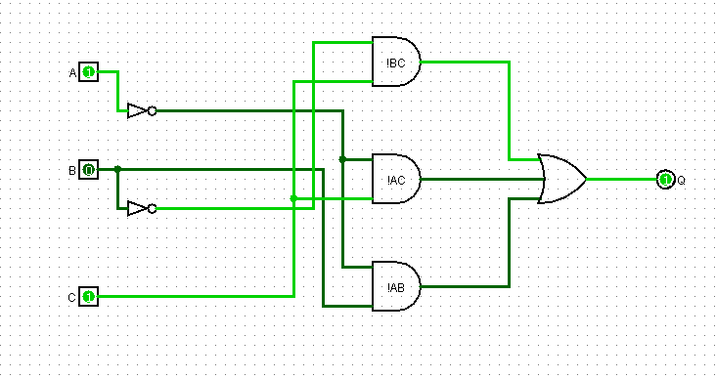

**3.5- NAND Only:**

