**CS 306 FINAL PROJECT REPORT**

**UML CLASS DIAGRAM:**

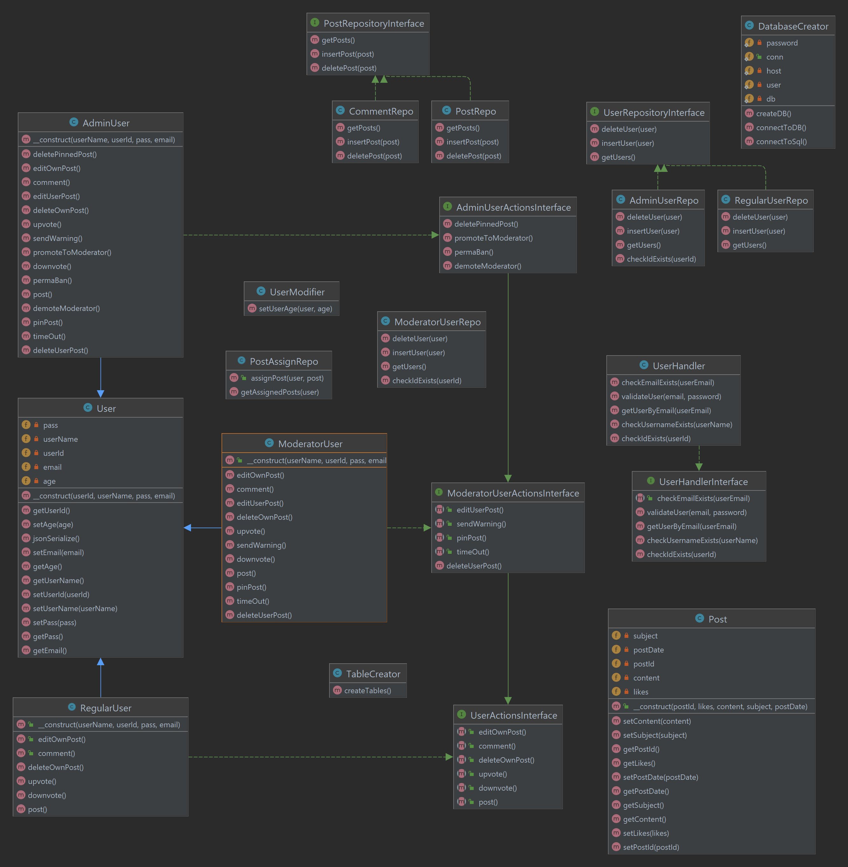

**Description:** This project aims to be the foundation for a fully functional personal website. Currently, a sophisticated login system is fully implemented, while a forum functionality remained only partial, with no user interactions available. Still, all the learning outcomes of the project are satisfied.

To run the project, please install and run XAMMP. Place the project folder in the root directory of XAMMP. Make sure your username is set to root and the password is empty. Otherwise, you can change these settings in DatabaseCreator.php.

Use a browser to navigate to <http://localhost/Web%20development/Personal%20Page/View/HTML/WelcomePage.html>

That’s it! The database and the tables will be created automatically. Also, an admin user will be created and added to the database. This will be important for future implementations, since all new users start as regular users, only the admin has the power to promote a user to a moderator, and there is no way to create an admin not hard-coded.

Disclaimer, the site is still at the very early stages of development; there are of course a lot of security issues (zero encryption) and many ways to break it. There is no profile page, no forum, and no functional shop. Finally, XAMMP creates some issues with the css files so the design might be slightly different if the HTML files are opened directly.

Despite all this, the project corresponds to all the requirements of the course and adds a lot of extra details, denoted in the comments of the code.

Thank you for taking the time to review it.