Assignment :01

24k_3055  
Bse-2A  
Malik Zaryab Awan

Q1:

package Q1;  
  
import java.util.ArrayList;  
  
public class Student {  
 int Std_id;  
 String Std_name;  
 int Std_age;  
 ArrayList<Sports> SportInterest;  
 ArrayList<Mentor> Mentor_assigned;  
  
 Student(int Std_id,String Std_name,int Std_age){  
 this.Std_id=Std_id;  
 this.Std_age=Std_age;  
 this.Std_name=Std_name;  
 SportInterest=new ArrayList<>();  
 Mentor_assigned=new ArrayList<>();  
  
 }  
 public void Display_Student_details()  
 {  
 System.*out*.println("Student Name: "+Std_name);  
 System.*out*.println("Student ID: "+Std_id);  
 System.*out*.println("Student Age: "+Std_id);  
 System.*out*.println("Sports Interest: "+ SportInterest);  
 }  
 public void Register_for_mentorship(Mentor m){  
 Mentor_assigned.add(m);  
 }  
 public void View_mentor_details(){  
 for(Mentor m:Mentor_assigned)  
 {  
 m.Display_mentor_details();  
 }  
 }  
 public void Update_sports_interest(Sports sports){  
 SportInterest.add(sports);  
  
 }  
}

package Q1;  
  
public class Skills {  
 private int Skill_id;  
 private String Skill_name;  
 private String Skill_description;  
  
 Skills(int skill_id,String skill_name,String skill_description){  
 this.Skill_name=skill_name;  
 this.Skill_description=skill_description;  
 this.Skill_id=skill_id;  
 }  
 public void Show_Skill_details(){  
 System.*out*.println("Skill ID: "+Skill_id);  
 System.*out*.println("Skill Name: "+Skill_name);  
 System.*out*.println("Skill Description: "+Skill_description);  
 }  
 public void Update_skill_description(String skill_description){  
 this.Skill_description=skill_description;  
 }  
}

package Q1;  
  
import java.util.ArrayList;  
  
public class Sports {  
 private int Sports_id;  
 private String Sports_name;  
 private String Sports_description;  
 private ArrayList<Skills> Required_skills;  
  
 Sports(int sports_id,String sports_name,String sports_description,ArrayList required_skills){  
 this.Sports_id=sports_id;  
 this.Sports_name=sports_name;  
 this.Sports_description=sports_description;  
 this.Required_skills=required_skills;  
 }  
 public void Add_skill(Skills s){  
 Required_skills.add(s);  
 }  
 public void Remove_skill(Skills s){  
 if(Required_skills.contains(s)){  
 Required_skills.remove(s);  
 }  
 else {  
 System.*out*.println("Skill not found");  
 }  
 }  
}

package Q1;  
  
import java.sql.SQLOutput;  
import java.util.ArrayList;  
  
public class Mentor {  
 private int Mentor_id;  
 private String Mentor_name;  
 private int Max_learners;  
 private ArrayList<Student> Assigned_learners;  
 private ArrayList<String> Sports_expertise;  
  
 Mentor(int Mentor_id,String Mentor_name,int Max_learners, ArrayList<String>Sports_expertise)  
 {  
 this.Mentor_id=Mentor_id;  
 this.Mentor_name=Mentor_name;  
 this.Max_learners=Max_learners;  
 this.Sports_expertise=Sports_expertise;  
 this.Assigned_learners=new ArrayList<>();  
 }  
 public void Assign_learner(Student s){  
 if(Assigned_learners.size()<Max_learners)  
 {  
 Assigned_learners.add(s);  
 System.*out*.println("Student Added Successfully");  
 }  
 else {  
 System.*out*.println("Cannot Assign(learners full)");  
 }  
 }  
 public void Remove_learner(Student s){  
 if(Assigned_learners.contains(s)){  
 Assigned_learners.remove(s);  
 System.*out*.println("Student Removed Successfully");  
 }  
 else {  
 System.*out*.println("Student Not found");  
 }  
 }  
 public void View_learners(){  
 for (Student assignedLearner : Assigned_learners) {  
 assignedLearner.Display_Student_details();  
 }  
 }  
 public void Provide_guidance(){  
 System.*out*.println("Bonus Tip: Sleep,Pray and Work Hard");  
 }  
 public void Display_mentor_details(){  
 System.*out*.println("Mentor Id: "+Mentor_id);  
 System.*out*.println("Mentor Name: "+Mentor_name);  
 System.*out*.println("Sports Expertise: "+Sports_expertise);  
 System.*out*.println("Max Learners: "+Max_learners);  
 }  
 }

package Q1;  
  
import java.util.ArrayList;  
  
public class Main {  
 public static void main(String[] args) {  
 Student std1=new Student(3055,"xaryab",19);  
 Student std2=new Student(2551,"arham",19);  
 ArrayList<String> M_Sports_expertise=new ArrayList<>();  
 M_Sports_expertise.add("Physical Fitness");  
 M_Sports_expertise.add("Team Work");  
 Mentor men1=new Mentor(2899,"Rehab",4,M_Sports_expertise);  
 Skills skill1=new Skills(1221,"fitness","Physically fit");  
 Skills skill2=new Skills(1332,"agility","ability to move quickly and easily");  
 Skills skill3=new Skills(1414,"Strength","ability to lift hard");  
 ArrayList<Skills> skills=new ArrayList<>();  
 skills.add(skill1);  
 skills.add(skill2);  
 Sports sport1=new Sports(1212,"Football","Football is played with a ball n 2 teams",skills);  
 std1.Register_for_mentorship(men1);  
 std1.Update_sports_interest(sport1);  
 std1.View_mentor_details();  
 men1.Assign_learner(std2);  
 men1.Provide_guidance();  
 men1.View_learners();  
 men1.Remove_learner(std1);  
 men1.View_learners();  
 sport1.Add_skill(skill3);  
 sport1.Remove_skill(skill1);  
 skill1.Show_Skill_details();  
  
 }  
}

Output:

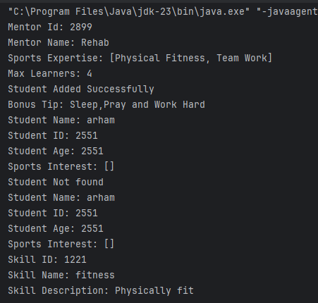

Q2:

package Q2;  
  
public class Robot {  
 String Robot_name;  
 int hits;  
  
 Robot(String robot_name){  
 this.Robot_name=robot_name;  
 this.hits=0;  
 }  
 public int getHits() {  
 return hits;  
 }  
 public void setHits(int hits) {  
 this.hits = hits;  
 }  
 public String getName() {  
 return Robot_name;  
 }  
 public void setName(String name) {  
 this.Robot_name = name;  
 }  
  
 void hit_ball(Ball ball,String direction){  
 if(direction.equalsIgnoreCase("right")){  
 ball.move(1,0);  
 }  
 if(direction.equalsIgnoreCase("left")){  
 ball.move(-1,0);  
 }  
 if (direction.equalsIgnoreCase("up")){  
 ball.move(0,-1);  
 }  
 if (direction.equalsIgnoreCase("down")){  
 ball.move(0,1);  
 }  
 this.hits++;  
 }  
  
}

package Q2;  
  
public class Ball {  
 private int x;  
 private int y;  
  
 Ball(int x,int y){  
 this.x = x;  
 this.y = y;  
 }  
 Ball(){  
 this.x = 0;  
 this.y = 0;  
 }  
 public int getX() {  
 return x;  
 }  
 public int getY() {  
 return y;  
 }  
 public void move(int dx,int dy) {  
 this.x += dx;  
 this.y += dy;  
 }  
 public int[] getPosition(){  
 return new int[]{this.x,this.y};  
 }  
}

package Q2;  
  
import java.util.Scanner;  
  
public class Game {  
 private Team team1;  
 private Team team2;  
 private Goal goal;  
 private Ball ball;  
  
 public Game(Team team1, Team team2) {  
 this.team1 = team1;  
 this.team2 = team2;  
 this.goal = new Goal();  
 this.ball = new Ball();  
 }  
 public void startGame(){  
 System.*out*.println("Game Start! Score the Goal with least hits. Goal at(3,3)");  
 play(team1);  
 ball = new Ball();  
 play(team2);  
 declare_winner();  
 }  
 public void play(Team team){  
 Scanner sc = new Scanner(System.*in*);  
 System.*out*.println(team.getTeamName()+ " is playing!");  
 while (!goal.isGoalReached(ball.getX(), ball.getY())){  
 String move;  
 System.*out*.println("Enter your choice: ");  
 System.*out*.println("(Up)--(Down)--(Left)--(Right)");  
 move = sc.nextLine();  
 team.getRobot().hit_ball(ball, move);  
 System.*out*.println(team.getTeamName()+" moved the ball "+move+". New coordinates("+ball.getX()+")("+ball.getY()+")");  
 }  
 System.*out*.println(team.getTeamName()+" reached goal with "+team.getRobot().getHits()+" hits!");  
 }  
  
 public void declare_winner(){  
 if(team1.getRobot().getHits()<team2.getRobot().getHits()){  
 System.*out*.println(team1.getRobot()+" Won the match with "+team1.getRobot().getHits()+" hits!");  
 } else if (team2.getRobot().getHits()<team1.getRobot().getHits()) {  
 System.*out*.println(team2.getRobot()+" Won the match with "+team2.getRobot().getHits()+" hits!");  
 }  
 else {  
 System.*out*.println("It is a tie!");  
 }  
 }  
}

package Q2;  
  
public class Goal {  
 private final int y = 3;  
 private final int x = 3;  
  
 public Boolean isGoalReached(int y, int x) {  
 if(this.y == y && this.x == x)  
 {  
 return true;  
 }  
 else return false;  
 }  
}

package Q2;  
  
public class Team {  
 private String TeamName;  
 private Robot robot;  
  
  
 Team(String TeamName,Robot robot) {  
 this.TeamName = TeamName;  
 this.robot = robot;  
 }  
  
 public String getTeamName() {  
 return TeamName;  
 }  
 public Robot getRobot() {  
 return robot;  
 }  
  
}

package Q2;  
  
public class Main {  
 public static void main(String[] args) {  
 System.*out*.println("Football Game Simulator!!");  
 Robot R1=new Robot("Cristiano");  
 Robot R2=new Robot("Messi");  
 Team t1=new Team("Portugal",R1);  
 Team t2=new Team("Argentina",R2);  
 Game G=new Game(t1,t2);  
 G.startGame();  
 }  
}

Output:

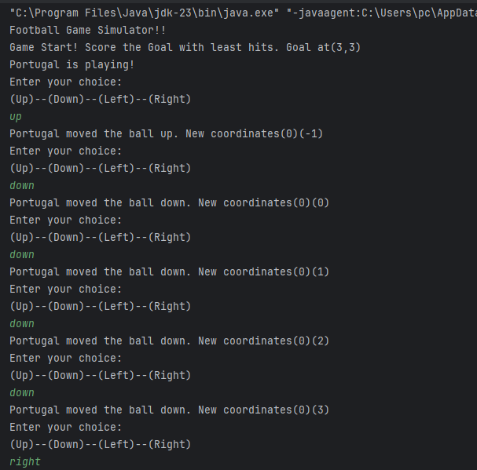

Q3:

package Q3;  
  
import java.util.ArrayList;  
import java.util.Scanner;  
  
public class User {  
 private int age;  
 private String LicenseType;  
 private String UserId;  
 private String ContactInformation;  
  
 public String getUserId() {  
 return UserId;  
 }  
  
 Boolean VehicleAllotted;  
  
 public String getLicenseType() {  
 return LicenseType;  
 }  
  
  
  
 public User(int age, String licenseType, String userId, String contactInformation) {  
 this.age = age;  
 LicenseType = licenseType;  
 UserId = userId;  
 ContactInformation = contactInformation;  
 VehicleAllotted = false;  
 }  
 public void UpdateInformation(){  
 Scanner sc=new Scanner(System.*in*);  
 System.*out*.println("What do you want to update?");  
 System.*out*.println("1. Age:");  
 System.*out*.println("2. LicenseType:");  
 System.*out*.println("3. ContactInformation:");  
 int choice=sc.nextInt();  
 switch(choice){  
 case 1:  
 System.*out*.println("Enter Age :");  
 int age=sc.nextInt();  
 this.age=age;  
 System.*out*.println("Age updated");  
 break;  
 case 2:  
 System.*out*.println("Enter LicenseType :");  
 String licenseType=sc.next();  
 this.LicenseType=licenseType;  
 System.*out*.println("License type updated");  
 break;  
 case 3:  
 System.*out*.println("Enter ContactInformation :");  
 String contactInformation=sc.next();  
 this.ContactInformation=contactInformation;  
 System.*out*.println("Contact information updated");  
 break;  
 default:  
 break;  
  
 }  
 }  
  
  
 public void setVehicleAllotted(boolean b) {  
 this.VehicleAllotted=b;  
 }  
}

package Q3;  
  
import java.util.ArrayList;  
  
public class Vehicles {  
 private String Name;  
 private String Model;  
 private int Rental_price;  
 private String Eligibility;  
  
 public Vehicles(String name,String model, int rental_price, String eligibility) {  
 this.Name=name;  
 this.Model = model;  
 this.Rental_price = rental_price;  
 this.Eligibility = eligibility;  
  
 }  
  
 public String getEligibility() {  
 return Eligibility;  
 }  
  
 public void Display_Vehicles(){  
 System.*out*.println("Model: "+Model);  
 System.*out*.println("Rental Price: "+Rental_price);  
 System.*out*.println("Eligibility: "+Eligibility);  
 }  
  
 public void displayVehicles() {  
 System.*out*.println("Name: "+Name);  
 System.*out*.println("Model: "+Model);  
 System.*out*.println("Rental Price: "+Rental_price);  
 System.*out*.println("Eligibility: "+Eligibility);  
 }  
}

package Q3;  
import java.util.*;  
public class Main {  
 public static void main(String[] args) {  
 Vehicles v1 = new Vehicles("Mustang", "1999", 3000, "Full");  
 Vehicles v2 = new Vehicles("Alto", "2006", 1000, "intermediate");  
 Vehicles v3 = new Vehicles("Mehran", "2010", 500, "Learner");  
 ArrayList<Vehicles> vehicles = new ArrayList<>();  
 vehicles.add(v1);  
 vehicles.add(v2);  
 vehicles.add(v3);  
 User u1 = new User(18, "Full", "3055", "xaryabawan@gmail.com");  
 User u2 = new User(19, "Intermediate", "2551", "Syedarham@gmail.com");  
 User u3 = new User(17, "Learner", "3007", "abdulrafay@gmail.com");  
  
 ArrayList<User> users = new ArrayList<>();  
 users.add(u1);  
 users.add(u2);  
 users.add(u3);  
  
 Scanner sc = new Scanner(System.*in*);  
 System.*out*.println("Available Vehicles:");  
 for (Vehicles v : vehicles) {  
 v.displayVehicles();  
 }  
  
  
 for (User user : users) {  
 boolean vehicleAllotted = false;  
 for (Vehicles v : vehicles) {  
 if (user.getLicenseType().equalsIgnoreCase(v.getEligibility())) {  
 System.*out*.println("Vehicle Allotted to User: " + user.getUserId());  
 vehicles.remove(v);  
 user.setVehicleAllotted(true);  
 vehicleAllotted = true;  
 break;  
 }  
 }  
 if (!vehicleAllotted) {  
 System.*out*.println(user.getUserId() + ": Vehicle Not Allotted");  
 }  
 }  
 int choiceInt = 0;  
 do {  
 System.*out*.println("Do you want to update information? (Y/N)");  
 String choice = sc.nextLine();  
 if (choice.equalsIgnoreCase("Y")) {  
 System.*out*.println("Which user's information would you like to update?");  
 System.*out*.println("1. "+u1.getUserId());  
 System.*out*.println("2. "+u2.getUserId());  
 System.*out*.println("3. "+u3.getUserId());  
 System.*out*.println("4. Exit");  
 choiceInt = sc.nextInt();  
 if(choiceInt == 1) {  
 u1.UpdateInformation();  
 }  
 else if(choiceInt == 2) {  
 u2.UpdateInformation();  
 }  
 else if(choiceInt == 3) {  
 u3.UpdateInformation();  
 }  
 }  
 else if (choice.equalsIgnoreCase("N")) {  
 System.*out*.println("exiting program....");  
 break;  
 }  
 if(choiceInt==4){  
 System.*out*.println("exiting program....");  
 break;  
 }  
 }while (choiceInt!=4);  
  
  
  
 }  
}

Output:

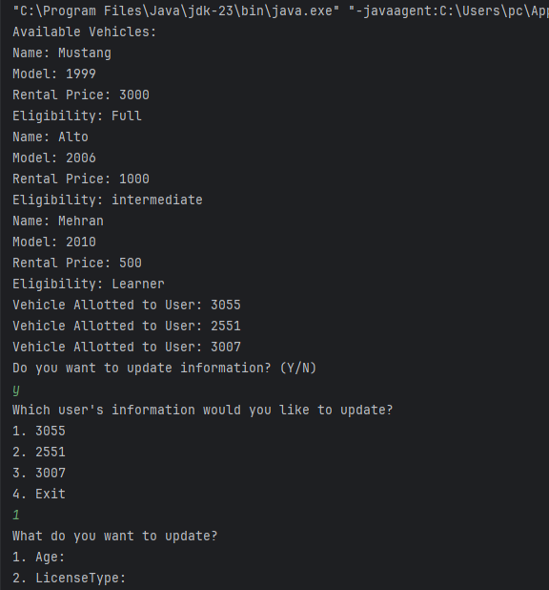

Q4:

package Q4;  
  
public class Student {  
 private String name;  
 private String StdId;  
 private double Balance;  
 private static final double *Sem_fee*=5000;  
 private Boolean TransportationCard;  
  
 public Student(String name, String stdId) {  
 this.name = name;  
 this.StdId = stdId;  
 this.Balance = 0;  
 this.TransportationCard = false;  
 }  
 public String getName() {  
 return name;  
 }  
 public String getStdId() {  
 return StdId;  
 }  
 public double getBalance() {  
 return Balance;  
 }  
 public Boolean getTransportationCard() {  
 return TransportationCard;  
 }  
 public void register(){  
 System.*out*.println(this.name + " has been registered");  
 }  
 public void payFee(double Fee){  
 if(Fee>=*Sem_fee*){  
 Balance+=Fee;  
 TransportationCard=true;  
 System.*out*.println("Fee has been payed for "+this.name);  
 }  
 else{  
 System.*out*.println("Insufficient funds");  
 }  
 }  
 public void CardStatus(){  
 if(TransportationCard){  
 System.*out*.println("Transportation Card is Active");  
 }  
 else{  
 System.*out*.println("Transportation Card is not Active");  
 }  
 }  
 public void tapCard(Bus bus){  
 if(TransportationCard){  
 Attendance.*RecordAttendance*(this,bus);  
 }  
 else {  
 System.*out*.println("Card is inactive . Please Pay ur semester Fee");  
 }  
 }  
  
}

package Q4;  
  
public class Bus {  
 private int Bus_id;  
 private String Bus_number;  
 private Transportation AssignedRoute;  
  
 public Bus( String bus_number, int bus_id) {  
 Bus_number = bus_number;  
 Bus_id = bus_id;  
 }  
  
 public int getBus_id() {  
 return Bus_id;  
 }  
  
 public String getBus_number() {  
 return Bus_number;  
 }  
  
 public Transportation getAssignedRoute() {  
 return AssignedRoute;  
 }  
 public void setAssignedRoute(Transportation assignedRoute) {  
 this.AssignedRoute = assignedRoute;  
 System.*out*.println("Bus:"+Bus_number+" Assigned Route:"+assignedRoute.getRouteName());  
  
 }  
}

package Q4;  
  
import java.util.ArrayList;  
  
public class Transportation {  
 private int route_id;  
 private String routeName;  
 private ArrayList<String> stops;  
  
 public String getRouteName() {  
 return routeName;  
 }  
  
 public int getRoute_id() {  
 return route_id;  
 }  
  
 public Transportation(int route_id, String routeName) {  
 this.route_id = route_id;  
 this.routeName = routeName;  
 stops=new ArrayList<>();  
 }  
 public void addStop(String stop) {  
 stops.add(stop);  
 System.*out*.println("Stop added to route"+this.routeName);  
 }  
 public void removeStop(String stop) {  
 if(stops.contains(stop)){  
 stops.remove(stop);  
 }  
 else {  
 System.*out*.println("Stop not found in route"+this.routeName);  
 }  
 }  
  
 public ArrayList<String> getStops() {  
 return stops;  
 }  
  
}

package Q4;  
  
public class Attendance {  
 private int Student_Id;  
 private String date;  
 private Boolean Status;  
  
 public int getStudent_Id() {  
 return Student_Id;  
 }  
  
 public String getDate() {  
 return date;  
 }  
  
 public Boolean getStatus() {  
 return Status;  
 }  
  
 public Attendance(int Student_Id, String date, Boolean Status) {  
 this.Student_Id = Student_Id;  
 this.date = date;  
 this.Status = Status;  
  
 }  
 public static void RecordAttendance(Student student,Bus bus){  
 System.*out*.println(student.getName()+" ID: "+student.getName()+" tapped thier card on bus "+bus.getBus_number());  
 System.*out*.println("Attendance Recorded for "+java.time.LocalDate.*now*());  
 }  
  
}

package Q4;  
  
public class Main {  
 public static void main(String[] args) {  
 System.*out*.println("24k-3055");  
 System.*out*.println("Xaryab");  
 System.*out*.println("Bse-2A");  
 Student s1=new Student("xaryab","3055");  
 Student s2=new Student("arham","2551");  
 s1.register();  
 s2.register();  
 s1.payFee(5000);  
 s2.payFee(4000);  
 s1.CardStatus();  
 s2.CardStatus();  
 Transportation route1=new Transportation(111,"Route 01");  
 route1.addStop("Stop_1");  
 route1.addStop("Stop_2");  
 Bus b1=new Bus("Bus112",112);  
 b1.setAssignedRoute(route1);  
 s1.tapCard(b1);  
 s2.tapCard(b1);  
  
 }  
}

CLASS DIAGRAM:

