LabTasks:03

Q1:

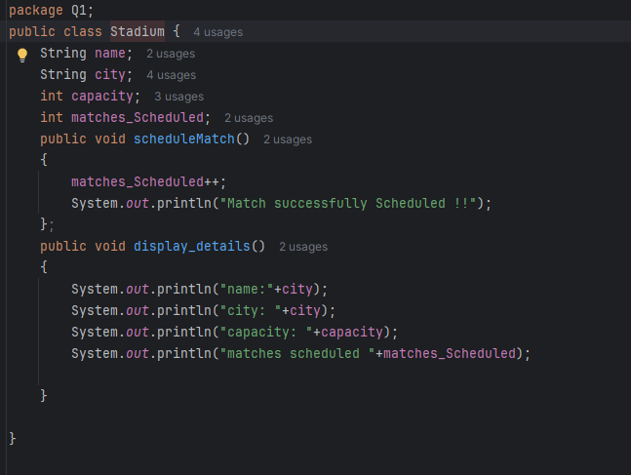

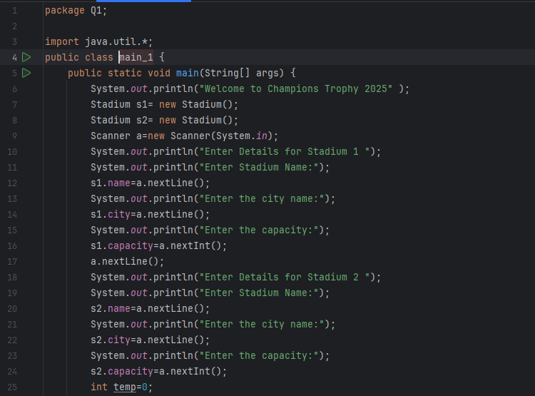

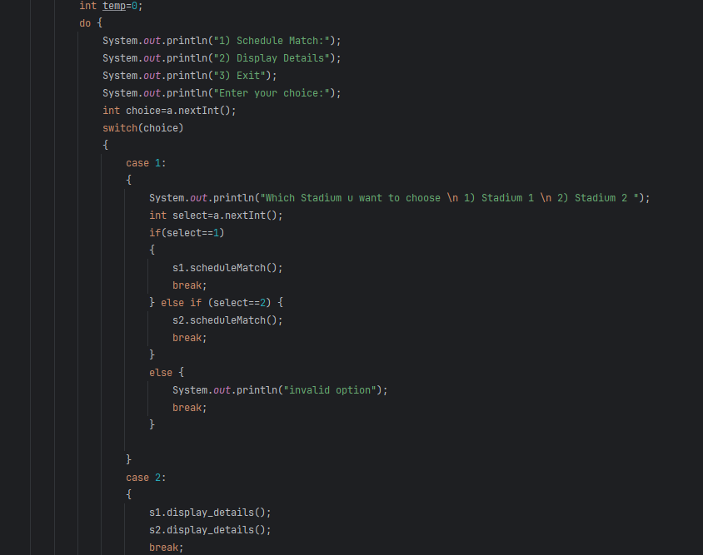

Output:

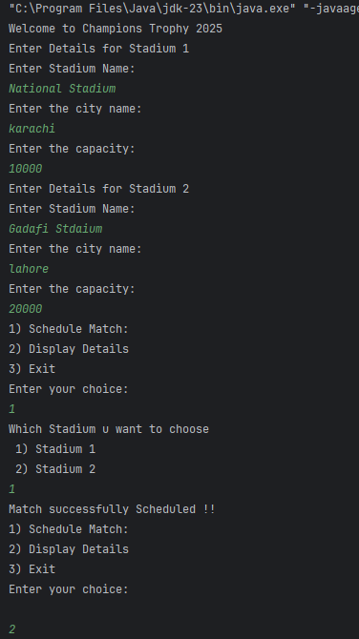

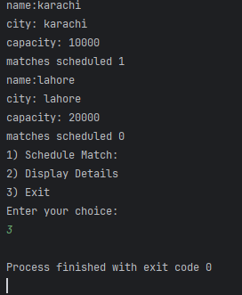

Q2:

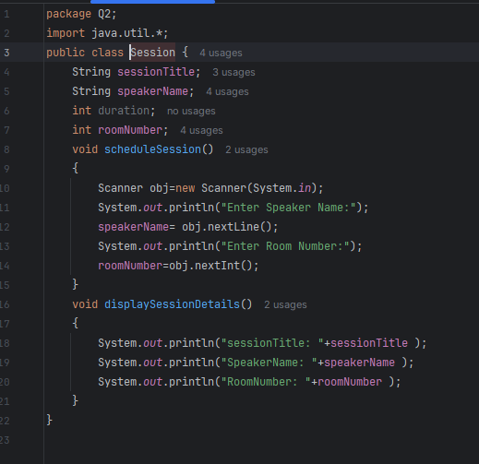

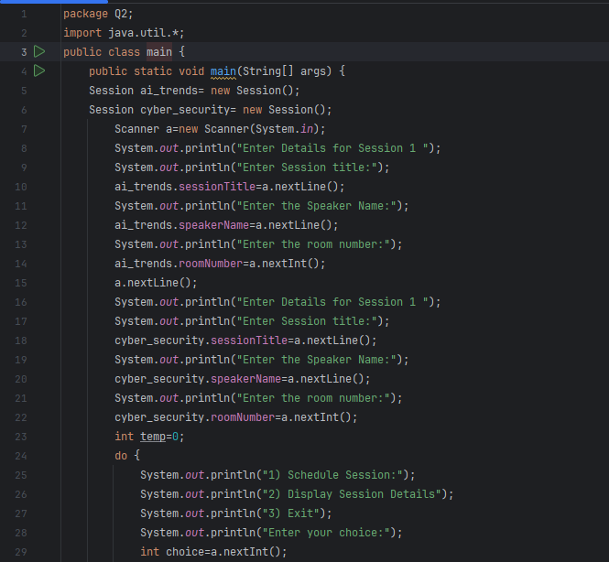

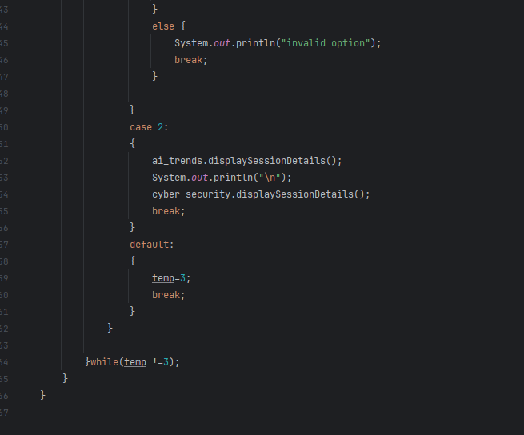

Output:

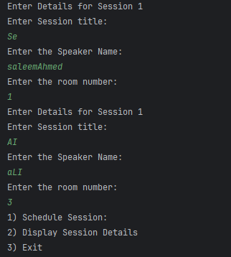

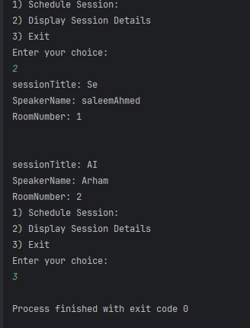

Q3:

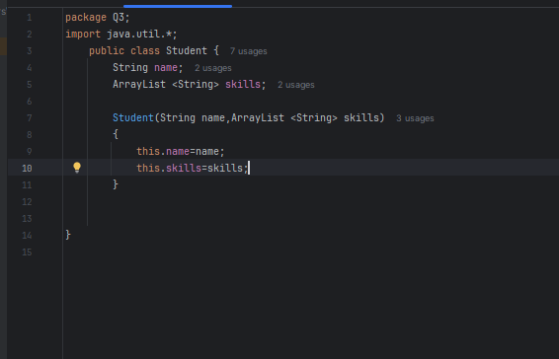

Output:

Q4:

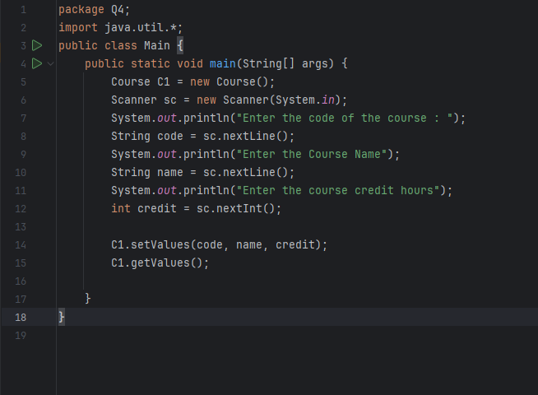

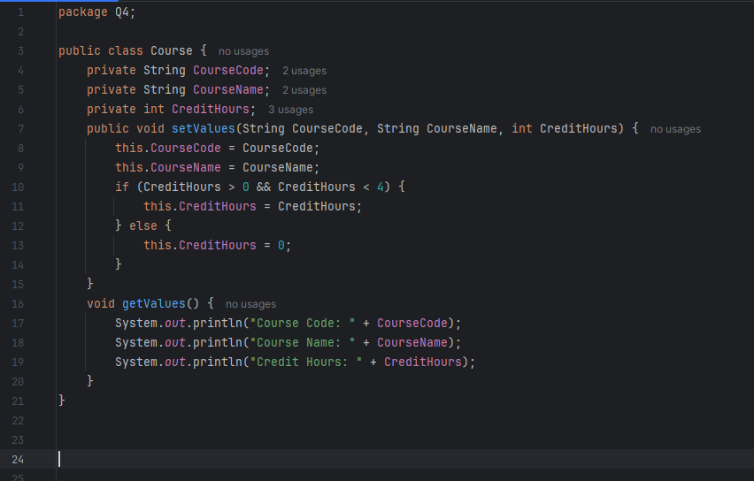

Output:

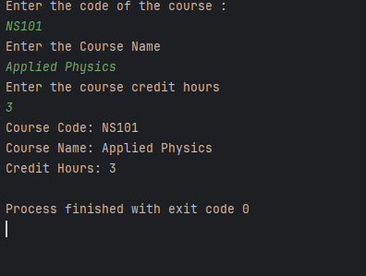

Q5:

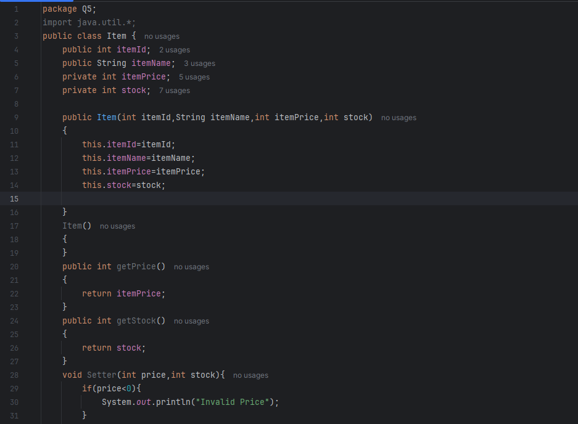

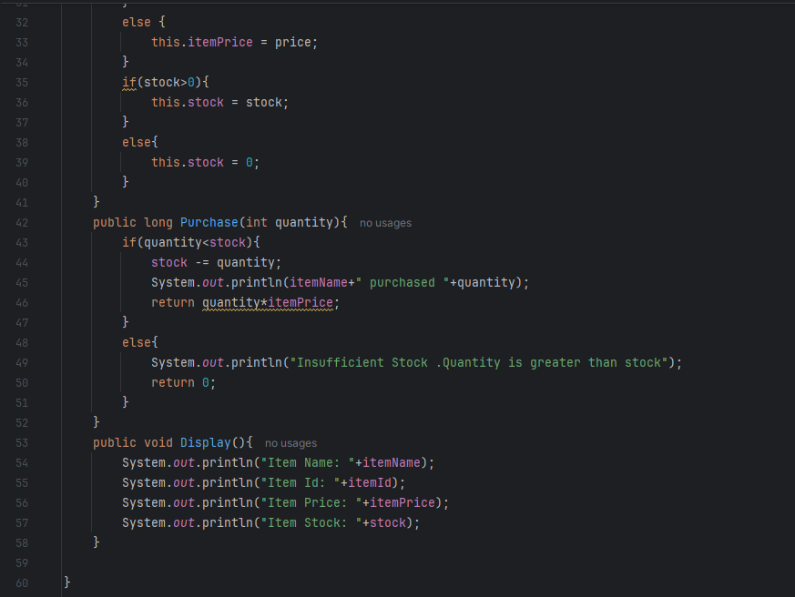

Output:

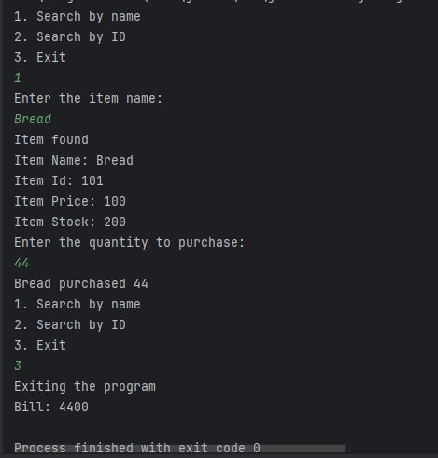

Q6:

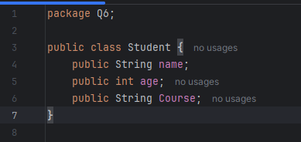

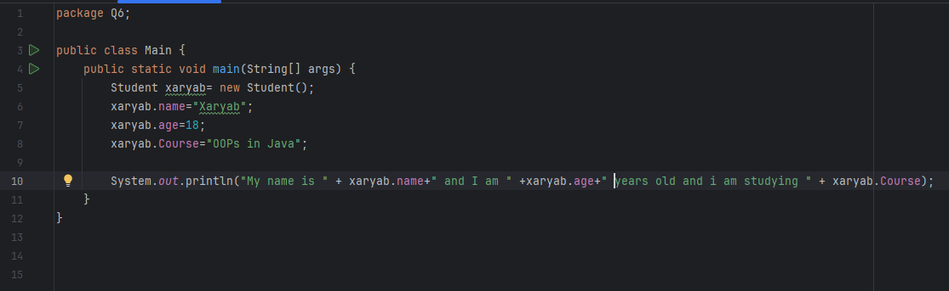

Output:

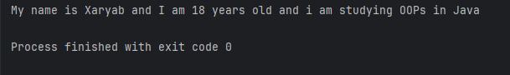

Q7:

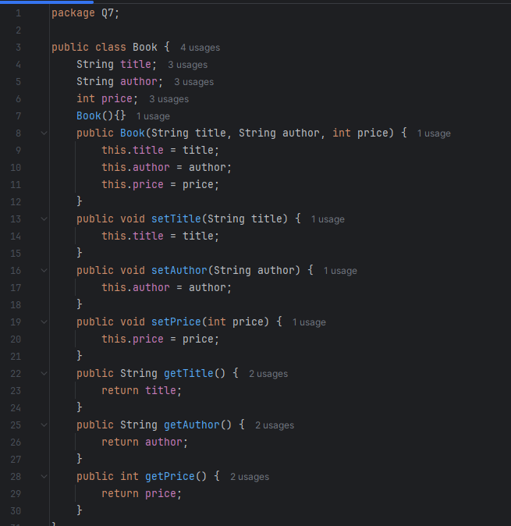

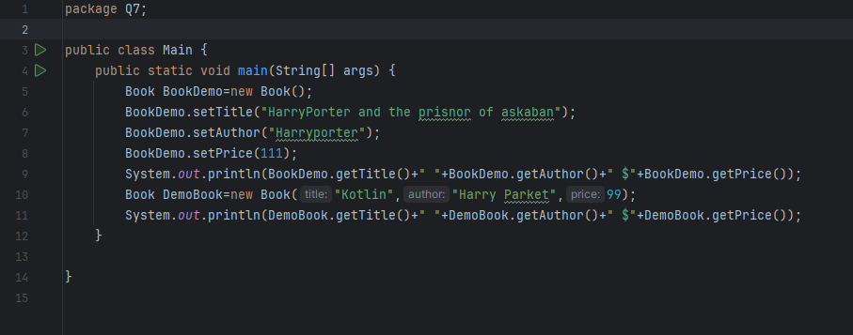

Output:

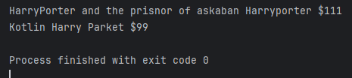

Q8:

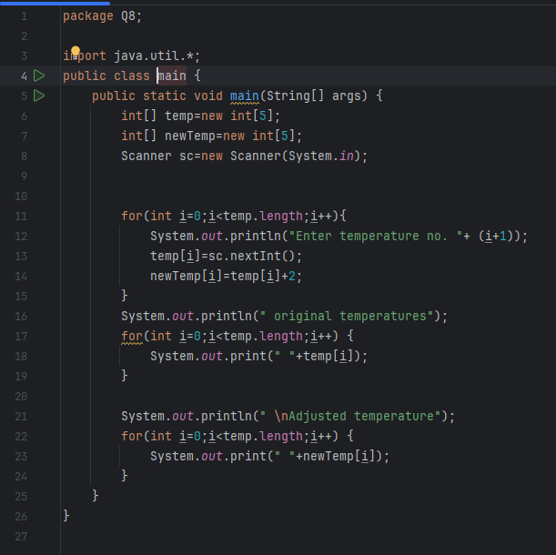

Output:

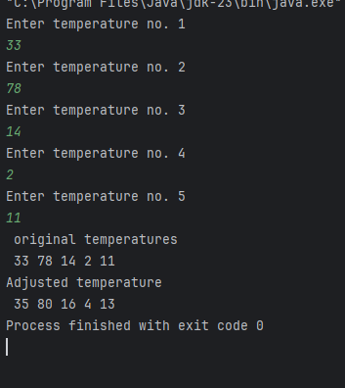

Q9:

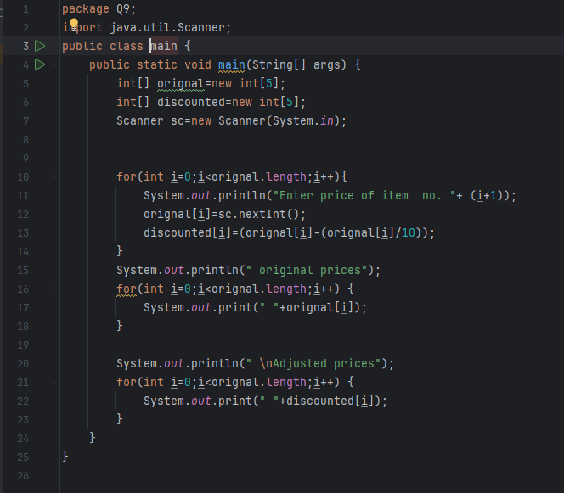

Output:

Q10:

OutPut:

Q11:

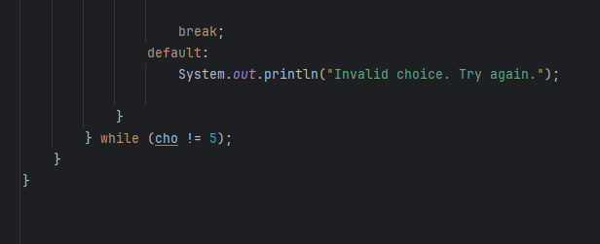

Output:

