Lab_task_05

24k_3055

Malik Zaryab Awan

Q1:

Q2:

Q3:

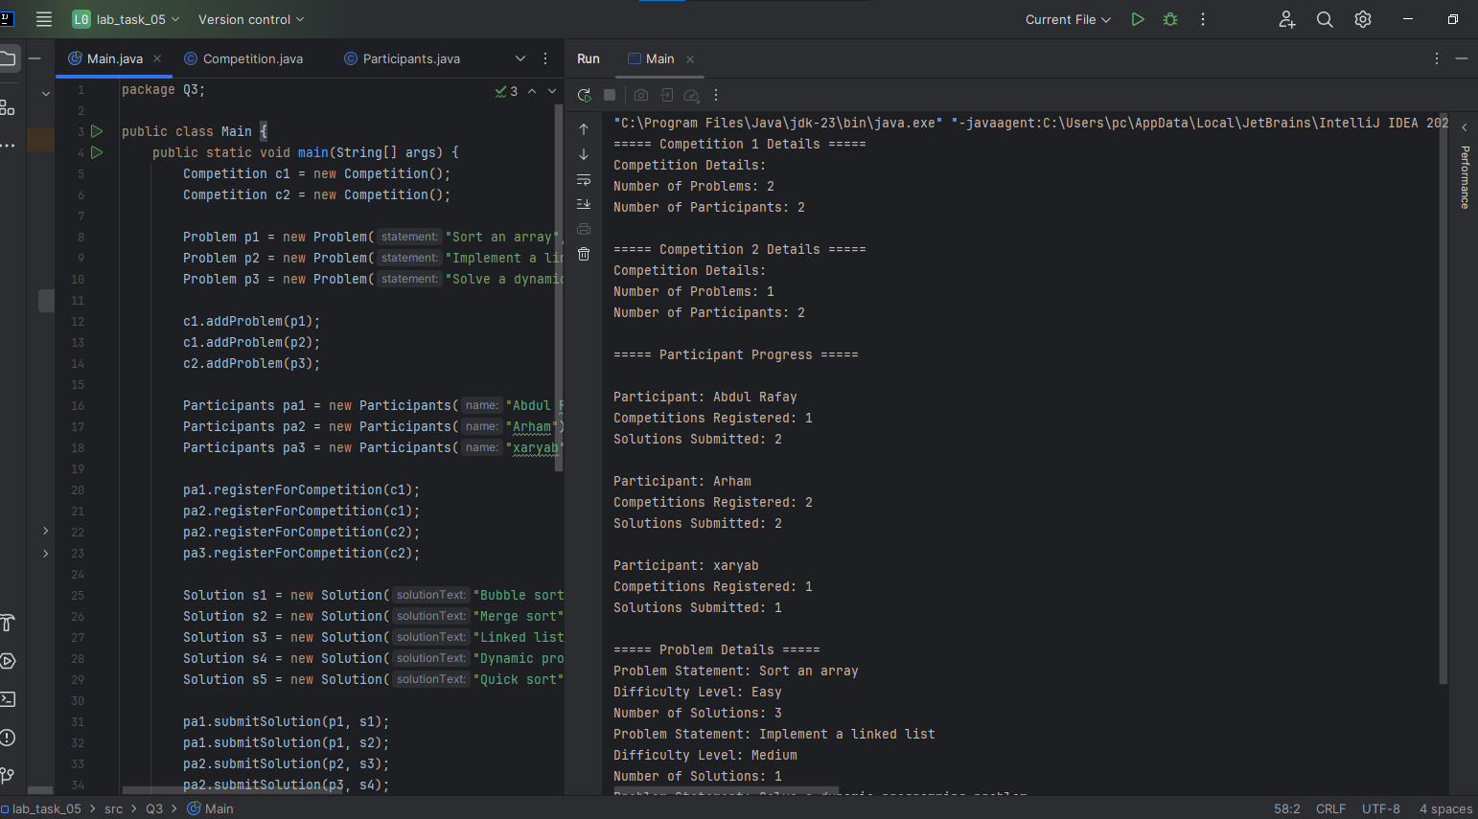

Q4:

Q5:

Q7:

Q12:

