# OOP LAB TASK # 08

24k-3055

BSE-2A

Malik Zaryab Awan

Q1:

Q2:

Q3:

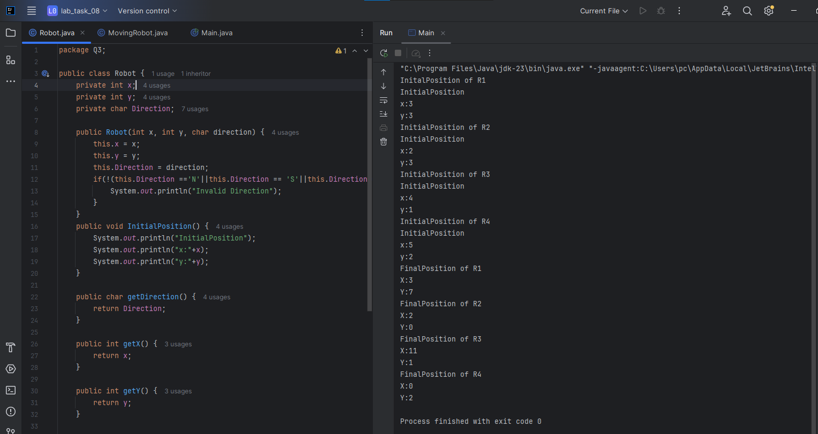

Q4:

Q5:

Q6:

Q7:

Q8:

Q9:

