# OOP LAB : 09

Malik Zaryab Awan

Bse-2A

24K-3055

Q1:

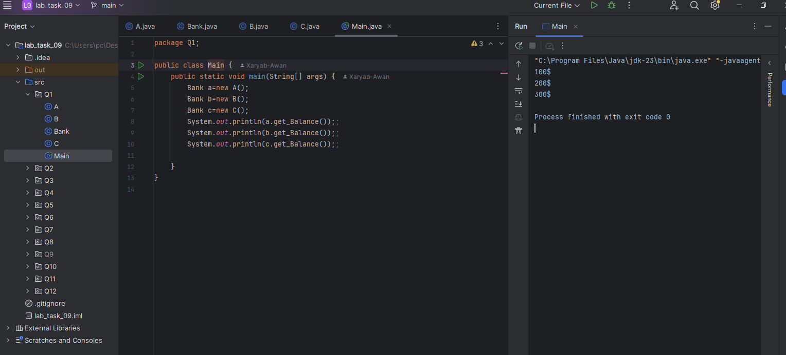

Q2:

Q3:

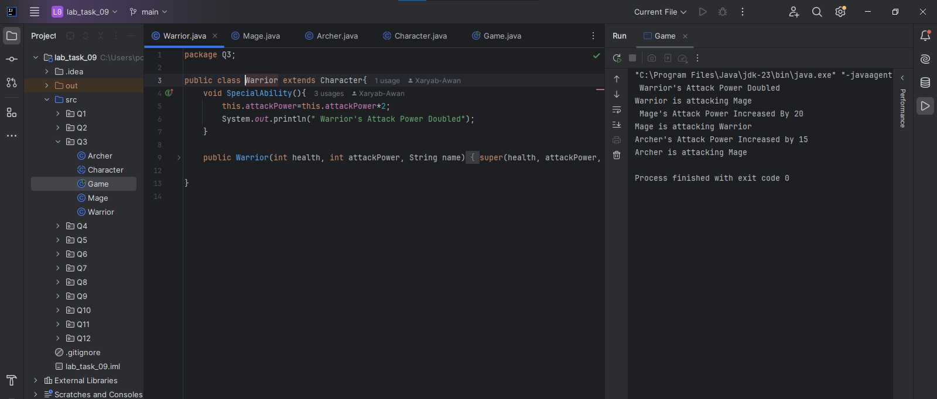

Q4:

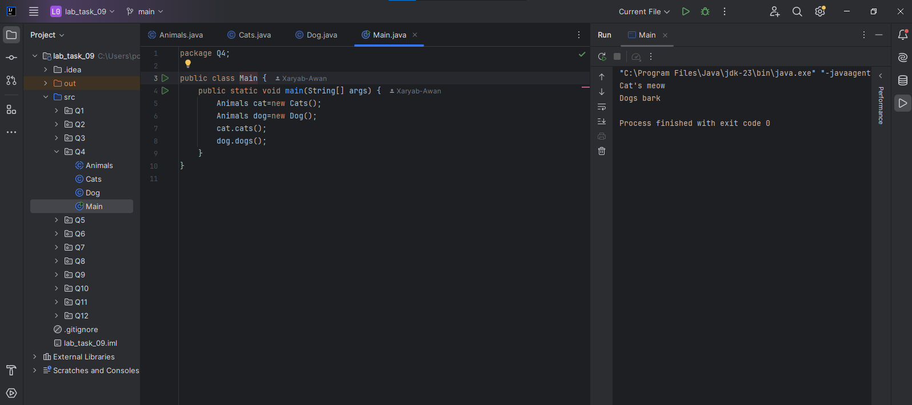

Q5:

Q6:

Q7:

Q8:

Q9:

Q10:

Q11:

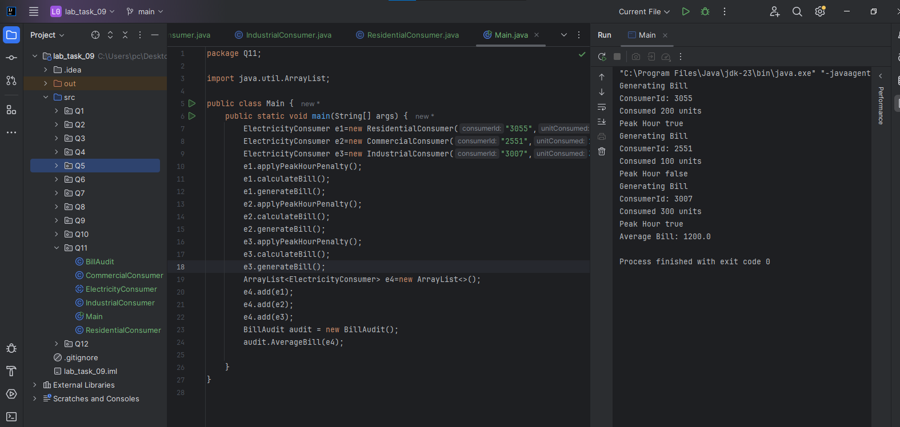

Q12:

