Assignment 6 Section A Xiangzhu Chen

InVision prototype: https://invis.io/6ZOUENL2RWV

Reflection

**The challenges of coding and how I overcame them**

The first challenge I encountered was to internalize the concept of object and map out the constructor function Item() for later use. I watched YouTube videos and asked peers, then finally learned the abstract logic of the this.example = example properties inside the object.

The next challenge was to grab the value of sizes and colors from the product detail page because they were images initially, which did not have values. To overcome this problem, I changed from images into divs, and added active status class to them, which would be called when the divs are selected. Also while the divs were selected, the text value in the div will be grabbed as well.

After finishing up most of the functions, I realized that having individual pages for each of the product caused repetitive codes in js, this when dealing with the next big challenge, which was to combine all the detail htmls into one html, and link all the selection-related functions into one. I did this by creating an array and put all the products, associated with their name, image, size, color(inside color there was another array), into this array, and get them whenever I needed them.

Another bug that gave me a headache was that after grabbing the values I needed and implemented the “add to cart” function, which creates new items and pushes them into the shopping cart array, I found all the objects in the array had undefined properties while testing in the console. This meant that none of the values I grabbed were passed in. I became so confusing about the disappearance of these values, so I reached out to my friends, a front-end developer, who pointed out that I need to “put” the values somewhere before I pass them to the functions. I solved this problem by creating a current cart array first, and then store all the properties such as name, size, price, etc. to it, then pass them while added to the cart. While looking back, this seems like an easy fix, however at that time it really took me some time to understand where the values went to.

For implementing the carousel, I watch a free class of it to figure it out.

As for bugs related to CSS, how to place the visual cue red dots above the shopping cart button took me a while to figure out. I successfully overlaid them on top of the button by using negative value for the position.

**Takeaways**

1. 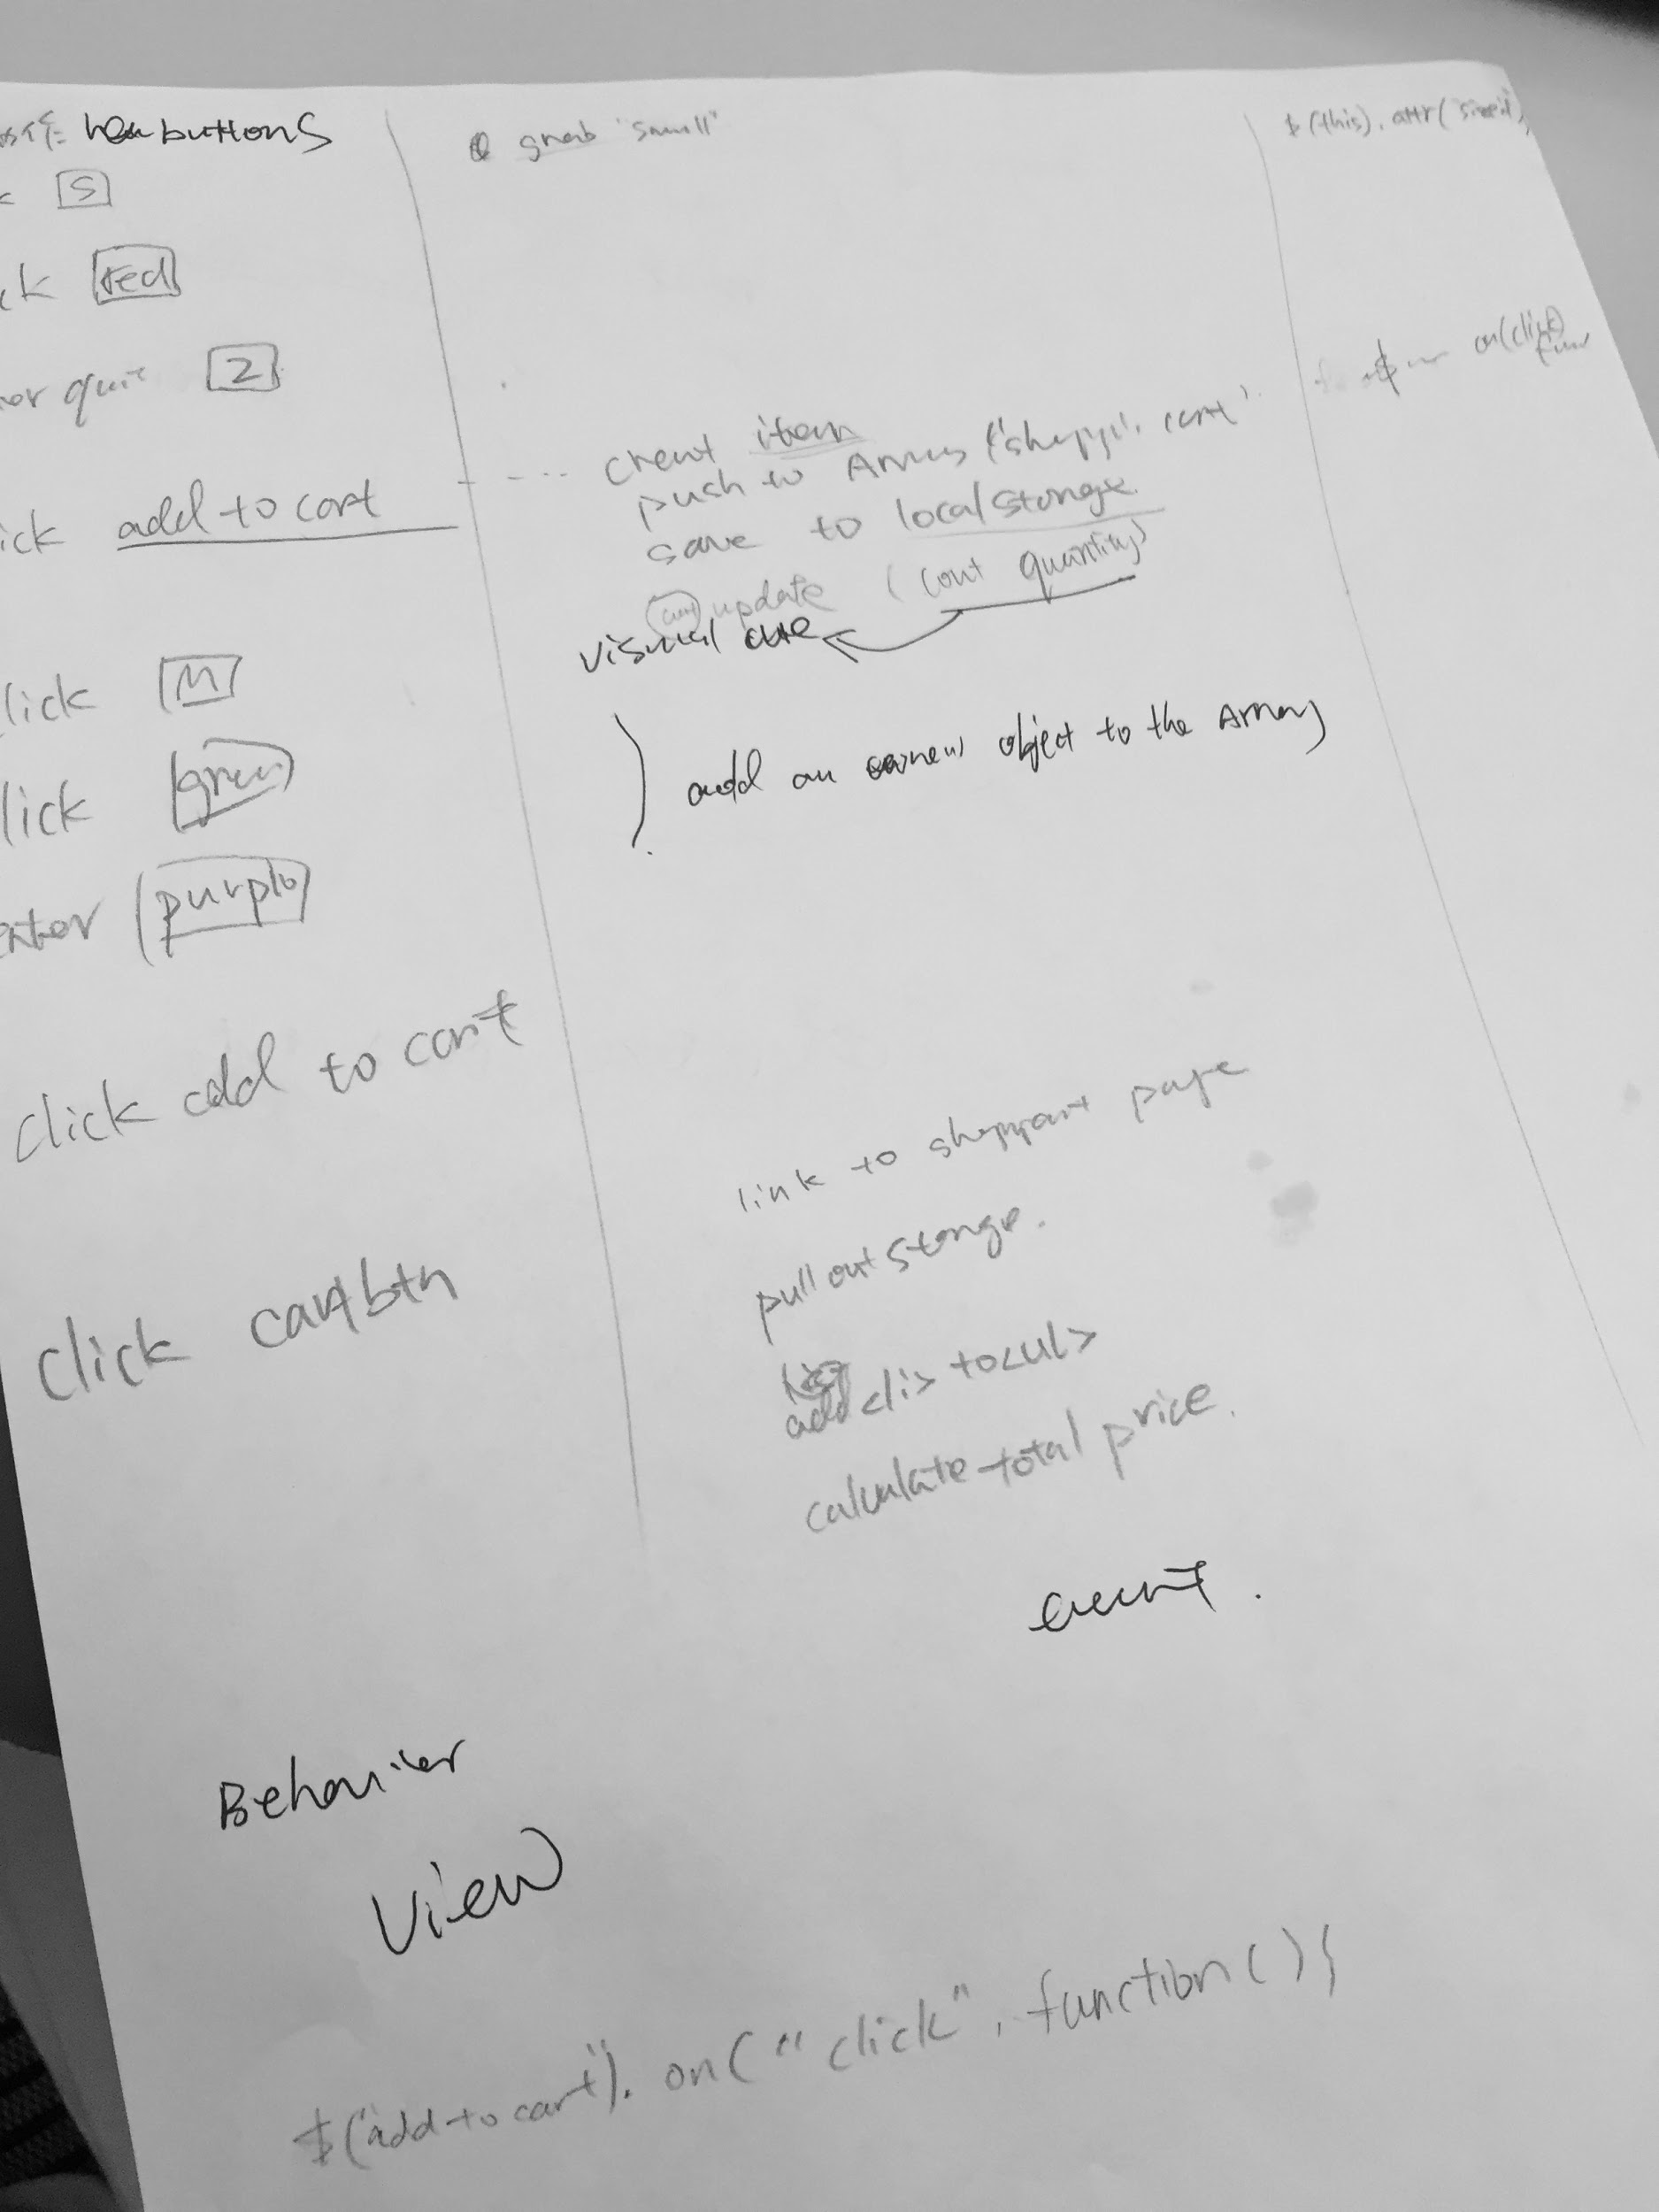Start early: I found myself spend much more time debugging than writing up the initial individual functions. The real challenges came when I tried to link these functions together and make the overall logic flow. Next time I would first draw out logic clearly on paper, then use comments to layout them in the codes, then dive into the actual coding process.
2. MVC is very helpful. I unconsciously used this framework while trying to make connections between user’s behaviors, in other words the events happen on the page, to the codes behind them. After I draw out links on the page, I got a better understanding of how event-based programming is like, and the separation of concern principles. (on the right is my sketch of relationship between behavior, events, codes)

**Citations of tutorials**

<https://www.youtube.com/watch?v=ES1jky86JLQ&list=PLoN_ejT35AEhzNoPStBzAkpqAu3YQwPj7&index=9>

This is a major tutorial of shopping cart js codes I watched. It was really helpful, and after watching this list of videos every day for one week, I successfully learned using objects, local storage, array, and major functions associated with them, such as counting the quantity and price.

<https://love2dev.com/blog/javascript-remove-from-array/>

<https://stackoverflow.com/questions/47032704/multiple-conditions-using-an-and-if-statement-javascript>

<https://www.imooc.com/learn/386> (This is a free class of how to make a carousel)

<https://stackoverflow.com/questions/1735230/can-i-add-custom-attribute-to-html-tag>

<https://stackoverflow.com/questions/554273/changing-the-image-source-using-jquery>

<https://stackoverflow.com/questions/11563638/how-do-i-get-the-value-of-text-input-field-using-javascript>

<https://www.w3schools.com/html/html_tables.asp>

<https://www.w3schools.com/jquery/sel_last.asp>

<https://www.oreilly.com/library/view/javascript-cookbook/9781449390211/ch12s13.html>

<https://www.w3schools.com/js/js_loop_for.asp>

<https://www.w3schools.com/jsref/met_storage_getitem.asp>

Lo-fi and Hi-fi Prototype Write Up

**The shopping cart**

**Iteration 1**

I designed a page of the shopping cart list page last time for the InVision prototype, however it was a very rough one. There was a list of wish list items for customers to select, however, after testing this iteration with peers, I got few negative feedbacks of the wish list at bottom. Users felt that there were too many buttons which were overwhelming together with the information above. They wanted to be able to concentrate on the products they had selected. They also felt it created hassles when going back and forth between product detail page and shopping cart list page to change the quantity of a certain product.

There were also lack of important information on this iteration. Users wanted to see more details of the product they selected, for example the size and color.

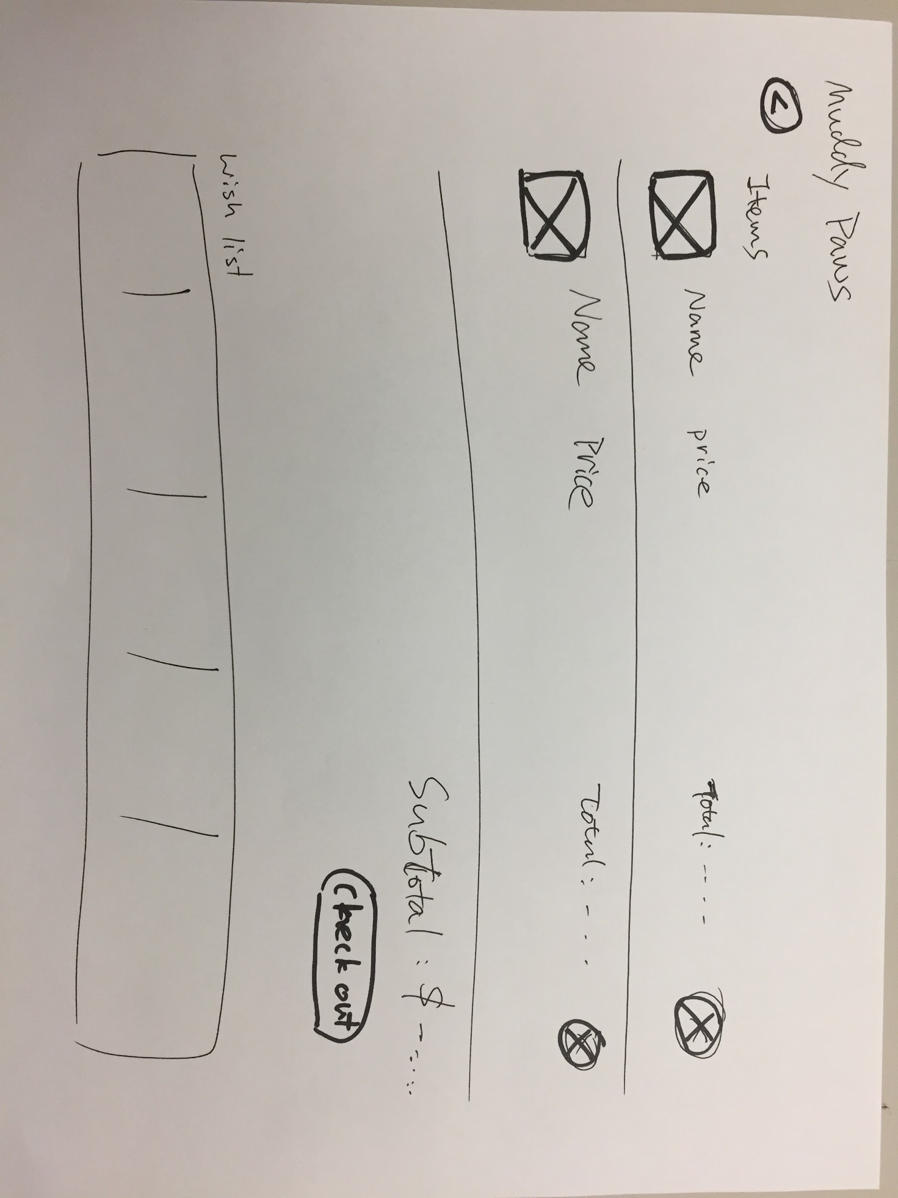

Lo-fi sketch of shopping cart list

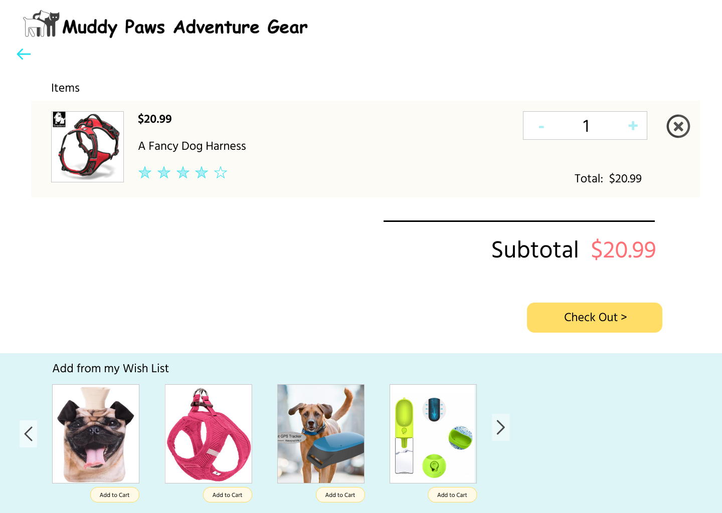

hi-fi prototype of shopping cart list (added in a quantity change box, so that users can easily change the quantity without going back)

**Iteration 2**

In this iteration, I got rid of the wish list scroll at the bottom, and made it into a separate page. The reason for this change is to reduce distractions and help users focus on checking out their selected products.

In addition to that, I added size, color, shipping price (in this case free) under each row of selected products to give more information to users for them do better review their choices and make a checkout decision.

After adding in the wish list, I also added an entry to it on the shopping cart page, so that users can add in their favorite items when needed.

Above design decisions were made largely due to the purpose of providing users a clean, easy, and flexible way of reviewing/adding/deleting selected products.

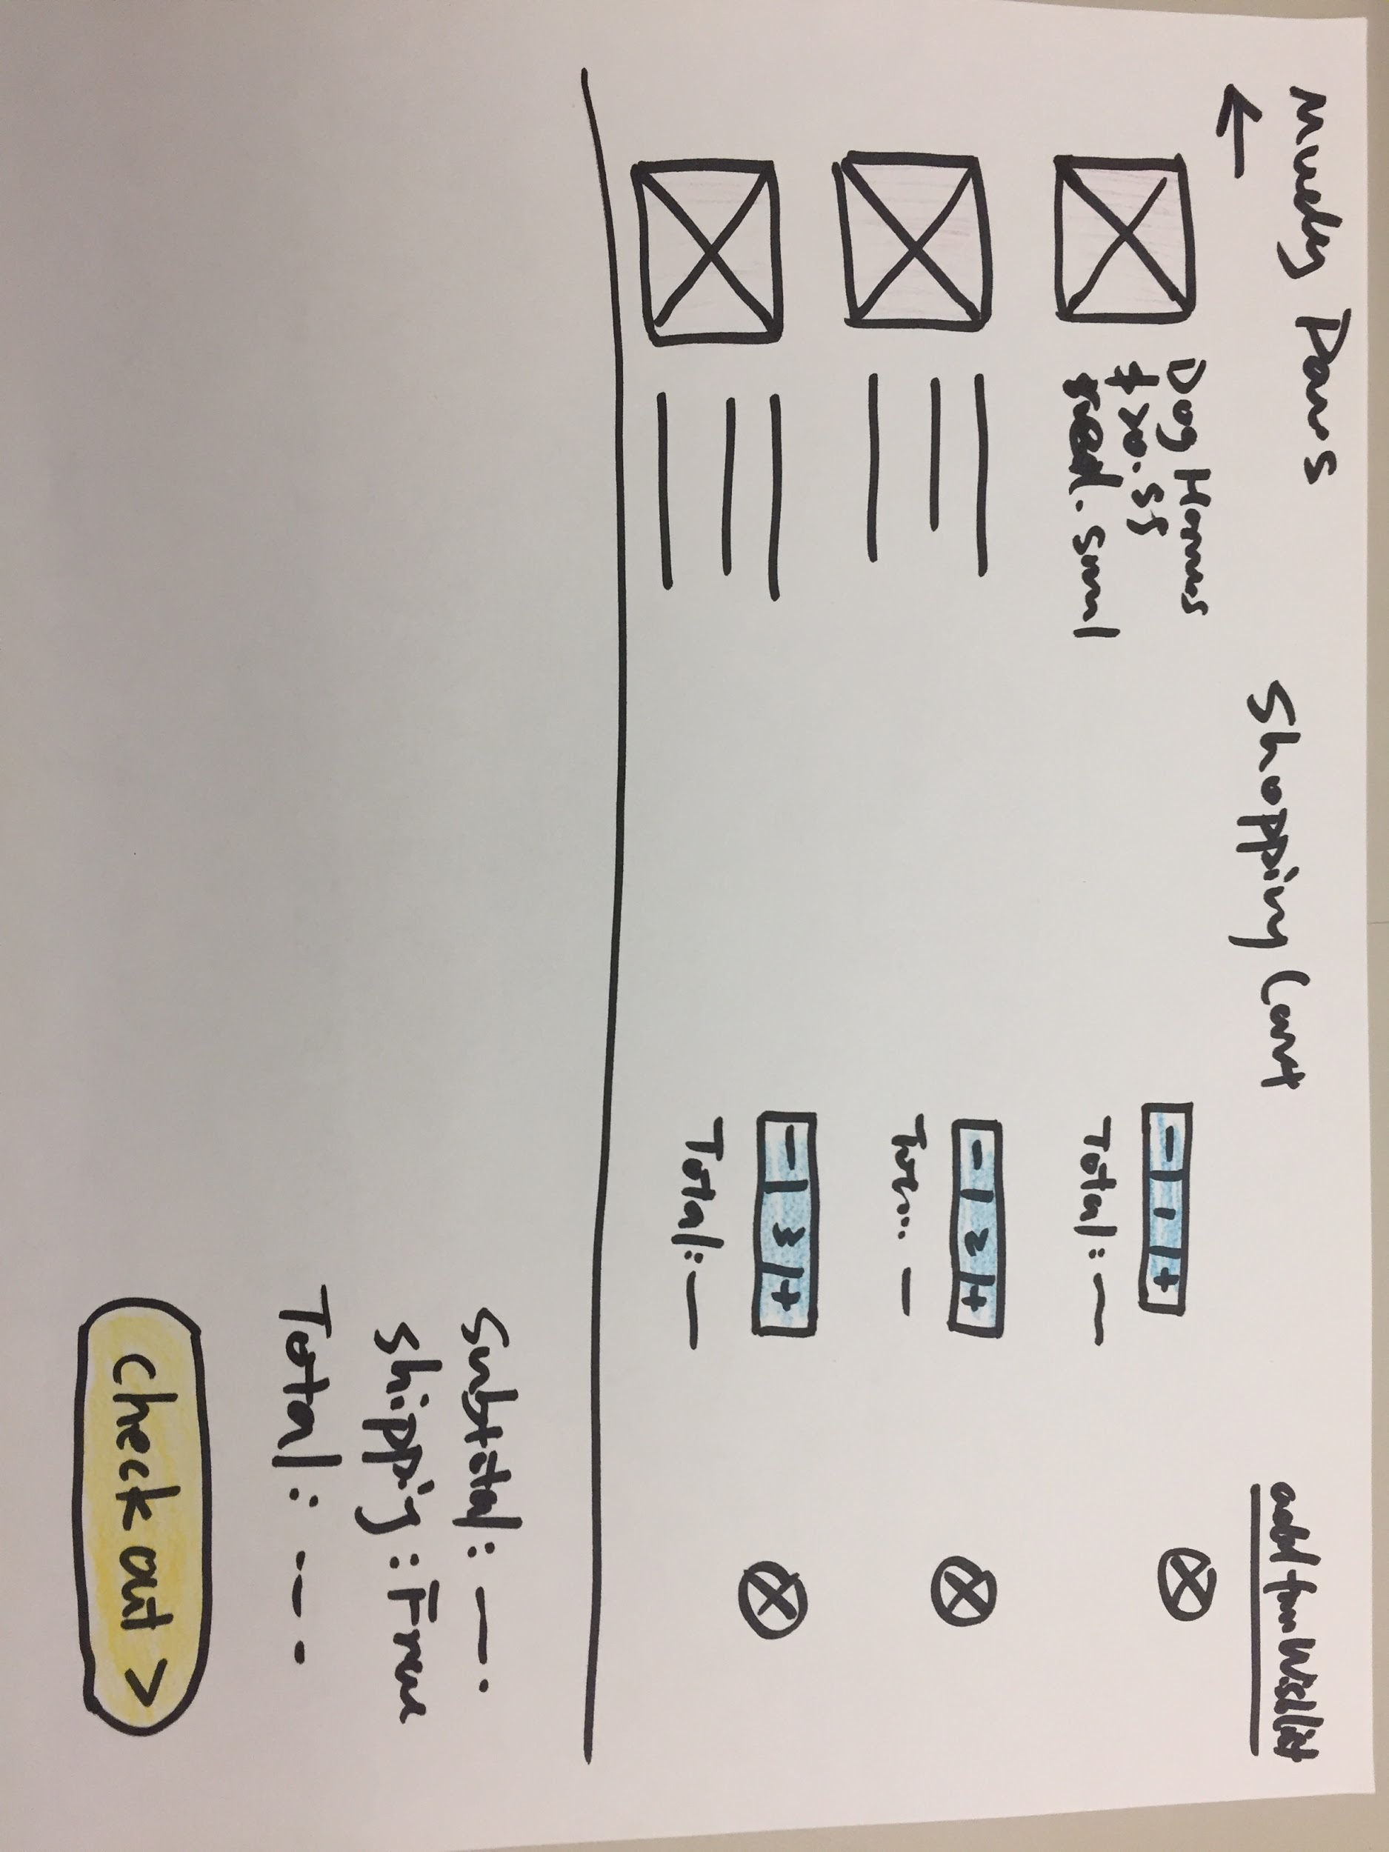

Shopping cart page lo-fi prototype

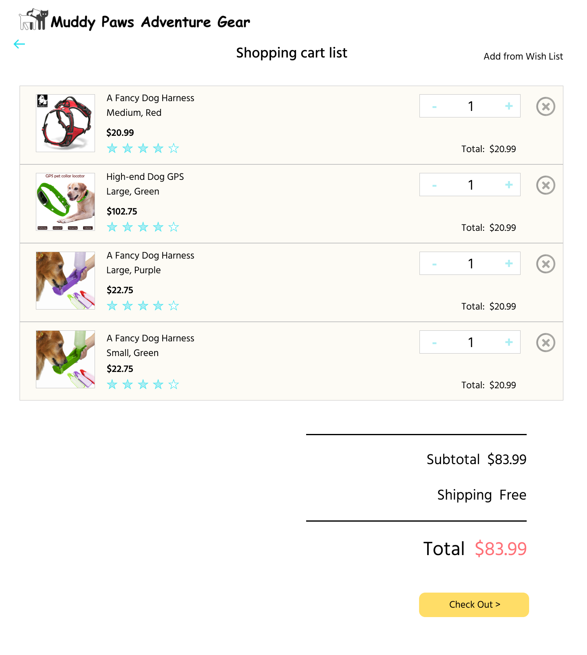

Shopping cart hi-fi prototype

**The product detail page**

In this iteration, the major changes were 1) adding “add to wish list” button and wish list FAB(floating action button, the button that floats on the page and provides additional actions) for the wish list feature, and 2) a carousel of related items to provide customers more choices.

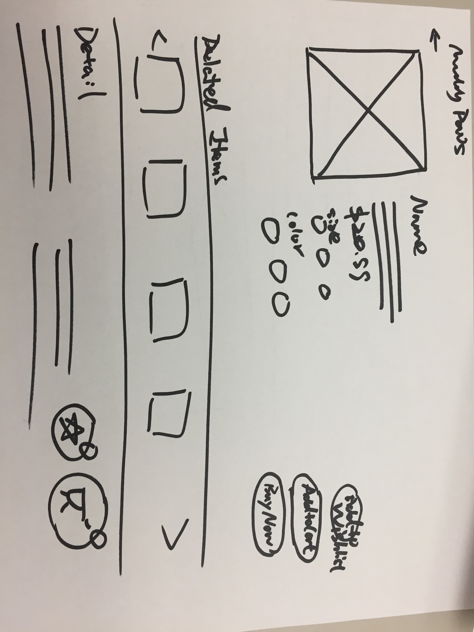

Revised product detail page lo-fi prototype

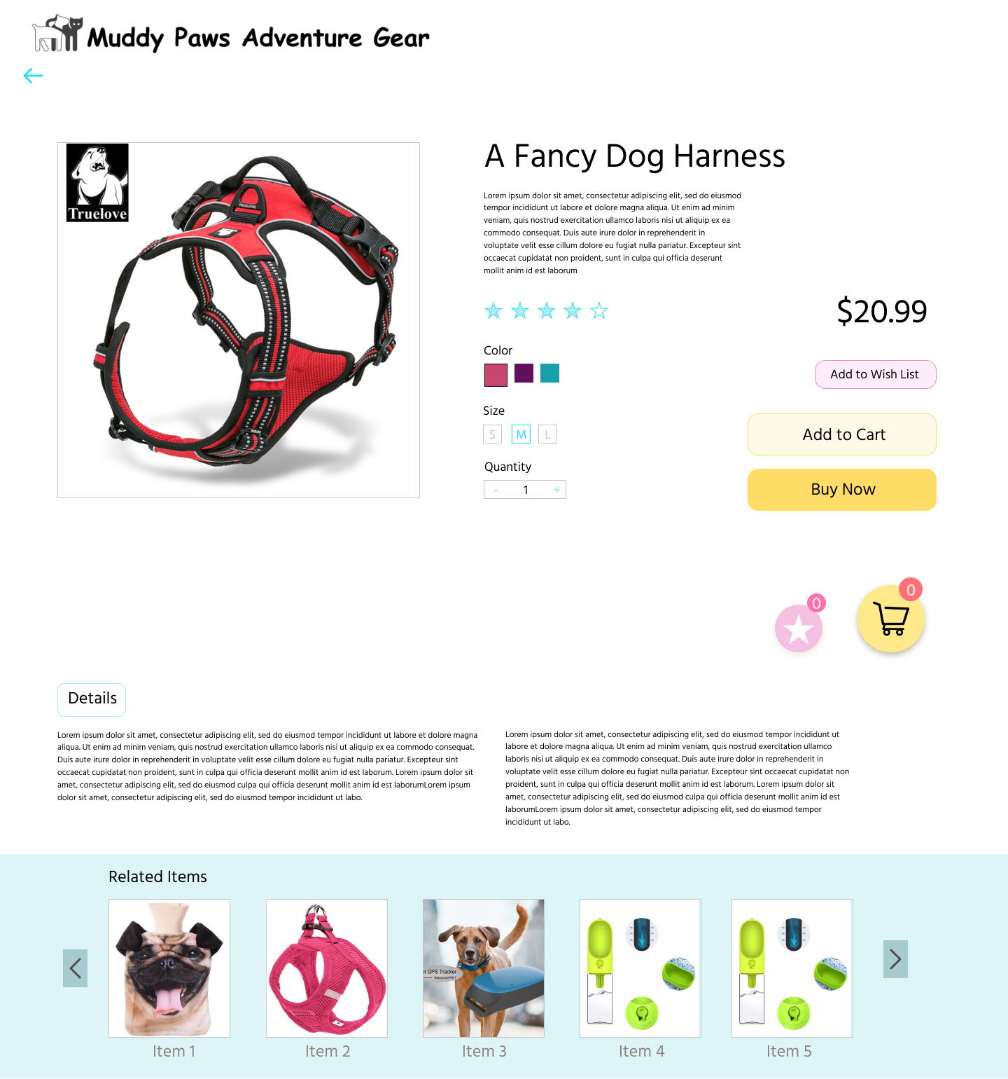

Revised product detail page hi-fi prototype (I changed the sequence of the carousel and the detail section, because the detail section and the product information should be one group of information, which needs to be visually grouped together as well)

**The Wish List**

The wish list is similar to the shopping cart list, however, there’s no quantity nor total prices based on that. Instead, I added “add to cart” button for each of the product, so that customers can easily add their favorites to the cart.

Beneath the list of products, there are buttons of wish list and shopping cart for customers to track the quantity in each of them and get access to shopping cart page conveniently.

When showing the prototypes to peers, the design of two FABs were welcomed due to their bright colors that match the overall color theme, and

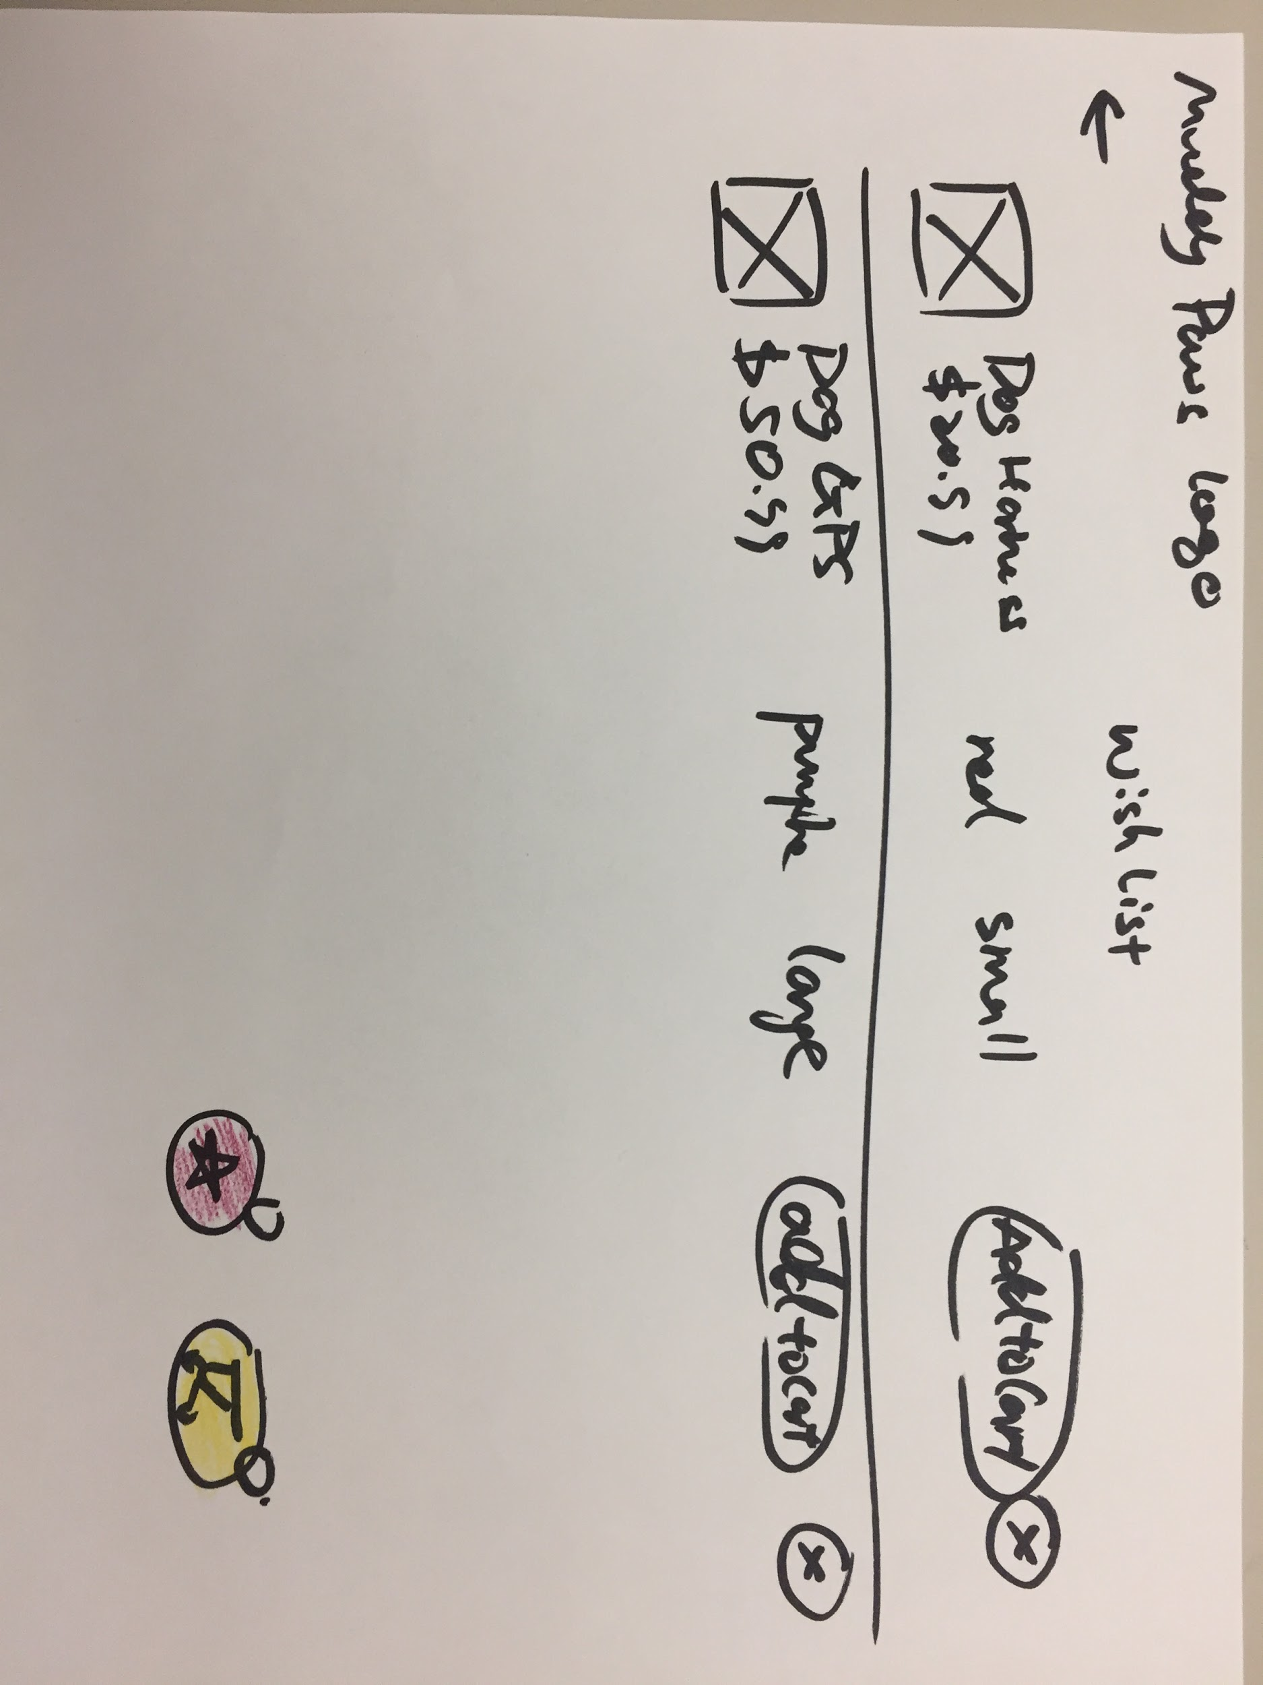

The wish list lo-fi prototype

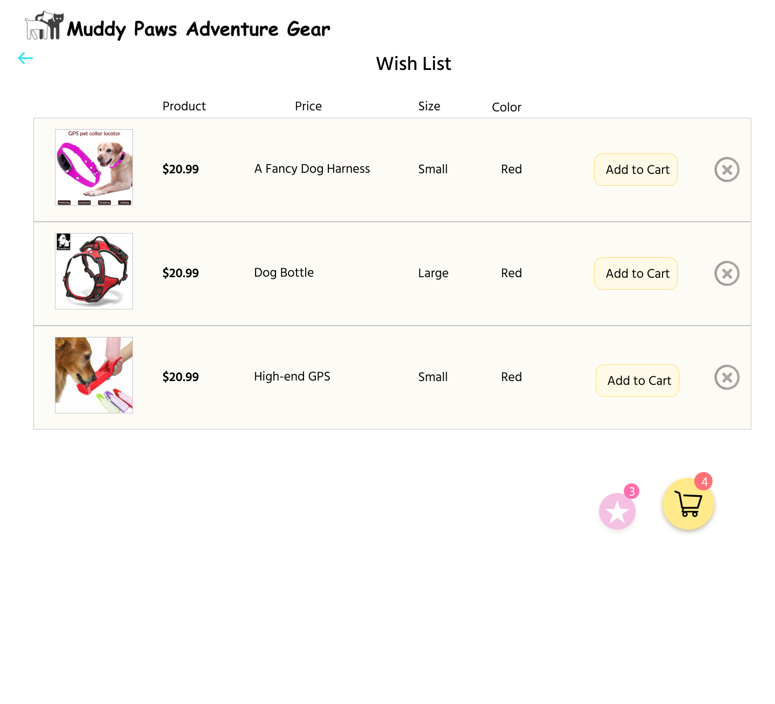

The wish list hi-fi prototype