7.1 Introduction
Machine learning has become a central analytical instrument for extracting predictive and explanatory value from complex tabular data. Across transportation safety, infrastructure analytics, health systems, finance, and other decision-intensive domains, researchers increasingly rely on combinations of statistical learning, ensemble methods, deep tabular architectures, and model explanation techniques to support classification, risk assessment, and policy-relevant inference. The preceding chapters demonstrated that these methods can produce strong empirical performance when they are carefully specified, validated, and interpreted. However, the broader contribution of machine learning research is not determined solely by benchmark accuracy or methodological novelty. Its practical value also depends on whether the analytical process can be reproduced, audited, extended, and transferred into operational settings where decisions are made under constraints of time, expertise, computing resources, and institutional accountability.
A persistent research-to-practice gap remains in applied machine learning systems. In many dissertation-scale and project-scale studies, the analytical workflow is assembled from notebooks, scripts, intermediate files, configuration fragments, manually tuned preprocessing routines, and separately generated reports. Such workflows are often sufficient for experimentation by the original researcher, but they are less effective as durable decision-support infrastructure. The problem is not merely one of convenience. Fragmented workflows can obscure the relationship between data preparation choices, model configuration, validation strategy, class imbalance treatment, and reported performance. They can also make it difficult to determine whether results were produced from the intended target variable, feature set, split strategy, preprocessing pipeline, or trained model version. As machine learning moves from exploratory analysis toward applied decision support, these weaknesses become methodological risks.
The limitations of fragmented analytical workflows are especially pronounced for tabular machine learning. Tabular datasets vary widely in size, missingness patterns, feature types, target distributions, class imbalance, leakage risks, and evaluation requirements. A typical workflow may require dataset ingestion, column selection, categorical encoding, train-validation-test partitioning, imbalance handling, edge-case checking, model selection, hyperparameter management, training monitoring, evaluation, visualization, and exportable reporting. When these steps are distributed across disconnected tools, reproducibility depends heavily on informal discipline and researcher memory. Small inconsistencies, such as balancing before splitting, reusing stale split artifacts, evaluating on transformed labels without a reliable mapping to original classes, or changing target columns without invalidating downstream artifacts, can materially alter conclusions. These issues are rarely visible in final performance tables, yet they shape the validity of the analysis.
These challenges motivate the need for integrated analytical platforms that treat the machine learning workflow as a coherent, inspectable, and reproducible system. An integrated machine learning platform should not simply provide a graphical interface over existing algorithms. It should encode methodological safeguards, preserve configuration state, separate training data from validation and test data, maintain transparent artifact lineage, and support both experimentation and deployment. For applied domains, such a platform must also be practitioner-oriented: it should reduce unnecessary technical friction without weakening analytical rigor. The goal is not to replace expert judgment, but to create a structured environment in which expert decisions about features, targets, models, imbalance strategies, validation design, and reporting are made explicit and persistent. In this sense, software architecture becomes part of the research methodology.
The need for such a system follows directly from the findings of Chapters 4 and 5. Chapter 4 established the comparative performance of traditional machine learning models and deep tabular learning models under rigorous benchmarking, cross-validation, and held-out testing. The results showed that no single modeling family is universally sufficient, while also identifying MambaAttention as the strongest overall deep-learning architecture in the evaluated setting. Chapter 5 extended the analysis beyond predictive performance by examining interpretability, analytical insight, and the explanatory behavior of trained models. Together, these chapters demonstrated that high-quality tabular machine learning requires coordinated attention to modeling capacity, validation design, class imbalance, and interpretability. Yet the same findings also highlight a practical question: how can these methodological advances be made available as a reproducible analytical workflow rather than as a collection of isolated scripts?
AVISTA was developed to address this question. In this dissertation, AVISTA is presented as a software artifact that operationalizes the methodological foundations established in the earlier chapters. It is an integrated, desktop-based machine learning and analytics platform for tabular classification workflows, designed to connect project setup, environment validation, data management, feature configuration, preprocessing decisions, splitting, imbalance handling, model selection, training, monitoring, reporting, and packaging within a single extensible architecture. Its purpose is not merely to simplify execution, but to formalize the end-to-end analytical pipeline so that each consequential modeling decision is represented in persistent project configuration and recoverable output artifacts. AVISTA therefore serves as both a practitioner-oriented implementation and a research artifact that embodies the dissertation’s methodological position: robust machine learning practice requires integration across data, models, validation, explanation, and reporting.
At the system level, AVISTA integrates project management, runtime and GPU environment inspection, dataset import, feature and target configuration, label-encoding management, train-validation-test splitting, imbalance handling, edge-case validation, model selection, training execution, real-time progress monitoring, automated report generation, Markdown and PDF export, and deployment-ready packaging. It supports traditional machine learning models, deep tabular learning models, and foundation-model-based tabular learning through a registry-based architecture that separates model metadata, configuration, optional dependencies, and training behavior. The platform is designed to preserve dataset-generic operation rather than encode assumptions from a single study domain. It also emphasizes artifact sensitivity: saved splits, encoders, reports, and training outputs are tied to current project configuration so that stale or incompatible results are not silently reused. These design choices are essential for reproducible analytical workflows in which methodological validity depends on traceable relationships among data, configuration, training, and evaluation.
The contribution of AVISTA is therefore best understood as a software-system contribution rather than a conventional graphical user interface. AVISTA translates the dissertation’s empirical and interpretive findings into a deployment-ready framework for reproducible tabular machine learning. It provides a structured decision-support capability for users who need to move from raw tabular data to trained models, validated outputs, diagnostic figures, and report-ready artifacts without reconstructing the workflow manually. Its extensible architecture allows new models, preprocessing routines, explanation methods, robustness checks, and reporting components to be incorporated without collapsing the distinction between backend logic and user-facing interaction. This is academically significant because it demonstrates how machine learning research can be embodied in a maintainable software artifact that supports reproducibility, usability, extensibility, and future deployment rather than remaining confined to experimental code.
The remainder of this chapter presents AVISTA as the applied software contribution of the dissertation. Section 7.2 positions AVISTA explicitly as a dissertation contribution and clarifies the relationship between the platform, the methodological work in earlier chapters, and the broader need for research-grade analytical systems. Subsequent sections describe the system architecture, workflow design, project and environment management, data configuration, splitting and imbalance handling, model selection and training, reporting capabilities, packaging strategy, and extensibility pathways. The chapter concludes by discussing the significance of AVISTA for reproducible machine learning practice and its role as a foundation for future decision-support, explainability, and robustness workflows. This transition is important because AVISTA is not simply an implementation detail appended to the dissertation; it is the mechanism through which the dissertation’s methodological contributions are converted into a reusable, practitioner-oriented, and deployment-ready analytical platform.

7.2 AVISTA as a Dissertation Contribution
7.2.1 Motivation for Software-System Contributions
Software artifacts have become an increasingly important form of research contribution in engineering, computer science, and applied analytics. In data-intensive research, methodological validity is no longer determined only by the mathematical formulation of a model or the statistical significance of an evaluation result. It also depends on whether the analytical process can be reproduced, inspected, transferred, and maintained. This issue is particularly important for machine learning research, where results are shaped by many interacting decisions, including data cleaning, feature selection, target encoding, sampling design, imbalance handling, model configuration, validation strategy, metric selection, and reporting procedure. When these decisions are distributed across informal scripts or undocumented execution sequences, the resulting workflow can be difficult to reproduce even when the original code is available.
The need for software-system contributions is therefore connected to a broader reproducibility challenge. Research prototypes often demonstrate that a method can work under controlled experimental conditions, but they do not necessarily provide a usable pathway for applying the method in operational environments. Notebooks and scripts are valuable for exploration, but they frequently depend on implicit execution order, local file paths, manually adjusted parameters, and researcher-specific assumptions. These characteristics limit their value as durable analytical infrastructure. In applied domains, where analytical results may inform planning, safety assessment, infrastructure investment, or operational decisions, this limitation is not trivial. A model that performs well in a dissertation chapter still requires a reproducible and governed workflow before it can support practitioner decision-making.
This dissertation therefore treats software development not as a supplementary implementation task, but as a legitimate research contribution. The central problem addressed by AVISTA is the translation of validated machine learning methods into a structured analytical platform that supports reproducibility, usability, extensibility, and deployment readiness. This framing aligns with the role of software artifacts in engineering dissertations: they provide an operational embodiment of the research logic, demonstrate feasibility beyond isolated experiments, and expose the methodological assumptions that must be controlled when analytical workflows are used by others.
7.2.2 AVISTA as a Research Artifact
AVISTA is developed in this dissertation as a software artifact, an integrated analytical platform, and an operational framework for tabular machine learning. Its contribution is not the existence of a graphical user interface. A graphical interface is only one access layer through which users interact with the system. The more substantive contribution is the design and implementation of an end-to-end analytical pipeline that organizes the complete machine learning process into persistent, inspectable, and reusable components.
AVISTA is more than a collection of scripts because it encodes relationships among project configuration, datasets, feature definitions, target variables, splitting strategies, imbalance treatments, model selections, training artifacts, and reports. These relationships are essential for analytical validity. For example, a trained model is meaningful only in relation to the feature set, target encoding, split artifacts, and preprocessing configuration used to create it. Similarly, a report is reproducible only when it can be traced back to the model outputs, data partitions, and project state that produced it. AVISTA formalizes these dependencies through project-level persistence, structured configuration, saved artifacts, and workflow constraints.
The .avista project file is central to this contribution. It allows analytical state to be preserved across sessions and supports project portability. Dataset management, environment validation, GPU diagnostics, feature selection, target configuration, label encoding configuration, train-validation-test splitting, imbalance handling, edge-case validation, model selection, training monitoring, reporting, and deployment packaging are integrated into a coherent platform. This integration converts the methodological work of earlier chapters into a practitioner-oriented implementation that can be executed, audited, and extended.
7.2.3 Contribution Dimensions
The first contribution dimension is methodological operationalization. Chapters 4 and 5 developed machine learning and interpretability workflows that required careful coordination among model design, benchmarking, validation, and explanation. AVISTA operationalizes these methodological findings by embedding them within a structured machine learning workflow. Traditional models and deep tabular learning models can be selected and trained through a unified registry-based framework. Splitting and imbalance handling are treated as explicit configuration steps rather than incidental preprocessing operations. Edge-case validation is incorporated before training so that problematic data conditions can be identified before they compromise downstream results. In this way, AVISTA transforms dissertation methods into executable analytical procedures.
The second contribution dimension is reproducibility. AVISTA standardizes the workflow from project creation to reporting. Project persistence through .avista files, managed datasets, saved configuration, target-aware split artifacts, encoded target mappings, and stored training outputs improves experiment repeatability. The system reduces the risk that results are produced from undocumented combinations of data, labels, model parameters, or validation partitions. Reproducibility is also supported by automated reporting, which links model results, diagnostic figures, metadata, and exportable summaries. This is important because reproducibility in applied machine learning requires more than saving code; it requires preserving the analytical state that generated the evidence.
The third contribution dimension is usability. AVISTA is designed for practitioner-oriented analytical workflows in which users may need to configure data, models, validation procedures, and reports without manually coordinating multiple programming environments. Usability here does not mean simplifying the science or hiding methodological choices. Instead, it means presenting the workflow in a way that makes required decisions explicit, reduces accidental misuse, and supports repeated analytical work. Project management, dataset previews, feature and target configuration, imbalance options, model selection, progress monitoring, and report export are organized as a coherent workflow. This design supports users who need a decision-support capability rather than a set of disconnected research scripts.
The fourth contribution dimension is extensibility. AVISTA uses a modular architecture that separates GUI presentation, core pipeline logic, model wrappers, utilities, training routines, and reporting. This separation allows future models, preprocessing methods, explanation workflows, robustness checks, and reporting modules to be added without redesigning the entire platform. The registry-based model structure is particularly important because it allows model metadata, dependencies, parameters, and training behavior to be managed systematically. This makes AVISTA a framework for continuing research rather than a fixed implementation of one experimental study.
The fifth contribution dimension is deployment readiness. AVISTA includes practical mechanisms for project portability, runtime validation, GPU diagnostics, Markdown and PDF reporting, and Windows packaging. Deployment readiness does not imply that the platform eliminates the need for expert review, institutional validation, or domain adaptation. Rather, it means that the dissertation artifact is designed to move beyond the research workstation. Packaging, installer generation, environment checks, and portable project files collectively support the transition from experimental code to a usable analytical system. This is an important distinction because many machine learning prototypes demonstrate technical feasibility but stop short of providing a reproducible pathway to practitioner deployment.
Table 7.1
AVISTA Contribution Summary
Contribution Category | Description | Evidence in AVISTA | Related Dissertation Chapter
Methodological Operationalization | Translates validated machine learning procedures into an executable analytical workflow. | Integrated model selection, train-validation-test splitting, imbalance handling, edge-case validation, traditional models, and deep tabular models. | Chapter 4
Reproducibility | Preserves analytical state and supports repeatable experiments. | .avista project files, managed datasets, persistent configuration, target-aware artifacts, saved encoders, training outputs, and automated reports. | Chapters 4 and 5
Usability | Provides a practitioner-oriented workflow for configuring and executing tabular machine learning analyses. | Project management, dataset management, feature and target configuration, training monitoring, and exportable reports. | Chapters 4 and 5
Extensibility | Supports continued research development through modular software architecture. | Separation of GUI, backend pipeline logic, model registry, training modules, reporting, and optional dependency handling. | Chapters 4 and 5
Deployment Readiness | Provides mechanisms for moving the research artifact toward practical use. | Environment validation, GPU diagnostics, project portability, Markdown/PDF export, and Windows packaging workflow. | Chapter 7
7.2.4 Relationship to Prior Dissertation Contributions
AVISTA serves as the integration layer for the earlier contributions of this dissertation. Chapter 4 established the empirical foundation by developing and evaluating traditional machine learning models and deep tabular learning architectures for classification. That chapter demonstrated the value of systematic benchmarking, cross-validation, held-out testing, and model comparison. It also showed that deep tabular architectures, particularly MambaAttention, can provide strong predictive performance when they are implemented and evaluated carefully. AVISTA incorporates this contribution by providing a structured platform in which traditional and deep models can be configured, trained, monitored, and compared within a reproducible workflow.
Chapter 5 contributed interpretability and explainability analysis by examining how model behavior can be understood beyond aggregate predictive metrics. That work emphasized that useful machine learning systems must support analytical insight, not only classification output. AVISTA connects to this contribution through its reporting framework, diagnostic outputs, model evaluation artifacts, and architecture for future explainability workflows. The platform provides the operational structure into which interpretability methods can be incorporated as part of the same project-governed analytical process. Thus, Chapter 5 informs AVISTA’s broader orientation toward transparent and auditable machine learning.
The relationship among these chapters is cumulative. Chapter 4 identifies and validates modeling strategies. Chapter 5 examines the interpretive requirements of model use. Chapter 7 converts these methodological and analytical findings into a software-system contribution. AVISTA is therefore not separate from the dissertation’s prior technical work; it is the system-level realization of that work. It demonstrates how validated models, evaluation practices, and reporting procedures can be assembled into an integrated machine learning platform capable of supporting reproducible and practitioner-oriented analysis.
7.2.5 Contribution Summary
AVISTA constitutes a software-system contribution of this dissertation by transforming validated machine learning methodologies into an integrated analytical platform capable of supporting reproducible, extensible, and practitioner-oriented machine learning workflows. Its contribution is not reducible to interface design or convenience. Rather, AVISTA provides an operational framework that connects data management, configuration persistence, validation, model training, monitoring, reporting, and deployment preparation within a single research artifact.
This contribution is academically defensible because it addresses a recognized limitation in applied machine learning research: the gap between methodological demonstration and operational use. AVISTA shows how dissertation-level machine learning contributions can be organized into a reproducible analytical workflow that preserves methodological rigor while improving usability and deployment readiness. It provides a foundation for future extensions, including additional explainability modules, robustness analysis, drift assessment, subgroup evaluation, and expanded reporting.
The next section develops this contribution more concretely by specifying the system requirements and design goals that guided AVISTA’s architecture. Section 7.3 therefore moves from the argument for AVISTA as a dissertation contribution to the engineering requirements necessary for building an integrated, reproducible, and deployment-ready tabular machine learning platform.

7.3 System Requirements and Design Goals
7.3.1 Design Motivation
The design of AVISTA was guided by the limitations of fragmented machine learning workflows commonly encountered in applied research. Although notebooks, scripts, and manually assembled pipelines are effective for exploratory modeling, they often provide limited support for reproducibility, configuration control, dependency validation, and long-term maintenance. In tabular machine learning, analytical results are shaped by many interdependent decisions, including feature selection, target definition, label encoding, train-validation-test partitioning, imbalance handling, model configuration, hardware availability, and reporting procedures. When these decisions are distributed across disconnected files and tools, the analytical record becomes difficult to audit, repeat, or transfer.
A second motivation was the difficulty of moving from research prototypes to operational software. Research notebooks often depend on implicit execution order, local paths, manually edited parameters, and assumptions known only to the original researcher. Such workflows may support dissertation experimentation but are less suitable for practitioner-oriented decision support. AVISTA was therefore designed as a unified analytical platform capable of preserving methodological rigor while supporting repeatable execution, explicit configuration, and deployment readiness.
7.3.2 Functional Requirements
The functional requirements define the capabilities AVISTA needed to provide to support an end-to-end tabular machine learning workflow. These requirements, summarized in Table 7.2, were specified at the workflow level rather than the interface level because the primary design concern was how analytical decisions should be organized, persisted, validated, and connected.
Table 7.2
Functional Requirements of AVISTA
Requirement ID | Requirement Description | Motivation
R1 Project Management | Support creation, loading, persistence, and portability of analytical projects. | Preserves project-level analytical state across sessions.
R2 Dataset Management | Import, store, preview, and manage tabular datasets. | Reduces ambiguity about which data were used.
R3 Environment Validation | Inspect dependencies, runtime configuration, and GPU availability. | Identifies runtime problems before training.
R4 Data Preparation | Configure features, targets, label encoding, splitting, imbalance handling, and edge-case checks. | Makes preprocessing decisions explicit and reproducible.
R5 Model Configuration | Support traditional and deep tabular model selection with persistent parameters. | Enables systematic model comparison.
R6 Training Execution | Train models from saved project configuration and prepared artifacts. | Connects analytical state to controlled model fitting.
R7 Result Monitoring | Track training progress, status, and outputs. | Improves transparency during computational workflows.
R8 Report Generation | Generate structured reports and export Markdown/PDF outputs. | Supports documentation and dissemination.
R9 Deployment Support | Provide packaging and distribution mechanisms. | Enables practical use beyond the development environment.
Together, these requirements establish AVISTA as more than a model execution tool. The platform had to manage dependencies among analytical choices and ensure that downstream results corresponded to the intended configuration.
7.3.3 Non-Functional Requirements
The non-functional requirements describe the quality attributes needed for AVISTA to function as a research-grade software artifact. As shown in Table 7.3, reproducibility was the central requirement because the platform was intended to preserve the analytical state associated with each experiment. Usability was also essential, not as a matter of visual convenience, but as a condition for practitioner adoption. Reliability required explicit validation of data, dependencies, and artifacts, while extensibility and maintainability were necessary to support future models, explainability workflows, robustness checks, and reporting extensions.
Table 7.3
Non-Functional Requirements of AVISTA
Requirement | Description | Design Implication
Reproducibility | Analytical decisions and outputs must be repeatable. | Persistent configuration, metadata, saved artifacts, and reports.
Usability | Workflows must be understandable without removing methodological control. | Guided workflow with explicit configuration stages.
Reliability | Invalid data states and dependency issues must be identified. | Edge-case validation and environment checks.
Extensibility | New models and analytical modules must be incorporable. | Modular architecture and model registry.
Maintainability | Components must remain testable and separable. | Separation of interface, core logic, models, and reporting.
Scalability | The system must support realistic tabular datasets. | Bounded previews and controlled processing stages.
Deployment Readiness | The platform must support distribution. | Packaging workflow and portable project files.
Performance | Training and reporting should remain responsive where possible. | Background execution and training workers.
Resource Awareness | CPU, memory, GPU, and dependency conditions must be considered. | Runtime validation and GPU diagnostics.
These requirements influenced AVISTA’s architecture by requiring persistent configuration, explicit validation, modular separation, and hardware-aware execution.
7.3.4 Design Goals
The first design goal was to support reproducible analytical workflows. AVISTA therefore needed to preserve project state, dataset references, modeling columns, target definitions, label encodings, split artifacts, imbalance settings, model parameters, training outputs, and generated reports. Reproducibility was treated as a system property rather than an after-the-fact documentation task.
The second design goal was to provide an integrated end-to-end pipeline. AVISTA was designed to connect dataset management, configuration, validation, model training, monitoring, and reporting within a single workflow. This integration reduces the risk that undocumented preprocessing steps or incompatible artifacts influence model results.
The third design goal was modular extensibility. Because the dissertation includes both traditional machine learning and deep tabular learning, the platform required an architecture capable of supporting heterogeneous model families. This goal motivated separation among project configuration, data management, core pipeline logic, model registration, training routines, and report generation.
The fourth design goal was hardware-aware execution. Deep tabular models and larger workflows may depend on GPU availability, runtime compatibility, and memory constraints. AVISTA therefore treats environment validation and GPU diagnostics as system requirements rather than external setup assumptions.
The fifth design goal was practitioner-oriented usability. The platform needed to make analytical decisions visible and manageable for users who may not want to manually coordinate scripts, configuration files, and output folders. This goal shaped the workflow sequence and reinforced clear validation boundaries.
The sixth design goal was deployment-ready software distribution. Since AVISTA is intended as a dissertation software artifact with practical relevance, the system needed project portability, report export, packaging support, and installer-oriented distribution.
7.3.5 Requirement-to-Design Traceability
The relationship between system requirements, design goals, and AVISTA modules is summarized in Table 7.4. This traceability demonstrates that the platform architecture was not organized around isolated software features, but around requirements derived from reproducible and practitioner-oriented machine learning practice.
Table 7.4
Requirement-to-Module Traceability Matrix
Requirement | Design Goal | AVISTA Module
Project management and portability | Reproducible analytical workflows | Project Management Module
Dataset import and preservation | Integrated end-to-end pipeline | Data Management Module
Dependency and GPU validation | Hardware-aware execution | Environment Module
Feature, target, and encoding configuration | Reproducible analytical workflows | Configuration Module
Splitting and imbalance handling | Integrated end-to-end pipeline | Data Preparation Module
Edge-case validation | Reliability and reproducibility | Validation Module
Model selection and parameter persistence | Modular extensible architecture | Model Registry
Training execution and monitoring | Practitioner-oriented usability | Training Framework
Report generation and export | Deployment-ready distribution | Reporting Module
Packaging and installer support | Deployment-ready distribution | Deployment Module
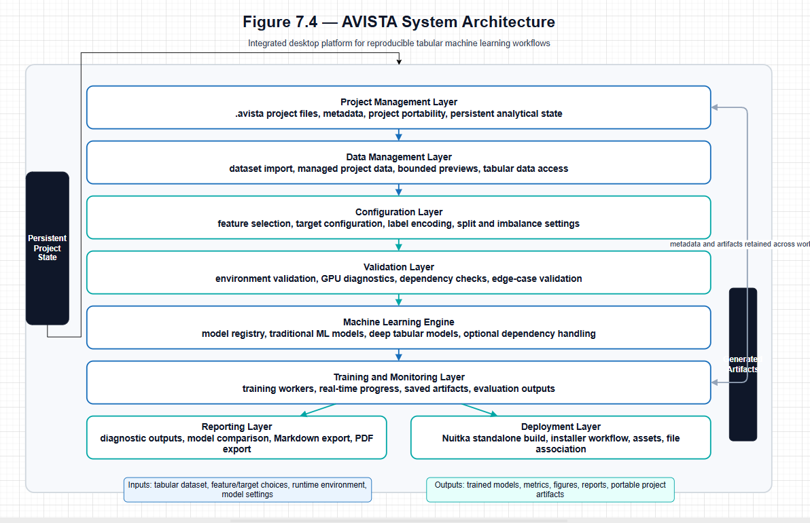
The draw.io file can be found in the reference\figures folder

Figure 7.4. AVISTA system architecture showing the layered organization of project management, data management, configuration, validation, machine learning, training, reporting, and deployment components.
Figure 7.4 provides the architectural interpretation of the traceability matrix. It shows how the requirements identified in this section are organized into layered system components, beginning with project management and data management and extending through configuration, validation, machine learning, training, reporting, and deployment. The figure therefore serves as a transition between the requirements analysis in this section and the detailed architectural discussion in Section 7.4.
7.3.6 Section Summary
This section defined the system requirements and design goals that guided AVISTA. The requirements emerged from the need to address fragmented machine learning workflows, weak reproducibility, dependency uncertainty, inconsistent model configuration, and the difficulty of transitioning from research notebooks to operational software. The resulting design goals emphasized reproducible analytical workflows, an integrated end-to-end pipeline, modular extensibility, hardware-aware execution, practitioner-oriented usability, and deployment-ready distribution.
These requirements directly informed the architecture presented in the next section. Section 7.4 builds on the traceability established here by describing how AVISTA organizes its project, data, configuration, validation, machine learning, training, reporting, and deployment components into a coherent system architecture.

7.4 System Architecture
7.4.1 Architectural Design Philosophy
AVISTA was designed as a modular, layered software architecture to support reproducible and extensible tabular machine learning workflows. The architectural objective was not only to execute models, but to organize the full analytical lifecycle in a way that preserves project state, separates methodological decisions, validates data and runtime conditions, and produces traceable analytical outputs. This design philosophy follows a central principle of research-oriented software engineering: analytical validity depends on the structure of the system that produces the results. When data preparation, model configuration, training, and reporting are tightly coupled or informally coordinated, reproducibility becomes fragile. AVISTA therefore separates these responsibilities into distinct architectural layers.
A layered architecture was selected because it provides a clear mapping between the design goals identified in Section 7.3 and the system components required to realize them. Modularity supports extensibility by allowing new models, validation procedures, reporting outputs, and deployment mechanisms to be added without redesigning the entire platform. Separation of concerns improves maintainability by distinguishing project state management, data handling, configuration, validation, model execution, reporting, and packaging. Reproducibility is supported by persistent configuration and artifact lineage across layers. Deployment readiness is supported by isolating runtime, packaging, and project portability concerns from analytical logic. Thus, the architecture treats AVISTA as a research software artifact rather than a single-purpose application.
7.4.2 Architectural Overview
Figure 7.4 presents the high-level system architecture of AVISTA. The figure organizes the platform into eight layers: the Project Management Layer, Data Management Layer, Configuration Layer, Validation Layer, Machine Learning Engine, Training and Monitoring Layer, Reporting Layer, and Deployment Layer. These layers collectively define the lifecycle of an analytical project, from project creation and dataset ingestion to model training, evaluation, reporting, and distribution.
The information flow in Figure 7.4 is intentionally sequential but not rigidly linear. Project metadata and configuration persist across the workflow, while artifacts generated in later stages remain linked to the project state that produced them. The analytical lifecycle begins with a project container, proceeds through managed data and user-defined analytical configuration, passes through validation gates, invokes model training, and terminates in reports and deployable artifacts. This structure reduces ambiguity about which data, target variable, feature set, split strategy, encoding scheme, and model configuration were used to produce a given result.
Figure 7.4 also illustrates that AVISTA is not organized around isolated tools. Each layer supplies structured information to the next layer while preserving the metadata required for reproducibility. The architecture therefore supports both exploratory modeling and formal analytical documentation. Table 7.5 summarizes the responsibilities of the architecture layers.
Table 7.5
Architecture Layer Responsibilities
Layer | Primary Responsibility | Key Components
Project Management Layer | Preserve project identity, state, metadata, and portability. | .avista project files, project metadata, saved configuration, project folders.
Data Management Layer | Manage tabular datasets within the project lifecycle. | Dataset ingestion, managed dataset storage, bounded previews, dataset metadata.
Configuration Layer | Capture analytical decisions before validation and training. | Feature selection, target configuration, label encoding configuration, model settings.
Validation Layer | Assess data integrity, runtime readiness, and training feasibility. | Edge-case validation, environment validation, GPU diagnostics, artifact checks.
Machine Learning Engine | Provide model definitions and unified access to supported algorithms. | Traditional ML models, deep tabular models, model registry, optional dependency handling.
Training and Monitoring Layer | Execute model training and track analytical outputs. | Training execution, worker processes, progress monitoring, learning curves, saved outputs.
Reporting Layer | Aggregate results into reproducible analytical reports. | Metrics, confusion matrices, classification reports, figures, Markdown and PDF exports.
Deployment Layer | Support practical distribution and project reuse. | Standalone packaging, installer generation, bundled assets, project portability.
7.4.3 Project and Data Management Layers
The Project Management Layer forms the foundation of the architecture shown in Figure 7.4. Its primary role is to preserve the analytical identity of a project across sessions. The .avista project file functions as the persistent representation of project state, including metadata, dataset references, selected configuration, and downstream analytical settings. This layer is central to reproducibility because it prevents the workflow from depending solely on transient interface state or undocumented local execution history.
Project state management also supports portability. A project is not treated as a loose collection of scripts and outputs, but as a structured analytical unit containing configuration, managed data references, and generated artifacts. This design allows the platform to maintain continuity between data preparation, model training, reporting, and later review.
The Data Management Layer extends this reproducibility logic by controlling how datasets enter and remain associated with a project. Dataset ingestion is not simply a file-opening operation; it establishes a managed data object within the analytical workflow. By storing datasets within the project structure and preserving dataset metadata, AVISTA reduces ambiguity about the data source used in an analysis. This layer also supports bounded data previews and dataset portability, ensuring that the analytical workflow can scale to practical tabular datasets without requiring the full dataset to be rendered or manually inspected at every stage.
Together, the Project Management and Data Management Layers provide the stateful basis for all subsequent layers in Figure 7.4. Configuration, validation, model training, and reporting all depend on the integrity of these foundational layers.
7.4.4 Configuration and Validation Layers
The Configuration Layer captures the analytical choices that define a machine learning experiment. These include feature selection, target configuration, label encoding configuration, split settings, imbalance handling choices, model selection, and model parameter settings. This layer is architecturally distinct because configuration decisions should be explicit, persistent, and inspectable before model training begins. Without such separation, preprocessing and modeling decisions can become embedded in execution scripts, making later replication difficult.
The Validation Layer is positioned after configuration and before training in Figure 7.4. This placement is methodologically important. Validation is separated from training so that data integrity problems, missing configuration, incompatible artifacts, dependency issues, and training readiness conditions can be assessed before computationally expensive or analytically consequential operations are executed. Edge-case validation supports the identification of problematic conditions such as invalid targets, inappropriate feature states, or data conditions that may compromise model results. Environment validation and GPU diagnostics address the runtime dimension of reproducibility by checking whether the computational environment is suitable for the selected workflow.
This separation ensures that training is not treated as the first point at which errors are discovered. Instead, AVISTA uses validation as an architectural gate between configuration and model execution. The result is a workflow in which analytical decisions are first recorded, then evaluated, and only then passed to the Machine Learning Engine and Training Layer.
7.4.5 Machine Learning Engine Layer
The Machine Learning Engine provides the algorithmic core of AVISTA. As shown in Figure 7.4, it receives validated configuration and exposes a unified structure for traditional machine learning models and deep tabular learning models. This layer supports classical classifiers, ensemble methods, boosting approaches, kernel and distance-based methods, deep tabular architectures, and foundation-model-based tabular learning where dependencies are available.
The architectural significance of this layer is its extensibility. Models are organized through a common registry structure rather than being embedded as isolated execution routines. This supports systematic model selection, parameter persistence, dependency awareness, and future model integration. New algorithms can be added by extending the model layer without modifying project management, dataset handling, validation, reporting, or deployment responsibilities.
This design reflects the dissertation’s broader methodological argument. Chapter 4 showed that tabular machine learning benefits from systematic comparison across model families. The Machine Learning Engine operationalizes that finding by providing a framework in which heterogeneous models can coexist under a consistent analytical workflow.
7.4.6 Training and Monitoring Layer
The Training and Monitoring Layer executes the validated modeling workflow. Its responsibilities include training execution, progress tracking, metric generation, learning curve capture, and persistence of model outputs. In Figure 7.4, this layer sits downstream of the Machine Learning Engine because training depends on the selected model definitions and the prepared analytical artifacts.
A key architectural principle is the separation between training logic and the user-facing interface. Long-running model training is treated as a controlled background process so that computational work does not compromise workflow responsiveness. This separation is especially important for deep tabular models, which may require iterative optimization, hardware-specific execution, and live metric tracking. Progress monitoring and learning curve generation provide transparency into the training process while maintaining a clear boundary between computational execution and presentation.
The Training and Monitoring Layer also preserves artifacts needed for subsequent evaluation and reporting. These artifacts include trained models, predictions, metrics, histories, and diagnostic outputs. By storing these outputs within the project structure, AVISTA maintains the relationship between model execution and the configuration state that produced it.
7.4.7 Reporting Layer
The Reporting Layer aggregates model outputs into reproducible analytical documents. It supports metric generation, model comparison, confusion matrices, classification reports, diagnostic figures, Markdown export, and PDF export. In the architecture shown in Figure 7.4, reporting follows training because it depends on saved evaluation artifacts rather than ad hoc recomputation.
This design improves reproducibility and communication. Reports provide a documented record of model performance, diagnostic outputs, project metadata, and generated artifacts. They also allow results to be reviewed outside the training environment, which is essential for dissertation documentation, practitioner communication, and decision-support workflows. The reporting layer therefore serves both a technical and scholarly function: it converts computational outputs into structured evidence.
Importantly, the Reporting Layer does not replace methodological interpretation. Instead, it preserves and organizes the evidence needed for interpretation. This distinction is consistent with the role of AVISTA as a research artifact: the platform supports transparent analysis without overstating the autonomy of the software.
7.4.8 Deployment Layer
The Deployment Layer addresses the practical transition from research software to usable analytical infrastructure. As indicated in Figure 7.4, deployment is positioned as a final architectural layer because it depends on the stability of the project, data, configuration, validation, training, and reporting layers. Deployment readiness includes standalone packaging, installer generation, bundled assets, model resources, and file association for portable project files.
This layer directly reflects the deployment readiness goal identified in Section 7.3. Many research prototypes stop at executable scripts, which limits their use outside the original development environment. AVISTA’s deployment architecture is intended to support distribution on practitioner machines while preserving project portability and runtime awareness. This does not eliminate the need for installation validation or domain-specific review, but it provides a structured pathway from dissertation software artifact to operational analytical platform.
7.4.9 Architectural Benefits
The layered architecture provides several benefits that align with the design goals established in Section 7.3. Reproducibility is supported through persistent project configuration, managed datasets, validation gates, saved training artifacts, and structured reports. Usability is supported by organizing complex analytical tasks into a coherent lifecycle rather than requiring users to coordinate disconnected tools. Extensibility is supported through modular separation and a model registry that can accommodate future algorithms, explanation methods, robustness checks, and reporting outputs. Maintainability is improved because each layer has a defined responsibility and limited coupling to other layers. Deployment readiness is supported by preserving project portability and separating packaging concerns from analytical logic.
Figure 7.4 therefore represents more than a structural diagram; it summarizes the architectural logic of AVISTA as a dissertation contribution. The system architecture operationalizes the requirements from Section 7.3 by mapping reproducibility, integration, extensibility, hardware awareness, usability, and deployment readiness into distinct but connected software layers.
The next section builds on this architectural overview by examining the core platform components in greater detail. Section 7.5 moves from the layered system architecture to the specific components through which AVISTA manages projects, data, configuration, validation, training, reporting, and deployment within the end-to-end analytical workflow.

7.5 Core Platform Components
The AVISTA architecture is implemented through a set of core platform components that correspond to the major stages of a reproducible tabular machine learning workflow. These components are not isolated utilities; they form an integrated analytical sequence in which project state, data assets, configuration decisions, validation results, and model selections are progressively structured before training is executed. This organization reflects the architectural goals described in Section 7.4. Each module addresses a specific source of uncertainty commonly encountered in applied machine learning workflows, including undocumented project state, inconsistent runtime environments, ambiguous dataset versions, implicit feature definitions, unstable data partitions, unverified target integrity, and inconsistent model configuration.
Table 7.6 summarizes the major platform components discussed in this section. The screenshots referenced throughout the section provide visual evidence of the implemented modules, but the contribution of AVISTA lies in the system design underlying these interfaces. The modules collectively transform a fragmented analytical process into a persistent, validated, and reproducible workflow.
Table 7.6
Core Platform Components
Module | Primary Function | Key Responsibilities
Project Management Module | Establish and preserve the analytical project state. | .avista project files, metadata persistence, project loading, project portability, dataset linkage.
Environment Management Module | Validate runtime and hardware readiness. | CPU inspection, memory inspection, GPU diagnostics, dependency verification, runtime metadata.
Data Management Module | Manage tabular data within the project structure. | Dataset import, project-local copying, format support, preview generation, dataset metadata.
Column Configuration Module | Define analytical variables explicitly. | Feature selection, target selection, categorical variable identification, encoding configuration.
Data Split and Imbalance Module | Create reproducible evaluation partitions and handle class imbalance. | Train-validation-test splitting, random seeds, stratification, imbalance mitigation, split artifact persistence.
Edge-Case Validation Module | Assess data and configuration readiness before training. | Missingness checks, target integrity checks, class coverage validation, readiness assessment.
Model Selection Module | Configure candidate models before execution. | Traditional model selection, deep tabular model selection, parameter persistence, model registry integration.
7.5.1 Project Management Module
The Project Management Module provides the foundation for AVISTA’s project-centric workflow. Its primary role is to convert an analysis from a temporary computational session into a persistent analytical object. In many machine learning studies, the relationship among the dataset, model settings, output folders, and evaluation artifacts is maintained informally through directory naming conventions or researcher memory. AVISTA addresses this limitation by using .avista project files as structured containers for project identity, metadata, dataset references, configuration settings, and workflow state.
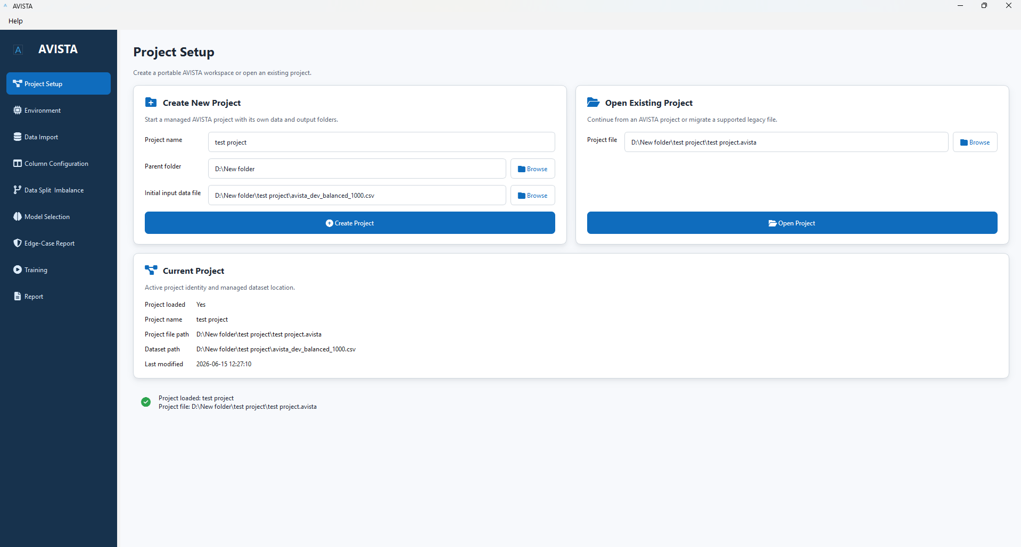

Figure 7.5. Project Setup Interface.
Figure 7.5 illustrates the Project Setup Interface, which represents the project-centric entry point of AVISTA. The figure should be interpreted not as a depiction of interface convenience, but as evidence of the project-centered design philosophy. A project-centered architecture ensures that subsequent modules operate within a known analytical context. Dataset management, column configuration, splitting, validation, model selection, training, and reporting all depend on the project state established at this stage.
The project system is central to reproducibility because it preserves analytical context across sessions. Rather than requiring the user to reconstruct the state of an experiment from separate scripts and file paths, AVISTA stores project-level information in a persistent configuration structure. This includes project metadata, application version information, dataset linkage, selected configuration, and downstream artifact references. By maintaining this information in a project file, AVISTA reduces ambiguity about which analytical state produced a given result.
Dataset linkage is another important function of the Project Management Module. The project file does not merely identify a folder; it records the relationship between the project and its managed dataset. This linkage improves experiment consistency because later workflow stages can resolve the appropriate data source from project metadata rather than relying on manual file selection. Project portability is also supported because the project structure preserves relative relationships among project configuration, data assets, and generated outputs. This makes the project a reproducible analytical unit rather than a loose collection of files.
7.5.2 Environment Management Module
The Environment Management Module addresses a different but equally important source of reproducibility risk: variability in runtime environments. Machine learning results and workflow stability can be affected by dependency versions, optional package availability, CPU and memory resources, GPU configuration, CUDA compatibility, and hardware-specific execution paths. These conditions are often assumed rather than documented in research prototypes. AVISTA treats environment validation as an explicit platform component.
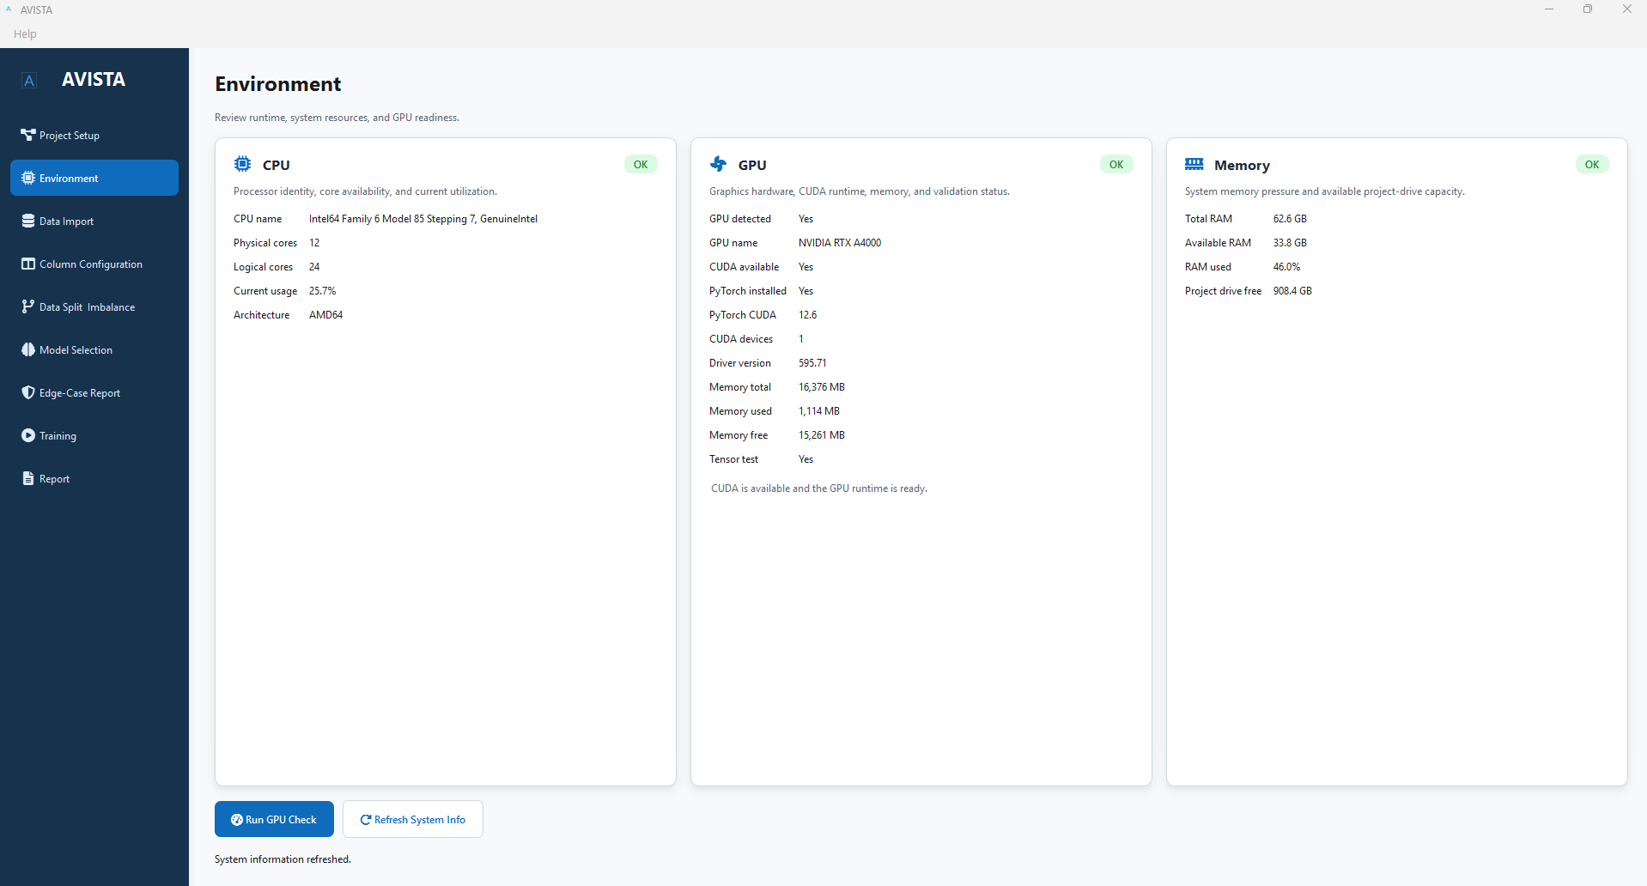
Figure 7.6. Environment Management Interface.
Figure 7.6 presents the Environment Management Interface, which illustrates AVISTA’s treatment of runtime validation as part of the analytical workflow. Its significance lies in the system’s recognition that computational environment is part of the analytical record. In applied machine learning, a model configuration alone is insufficient to reproduce a workflow if the execution environment is unknown or incompatible.
The module performs system inspection, including CPU detection, memory detection, GPU validation, dependency verification, and runtime diagnostics. This information supports both operational readiness and reproducibility. If a deep tabular model depends on GPU acceleration or a specific optional package, the platform must be able to determine whether the current environment can support that workflow. Similarly, if a project is transferred to another machine, runtime diagnostics help identify whether the new environment differs from the environment in which prior outputs were generated.
Dependency verification is particularly important in AVISTA because the platform supports both traditional machine learning models and deep tabular learning models. Optional libraries may be required for specific model families, while GPU acceleration may depend on compatible runtime components. By isolating environment inspection within its own module, AVISTA avoids embedding dependency assumptions inside training routines. This separation improves maintainability and supports clearer error interpretation.
7.5.3 Data Management Module
The Data Management Module governs how tabular datasets enter the analytical workflow and remain associated with a project. Dataset management is a critical design concern because machine learning experiments are highly sensitive to the exact data version used for modeling. In fragmented workflows, it is common for notebooks or scripts to reference external files through local paths, creating uncertainty when projects are moved, shared, or revisited. AVISTA addresses this issue by copying imported datasets into the project structure and treating them as managed project assets.
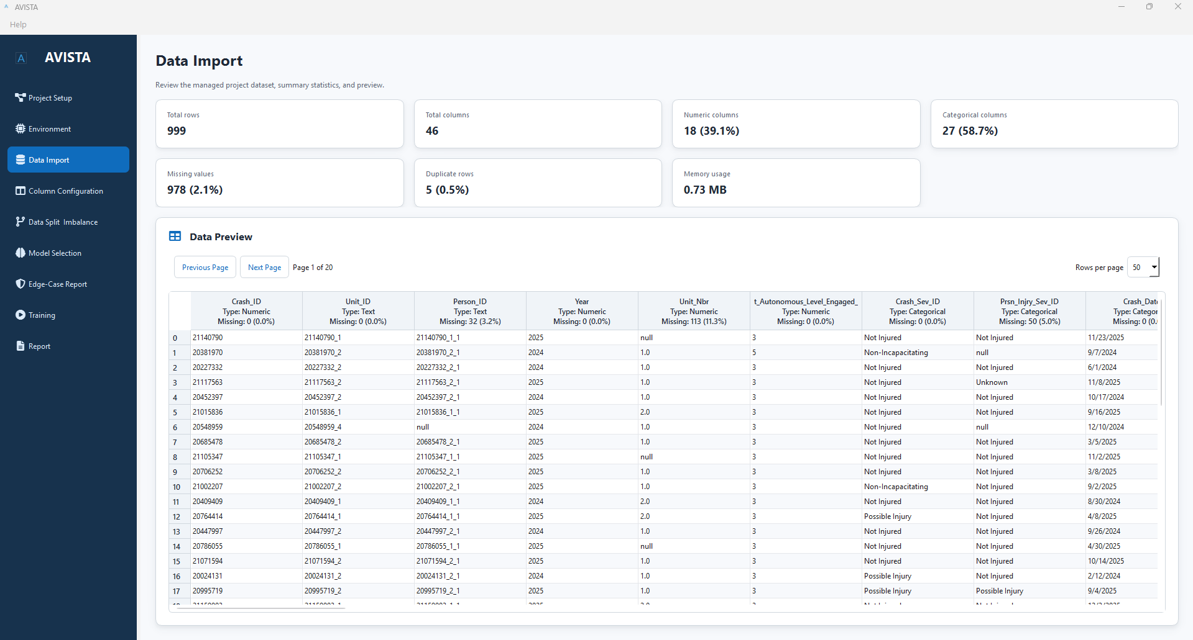
Figure 7.7. Dataset Import Interface.
Figure 7.7 shows the Dataset Import Interface. The screenshot supports the architectural discussion by demonstrating that dataset ingestion is positioned as a formal workflow stage. Dataset import is not treated as an incidental file-opening event; it establishes the data asset on which feature configuration, target definition, splitting, validation, training, and reporting depend.
The module supports common tabular formats, including CSV, Excel, Parquet, Feather, and FST. The specific format support is less important than the architectural principle: once a dataset is imported, it becomes part of the managed analytical context. Dataset metadata, project linkage, and bounded previews allow the platform to maintain awareness of the data source without requiring the full dataset to be repeatedly loaded into the interface. This is especially important for larger tabular datasets, where unrestricted preview rendering can reduce responsiveness and obscure workflow clarity.
Managed dataset storage improves experiment consistency in several ways. It reduces the risk that a project accidentally uses a modified external file. It supports portability by storing the analytical dataset within the project structure. It also allows downstream modules to access a consistent dataset reference. This design is important because reproducible modeling requires that the same dataset, not merely the same code, be available when the workflow is repeated.
7.5.4 Column Configuration Module
The Column Configuration Module defines the analytical variables used in modeling. In tabular machine learning, the distinction between available columns, selected features, target variables, categorical predictors, and encoded values is fundamental. If these decisions are implicit, results can become difficult to reproduce or interpret. AVISTA therefore treats column configuration as a distinct module rather than a hidden preprocessing step.
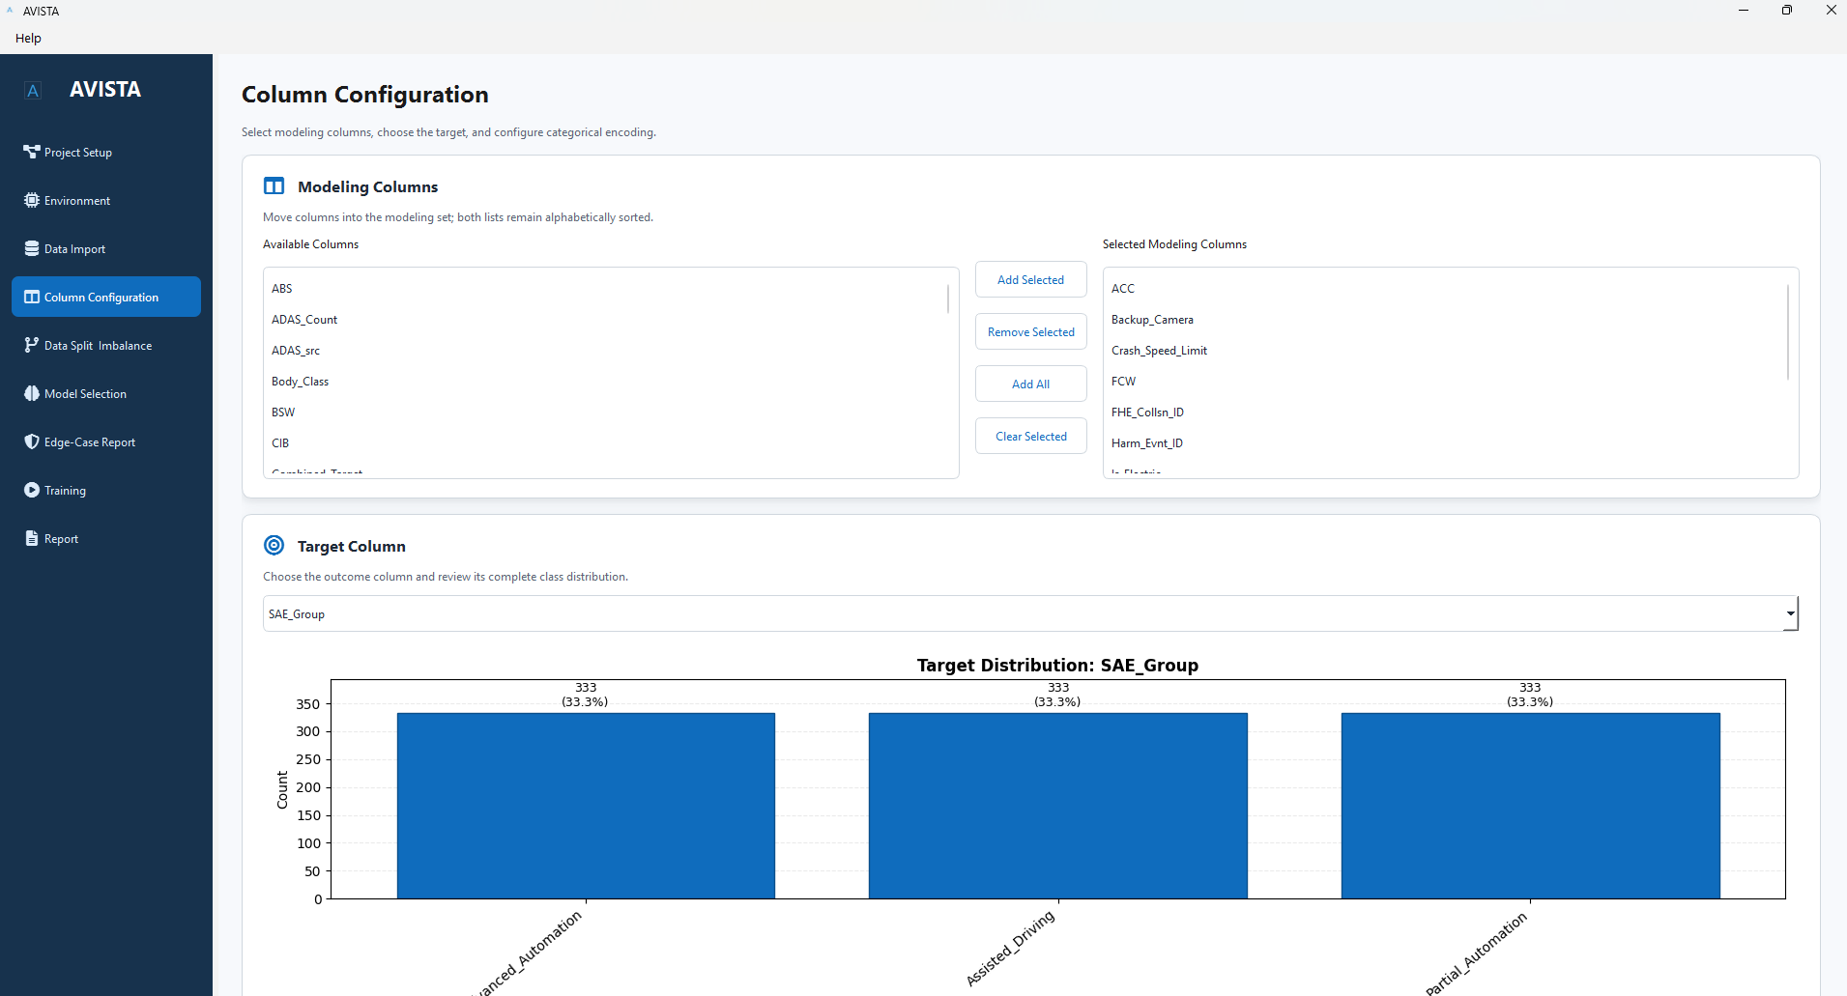
Figure 7.8. Column Configuration Interface.
Figure 7.8 presents the Column Configuration Interface, which illustrates the explicit definition of modeling variables before downstream analysis. The figure provides evidence that AVISTA requires analytical variable definitions before splitting, validation, and training proceed. This requirement improves transparency because modeling decisions are captured at the project level rather than embedded inside training scripts.
The module supports feature selection, target selection, categorical variable configuration, and encoding configuration. These functions allow the analytical dataset to be transformed from a raw table into a defined modeling structure. Explicit feature selection ensures that only intended predictors enter the model. Target configuration identifies the response variable and establishes the basis for downstream target encoding, split stratification, evaluation metrics, and reporting. Categorical variable configuration and label encoding settings make preprocessing assumptions visible and persistent.
The Column Configuration Module interacts directly with the Data Management Module and the Data Split and Imbalance Module. It receives the managed dataset as input and produces a modeling configuration that determines which columns are available for splitting, preprocessing, and training. It also interacts with the Edge-Case Validation Module, because target integrity and feature suitability can be assessed only after the relevant columns have been defined. In this way, column configuration acts as a bridge between raw data management and methodological validation.
7.5.5 Data Split and Imbalance Module
The Data Split and Imbalance Module is responsible for creating reproducible evaluation partitions and addressing class imbalance in the training data. This module exists because data splitting is one of the most consequential operations in machine learning evaluation. If train, validation, and test sets are not created consistently, performance estimates may become unstable, biased, or incomparable across models. Similarly, class imbalance mitigation must be applied carefully to avoid information leakage.
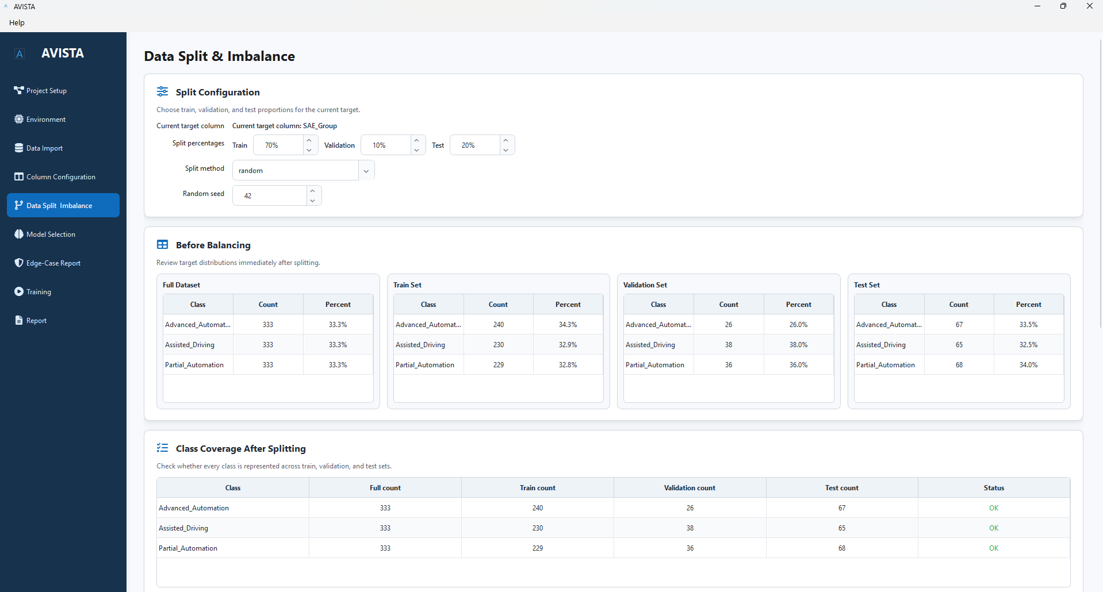
Figure 7.9. Data Split and Imbalance Interface.
Figure 7.9 shows the Data Split and Imbalance Interface, which reflects the module’s role in making evaluation design explicit. Rather than allowing split logic to remain hidden in scripts, AVISTA records the split configuration, class distributions, random seed, and imbalance strategy as part of the project workflow. The resulting artifacts provide a stable basis for model comparison and later reporting.
AVISTA treats train-validation-test partitioning as an independent module because splitting establishes the experimental design for model evaluation. The module supports reproducible random seeds, stratified splitting, and other partitioning strategies. Persisting split artifacts allows multiple models to be trained and compared using the same underlying partitions. This is essential for fair benchmarking and aligns with the evaluation logic developed in Chapter 4.
Imbalance handling is integrated into the same module because class distribution is closely tied to training set construction. AVISTA’s design separates training data modification from validation and test evaluation. This is methodologically important: balancing operations should be derived from and applied to the training partition, while validation and test sets should remain representative of the evaluation conditions. By managing imbalance at this stage, the platform reduces the likelihood of leakage from evaluation data into training.
This module interacts with the Column Configuration Module through the selected target and features, with the Edge-Case Validation Module through class coverage and readiness checks, and with the Training Layer through saved data artifacts. Its independence from training allows AVISTA to verify and preserve the evaluation structure before any model is fitted.
7.5.6 Edge-Case Validation Module
The Edge-Case Validation Module provides automated assessment of data and configuration conditions that may compromise model training or evaluation. Applied tabular datasets frequently contain missing values, sparse classes, inconsistent target values, high-cardinality fields, degenerate columns, or class coverage problems across partitions. These conditions may not always cause immediate software failure, but they can produce misleading results or invalid comparisons. AVISTA therefore includes validation as a dedicated module rather than relying on model training errors to reveal problems.
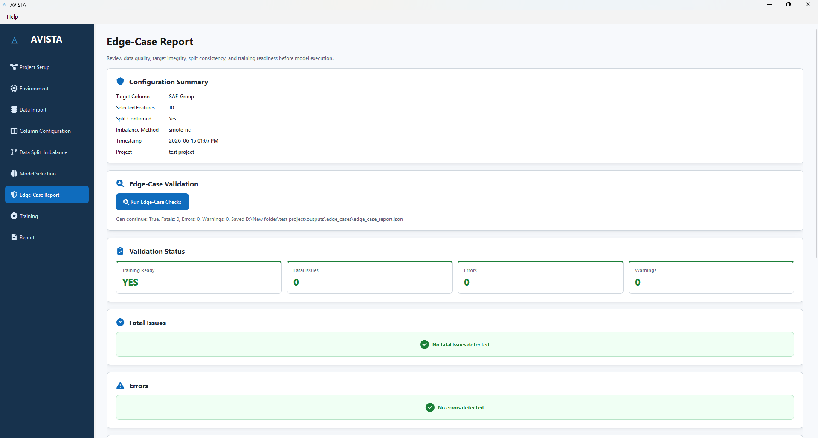
Figure 7.10. Edge-Case Validation Interface.
Figure 7.10 presents the Edge-Case Validation Interface, showing validation as a formal analytical stage rather than an incidental warning system. Automated validation reduces analytical errors by making potential issues visible before training begins. This is particularly important in practitioner-oriented workflows, where users may need structured support identifying data conditions that affect model validity.
The module supports missing data validation, target integrity validation, class coverage validation, and overall readiness assessment. Missing data checks help identify feature conditions requiring preprocessing or interpretation. Target integrity checks assess whether the selected response variable is suitable for classification. Class coverage validation examines whether classes are adequately represented in training and evaluation partitions. Readiness assessment provides a structured judgment about whether the configured workflow is suitable for model training.
The Edge-Case Validation Module interacts with nearly all preceding modules. It depends on the managed dataset, column configuration, split artifacts, and imbalance settings. Its outputs inform the Training and Monitoring Layer by determining whether the workflow is ready for model execution. Architecturally, this module functions as a methodological checkpoint, ensuring that model training is based on a verified analytical state.
7.5.7 Model Selection Module
The Model Selection Module governs how candidate algorithms are selected and configured before execution. AVISTA supports both traditional machine learning models and deep tabular learning models, including linear, tree-based, boosting, kernel or distance-based, naive Bayes, deep architecture, and foundation-model categories. The purpose of the module is not simply to list algorithms, but to provide a structured mechanism for managing model metadata, parameter configuration, dependency requirements, and selection state.
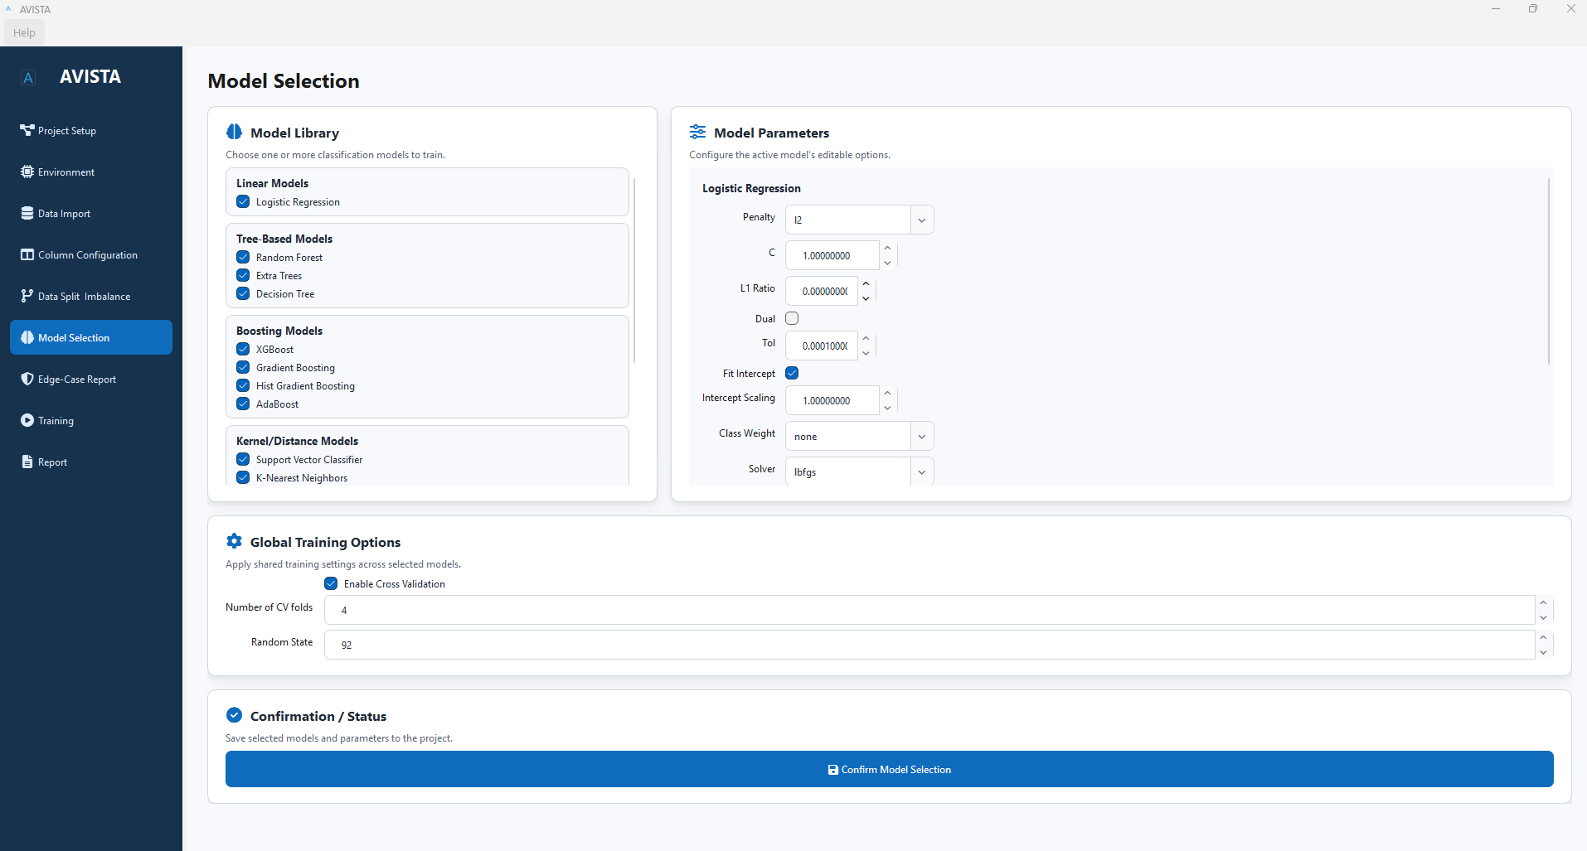
Figure 7.11. Model Selection Interface.
Figure 7.11 presents the Model Selection Interface, which supports the system-design argument that model selection is treated as a configurable analytical stage rather than an ad hoc training command. This distinction is important because model comparison requires consistent configuration and persistent parameter settings. If model choices are made only inside scripts, it becomes more difficult to determine which algorithm variants produced a reported output.
A central design feature of this module is the extensible model registry. The registry separates model definition from model execution. Model definition includes canonical names, display names, categories, default parameters, optional dependency requirements, and capability metadata. Model execution occurs later in the training framework. This separation improves maintainability and extensibility because new models can be introduced without restructuring the entire workflow. It also supports dependency-aware behavior, since optional libraries for specific model families can be evaluated without imposing unnecessary requirements on unrelated models.
The Model Selection Module interacts with the Configuration Layer, Environment Management Module, and Training Framework. It persists selected models and parameters to project configuration, relies on environment checks to identify dependency availability, and supplies validated model choices to the training process. This design enables systematic comparison across heterogeneous model families while preserving the reproducibility of model configuration.
Collectively, the core platform components described in this section implement the workflow foundation of AVISTA. The Project Management Module establishes persistent analytical identity; the Environment Management Module records runtime readiness; the Data Management Module preserves dataset consistency; the Column Configuration Module makes analytical variables explicit; the Data Split and Imbalance Module defines the evaluation structure; the Edge-Case Validation Module provides methodological safeguards; and the Model Selection Module prepares candidate algorithms for controlled execution. These modules jointly operationalize the dissertation’s emphasis on reproducible and practitioner-oriented machine learning workflows.
The next section builds on this foundation by examining the Machine Learning Engine in greater detail. Section 7.6 focuses on how AVISTA organizes traditional machine learning models, deep tabular learning models, model metadata, dependency awareness, and training integration within a unified analytical framework.

7.6 Machine Learning Engine
7.6.1 Design Objectives of the Machine Learning Engine
The Machine Learning Engine forms the analytical core of AVISTA. Its purpose is to provide a unified framework through which heterogeneous tabular learning models can be registered, configured, trained, evaluated, and connected to reporting outputs. The engine was designed to address a recurring limitation in applied machine learning workflows: models are often implemented as separate scripts, each with different assumptions about preprocessing, parameter management, output generation, and evaluation. Such fragmentation makes systematic comparison difficult and weakens reproducibility. AVISTA therefore treats model execution as an architectural concern rather than an isolated computational task.
The principal design objectives of the Machine Learning Engine are flexibility, extensibility, reproducibility, and support for heterogeneous model families. Flexibility is required because tabular machine learning problems vary substantially in feature structure, sample size, class distribution, and computational constraints. Extensibility is required because new model families continue to emerge, particularly in deep tabular learning and foundation-model-based tabular prediction. Reproducibility is required because model results are meaningful only when the corresponding parameter settings, training artifacts, evaluation outputs, and project configuration can be recovered. Support for heterogeneous model families is required because traditional machine learning models and deep tabular architectures differ substantially in assumptions, dependencies, training procedures, and artifact structures.
A unified engine was necessary because AVISTA is intended to operationalize the methodological work of earlier chapters rather than reproduce a single modeling experiment. Chapter 4 demonstrated the value of comparing traditional machine learning models with deep tabular learning approaches under a consistent evaluation framework. The Machine Learning Engine translates this methodological requirement into software architecture by providing common registration, configuration, execution, evaluation, and reporting interfaces. This design allows AVISTA to support diverse algorithms while maintaining consistent workflow semantics across models.
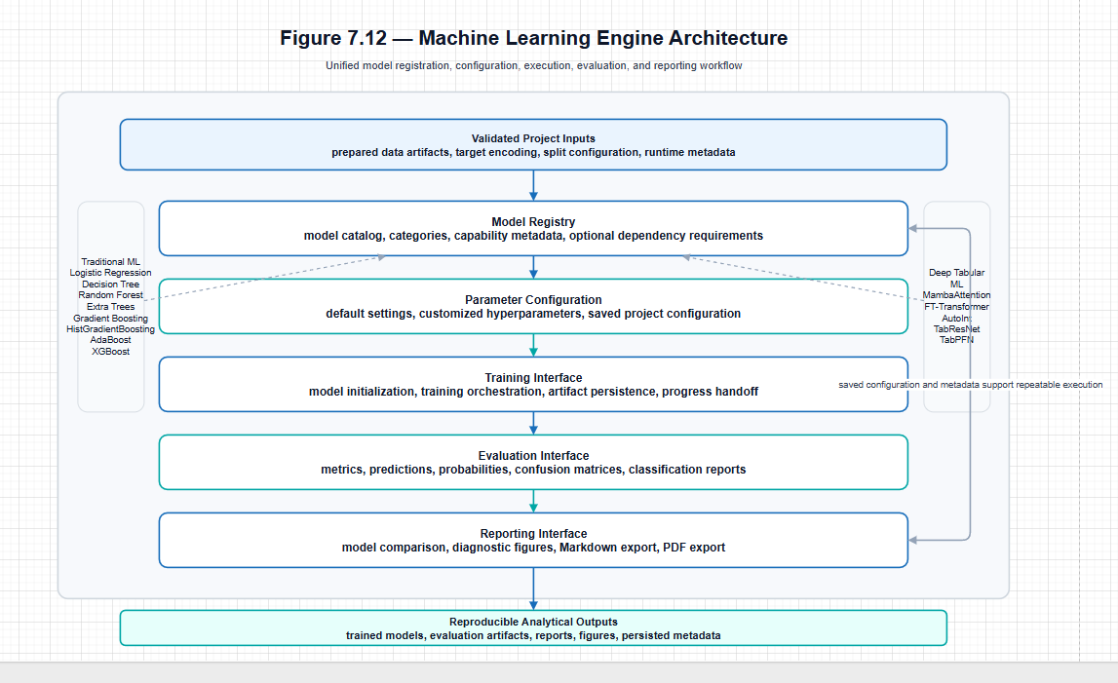
Figure 7.12. Machine Learning Engine architecture showing the flow from model registry to parameter configuration, training interface, evaluation interface, and reporting interface.
Figure 7.12 should be placed here, immediately after the introductory design-objectives discussion and before the section turns to specific model families. This placement allows the figure to serve as the conceptual map for the entire section. The figure should show the Machine Learning Engine as a layered pipeline in which the Model Registry supplies available algorithms, the Parameter Configuration component stores model-specific settings, the Training Interface initializes and executes model fitting, the Evaluation Interface standardizes metrics and diagnostic outputs, and the Reporting Interface transfers results into exportable analytical products.
7.6.2 Traditional Machine Learning Framework
Traditional machine learning models remain essential in AVISTA because they provide strong, interpretable, and computationally efficient baselines for tabular classification. In many structured-data problems, tree-based ensembles, boosting methods, and regularized linear models remain competitive with or superior to deep learning architectures, especially when datasets are modest in size, contain heterogeneous feature types, or require transparent diagnostic interpretation. Their inclusion is therefore not merely for comparison; it reflects the practical reality that robust decision-support systems must support methods that are efficient, stable, and widely understood.
AVISTA includes linear, tree-based, ensemble, and boosting models as part of its traditional machine learning framework. Linear models provide a useful reference for problems where relationships are approximately additive or where interpretability and calibration are important. Decision trees and ensemble tree methods support nonlinear relationships and feature interactions without requiring the same training complexity as deep architectures. Boosting methods are included because they have a strong empirical record in tabular machine learning and often provide high-performing solutions for structured datasets.
Table 7.7
Traditional Machine Learning Models Implemented in AVISTA
Model | Category | Primary Characteristics
Logistic Regression | Linear Model | Regularized linear classifier suitable for interpretable baseline modeling and probability estimation.
Decision Tree | Tree-Based Model | Nonlinear model that partitions feature space through hierarchical decision rules.
Random Forest | Tree-Based Ensemble | Bagged ensemble of decision trees designed to improve stability and reduce variance.
Extra Trees | Tree-Based Ensemble | Randomized tree ensemble that increases split randomness to improve generalization efficiency.
Gradient Boosting | Boosting Model | Sequential ensemble that combines weak learners to reduce predictive error.
HistGradientBoosting | Boosting Model | Histogram-based gradient boosting designed for efficient training on larger tabular datasets.
AdaBoost | Boosting Model | Adaptive boosting method that iteratively emphasizes difficult-to-classify observations.
XGBoost | Gradient Boosting Framework | Optimized gradient boosting implementation with regularization and strong tabular-data performance.
The traditional framework also supports AVISTA’s reproducibility objective. Because these models are commonly used in applied research, their configuration and comparison must be handled consistently. The Machine Learning Engine ensures that model choices, parameter values, training outputs, and evaluation results are linked to the same project configuration and data partitions used by other model families.
7.6.3 Deep Tabular Learning Framework
Deep tabular learning has emerged as an active research area because conventional neural architectures developed for images, language, and sequences do not automatically transfer to structured tabular data. Tabular datasets often include mixed feature types, sparse or noisy predictors, nonlinear interactions, and limited sample sizes relative to feature complexity. Recent research has therefore explored architectures that combine representation learning with mechanisms better suited to feature interaction modeling, attention, residual learning, and pretraining.
AVISTA incorporates deep tabular learning models to operationalize the dissertation’s investigation of advanced model families. The supported models include MambaAttention, FT-Transformer, AutoInt, TabResNet, and TabPFN. These architectures represent several directions in modern tabular learning: attention-based modeling, transformer-inspired feature tokenization, automatic feature interaction learning, residual neural architectures, and foundation-model-based inference. Their inclusion allows the platform to support a broader analytical space than classical machine learning alone.
Table 7.8
Deep Tabular Learning Models Implemented in AVISTA
Model | Architecture Type | Primary Characteristics
MambaAttention | Attention-enhanced deep tabular architecture | Combines deep representation learning with attention mechanisms for tabular classification workflows.
FT-Transformer | Transformer-inspired tabular architecture | Uses feature tokenization and transformer-style attention to model interactions among tabular features.
AutoInt | Attentional feature interaction network | Learns explicit high-order feature interactions through multi-head self-attention mechanisms.
TabResNet | Residual neural tabular architecture | Applies residual learning principles to structured tabular features for stable deep model training.
TabPFN | Foundation-model tabular learner | Uses pretrained tabular inference mechanisms to support rapid classification on compatible datasets.
The deep tabular framework is intentionally integrated into the same engine as traditional models. This avoids the creation of a parallel deep learning workflow disconnected from project configuration, validation, evaluation, and reporting. Instead, deep models share the same broader analytical lifecycle while retaining model-specific training behavior where necessary. This design supports systematic comparison without forcing all algorithms into an overly simplistic execution pattern.
7.6.4 Unified Model Registry Architecture
The unified model registry is the organizing structure of the Machine Learning Engine. Its role is to centralize model registration, model metadata, category information, parameter defaults, dependency requirements, and capability descriptors. This registry-based design avoids scattering model definitions across unrelated parts of the platform. It also allows the system to distinguish between model availability, model configuration, and model execution.
As shown conceptually in Figure 7.12, the Model Registry is the entry point of the Machine Learning Engine. It supplies the list of available algorithms and the metadata required to configure them. The registry then connects to the Parameter Configuration component, which captures model-specific settings before training begins. This separation allows AVISTA to integrate new models without redesigning the project management, data preparation, validation, training, evaluation, or reporting layers.
The abstraction layer provided by the registry is especially important because AVISTA supports heterogeneous model families. A logistic regression model, a gradient boosting model, a transformer-inspired tabular model, and a foundation tabular model differ substantially in computational requirements and training behavior. However, from the perspective of the project workflow, each must be selectable, configurable, trainable, evaluable, and reportable. The registry establishes this common structure while allowing model-specific details to remain encapsulated.
7.6.5 Hyperparameter Configuration Framework
Hyperparameter configuration is a central reproducibility concern in machine learning. Model results cannot be interpreted or repeated without knowing the parameter values used during training. AVISTA therefore treats hyperparameters as persistent analytical configuration rather than transient execution arguments. The Hyperparameter Configuration Framework stores default configurations, supports user customization, and preserves selected values as part of the project state.
Default configurations serve two purposes. First, they provide a stable starting point for model execution. Second, they define the expected parameter space for each registered model. User customization allows the platform to support analytical flexibility without sacrificing traceability. When parameter settings are saved with the project, model comparisons can be revisited, repeated, or audited more reliably.
Figure 7.12 situates parameter management between model registration and training execution. This placement is methodologically important because parameter settings must be resolved before a model is initialized. By storing these settings before training, AVISTA ensures that downstream artifacts can be interpreted in relation to the exact configuration that produced them. This is particularly important for deep tabular models, where learning rate, batch size, epochs, dropout, architecture dimensions, and monitoring settings may substantially influence training behavior.
7.6.6 Model Lifecycle Management
The Machine Learning Engine manages the model lifecycle from creation to reporting. Model creation begins when the registry identifies a selected model and its associated configuration. Training initialization then connects the model definition to prepared data artifacts, target encodings, split information, imbalance handling outputs, and runtime conditions. This ensures that each model is trained under the intended analytical state rather than under ad hoc script assumptions.
Evaluation integration follows training. AVISTA standardizes the generation of metrics, predictions, confusion matrices, classification reports, probability outputs where available, and diagnostic artifacts. This standardization is necessary because different model families produce outputs in different formats. A unified evaluation interface allows these outputs to be converted into comparable analytical evidence while preserving model-specific information when needed.
Result persistence completes the lifecycle. Trained model artifacts, evaluation outputs, training histories, diagnostic figures, and metadata are stored within the project structure. This design allows the Reporting Interface shown in Figure 7.12 to aggregate model outputs without requiring retraining. It also allows multiple models to be compared within the same project context. Lifecycle management therefore links the Machine Learning Engine to the broader reproducibility goals of AVISTA.
Table 7.9
Machine Learning Engine Components
Component | Responsibility | Associated Modules
Model Registry | Centralizes supported models, metadata, categories, defaults, dependencies, and capability descriptors. | Model Selection Module, Machine Learning Engine
Parameter Configuration | Stores default and customized model settings as reproducible project configuration. | Model Selection Module, Project Management Module
Training Interface | Initializes and executes model training using prepared data and saved configuration. | Training and Monitoring Framework
Evaluation Interface | Standardizes metrics, predictions, diagnostic outputs, and model comparison artifacts. | Evaluation Module, Reporting Framework
Reporting Interface | Transfers model outputs into Markdown, PDF, figures, and structured analytical reports. | Reporting Module
7.6.7 Extensibility of the Machine Learning Engine
Extensibility is one of the central reasons for designing the Machine Learning Engine as a registry-based and interface-driven architecture. The current model set includes traditional machine learning models, deep tabular architectures, and a foundation-model approach, but the architecture is intended to support future model families. Additional deep learning architectures, updated foundation models, AutoML modules, calibration methods, uncertainty estimation techniques, and explainability modules can be incorporated by extending the relevant registry, configuration, training, evaluation, and reporting interfaces.
This extensibility is important for a dissertation software artifact because machine learning methods evolve quickly. A platform that hard-codes a fixed model set would become obsolete as new tabular learning approaches emerge. AVISTA instead provides a structure in which new models can be integrated while preserving the surrounding workflow. The same project management, data preparation, validation, training monitoring, evaluation, and reporting layers can remain stable even as the model library expands.
The engine also provides a natural pathway for future explainability integration. Feature importance summaries, SHAP-based explanations, per-row interpretation, subgroup diagnostics, and robustness analyses can be connected to saved model artifacts and evaluation outputs. Because the Machine Learning Engine already standardizes model metadata and result persistence, these future modules can build on existing project and reporting structures rather than operating as separate post-processing scripts.
In summary, the Machine Learning Engine is the analytical core through which AVISTA operationalizes heterogeneous tabular learning methods. It supports traditional models for robust baseline and applied modeling, deep tabular learning models for advanced representation learning, and foundation-model approaches for emerging tabular inference workflows. More importantly, it integrates these models through a unified registry, parameter configuration framework, lifecycle management process, and reporting interface. This architecture enables model diversity without sacrificing reproducibility or workflow consistency.
The next section extends this discussion by examining how model execution is managed during training. Section 7.7 focuses on the Training and Monitoring Framework, including training orchestration, progress tracking, learning-curve generation, output persistence, and the system mechanisms that connect model execution to reproducible analytical reporting.

7.7 Training and Monitoring Framework
7.7.1 Training Framework Objectives
The Training and Monitoring Framework is responsible for coordinating model execution, tracking training state, preserving outputs, and connecting trained models to evaluation and reporting workflows. Within AVISTA, training is not treated as an isolated algorithmic operation. It is a governed analytical process that begins only after project configuration, dataset preparation, feature selection, target definition, split generation, imbalance handling, and edge-case validation have established a reproducible modeling state. This separation reflects a central design principle of the platform: model fitting should occur only after the analytical context has been explicitly defined and validated.
The framework was designed to satisfy five objectives: reproducibility, consistency, scalability, responsiveness, and monitoring capability. Reproducibility requires training to use saved project configuration and prepared artifacts rather than transient interface state. Consistency requires traditional machine learning models and deep tabular learning models to follow a comparable lifecycle, even when their internal training procedures differ. Scalability requires the platform to support computationally demanding workflows without restructuring the system. Responsiveness requires long-running training jobs to execute without blocking the application. Monitoring capability requires training progress, logs, learning curves, and incremental results to be visible during execution.
Training management was therefore separated from model configuration. Model configuration defines what should be trained; the training framework governs how training is executed, monitored, evaluated, and persisted. This distinction improves maintainability and supports reproducible model comparison across heterogeneous algorithms.
7.7.2 Training Workflow Architecture
The overall training workflow begins with project readiness. A model can be trained only when the project contains a managed dataset, confirmed column configuration, saved data split and imbalance artifacts, selected models, and a valid readiness assessment. This requirement ensures that training is linked to a defined analytical state rather than an informal execution context. Once readiness is established, the framework initializes the selected model, executes training, evaluates outputs, persists results, and makes artifacts available for reporting.
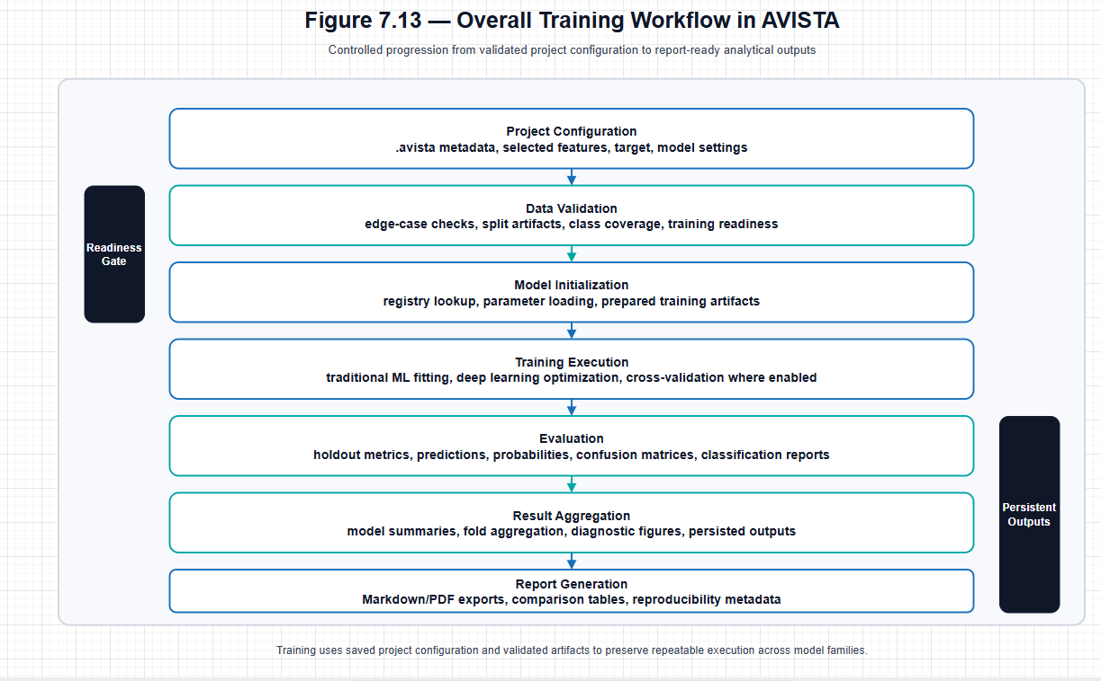
Figure 7.13. Overall training workflow implemented within the AVISTA analytical framework.
As shown conceptually in Figure 7.13, the training workflow is structured as a sequence of controlled transitions. Project configuration supplies the analytical state. Data validation determines whether the project is suitable for training. Model initialization connects selected algorithms with the prepared data artifacts. Training execution produces fitted models and intermediate outputs. Evaluation converts predictions into metrics and diagnostic artifacts. Result aggregation standardizes outputs across models. Report generation then consumes the persisted results without requiring retraining.
7.7.3 Training Execution Architecture
AVISTA supports both traditional machine learning execution and deep-learning execution within a unified training abstraction. Traditional models generally follow a fit-and-evaluate pattern in which the estimator is initialized with saved parameters and trained on prepared training artifacts. Deep tabular models require a more iterative execution lifecycle, including epoch-level optimization, validation monitoring, learning curve generation, and model-state persistence. Despite these differences, both model families must interact with the broader AVISTA workflow in a consistent way.
The training framework resolves this challenge by standardizing the lifecycle around model initialization, data binding, training execution, evaluation, and artifact storage. This design allows heterogeneous model families to produce comparable outputs while preserving model-specific behavior where needed. A tree-based model and a deep neural architecture may differ internally, but both are represented in the system through trained artifacts, predictions, evaluation metrics, diagnostic figures, and metadata. This consistency is essential for downstream reporting and model comparison.
The framework also supports cross-validation and holdout evaluation. Cross-validation provides a structured basis for estimating training-set robustness, while holdout evaluation preserves the validation and test partitions established earlier in the workflow. By grounding both procedures in saved split artifacts, AVISTA reduces the risk that evaluation results are generated from inconsistent partitions.
7.7.4 Background Processing and Responsiveness
Training can be computationally expensive, particularly for deep tabular models, cross-validation runs, and workflows involving multiple selected algorithms. AVISTA therefore separates training execution from user-facing operations through a worker-based architecture. This design prevents long-running model fitting from blocking the application and allows progress updates, logs, and intermediate results to be communicated during execution.
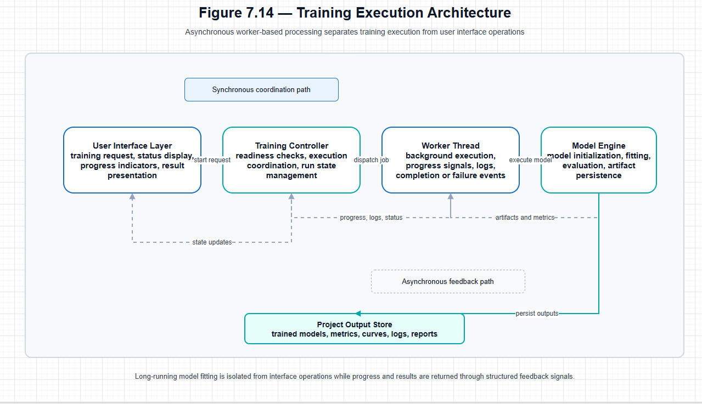
Figure 7.14. Separation of training execution and user interface operations through asynchronous worker-based processing.
Figure 7.14 illustrates that the training controller coordinates execution requests, while worker threads perform long-running computational tasks. The model engine handles algorithm-specific fitting and evaluation, and status updates are returned to the monitoring layer. This separation is important for reliability as well as usability. If training execution were tightly coupled to interface operations, computational delays could reduce responsiveness, obscure failure states, and make cancellation or progress reporting more difficult. The worker-based design allows AVISTA to maintain a responsive analytical environment while supporting models with substantially different computational profiles.
7.7.5 Real-Time Monitoring Framework
The monitoring framework provides visibility into the state of model training. It tracks progress, reports execution status, records training logs, and updates model-level results as training proceeds. This monitoring capability is important because machine learning workflows can fail or degrade for many reasons, including invalid configuration, dependency limitations, memory constraints, unstable optimization, or unexpected data conditions. Real-time monitoring helps distinguish normal long-running computation from stalled or failed execution.
Status reporting also improves transparency. Users can observe which model is being trained, whether execution is running or complete, and whether failures occurred. Training logs provide a structured record of execution events, while progress indicators communicate workflow state. These mechanisms support reproducibility by preserving evidence of how training proceeded, not only the final metrics produced after execution.
7.7.6 Learning Curve Visualization
Learning curve visualization is particularly important for deep tabular learning models. Unlike many traditional estimators, deep models are trained through iterative optimization, and their behavior cannot be fully understood from final test metrics alone. Monitoring loss, accuracy, validation performance, and related training metrics helps identify instability, underfitting, overfitting, convergence problems, and the effect of early stopping or validation-based model selection.
Figure 7.15 should be placed after this subsection because it provides visual evidence of AVISTA’s real-time monitoring capability, including progress indicators, training logs, learning curves, and result summaries. The figure should be interpreted as architectural evidence of monitoring integration rather than as a walkthrough of the interface.
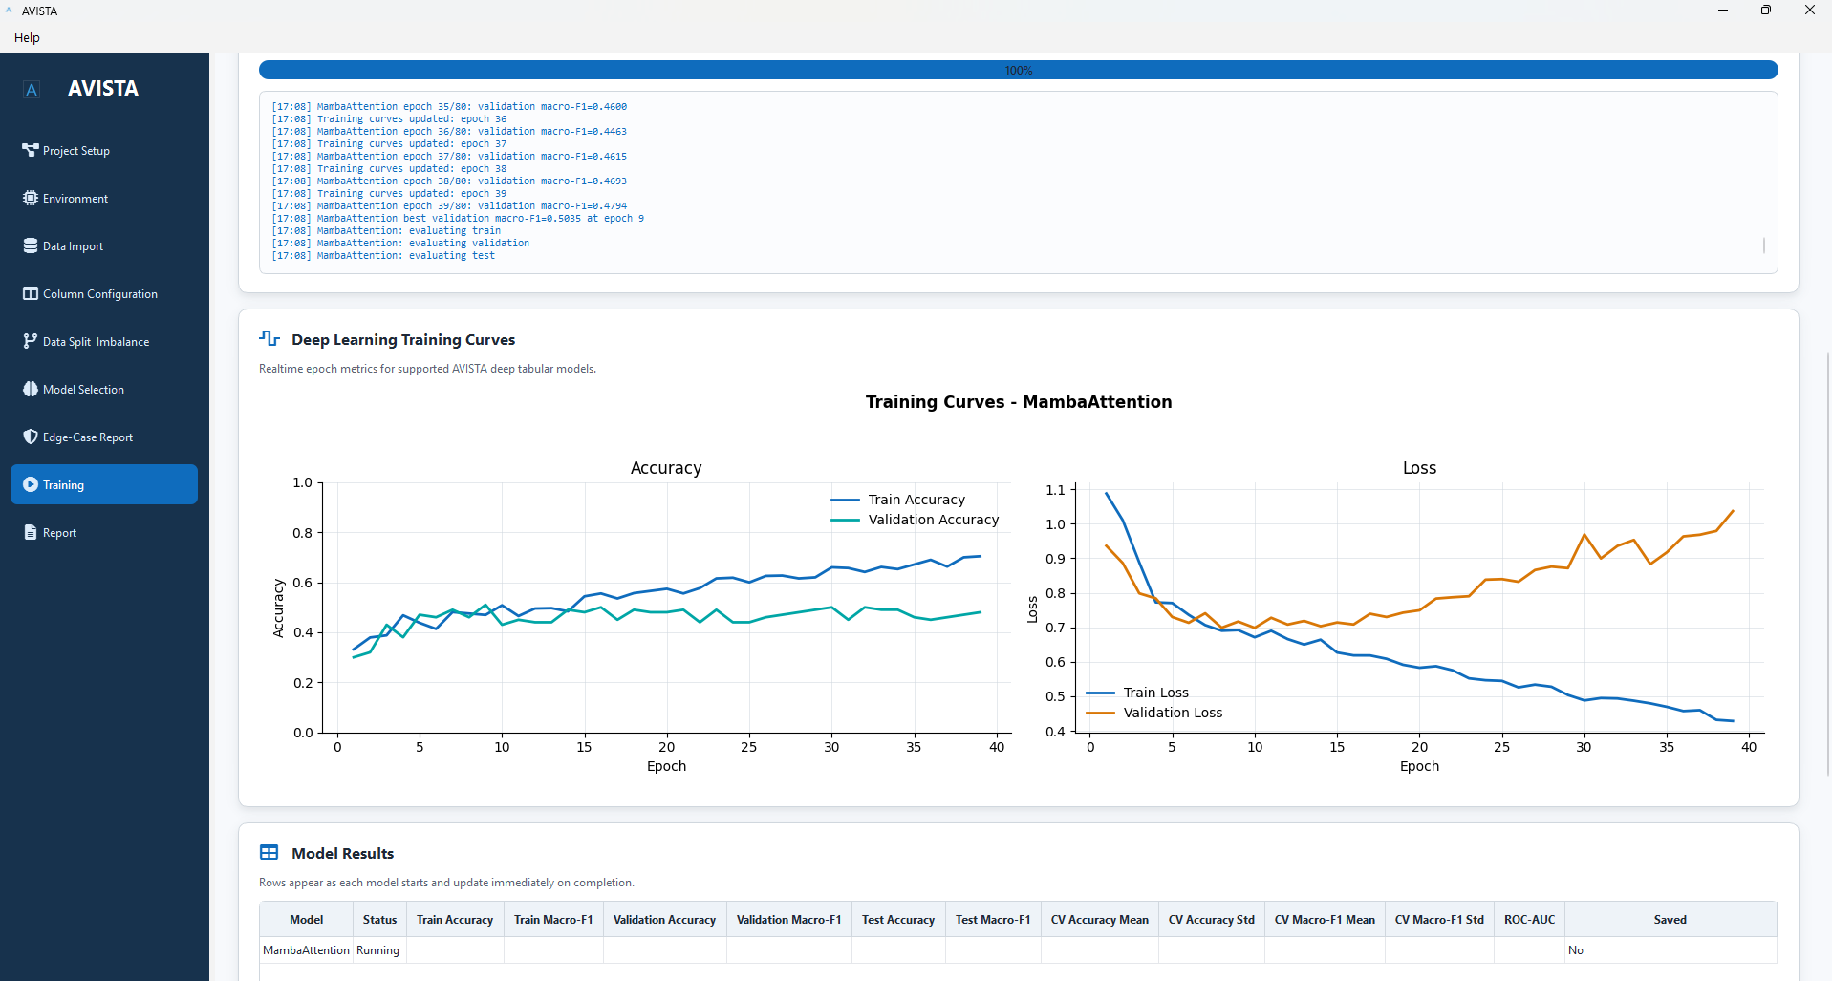Figure 7.15. Real-time monitoring interface supporting progress tracking, training diagnostics, and model evaluation.
As suggested by Figure 7.15, training curves serve a diagnostic role within the framework. They allow users to evaluate whether a model’s learning process is consistent with expected behavior and whether validation performance diverges from training performance. This capability is especially relevant when comparing traditional models with deep tabular architectures, since deep models may require more careful monitoring of optimization dynamics.
7.7.7 Result Aggregation and Persistence
Result aggregation standardizes outputs across models after training and evaluation. The framework collects metrics, predictions, probability outputs where available, confusion matrices, classification reports, learning histories, and cross-validation summaries. These artifacts are stored within the project structure so that they can be inspected, compared, and incorporated into reports without rerunning model training.
Fold aggregation is important when cross-validation is enabled. AVISTA must preserve both fold-level evidence and summarized results so that cross-validation does not become a disconnected experiment. Similarly, holdout evaluation results must remain linked to the saved validation and test partitions. The Result Aggregator therefore functions as the bridge between model execution and the Reporting Framework.
Table 7.10
Training Framework Components
Component | Primary Responsibility | Generated Outputs
Training Controller | Coordinates training requests and enforces readiness requirements. | Training state, execution sequence, model run metadata.
Worker Manager | Executes long-running training tasks asynchronously. | Worker status, completion signals, failure messages.
Monitoring System | Tracks progress, logs, and training-state updates. | Progress records, training logs, live status updates, learning curves.
Evaluation Engine | Computes standardized model evaluation artifacts. | Metrics, predictions, probabilities, confusion matrices, classification reports.
Result Aggregator | Consolidates model outputs for comparison and reporting. | Summary tables, fold summaries, persisted artifacts, report-ready outputs.
7.7.8 Framework Benefits
The Training and Monitoring Framework directly supports the design goals established in Section 7.3. It improves reproducibility by ensuring that training uses saved project configuration and validated artifacts. It improves scalability by supporting computationally intensive workflows through asynchronous execution. It improves transparency by exposing progress, logs, learning curves, and model outputs during training. It improves usability by making long-running execution observable rather than opaque. It improves extensibility by allowing new model families to connect to a standardized training, evaluation, and reporting lifecycle.
The framework also reinforces AVISTA’s role as an integrated analytical platform. Training is not an isolated stage but a controlled transition from validated project configuration to persistent evaluation evidence. By linking training execution with monitoring, result aggregation, and reporting, AVISTA provides a reproducible pathway from configured models to dissertation-ready and practitioner-oriented analytical outputs.
The next section extends this discussion from model execution to analytical communication. Section 7.8 describes the Reporting Framework, which aggregates training outputs, diagnostic artifacts, model comparisons, and project metadata into reproducible reports suitable for review, dissemination, and decision-support use.

7.8 Reporting Framework
7.8.1 Design Objectives
The AVISTA Reporting Framework is responsible for transforming model outputs into structured, reproducible analytical documents. Its primary objective is to ensure that results generated during training and evaluation are not left as disconnected files, but are consolidated into a coherent reporting structure. This design supports reproducibility, consistency, and communication of analytical findings. In applied machine learning workflows, the reliability of a result depends not only on the model that produced it, but also on whether the associated metrics, figures, configuration metadata, and diagnostic outputs can be recovered and reviewed. AVISTA therefore treats reporting as an integral component of the analytical pipeline rather than a post-processing convenience.
A second objective is standardization. Because AVISTA supports multiple model families, including traditional machine learning and deep tabular learning models, the reporting framework must provide comparable output structures across heterogeneous algorithms. Standardized reporting enables model outputs to be reviewed under a common structure while preserving model-specific evidence where needed.
7.8.2 Result Aggregation
The reporting process begins after model training and evaluation have completed. At this stage, AVISTA collects outputs from multiple trained models and consolidates them into a unified reporting structure. These outputs include performance summaries, evaluation metrics, predictions, diagnostic figures, confusion matrices, classification reports, and training histories where available. Result aggregation is necessary because each model may generate outputs in different forms, especially when comparing traditional estimators with deep learning models.
AVISTA addresses this heterogeneity by standardizing how results are organized and presented. Metrics are consolidated into model-level summaries, diagnostic artifacts are linked to their corresponding model and data partition, and missing outputs are represented consistently rather than disrupting report generation. This design improves reproducibility because reports can be regenerated from stored artifacts without retraining models. It also improves interpretability by placing model outputs in a common analytical context.
7.8.3 Visualization Generation
Visualization generation is a central function of the Reporting Framework. AVISTA supports ROC visualizations, precision-recall visualizations, training curve visualizations, and confusion matrices. These figures summarize different aspects of model behavior. ROC and precision-recall curves support comparative assessment of classification behavior across thresholds. Confusion matrices provide class-level diagnostic information. Training curves document optimization behavior for deep tabular models, including loss and validation trends.
The role of these visualizations is not to replace statistical evaluation, but to complement tabular metrics with interpretable graphical evidence. Visual summaries are especially useful in decision-support contexts because they allow readers to identify performance patterns, class-level errors, and training behavior more efficiently than through numerical tables alone.
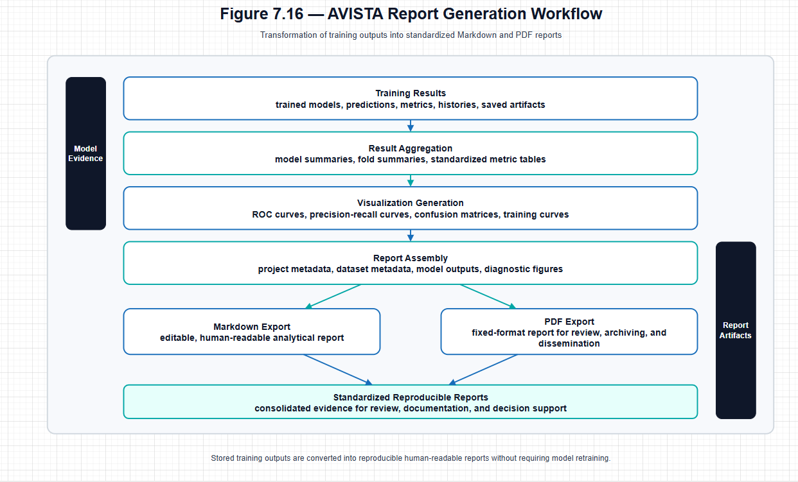Figure 7.16. Workflow used by the AVISTA reporting framework to transform analytical outputs into standardized reports.
As shown in Figure 7.16, the reporting workflow proceeds from training results to result aggregation, visualization generation, report assembly, Markdown export, and PDF export. This workflow ensures that analytical outputs are transformed into reproducible documents through a controlled sequence rather than through manual file compilation.
7.8.4 Report Export
AVISTA supports both Markdown and PDF report generation. Markdown provides a portable, human-readable format that can be inspected, edited, versioned, and incorporated into research documentation workflows. PDF provides a stable presentation format suitable for dissemination, archiving, and review. The use of both formats supports different stages of the research and reporting lifecycle: Markdown facilitates transparency and revision, while PDF supports finalized communication.
Report export also strengthens reproducibility. By including model summaries, diagnostic outputs, figures, and metadata in a structured document, AVISTA preserves the analytical context needed to interpret results. Reports can serve as durable records of model outputs and as communication artifacts for research, technical review, and decision-support settings.

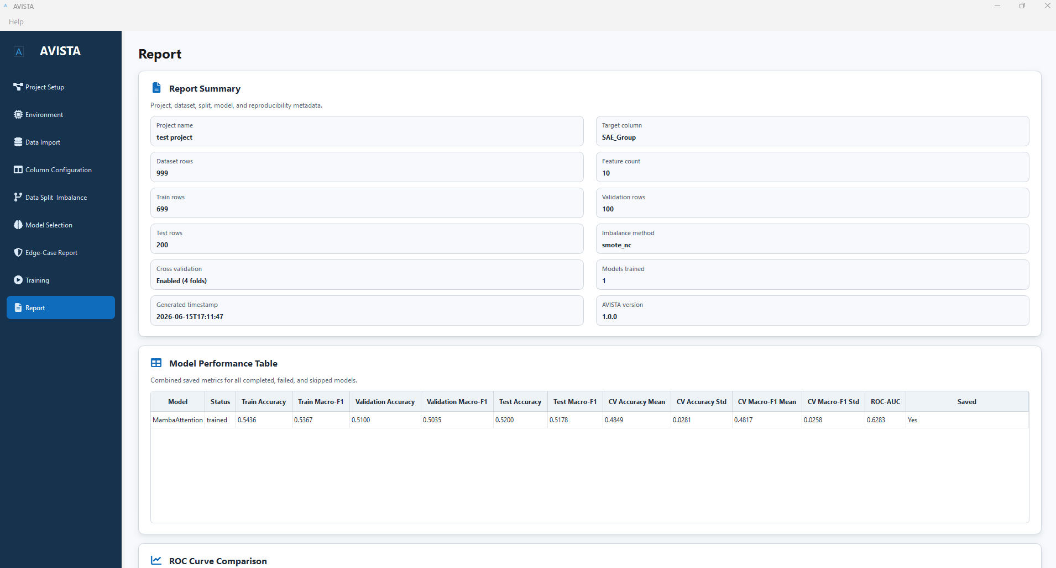
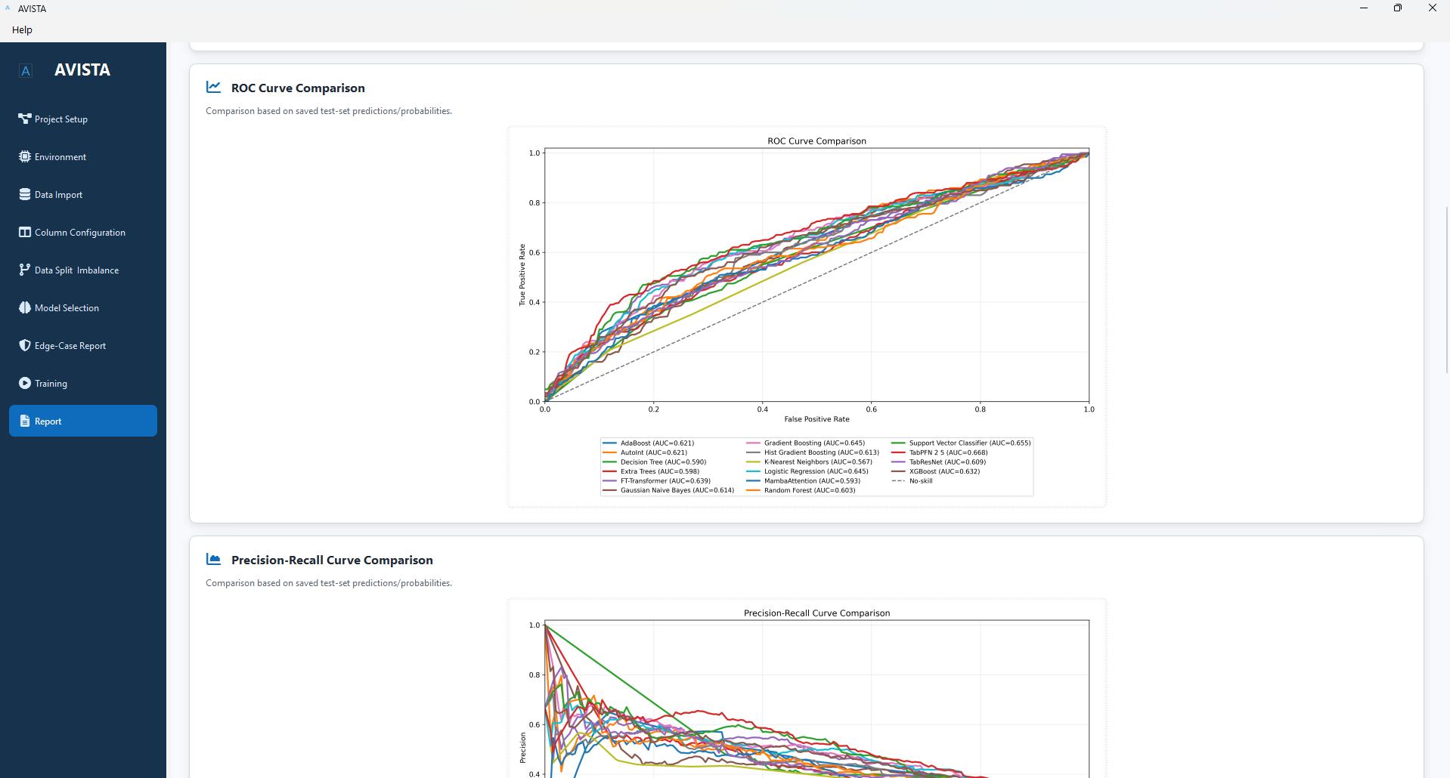

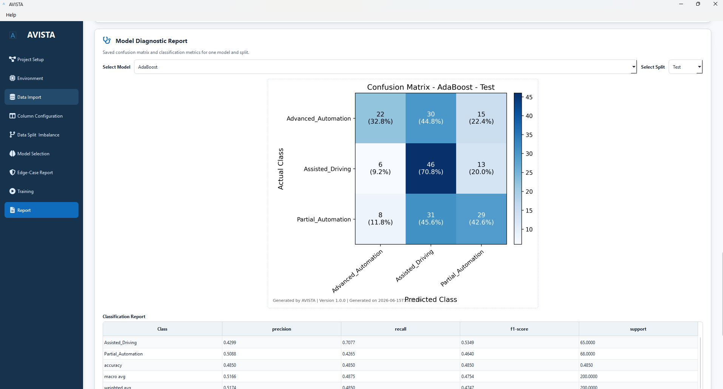Figure 7.17. Report interface supporting visualization review and export of consolidated analytical outputs.
Figure 7.17 provides visual evidence of the reporting framework’s role in consolidating outputs for review and export. The figure should be interpreted as a representation of the reporting layer rather than as a description of interface operation.
Table 7.11
Report Components Generated by AVISTA
Component | Description | Output Format
Performance Summary | Consolidated model metrics and comparison summaries. | Tables, Markdown, PDF
Confusion Matrix | Class-level prediction summary for trained models. | Figure, CSV, Markdown, PDF
Classification Report | Precision, recall, F1-score, and support by class. | Table, Markdown, PDF
ROC Visualization | Threshold-based classification performance visualization. | PNG/PDF figure, Markdown, PDF
Precision-Recall Visualization | Precision-recall tradeoff visualization for classification. | PNG/PDF figure, Markdown, PDF
Training Curves | Loss and validation metric trends for iterative models. | PNG/PDF figure, Markdown, PDF
Markdown Report | Editable structured analytical report. | .md
PDF Report | Fixed-format report for review and dissemination. | .pdf
7.8.5 Framework Benefits
The Reporting Framework provides four main benefits. First, it improves reproducibility by linking reports to stored model outputs and project metadata. Second, it improves communication by converting dispersed analytical artifacts into structured documents. Third, it supports documentation by preserving metrics, figures, and diagnostic summaries in durable formats. Fourth, it strengthens decision support by presenting model evidence in forms suitable for review by researchers, analysts, and practitioners.
In the broader AVISTA architecture, reporting completes the transition from model execution to interpretable analytical output. It ensures that training results are not merely generated, but organized into reproducible evidence that can support review, comparison, and dissemination.

7.10 Limitations and Future Extensions
7.10.1 Current Limitations
AVISTA was developed as a focused software artifact for reproducible tabular machine learning workflows. Its current scope reflects the methodological priorities of this dissertation and should be interpreted as a deliberate boundary rather than a general-purpose claim over all machine learning applications. The platform is centered on structured tabular data, with support for project management, environment validation, dataset management, feature configuration, train-validation-test splitting, imbalance handling, edge-case validation, traditional and deep tabular models, training monitoring, report generation, Markdown/PDF export, and Windows deployment. This scope is appropriate for the dissertation’s analytical setting, but it also defines the current limits of the system.
The first limitation is modality scope. AVISTA is designed for tabular data and does not currently support image, audio, text, geospatial raster, time-series sensor streams, or multimodal learning workflows. Second, training is primarily oriented toward local computational resources. Although the platform includes environment inspection and GPU diagnostics, it does not yet provide distributed training, multi-GPU orchestration, cluster scheduling, or cloud-native execution. Third, while the reporting framework supports diagnostic outputs and model summaries, integrated explainability workflows such as SHAP, LIME, and per-instance interpretation remain future extensions rather than completed platform components.
AVISTA also provides limited AutoML functionality. The current design emphasizes explicit, researcher-controlled configuration of features, targets, splits, imbalance strategies, model selection, and parameters. This supports methodological transparency but does not yet include automated hyperparameter optimization, automated model selection, or neural architecture search. In addition, the platform is currently designed for single-user desktop workflows. It does not yet include collaborative project management, role-based access control, shared experiment repositories, or multi-user review environments. These limitations are not design failures; they represent a constrained implementation strategy intended to produce a reproducible, maintainable, and deployment-ready platform within the dissertation scope.
7.10.2 Future Extensions
The modular architecture of AVISTA provides several natural pathways for future development. The most immediate extension is integrated explainability. Future versions could incorporate SHAP, LIME, feature importance summaries, partial dependence analysis, and per-row explanation views. These additions would strengthen the connection between model training and interpretable decision support, particularly for practitioners who require transparent evidence rather than predictive outputs alone.
A second extension concerns additional deep tabular learning models. AVISTA currently supports several advanced tabular architectures, but the field continues to evolve rapidly. Future integration of TabM, SAINT, TabTransformer, and newer foundation-model approaches would expand the platform’s benchmarking and applied modeling capabilities. Because AVISTA already uses a registry-based model architecture, these additions could be incorporated without redesigning the full workflow.
AutoML support is another important development direction. Future work could include automated model selection, structured hyperparameter optimization, cross-validation-based model ranking, and neural architecture search. Such functionality would need to be implemented carefully to preserve reproducibility and avoid obscuring methodological choices. A useful direction would be transparent AutoML, where the system records every search space, trial configuration, random seed, and selection criterion.
Distributed and cloud execution would extend AVISTA beyond local desktop computation. Multi-GPU support, cloud deployment, and cluster execution could make the platform suitable for larger datasets and more computationally intensive experiments. These extensions would require additional architecture for job scheduling, remote artifact storage, authentication, and runtime monitoring.
A plugin ecosystem would further improve extensibility. User-defined models, preprocessing modules, evaluation metrics, report sections, and visualization components could allow researchers to adapt AVISTA to new domains without modifying the core platform. Expanded data modalities also represent a longer-term research direction. Support for image, text, time-series, and multimodal learning would broaden the platform’s applicability, although such extensions would require new data management, preprocessing, model, and reporting abstractions.
Table 7.13
Potential Future Extensions of AVISTA
Extension Area | Description | Expected Benefit
Explainability | Integrate SHAP, LIME, feature interpretation, and per-instance explanations. | Improves transparency and decision-support value.
AutoML | Add automated model selection, hyperparameter optimization, and architecture search. | Reduces manual experimentation while preserving traceable search records.
Distributed Training | Support multi-GPU, cluster, and large-scale training workflows. | Expands scalability for computationally intensive analyses.
Cloud Deployment | Enable remote execution, cloud storage, and cloud-hosted analytical workflows. | Supports broader access and larger compute environments.
Plugin Architecture | Allow user-defined models, preprocessing routines, metrics, and reports. | Improves extensibility and domain adaptation.
Multimodal Learning | Expand beyond tabular data to image, text, time-series, and combined modalities. | Broadens analytical scope beyond structured datasets.
Foundation Models | Integrate emerging tabular and multimodal foundation models. | Supports evaluation of new model families within reproducible workflows.
7.10.3 Research Opportunities
Beyond software enhancement, AVISTA provides a foundation for several future research directions. As a research platform, it can support controlled studies comparing traditional machine learning, deep tabular learning, foundation models, and future AutoML methods under consistent data preparation and evaluation settings. As an educational platform, it can help students and practitioners understand how modeling decisions, splitting strategies, imbalance handling, validation, and reporting interact in applied machine learning workflows. As a benchmarking platform, AVISTA can provide repeatable experimental conditions for evaluating new algorithms across multiple datasets.
The platform also has potential as a reproducible experimentation framework. Because AVISTA preserves project configuration, data references, split artifacts, model settings, training outputs, and reports, future studies can build upon its architecture to examine reproducibility, robustness, model transparency, and deployment readiness in applied machine learning systems. These opportunities follow directly from the modular architecture described earlier in the chapter.
The next section concludes the chapter by summarizing AVISTA’s role as a dissertation software artifact and by restating how the platform operationalizes the methodological contributions developed throughout the dissertation.

