  - MS BLOCKCHAIN | PRACTICAL IMPLEMENTATION

Implementation Report
Authoring Workbook
Fake Media Detection: a MultiChain adaptation
Field | Complete before submission
Student | [Enter your full name]
Roll number / section | [Enter]
Course / instructor | [Enter current course and instructor]
Repository URL / commit | [Add after publishing]
Submission date | [Enter]

Use this document as an editable structure, not as a finished report. Replace prompts with your own technical explanations, insert actual results/screenshots and remove instructional material before exporting the final PDF.
The teacher limits AI-generated writing to 10%. Predominantly student-authored text and an honest assistance record are required; this workbook does not certify a percentage. A separate AI-assisted technical reference is provided for study.

Required deliverables
Selected paper PDF; completed implementation report PDF; actual GitHub repository link. Keep node wallets, passwords and private configuration outside the repository.

Abstract and introduction

Abstract
Write 120-180 words after the implementation and tests. State the problem, your actual adaptation, the measured result you can support, and one important limitation. Do not copy the technical reference or promise paper-equivalent accuracy.
[Write your own explanation here.]
________________________________________________________________________________
________________________________________________________________________________
________________________________________________________________________________

1. Introduction
Explain the background, specific problem, motivation and objectives in your own words. Why do provenance and authority controls help? What can a blockchain not decide about an article? Which MultiChain concepts are used? Cite the paper [1].
[Write your own explanation here.]
________________________________________________________________________________
________________________________________________________________________________
________________________________________________________________________________
________________________________________________________________________________

2. Selected paper and original architecture
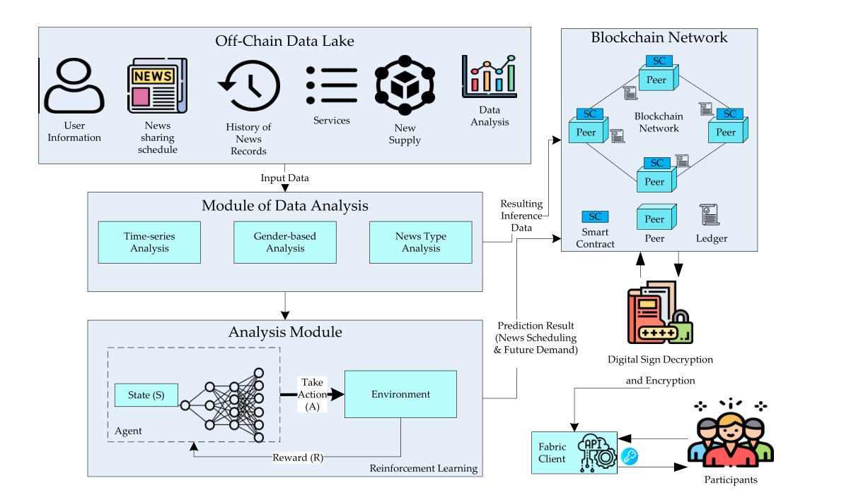
Figure F01. Shahbazi and Byun [1], original Figure 1, cropped from PDF p.3 / printed p.128444. CC BY 4.0.
Write a paper summary of no more than one page. Explain the original data flow, entities, Fabric/Composer platform and NLP/RL components. Distinguish the paper's PoA design discussion from its PBFT/RAFT evaluation discussion. Do not invent a single fully reproduced configuration.
[Write the source-grounded paper summary and your explanation of Figure F01.]
________________________________________________________________________________
________________________________________________________________________________
________________________________________________________________________________
________________________________________________________________________________

3. Methodology and mapping
For each row, state your actual implementation choice and why it preserves the core idea or deliberately simplifies it. Use docs/PAPER_MAPPING.md and the code as study material, then explain the mapping independently.
Original component | Your implemented equivalent | Your justification / limitation
User identification | Signed role enrollment | [Explain]
Publisher | Publisher node / news stream | [Explain]
Validator | Two reviewer nodes / votes | [Explain]
News history | Signed stream items and hashes | [Explain]
NLP / DRL | Teaching NLP / terminal Q model | [Explain]
Smart contract | Python policy + native write ACLs | [Explain]
Consensus | Native permissioned mining | [Explain]
Credibility / incentive | Descriptive score + separate asset | [Explain]

Future direction addressed
Read the exact conclusion on PDF p.11. Identify its user-validation/PoA investigation direction. Explain the bounded role-validation controls you implemented and what remains unresolved; do not attribute a different future direction to the paper.
[Write your own explanation here.]
________________________________________________________________________________
________________________________________________________________________________

4. Proposed MultiChain architecture
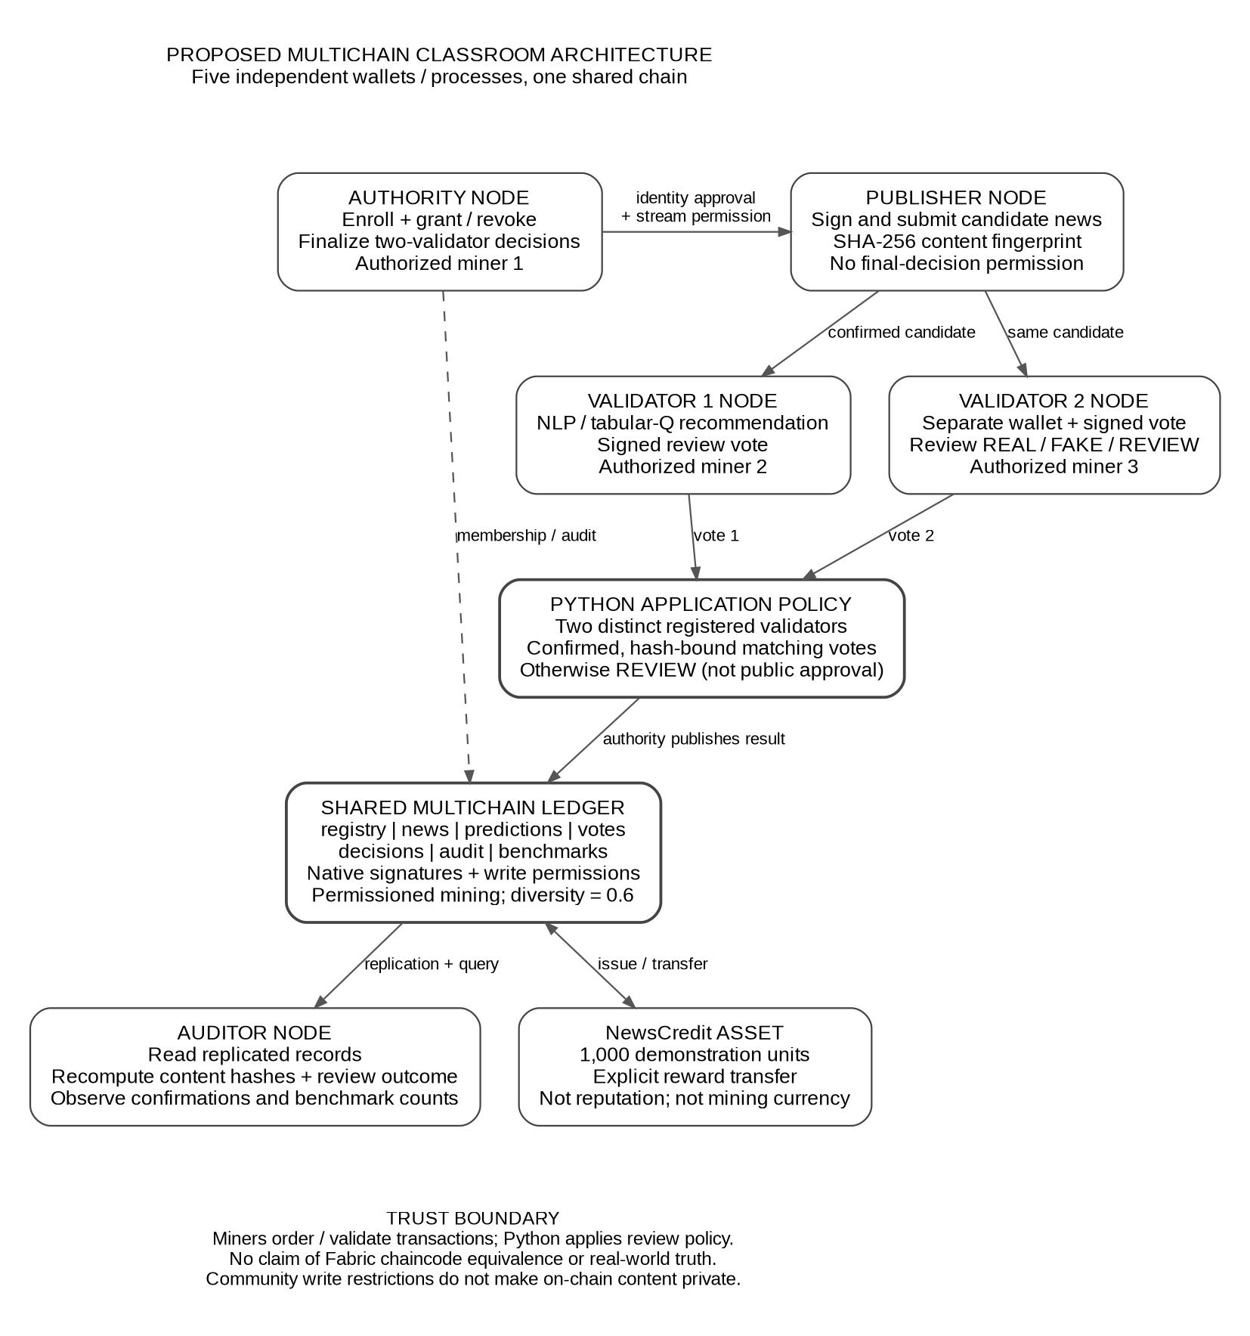
Figure F02. Code-derived adaptation diagram; review and acknowledge assisted preparation. Replace or refine it if your implementation differs.
Explain one complete article path and the administrator trust assumption. Distinguish block miners, article reviewers and the Python decision policy.
[Write your own explanation here.]
________________________________________________________________________________

5. Deployment environment and node roles
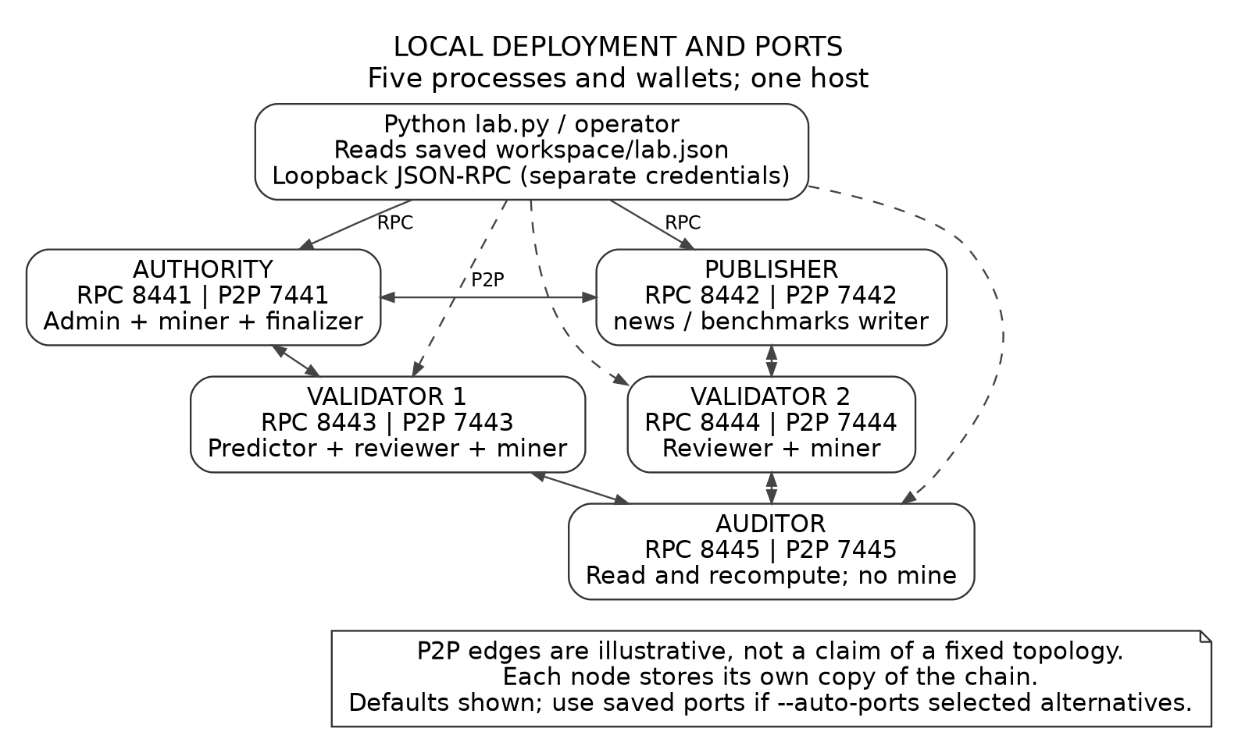
Figure F03. Local role/port diagram. Defaults shown; record actual values from your run.
Observation | Actual value / evidence ID
OS / CPU / RAM / Python | [Record]
MultiChain / lab / commit | [Record]
Workspace strategy / ports | [Describe without exposing secrets]
Single-host or multi-host | [Record accurately]

Insert screenshots S01-S03 or place them in a labeled appendix. Explain the executable folder vs private data directory, and RPC vs P2P ports.
[Write your own explanation here.]
________________________________________________________________________________

6. Chain parameters and permissions
Parameter | Requested default | Actual observed value
target-block-time | 2 | [Record]
maximum-block-size | 8388608 | [Record]
mining-diversity | 0.6 | [Record]
mining-turnover | 0 | [Record]
mine-empty-rounds | -1 | [Record]
setup-first-blocks | 10 | [Record]
selected anyone-can-* flags | false | [Record]
root-stream-open | false | [Record]

Explain why these parameters were set before genesis and why live params.dat must not be overwritten. Add S04 and describe observed values, not only defaults. Explain listminers.permitted vs diversitywaitblocks.
[Write your own explanation here.]
________________________________________________________________________________
________________________________________________________________________________
________________________________________________________________________________
Add a writer-permission table for registry, news, predictions, votes, decisions, audit and benchmarks. Explain why a write-restricted stream is not private storage in this setup. Attach S05.
[Write your own explanation here.]
________________________________________________________________________________
________________________________________________________________________________

7. MultiChain setup workflow
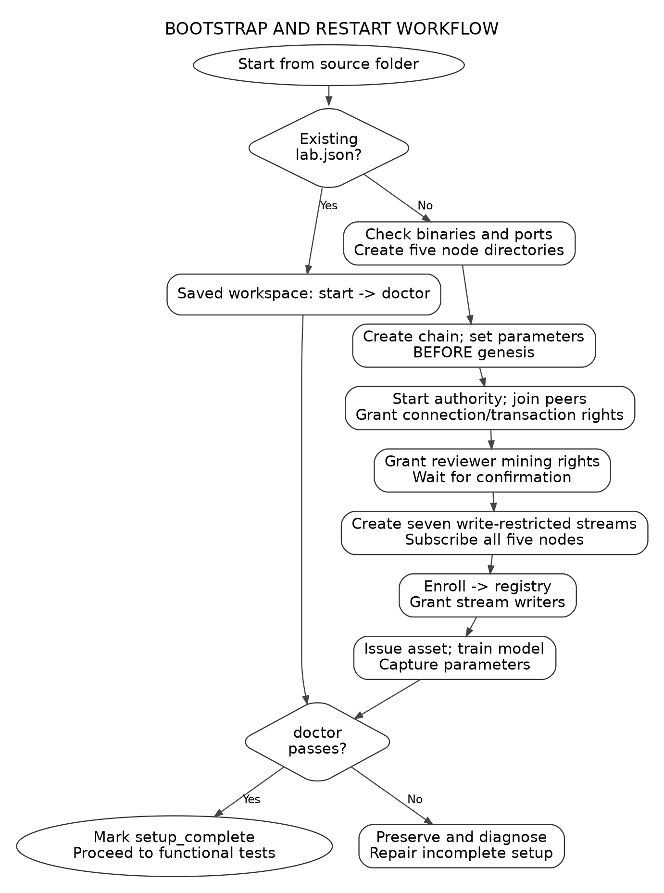
Figure F04. Setup/restart workflow; annotate your executed path and cite code symbols from docs/CODE_INDEX.md.
Explain each stage you actually performed: binaries/ports, directories, creation parameters, peer grants, streams/subscription, enrollment, asset and readiness. Link the stages to commands and screenshot IDs.
[Write your own explanation here.]
________________________________________________________________________________

8. Enrollment and authority validation
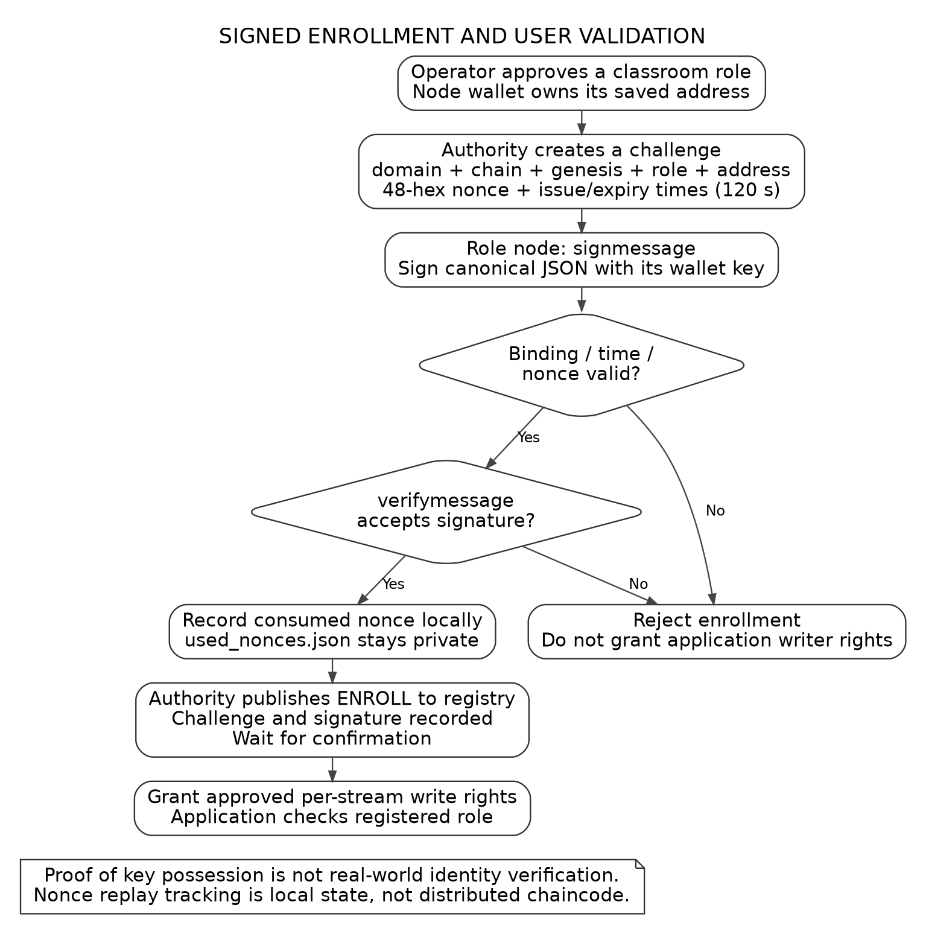
Figure F05. Challenge/response enrollment. This is a conceptual flow, not an execution screenshot.
Explain each challenge field and replay protection, where the nonce is stored, which key signs, and how authority registration differs from verified real-world identity. Add S06 and a test observation.
[Write your own explanation here.]
________________________________________________________________________________
________________________________________________________________________________

9. Article submission and analysis workflow
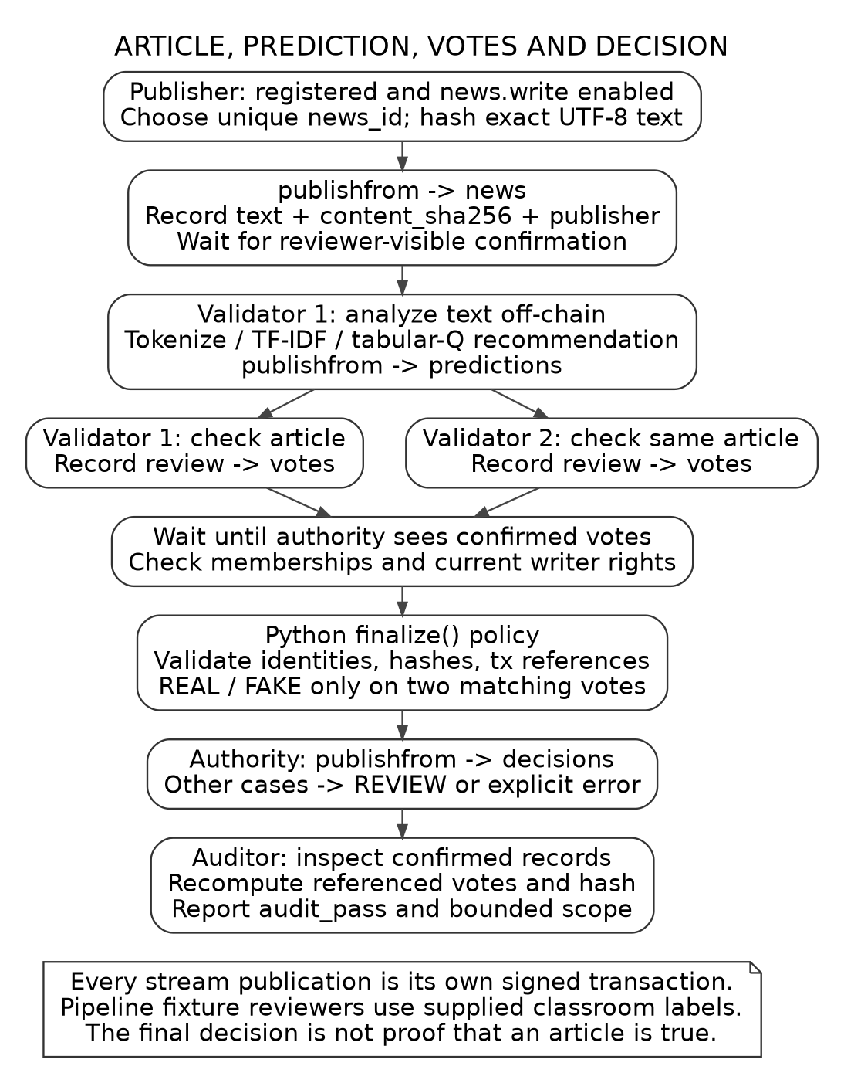
Figure F06. Article workflow. Explain each publication and identify the five transaction IDs in one actual run.
Add S07-S09. Distinguish article ID, text hash, model hash and transaction ID. Explain the teaching model and why fixture reviewer labels do not demonstrate independent fact checking.
[Write your own explanation here.]
________________________________________________________________________________

10. Decision and audit workflow
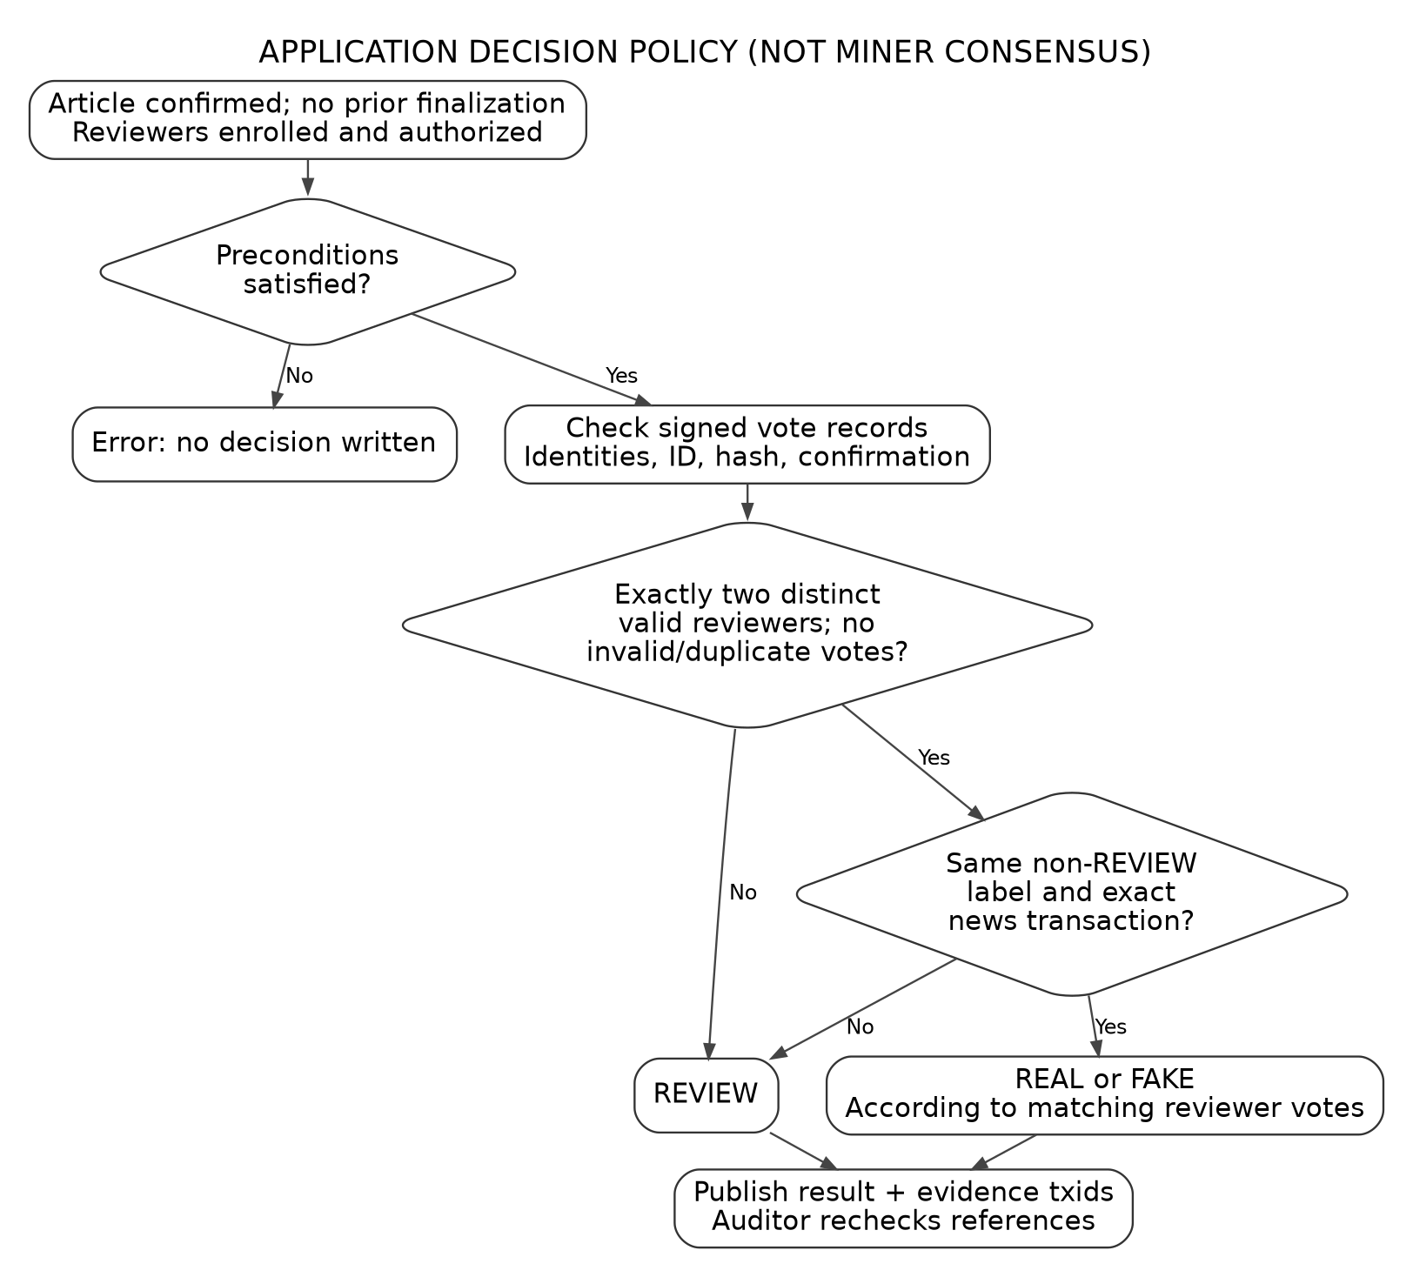
Figure F07. Python review policy. The decision rule is not native mining consensus.
Explain agreement, disagreement, missing/duplicate reviewers and failed preconditions. Add S10 showing an actual audit. State precisely what inspect checks and what it does not reconstruct.
[Write your own explanation here.]
________________________________________________________________________________
________________________________________________________________________________

11. Security validation and asset demonstration
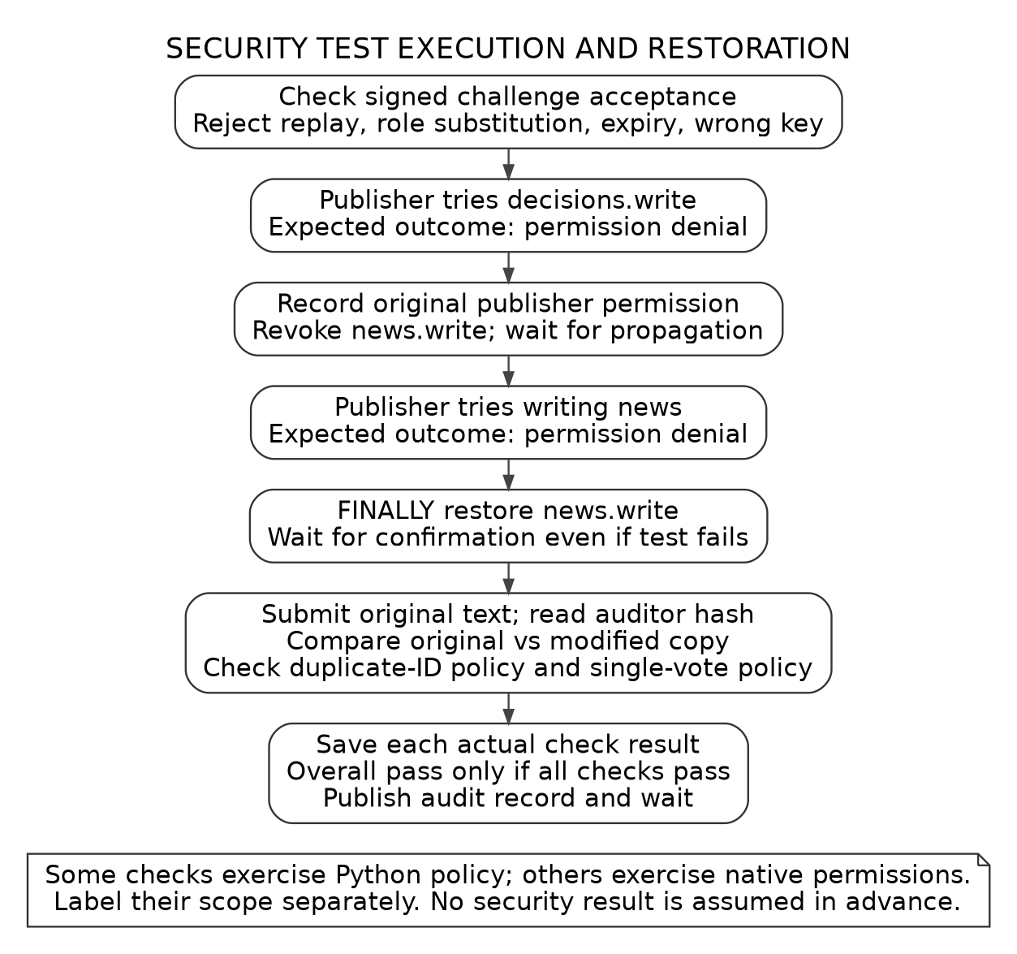
Figure F09. Security-test flow. Include only actual pass/fail evidence, not expected outputs as measured results.
Add S11-S12. Explain native ACL tests vs local policy tests, a deliberate rejection, restored publisher rights, and text-integrity verification. Distinguish NewsCredit, descriptive credibility and native mining rewards.
[Write your own explanation here.]
________________________________________________________________________________
________________________________________________________________________________

12. Load-test methodology
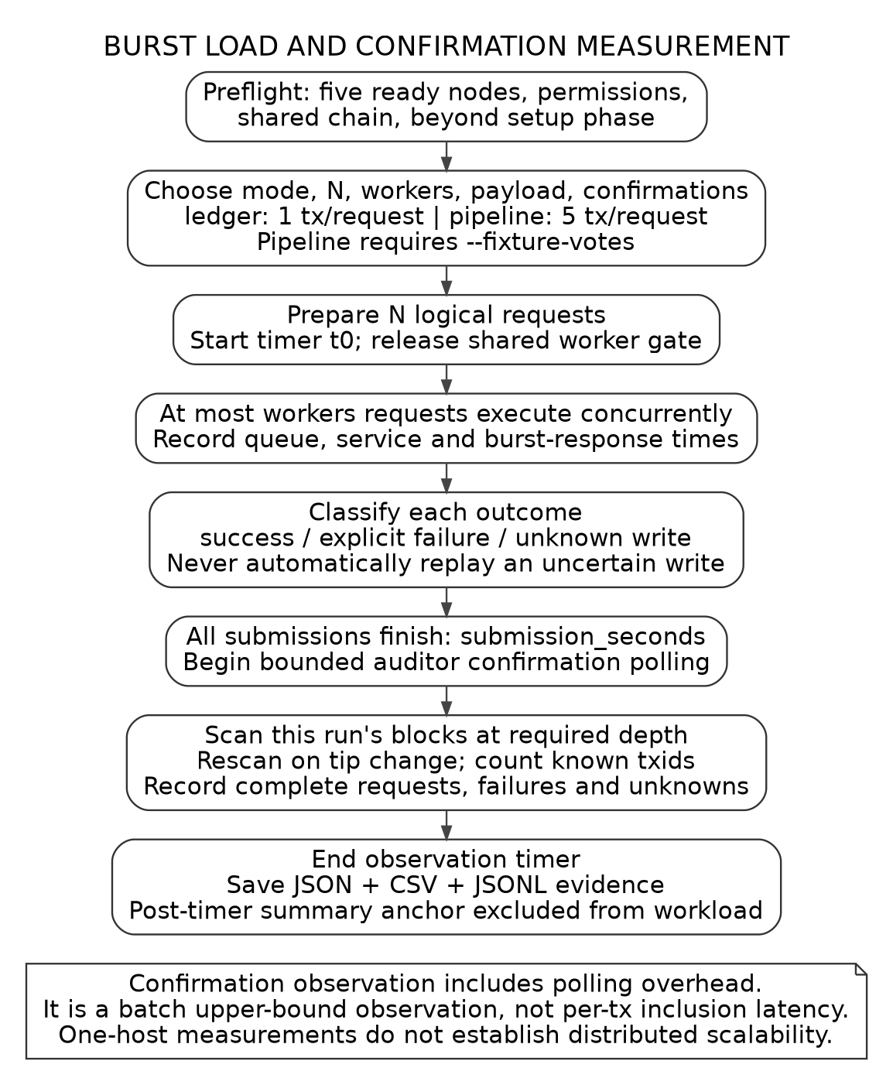
Figure F08. Burst and confirmation observation. Fill in the actual N, workers, payload, depth and hardware.
Explain ledger vs pipeline workload units, arrival time, worker queue, successful-only percentiles and post-submission observation. State that a one-host test is not a distributed scalability experiment. Add S13-S14.
[Write your own explanation here.]
________________________________________________________________________________
________________________________________________________________________________

13. Results and discussion

Evidence already available
The supplied log supports successful readiness and native CLI access, shared block 552 agreement and a one-block sampled height lag. It does not establish later live demo/security/benchmark pass results. Cite the actual log or your newly captured replacement. [E1]
Test / run ID | Actual outcome | Screenshot / trace
Network readiness | [Your current observation] | [S02]
Demo: REAL / FAKE / REVIEW | [Actual per-case audit results] | [Add]
Security tests | [Actual checks and failures] | [S11]
Ledger: 10 requests | [Counts; Ts; Tc; p95] | [S13]
Ledger: 1,000 requests | [Counts; Ts; Tc; p95] | [S14]
Additional experiment | [Only if executed] | [Add]

Add a detailed measured-results table from your exported summary.json files. Include requested/success/failure/unknown/confirmed-complete counts, units and repeated-run variability. Missing is not zero. Explain observed bottlenecks rather than inventing them.
[Write your own explanation here.]
________________________________________________________________________________
________________________________________________________________________________
________________________________________________________________________________

14. Limitations, conclusion and reflection

Limitations
Explain single-host ownership; synthetic 32-row teaching data; no original DRL reproduction; off-chain Python policy; local nonce state; no private article content or fact-truth guarantee; limits of referenced-record audit. Discuss any actual remaining failures.
[Write your own explanation here.]
________________________________________________________________________________
________________________________________________________________________________
________________________________________________________________________________

Conclusion
Summarize only what your implementation and measured results establish. Reconnect the controls to the exact conclusion direction from the selected paper. Identify a concrete next step without claiming it has been implemented.
[Write your own explanation here.]
________________________________________________________________________________
________________________________________________________________________________
________________________________________________________________________________

Your technical reflection
Which error did you debug? Explain the data-directory issue or authorized-miner waiting state in your own words. What change fixed it, and how did you verify the fix?
[Write your own explanation here.]
________________________________________________________________________________
________________________________________________________________________________

References, screenshots and authorship

References to complete
[1] Z. Shahbazi and Y.-C. Byun, Fake Media Detection Based on Natural Language Processing and Blockchain Approaches, IEEE Access 9, 128442-128453, 2021. DOI: 10.1109/ACCESS.2021.3112607.
Add only sources actually cited in your report. Use REFERENCES.md for verified source details. Cite original-paper figures separately from your implementation figures and raw evidence. Add your actual repository URL and commit hash.
[Write your own explanation here.]
________________________________________________________________________________
________________________________________________________________________________

Screenshot appendix
Insert the actual screenshots listed in SCREENSHOT_PLAN.md. Give each one an ID, caption, command context and explanation of the observed fields. Do not paste wallet/configuration secrets or replace screenshots with generated terminal pictures.
[Insert reviewed screenshots and your explanations on additional pages.]
________________________________________________________________________________

AI assistance and final check
Complete an accurate assistance statement according to your instructor's rules. Keep authorship notes/drafts. Do not submit this workbook unchanged or claim its generated text is yours. Verify the required majority of student writing and ask how captions/figures/code are counted.
Before export: remove prompts; fill identity fields and measurements; check cross-references; label every figure/table; verify original paper PDF and real GitHub link; confirm examiner access; export the final report to submission/Implementation_Report.pdf.

