Distributed vs Parallel Computing
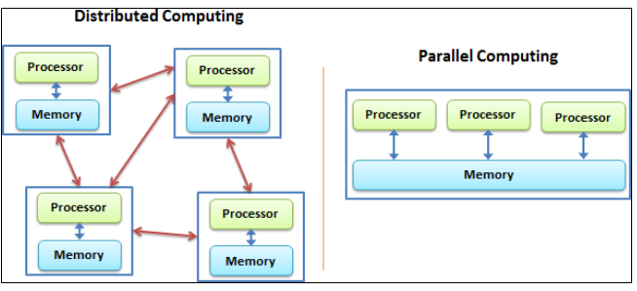

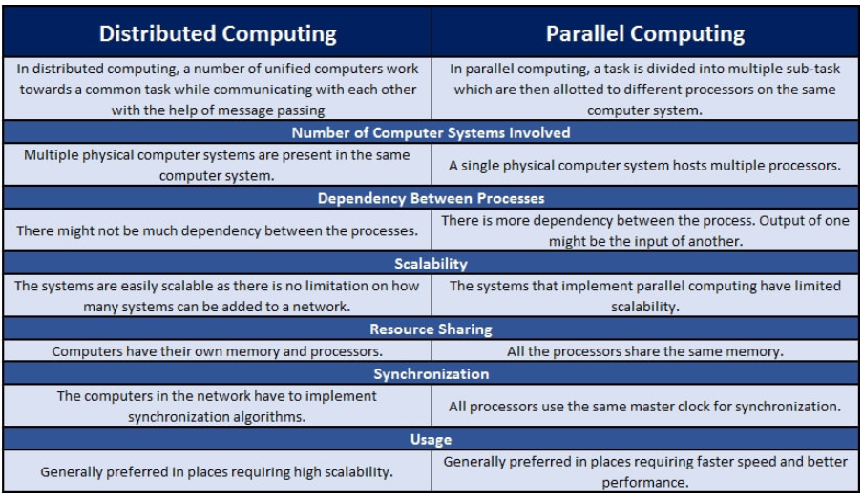
Distributed Computing | Parallel Computing
Typically consists of a network of computers | Mainly uses several processors
Used to share resources | Used for high performance
Used for consistency and availability | Used for concurrency
Designed to tolerate failures | Designed for massive calculations

Concurrency vs Parallelism
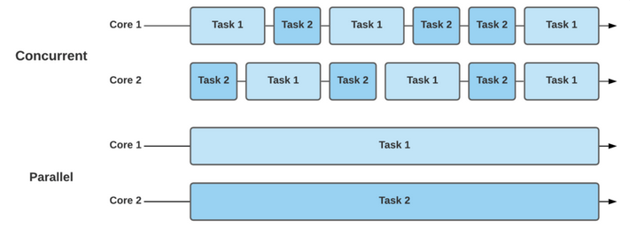
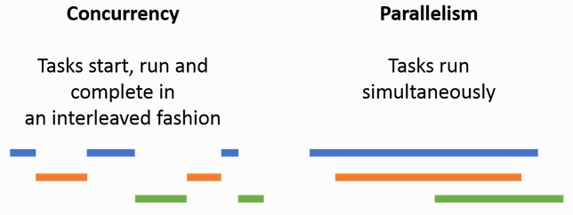

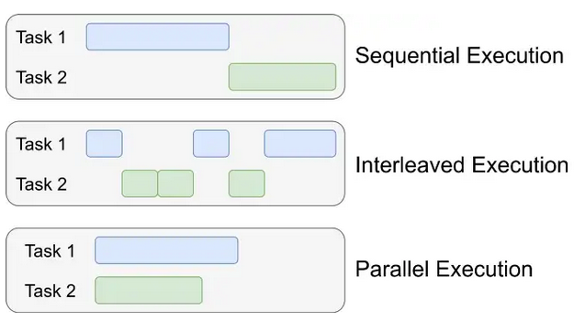

Mono vs Multi Processing
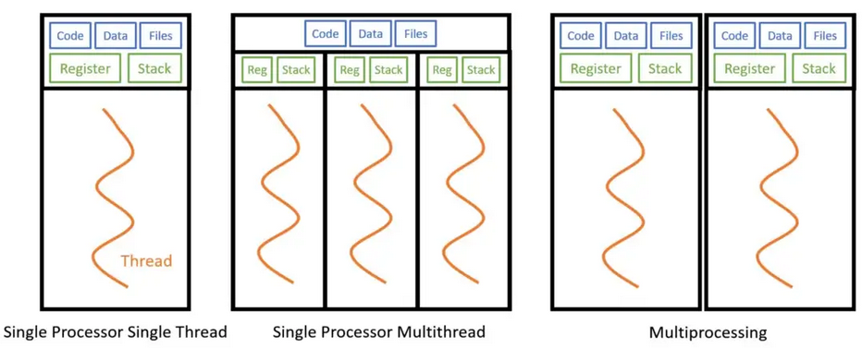

Synchronous vs Asynchronous Processing

