Contents
App 1 : Login Page 1
App2 : Simple Calculator 2
App 3 : Intent 3
App 4 : Activity Life Cycle 4
App 5 : Check Box and Radio Button 5
App 6 : Implicit Intent 6
App 7 : List View 7
App 8 : Scroll View 8
App 9 : Spinner 9
App 10 : Shared Preferances 10
Date:
APP 1: Login Page

Aim: Design a Login page with username and password using Linear Layout and Toast Valid and
Invalid credentials.

Program Code:

MainActivity.java
package com.example.myapplication;
import androidx.appcompat.app.AppCompatActivity;

import android.os.Bundle;
import android.view.View;
import android.widget.Button;
import android.widget.EditText;
import android.widget.Toast;

public class MainActivity extends AppCompatActivity {
Button b;
EditText u,p;
@Override
protected void onCreate(Bundle savedInstanceState) {
super.onCreate(savedInstanceState);
setContentView(R.layout.activity_main);
b=(Button) findViewById(R.id.b);
u=(EditText) findViewById(R.id.user);
p=(EditText) findViewById(R.id.pass);
b.setOnClickListener(new View.OnClickListener() {
@Override
public void onClick(View view) {
String user=u.getText().toString();
String pass=p.getText().toString();
if (user.equals("usr")&& pass.equals("123"))
Toast.makeText(getApplicationContext(),"logged in successfully",Toast.LENGTH_SHORT).show();
else
Toast.makeText(getApplicationContext(),"Invalid credentials",Toast.LENGTH_SHORT).show();
}})
}
}

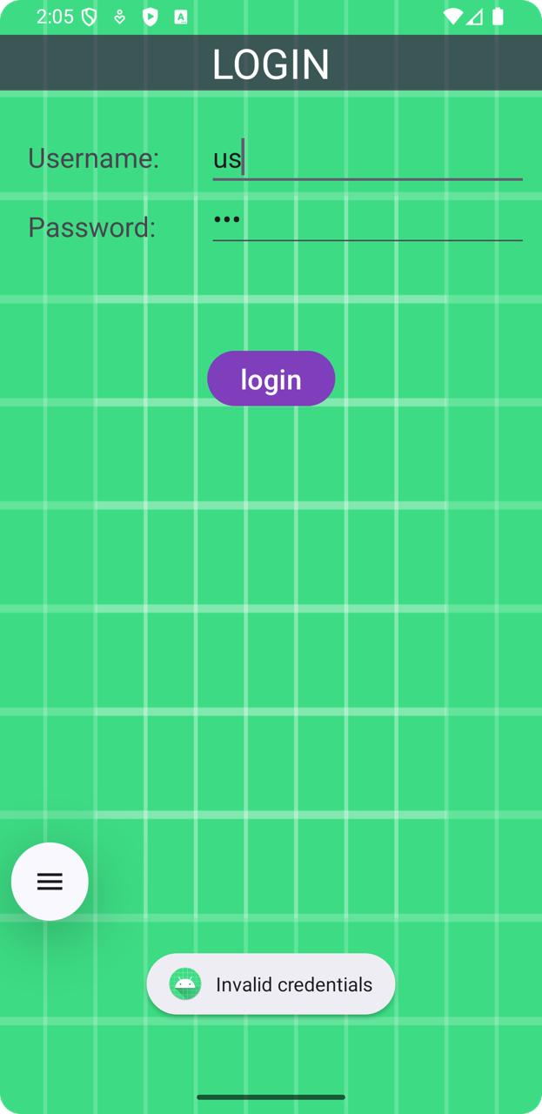
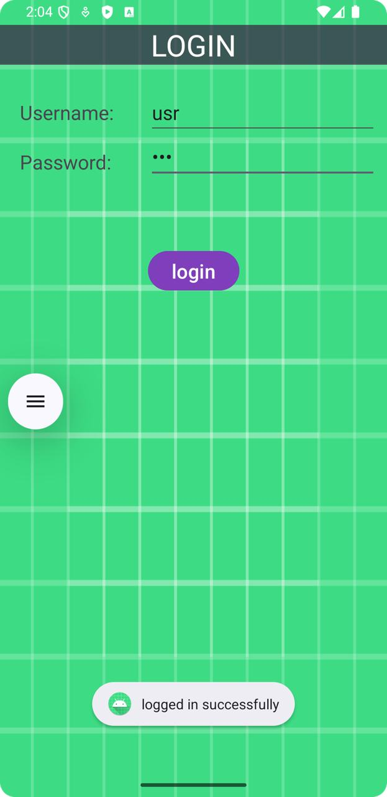
Activity_main.xml
<?xml version="1.0" encoding="utf-8"?>
<LinearLayout xmlns:android="http://schemas.android.com/apk/res/android"
xmlns:app="http://schemas.android.com/apk/res-auto"
xmlns:tools="http://schemas.android.com/tools"
android:layout_width="match_parent"
android:layout_height="match_parent"
tools:context=".MainActivity"
android:background="@drawable/ic_launcher_background">
<RelativeLayout
android:layout_width="match_parent"
android:layout_height="match_parent">

<TextView
android:id="@+id/l"
android:layout_width="1200dp"
android:layout_height="wrap_content"
android:layout_alignParentEnd="true"
android:layout_marginTop="25dp"
android:layout_marginEnd="0dp"
android:background="#B23B1E40"
android:text="LOGIN"
android:textAlignment="center"
android:textColor="#ffffff"
android:textSize="30dp" />

<TextView
android:id="@+id/u"
android:layout_width="wrap_content"
android:layout_height="wrap_content"
android:text="Username:"
android:layout_marginTop="100dp"
android:layout_marginLeft="20dp"
android:textSize="20dp”
/>

<TextView
android:id="@+id/textView3"
android:layout_width="wrap_content"

Result: The program has executed successfully and output is verified

android:layout_height="wrap_content"
android:text="Password:"
android:layout_marginTop="150dp"
android:layout_marginLeft="20dp"
android:textSize="20dp"
/>
<Button
android:id="@+id/b"
android:layout_width="wrap_content"
android:layout_height="wrap_content"
android:layout_marginLeft="150dp"
android:layout_marginTop="250dp" android:backgroundTint="#DF803BBC"
android:text="login"
android:textSize="20dp" />

<EditText
android:id="@+id/user"
android:layout_width="wrap_content"
android:layout_height="wrap_content"
android:layout_marginTop="90dp"
android:layout_marginLeft="150dp"
android:textSize="20dp"
android:ems="10"
android:inputType="text"
android:text="" />

<EditText
android:id="@+id/pass"
android:layout_width="wrap_content"
android:layout_height="wrap_content"
android:layout_marginTop="135dp"
android:layout_marginLeft="150dp"
android:textSize="20dp"
android:ems="10"
android:inputType="textPassword" />
</RelativeLayout>

</LinearLayout>

Date:
APP 2: Simple Calculator

Aim: Create a simple calculator to perform arithmetic operations

Program Code:

MainActivity.java
package com.example.calculator;
import androidx.appcompat.app.AppCompatActivity;
import android.os.Bundle;
import android.view.View;
import android.widget.Button;
import android.widget.EditText;
public class MainActivity extends AppCompatActivity
{
EditText t1;
Button bac;
String firstNumber="",operator="";
@Override
protected void onCreate(Bundle savedInstanceState)
{
super.onCreate(savedInstanceState);
setContentView(R.layout.activity_main);
t1=(EditText) findViewById(R.id.t1);
bac=(Button) findViewById(R.id.bac);
int b[]=new int[17];
for(int i=0;i<=16;i++)
{
String s="b"+(i);
int rid=getResources().getIdentifier(s,"id",getPackageName());
b[i]=rid;
}
for(int id:b)
{
Button button=findViewById(id);
if(button !=null)
{
button.setOnClickListener(new View.OnClickListener()
{
@Override
public void onClick(View view)

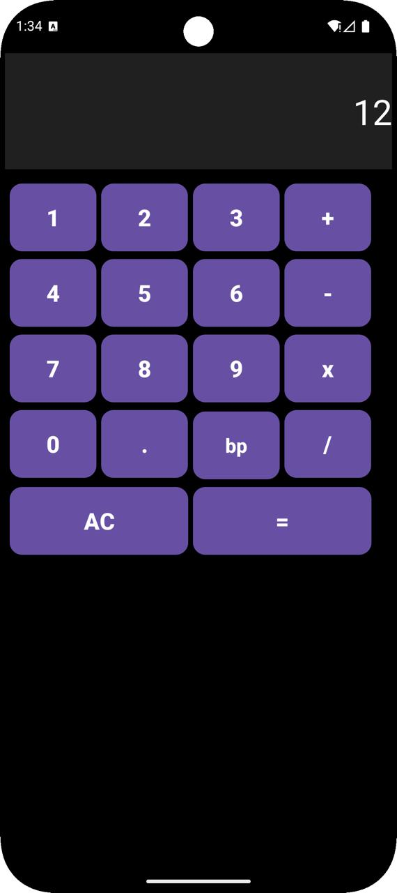

{
handleButtonClick(view.getId());
}});
}}

bac.setOnClickListener(new View.OnClickListener()
{
@Override
public void onClick(View view)
{
t1.setText("");
}});
}

private void handleButtonClick(int id)
{
String txt = t1.getText().toString();
if (id == R.id.b16)
{
if (!firstNumber.isEmpty() && !operator.isEmpty())
{
String secondNumber = txt;
double result = 0;
double num1 = Double.parseDouble(firstNumber);
double num2 = Double.parseDouble(secondNumber);

switch (operator)
{
case "+":
result = num1 + num2;
break;
case "-":
result = num1 - num2;
break;
case "x":
result = num1 * num2;
break;
case "/":
result = num1 / num2;
break;
}

t1.setText(String.valueOf(result));
firstNumber = "";
operator = "";
}}
else if (id == R.id.b10)
if (!txt.contains("."))
t1.setText(txt + ((Button) findViewById(id)).getText());
else if (id == R.id.b12 || id == R.id.b13 || id == R.id.b14 || id == R.id.b15)
if (!txt.isEmpty())
{
firstNumber = txt;
operator = ((Button) findViewById(id)).getText().toString();
t1.setText("");
}
else if (id == R.id.b11)
if (txt.length() > 0)
t1.setText(txt.substring(0, txt.length() - 1));
else
t1.setText(txt + ((Button) findViewById(id)).getText());
}}

Activity_main.xml

<?xml version="1.0" encoding="utf-8"?>
<LinearLayout xmlns:android="http://schemas.android.com/apk/res/android"
xmlns:app="http://schemas.android.com/apk/res-auto"
xmlns:tools="http://schemas.android.com/tools" android:layout_width="match_parent"
android:layout_height="match_parent"
android:background="#000000"
tools:context=".MainActivity">

<GridLayout
android:layout_width="match_parent"
android:layout_height="match_parent"
android:columnCount="4"
android:rowCount="6"
android:layout_margin="5dp">

<EditText
android:id="@+id/t1"
android:layout_marginTop="350dp"
android:layout_marginBottom="15dp"
android:layout_width="match_parent"
android:layout_height="150dp"
android:layout_row="0"
android:layout_column="0"
android:ems="10"
android:layout_columnSpan="4"
android:inputType="text"
android:textSize="92px"
android:textAlignment="viewEnd"
android:background="#20ffffff"
android:textColor="#ffffff"
android:text=""/>
android:background="@drawable/button_background"
android:gravity="center"
android:text="2"
android:textAlignment="center"
android:textSize="22dp"
android:textStyle="bold"

android:layout_marginBottom="10dp"/>

<Button
android:id="@+id/b3"
android:layout_width="105dp"
android:layout_height="75dp"
android:layout_row="1"
android:layout_column="2"
android:layout_marginLeft="5dp" android:background="@drawable/button_background"
android:text="3"
android:gravity="center"
android:textAlignment="center"
android:textSize="28dp"
android:textStyle="bold"
android:layout_marginBottom="10dp"/>

<Button
android:id="@+id/b12"
android:layout_width="105dp"
android:layout_height="75dp"
android:layout_marginLeft="5dp"
android:layout_row="1"
android:layout_column="3"
android:gravity="center"
android:textAlignment="center"
android:textSize="28dp"
android:textStyle="bold"
android:layout_marginBottom="10dp"
android:background="@drawable/op_bg"
android:textColor="#ffffff"
android:text="+"/>

<Button
android:id="@+id/b4"
android:layout_width="105dp"
android:layout_height="75dp"
android:layout_marginLeft="5dp"
android:layout_row="2"
android:layout_column="0"
android:gravity="center"
android:textAlignment="center"
android:textSize="28dp"
android:textStyle="bold"
android:layout_marginBottom="10dp"
android:background="@drawable/button_background" android:text="4"/>

<Button
android:id="@+id/b5"
android:layout_width="105dp"
android:layout_height="75dp"
android:layout_marginLeft="5dp"
android:layout_row="2"
android:layout_column="1"
android:gravity="center"
android:textAlignment="center"
android:textSize="28dp"
android:textStyle="bold"
android:layout_marginBottom="10dp" android:background="@drawable/button_background" android:text="5"/>

<Button
android:id="@+id/b6"
android:layout_width="105dp"
android:layout_height="75dp"
android:layout_marginLeft="5dp"
android:layout_row="2"
android:layout_column="2" android:background="@drawable/button_background" android:gravity="center"
android:textAlignment="center"
android:textSize="28dp"
android:textStyle="bold"
android:layout_marginBottom="10dp"
android:text="6"/>

<Button
android:id="@+id/b13"
android:layout_width="105dp"
android:layout_height="75dp"
android:layout_marginLeft="5dp

android:layout_row="2"
android:layout_column="3"
android:background="@drawable/op_bg"
android:textColor="#ffffff"
android:gravity="center"
android:textAlignment="center"
android:textSize="28dp"
android:textStyle="bold"
android:layout_marginBottom="10dp"
android:text="-"/>

<Button
android:id="@+id/b7"
android:layout_width="105dp"
android:layout_height="75dp"
android:layout_marginLeft="5dp"
android:layout_row="3"
android:layout_column="0"
android:gravity="center"
android:textAlignment="center"
android:textSize="28dp"
android:textStyle="bold"
android:layout_marginBottom="10dp"
android:background="@drawable/button_background" android:text="7"/>

<Button
android:id="@+id/b8"
android:layout_width="105dp"
android:layout_height="75dp"
android:layout_marginLeft="5dp"
android:layout_row="3"
android:layout_column="1"
android:gravity="center"
android:textAlignment="center"
android:textSize="28dp"
android:textStyle="bold"
android:layout_marginBottom="10dp"
android:background="@drawable/button_background" android:text="8"/>

<Button
android:id="@+id/b9"
android:layout_width="105dp"
android:layout_height="75dp"
android:layout_marginLeft="5dp"
android:layout_row="3"
android:layout_column="2"
android:gravity="center"
android:textAlignment="center"
android:textSize="28dp"
android:textStyle="bold”
android:layout_marginBottom="10dp"
android:background="@drawable/button_background" android:text="9"/>

<Button
android:id="@+id/b14"
android:layout_width="105dp"
android:layout_height="75dp"
android:layout_marginLeft="5dp"
android:layout_row="3"
android:layout_column="3"
android:gravity="center"
android:textAlignment="center"
android:textSize="28dp"
android:textStyle="bold"
android:layout_marginBottom="10dp"
android:background="@drawable/op_bg"
android:textColor="#ffffff"
android:text="x"/>

<Button
android:id="@+id/b0"
android:layout_width="105dp"
android:layout_height="75dp"
android:layout_marginLeft="5dp"
android:layout_row="4"
android:layout_column="0"
android:gravity="center"
android:textAlignment="center"
android:textSize="28dp"
android:textStyle="bold"
android:layout_marginBottom="10dp"
android:background="@drawable/button_background" android:text="0"/>
<Button

android:id="@+id/b10"
android:layout_width="105dp"
android:layout_height="75dp"
android:layout_marginLeft="5dp"
android:layout_row="4"
android:layout_column="1"
android:gravity="center"
android:textAlignment="center"
android:textSize="28dp"
android:textStyle="bold"
android:layout_marginBottom="10dp"
<Button
android:id="@+id/b10"
android:layout_width="105dp"
android:layout_height="75dp"
android:layout_marginLeft="5dp"
android:layout_row="4"
android:layout_column="1"
android:gravity="center"
android:textAlignment="center"
android:textSize="28dp"
android:textStyle="bold"
android:layout_marginBottom="10dp"
android:background="@drawable/button_background"android:text="."/>

<Button
android:id="@+id/b11"
android:layout_width="105dp"
android:layout_height="75dp"
android:layout_marginLeft="5dp"
android:layout_row="4"
android:layout_column="2"
android:gravity="center"
android:textAlignment="center"
android:textSize="28dp"
android:textStyle="bold"
android:layout_marginBottom="10dp" android:background="@drawable/button_background" android:text="bp"/>

<Button
android:id="@+id/b15"
android:layout_width="105dp"
android:layout_height="75dp"
android:layout_marginLeft="5dp"
android:layout_row="4"
android:layout_column="3"
android:gravity="center"
android:textAlignment="center"
android:textSize="28dp"
android:textStyle="bold"
android:layout_marginBottom="10dp"
android:background="@drawable/op_bg"
android:textColor="#ffffff"
android:text="/"/>
<Button
android:id="@+id/bac"
android:layout_width="215dp"
android:layout_height="75dp"
android:layout_row="5"
android:layout_column="0"
android:layout_columnSpan="2"
android:layout_marginLeft="5dp"
android:text="AC"
android:textColor="#ffffff” android:background="@drawable/op_bg"
android:gravity="center"
android:textAlignment="center"
android:textSize="28dp"
android:textStyle="bold" android:layout_marginBottom="10dp"/>

<Button
android:id="@+id/b16"
android:layout_width="215dp"
android:layout_height="75dp"
android:layout_marginLeft="5dp"
android:layout_row="5"
android:layout_column="2"
android:layout_columnSpan="2"
android:gravity="center"
android:textAlignment="center"
android:textSize="28dp"
android:textStyle="bold"
android:layout_marginBottom="10dp"

android:background="@drawable/op_bg"
android:textColor="#ffffff"
android:text="="/>
</GridLayout>
</LinearLayout>

Result: The program has executed successfully and output is verified

Date:
APP 3: Intent

Aim: Create two activities , 1st activity contains login details, when clicked to submit, go to 2nd activity.

Program Code:

MainActivity.java
package com.example.login;
import android.content.Intent;
import android.os.Bundle;
import android.view.View;
import android.widget.Button;
import android.widget.EditText;
import android.widget.Toast;
import androidx.activity.EdgeToEdge;
import androidx.appcompat.app.AppCompatActivity;
import androidx.core.graphics.Insets;
import androidx.core.view.ViewCompat;
import androidx.core.view.WindowInsetsCompat;

public class MainActivity extends AppCompatActivity {
EditText e1,e2;
Button b1;
@Override
protected void onCreate(Bundle savedInstanceState) {
super.onCreate(savedInstanceState);
EdgeToEdge.enable(this);
setContentView(R.layout.activity_main);
ViewCompat.setOnApplyWindowInsetsListener(findViewById(R.id.main), (v, insets) -> {
Insets systemBars = insets.getInsets(WindowInsetsCompat.Type.systemBars());
v.setPadding(systemBars.left, systemBars.top, systemBars.right, systemBars.bottom);
return insets;
});
e1=(EditText) findViewById(R.id.edittext1);
e2=(EditText) findViewById(R.id.edittext2);
b1=(Button) findViewById(R.id.btn1);
b1.setOnClickListener(new View.OnClickListener() {
@Override
public void onClick(View v) {
String username=e1.getText().toString().trim();
String pass=e2.getText().toString();
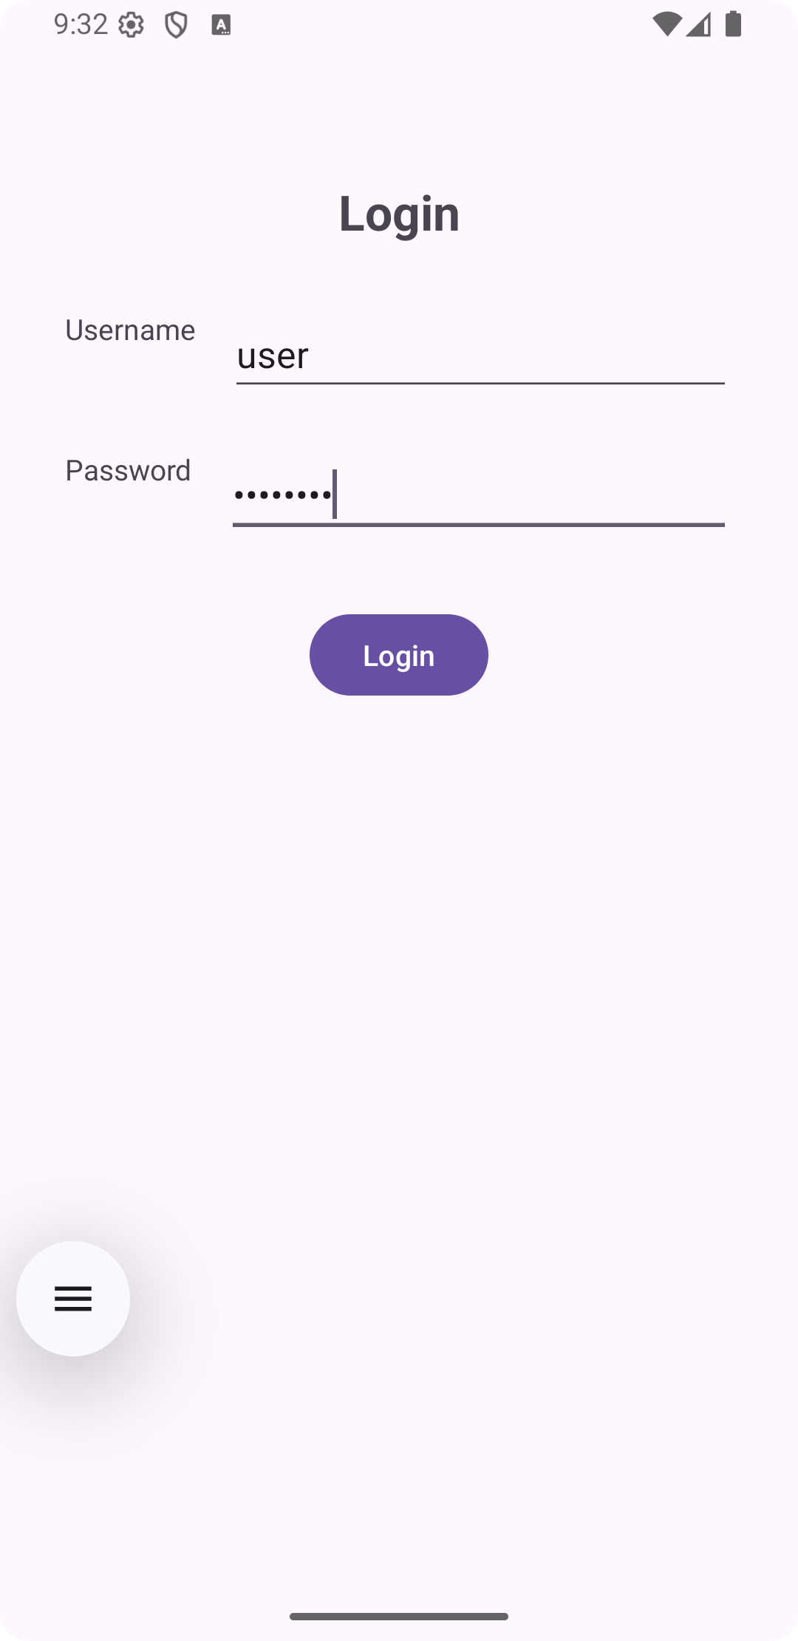
if(username.equals("user") && pass.equals("admin123")) {
Toast.makeText(MainActivity.this, "Login successful", Toast.LENGTH_SHORT).show();
Intent intent = new Intent(MainActivity.this, Homepage.class);
startActivity(intent);
}
else
Toast.makeText(MainActivity.this,"Login failed",Toast.LENGTH_SHORT).show();
}
});
}}

Activity_Main.xml

<androidx.constraintlayout.widget.ConstraintLayout xmlns:android="http://schemas.android.com/apk/res/android"
xmlns:app="http://schemas.android.com/apk/res-auto"
android:id="@+id/main"
android:layout_width="match_parent"
android:layout_height="match_parent">

<TextView
android:id="@+id/textView3"
android:layout_width="wrap_content"
android:layout_height="wrap_content"
android:text="Login"
android:textSize="24sp"
android:textStyle="bold"
app:layout_constraintTop_toTopOf="parent"
app:layout_constraintStart_toStartOf="parent"
app:layout_constraintEnd_toEndOf="parent"
android:layout_marginTop="64dp" />

<TextView
android:id="@+id/textView4"
android:layout_width="wrap_content"
android:layout_height="wrap_content"
android:text="Username" app:layout_constraintTop_toBottomOf="@id/textView3"
app:layout_constraintStart_toStartOf="parent"
android:layout_marginTop="32dp"
android:layout_marginStart="32dp" />
<EditText
android:id="@+id/edittext1"
android:layout_width="0dp"
android:layout_height="wrap_content"
android:hint="Enter username"
android:inputType="text"
app:layout_constraintStart_toEndOf="@id/textView4"
app:layout_constraintEnd_toEndOf="parent"
app:layout_constraintTop_toTopOf="@id/textView4"
android:layout_marginStart="16dp"
android:layout_marginEnd="32dp" />
<TextView
android:id="@+id/textView5"
android:layout_width="wrap_content"
android:layout_height="wrap_content"
android:text="Password"
app:layout_constraintTop_toBottomOf="@id/edittext1"
app:layout_constraintStart_toStartOf="parent"
android:layout_marginTop="24dp"
android:layout_marginStart="32dp" />

<EditText
android:id="@+id/edittext2"
android:layout_width="0dp"
android:layout_height="wrap_content"
android:hint="Enter password"
android:inputType="textPassword"

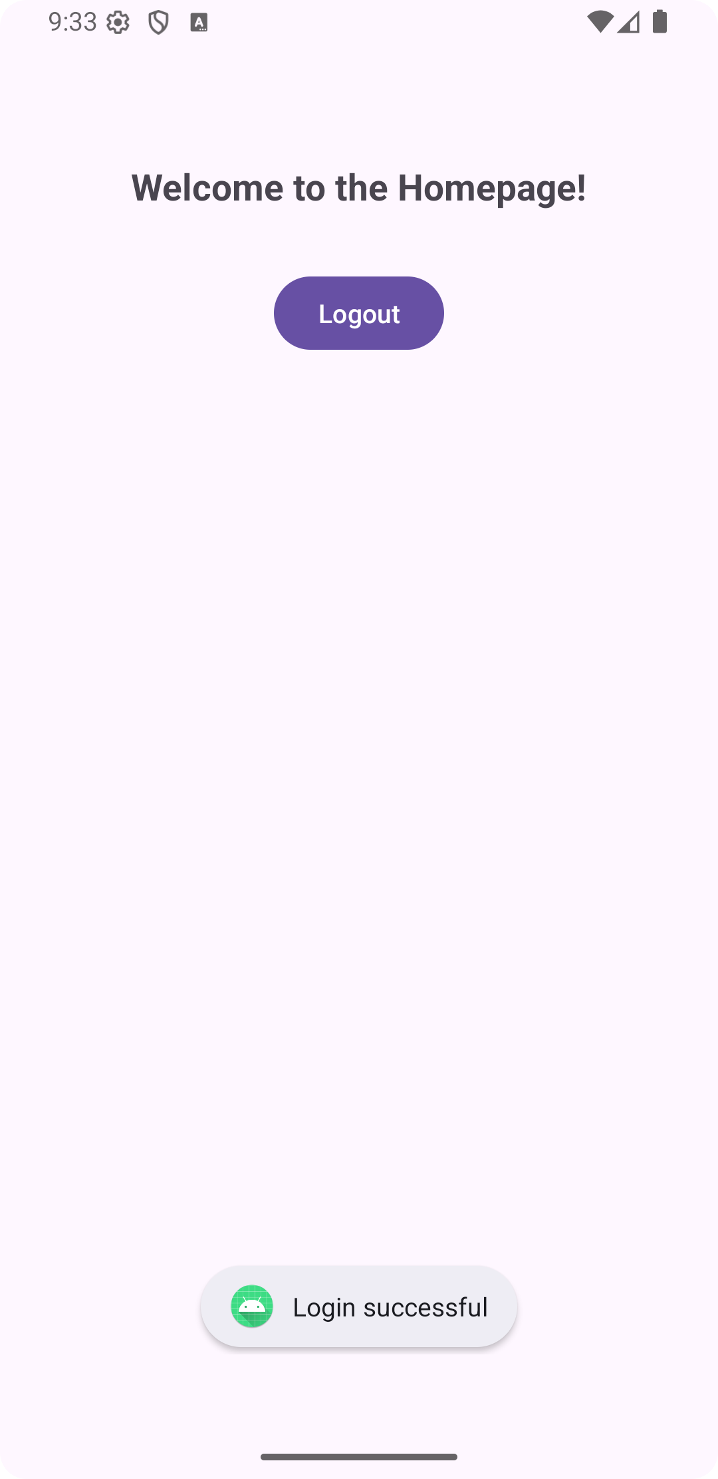

app:layout_constraintStart_toEndOf="@id/textView5"
app:layout_constraintEnd_toEndOf="parent"
app:layout_constraintTop_toTopOf="@id/textView5"
android:layout_marginStart="16dp"
android:layout_marginEnd="32dp" />

<Button
android:id="@+id/btn1"
android:layout_width="wrap_content"
android:layout_height="wrap_content"
android:text="Login"
app:layout_constraintTop_toBottomOf="@id/edittext2"
app:layout_constraintStart_toStartOf="parent"
app:layout_constraintEnd_toEndOf="parent"
android:layout_marginTop="32dp" />
</androidx.constraintlayout.widget.ConstraintLayout>

Homepage.java
package com.example.login;
import android.content.Intent;
import android.os.Bundle;
import android.view.View;
import android.widget.Button;
import androidx.activity.EdgeToEdge;
import androidx.appcompat.app.AppCompatActivity;
import androidx.core.graphics.Insets;
import androidx.core.view.ViewCompat;
import androidx.core.view.WindowInsetsCompat;

public class Homepage extends AppCompatActivity {
Button logoutButton;
@Override
protected void onCreate(Bundle savedInstanceState) {
super.onCreate(savedInstanceState);
EdgeToEdge.enable(this);
setContentView(R.layout.activity_homepage);
ViewCompat.setOnApplyWindowInsetsListener(findViewById(R.id.main), (v, insets) -> {
Insets systemBars = insets.getInsets(WindowInsetsCompat.Type.systemBars());
v.setPadding(systemBars.left, systemBars.top, systemBars.right, systemBars.bottom);
return insets;
});

logoutButton = findViewById(R.id.logoutButton);
logoutButton.setOnClickListener(new View.OnClickListener() {
@Override
public void onClick(View v) {
// Go back to login screen

Intent intent = new Intent(Homepage.this, MainActivity.class);
startActivity(intent);
finish();
}
});
}}

Activity_HomePage.xml

<?xml version="1.0" encoding="utf-8"?>
<androidx.constraintlayout.widget.ConstraintLayout
xmlns:android="http://schemas.android.com/apk/res/android"
xmlns:app="http://schemas.android.com/apk/res-auto"
android:layout_width="match_parent"
android:layout_height="match_parent"
android:id="@+id/main"
android:padding="24dp">

<TextView
android:id="@+id/welcomeText"
android:layout_width="wrap_content"
android:layout_height="wrap_content"
android:text="Welcome to the Homepage!"
android:textSize="20sp"
android:textStyle="bold"
app:layout_constraintTop_toTopOf="parent" app:layout_constraintStart_toStartOf="parent"
app:layout_constraintEnd_toEndOf="parent"
android:layout_marginTop="64dp" />
<Button
android:id="@+id/logoutButton"
android:layout_width="wrap_content"
android:layout_height="wrap_content"
android:text="Logout"

Result: The program has executed successfully and output is verified

app:layout_constraintTop_toBottomOf="@id/welcomeText"
app:layout_constraintStart_toStartOf="parent"
app:layout_constraintEnd_toEndOf="parent"
android:layout_marginTop="32dp" />
</androidx.constraintlayout.widget.ConstraintLayout>

Date :
APP 4: Activity Life Cycle
Aim: Create an app to demonstrate Activity Life Cycle.
Program Code :

MainActivity.java

package com.example.start;
import androidx.appcompat.app.AppCompatActivity;
import android.nfc.Tag;
import android.os.Bundle;
import android.util.Log;
public class MainActivity extends AppCompatActivity
{
@Override
protected void onCreate(Bundle savedInstanceState)
{
super.onCreate(savedInstanceState);
setContentView(R.layout.activity_main);
Log.d("Appstate","Created");
}
@Override
protected void onStart()
{
super.onStart();
Log.d("Appstate","Starting");
}
@Override
protected void onResume()
{
super.onResume();
Log.d("Appstate","Resuming");
}

Result: The program has executed successfully and output is verified

@Override
protected void onPause()
{
super.onPause();
Log.d("Appstate","Paused");
}
@Override
protected void onStop()
{
super.onStop();
Log.d("Appstate","Stopped");
}
@Override
protected void onRestart()
{
super.onRestart();
Log.d("Appstate","Restarted");
}
@Override
protected void onDestroy()
{
super.onDestroy();
Log.d("Appstate","Destroyed");
}
}

Date :

APP 5: Checkbox and Radiobutton
Aim : Create an app to demonstrate the usage of Checkbox and Radio buttons
Program Code :
MainActivity.java:
package com.example.radiocheck;
import androidx.appcompat.app.AppCompatActivity;
import android.os.Bundle;
import android.view.View;
import android.widget.Button;
import android.widget.CheckBox;
import android.widget.RadioButton;
import android.widget.RadioGroup;
import android.widget.TextView;
import android.widget.Toast;
public class MainActivity extends AppCompatActivity
{
Button b1;
RadioGroup rg;
RadioButton r1,r2;
CheckBox e,m,h;
TextView t;
@Override
protected void onCreate(Bundle savedInstanceState)
{
super.onCreate(savedInstanceState);
setContentView(R.layout.activity_main);
b1=(Button) findViewById(R.id.submit);
r1=(RadioButton) findViewById(R.id.male);
r2=(RadioButton) findViewById(R.id.female);
e=(CheckBox)findViewById(R.id.e);
m=(CheckBox)findViewById(R.id.m);
h=(CheckBox)findViewById(R.id.h);
t=(TextView)findViewById(R.id.tv);
b1.setOnClickListener(new View.OnClickListener()
{
@Override
public void onClick(View view)
{
String s[]=new String[3];
t.setText("Languages Known: ");
if(e.isChecked())
t.setText(t.getText().toString()+" "+e.getText());
if(m.isChecked())
t.setText(t.getText().toString()+" "+m.getText());

if(h.isChecked())
t.setText(t.getText().toString()+" "+h.getText());
}
});
rg=(RadioGroup) findViewById(R.id.rg);
rg.setOnCheckedChangeListener(new RadioGroup.OnCheckedChangeListener()
{
@Override
public void onCheckedChanged(RadioGroup group, int checkedId)
{
if(checkedId==R.id.female)
{ Toast.makeText(getApplicationContext(),r2.getText().toString(),Toast.LENGTH_SHORT).show();
}
else
{ Toast.makeText(getApplicationContext(),r1.getText().toString(),Toast.LENGTH_SHORT).show();
}
}
});
}
}

Activity_home_page.xml

<?xml version="1.0" encoding="utf-8"?>
<LinearLayout
xmlns:android="http://schemas.android.com/ap
k/res/android"
xmlns:app="http://schemas.android.com/apk/res-auto"
xmlns:tools="http://schemas.android.com/tool"
android:layout_width="match_parent"
android:layout_height="match_parent"
tools:context=".MainActivity">
<RelativeLayout
android:layout_width="match_parent"
android:layout_height="match_parent">
<TextView
android:layout_width="wrap_content"
android:layout_height="30dp"
android:layout_marginTop="50dp"
android:layout_marginLeft="150dp"
android:id="@+id/h1"
android:text="Registration"
android:textSize="24dp"/>
<TextView
android:layout_width="wrap_content"
android:layout_height="30dp"
android:layout_marginTop="100dp"
android:layout_marginLeft="50dp"
android:id="@+id/gender"
android:text="Choose Gender"
android:textSize="20dp"/>
<RadioGroup
android:layout_width="250dp"
android:layout_height="wrap_content"
android:id="@+id/rg"
android:layout_marginTop="150dp"
android:layout_marginLeft="50dp">
<RadioButton
android:layout_width=
"wrap_content"
android:layout_height=
"wrap_content"
android:text="Male"
android:id="@+id/male"/>
<RadioButton
android:layout_width=
"wrap_content"
android:layout_height=
"wrap_content"

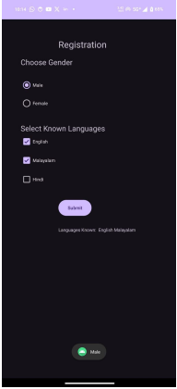

android:text="Female"
android:id="@+id/female"/>
</RadioGroup>
<TextView
android:layout_width="wrap_content"
android:layout_height="30dp"
android:layout_marginTop="275dp"
android:layout_marginLeft="50dp"
android:id="@+id/lang"
android:text="Select Known Languages"
android:textSize="20dp"/>
<CheckBox
android:id="@+id/e"
android:layout_width="wrap_content"
android:layout_height="wrap_content"
android:text="English"
android:layout_marginTop="300dp"
android:layout_marginLeft="50dp"/>
<CheckBox
android:id="@+id/m"
android:layout_width="wrap_content"
android:layout_height="wrap_content"
android:text="Malayalam"
android:layout_marginTop="350dp"
android:layout_marginLeft="50dp"/>
<CheckBox
android:id="@+id/h"
android:layout_width="wrap_content"
android:layout_height="wrap_content"
android:text="Hindi"
android:layout_marginTop="400dp"
android:layout_marginLeft="50dp"/>
<Button
android:layout_width="wrap_content"
android:layout_height="50dp"
android:layout_marginTop="475dp"
android:layout_marginLeft="150dp"
android:text="Submit"
android:id="@+id/submit"/>

Result: The program has executed successfully and output is verified.

<TextView
android:layout_width="wrap_content"
android:layout_height="50dp"
android:layout_marginTop="550dp"
android:layout_marginLeft="150dp"
android:text=""
android:id="@+id/tv"/>
</RelativeLayout>
</LinearLayout>

Date :

APP 6: Implicit Intent

Aim : Create an app to demonstrate the usage of implicit intent by opening a website form the app
Program Code :
MainActivity.java:
import android.content.Intent;
import android.net.Uri;
import android.os.Bundle;
import android.view.View;
import android.widget.Button;
import android.widget.TextView;
import androidx.activity.EdgeToEdge;
import androidx.appcompat.app.AppCompatActivity;
public class MainActivity extends AppCompatActivity
{
Button b;
TextView t;
@Override
protected void onCreate(Bundle savedInstanceState)
{
super.onCreate(savedInstanceState);
EdgeToEdge.enable(this);
setContentView(R.layout.activity_main);
b=(Button) findViewById(R.id.b1);
t=(TextView) findViewById(R.id.t1);
b.setOnClickListener(new View.OnClickListener()
{
@Override
public void onClick(View view) {
Intent intent = new Intent(Intent.ACTION_VIEW);
intent.setData(Uri.parse("https://www.cet.ac.in"));
startActivity(intent);
t.setText("Youtube Opened");
}
});
}
}

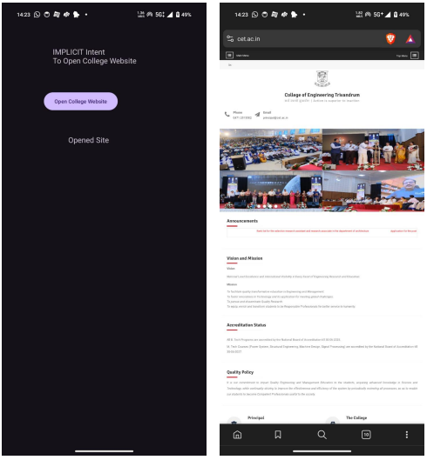
Activity_home_page.xml

<?xml version="1.0" encoding="utf-8"?>

<LinearLayout
xmlns:android="http://schemas.android.com/ap
k/res/android"
xmlns:app="http://schemas.android.com/apk/res-auto"
xmlns:tools="http://schemas.android.com/tools" android:id="@+id/main" android:layout_width="match_parent" android:layout_height="match_parent" tools:context=".MainActivity">

<RelativeLayout
android:layout_width="wrap_content"
android:layout_height="wrap_content">

<TextView
android:layout_width="wrap_content"
android:layout_height="wrap_content"
android:text="IMPLICIT Intent \nTo
Open College Website"
android:layout_marginLeft="115dp"
android:layout_marginTop="100dp"
android:textSize="20sp">
</TextView>

<Button
android:id="@+id/b1"
android:layout_width="wrap_content"
android:layout_height="wrap_content"
android:layout_marginLeft="95dp"
android:layout_marginTop="200dp"
android:text="Open College Website">
</Button>

Result: The program has executed successfully and output is verified

<TextView
android:id="@+id/t1"
android:layout_width="wrap_content"
android:layout_height="wrap_content"
android:text=""
android:layout_marginTop="300dp"
android:layout_marginLeft="150dp"
android:textSize="20sp"></TextView>
</RelativeLayout>
</LinearLayout>

Date :

APP 7: List View

Aim : Create an app to create a List view with few items in it

Program Code :
MainActivity.java:

package com.example.listview;
import android.os.Bundle;
import android.view.View;
import android.widget.AdapterView;
import android.widget.ArrayAdapter;
import android.widget.ListView;
import android.widget.Toast;
import androidx.activity.EdgeToEdge;
import androidx.appcompat.app.AppCompatActivity;
public class MainActivity extends AppCompatActivity
{
ListView lv;
String arr[]={"Deepak","Subi","Misira","Bhavana","Zuhri"};
@Override
protected void onCreate(Bundle savedInstanceState)
{
super.onCreate(savedInstanceState);
EdgeToEdge.enable(this);
setContentView(R.layout.activity_main);
lv=(ListView) findViewById(R.id.lv);
ArrayAdapter adapter=new ArrayAdapter<String>(this, android.R.layout.simple_list_item_1,arr);
lv.setAdapter(adapter);
lv.setOnItemClickListener(new AdapterView.OnItemClickListener()
{
@Override
public void onItemClick(AdapterView<?> parent, View view, int position, long id)
{
Toast.makeText(MainActivity.this,"Name Clicked: "+adapter.getItem(position),
Toast.LENGTH_SHORT).show();
}
});
}
}
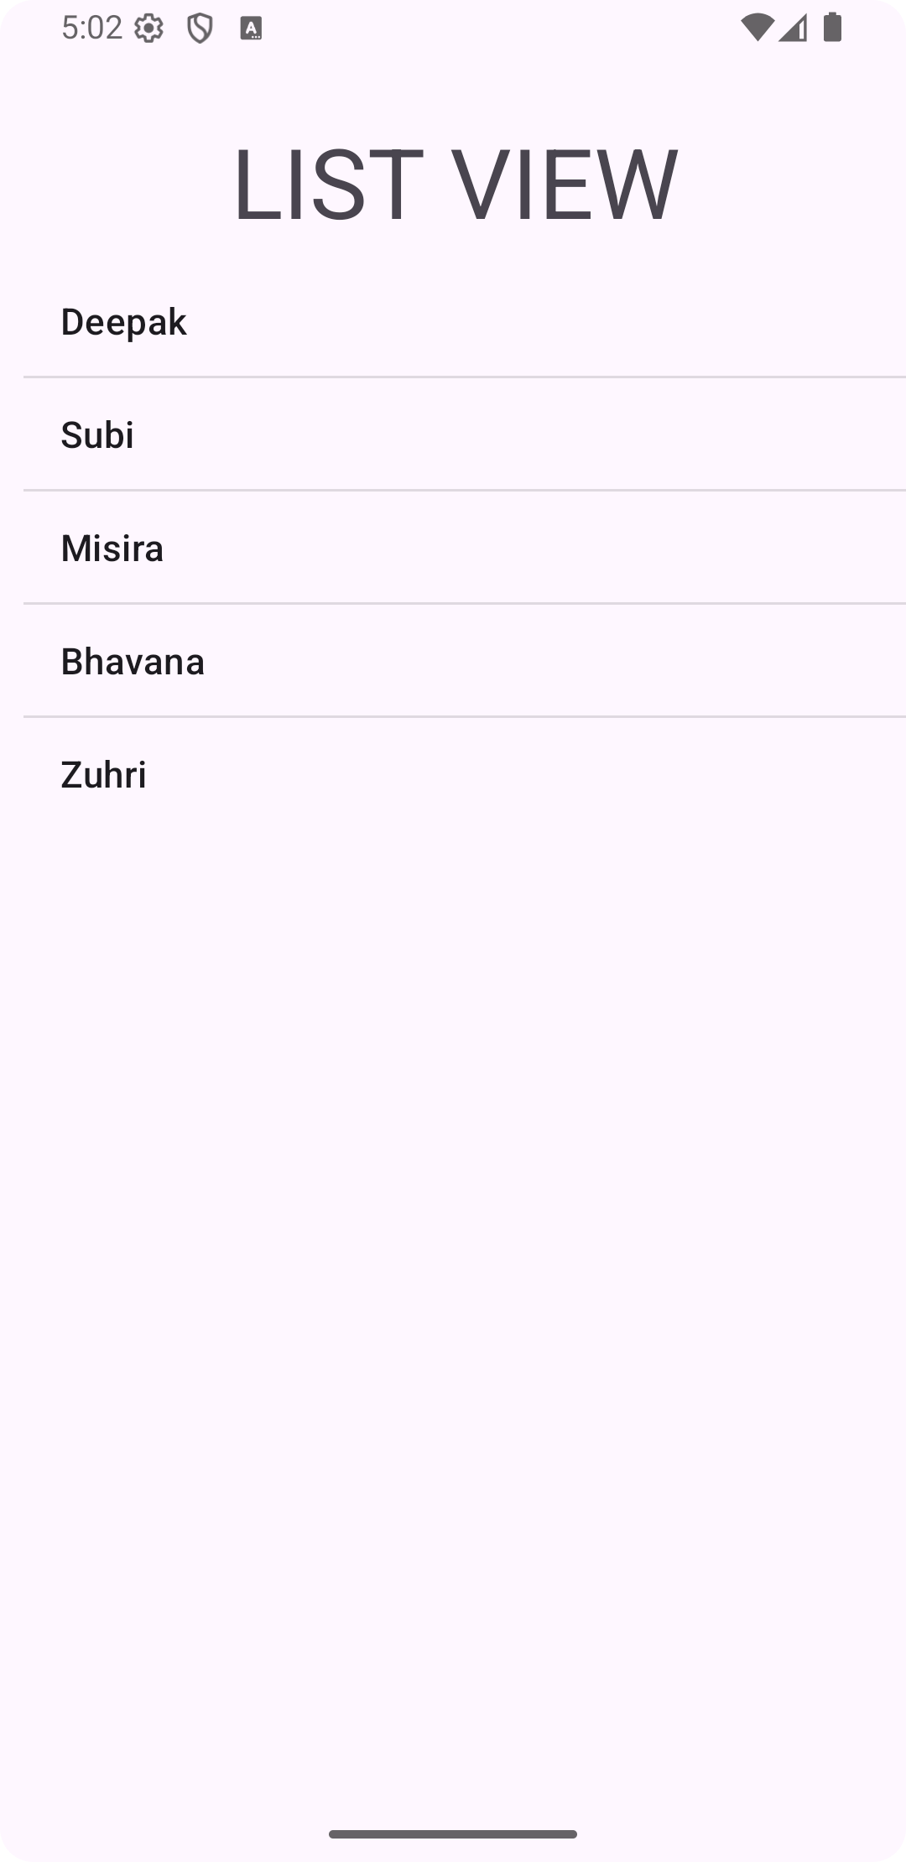
Activity_home_page.xml

<?xml version="1.0" encoding="utf-8"?>
<LinearLayout
xmlns:android="http://schemas.android.com/apk/res/android"
xmlns:app="http://schemas.android.com/apk/res-auto"
xmlns:tools="http://schemas.android.com/tools"
android:id="@+id/main"
android:layout_width="match_parent"
android:layout_height="match_parent"
tools:context=".MainActivity">

<RelativeLayout
android:layout_width="wrap_content"
android:layout_height="wrap_content">

<TextView
android:layout_width="wrap_content"
android:layout_height="wrap_content"
android:layout_marginTop="50dp"
android:layout_marginLeft="100dp"
android:text="LIST VIEW"
android:textSize="42dp">
</TextView>

<ListView
android:id="@+id/lv"
android:layout_width="wrap_content"
android:layout_height="wrap_content"
android:layout_marginTop="115dp"
android:layout_marginBottom="50dp"
android:layout_marginLeft="10dp">
</ListView>

</RelativeLayout>
</LinearLayout>
Result: The program has executed successfully and output is verified.

Date :

APP 8 : Scroll View

Aim : Create an app to create a spinner and select an item from it.

Program Code :
MainActivity.java:
package com.example.scrollview;
import android.os.Bundle;
import android.widget.LinearLayout;
import android.widget.TextView;
import androidx.activity.EdgeToEdge;
import androidx.appcompat.app.AppCompatActivity;
public class MainActivity extends AppCompatActivity
{
@Override
protected void onCreate(Bundle savedInstanceState)
{
super.onCreate(savedInstanceState);
EdgeToEdge.enable(this);
setContentView(R.layout.activity_main);
LinearLayout linearLayout = findViewById(R.id.linearLayoutContainer);
for (int i = 1; i <= 20; i++)
{
TextView textView = new TextView(this);
textView.setText("TextView " + i);
textView.setTextSize(45);
textView.setPadding(16, 16, 16, 16);
linearLayout.addView(textView);
}}}

Activity_home_page.xml

<?xml version="1.0" encoding="utf-8"?>
<ScrollView
xmlns:android="http://schemas.android.com/apk/res/android"
xmlns:app="http://schemas.android.com/apk/resauto"
xmlns:tools="http://schemas.android.com/tools"
android:id="@+id/main"
android:layout_width="match_parent"
Result: The program has executed successfully and output is verified

android:layout_height="match_parent"
android:padding="16dp"
tools:context=".MainActivity">
<LinearLayout
android:id="@+id/linearLayoutContainer"
android:layout_width="match_parent"
android:layout_height="wrap_content"
android:orientation="vertical">
</LinearLayout>
</ScrollView>

Date :

APP 9 : Spinner

Aim : Create an app to create a spinner and select an item from it.
Program Code :
MainActivity.java:
package com.example.spinner;
import androidx.appcompat.app.AppCompatActivity;
import android.os.Bundle;
import android.view.View;
import android.widget.AdapterView;
import android.widget.ArrayAdapter;
import android.widget.Spinner;
import android.widget.TextView;
import android.widget.Toast;
import java.util.ArrayList;
public class MainActivity extends AppCompatActivity
{
Spinner s;
TextView t1;
@Override
protected void onCreate(Bundle savedInstanceState)
{
super.onCreate(savedInstanceState);
setContentView(R.layout.activity_main);
s=(Spinner)findViewById(R.id.sp);
t1=(TextView) findViewById(R.id.t1);
ArrayList <String> al=new ArrayList<String>();
al.add("mango");
al.add("apple");
al.add("pineapple");
al.add("banana");
ArrayAdapter ad=new ArrayAdapter<>(this, androidx.appcompat.R.layout.support_simple_
spinner_dropdown_item,al);
s.setAdapter(ad);
s.setOnItemSelectedListener(new AdapterView.OnItemSelectedListener()
{
@Override
public void onItemSelected(AdapterView<?> parent, View view, int position, long id)
{
t1.setText("Selected Fruit: "+al.get(position));
}

@Override
public void onNothingSelected(AdapterView<?> parent)
{
t1.setText("Select a Fruit !!!!");
}
});
}
}
Activity_home_page.xml

<?xml version="1.0" encoding="utf-8"?>
<LinearLayout
xmlns:android="http://schemas.android.com/ap
k/res/android"
xmlns:app="http://schemas.android.com/apk/re
s-auto"
xmlns:tools="http://schemas.android.com/tools
"
android:id="@+id/main"
android:layout_width="match_parent"
android:layout_height="match_parent"
tools:context=".MainActivity">
<RelativeLayout
android:layout_width="wrap_content"
android:layout_height="wrap_content">
<TextView
android:layout_width="wrap_content"
android:layout_height="wrap_content"
android:layout_marginLeft="150dp"
android:layout_marginTop="50dp"
android:text="Spinner"
android:textSize="42dp"></TextView>
<TextView
android:layout_width="wrap_content"
android:layout_height="wrap_content"
android:layout_marginLeft="85dp"
android:layout_marginTop="135dp"
android:text="Select Fruit:"
android:textSize="20dp">
</TextView>

Result: The program has executed successfully and output is verified.

<Spinner
android:layout_width="wrap_content"
android:layout_height="wrap_content"
android:layout_marginLeft="200dp"
android:layout_marginTop="135dp"
android:id="@+id/sp"></Spinner>
<TextView
android:id="@+id/t1"
android:layout_width="wrap_content"
android:layout_height="wrap_content"
android:layout_marginLeft="150dp"
android:layout_marginTop="250dp"
android:text=""
android:textSize="20dp"></TextView>
</RelativeLayout>
</LinearLayout>

Date :

APP 10 : Shared Preferances

Aim : Create an app to demonstrate the usage of shared preferences by writing and reading data.

Program Code :

MainActivity.java
import android.content.SharedPreferences;
import android.os.Bundle;
import android.view.View;
import android.widget.Button;
import android.widget.TextView;
import androidx.activity.EdgeToEdge;
import androidx.appcompat.app.AppCompatActivity;
public class MainActivity extends AppCompatActivity
{
TextView txt;
Button br,bw;
@Override
protected void onCreate(Bundle savedInstanceState)
{
super.onCreate(savedInstanceState);
EdgeToEdge.enable(this);
setContentView(R.layout.activity_main);
txt=(TextView) findViewById(R.id.text_status);
bw=(Button) findViewById(R.id.btn_write);
br=(Button) findViewById(R.id.btn_read);
String usernamedemo="demo1po";
String emaildemo="demo1@gmail.ou";
SharedPreferences sp =getSharedPreferences("sp_abc",MODE_PRIVATE);
bw.setOnClickListener(new View.OnClickListener()
{
@Override
public void onClick(View view)
{
SharedPreferences.Editor se = sp.edit();
se.putString("username",usernamedemo);
se.putString("email",emaildemo);
se.apply();
txt.setText("Written Data");
}
});
br.setOnClickListener(new View.OnClickListener()
{
@Override
public void onClick(View view) {
String u,e;
u=sp.getString("username","");
e=sp.getString("email","");
txt.setText("Username: "+u+" \nEmail: "+e);
}
});
}
}

Activity_home_page.xml

<?xml version="1.0" encoding="utf-8"?>
<LinearLayout
xmlns:android="http://schemas.android.com/ap
k/res/android"
xmlns:app="http://schemas.android.com/apk/re
s-auto"
xmlns:tools="http://schemas.android.com/tools
"
android:layout_width="match_parent"
android:layout_height="match_parent"
tools:context=".MainActivity"
android:orientation="vertical"
android:gravity="center">
<TextView
android:layout_width="wrap_content"
android:layout_height="wrap_content"
android:text="Shared Preference"
android:textSize="42dp"/>
<Button
android:layout_width="wrap_content"
android:layout_height="wrap_content"
android:text="Write Data"
android:layout_marginTop="50dp"
android:id="@+id/btn_write"/>

Result: The program has executed successfully and output is verified.

<Button
android:layout_width="wrap_content"
android:layout_height="wrap_content"
android:text="Read Data"
android:id="@+id/btn_read"/>
<TextView
android:id="@+id/text_status"
android:layout_width="wrap_content"
android:layout_height="wrap_content"
android:layout_marginTop="50dp"
android:text="STATUS"
android:textSize="22dp"/>

</LinearLayout>

