UI implementation. Attributes, Classes and CSS Manipulation

Name:Xavier Lliteras
Course:DAM2A

Índex
Introduction. 3
Part 1: Testing the correct functionality. 4
Part 2 technical considerations: 7

Introduction.

Components of the program:
-Boxes: This is the part of the program that we can see the result of what we are doing, we have three white boxes when we load the page.

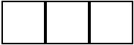Capture 1

-ToogleColors button: A button that changes the color of all boxes depending on their actual color.

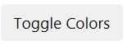Capture 2

-Toogle Rounded Borders button: A button that changes the border of all boxes depending on their actual border.

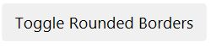Capture 3

-Add a new box button: A button that adds a new box to the boxes that we already have.

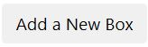Capture 4

Part 1: Testing the correct functionality.

1.Click Toggle Colors.

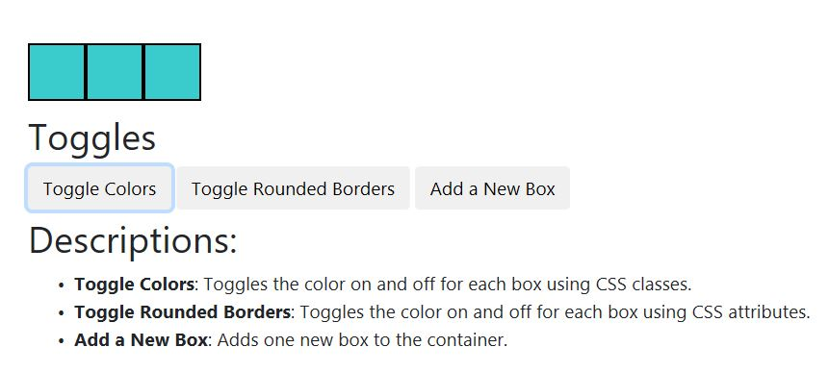Capture 5

2.Click add new box 3 times.

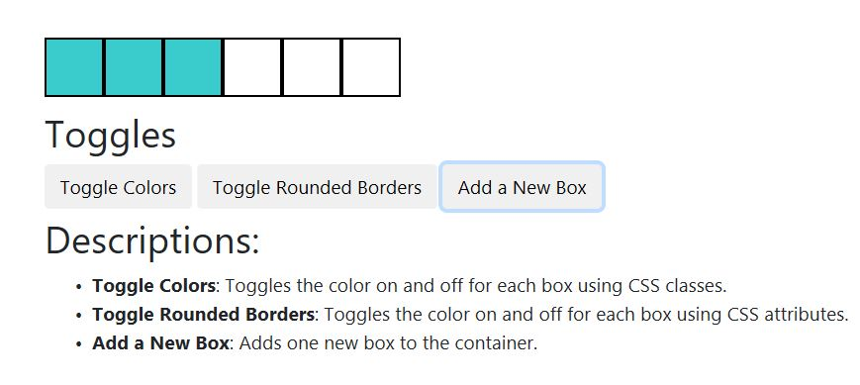Capture 6

3.Click Toggle colors.

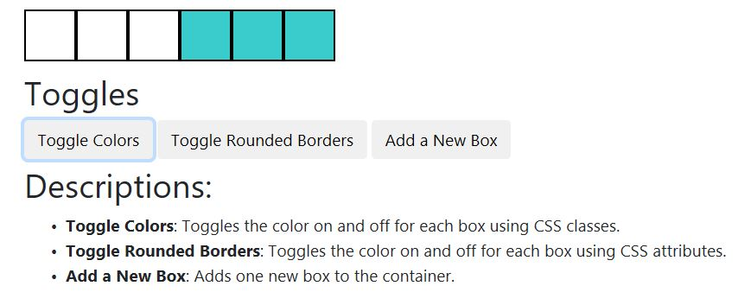Capture 7

4.Click Add a New Box three times.

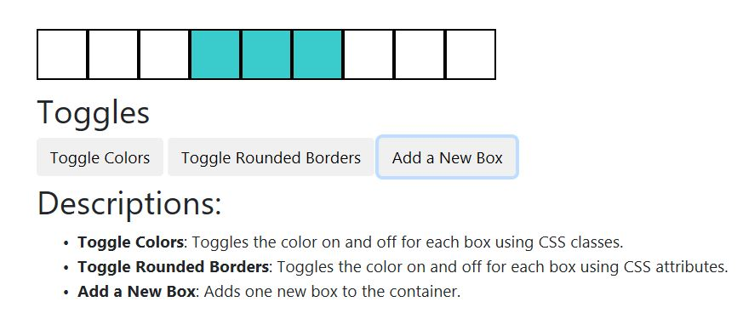Capture 8

5.Click Toggle Rounded Borders.

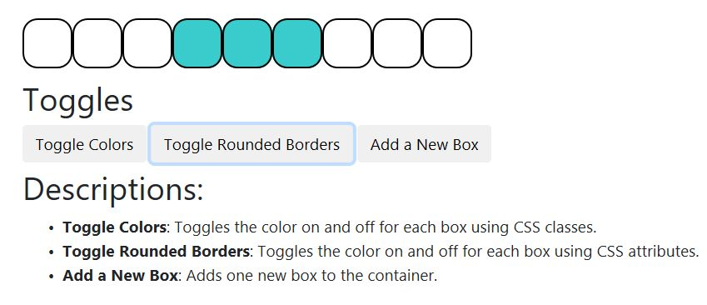Capture 9

Part 2 technical considerations:

Code implementation:
We have 4 methods in our javascript file:

-addBox: Adds a box to the boxes that we already have. It incluides all the classes and colors that the boxes have by default.
Capture 10

-ClassAndColorBoxes: It adds a class and color to the first three boxes that are in the html file.

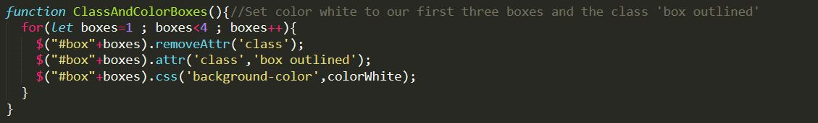Capture 11
-colorBox: It changes the color of all boxes, it colors the box with blue if it’s white and white if it’s blue.
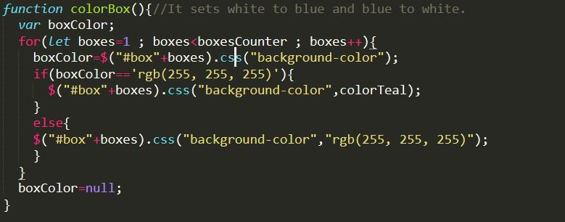Capture 12

-roundBorders: It changes the border of all boxes, it rounds the box if it’s not rounded and unround them if they’re rounded.
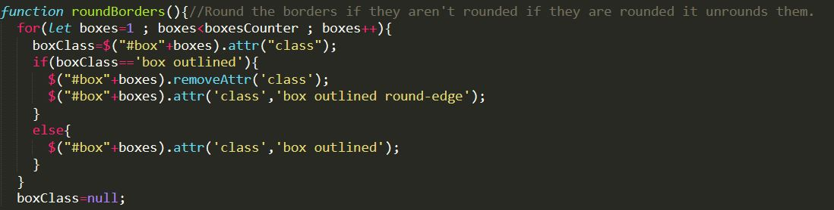Capture 13

