Civilized Region
The Civilized Region is the part of the world that human civilization has so far observed, explored and divided up. Through Resolution 4, the United Government (UG) divided the Civilized Region into seven continents.

Extent
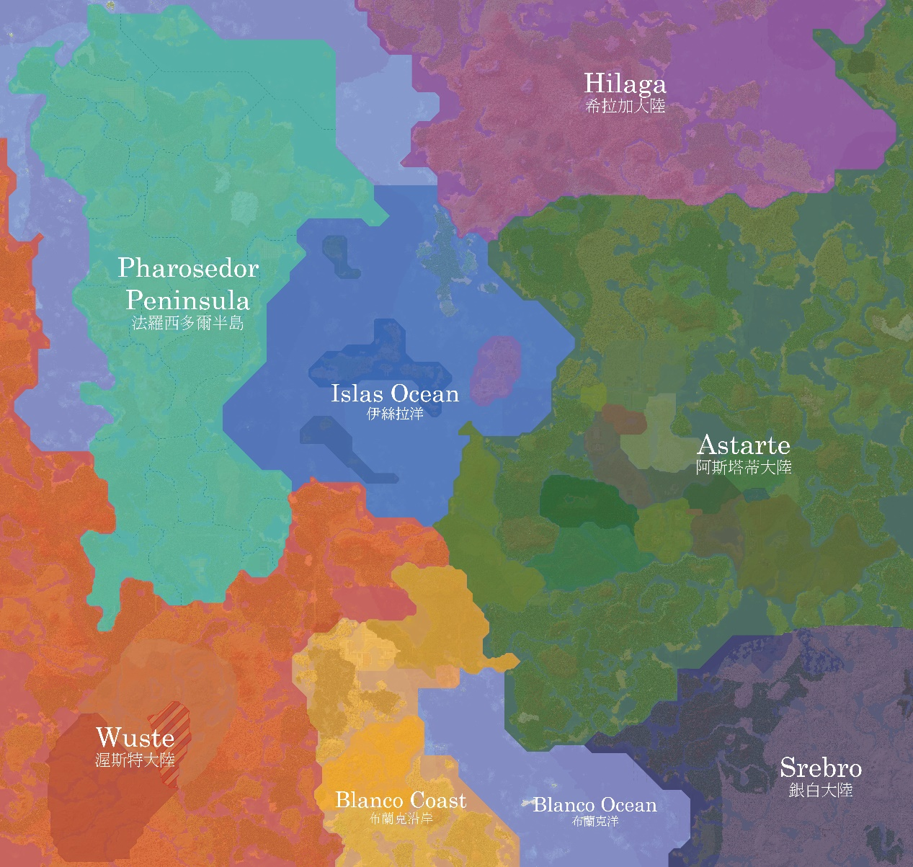
The seven continents of the Civilized Region
The boundary of the Civilized Region is based on world coordinates and spans [X: -5883 to 2015, Z: -4406 to 3035].

Significance
The United Government neither encourages nor recognizes any political entity formed outside the Civilized Region, so that the development of all countries stays concentrated and exchange between them is promoted.

Beyond the Civilized Region
Areas outside the Civilized Region in principle fall outside the United Government's jurisdiction and are all treated as unclaimed land, except where mediation between member states is involved.

See also
• United Government
• Unclaimed land
• No Man's Land
• Birthplace

References
• Continent

