Continent

Division into continents
A continent is a region defined by geographical conditions, culture and countries. The United Government (UG) currently divides the Civilized Region into seven continents.
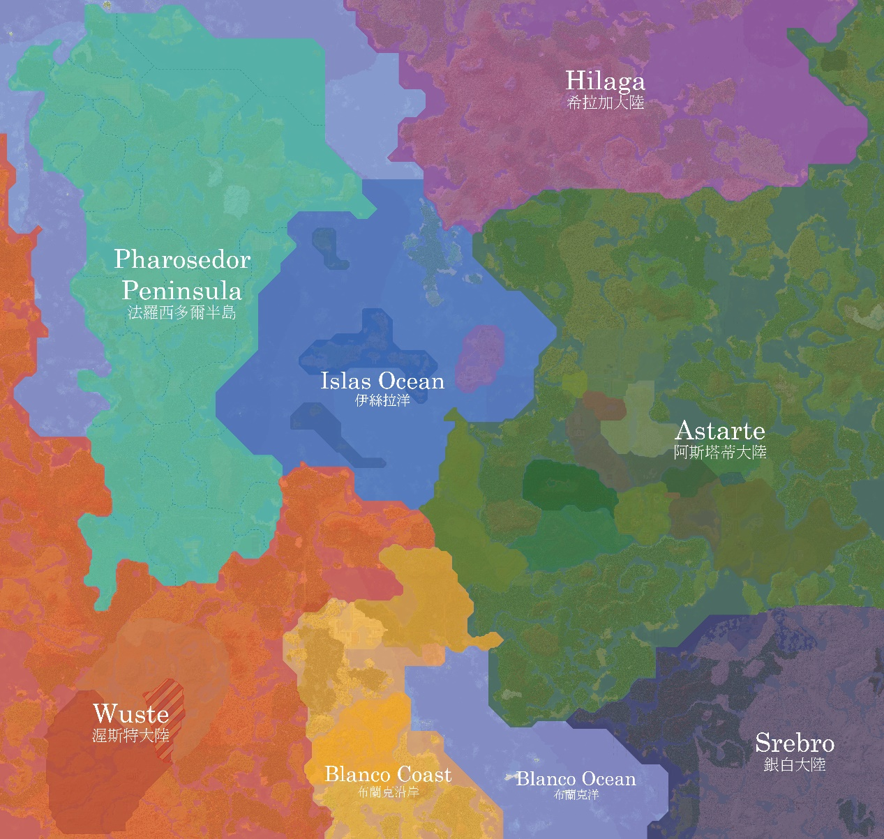
Purple: Hilaga
Cyan: Pharosedor Peninsula
Blue: Islas Ocean
Dark green: Astarte
Orange: Wuste
Yellow: Blanco Coast
Dark blue: Srebro

Hilaga
Hilaga currently has no organized towns, governments or countries. Only one village there has been observed by civilization, and there has been no contact with it.
The name Hilaga comes from the Filipino word for "north"; it was given by a Filipino explorer who discovered the land.
Very little is known about Hilaga.

Pharosedor Peninsula
The Pharosedor Peninsula coincides exactly with the territory of the Pharosedor Federation, making it the only continent in the world entirely controlled by a single country.
The Pharosedor Peninsula was once regarded as part of Wuste, but under United Government Resolution 4(B) it was separated as an independent continent to commemorate the unification of the Pharosedor Federation.

Islas Ocean
The Islas Ocean is currently the only continent in the world whose water area exceeds its land area, and the only one with no unclaimed land. It is divided among five countries: Nisia, the Federated States of Erimianesia, the Republic of Ten Thousand Times Town, the Republic of Oasinesia and North Island.
The five Islas Ocean countries have long discussed forming a federal government, but the chaotic situation on North Island and the great differences in culture and level of development between them have made the plan very difficult to carry out.

Astarte
Astarte is the largest continent in the Civilized Region. Member states kept joining the federation, and since Zoloto joined on Day 7584 the Federal Republic of Astarte has been the only country on the continent, although large areas of unclaimed land and No Man's Land remain.
Astarte is currently the continent with the largest area developed by human civilization, and it is also home to the Birthplace.

Wuste
Only two countries are currently located in Wuste: the State of Rayhagen and the State of Saturman. The Civilized Region's only coral reefs and deserts are also found here.
The Pharosedor Peninsula once belonged to Wuste, but was separated as a new continent after United Government Resolution 4(B).

Blanco Coast
The Blanco Coast is the region surrounding the Blanco Sea. When the United Government divided the world into geographical regions, merging it into Wuste was discussed, but it was classified as a separate region because of its culture, level of economic development and national territories. The countries currently on the Blanco Coast are the Republic of Canal, the Republic of Bruja, Alpino and the Republic of Apati.

Srebro
Srebro covers the polar region in the southeast of the Civilized Region and the surrounding areas. Luminous Town is the only town in the region.
Humans have set up many research institutions in Srebro that are not administered by any country, but because of its climate and geography, Srebro remains very little developed.
Srebro is also regarded as an important repository of human civilization: the Luminous Town World Library and the World Seed Vault are located here.

