Product specification

Quick Reference Date
 | Antenna module on the system board
Frequenc Range | 2400 ~ 2500GHz
Ant. Port Input Pwr. (dBm) | 0 (Typ. BT class 2 output power)
Peak EIRP(dBm) | -1.2
Directivity (dBi) | 1 (all direction antenna)
Input Impendence(ohm) | 50
Polarization Type | V ertical & Horizontal
V . S .W . R | < 3

All the technical data and information contained herein are subject to change without prior notice

Antenna Layout & module on the system board

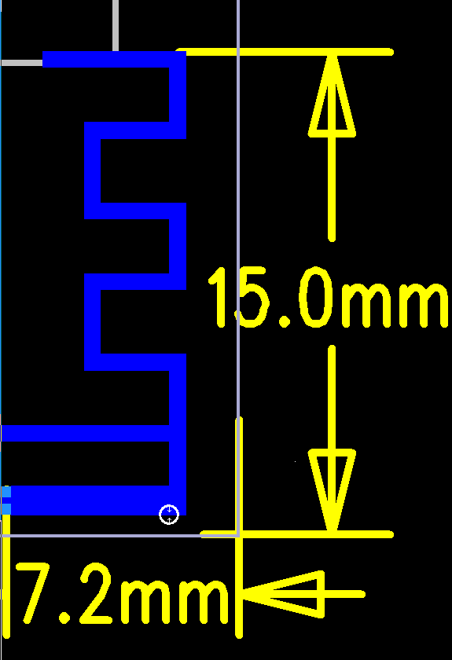

Antenna Gain

Freq(Mhz) | Max(dB) | Min(dB) | Gain(dBi) | Effi(%)
2402 | -0.24 | -16.8 | -0.24 | 31
2440 | 0.1 | -15.6 | 0.1 | 33
2480 | -0.41 | -19.7 | -0.41 | 29

ERP

Freq(Mhz) | TRP (dBm) | NHPRP±45/NHPIS±45 (dBm) | NHPRP±30/NHPIS±30 (dBm)
2402 | -4.439329833 | -5.472563248 | -6.58401478
2440 | -4.833811857 | -5.845939228 | -6.932441487
2480 | -1.277852118 | -2.230627413 | -3.625901541

Return Loss

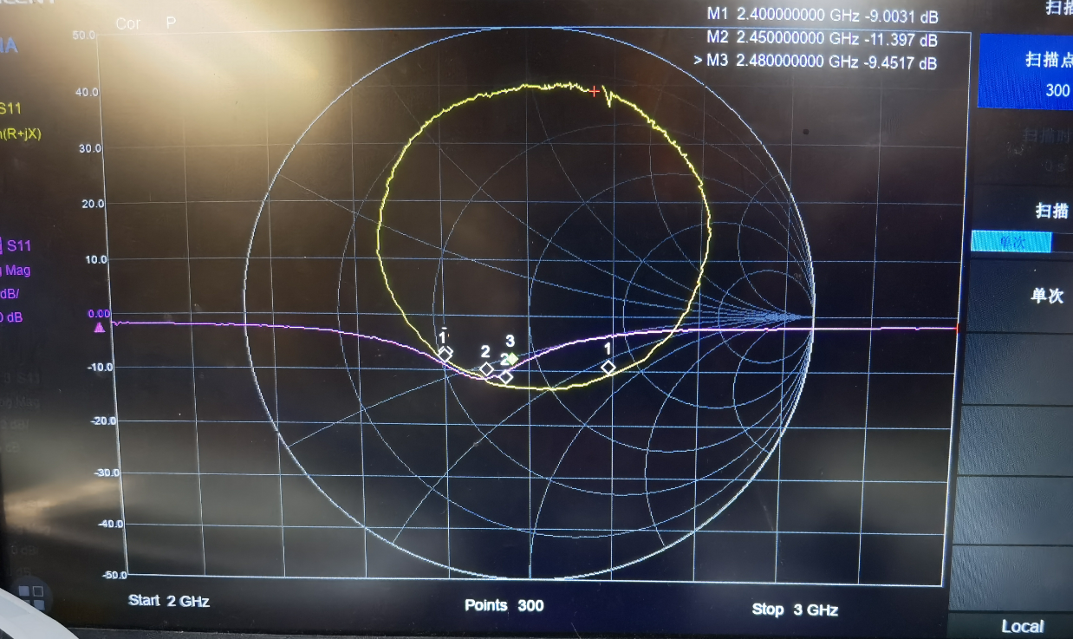

2D radiation pattern diagram

XY-plane XZ-plane YZ-plane
