Adaptive Threshold TMS Force Task (V7)
Updated detailed technical report: experiment flow, adaptive algorithms, GUI, QC, feedback, outputs, and plotting
Source reviewed: AdaptiveTh_TMS_task_ADPTPD_V7.py (final task code supplied by user)
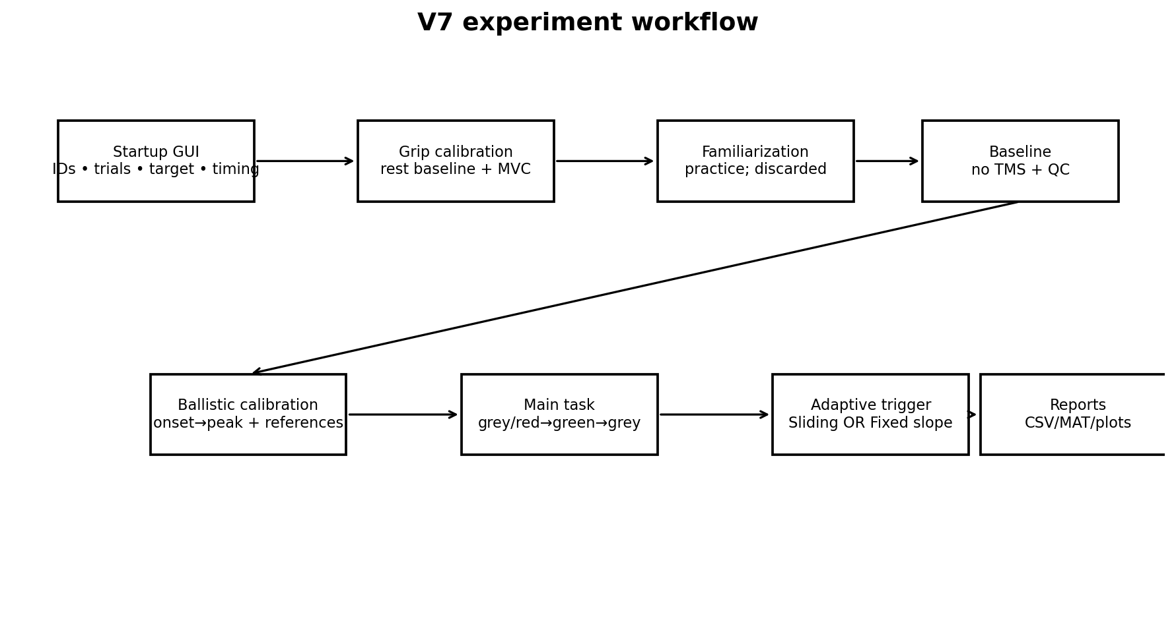
Figure 1. V7 workflow, including baseline QC and the two selectable RFD triggering algorithms.

1. Executive summary
V7 is a single-handle right-hand ballistic force-production task that normalizes grip input to a participant-specific MVC scale and makes at most one adaptive stimulation decision per Main Task trial. All adaptive force-development measurements are anchored to detected force onset rather than the visual GO cue. The operator can choose RFD-only, force-only, or combined decision logic; BELOW or ABOVE direction; and either the legacy sliding-checkpoint RFD algorithm or the newer adaptive Fixed Early Slope algorithm.
The major V7 change is that baseline timing is now calibrated to a ballistic onset-to-peak endpoint rather than requiring a sustained force plateau. For Fixed Early Slope, the fit endpoint is a selectable fraction (1/4, 2/4, or 3/4) of the predicted onset-to-peak latency. The stimulation decision is evaluated after that fit is complete, and the intended TMS time is the adaptive fit endpoint plus an operator-configurable delay (default 5 ms). During the Main Task, predicted peak latency and therefore the fixed fit window adapt from the most recent valid trials.
V7 also adds a compact wide-screen startup interface, editable familiarization/baseline/task trial counts, editable target force level and tolerance, baseline QC with automatic report saving or interactive trial rejection, optional participant performance feedback, and algorithm-aware plotting so Fixed-mode triggers are represented at their actual onset-relative stimulation times rather than being forced onto the sliding checkpoint grid.

2. System architecture and timing
Force acquisition is nominally 500 Hz and display drawing is gated to 64 frames/s. Pygame reads the right-hand input and renders the participant display. Samples are stored in a thread-safe shared force buffer. A background RFDMonitor detects onset and performs real-time adaptive decisions without directly reading the joystick. DAQ stimulation output is serialized with a lock; if nidaqmx is unavailable, the program can run in simulation/debug mode.
Component | V7 default / behavior
Sampling | 500 Hz force acquisition
Display | 64 FPS
Smoothing | 3 samples (~6 ms at 500 Hz)
Onset | ≥0.05 MVC for 5 consecutive samples
Onset search | 0.850 s after GO
Post-onset retained window | 2.0 s
Adaptive history | previous 3 valid trials/references

3. Startup GUI and operator-configurable parameters
The V7 startup GUI is arranged in two broad columns so controls use screen width instead of stacking vertically. Numeric fields occupy the left side and mode controls/actions occupy the right side. This is intended for a wide but relatively short secondary monitor.
GUI control | Meaning / allowed behavior
Familiar trials | Editable integer, minimum 1
Baseline trials | Editable integer, minimum 1
Task trials | Editable integer, minimum 1
Target level (MVC) | Editable; clipped to 0.05–0.95
Half-height (MVC) | Target tolerance; clipped to 0.01–0.40
Fixed slope end (ms) | Editable fallback/pre-baseline value; 10–200 ms; baseline can overwrite it
TMS delay after fit (ms) | Editable 0–100 ms; default 5 ms
RFD algorithm | Sliding RFD or Fixed Early Slope
Fixed timing fraction | FIT_1Q, FIT_2Q, or FIT_3Q
Direction | Trigger BELOW or ABOVE
Stimulation metric | RFD only, Force only, or Combined
Cue | Red cue ON or grey-to-green
Feedback | On/off plus selectable metric
Baseline review | QC auto-save or QC interactive
Loadbar | Main-task loadbar on/off
Implementation note: the timing-fraction button text in the supplied V7 source still contains the literal text “TMS +5ms”, while the actual delay is independently configurable through the TMS delay field. The real trigger calculation uses the configured delay, not the hard-coded label text.

4. Calibration and normalized force
Calibration measures the actual resting raw-axis baseline. Force is based on absolute displacement away from that measured baseline, applies a raw-axis deadzone, divides by the calibrated maximum deflection times CALIBRATION_SCALE_FACTOR, and clips the stored normalized force to [0, 1]. The default calibration scale factor is 1.00.

5. Target display and cue-state behavior
The target is defined in physiological force units. TARGET_FORCE_LEVEL controls its vertical center and TARGET_TOLERANCE controls its half-height; create_target_rect converts twice the tolerance into pixel height. The target is horizontally centered within the task area; when participant feedback is enabled, approximately 70% of screen width is reserved for the task and the right side is reserved for the feedback panel.
During normal trial states the target remains visible: PREP displays red when the red cue is enabled and neutral grey otherwise; GO displays green; after the visible GO interval and during ITI it is neutral grey. Thus disabling the red cue produces a grey-to-green transition rather than making the target disappear. The separate BREAK screen is a full break/countdown state rather than a normal trial pause.

6. Movement onset detection
The smoothed force signal is searched for the first point at which force reaches at least 0.05 MVC and remains at or above that level for 5 consecutive samples. This onset becomes t = 0 for adaptive RFD, force-reference, ballistic peak, trigger-latency, and post-hoc onset-aligned measurements. A trial cannot make an adaptive decision if a valid onset is not found within 0.850 s after GO.

7. Ballistic onset-to-peak calibration
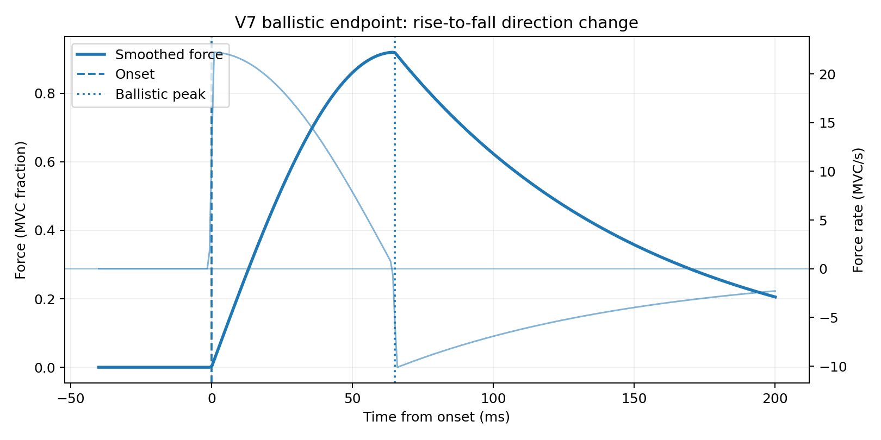
Figure 2. Conceptual V7 ballistic peak detection. The endpoint is based on the rising-to-falling direction change, not a sustained plateau.
The function calculate_time_to_force_plateau retains its historical name, but its V7 behavior is ballistic peak detection. After onset, the code searches up to 350 ms (or the retained post-onset limit if shorter). Trials must reach at least 0.15 MVC. It computes the gradient of smoothed force, smooths that rate again, and searches for the first robust local maximum where force is at least 60% of the global peak in the search window, the mean rate immediately before the candidate is positive, and the mean rate over the confirmation interval after the candidate is non-positive. The direction confirmation interval is 8 ms. If no such direction change is found, the global maximum within the ballistic search window is used as a fallback.
The older sustained-plateau calculation (95% of peak held for 50 ms) remains in the source only as a legacy QC/reporting helper; it is no longer the endpoint used to individualize the ballistic timing calibration.

8. Baseline phase and quality control
Baseline runs without stimulation. Each trial stores its force trace and ballistic onset-to-peak latency. A baseline trial is initially considered valid for QC when both a ballistic peak latency and a fixed early-slope value are finite. At least max(3, ceil(number of baseline trials / 2)) included trials must contain a valid ballistic peak for baseline calibration to succeed.
AUTO_SAVE mode automatically includes the initially valid trials and writes a Baseline_QC report folder. INTERACTIVE mode presents one trial at a time, with fixed y-axis limits of 0–1 MVC for direct visual comparison. The operator can move between trials, toggle INCLUDE/REJECT, and finalize the selection. The final selected set is then used to compute baseline metrics and Main Task seeds.
Baseline QC output | Contents
baseline_trial_XX.png | Smoothed onset-aligned force, onset, ballistic peak, fixed-slope endpoint, include/reject status
baseline_trial_qc.csv | Trial number, inclusion, onset, peak force, peak latency, fixed slope, validity
baseline_summary.csv | Included count, mean/SD peak force, mean/SD onset-to-peak latency, mean/SD fixed slope, final fixed window

9. Sliding-checkpoint RFD algorithm
SLIDING_CHECKPOINTS retains the local-RFD approach. A straight line is fitted over the most recent 20 ms of smoothed force at each onset-relative checkpoint. Checks begin at 20 ms and advance in 6-ms steps. Baseline also individualizes the final checking endpoint, which remains capped at 180 ms. RFD and force references are checkpoint-specific rolling means based on previous completed profiles, initially seeded from baseline.
For BELOW, RFD must fall below 90% of its adaptive reference; ABOVE requires RFD above 110%. Force uses the same 10% relative separation. In BELOW mode, the force condition additionally requires force below FORCE_TRIGGER_CEILING = target level − target tolerance. RFD_ONLY uses only the RFD criterion, FORCE_ONLY uses only force, and COMBINED requires both at the same decision point.

10. Adaptive Fixed Early Slope algorithm
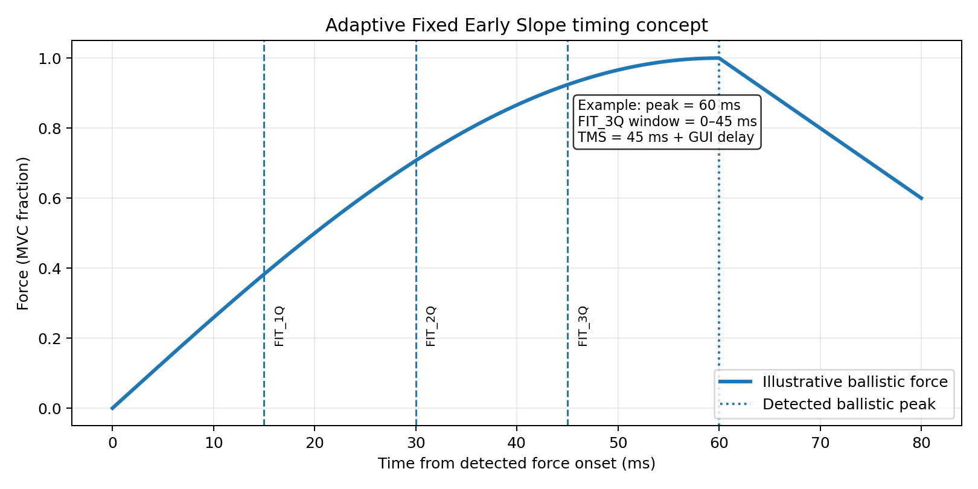
Figure 3. Fixed Early Slope uses an adaptive onset-anchored regression window and schedules TMS shortly after the fit endpoint.
FIXED_EARLY_SLOPE makes exactly one adaptive decision per trial. It fits one regression from force onset to an adaptive endpoint. The endpoint is predicted onset-to-peak latency multiplied by the selected timing fraction: 0.25 for FIT_1Q, 0.50 for FIT_2Q, or 0.75 for FIT_3Q. The fit window is clipped to 10–300 ms. The intended stimulation latency is fit endpoint + FIXED_TRIGGER_DELAY_S, where the delay is editable from the GUI and defaults to 5 ms.
Baseline sets the initial fixed window from the mean included onset-to-peak latency. Example: with a 60-ms mean peak latency, FIT_2Q produces a 0–30 ms fit; with a 5-ms delay, the intended TMS time is approximately 35 ms after onset. FIT_3Q produces 0–45 ms and approximately 50 ms stimulation timing with the same delay.
During the Main Task, predicted peak latency is the mean of the most recent valid onset-to-peak latencies, limited to the most recent three by SLOPE_REFERENCE_TRIALS. The slope threshold is then recomputed from the most recent three valid reference trials using exactly the same newly selected adaptive window. The force reference for FORCE_ONLY or COMBINED is likewise recomputed at that same fit endpoint. This means both the window duration and the reference values can adapt from trial to trial.
At run time the monitor waits until fit endpoint + configured delay. It then computes the slope over the earlier frozen onset-to-fit interval, evaluates the selected BELOW/ABOVE and RFD/force/combined rule, and either sends the one stimulation trigger or ends the Fixed decision with a criterion-not-met reason. The Fixed algorithm does not continue through the sliding checkpoint loop.

11. Participant performance feedback
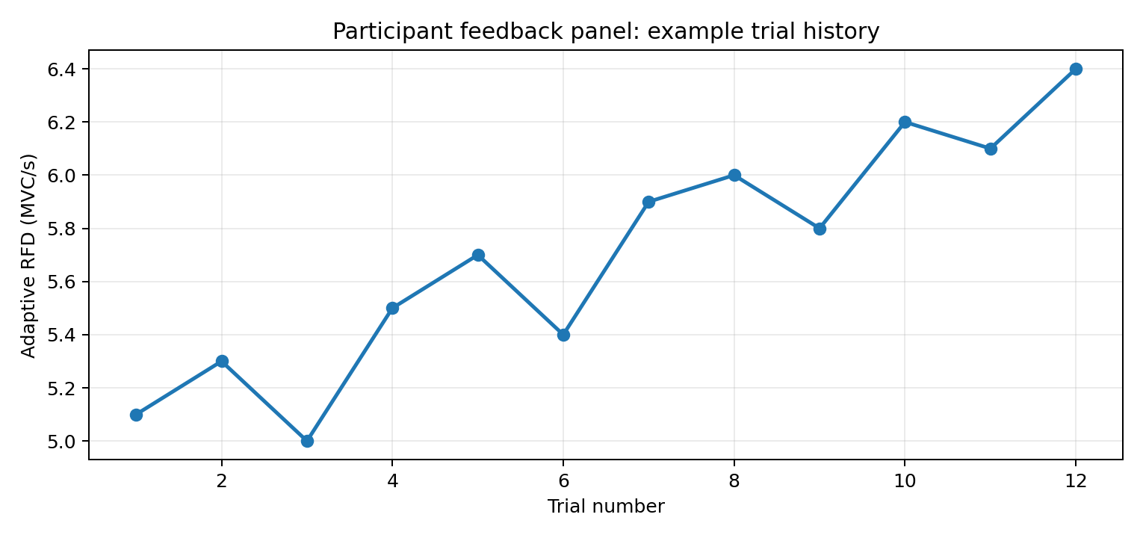
Figure 4. Example of the optional right-side trial-history feedback panel with explicit axis units.
When enabled, a right-side panel plots up to the most recent 30 trials. The x-axis is Trial number and the y-axis explicitly names the selected metric and unit. The panel reports the latest value and whether it improved or worsened relative to the previous finite value. Lower values are treated as better for reaction time and target error; higher values are treated as better for the other metrics.
Feedback metric | V7 value plotted
PEAK_FORCE | right_peak_force; MVC
ADAPTIVE_RFD | actual onset-to-adaptive-window fixed early slope; MVC/s; latest window shown in ms
RFD_80MS | legacy/reporting onset-to-80-ms RFD; MVC/s
REACTION_TIME | right reaction time; displayed in ms
TARGET_ERROR | mean absolute target error; MVC

12. Main-task adaptive updating
Before each Main Task trial, sliding checkpoint thresholds and force references are calculated from their rolling histories. Independently, the Fixed-mode timing is recalculated from recent peak-latency history, and Fixed slope/force references are recomputed from recent raw reference trials over that exact current window. After each trial, the new trial contributes to the histories used for subsequent trials. This is why the Fixed window does not remain permanently equal to the baseline value.

13. Reporting, figures, and trigger-marker corrections
V7 session plots are algorithm-aware. Fixed Early Slope per-trial figures represent the fitted onset-anchored regression and its fixed-slope reference rather than drawing a misleading sliding-RFD threshold. Heatmap stimulation stars use the actual recorded right_trigger_from_onset_s when available and interpolate that physical latency onto the heatmap x-coordinate, so a trigger at 35 ms can appear between neighboring checkpoint columns instead of disappearing because it is not exactly on the 6-ms grid.
The Trigger Map likewise uses actual onset-relative TMS latency. Threshold Evolution uses a rolling fixed-slope reference and its BELOW/ABOVE decision boundary for all-Fixed sessions, while sliding sessions retain checkpoint-specific threshold curves. The normalized RFD + Force overview uses the fixed early slope/reference for Fixed trials and checkpoint metrics for Sliding trials, and it no longer silently omits a confirmed trigger merely because a legacy normalized series is unavailable.

14. Saved trial-level fields relevant to V7
- Algorithm metadata: stimulation metric mode, RFD trigger algorithm, fixed timing mode.
- Fixed timing: fixed slope window, configurable trigger delay, planned trigger target.
- Trigger result: triggered flag, trigger checkpoint/key, actual trigger latency from onset and GO, trigger RFD/slope, threshold, force and force reference, decision reason.
- Adaptive/post-hoc metrics: checkpoint RFD/force profiles, fixed early slope, reaction time, peak force, target error, onset-to-peak latency and other trial metrics.
- Session metadata include participant-feedback settings, baseline-review mode, target settings, requested/completed trial counts, and baseline configuration.

15. Core parameter summary
Parameter | V7 default
Sampling rate | 500 Hz
Display rate | 64 FPS
Smoothing | 3 samples
Onset threshold | 0.05 MVC
Onset confirmation | 5 samples
Ballistic peak search | 350 ms
Direction confirmation | 8 ms
Minimum ballistic peak | 0.15 MVC
Reference history | 3 trials
Sliding RFD window | 20 ms
Sliding checkpoint step | 6 ms
RFD margin | 10%
Force margin | 10%
Fixed timing fraction | FIT_3Q default
Fixed trigger delay | 5 ms default; GUI configurable
Feedback history | 30 trials
Target | 0.85 MVC ±0.10 default
Familiarization / baseline / task | 5 / 10 / 15 defaults; all GUI editable

16. Interpretation and implementation cautions
- “Time-to-plateau” variable/function names persist in places for backward compatibility, but the active baseline endpoint is ballistic onset-to-peak latency.
- Fixed Early Slope compares slopes fitted over the same current adaptive window across the current and reference trials; it is not a sliding local-RFD threshold.
- The stimulation delay is relative to the adaptive fit endpoint, not to the next quarter boundary.
- Actual trigger latency should be used when interpreting stimulation timing; checkpoint labels are primarily a Sliding-algorithm concept.
- Interactive baseline rejection changes the trials used to compute the final baseline calibration and reference seeds.

