Adaptive Thresholding TMS Task V7
Core Metrics and Logic Report
Source reviewed: AdaptiveTh_TMS_task_ADPTPD_V7.py (final task code supplied by user)

1. Executive summary
V7 records right-handle force at 500 Hz and anchors adaptive measurements to detected force onset. It supports two RFD triggering algorithms. Sliding RFD repeatedly evaluates a 20-ms local slope at 6-ms-spaced checkpoints. Fixed Early Slope makes one decision using an onset-anchored regression whose duration adapts to the participant’s recent ballistic onset-to-peak latency. Stimulation can use RFD only, force only, or both, and can target BELOW or ABOVE recent performance.
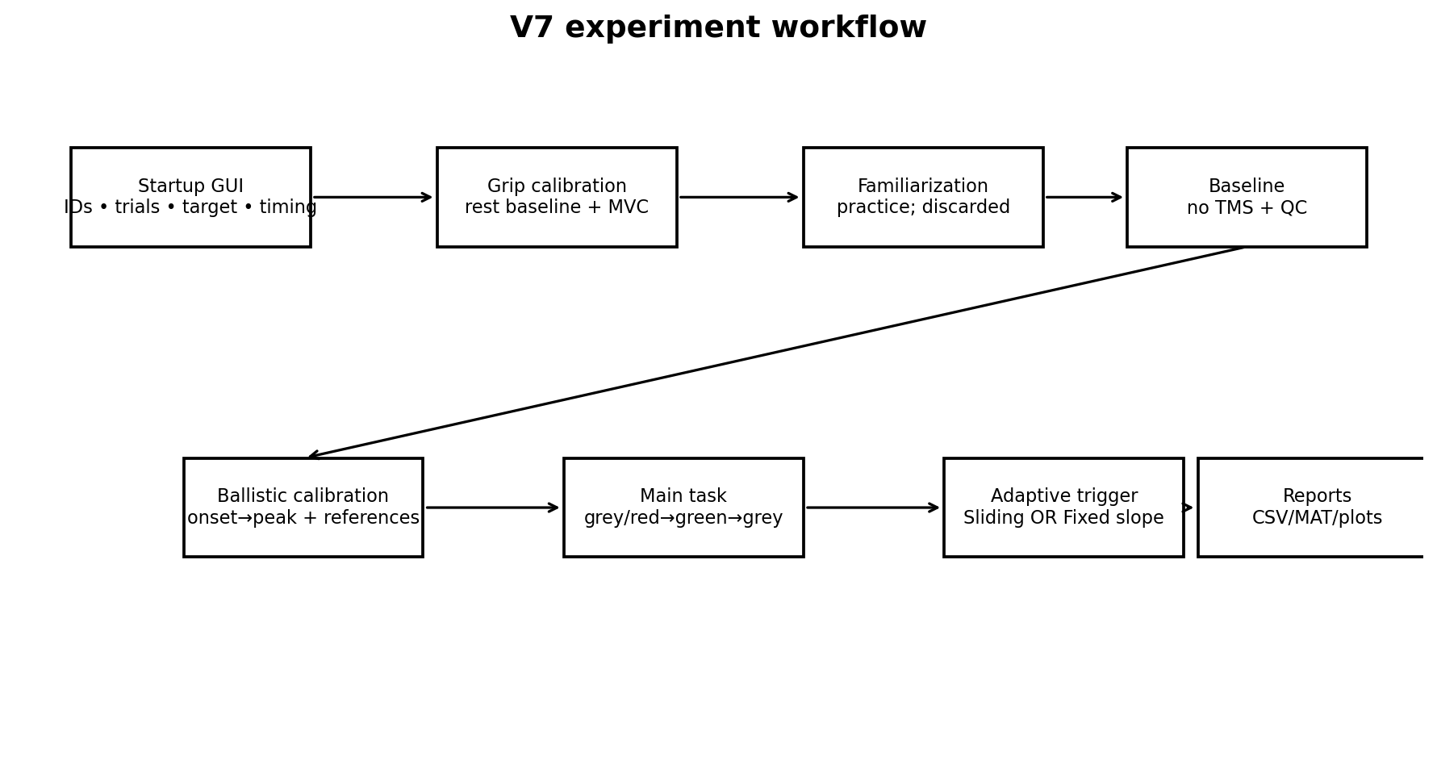
Figure 1. V7 task flow.

2. Core parameters
Parameter | V7 default / role
Sampling | 500 Hz
Smoothing | 3 samples (~6 ms)
Onset | 0.05 MVC sustained for 5 samples
Onset search | 0.850 s after GO
Reference history | previous 3 trials
Sliding local RFD | 20-ms regression
Sliding checkpoints | 20 ms onward, every 6 ms; baseline-individualized end ≤180 ms
Margins | 10% RFD; 10% force
Ballistic peak search | ≤350 ms after onset
Fixed timing | 1/4, 2/4, or 3/4 of predicted onset→peak
Post-fit TMS delay | 5 ms default; GUI configurable 0–100 ms
Target | 0.85 MVC ±0.10 default; GUI editable
Trial counts | 5 familiarization / 10 baseline / 15 task defaults; GUI editable

3. Baseline: ballistic peak, not sustained plateau
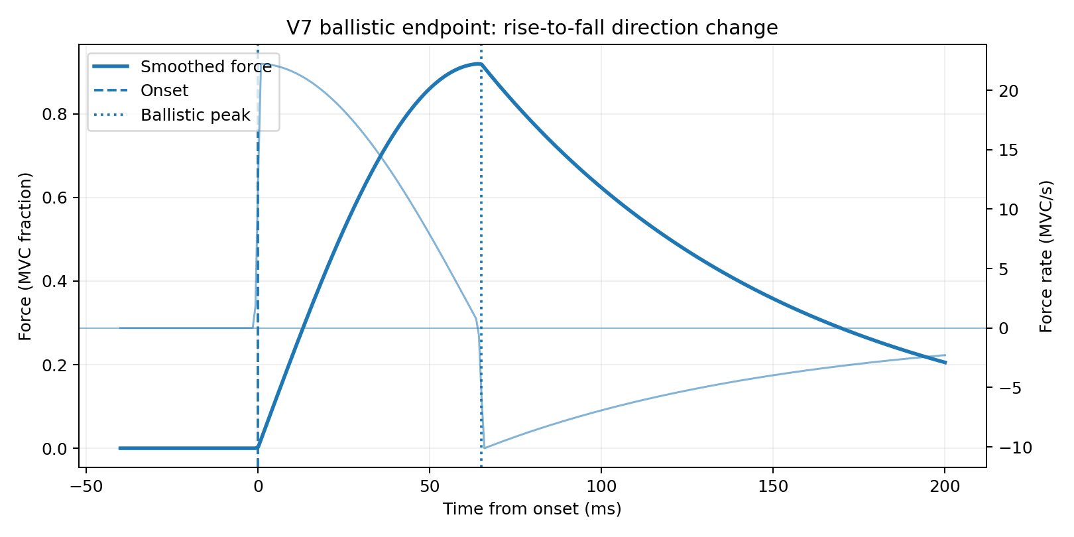
Figure 2. Ballistic peak is detected from the rise-to-fall change in force rate.
After force onset, V7 searches for a ballistic local maximum. The candidate must occur after force has reached at least 60% of the search-window peak, with positive mean force rate immediately before it and non-positive mean rate afterward for an 8-ms confirmation interval. If no robust direction change is found, the global maximum within the 350-ms search window is used. The old 95%-of-peak-for-50-ms plateau method remains only as a legacy QC helper.

4. Baseline QC and adaptive initialization
Baseline can run in AUTO_SAVE or INTERACTIVE review mode. Auto-save writes trial plots and CSV metrics and keeps initially valid trials. Interactive review shows every trial with force y-axis fixed to 0–1 MVC and lets the operator include or reject trials before final calibration. At least max(3, ceil(baseline trials/2)) included trials need a valid ballistic peak.
The mean included onset-to-peak latency initializes the Fixed Early Slope window using the selected fraction. Baseline also computes sliding checkpoint RFD/force profiles and fixed slope/force references used to seed the Main Task.

5. Two RFD algorithms
Algorithm | How the decision metric is formed | When it can trigger
Sliding RFD | 20-ms local regression ending at each checkpoint | First eligible checkpoint satisfying the rule
Fixed Early Slope | One regression from onset to adaptive fractional peak-latency endpoint | Fit endpoint + configurable delay; exactly one decision point
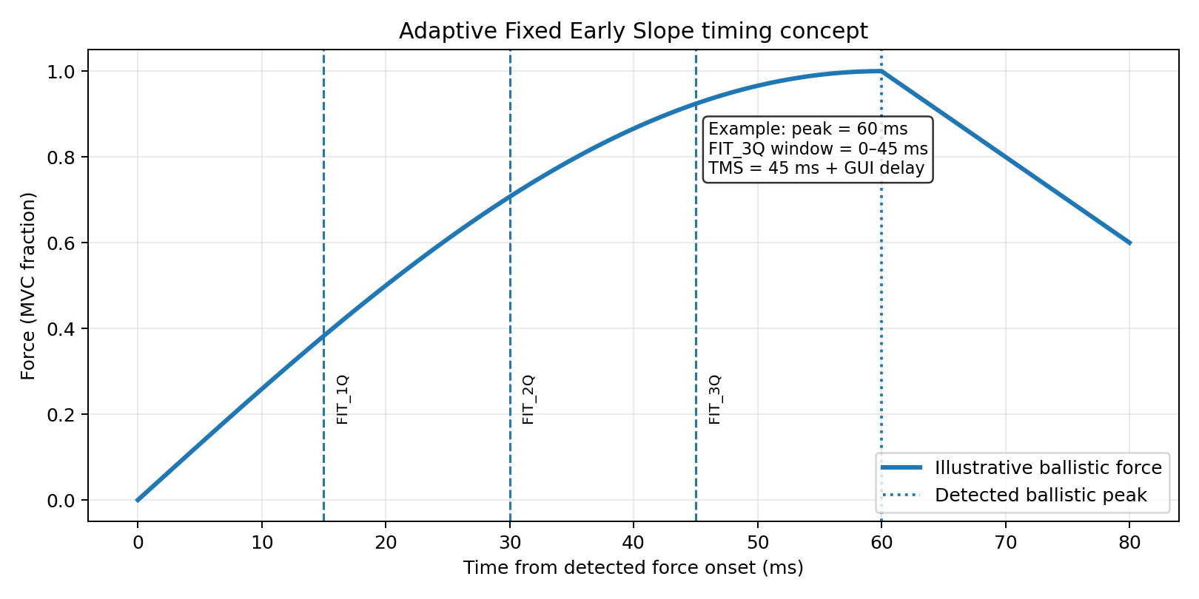
Figure 3. Fixed timing example. With a 60-ms predicted peak, FIT_2Q ends at 30 ms and a 5-ms delay targets ~35 ms.
For Fixed mode, predicted onset-to-peak latency is updated from the most recent valid trials (up to 3). The current fit duration is predicted peak × 0.25, 0.50, or 0.75. Reference slopes from previous trials are recomputed over that same current window, so the comparison is like-for-like even when the window adapts.

6. Trigger rules
Direction | RFD criterion | Force criterion
BELOW | current < 0.90 × adaptive reference | current < 0.90 × force reference and below target lower bound/ceiling
ABOVE | current > 1.10 × adaptive reference | current > 1.10 × force reference
RFD_ONLY uses the RFD criterion, FORCE_ONLY uses the force criterion, and COMBINED requires both. In Fixed mode, force is evaluated at the adaptive slope-fit endpoint; in Sliding mode, force and local RFD are evaluated at the same checkpoint.

7. Target and participant feedback
The target remains present through normal trial states: neutral grey during non-GO periods, red during PREP when the red cue is enabled, and green during GO. Target vertical position and height are controlled by GUI-editable target level and tolerance. When participant feedback is enabled, the task uses the left ~70% of the display and a right-side panel shows trial-by-trial performance.
Feedback option | Plotted quantity / unit
Peak force | MVC
Adaptive RFD | actual Fixed Early Slope for that trial, MVC/s
RFD 0–80 ms | reporting RFD, MVC/s
Reaction time | ms
Target error | MVC

8. Plotting and saved timing
V7 plotting distinguishes Fixed from Sliding logic. Fixed-mode per-trial figures show the onset-anchored linear fit/reference instead of a sliding threshold. Heatmaps and the Trigger Map use actual onset-relative stimulation latency, so triggers between the 6-ms checkpoint columns are still shown. Fixed threshold-evolution and normalized overview plots use fixed-slope quantities rather than legacy checkpoint values.

9. Compact V7 processing pipeline
1. Acquire and normalize right-hand force; smooth with 3 samples.
2. After GO, detect force onset at ≥0.05 MVC sustained for 5 samples.
3. Baseline: detect ballistic onset-to-peak latency and optionally review/reject trials.
4. Initialize sliding profiles and the selected fractional Fixed slope window from baseline.
5. Before each Main Task trial, update rolling references; in Fixed mode also update predicted peak latency and fit duration.
6. Evaluate Sliding checkpoints or the one Fixed decision point using BELOW/ABOVE and RFD/force/combined logic.
7. If eligible, send one trigger and store actual trigger latency from onset.
8. Update histories after the trial, display optional performance feedback, and save CSV/MAT/algorithm-aware figures.

10. Key interpretation
The central V7 idea is to compare each ballistic contraction with recent behavior at a physiologically matched early-ramp time. Sliding mode asks this repeatedly across onset-relative checkpoints. Fixed mode instead predicts the participant’s current rise duration, fits a single comparable early-ramp slope, and makes one decision shortly after that fit endpoint. The adaptive window, reference slope, and intended stimulation time can therefore evolve across trials while remaining anchored to force onset.

