Adaptive Threshold TMS Force Task (V6)
Detailed technical report: experiment flow, signal processing, adaptive thresholds, trigger logic, configuration parameters, outputs, and implementation notes
Source reviewed: AdaptiveTh_TMS_task_ADPTPD_V6.py (5,135 lines)
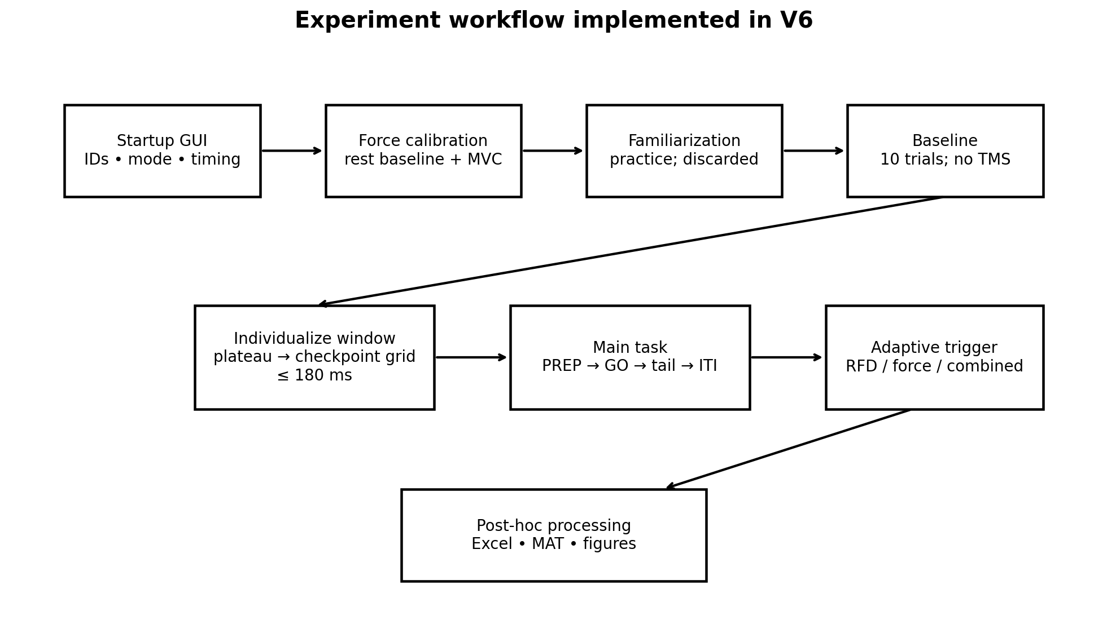

1. Executive summary
This program implements a single-handle, right-hand force-production task designed to make a real-time stimulation decision from the participant’s force trajectory. The task first calibrates the physical input device to a participant-normalized force scale, optionally provides familiarization, then runs a baseline phase without stimulation. Baseline trials are used to estimate both a participant-specific early-force checking window and checkpoint-specific reference profiles. The main task then compares each new contraction with adaptive references derived from the most recent completed trials. Depending on the operator-selected task version, stimulation can be decided from local rate of force development (RFD), checkpoint force, or the conjunction of both. The direction can be BELOW (identify unusually low early force development) or ABOVE (identify unusually high early force development).
A key architectural feature is that all adaptive measurements are anchored to detected force onset rather than the visual GO cue. This separates the force-development measurement from reaction-time variability. The main acquisition loop samples force nominally at 500 Hz, while display drawing is separately gated to 64 frames/s. A background RFDMonitor thread reads the shared force buffer, detects onset, evaluates elapsed checkpoints, and sends at most one stimulation trigger per trial.
The current executable logic uses a 20-ms local RFD regression window, a 6-ms checkpoint spacing, a 10% relative RFD trigger margin, a 10% force-reference margin, and a baseline-individualized final checkpoint capped at 180 ms after force onset. With the default target of 0.85 MVC and tolerance of ±0.10 MVC, the target region is 0.75–0.95 MVC; in BELOW mode, force-based triggering is additionally suppressed at or above 0.75 MVC.

2. System architecture and data flow
The program separates acquisition, display, adaptive monitoring, post-hoc analysis, and export. Pygame handles the joystick and participant display. Force samples are normalized and appended to a thread-safe ForceBuffer. The main thread is the only component that reads the joystick, which avoids concurrent Pygame input access. The RFDMonitor thread only reads snapshots of the recent buffer and performs adaptive calculations. DAQ output is protected by a lock so cue and stimulation trigger writes cannot collide.


3. Participant and operator workflow

3.1 Startup interface
The startup GUI allows the operator to edit Subject, Session, and Block identifiers; choose RFD_ONLY, FORCE_ONLY, or COMBINED stimulation logic; choose BELOW or ABOVE trigger direction; toggle the red preparatory cue; edit base cue/GO/ITI durations and their jitters; toggle the main-task loadbar; and launch calibration, familiarization, baseline, or the main task. Calibration and baseline are retained when a block finishes and the GUI reopens. Changing Subject or Session invalidates the retained calibration/baseline relationship; changing Block does not.

3.2 Force calibration
Calibration first estimates the actual resting raw-axis baseline rather than assuming the device rests at zero. Contraction magnitude is computed as the absolute displacement away from that measured baseline, a raw-unit deadzone is removed, and the remaining deflection is scaled by the measured maximum deflection. This produces a participant-normalized force from 0.0 to 1.0 MVC fraction.

3.3 Familiarization
Familiarization uses the task display and force acquisition but does not permit adaptive thresholds or DAQ/TMS triggering. Its data are discarded at the end of the phase.

3.4 Baseline calibration
Baseline also runs without stimulation. Each baseline trial is onset-aligned, and the code estimates the time from onset to a sustained near-maximum force plateau. Valid plateau times are averaged, snapped to the checkpoint grid, and capped by MAX_RFD_CHECK_END_S. Baseline also creates the initial checkpoint-by-checkpoint RFD reference and force reference used to seed the main task.

3.5 Main task
The main task runs PREP, GO, RECORD_TAIL, ITI, and periodic BREAK states. The adaptive monitor is armed at GO. When force onset is confirmed, it evaluates each elapsed checkpoint in order and can trigger on the first checkpoint that satisfies the selected rule. Force recording continues after the adaptive window for post-hoc analysis, but no new adaptive/TMS decision is allowed in the recording tail.

4. Force calibration and normalization
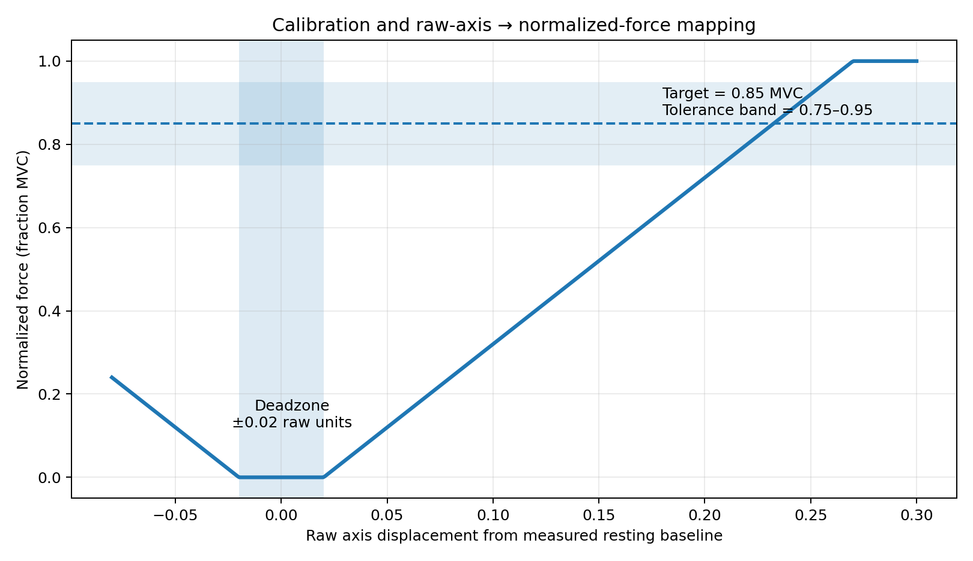
The raw-to-force mapping is implemented in two stages. First, raw_to_deflection computes |raw − baseline|. If that displacement is less than or equal to DEADZONE_RAW, it becomes zero; otherwise the deadzone is subtracted. Second, deflection_to_force divides the deflection by max_deflection × CALIBRATION_SCALE_FACTOR and clips the result to [0, 1]. Therefore, values above the calibrated maximum do not exceed 1.0 in the stored force signal.
With CALIBRATION_SCALE_FACTOR = 1.00, the measured maximum deflection maps to 1.00. Increasing this factor would make the same measured maximum appear below 1.00, creating headroom. MIN_VALID_CALIBRATION_DEFLECTION is used to reject calibrations in which the participant/device does not produce a meaningful displacement.

5. Target display and force feedback
The active target is expressed directly in force units rather than arbitrary screen position. TARGET_FORCE_LEVEL = 0.85 places the center at 85% of calibrated MVC. TARGET_TOLERANCE = 0.10 makes the accepted target region 0.75–0.95 MVC. The force cursor is vertically mapped to the same force scale, so cursor position and target geometry have a physiological interpretation. The right handle is always active in this single-handle version.

6. Force-onset detection
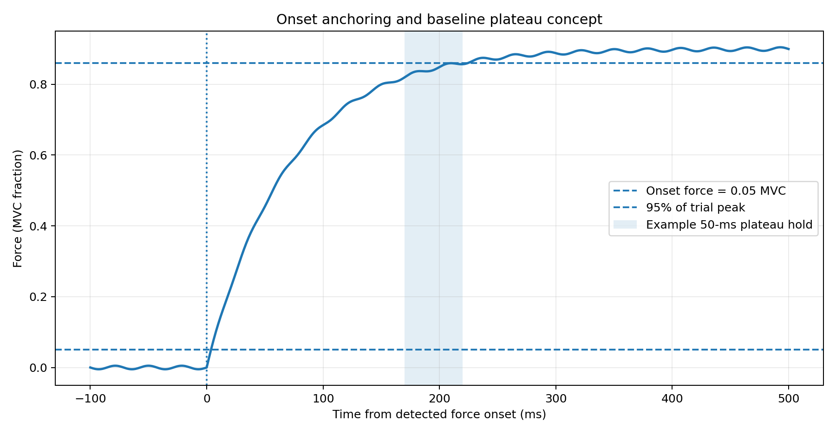
All real-time and post-hoc RFD checkpoints are aligned to force onset. The signal is first smoothed using a causal-safe moving average with SLOPE_SMOOTHING_SAMPLES = 3. The onset detector then searches for the first point at which smoothed force reaches RISING_ONSET_FORCE = 0.05 MVC and remains at or above that level for ONSET_CONFIRM_SAMPLES = 5 consecutive samples. At 500 Hz, five samples correspond to approximately 10 ms of confirmation. If no confirmed onset is found within ONSET_SEARCH_WINDOW_S = 0.850 s after GO, the adaptive monitor records the trial as having no detected onset.
The code explicitly guards against setting ONSET_CONFIRM_SAMPLES less than or equal to the smoothing-kernel width. This is important because a single spike can be spread across several samples by smoothing; requiring a longer confirmation sequence reduces the chance that such a spike becomes the anchor for every later metric.

7. Baseline-derived individualized RFD checking window
For each baseline trial, the program finds onset, searches the post-onset signal, determines the trial peak, and defines a plateau level as PLATEAU_FRACTION_OF_PEAK × peak force. With the default 0.95, the plateau threshold is 95% of that trial’s peak. The signal must remain at or above this level for PLATEAU_HOLD_S = 0.050 s. The first sample of that sustained run defines the trial’s onset-to-plateau time.
At least max(3, ceil(BASELINE_TRIALS/2)) baseline trials must yield valid plateau estimates. With the default 10 baseline trials, at least 5 valid plateau trials are required. The mean valid plateau time is converted into a checkpoint grid by rounding upward to the 6-ms checkpoint spacing. The main-task grid is then truncated so no checkpoint exceeds MAX_RFD_CHECK_END_S = 0.180 s. Because the grid starts at 20 ms and advances in 6-ms steps, the latest grid point not exceeding 180 ms is 176 ms.

8. Real-time local RFD calculation
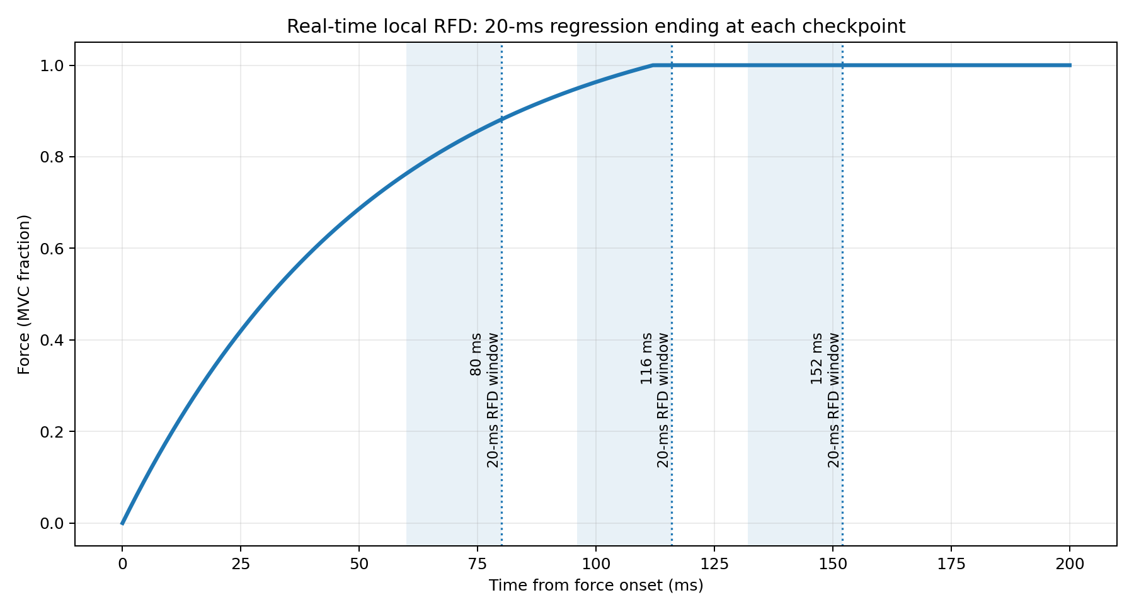
The actual adaptive RFD metric in V6 is a local sliding-window slope. At each onset-relative checkpoint, calculate_epoch_rfd fits a straight line to the most recent LOCAL_RFD_WINDOW_S = 0.020 s of smoothed force ending at that checkpoint. For checkpoints earlier than one full local window, the start of the fit is clamped to onset. A checkpoint is valid only after its end time has elapsed and at least MIN_EPOCH_SAMPLES = 5 samples are available.
RFD is therefore expressed in MVC fractions per second (MVC/s). The use of a local window means RFD is expected to be large during the rapid rising phase and to fall toward zero as the force trajectory plateaus. This is why the program can optionally require a simultaneous force condition: a low local RFD late in the rise does not necessarily mean poor performance if force is already high.

9. Adaptive checkpoint references
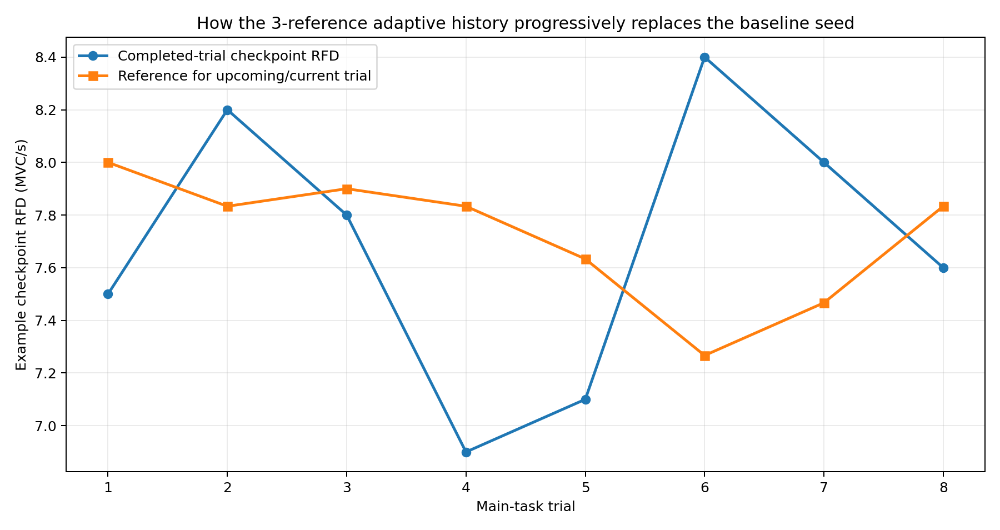
There is one adaptive RFD reference per checkpoint. calculate_checkpoint_thresholds takes the most recent SLOPE_REFERENCE_TRIALS completed checkpoint profiles and, for each checkpoint independently, calculates their mean only when all required values are finite. The default SLOPE_REFERENCE_TRIALS is 3. The force reference is computed analogously from the previous FORCE_REFERENCE_TRIALS = 3 checkpoint-force profiles.
The main task does not begin with an empty history. Instead, the baseline mean RFD profile is copied three times into the RFD history and the baseline mean force profile is copied three times into the force history. Consequently, Main Task Trial 1 is compared with the baseline mean profile. After Trial 1 completes, the next three-reference average contains two baseline copies plus Trial 1; after Trial 2 it contains one baseline copy plus Trials 1–2; after Trial 3 it is fully based on the three most recent main-task trials. This progressive replacement is the operative V6 behavior and supersedes older comments near the top of the file that describe early trials as having no threshold.

10. Trigger margins and decision thresholds
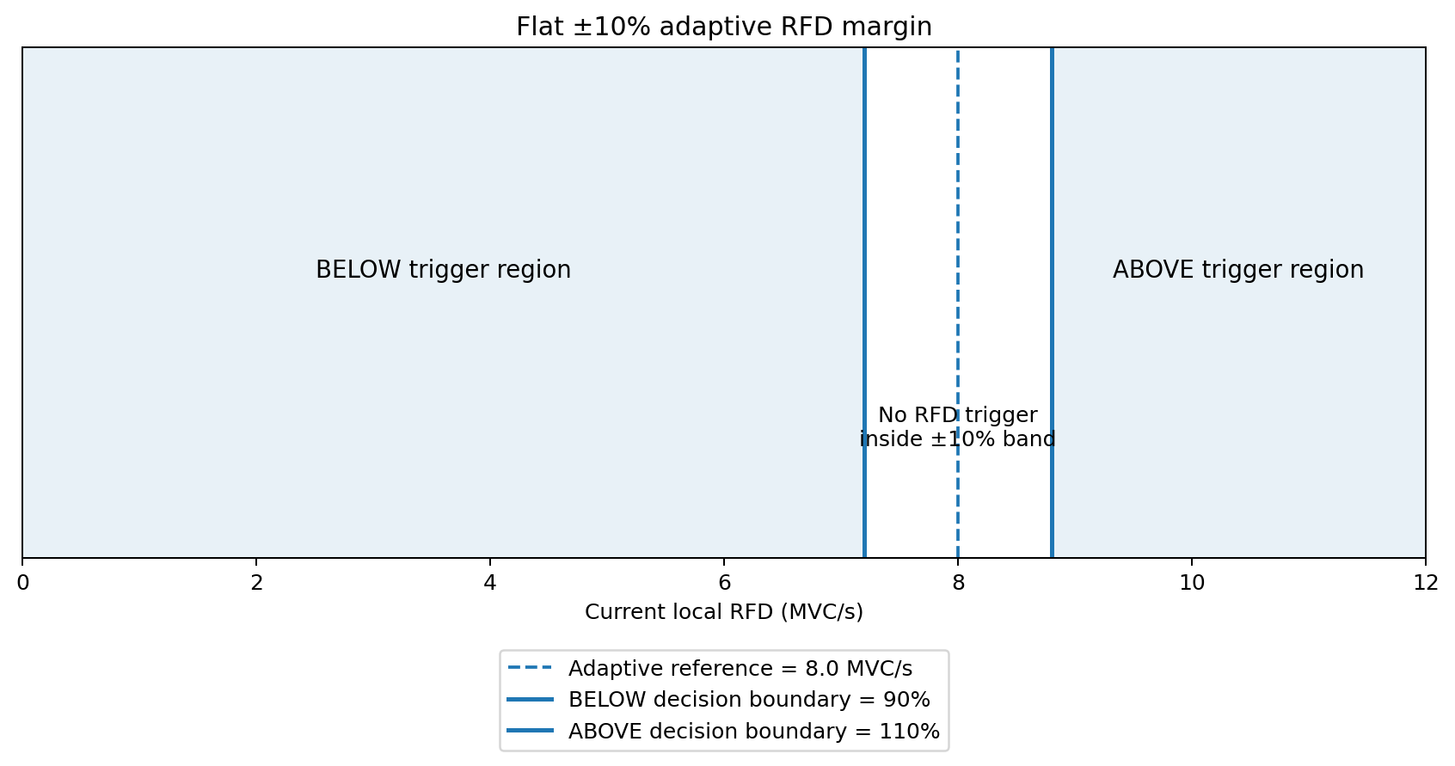
The adaptive reference itself is not the final trigger boundary. The program applies TRIGGER_MARGIN_FRACTION = 0.10. In BELOW mode, the current local RFD must be strictly less than 90% of the adaptive checkpoint reference. In ABOVE mode, it must be strictly greater than 110% of the reference. This creates a neutral band around the rolling reference and reduces triggering on small fluctuations.
Force uses a separate FORCE_REFERENCE_MARGIN = 0.10. In BELOW mode, checkpoint force must be below 90% of the checkpoint force reference and also below FORCE_TRIGGER_CEILING. With the default target settings, FORCE_TRIGGER_CEILING = TARGET_FORCE_LEVEL − TARGET_TOLERANCE = 0.75 MVC. In ABOVE mode, checkpoint force must exceed 110% of the force reference; the high-force ceiling is not applied.

11. Stimulation metric modes
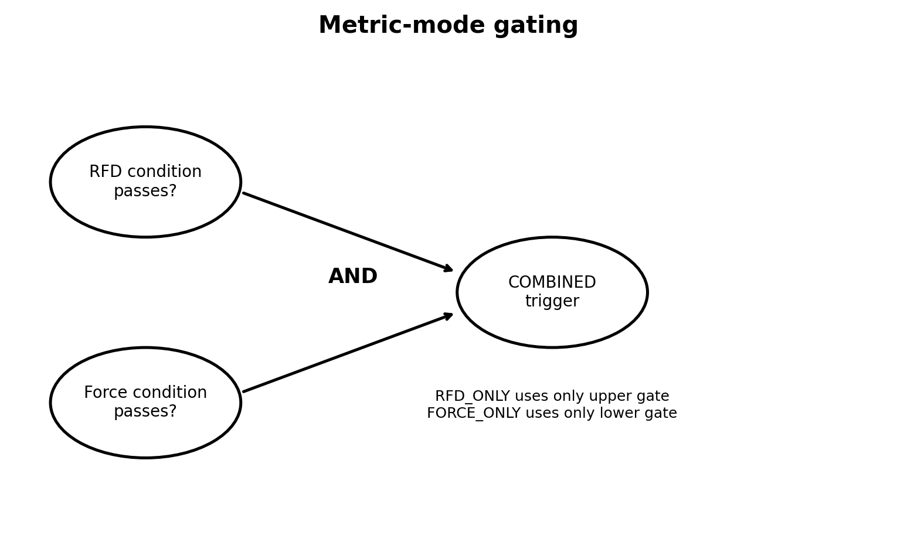
Mode | RFD gate | Force gate | Trigger condition
RFD_ONLY | Used | Ignored | RFD condition alone
FORCE_ONLY | Ignored | Used | Force condition alone
COMBINED | Used | Used | RFD AND force must both pass
The monitor checks checkpoints in chronological order and stops at the first checkpoint that satisfies the selected metric rule. Thus there is at most one adaptive stimulation trigger per trial. If no checkpoint satisfies the rule by the individualized RFD_CHECK_END_S, the monitor finishes with a no-criterion decision reason.

12. Trial state machine and timing
PREP lasts PREP_DURATION_S plus uniform random jitter from 0 to PREP_JITTER_S. If USE_RED_CUE is true, the red target is shown; otherwise this interval is visually silent. A cue DAQ trigger is sent CUE_TRIGGER_LEAD_S before the PREP interval ends. GO begins when the green target appears. The visible green duration is GO_DURATION_S plus uniform jitter from 0 to GO_JITTER_S.
The adaptive monitor may remain armed longer than the visible GO cue. main_go_duration_s is max(GO_DURATION_S, ONSET_SEARCH_WINDOW_S + RFD_CHECK_END_S + 0.02). This ensures that a late but still valid onset has time to reach the last adaptive checkpoint. After the adaptive period, RECORD_TAIL continues sampling until POST_GO_RECORDING_END_S after GO. ITI is drawn uniformly from ITI_MIN_S to ITI_MIN_S + ITI_JITTER_S.
Breaks are non-blocking. If the elapsed time since the previous break reaches BREAK_INTERVAL while the state is PREP or ITI, the program enters BREAK for BREAK_DURATION seconds. Sampling/event handling continues rather than freezing the application.

13. DAQ trigger behavior
The code defines separate analog-output channels for the cue trigger and adaptive RFD trigger. send_trigger is serialized with _daq_lock, preventing simultaneous writes from the main thread and monitor thread. nidaqmx is optional: if it cannot be imported, the program continues in a simulation/debug mode and reports that triggers will be simulated. This makes the task testable without attached DAQ hardware.

14. Post-hoc metrics
After each trial, calculate_trial_metrics derives onset-aligned RFD, reaction time, peak and time-to-peak measures, force values at predefined onset-relative time points, checkpoint RFDs, checkpoint forces, live-versus-post-hoc consistency fields, trigger timing, and target-accuracy metrics. The diagnostic running-slope trace is retained for visualization but is not used for the stimulation decision.
RFD_EPOCH_S = 0.08 identifies the primary 80-ms checkpoint reported in summaries. RFD_EPOCHS_S additionally requests 50, 100, 150, 200, and 300 ms post-hoc epochs. PEAK_RFD_WINDOW_S = 0.04 controls the short moving window used to estimate peak instantaneous RFD. FORCE_TIMEPOINTS_FROM_ONSET_S records force at 50, 100, 150, 200, 300, and 400 ms after onset.

15. Output files and figures
Outputs are written under OUTPUT_ROOT / Subject / Session / Block / TaskVersion. The default root is the user Desktop/ADAPT_BK; if that location is not writable, the program falls back to Documents/ADAPT_BK_Exp2. The task-version folder combines the selected metric mode and direction, for example COMBINED_BELOW.
The Excel workbook can contain Trial_Summary, Trial_TimeSeries, Calibration, Baseline_Thresholds, Baseline_Plateau, and Raw_Data sheets. A MATLAB .mat file stores raw force, calibration values, baseline profiles, task settings, trial-level columns, and selected time-series columns. The plotting subsystem generates raw/session force plots, trial RFD summaries, onset-aligned force overlays, individual-trial diagnostic figures, and multiple session-level RFD/force summary visualizations.

16. Configuration safeguards
- ONSET_CONFIRM_SAMPLES must be greater than SLOPE_SMOOTHING_SAMPLES.
- RFD_EPOCH_S must exactly match one member of RFD_CHECKPOINTS_S.
- POST_ONSET_WINDOW_S must be at least as long as RFD_CHECK_END_S.
- RFD_CHECK_START_S must be long enough to contain MIN_EPOCH_SAMPLES at the configured sampling rate.
- validate_and_fix_timing raises too-short GO duration to ONSET_SEARCH_WINDOW_S + RFD_CHECK_END_S when needed.
- POST_GO_RECORDING_END_S is raised if it would end before the longest visible GO duration.
- Negative PREP, ITI, or jitter values are clamped to zero by the timing validator/startup editor.

17. Important implementation notes and internal inconsistencies
Several comments/docstrings appear to describe older versions and should not be treated as the executable specification. The report therefore prioritizes the actual V6 code paths.

Baseline seeding vs. “no threshold” header comment
The file header says Trial 1 and Trial 2 have no threshold, but main() explicitly seeds the main-task RFD and force histories with repeated baseline mean profiles. Therefore Main Task Trial 1 already has a valid baseline-derived reference when baseline calibration succeeded.

Reference count examples
Some older text examples describe a two-trial rolling mean, while SLOPE_REFERENCE_TRIALS and FORCE_REFERENCE_TRIALS are both 3 in V6. The executable functions use the configured value 3.

RFD window wording
LOCAL_RFD_WINDOW_S is 0.020 s (20 ms), but some docstrings/comments still mention a 50-ms local window. calculate_epoch_rfd uses its default window_s=LOCAL_RFD_WINDOW_S, so the actual adaptive window is 20 ms.

Checkpoint start wording
Comments in a few places refer to starting at 60 ms, but RFD_CHECK_START_S is 0.020 s and the generated grid starts at 20 ms. The 80-ms primary checkpoint is on the 6-ms grid because 20 + 10×6 = 80 ms.

Individualization wording
make_rfd_checkpoints rounds the requested endpoint upward to the grid, but baseline processing then removes checkpoints above the hard 180-ms cap. The final main-task endpoint is therefore the last retained grid point, at most 176 ms with current grid settings.

18. Parameter reference
The following tables cover the top-level configuration constants that control participant/session identity, hardware, calibration, adaptive logic, timing, display, plotting, DAQ, breaks, and output. Derived/internal objects such as locks and caches are discussed separately.

Identity and hardware
Parameter | Default / expression | Meaning / effect | Source line
X_NUMBER | "X00000" | Default participant identifier; editable in startup GUI. | 96
SESSION | "Session_1" | Default session identifier; editable in startup GUI. | 97
BLOCK | "Block_1" | Default block identifier; editable in startup GUI. | 98
RIGHT_AXIS | 0 | Pygame joystick axis index used for the right-hand transducer. | 106
ALLOW_SINGLE_SCREEN | True | Allows debug operation on the primary monitor when a second display is absent. | 109

Calibration
Parameter | Default / expression | Meaning / effect | Source line
CALIBRATION_DURATION_S | 2.0 | Duration of maximum-contraction sampling during calibration. | 116
CALIBRATION_REST_DURATION_S | 5.0 | Duration used to measure resting raw-axis baseline. | 117
CALIBRATION_SCALE_FACTOR | 1.00 | Multiplier applied to measured max deflection before normalization; >1 creates display headroom. | 122
DEADZONE_RAW | 0.02 | Raw-axis displacement around baseline treated as zero force. | 126
MIN_VALID_CALIBRATION_DEFLECTION | 0.01 | Minimum raw deflection required for calibration to count as a real contraction. | 129
CAL_OK | "ok" | Calibration status string for success. | 132
CAL_QUIT | "quit" | Calibration status string for operator/user abort. | 133
CAL_NO_FORCE | "no_force" | Calibration status string for insufficient contraction. | 134

Trials and baseline
Parameter | Default / expression | Meaning / effect | Source line
TOTAL_TRIALS | 15 | Requested number of main-task trials per block. | 141
FAMILIARIZATION_TRIALS | 5 | Number of practice trials; data discarded. | 145
BASELINE_TRIALS | 10 | Number of no-stimulation baseline trials used for individualized references. | 146
MAIN_TASK_LOADBAR_DEFAULT | True | Default state of PREP loadbar in main task. | 149
PLATEAU_FRACTION_OF_PEAK | 0.95 | Fraction of trial peak defining the baseline plateau level. | 155
PLATEAU_HOLD_S | 0.050 | Required continuous time at/above plateau level. | 156
INDIVIDUALIZE_RFD_CHECK_END | True | Whether baseline-derived plateau timing replaces the fallback RFD checking endpoint. | 161
MAX_RFD_CHECK_END_S | 0.180 | Hard maximum allowed endpoint for stimulation checking. | 167

Adaptive and onset
Parameter | Default / expression | Meaning / effect | Source line
SLOPE_REFERENCE_TRIALS | 3 | Number of previous checkpoint RFD profiles averaged for the adaptive RFD reference. | 175
FORCE_REFERENCE_TRIALS | 3 | Number of previous checkpoint force profiles averaged for force reference. | 178
SLOPE_TRIGGER_MODE | "BELOW" | Default direction: BELOW or ABOVE; startup GUI can override. | 182
STIMULATION_METRIC_MODE | "COMBINED" | Default decision metric: RFD_ONLY, FORCE_ONLY, or COMBINED. | 189
VALID_STIMULATION_METRIC_MODES | ("RFD_ONLY", "FORCE_ONLY", "COMBINED") | Allowed startup metric-mode values. | 190
TRIGGER_MARGIN_FRACTION | 0.10 | Relative RFD separation required from adaptive reference; 0.10 means 90%/110% boundaries. | 200
RISING_ONSET_FORCE | 0.05 | Force threshold, in MVC fraction, for candidate onset. | 213
ONSET_CONFIRM_SAMPLES | 5 | Consecutive above-threshold samples required to confirm onset. | 223
ONSET_SEARCH_WINDOW_S | 0.850 | Maximum time after GO in which onset can be accepted. | 231
POST_ONSET_WINDOW_S | 2.00 | Amount of post-onset data retained/considered for analysis. | 239
SLOPE_SMOOTHING_SAMPLES | 3 | Causal moving-average kernel length before onset/RFD calculations. | 247

RFD
Parameter | Default / expression | Meaning / effect | Source line
LOCAL_RFD_WINDOW_S | 0.020 | Length of local regression window used for real-time RFD. | 279
RFD_CHECK_START_S | 0.020 | First onset-relative adaptive checkpoint. | 284
RFD_CHECK_END_S | 0.210 | Fallback/active last adaptive checkpoint before baseline individualization. | 288
RFD_CHECK_STEP_S | 0.006 | Spacing between adaptive checkpoints. | 293
RFD_CHECKPOINTS_S | tuple(  round(x, 4)  for x in np.arange(  RFD_CHECK_START_S,  RFD_CHECK_END_S + RFD_CHECK_ | Generated tuple of onset-relative checkpoints. | 295
RFD_EPOCH_S | 0.08 | Primary checkpoint/epoch reported in summaries. | 305
RFD_EPOCHS_S | (0.05, 0.10, 0.15, 0.20, 0.30) | Additional post-hoc RFD epochs. | 314
MIN_EPOCH_SAMPLES | 5 | Minimum samples required for a valid local RFD fit. | 322
PEAK_RFD_WINDOW_S | 0.04 | Sliding window used for descriptive peak RFD. | 325
FORCE_TIMEPOINTS_FROM_ONSET_S | (0.05, 0.10, 0.15, 0.20, 0.30, 0.40) | Onset-relative times at which force is recorded post hoc. | 328
MIN_SLOPE_SAMPLES | 10 | Minimum samples for diagnostic running local-slope calculation. | 340

Plot axes and rates
Parameter | Default / expression | Meaning / effect | Source line
PLOT_TIME_FROM_GO_S | (-0.2, 2.0) | Default x-axis range for GO-aligned trial figures. | 376
PLOT_TIME_FROM_ONSET_S | (-0.2, 1.5) | Default x-axis range for onset-aligned figures. | 379
PLOT_FORCE_LIMITS | (-0.10, 1.5) | Shared force-axis limits. | 382
PLOT_RFD_LIMITS | (-15.0, 15.0) | Shared RFD-axis limits. | 385
PLOT_TRIAL_RFD_LIMITS | None | Optional session-level trial RFD axis override. | 388
PLOT_FONT_SIZE | 20 | Plot axis-label font size. | 391
PLOT_TICK_SIZE | 15 | Plot tick-label size. | 392
PLOT_TITLE_SIZE | 20 | Plot title size. | 393
PLOT_LEGEND_SIZE | 14 | Plot legend size. | 394
PLOT_FONT_WEIGHT | "bold" | Plot font weight. | 395
FPS | 64 | Display refresh target; independent of force sampling. | 402
SAMPLING_RATE_HZ | 500 | Nominal force acquisition frequency. | 403

Target and display
Parameter | Default / expression | Meaning / effect | Source line
TARGET_DISPLAY_MODE | "RIGHT_ONLY" | Target presentation mode; right-only in this version. | 411
TARGET_FORCE_LEVEL | 0.85 | Center of target box in MVC fraction. | 414
TARGET_TOLERANCE | 0.1 | Half-width of target acceptance band in MVC fraction. | 415
FORCE_TRIGGER_CEILING | TARGET_FORCE_LEVEL - TARGET_TOLERANCE | BELOW-mode high-force suppression boundary; target level minus tolerance. | 419
FORCE_REFERENCE_MARGIN | 0.10 | Relative separation required from adaptive force reference. | 422
RECT_WIDTH | 300 | Target rectangle width in pixels. | 424
RECT_OUTLINE_WIDTH | 6 | Target outline thickness in pixels. | 425
RANDOM_TARGET_MIN_FORCE | 0.20 | Lower force bound for random-target positioning helper. | 429
RANDOM_TARGET_MAX_FORCE | 0.70 | Upper force bound for random-target positioning helper. | 430
CURSOR_RADIUS | 10 | Force cursor radius in pixels. | 437
CURSOR_OUTLINE_WIDTH | 4 | Force cursor outline thickness. | 438
CURSOR_COLOR | (255, 255, 0) | RGB fill color for force cursor. | 440
CURSOR_OUTLINE_COLOR | (255, 255, 255) | RGB outline color for force cursor. | 441
CURSOR_TRACK_WIDTH | 4 | Vertical guide-rail width. | 444
CURSOR_TRACK_COLOR | (45, 45, 45) | RGB guide-rail color. | 445
LOADBAR_WIDTH | 40 | Loadbar width in pixels. | 452
LOADBAR_HEIGHT_FRAC | 0.60 | Loadbar height as fraction of screen height. | 453
LOADBAR_X_OFFSET | 50 | Loadbar horizontal offset. | 454

Timing
Parameter | Default / expression | Meaning / effect | Source line
PREP_DURATION_S | 3.0 | Base preparatory interval before GO; editable in GUI. | 470
PREP_JITTER_S | 0.0 | Uniform extra PREP duration range. | 474
USE_RED_CUE | True | Whether PREP visibly shows the red target. | 479
GO_DURATION_S | 1.10 | Base visible green GO duration; editable in GUI. | 494
GO_JITTER_S | 0.0 | Uniform extra visible GO duration. | 499
POST_GO_RECORDING_END_S | 2.00 | Time after GO until force recording ends; no stimulation in tail. | 503
ITI_MIN_S | 1.0 | Base inter-trial interval. | 509
ITI_JITTER_S | 0.5 | Uniform extra ITI range. | 510
ITI_MAX_S | ITI_MIN_S + ITI_JITTER_S | Derived upper ITI bound = base + jitter. | 511
_MIN_EPOCH_DURATION_S | MIN_EPOCH_SAMPLES / SAMPLING_RATE_HZ | Top-level configuration or display constant used by the implementation. | 592

DAQ, breaks, output and colors
Parameter | Default / expression | Meaning / effect | Source line
CUE_TRIGGER_LEAD_S | 0.1 | How long before PREP ends the cue DAQ trigger is sent. | 613
BREAK_DURATION | 30 | Duration of scheduled break state. | 623
BREAK_INTERVAL | 5 * 60 | Elapsed interval between breaks. | 624
USER_HOME | os.path.expanduser("~") | Top-level configuration or display constant used by the implementation. | 638
OUTPUT_ROOT | os.path.join(USER_HOME, "Desktop", "ADAPT_BK") | Primary root directory for saved results. | 639
WHITE | (255, 255, 255) | RGB white. | 648
BLACK | (0, 0, 0) | RGB black. | 649
BLUE | (0, 191, 255) | RGB blue. | 650
GREEN | (0, 255, 64) | RGB green. | 651
RED | (220, 20, 60) | RGB red. | 652
NEUTRAL_GRAY | (90, 90, 90) | RGB neutral gray. | 653
YELLOW | (255, 255, 0) | RGB yellow. | 654
GLOBAL_START_TIME | None | Top-level configuration or display constant used by the implementation. | 661

Plot-export constants
Parameter | Default / expression | Meaning / effect | Source line
PLOT_DPI | 350 | Resolution used when saving publication-style plots. | 3197
PLOT_COLORS | {  "right": "#0072B2",  "mean": "#005AB5",  "trial": "#8A8A8A",  "threshold": "#CC79A7",  "trig | Named color palette for plotting. | 3198

19. Core function and class catalog
This appendix lists every top-level function/class in the supplied file. It is intended as an implementation map rather than a substitute for the detailed algorithm sections above.
Lines | Type | Function / class | Purpose (from code/docstring)
344–354 | Function | apply_plot_style(ax, title, xlabel, ylabel) | Internal helper; purpose inferred from its implementation and call sites.
357–362 | Function | bold_legend(ax) | Internal helper; purpose inferred from its implementation and call sites.
524–526 | Function | required_go_duration_s() | Minimum GO_DURATION_S needed for the adaptive checking window.
529–583 | Function | validate_and_fix_timing() | Re-validate the (possibly operator-edited) timing globals.
668–703 | Class | ForceBuffer | Thread-safe storage for force samples.
720–737 | Class | Calibration | Right-handle resting baseline and maximum deflection.
744–756 | Function | raw_to_deflection(raw, baseline) | Signed distance from rest, deadzoned, in RAW AXIS UNITS.
759–778 | Function | deflection_to_force(deflection, max_deflection) | Participant-normalised force.
781–784 | Function | read_raw_axes(joystick) | Read the RIGHT handle axis only.
790–801 | Function | acquire_force_sample(joystick, start_time, calibration) | Acquire one participant-normalised RIGHT-handle force sample.
803–804 | Function | get_grip_samples_numpy() | Internal helper; purpose inferred from its implementation and call sites.
807–811 | Function | clear_force_buffer() | Remove samples between experiment phases so timestamps cannot overlap.
814–815 | Function | get_recent_samples_numpy() | Internal helper; purpose inferred from its implementation and call sites.
822–853 | Function | list_joysticks() | Internal helper; purpose inferred from its implementation and call sites.
856–864 | Function | diagnose_axes(joystick, duration_s) | Optional helper: print the raw RIGHT-handle axis value.
870–911 | Function | open_on_second_screen() | Internal helper; purpose inferred from its implementation and call sites.
921–924 | Function | get_font(size) | Internal helper; purpose inferred from its implementation and call sites.
927–945 | Function | show_text(text, color, screen, size, y_center) | Internal helper; purpose inferred from its implementation and call sites.
952–974 | Function | draw_menu_button(screen, rect, text, enabled, hovered, selected) | Draw one startup-menu button with a persistent selected state.
977–990 | Function | make_rfd_checkpoints(end_s) | Build the onset-anchored checkpoint grid up to an individualized end.
993–1037 | Function | calculate_time_to_force_plateau(t, force) | Estimate time from force onset to the maximum-force plateau for one trial.
1040–1052 | Function | _average_checkpoint_history(checkpoint_history, checkpoints) | Mean RFD at each checkpoint across valid baseline trials.
1055–1064 | Function | _draw_phase_header(screen, title, subtitle, trial_number, total_trials) | Small phase label shown during familiarization/baseline runs.
1067–1303 | Function | run_pre_task_phase(screen, joystick, calibration, right_rect, phase, n_trials) | Run Familiarization or Baseline without adaptive/TMS triggering.
1306–1827 | Function | startup_menu(screen, joystick, right_rect, calibration, baseline_result, subject_id, session_id, block_id, trigger_mode, stimulation_metric_mode, show_loadbar) | Operator interface controlling the full experiment flow.
1830–1833 | Function | show_end_screen(screen) | Internal helper; purpose inferred from its implementation and call sites.
1836–1855 | Function | countdown(screen) | Internal helper; purpose inferred from its implementation and call sites.
1862–1874 | Function | force_to_cursor_y(force, screen_height) | Participant-normalised force -> screen Y.
1877–1887 | Function | draw_cursor_track(screen, target_rect) | Internal helper; purpose inferred from its implementation and call sites.
1890–1903 | Function | draw_force_cursor(screen, force, target_rect, visible) | Internal helper; purpose inferred from its implementation and call sites.
1906–1908 | Function | draw_active_target(screen, rect, color) | Internal helper; purpose inferred from its implementation and call sites.
1915–1922 | Function | create_target_rect(screen_height) | Box height is derived from the force tolerance, so that being inside
1925–1930 | Function | place_targets(right_rect, width, height, right_force_level) | Place the single RIGHT-hand target in the horizontal centre.
1932–1935 | Function | configure_targets_for_trial(trial_number, right_rect, width, height) | Configure the single RIGHT-hand target for every trial.
1941–1958 | Function | send_trigger(channel) | Internal helper; purpose inferred from its implementation and call sites.
1965–1988 | Function | measure_baseline(joystick, screen, duration_s, message) | Measure the resting baseline of the RIGHT handle only.
1990–2056 | Function | calibrate_hand(joystick, screen, calibration) | Measure the participant's maximum contraction for the RIGHT handle.
2058–2089 | Function | run_calibration(joystick, screen) | Calibrate only the RIGHT handle.
2095–2115 | Function | smooth_signal(values, samples) | Causal-safe moving average.
2122–2160 | Function | find_rising_onset(t, force, smoothed) | Locate force onset: the first sample where smoothed force crosses
2167–2210 | Function | calculate_epoch_rfd(t, force, epoch_s, onset_idx, smoothed, window_s) | Local/sliding-window RFD used by the adaptive decision.
2217–2258 | Function | calculate_peak_rfd(t, force, onset_idx, smoothed, window_s) | Maximum instantaneous RFD: the steepest short-window slope anywhere
2261–2311 | Function | calculate_rfd_to_peak(t, force, onset_idx, smoothed) | Average RFD from onset to peak force.
2314–2337 | Function | calculate_running_slope(t, force, onset_idx, smoothed, window_s) | Continuous diagnostic LOCAL RFD over the most recent 50-ms window.
2340–2359 | Function | compute_checkpoint_forces(t, force, onset_idx, smoothed, checkpoints) | Smoothed force at each onset-anchored checkpoint.
2362–2372 | Function | calculate_checkpoint_force_references(force_history) | Mean checkpoint force from the previous two completed trials.
2379–2404 | Function | compute_checkpoint_rfds(t, force, onset_idx, smoothed, checkpoints) | RFD at every checkpoint, all measured from the SAME onset.
2407–2437 | Function | calculate_checkpoint_thresholds(checkpoint_history) | One threshold per checkpoint, each the mean of the previous
2440–2465 | Function | calculate_rfd_threshold(rfd_history) | Threshold for the upcoming trial = mean of the fixed-epoch RFD from
2472–2832 | Class | RFDMonitor | Watches the RIGHT handle during the GO period and checks RFD REPEATEDLY as
2839–2885 | Function | _hand_timeseries(trial_number, hand, t, force, go_start_time) | Build the per-hand time series, anchored to onset.
2888–2900 | Function | extract_trial_timeseries(trial_number, go_start_time, time_array, right_force_array) | Retain the RIGHT-handle time series for one trial.
2906–3083 | Function | _hand_metrics(side, t, force, go_start_time, monitor_result) | All post-hoc measures for one hand, every one anchored to onset.
3086–3158 | Function | _accuracy_metrics(side, t, force, go_start_time, target_level, tolerance) | Trial-by-trial spatial/temporal accuracy of the force cursor relative
3161–3191 | Function | calculate_trial_metrics(trial_number, go_start_time, time_array, right_force_array, prev_right_rfd, right_result) | Calculate all trial metrics for the RIGHT handle only.
3208–3223 | Function | apply_publication_plot_style() | Apply one consistent style to every saved Matplotlib figure.
3226–3228 | Function | _style_axis(ax) | Internal helper; purpose inferred from its implementation and call sites.
3231–3235 | Function | _save_figure(fig, path) | Internal helper; purpose inferred from its implementation and call sites.
3238–3239 | Function | _checkpoint_ms() | Internal helper; purpose inferred from its implementation and call sites.
3242–3256 | Function | _checkpoint_matrix(df_trials, side, kind) | Return trials x checkpoints matrix for RFD or threshold values.
3259–3261 | Function | _trigger_threshold_matrix(df_trials, side) | Exact adaptive trigger threshold used by the real-time decision.
3264–3279 | Function | _smooth_curve(x, y, n) | Smooth an observed checkpoint trajectory without extrapolating it.
3282–3292 | Function | _finite_mean_sd(matrix) | Column-wise mean/SD while avoiding warnings for all-NaN columns.
3301–3315 | Function | plot_force_data(time_data, right_force_data, trial_log, out_dir) | Whole-session RIGHT-handle force trace.
3317–3327 | Function | _nearest_available_checkpoints(target_ms, available_ms) | Return unique real checkpoints nearest to requested display times.
3334–3443 | Function | plot_trial_rfd(df_trials, out_dir) | RIGHT-handle local RFD across trials at multiple onset timepoints.
3451–3472 | Function | plot_onset_aligned_forces(trial_timeseries, out_dir) | Overlay RIGHT-handle force traces aligned to force onset.
3478–3536 | Function | resolve_rfd_limits(df_trials, df_timeseries) | Decide ONE RFD axis range for the whole session, so every trial
3539–3542 | Function | _label(value, fmt) | Internal helper; purpose inferred from its implementation and call sites.
3545–3816 | Function | plot_individual_trial_figures(df_timeseries, df_trials, out_dir, rfd_limits) | Publication-style RIGHT-handle force/RFD figure for every trial.
3822–3850 | Function | plot_mean_rfd_profile(df_trials, out_dir, rfd_limits) | Mean RIGHT-handle checkpoint RFD +/- SD and mean adaptive threshold.
3852–3876 | Function | plot_rfd_spaghetti(df_trials, out_dir, rfd_limits) | RIGHT-handle trial trajectories with session mean, SD and threshold.
3878–3905 | Function | plot_rfd_heatmap(df_trials, out_dir) | RIGHT-handle trials x checkpoints heatmap; stars mark triggers.
3907–3924 | Function | plot_trigger_map(df_trials, out_dir) | RIGHT-handle trial number versus stimulation trigger checkpoint.
3926–3942 | Function | plot_threshold_evolution(df_trials, out_dir, rfd_limits) | RIGHT-handle adaptive threshold at every checkpoint over trials.
3944–3964 | Function | plot_session_rfd_summaries(df_trials, out_dir, rfd_limits) | Create all session-level RFD, Force, and combined visualisations.
3972–3979 | Function | _summary_checkpoint_keys(df_trials, prefix) | Internal helper; purpose inferred from its implementation and call sites.
3982–4023 | Function | plot_mean_force_profile(df_trials, out_dir) | Internal helper; purpose inferred from its implementation and call sites.
4026–4056 | Function | plot_force_spaghetti(df_trials, out_dir) | Internal helper; purpose inferred from its implementation and call sites.
4059–4096 | Function | plot_force_heatmap(df_trials, out_dir) | Internal helper; purpose inferred from its implementation and call sites.
4099–4129 | Function | plot_force_reference_evolution(df_trials, out_dir) | Internal helper; purpose inferred from its implementation and call sites.
4136–4228 | Function | plot_rfd_force_phase_map(df_trials, out_dir) | Multi-timepoint local-RFD versus Force phase map.
4232–4280 | Function | plot_rfd_force_normalized_overview(df_trials, out_dir) | Internal helper; purpose inferred from its implementation and call sites.
4287–4324 | Function | matlab_safe(values) | Convert a pandas column into something savemat can serialise.
4331–5127 | Function | main() | Internal helper; purpose inferred from its implementation and call sites.

20. Practical interpretation of the adaptive rule
For a concrete BELOW/COMBINED example, suppose the adaptive RFD reference at a checkpoint is 8.0 MVC/s and the force reference is 0.60 MVC. The 10% margins produce an RFD decision boundary of 7.2 MVC/s and a force decision boundary of 0.54 MVC. A trigger requires current local RFD < 7.2 AND current force < 0.54 AND current force < 0.75 MVC. If the RFD is low but force is already 0.80 MVC, COMBINED does not trigger because the force gate and the high-force ceiling fail. This is the intended protection against interpreting the natural fall of local RFD near a successful plateau as a low-performance event.
For ABOVE/COMBINED using the same references, the RFD boundary is 8.8 MVC/s and the force boundary is 0.66 MVC. A trigger requires both current local RFD > 8.8 and current force > 0.66. The first checkpoint meeting the full rule sends the stimulation pulse and ends adaptive checking for that trial.

21. Summary
V6 is best understood as a baseline-seeded, onset-anchored, checkpoint-adaptive force task. Calibration converts device displacement into normalized MVC force; baseline establishes an individualized early-force window and reference trajectories; the main task repeatedly compares 20-ms local RFD and/or checkpoint force with rolling three-profile references; a ±10% margin defines meaningful deviation; and a first-passing-checkpoint rule determines whether stimulation occurs. The implementation also includes explicit timing guards, no-onset handling, high-force suppression for corrective BELOW triggering, hardware-optional debugging, comprehensive trial/time-series exports, and a substantial plotting pipeline.

